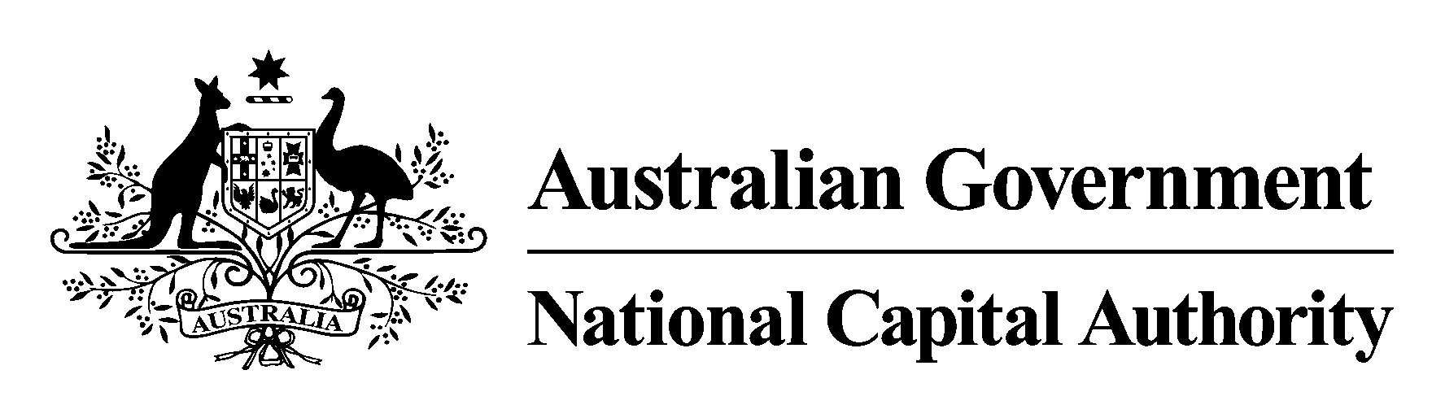

The Australian Capital Territory
(Planning and Land Management) Act 1988

NATIONAL CAPITAL PLAN
AMENDMENT 49

Civic
Principles and Policies

February 2005

National Capital Plan Amendment 49
(Civic Principles and Policies)

The National Capital Plan is amended by:

(a) Replacing Figure 21 on page 87 of the Plan with a revised Figure 21 that follows;

(b) Including under the heading of National Interest in Civic, on page 89 of the
Plan, after the words “The Commonwealth’s interest in Civic is different and is related to:”, the following:

(i) a new first dot point:
- maintaining the geometry and intent of the plan for Civic which is integral to the integrity of the Griffin Plan as a work of national and international significance and the role of the Griffin Plan as the principal organising framework for Civic and the Central National Area.

(ii) additional words in the first existing dot point so that the re-worded dot
point becomes:
- its location at the apex of the National Triangle, the centrepiece of Griffin’s Plan. The point of the apex is City Hill which will ultimately become the symbolic and geographical centre of Civic as it develops to the south and west.

(iii) an additional dot point:
- the Main Avenues converging on Civic provide important strategic
corridors linking major centres of Commonwealth and municipal activity in the Central National Area – eg Government, University, Defence and Civic administration. These Main Avenues are suitable for the development of higher densities of retail, employment and residential activity to support key public transport corridors and provide the principal visual and symbolic connections between the city and the landscape.

(c) Deleting from the penultimate sub-paragraph on page 89 of Part One of the National Capital Plan the final sentence which reads ‘These considerations are best met by special requirements’;

(d) Deleting the paragraph on page 90 of Part One of the National Capital Plan immediately preceding the heading ‘Special Requirements’ in section 4.5.4;

(e) Deleting the heading Special Requirements and the material following that heading set out in section 4.5.4 Civic in Chapter 4 Urban Areas, pages 90 and 91 of Part One of the National Capital Plan and substituting the following:

4.5.4.1 Principles for Civic

Civic’s continued development should recognise its metropolitan significance and role, achieve a satisfactory relationship between Civic and other development and features of the Central area, and meet the following Principles:

- Future development and redevelopment in Civic should aim both to reinforce Civic's role as the prime metropolitan centre, and contribute to a diverse, lively and attractive character.
.
- The design of buildings and the amenity and environmental quality of the main public spaces should result in an accessible, attractive, high quality and distinctive centre consistent with Civic's role as the major metropolitan centre and its location at one point of the National Triangle, Griffin’s major organizing element of the Central National Area.

4.5.4.2 Policies for Civic

The following Policies shall apply within those areas of Civic identified in Figure 21:

(a) Transport and movement

Long term impacts of development shall be taken into account. Measures for discouraging through traffic from using the Civic road network in peak periods must be considered. Future demand for car parking should be met by the construction of structured car parks in locations that service needs throughout Civic while aiming to minimise congestion, and/or by on-site provision of parking spaces. Vehicle access and traffic management throughout the area should seek to maintain the ease and comfort of moving around the city, catering to a diversity of pedestrian, cycle, vehicular and public transport modes.

(b) Urban Design

- The symbolic importance of the Main Avenues radiating from City Hill (Northbourne, Ainslie, Constitution, Edinburgh and University Avenues) and their role as the main public transport corridors should be complimented through the landscape and architectural treatment on abutting blocks.

- The design and development of Civic should continue to reflect the geometry and fine grain pattern of streets and blocks of the Griffin Plan.

- The design and development of streets should provide a continuous planting of large scale street trees and high quality landscape character that fosters a compact, connective and pedestrian-friendly environment for central city living.

- The massing, height, colours and materials used for buildings in Civic should result in a harmonious and high quality urban design outcome with a recognisable city edge.

- Buildings in Civic must be of permanent construction.

- The height of buildings in Civic may be less than but not more than 9 storeys provided that:

- plant rooms and other service elements may be allowed above this height subject to being set back from the building edges and screened from street level view.

- one or more taller building(s) per section up to a maximum height of RL 617m shall be considered only in accordance with an approved comprehensive design for the whole section. Comprehensive section designs shall seek to use building height to emphasise and reinforce the geometry of the Griffin Plan and the symbolic Main Avenues radiating out from City Hill. and

- where an existing building exceeds the height limitations set out above it shall be permissible to consider rebuilding to the same height as the existing building or lower.
and

(f) Replacing Figure 20 on page 85 of the Plan with a revised Figure 20 that follows. The revised Figure 20 no longer indicates Special Requirements for the Civic Area.

