Explanatory Statement

Southern Squid Jig Fishery Management Plan 2005

Subsection 17(1) of the Fisheries Management Act 1991 (the Act) provides that the Australian Fisheries Management Authority (AFMA) must determine written plans of management for each fishery that it manages. AFMA has determined the Southern Squid Jig Fishery Management Plan 2005 (the plan).

Table of Contents

The Southern Squid Jig Fishery 2
Determination and acceptance 3
Content of the Plan 3
Regulation Impact Statement 4
PART 1: Preliminary 5
PART 2: Specific ecosystem requirements 5
PART 3: Total allowable effort 5
PART 4: Right to fish in the fishery 6
PART 5: Statutory fishing rights 6
PART 6: Obligations of holders of SFRs 7
PART 7: Miscellaneous 8
PART 8: Transitional 8
SCHEDULE 1 Area of the fishery 8

The Southern Squid Jig Fishery

The Southern Squid Jig Fishery (SSJF) encompasses Commonwealth waters from Sandy Cape on Fraser Island (24°30′S) to the South Australian/Western Australian border (129°E) (refer Figure 2) and includes all Commonwealth waters around Tasmania.
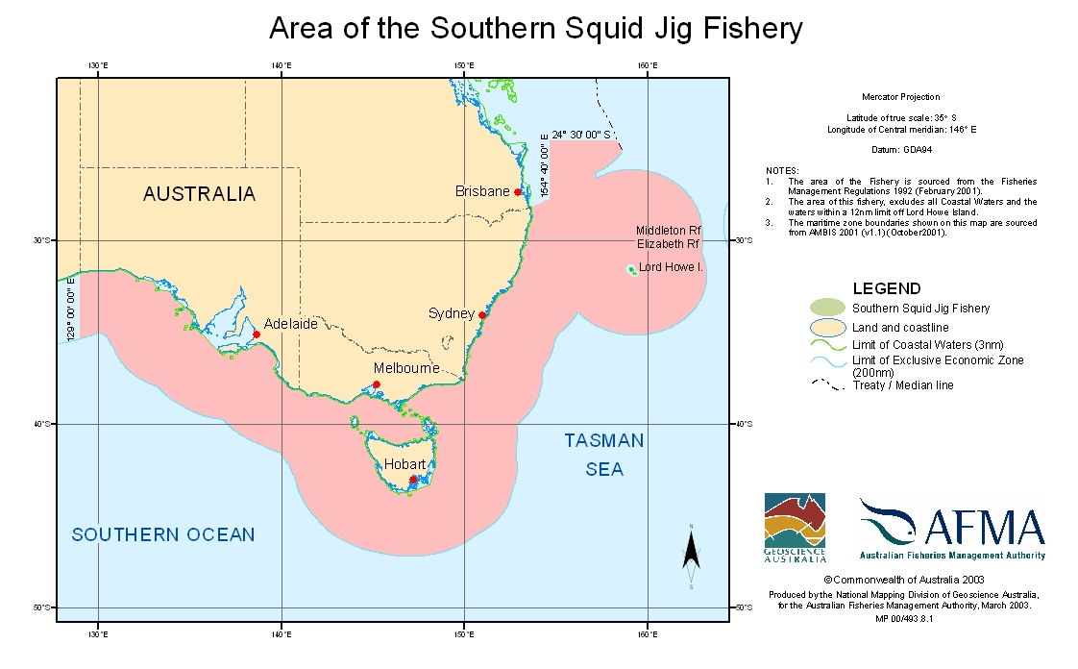
There are two other fisheries in Commonwealth waters that also take squid in the region of the SSJF. The waters of the South East Trawl (SET) sector of the Southern and Eastern Scalefish and Shark Fishery (SESSF) overlaps the entire area of the SSJF. The Great Australian Bight Trawl (GAB) sector of the SESSF is also adjacent to the SSJF and overlaps an area from the South Australian/Western Australian border to Cape Jervis near Adelaide. While the majority of squid caught by jigging methods are taken from fishing grounds off Portland, Queenscliff and Lakes Entrance in Victoria, there is a growing interest in the method by operators who fish in South Australian waters. A number of operators from South Australian prawn trawl fisheries have recently purchased fishing permits (from other SSJF operators) in order to utilise their considerable down time from the prawn fisheries which are open for less than 100 days per year.
Jigging is a particularly successful method for targeting squid. Squid are attracted to light, have voracious feeding habits and a tendency to congregate, particularly near thermoclines. Squid jigging has a high level of specificity for the target species.
The Fishery was previously managed under Fishing Permits granted to operators on an annual basis. Management measures were included on Fishing Permits by way of conditions.

Determination and acceptance

Plans can only be determined after consultation with such persons engaged in fishing as appear to AFMA to be appropriate and, in accordance with subsection 17(3) of the Fisheries Management Act 1991, after giving due consideration to any representations made to AFMA on the draft plan. Subsection 17(2) of the Act requires that interested persons must be invited, by public notice, to make representations on a draft of the Plan. Subsection 17(2A) of the Act provides that persons and organisations listed in the register established under section 17A must also be notified that a draft plan is available and that representations may be made in connection with the draft.

AFMA provided a draft of the Plan for public comment as prescribed in the Act and gave due consideration to the representations that were received in respect of that draft.

Once determined, a plan is then submitted to the Minister for acceptance in accordance with section 18 of the Act. AFMA must inform the Minister of any representations that were received and of the consultations that were conducted before determining the plan. The Minister must accept the plan if it appears to the Minister that AFMA gave due consideration to any representations received, and conducted adequate consultations. The Minister must also be satisfied that the plan is consistent with AFMA's corporate plan and current annual operational plan.

Content of the Plan

The Plan provides a number of mechanisms designed to focus, and provide for, the management of the Fishery.

The Plan provides objectives for the Plan, measures by which the objectives are to be attained and performance criteria against which the measures taken may be assessed, as required under subsection 17(5) of the Act. These matters are designed to accord with the Environment Protection and Biodiversity Act 1991. In addition, reporting and review mechanisms are incorporated into the performance criteria.

The objectives of the Plan reflect the objectives set out in section 3 of the Act.

The measures by which the objectives are to be achieved are set out in section 6 of the Plan. These include the determination of reference points for maintaining the sustainability of the Fishery, granting of transferable statutory fishing rights (SFRs), reviewing the bycatch action plan, the development of management strategies, research, data collection, monitoring, compliance and the recovery of costs for management of the Fishery.

Subsection 17(5A) of the Act provides that the measures to be set out in the plan are to include a facility for AFMA to direct that fishing is not to be engaged in (in) the Fishery or part of the Fishery. Section 18 of the Plan provides for AFMA to make directions that will prohibit holders of SFRs from carrying on activities specified in those directions. The manner of making the directions is consultative, except in an emergency, in that AFMA must consult with Southern Squid Jig Fishery Management Advisory Committee (SquidMAC). SquidMAC includes members who are engaged in industry, environmental groups, research and government.

In addition, subsection 17(6D) of the Act provides that a plan of management must contain measures directed at reducing incidental catch of fish and other species to a minimum. Section 9 of the Plan provides that AFMA must implement a bycatch action plan (BAP), which is to be reviewed at least every second year. The development, implementation and review of the BAP are included in the measures that are set out for achieving the objectives, in section 6 of the Plan. Assessment of the impact of catch on non-target species is included in the performance criteria for assessing those measures.

The Plan provides for a system of gear statutory fishing rights (SFRs). Gear SFRs will be issued for the use of a certain number of squid jigging machines. For a season, each SFR entitles the holder of that SFR to use an equal share of the Total Allowable Effort (TAE) using squid jig machines. The TAE will be determined annually by AFMA in accordance with the Plan (section 11). The SFRs are of the same duration as the Plan itself, unless they are surrendered or cancelled, in which case they will expire.

The Plan also allows persons to fish in the Fishery for the purposes of scientific research, if they hold a scientific permit granted under the Act.

Under the Plan, TAE for a season are to be determined by AFMA prior to the commencement of the season. AFMA will take into account, among other things, information and advice from SquidMAC and the Southern Squid Jig Fishery Resource Assessment Group (SquidRAG).

Specific obligations on holders of SFRs are set out in the Plan. These obligations are primarily designed to ensure that the fishing that takes place in the Fishery:

- does not result in the level of effort catch in the Fishery exceeding the TAE,
- can be independently observed, and
- is done in accordance with all relevant legislation, including the Act, regulations, directions, conditions on SFRs and other laws as they apply from time to time.

The Plan allows for the leasing of SFRs. Under a lease, the owner of the SFR would grant to the lessee of the SFR the right to use the SFR for the period of the lease. Therefore the owner would cease to be the holder of the SFR and the lessee would become the holder.

Regulation Impact Statement

A Regulation Impact Statement (RIS) for prepared for the Southern Squid Jig Fishery Management Plan 2005 which was assessed by ORR. ORR advised AFMA on 25 January 2005 that the RIS satisfied the Australian Government’s RIS requirements as specified in A

Guide to Regulation.

The ORR identification number for the RIS is 6340.

The Plan commences on the day after it is registered. A detailed description of the Plan is set out below.

PART 1: Preliminary

Section 1 provides that the Plan may be cited as the Southern Squid Jig Fishery Management Plan 2005.

Section 2 provides that the Plan commences after it is registered.

Section 3 sets out the definitions of technical words used in the Plan.

Section 4 sets out the origin for geographical coordinates used within the Plan.

Sections 5, 6 and 7 set out the objectives of the Plan, measures by which AFMA will attain the objectives and the performance criteria for assessing achievement against the objectives. The objectives are consistent with the Act.

The measures for achieving the objectives address the key issues of sustainability, economic efficiency, impacts on non-target species and the marine environment, the collection and use of fishery data, efficient and cost-effective management and consistency with international obligations.

The performance criteria against which the measures taken under the plan may be assessed are set out in section 7.

Section 8 indicates the persons to whom the management plan applies. This includes persons fishing commercially for squid using squid jigging equipment and/or undertaking scientific research using a squid jigging machine.

PART 2: Specific ecosystem requirements

Section 9 requires AFMA to develop and implement a bycatch action plan (BAP) to ensure that the bycatch of the Fishery is reduced to or kept at a minimum. AFMA must review this Plan at least every two years to ensure that it is achieving it objectives. Subsection 9 (5) provides that if information gathered under a BAP shows that it is necessary, AFMA must consider making changes to the Management Plan or consider issuing a direction to stop fishing or consider making changes to conditions on gear SFRs.

Section 10 specifies that AFMA must determine reference points, as soon as practicable after the plan comes into force, to maintain ecologically viable squid stocks. It also requires an annual review of those reference points, once set.

PART 3: Total allowable effort

Section 11 sets out the process, including consultation, which AFMA must undertake in determining the total allowable effort for the fishery.

Section 12 provides the formula to be used to determine the number of standard squid jigging machines allocated to an SFR for a fishing year.

Section 13 requires AFMA to notify SFR holders prior to the commencement of the season the TAE for the fishing year, the number of gear SFRs held by the holder, the number of standard squid jig machines allocated to the SFR for the fishing year and the name of the boat nominated for the SFR.

Section 14 specifies the formula for calculating the number of non-standard squid jigging machines that can be allocated to a gear SFR for a fishing year. A SFR holder must apply to AFMA for a decision regarding the number of non standard machines or part of non standard machines allocated to each SFR. Such a decision by AFMA is reviewable.

PART 4: Right to fish in the fishery

Section 15 specifies that in order to operate in the squid jigging fishery an operator must hold the required number of gear SFRs and have them nominated against a boat to fish in the Fishery.

Section 16 specifies the number of machines that can be carried by a nominated boat on a squid jig fishing trip.

Section 17 states that a person may use a boat to undertake scientific research, using squid jigging equipment in the fishery if they hold or acting on behalf someone who holds a scientific permit that authorises it.

Section 18 states that AFMA may direct that fishing is not to be engaged in in the fishery, or in a part of the fishery or during a specified time period. It also specifies that AFMA must consult with SquidMAC prior to making such a direction, the period of time before a direction comes into force as well as specifying the process should an emergency direction be required.

PART 5: Statutory fishing rights

Division 5.1 Registration of eligible persons for grant of SFRs

Section 19 provides the conditions for persons eligible to register for the grant of SFRs, including holding a Fishing Permit on a certain, specified, date.

Division 5.2 Availability and grant of SFRs

Section 20 provides the formula for the allocation of gear SFRs to those persons eligible for the grant of one or more SFR.

Section 21 provides specific details for the process of granting SFRs in the Fishery including the procedures for requesting the grant and the consequences of non-compliance with time lines. Reminder and final notices are sent regarding the requests for grants.

Section 22 sets out the information about the SFRs to be included in the certificate evidencing the grant of the SFRs and subsection 22(2) allows for more than one SFR to be listed on the one certificate.

Division 5.3 Nomination of boat

Section 23 sets out the process for SFR holders to apply to have a boat nominated as an eligible boat on the Register and sets out the information to be included on the Register, such as the name of the nominated boat. This section also permits holders to nominate only one boat against one gear SFRS at a time.

Section 24 provides that AFMA must cancel a boat nomination where requested in writing from the holder of an SFR for which the boat is the nominated boat.

Section 25 sets out the process for removing a boat from the register at AFMA’s request. A decision made by AFMA to remove a boat from the register is a reviewable decision under section 165 of the Act. AFMA may remove a boat from the register, if the holder of the gear SFR for which the boat is nominated, does not comply with a request for information regarding obligations to carry observers and their equipment on their boats.

Division 5.4 Nomination of boat

Section 26 provides that a transfer is not a lease.

Section 27 sets out the administrative procedure for applying for and processing applications for the transfer of an SFR.

Section 28 requires that if AFMA approves the transfer of an SFR it must amend the SFR certificate to reflect the transfer and notify the relevant parties.

Section 29 sets out the administrative procedures relating to the lease of an SFR.

PART 6: Obligations of holders of SFRs

Section 30 sets out obligations on the holders of SFRs. These include, among other things, a requirement to:
- comply with the Plan and any Regulation made under the Plan;
- comply with any direction made under subsection 18(1) of the Plan;
- provide biological, economic or technical information, or retain biological samples;
- carry onboard the boat a copy of an extract from the SFR register.

Section 31 sets out the obligations of holders relating to carrying observers. If the holders provides a statement to AFMA as specified in (1) (b) that the nominated boat can not safely carry an observer then AFMA may remove the nominated boat from the register.

Section 32 sets out the obligations of holders SFRs relating to interactions with certain species and communities.

PART 7: Miscellaneous

Section 33 sets out the procedure for issuing replacement certificates for gear SFRs in the event of their amendment or loss.

Section 34 provides for AFMA to delegate certain powers under the Plan.

Section 35 sets out the procedure for an SFR holder to appoint an agent to exercise certain powers in respect of their SFRs.

Section 36 sets out the details for the dispatch and receipt of notices required under the Plan.

PART 8: Transitional

Section 37 sets out the transitional arrangements, which will take effect on commencement of the Plan until ceased through a public notice in the Gazette. These arrangements will allow for fishing to continue during this transition period under a system of fishing permits.

SCHEDULE 1 Area of the fishery

The area of the fishery, as provided by section 3 is the part of the Australian Fishing Zone that is:

- off the east coast of Queensland, south of the parallel of latitude 24°30’S and east of a line joining the following points:
- latitude 24° 30’S, longitude 154° 40’E;
- latitude 27° 47’ 25.29”S, longitude 154° 40’E;
- latitude 27° 48’ S, longitude 154° 22’ E;
- latitude 27° 58’ S, longitude 154° 00’ E;
- the intersection of the eastern shore of Australia with the parallel of latitude 28° 10’ S; and

(b) adjacent to New South Wales, Victoria, South Australia and Tasmania, excluding coastal waters.

