Export Control (Prescribed Goods — General) Amendment Order 2005 (No. 1)
I, WARREN ERROL TRUSS, Minister for Agriculture, Fisheries and Forestry, make this Order under regulation 3 of the Export Control (Orders) Regulations 1982.
Dated 23 June 2005
WARREN TRUSS
Minister for Agriculture, Fisheries and Forestry

1 Name of Order
This Order is the Export Control (Prescribed Goods — General) Amendment Order 2005 (No. 1).
2 Commencement
This Order commences on 1 July 2005.
3 Amendment of Export Control (Prescribed Goods — General) Order 2005
Schedule 1 amends the Export Control (Prescribed Goods — General) Order 2005.

Schedule 1 Amendments
(section 3)

[1] Subsection 13.07 (1)
substitute
(1) For the purposes of the definition of official mark in section 3 of the Act, a mark of the following design is an official mark:
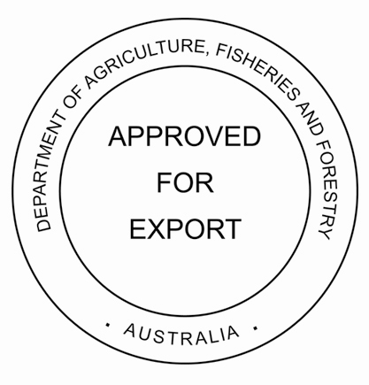
[2] Subsection 13.08 (1)
substitute
(1) For the purposes of the definition of official mark in section 3 of the Act, a mark:
(a) of the following design (but with a number, or a combination of letters and numbers, substituted for ‘A’); and
(b) printed in black, except for the Coat of Arms which is printed in red, on a white or security background; and
(c) of the dimensions set out in subsection (2);
is an official mark:
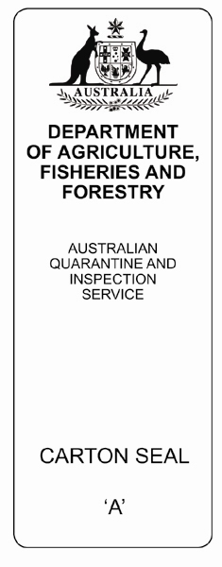
[3] Subsection 13.09 (1)
substitute
(1) For the purposes of the definition of official mark in section 3 of the Act, a mark:
(a) of the following design (but with a number, or a combination of letters and numbers, substituted for ‘A’); and
(b) printed in green, except for the Coat of Arms which is printed in red, on a white or security background; and
(c) of the dimensions set out in subsection (2);
is an official mark:
