SOUTHERN RIGHT WHALE

RECOVERY PLAN

2005 - 2010

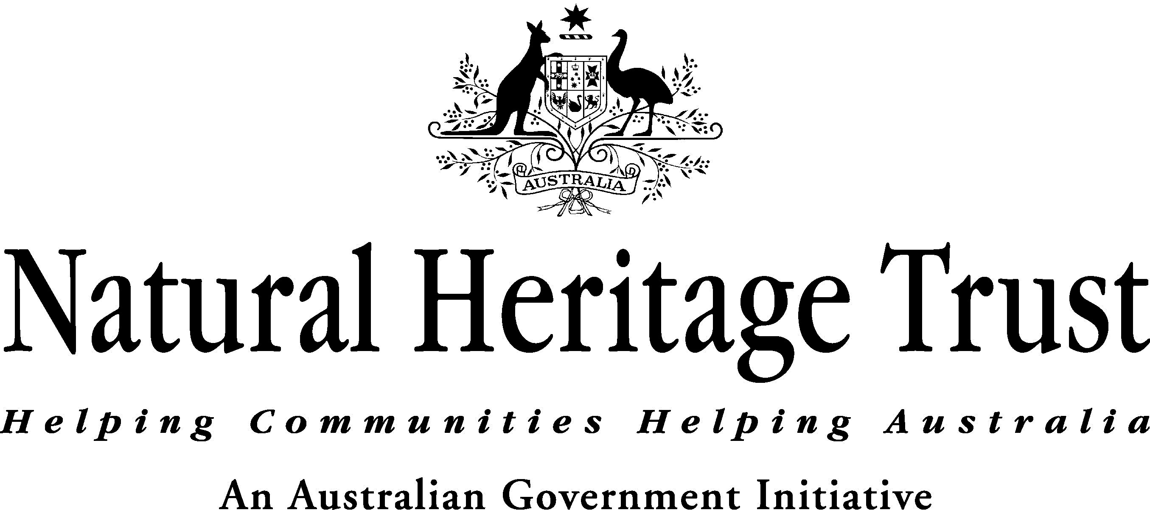
The southern right whale (Eubalaena australis) is listed as endangered under the Environment Protection and Biodiversity Conservation Act 1999 (EPBC Act). This plan outlines the measures necessary to ensure recovery of the Australian population of southern right whales and is set out in accordance with Part 13, Division 5 of the EPBC Act.

Objectives for recovery
The objectives are:
- the recovery of the southern right whale population utilising Australian waters so that the population can be considered secure in the wild;
- a distribution of southern right whales utilising Australian waters that is similar to the pre-exploitation distribution of the species; and
- to maintain the protection of southern right whales from human threats.

For the purposes of this plan ‘secure in the wild’ is defined qualitatively, recognising that stricter definitions are not yet available, but will be refined and where possible quantified during the life of this plan by work currently underway and identified in the actions of this plan.

‘Secure in the wild’ with respect to southern right whales in Australian waters means: a population with sufficient geographic range and distribution, abundance, and genetic diversity to provide a stable population over long time scales.

Criteria to measure performance of the plan against the objectives
It is not anticipated that the objectives for recovery will be achieved during the life of this plan. However, the following criteria can be used to measure the ongoing performance of this plan against the objectives:
- the Australian population of southern right whales continued to recover at, or close to, the optimum biological rate (understood to be approximately 7% per annum at the commencement of this plan);
- continued expansion into suitable habitat, potentially including pre-exploitation areas of importance; and
- domestic and international protection regimes that support the recovery of the species were maintained and where possible improved.

Species information
Southern right whales are medium to large, baleen whales (order Cetacea, family Balaenidae). The species is closely related to the northern hemisphere right whales E. glacialis of the north Atlantic and E. japonica of the North Pacific, but tend to be smaller on average with females being slightly larger than males in all species. Right whales are characterised by the lack of a dorsal fin, distinctly ‘V’ shaped blow and the presence of white/grey cornified growths on the head, known as callosities. There is evidence that these whales may live to 60 or more years of age.

Right whale numbers were critically low world-wide at the beginning of the 20th century following hundreds of years of hunting in the northern hemisphere and a briefer but very intensive period of hunting in the southern hemisphere from the early 19th century. Hunting pressure on right whales was intense because whalers considered the species were the "right" whales to kill – the whales swam slowly, often hugged the shoreline, provided a great quantity of oil, and floated when dead.

In 1931, right whales were the first of the great whales to be granted international protection under a League of Nations convention intended to take effect in 1935, and then protected under the International Whaling Commission (IWC) from its inception in 1946. However, commercial and illegal, unreported and unregulated whaling continued up to the 1970’s, hindering recovery of the species. The IWC imposed a moratorium on all commercial whaling from the 1985-86 season.

Population levels prior to exploitation are difficult to estimate but it has been suggested that for right whales in the southern hemisphere the population was approximately 60,000. Recent estimates of the population size in Australia are around 1,500 individuals. The estimated annual rate of increase for the Australian population is approximately 7% per annum, at or near to the theorised maximum rate for the species.

Southern right whales inhabit sub-antarctic waters where the main summer feeding grounds are thought to be between 40° and 55° S, but have been documented in latitudes south of 60° S. The species generally spends winters in warmer waters, with current strongholds off eastern South America, South Africa, southern Australia, and in the vicinity of oceanic islands at Tristan da Cunha and Auckland Island, New Zealand.

In Australia, southern right whales have been recorded in the coastal waters of all States with sightings ranging from Stradbroke Island and Hervey Bay in Queensland, and around the entire southern coastline, including Tasmania, to Exmouth in Western Australia. No sightings have been recorded from the Northern Territory.

Further information on the biology, population status, distribution and habitat of southern right whales can be found on the Species Profiles and Threats Database – www.deh.gov.au/sprat. This information is regularly updated to ensure that it reflects the most recent research.

Habitat critical to the survival of southern right whales
It is not currently possible to define habitat critical to the survival of southern right whales. The flexibility and adaptability of the species’ habitat requirements are not known, and it is not clear if all the currently used areas are critical to survival or whether the loss of one of these areas could be sustained. The plan therefore focuses on habitat important to the survival of southern right whales.

For the purpose of this plan, habitat important (and potentially critical) to the survival of southern right whales is defined as those areas known to seasonally support significant aggregations of whales, and those ecosystem processes on which southern right whales rely. Areas or processes that do not currently support significant aggregations of whales, but are potentially suitable, are also explicitly recognised as important habitat, in the context of facilitating the recovery of the population. At the time of writing this plan it is only the locations of currently used calving areas around the Australian coastline that have been identified with any certainty through regular observation and monitoring. It should be noted that the characteristics that define habitat quality and influence habitat selection are generally not well understood. Uncertainty also exists about the specific locations of feeding grounds and migratory pathways.

Southern right whales are still at an early stage of recovery. This is reflected by the Australian population’s limited breeding distribution and abundance compared with pre-whaling records. Consequently, habitat important to the population in areas that have yet to show strong signs of increasing whale numbers (e.g. southern right whales around Tasmania) may be anticipated at a broad scale from historical records (e.g. lower reaches of the Derwent River, Tasmania). It should be noted that historic distribution may not be a good indicator of current habitat importance, particularly where habitat quality has been affected in the intervening years. Revisions to this plan should include updates on identified habitats important to southern right whales.

Calving
Calving areas for right whales tend to be very close to the shore. The main calving areas (based on observations of mothers with very young calves in multiple years) currently known for southern right whales along the Australian coast include:
- Western Australia – Doubtful Islands Bay (including Point Ann/Point Charles area), Israelite Bay area, Twilight Cove, Flinders Bay, Albany/Cape Riche area, and Yokinup Bay/Cape Arid area;
- South Australia - Head of the Bight, Fowlers Bay, and Encounter Bay; and
- Victoria – Warrnambool.

In addition, areas that have been used intermittently as calving areas or by small numbers of mothers with very young calves include:
- Western Australia – a number of locations along the coast between the major aggregation areas west of Israelite Bay;
- South Australia – Sleaford Bay;
- Victoria – Port Fairy and Portland;
- New South Wales – Eden; and
- Tasmania – Maria Island and Bruny Island.

Mothers with young calves are also occasionally present at other scattered locations along the southern Australian coast.

Figure 1 outlines the current extent of the Australian coastal distribution of southern right whales with the most significant recognised calving areas indicated. Habitat connectivity between the identified areas is also considered important as southern right whales are frequently seen outside these core areas, and it is well documented that southern right whales move between these areas throughout the autumn/winter months. It should be noted that the boundaries presented on the map are indicative only and there is inherent variability in the movements of the species.

Feeding
Southern right whales feed predominantly on copepods, krill and other swarming zooplankton, although the details of this diet remains poorly described. The species ranges (and presumably feed) predominantly in southern ocean waters between 40° and 55° S. While feeding areas for the Australian population of southern right whales are poorly known, it is likely that the spatial and temporal distribution patterns in these areas are likely to be linked to ecosystem processes and respond to variability in oceanographic, climatic and other environmental parameters.

Migration
Migration patterns for southern right whales are poorly known. Until monitoring of migration travel is undertaken, it will not be possible to identify migratory movements with any certainty.

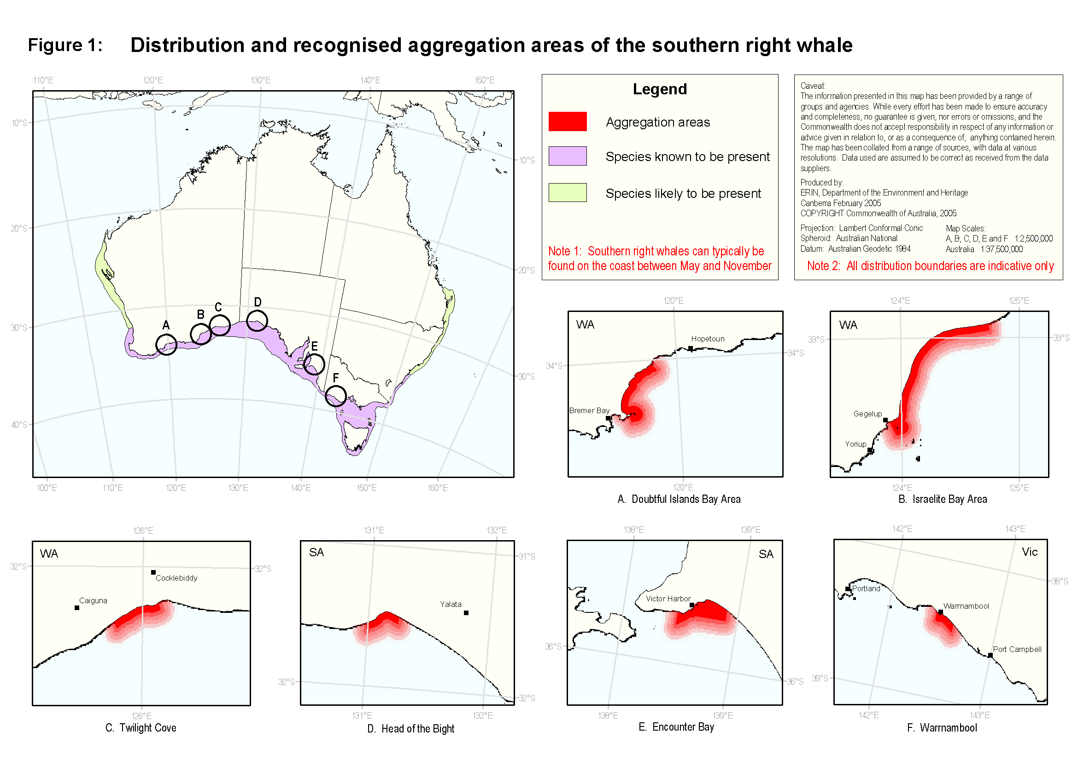
Management practices
Domestic measures
In Australia, southern right whales are listed as endangered under the EPBC Act. The EPBC Act established the Australian Whale Sanctuary and gives high levels of protection to cetaceans in Commonwealth waters. The Australian Whale Sanctuary encompasses the area of the Exclusive Economic Zone (EEZ) outside state waters and generally extends 200 nm from the coast, but further in some areas to cover the continental shelf and slope. It also includes the waters around the Australian Antarctic Territory and external territories including Christmas, Macquarie, Heard and McDonald Islands.

Within the Australian Whale Sanctuary it is an offence to kill, injure, take, trade, keep, move or interfere with a cetacean. The EPBC Act also makes it an offence for Australians to carry out any of these actions beyond the limits of the Australian Whale Sanctuary, that is, in international or foreign waters. Other than in the case of killing or taking for live display, permits may be issued by the Australian Government Minister for the Environment and Heritage to carry out these activities (e.g. for the purpose of research).

Southern right whales are also protected in all States and Territories under general native species and/or threatened species protection and management legislation.

A number of measures currently exist to manage interactions with all species of whales. These include administrative guidelines under the EPBC Act relating to interactions between offshore seismic operations and whales, and both Commonwealth and State regulations to manage whale watching activities.

In Victoria an Action Statement has been prepared to protect southern right whales in Victorian waters and the species is listed as threatened under the Flora and Fauna Guarantee Act 1988. In addition, regulations have been implemented to protect southern right whales in the calving grounds at Logan’s Beach, Warrnambool, by prohibiting boating in the area for that time.

The South Australian Government has declared a whale sanctuary and marine park at the Head of the Great Australian Bight. This declaration permanently excludes activities that are disruptive to habitat, and/or have the potential to conflict with the whales in this significant aggregation and calving area and prohibits mining from the Conservation Zones in State Waters for 12 months of the year. The Australian Government has declared a large extension to this sanctuary zone into Commonwealth waters creating the Great Australian Bight Marine Park. This marine park has as one of its primary purposes the conservation of southern right whales.

International measures
The southern right whale is afforded a degree of international protection through its listing on Appendix I of the Convention on International Trade in Endangered Species (CITES), on Appendix II of the Convention on Migratory Species (CMS), and as vulnerable under the World Conservation Union Red List of Threatened Species (IUCN).

In addition, Australia participates in several other international agreements that directly or indirectly relate to the conservation of marine mammals. Specifically, Australia was a founding member of the International Whaling Commission (IWC), is the host country of the Convention on the Conservation of Antarctic Marine Living Resources (CCAMLR), and a key player in Antarctic Treaty Consultative Meetings (ATCM).

Whales are protected from commercial whaling by IWC member states as part of the current moratorium and by the IWC’s Indian Ocean Sanctuary and Southern Ocean Sanctuary. Sanctuaries do not protect whales from whaling under special permit and are reviewed every ten years.

Australia is also working within the South Pacific Regional Environment Programme (SPREP) to establish a Memorandum of Understanding for the conservation and management of marine mammals in the South Pacific region, under the Convention on Migratory Species.

Threats

Identified threats
- The resumption of commercial whaling and/or the expansion of scientific whaling
The impacts of commercial hunting on southern right whales have been well documented. While currently banned under the IWC moratorium on commercial whaling, the potential for commercial whaling to recommence exists and pressure may well increase as the population recovers.

An additional area of concern is the potential expansion of de facto commercial whaling under the guise of scientific whaling. The IWC Convention allows member states to issue special permits to kill whales for research purposes and then process these animals for sale. Since 1986, Japan and Iceland have issued special permits for several whale species as part of their scientific whaling research programs. The recent expansion of these programs in the Northern Hemisphere involve the killing of various baleen whales including minke, Bryde's, fin, sperm and sei whales. In addition, since the implementation of the Southern Ocean Sanctuary in 1994, Japan has continued to harvest minke whales there under special permits. While not likely in the near future, there is no guarantee that right whales will not be included in future lethal research programs.

- Habitat degradation
Southern right whales use habitat seasonally and are found along the Australian coast for seven months of the year (approximately May to November). Anthropogenic activities have the potential to degrade habitat important to the species. These activities may degrade habitat by operating at times that coincide with the presence of whales, or they may occur when whales are absent, but degrade habitat suitability on a permanent or semi-permanent basis. These activities may include:
- acoustic pollution (e.g. commercial and recreational vessel noise, and seismic survey activity);
- entanglement (e.g. in marine debris, fishing and aquaculture equipment);
- physical injury and death from ship strike;
- built structures that impact upon habitat availability and/or use (e.g. marinas, wharves, aquaculture installations, mining or drilling infrastructure);
- changing water quality and pollution (e.g. runoff from land based agriculture, oil spills, outputs from aquaculture); and
- changes to water flow regimes causing extensive sedimentation or erosion or altered currents in near shore habitat (e.g. canals and dredging).

Southern right whales may be particularly vulnerable to these activities because of the species’ use of inshore areas for calving, some of which are close to populated centres. Currently, less than 10% of the Australian southern right whale population uses the coastline east of Adelaide. This southeastern component of the population may be more vulnerable to threats due to its lower numbers and the larger and increasing human presence on Australia’s southeast coast.

Habitat degradation may result in reduced occupancy and/or exclusion of individual whales from suitable habitat, compromised reproductive success, and mortality. It is possible that impacts on a sufficient number of individual whales could lead to broader impacts at the population level, e.g. by reducing recruitment to such an extent that species recovery is impeded. This would be more likely to arise where activities that cause habitat degradation occurred intensively and/or cumulatively, or over a large portion of their range.

It should be noted that at the time of writing this plan the southern right whale population was increasing at or close to the optimum biological rate, suggesting that to date habitat degradation has not had a negative impact at the population level. Nevertheless, ongoing monitoring and management are required to ensure that habitat degradation does not become a significant issue for southern right whale recovery. This should focus on both those areas currently known to be used by the species as well as on those areas of potential future importance.

Potential threats
- Climate and oceanographic change
Most of the world's leading scientists agree that global warming caused by human activity is occurring. The exact implications of these changes are unknown, but it is predicted that there will be reduced productivity of Southern Ocean ecosystems and unpredictable weather events caused by increasing ocean water temperatures, changing ocean currents, rising sea levels and reductions in sea ice.

The potential impacts of climate and oceanographic change on southern right whales are twofold:
- Habitat availability
Southern right whale migration, feeding, and calving site selection may be influenced by factors such as ocean currents and water temperature. Any changes in these factors could affect southern right whale population recovery by rendering currently used habitat areas unsuitable.

- Food availability
Changes to climate and oceanographic processes may also lead to decreased productivity and different patterns of prey distribution and availability. Such changes would certainly effect dependant predators such as southern right whales.

- Prey depletion due to over harvesting
Southern right whales rely at least partly on krill as a major food source and require adequate supplies of food to accumulate energy reserves that is essential for migration and breeding. Depletion of krill through over harvesting may be a potential future threat for the Australian population of southern right whales. However, it should be noted that:
- the krill fishery is managed through the Convention on the Conservation of Antarctic Marine Living Resources (CCAMLR) on an ecosystem basis which takes into account the needs of predators such as whales;
- while the fishery is likely to grow, fishing currently occurs well within the current precautionary limits;
- it is likely that the spatial feeding grounds of the Australian population of southern right whales do not overlap with potential harvest stocks of krill further south; and
- the extent to which dietary shifts could compensate for any reduction in krill availability is unknown.

Actions to achieve the objectives
Population recovery
- Implement a program to measure population abundance, trends and recovery for Australian population of southern right whales
- Included within this activity is the need to:
  - gather information on population structures using methodologies including genetic analyses, comparisons of photo identification and telemetry studies;
  - establish models for measuring recovery and species status, incorporating a range of indicators (e.g. population numbers, structure, use of habitats etc); and
  - continue to collect long-term data sets using standardised survey methodologies for southern right whales in a statistically robust manner.

Habitat use and needs
- Implement a program to better define the characteristics (spatial, temporal, physical) of calving, feeding, and migratory areas
- Included within this activity is the need to:
  - determine the values and characteristics of important migratory pathways and aggregation areas (calving, resting, and feeding) particularly in areas where human use is likely to impact upon the species;
  - gather information on movements, migrations, and feeding grounds – e.g. through the use of satellite tracking and other survey methods; and
  - examine the historical and potential future use of southern right whale habitat with a view to defining these areas and assessing human use activities to ensure impacts are appropriately managed and regulated.

Protection from threats
- Prevent commercial whaling and/or the expansion of scientific whaling
- Australia should maintain its position on promoting high levels of protection for southern right whales in all relevant international agreements including the IWC, CITES, CMS, fisheries-related agreements, and Antarctic Treaty Consultative Meetings (ATCM).
- Australia should continue to support a ban on directed take of southern right whales.

- Protect habitat important to the survival of the species
- Ensure that in areas important to the survival of the species environmental assessment process and research activities are in place to determine the level of impact and threat of human activities, and implement management measures to ensure the ongoing recovery of the species. This should include, but not be limited to, the following actions:
  - assess and manage acoustic disturbance – including the development and application of administrative guidelines under the EPBC Act such as the “Guidelines on the application of the EPBC Act to interactions between offshore seismic operations and larger cetaceans”;
  - encourage best practice approaches that will reduce the likelihood of southern right whales being entangled in marine debris and marine industry equipment. If entanglements occur, manage the impact of individual entanglements through the application of national standards for disentangling large cetaceans;
  - ensure that southern right whale habitat requirements are considered in the establishment and management of marine conservation areas and reserves;
  - manage the potential impacts of tourism – e.g. through the application of consistent Commonwealth and State tourism and whale watching regulations; and
  - assess and manage physical disturbance and development activities (such as ship-strike, aquaculture, pollution, recreational boating, and exploration and extraction industries) – including the application of environmental impact assessment and approvals and the development of industry guidelines and State/Commonwealth government regulations.
- Implement education programs to inform marine users (e.g. whale watchers, fishermen, and shipping crews using important habitat) about best practice behaviours and regulations when interacting with whales.

- Monitor and manage the potential impacts of prey depletion due to over harvesting
- Improve knowledge of southern right whale feeding ecology, and the ecology of prey species in order to determine if or when prey depletion becomes a threat.
- Australia should support regional ecosystem approaches to krill management through its involvement in CCAMLR and other fora.

- Monitor climate and oceanographic change
- Develop an understanding of the effects of climate and oceanographic change on the southern right whale population to determine if species survival and recovery are being, or are likely to be affected.

Major benefits to other native species or ecological communities
As the southern right whale is both a coastal and oceanic ranging species, marine mammal protection regimes may have benefit for other cetaceans found within Australian waters, including the large whales - blue, Bryde’s, minke, fin, sei, humpback and sperm whales. Conservation measures pertaining to calving habitats may also benefit small cetaceans and other species in coastal waters.

Implementation of this plan is unlikely to have negative impacts on any other native species or ecological community.

Duration and cost of the recovery process
It is anticipated that the recovery process will take longer than the life of the plan (2005-2010), which should be reviewed after five years. A recovery plan for the species should remain in place until such time that the population of southern right whales utilising Australian waters has improved to the point that the population is considered secure.

The cost of this plan will be met through various direct and indirect funding activities undertaken by the Australian Government, State and Territory governments, researchers, conservation groups, marine based industries and the Australian public. Costing of specific actions will be determined at the time of activity.

Role and interests of Indigenous people
Many marine mammal species have cultural significance to Aboriginal or Torres Strait Islander people. Recognising this cultural connection to whales is important. No record has been found of whale hunting before the arrival of Europeans, although it is likely that some use was made of whales that washed ashore. Indigenous people must be considered if plans for development or use of an area are expected to impact upon indigenous ownership or native title interests. Agreements between government and Indigenous people are essential and serve to increase the involvement of all parties with a stake in the welfare and recovery of whales.

The Head of the Bight in South Australia is one of the primary coastal aggregation areas for southern right whales in Australia and terrestrial access to the region is via Aboriginal land. The Yalata community are the traditional owners of this area and have been actively involved in the management of visitor activities and the provision of services to whale watchers in that area. The community maintains strong ties to its land and indigenous rangers work in the region.

Social and economic impacts
It is not anticipated that this plan will have significant economic and/or social impacts in the short or long-term.

Affected interests
Organisations likely to be affected by the actions proposed in this plan include the following:

Australian Government:  Aboriginal and Torres Strait Islander Commission  Australian Fisheries Management Authority  Australian Maritime Safety Authority  Department of Agriculture, Fishing and Forestry  Department of Defence  Department of Foreign Affairs and Trade  Department of Industry, Tourism and Resources  Department of the Environment and Heritage  Great Barrier Reef Marine Park Authority  Indigenous Land Corporation  Industry and Non-Government Organisations:  Commercial fishers and associations  Commercial shipping  Conservation groups  Energy distribution networks  Indigenous Land Councils and communities  Local communities  Nature-based tourism industry  Oil and gas exploration and production industry  Recreational fishers and associations  Universities and other research organisations  Whale-watching industry and associations | State/Territory Governments:  Department of Conservation and Land Management, WA  Department of Environment and Heritage, SA  Department of Primary Industries, Water and Environment, TAS  Department of Primary Industry, QLD  Department of Sustainability and Environment, VIC  Environment Protection Agency, QLD  Fisheries agencies  Museums  National Parks and Wildlife Service, NSW  Parks and Wildlife Commission, NT  Parks Victoria  Shipping, oil and gas exploration and development agencies

Organisations/persons involved in evaluating the performance of the plan
The Threatened Species Scientific Committee (TSSC) with the assistance of relevant scientists, managers and other stakeholders should evaluate the performance of this plan and report the results of their review to the Australian Government Minister for the Environment and Heritage.

Where to get the plan
This recovery plan is obtainable from:
http://www.deh.gov.au/biodiversity/threatened/recovery/list-common.html

Wildlife Impact and Protection Section
Wildlife Conservation Branch
Department of the Environment and Heritage
GPO Box 787
Canberra ACT 2601

