Family Law Amendment Rules 2005 (No. 2)¹
Select Legislative Instrument 2005 No. 212
We, Judges within the meaning of the Family Law Act 1975, make the following Rules of Court under that Act.
Dated 14 September 2005

DIANA BRYANT C.J.

J. FAULKS D.C.J.

N.J. BUCKLEY

MICHELLE MAY

J.M. BOLAND

K.A. MURRAY

RODERICK JOSKE

JAMES BARRY

J.S. PURDY
G.R. MULLANE
N. MUSHIN

B.J. WARNICK

B. JORDAN
SUSAN MORGAN
CHRISTINE E. DAWE
JOHN STEELE
ROD BURR

HEATHER B. CARTER

M. WATT
S. STRICKLAND

JANINE STEVENSON

PETER YOUNG
DONNA O’REILLY

TIM CARMODY

R. BENJAMIN
Judges of the Family Court
of Australia

A.M. FILIPPELLO
Principal Registrar
Family Court of Australia

C.E. MARTIN
J. PENNY
S. THACKRAY
Judges of the Family Court
of Western Australia
A. MORONI
Acting Principal Registrar
Family Court of Western Australia
1 Name of Rules
These Rules are the Family Law Amendment Rules 2005 (No. 2).
2 Commencement
These Rules commence on 19 September 2005.
3 Amendment of Family Law Rules 2004
Schedule 1 amends the Family Law Rules 2004.
Schedule 1 Amendments
(rule 3)

[1] Paragraphs 1.05 (2) (f) and (g)
substitute
(f) the case is an application for divorce;
(g) the case is a child support application or appeal; or
(h) the case involves a court’s jurisdiction in bankruptcy under section 35 or 35B of the Bankruptcy Act.
[2] Paragraph 1.20 (2) (a)
substitute
(a) subject to subrule (3), the family name of a party, but not a given name;
[3] After subrule 1.20 (2)
insert
(3) For a case in which a court has jurisdiction in bankruptcy under section 35 or 35B of the Bankruptcy Act, the list may contain the given name of a party.
[4] Rule 2.01, Table 2.1, item 10
substitute
10 | Failure to comply with a bond entered into in accordance with the Act | Application — Contravention (Form 18)
11 | Contempt of court | Application — Contempt (Form 19)
[5] Rule 2.01, Table 2.1, note 3, paragraph (f)
substitute
(f) an application relating to the failure of a party to comply with a bond, see Chapter 21;
(g) an appeal or an application relating to an appeal, see Chapter 22; and
(h) an application relating to a bankruptcy case, see Chapter 26.
[6] Subrules 4.23 (2) and 4.26 (1)
omit
Child Support Application
insert
child support application
[7] Subrule 5.04 (4)
substitute
(4) This rule does not apply to restrict the filing of a Form 2 by:
(a) a child representative;
(b) the Director of Public Prosecutions, when making an application under section 79C, 79D, 90N or 90P of the Act, to stay or lift a stay of a property settlement or spousal maintenance case;
(c) a bankruptcy trustee; or
(d) a trustee of a personal insolvency agreement.
[8] Part 6.4, heading
substitute
Part 6.4 Progress of case after death
[9] After rule 6.15
insert
Part 6.5 Progress of a case after bankruptcy or personal insolvency agreement
[10] Rule 6.16
substitute
6.16 Interpretation
In this Part:
bankruptcy proceedings means proceedings under the Bankruptcy Act, in the Federal Court or the Federal Magistrates Court, in relation to:
(a) the bankruptcy of a relevant party; or
(b) a relevant party’s capacity as a debtor subject to a personal insolvency agreement.
relevant case means any of the following:
(a) a pending case under section 66G, 66S, 74, 78, 79, 79A or 83 of the Act;
(b) a pending case under Division 4 or 5 of Part 7 of the Assessment Act;
(c) a pending case for enforcement of an order made under a provision mentioned in paragraph (a) or (b).
relevant party means a person who is:
(a) a party to a marriage; and
(b) a party to a relevant case in relation to that marriage.
Note The following terms are defined in the Bankruptcy Act:
• bankruptcy trustee (subsection 4 (1))
• debtor subject to a personal insolvency agreement (section 5)
• trustee, in relation to a personal insolvency agreement (subsection 4 (1)).

6.17 Notice of bankruptcy or personal insolvency agreement
(1) If a relevant party is also a bankrupt or a debtor subject to a personal insolvency agreement, that party must notify:
(a) all other parties to the relevant case, in writing, about the bankruptcy or personal insolvency agreement;
(b) the bankruptcy trustee or the trustee of the personal insolvency agreement, as the case may be, about the relevant case in accordance with rule 6.18; and
(c) the court in which the relevant case is pending, in accordance with rule 6.19.
(2) A party may apply for procedural orders for the future conduct of the case.

6.18 Notice under paragraph 6.17 (1) (b)
For paragraph 6.17 (1) (b), notice to a bankruptcy trustee or a trustee of a personal insolvency agreement must:
(a) be in writing;
(b) be given within 7 days, or as soon as practicable, after the date on which the party becomes both:
(i) a relevant party; and
(ii) a bankrupt or debtor;
(c) attach a copy of the application starting the relevant case, response (if any), and any other relevant documents; and
(d) state the date and place of the next court event in the relevant case.

6.19 Notice under paragraph 6.17 (1) (c)
For paragraph 6.17 (1) (c), notice to the court must:
(a) be in writing;
(b) be given within 7 days, or as soon as practicable, after the date on which the party becomes both:
(i) a relevant party; and
(ii) a bankrupt or debtor; and
(c) attach a copy of the notices given in accordance with paragraphs 6.17 (1) (a) and (b).

6.20 Notice of bankruptcy proceedings
(1) If a relevant party is a party to bankruptcy proceedings the party must give notice of the bankruptcy proceedings, in accordance with subrule (2), to:
(a) the court in which the relevant case is pending; and
(b) the other party (or parties) to the case.
(2) The notice must:
(a) be in writing;
(b) be given within 7 days, or as soon as practicable, after the date on which the party becomes a party to bankruptcy proceedings; and
(c) state the date and place of the next court event in the bankruptcy proceedings.
6.21 Notice of application under section 139A of the Bankruptcy Act
(1) If the bankruptcy trustee of a bankrupt party to a marriage has applied under section 139A of the Bankruptcy Act for an order under Division 4A of Part VI of that Act, and the trustee knows that a relevant case in relation to the bankrupt party is pending in a court exercising jurisdiction under the Act, the trustee must notify:
(a) the court exercising jurisdiction under the Act in the relevant case, in accordance with subrule (2); and
(b) if the bankruptcy trustee’s application relates to an entity other than the other party to the marriage — the other party to the marriage, in accordance with subrule (3).
(2) For paragraph (1) (a), notice to the court must:
(a) be in writing;
(b) be given within 7 days, or as soon as practicable, after the bankruptcy trustee makes the application under section 139A of the Bankruptcy Act; and
(c) state the date and place of the next court event in the proceedings under section 139A of the Bankruptcy Act.
(3) For paragraph (1) (b), notice to the other party to the marriage must:
(a) be in writing;
(b) be given within 7 days, or as soon as practicable, after the bankruptcy trustee makes the application under section 139A of the Bankruptcy Act;
(c) attach a copy of the application, other initiating process and any other relevant documents in the application under section 139A of the Bankruptcy Act; and
(d) state the date and place of the next court event in the proceedings under section 139A of the Bankruptcy Act.
6.22 Official name of trustee
(1) If a bankruptcy trustee or a trustee of a personal insolvency agreement is added as a party to a relevant case, the trustee must be added using the prescribed official name of the trustee.
(2) In subrule (1):
prescribed official name of the trustee has the meaning given by:
(a) for a bankruptcy trustee — subsection 161 (2) of the Bankruptcy Act; and
(b) for a trustee of a personal insolvency agreement — subsection 219 (2) of the Bankruptcy Act.
[11] Paragraph 7.04 (2) (c)
omit
birth certificate, order or decree
insert
birth certificate or order
[12] Subrules 10.01 (1) and (2)
omit
Offer to Settle (Form 60)
insert
offer to settle
[13] Subrules 10.01 (3) and (4), except the note
substitute
(3) An offer to settle:
(a) must be in writing; and
(b) must not be filed.
[14] Subrule 10.02 (4)
substitute
(4) Subrule (2) does not apply to:
(a) an application relating to an offer; or
(b) an application for costs.
[15] Subrule 10.06 (3), note 2
substitute
Note 2 An offer to settle is a factor that must be taken into account when the court exercises its discretion in relation to costs (see paragraph 117 (2A) (f) of the Act).
[16] Rule 10.16
substitute
10.16 Notice to superannuation trustee
(1) This rule applies in a property case if a party intends to apply for a consent order which is expressed to bind the trustee of an eligible superannuation plan.
(2) The party must, not less than 28 days before lodging the draft consent order or filing the Form 11, notify the trustee of the eligible superannuation plan in writing of the following:
(a) the terms of the order that will be sought to bind the trustee;
(b) the next court event (if any);
(c) that the parties intend to apply for the order sought if no objection to the order is received from the trustee within the time mentioned in subrule (3);
(d) that if the trustee objects to the order sought, the trustee must give the parties written notice of the objection within the time mentioned in subrule (3).
(3) If the trustee does not object to the order sought within 28 days after receiving notice under subrule (2), the party may file the application or lodge the draft consent order.
(4) Despite subrule (3), if, after service of notice under subrule (2) on the trustee, the trustee consents, in writing, to the order being made, the parties may file the Form 11 or lodge the draft consent order.
Note Eligible superannuation plan is defined in section 90MD of the Act.
[17] Subrule 12.09 (2)
omit
further procedural orders by a Judge.
insert
further procedural orders.
[18] Rule 14.06
substitute
14.06 Notice to superannuation trustee
(1) This rule applies in a property case if:
(a) a party seeks an order to bind the trustee of an eligible superannuation plan; and
(b) the case has been listed for a trial.
(2) The party must, not less than 28 days before the date fixed for the trial, notify the trustee of the eligible superannuation plan in writing of the terms of the order that will be sought at the trial to bind the trustee, and the date of the trial.
(3) If the court makes an order binding the trustee of an eligible superannuation plan, the party that sought the order must serve a copy of the order on the trustee of the eligible superannuation plan in which the interest is held.
Note 1 Subrule 7.13 (2) sets out how to prove service of a copy of an order.
Note 2 Eligible superannuation plan is defined in section 90MD of the Act.
[19] Rule 15.09, note 1
omit
[20] Rule 15.09, note 2
renumber as note 1
[21] Paragraph 15.19 (2) (c)
substitute
(c) an application for divorce; or
[22] Subrule 18.02 (3)
omit
(d), (e) and (h) do not apply
insert
(d) and (e) do not apply
[23] Subrule 18.05 (1), Table 18.2, after item 1
insert
1A | subsection 46 (3A) | Power to remove a case from a court of summary jurisdiction
[24] Subrule 18.06 (1), Table 18.4, after item 3
insert
3A | section 27A | Power to direct, at any stage, that a case or part of a case be conducted or continued at a specified place subject to conditions (if any)
[25] Subrule 18.06 (1), Table 18.4, item 8
omit
[26] Subrule 18.06 (1), Table 18.4, item 9, column 3
omit
a decree of dissolution of marriage
insert
a divorce order
[27] Subrule 18.06 (1), Table 18.4, item 10, column 3
omit
a decree absolute
insert
a divorce order to take effect
[28] Subrule 18.06 (1), Table 18.4, item 12, column 3
omit
a decree nisi
insert
a divorce order
[29] Subrule 18.06 (1), Table 18.4, item 27
substitute
27 | subsection 117 (2) (except an order as to security for costs) | Power to make a costs order in a case before the Deputy Registrar
[30] Subrule 18.06 (1), Table 18.4, after item 30
insert
Bankruptcy Act
31 | section 33 | Adjournment, amendment of process and extension and abridgment of times
32 | section 81 | Powers in relation to examinations
33 | section 264B | Power to issue a warrant
34 | subsection 309 (2) | Power to order substituted service
[31] Subrule 18.06 (2), Table 18.5, item 32
substitute
32 | Chapter 19 (except rules 19.16 and 19.17 and Parts 19.2 and 19.8) | Power to make an order in relation to costs and the assessment of costs
[32] Subrule 18.06 (2), Table 18.5, after item 37
insert
38 | rule 26.05 | Power to grant leave to a person who is not a party to a case to be heard
39 | paragraph 26.12 (a) | Power to direct the manner of service of a summons for examination
40 | rule 26.13 | Power to adjourn or discharge a summons
41 | paragraph 26.18 (a) | Power to direct the manner of service of a summons for examination
42 | rule 26.29 | Power to order that a warrant be kept in the Registry
43 | rule 26.30 | Power to order costs
[33] Rule 18.08, Table 18.6, after item 4
insert
5 | Order made by a Judicial Registrar, Registrar or Deputy Registrar in a bankruptcy case | within 21 days after the Judicial Registrar, Registrar or Deputy Registrar makes the order
[34] Subrule 18.09 (3)
omit
a decree nisi
insert
a divorce order
[35] Chapter 19, summary
substitute
Summary of Chapter 19
Chapter 19 regulates the charges of lawyers in family law cases, except any part of a case in which a Family Court is exercising its bankruptcy jurisdiction. Chapter 26 contains provisions which regulate the charges of lawyers for a part of a case involving bankruptcy matters.
The rules in Chapter 1 relating to the court’s general powers apply in all cases and override all other provisions in these Rules.
A word or expression used in this Chapter may be defined in the dictionary at the end of these Rules.
[36] Subrule 19.01 (1)
omit
(1) This Chapter applies to costs
insert
(1) Subject to subrule (3), this Chapter applies to costs
[37] After subrule 19.01 (2)
insert
(3) This Chapter does not apply to costs in any part of a case in which a Family Court is exercising its jurisdiction under section 35 or 35B of the Bankruptcy Act.
[38] Subrule 20.08 (2)
omit
may
insert
must
[39] Chapter 21, summary
substitute
Summary of Chapter 21
Chapter 21 sets out how a party may seek an order:
• to enforce a parenting order;
• that a person be punished for contravening an order, bond or sentence, or for contempt of court; or
• to locate or recover children.
Before filing an application, a party should consider the result that the party wants to achieve. The remedies available from the court range from the enforcement of a bond or order to the punishment of a person for failure to comply with an order, bond or sentence. For example, the court may make an order that:
• ensures the resumption of the arrangements set out in an earlier order;
• compensates a person for lost contact time;
• varies an existing order;
• puts a person on notice that if the person does not comply with an order, the person will be punished; or
• punishes a person by way of a fine or imprisonment.
Contempt of court should be alleged only if the conduct complained of is serious enough to warrant such a serious charge, for example, if it is alleged that the contravention of an order involves a flagrant challenge to the court’s authority (see subsection 112AP (1) of the Act). A person found to be in contempt of the court may be imprisoned.
The rules in Chapter 1 relating to the court’s general powers apply in all cases and override all other provisions in these Rules.
A word or expression used in this Chapter may be defined in the dictionary at the end of these Rules.
[40] Paragraphs 21.01 (b) and (c)
substitute
(b) under Division 13A of Part VII or Part XIIIA of the Act; or
[41] Rule 21.01, note 1
substitute
Note 1 Subsection 69C (2) of the Act specifies who may apply for an order in relation to a child. Division 13A of Part VII of the Act sets out the consequences of failing to comply with an order or other obligation that affects children. Part XIIIA of the Act sets out the sanctions the court may impose on a person who fails to comply with an order or other obligation that does not affect children. Part XIIIB of the Act sets out the punishment the court may impose on a person found to be in contempt of court.
[42] Subrule 21.02 (1), Table 21.1, after item 4
insert
5 | Failure to comply with a bond entered into in accordance with the Act | Application — Contravention (Form 18)
[43] Paragraph 21.02 (2) (b)
substitute
(b) for an application mentioned in item 1 of Table 21.1 — has attached to it a copy of any order, bond, agreement or undertaking that the court is asked to enforce or that is alleged to have been contravened.
[44] Rule 21.06
omit
item 1A, 2, 3 or 4
insert
item 1A, 2, 3, 4 or 5
[45] Paragraph 21.07 (b)
omit
item 1A, 2, 3 or 4
insert
item 1A, 2, 3, 4 or 5
[46] Rule 21.08
omit
item 1A, 2, 3 or 4
insert
item 1A, 2, 3, 4 or 5
[47] Rule 21.08, note
substitute
Note For the penalties that may be imposed by the court, see sections 67X, 70NG, 70NJ, 70NN, 112AD, 112AH and 112AP of the Act.
[48] Subparagraph 21.16 (1) (a) (iii)
omit
3 or 4 of Table 21.1; and
insert
3, 4 or 5 of Table 21.1; and
[49] Part 22.2, note 1 after the heading
omit
subsections 94AA (1) and (2A)
insert
subsection 94AA (1)
[50] Subrule 22.22 (4)
omit
excluding the transcript,
insert
including the transcript,
[51] Division 22.7.2, note after the heading
omit
subsections 94AA (1) and (2A)
insert
subsection 94AA (1)
[52] Subrule 22.51 (1)
omit
(1) A party to an appeal who seeks to apply for an order
insert
(1) A party to an appeal, other than an appeal that is a hearing de novo, who seeks to apply for an order
[53] Rule 22.55
omit
[54] Part 22.9
omit
[55] Subrule 23.01 (2), note 2
substitute
Note 2 For requirements relating to the registration of orders (other than in divorce or validity of marriage cases), see regulation 17 of the Regulations.
[56] After Chapter 25
insert
Chapter 26 Cases to which the Bankruptcy Act 1966 applies
Summary of Chapter 26
Chapter 26 sets out the rules about a case in which a Family Court has jurisdiction in bankruptcy under section 35 or 35B of the Bankruptcy Act 1966. Delegation of the Family Court’s power in such cases is set out in Chapter 18 of these Rules.
The rules in Chapter 1 relating to the court’s general powers apply in all cases and override all other provisions in these Rules.
A word or expression used in this Chapter may be defined in the dictionary at the end of these Rules.
Part 26.1 Introduction

26.01 Application of Chapter 26
(1) In a bankruptcy case, the rules in Chapter 1 apply to the case and override all other provisions in these Rules.
(2) To the extent to which a rule in this Chapter applies to a bankruptcy case, and does not conflict with a rule in Chapter 1, the rule in this Chapter applies to the case and overrides all other provisions in these Rules.
(3) A rule in Chapter 25 of these Rules does not apply to a bankruptcy case.
Note The Rules of Court made under the Federal Court of Australia Act 1976 apply to a case transferred to a Family Court under section 35A of the Bankruptcy Act.
26.02 Expressions used in the Bankruptcy Act
Unless the contrary intention appears, an expression used in this Chapter and in the Bankruptcy Act has the same meaning in this Chapter as it has in the Bankruptcy Act.
Note The following expressions are used in this Chapter and defined in section 5 of the Bankruptcy Act:
• bankrupt
• books
• creditor
• District
• examinable affairs
• examinable person
• Official Receiver
• property
• the trustee.
26.03 Forms
(1) In this Chapter, a reference to a form followed by a number is a reference to the form so numbered in Schedule 2 to these Rules.
(2) It is sufficient compliance with this Chapter in relation to a document that is required to be in accordance with a form in Schedule 2 if the document is substantially in accordance with the form required or has only such variations as the nature of the case requires.
Part 26.2 General

26.04 Bankruptcy Application and Bankruptcy Application in a Case
(1) Unless this Chapter otherwise provides, a person must make an application required or permitted by the Bankruptcy Act to be made to the court:
(a) if the application is not made in a bankruptcy case already commenced in the court — by filing a Bankruptcy Application in accordance with Form 21; and
(b) otherwise — by filing a Bankruptcy Application in a Case in accordance with Form 22.
(2) A person may make an application to the court in relation to a bankruptcy case in respect of which final relief has been granted by filing a Bankruptcy Application in a Case in accordance with Form 22.
(3) A Bankruptcy Application must state:
(a) each section of the Bankruptcy Act, or each regulation of the Bankruptcy Regulations 1996, under which the case is brought; and
(b) the relief sought.
(4) A Bankruptcy Application in a Case must state:
(a) if appropriate, each section of the Bankruptcy Act, or each regulation of the Bankruptcy Regulations 1996, or each rule of court under which the application is made; and
(b) the relief sought.
Note Each application and appeal mentioned below must be commenced by filing an application in accordance with Form 21. The list is not exhaustive:
(a) an application, under section 78 of the Bankruptcy Act, for the issue of a warrant for the arrest of a debtor or bankrupt;
(b) an appeal, under subsection 82 (5) of the Bankruptcy Act, against an estimate by the trustee of the value of a debt or liability provable in a bankruptcy;
(c) an application, under section 153B of the Bankruptcy Act, for the annulment of a bankruptcy;
(d) an application, under subsection 157 (6) of the Bankruptcy Act, objecting to the appointment of a person as a trustee;
(e) an application, under section 180 of the Bankruptcy Act, for acceptance of a trustee’s resignation from the office of trustee of an estate;
(f) an application, under section 183 of the Bankruptcy Act, for release of a trustee from the trusteeship of an estate;
(g) an appeal from a decision of a taxing officer, appointed under subsection 167 (8) of the Bankruptcy Act, allowing or disallowing a bill of costs or charges, or an item in such a bill.
26.05 Leave to be heard
(1) The court may grant leave to be heard in a bankruptcy case to a person who is not a party to the case.
(2) The court may grant the leave on conditions and may revoke the leave at any time.
(3) The court may order the person to pay costs if:
(a) the granting of leave to the person causes additional costs for a party to the case; and
(b) the court considers that the costs should be paid by the person.
(4) The court may also order that the person is not to be further heard in the case until the costs are paid or secured to the court’s satisfaction.
(5) The court may grant leave or make an order under this rule on the court’s own initiative or on the application of a party or another person having an interest in the case.
(6) An application for leave or for an order must be made by filing a Bankruptcy Application in a Case in accordance with Form 22.
26.06 Appearance at application or examination
A person who intends to appear at the hearing of an application, or take part in an examination, must file a Notice of Appearance in accordance with Form 23.
26.07 Opposition to Bankruptcy Application or a Bankruptcy Application in a Case
(1) In this rule:
application includes a Bankruptcy Application and a Bankruptcy Application in a Case.
(2) A person who intends to oppose an application must, at least 3 days before the date fixed for the hearing of the application:
(a) file a Notice of Appearance in accordance with Form 23;
(b) file a notice in accordance with Form 24 stating the grounds of opposition;
(c) file an affidavit in support of the grounds of opposition; and
(d) serve the notices and supporting affidavit on the applicant.
Part 26.3 Examinations

Division 26.3.1 Interpretation
26.08 Definition for Part 26.3
In this Part:
relevant person means a relevant person within the meaning of section 81 of the Bankruptcy Act.
Note Examinable person is defined in subsection 5 (1) of the Bankruptcy Act.
Division 26.3.2 Examination of relevant person
26.09 Application for summons (Bankruptcy Act s 81)
(1) An application to the court for a relevant person to be summoned for examination in relation to the person’s bankruptcy must be in accordance with Form 26.
(2) The application must be accompanied by:
(a) a draft of each summons applied for; and
(b) an affidavit identifying:
(i) each relevant person to be summoned; and
(ii) if the summons is to require the relevant person to produce books at the examination, the books that are to be produced.
Note A relevant person may be required to produce books at an examination that are in the possession of the person and relate to the person or to any of the person’s examinable affairs — see subsection 81 (1B) of the Bankruptcy Act.
26.10 Hearing of application
The application may be heard in the absence of a party or in chambers.
26.11 Requirements of summons
(1) A summons must be in accordance with Form 25.
(2) A Registry Manager must:
(a) sign and seal the summons; and
(b) give it to the applicant for service on the relevant person.
(3) If the summons requires the relevant person to produce books at the examination, the summons must identify the books that are to be produced.
26.12 Service of summons
At least 8 days before the date fixed for the examination, the applicant must:
(a) serve the summons on the relevant person by special service, or in another way directed by the court; and
(b) give written notice of the date, time and place fixed for the examination to each creditor of the relevant person of whom the applicant has knowledge.
Note Part 7.2 of the Rules deals with special service.
26.13 Failure to attend examination
If the relevant person does not attend the examination in accordance with the summons, the court may:
(a) adjourn the examination generally or to another day, time or place; or
(b) discharge the summons.
26.14 Application for discharge of summons
(1) A relevant person who is served with a summons and wishes to apply for an order to discharge the summons may do so by filing:
(a) a Bankruptcy Application in a Case in accordance with Form 22 in the proceeding in which the summons was issued; and
(b) an affidavit setting out the grounds in support of the application.
(2) As soon as possible after filing the Bankruptcy Application in a Case and supporting affidavit, the relevant person must serve a copy of each document:
(a) on the person who applied for the summons; and
(b) if the person who applied for the summons is not the Official Receiver, on the Official Receiver.
Division 26.3.3 Examination of examinable person
26.15 Application for summons (Bankruptcy Act s 81)
(1) An application to the court for an examinable person to be summoned for examination in relation to the bankruptcy of a relevant person must be in accordance with Form 26.
(2) A single application may be made for the summons of 2 or more examinable persons in relation to a relevant person’s bankruptcy.
(3) The application must be accompanied by:
(a) a draft of each summons applied for; and
(b) an affidavit (the supporting affidavit) that complies with subrule (4).
(4) The supporting affidavit must:
(a) state whether the applicant is:
(i) a creditor who has a debt provable in the bankruptcy;
(ii) the trustee of the relevant person’s estate; or
(iii) the Official Receiver;
(b) state the facts relied on by the applicant to establish that each person to be summoned is an examinable person; and
(c) if the summons is to require an examinable person to produce books at the examination:
(i) identify the books that are to be produced; and
(ii) give details of:
(A) any inquiry by the applicant about the books to be produced; and
(B) any refusal by the examinable person to cooperate with the inquiry.
Note An examinable person may be required to produce books at an examination that are in the possession of the person and relate to the relevant person or to any of the relevant person’s examinable affairs — see subsection 81 (1B) of the Bankruptcy Act.
(5) The supporting affidavit may be filed in a sealed envelope marked ‘Affidavit supporting application for summons for examination under subsection 81 (1) of the Bankruptcy Act 1966’.
(6) If the supporting affidavit is filed in a sealed envelope in accordance with subrule (5), the Registry Manager must not make it available for public inspection.
26.16 Hearing of application
The application may be heard in the absence of a party or in chambers.
26.17 Requirements of summons
(1) A summons must be in accordance with Form 25.
(2) A Registry Manager must:
(a) sign and seal the summons; and
(b) send it to the applicant for service on each examinable person to be summoned for examination.
(3) If the summons requires an examinable person to produce books at the examination, the summons must identify the books that are to be produced.
26.18 Service of summons
At least 8 days before the date fixed for the examination, the applicant must:
(a) serve the summons on each examinable person by special service or in another way directed by the court; and
(b) give written notice of the date, time and place fixed for the examination to each creditor of the relevant person of whom the applicant has knowledge.
Note Part 7.2 of the Rules deals with special service.
26.19 Application for discharge of summons
(1) An examinable person who is served with a summons and wishes to apply for an order to discharge the summons may do so by filing:
(a) a Bankruptcy Application in a Case in accordance with Form 22 in the case in which the summons was issued; and
(b) an affidavit setting out the grounds in support of the application.
(2) As soon as possible after filing the Bankruptcy Application in a Case and supporting affidavit, the examinable person must serve a copy of each document:
(a) on the person who applied for the summons; and
(b) if the person who applied for the summons is not the Official Receiver, on the Official Receiver.
26.20 Conduct money and witnesses expenses
(1) A person (other than a relevant person) who, in accordance with a summons, attends an examination to give evidence or produce documents is entitled to be paid:
(a) enough conduct money to cover the reasonable expenses of travelling from and to the place where the person lives, and any reasonable accommodation expenses; and
(b) reasonable expenses for the person’s attendance as a witness.
(2) The expenses must be paid by the applicant for the summons.
(3) The expenses mentioned in paragraph (1) (a) must be paid a reasonable time before the person is to attend the examination.
(4) In this rule:
conduct money means a sum of money or its equivalent, such as pre-paid travel, sufficient to meet a person’s reasonable expenses of attending an examination and returning after so attending.
Part 26.4 Annulment of bankruptcy

26.21 Application of Part 26.4
This Part applies to an application under section 153B of the Bankruptcy Act for the annulment of a bankruptcy.
26.22 Requirements of application
(1) The application must be accompanied by an affidavit (the supporting affidavit) setting out the grounds on which the annulment is sought.
(2) The application and the supporting affidavit must be served on the trustee at least 28 days before the hearing date fixed for the application.
26.23 Notice to creditors
(1) The applicant must give notice of the application to each person known to the applicant to be a creditor of the bankrupt.
(2) The notice must be in accordance with Form 27.
(3) The applicant must serve the notice on each creditor at least 14 days before the hearing date fixed for the application.
26.24 Report by trustee
(1) The trustee must prepare a report for the periods before and after the bankruptcy.
(2) The report must include information about:
(a) the bankrupt’s conduct;
(b) the bankrupt’s examinable affairs; and
(c) the administration of the bankrupt’s estate.
(3) The report must:
(a) be in the form of an affidavit; and
(b) be filed at least 5 days before the hearing date fixed for the application.
26.25 Service of annulment order
If the court orders an annulment, the applicant must serve a sealed copy of the order on the trustee and the Official Receiver for the District in which the order was made, within 2 days after the applicant receives the sealed order.
Part 26.5 Trustees

26.26 Objection to appointment of trustee (Bankruptcy Act s 157 (6))
(1) An application objecting to the appointment of a person as a trustee must be accompanied by an affidavit stating the grounds in support of the application.
(2) At least 28 days before the hearing date fixed for the application, the application and supporting affidavit must be served on the trustee and any petitioning creditor.
(3) At least 14 days before the hearing date fixed for the application, the application and supporting affidavit must be served on each other person known to the applicant to be a creditor of the bankrupt or a creditor of the estate of the deceased person.
26.27 Resignation or release of trustee (Bankruptcy Act ss 180 and 183)
(1) An application for acceptance of a trustee’s resignation from the office of trustee of an estate, or release of a trustee from the trusteeship of an estate, must be accompanied by:
(a) an affidavit stating the grounds in support of the application; and
(b) if the application is for release of a trustee from the trusteeship of an estate:
(i) a statement giving details of the realisation of the bankrupt’s property and the distribution of the estate by the trustee; and
(ii) a copy of the most recent of the accounts required under subsection 173 (1) of the Bankruptcy Act.
(2) The application and supporting documents must be served on:
(a) the Official Receiver;
(b) the bankrupt; and
(c) anyone else (including a creditor) as ordered by the court.
(3) If the court makes the order sought, the applicant must serve a copy of the sealed order on the Official Receiver for the District in which the order was made, within 2 days after the applicant receives the sealed order.
Part 26.6 Warrants

26.28 Arrest of bankrupt (Bankruptcy Act s 78)
(1) An application for the issue of a warrant for the arrest of a bankrupt must state the grounds for the issue of the warrant.
(2) The application must be accompanied by an affidavit stating the facts in support of the application.
(3) The warrant must be in accordance with Form 28.
(4) If a bankrupt is arrested under the warrant, the person who carried out the arrest must immediately give notice of the arrest to the Registry Manager in the Registry from which the warrant was issued.
26.29 Apprehension of person failing to attend Court (Bankruptcy Act s 264B (1))
(1) A warrant for the apprehension of a person who fails to comply with a summons must be in accordance with Form 29.
(2) The court may order that the warrant be kept in the Registry:
(a) for a stated time; and
(b) on any conditions that the court considers appropriate.
(3) If a person is arrested under the warrant, the person who carried out the arrest must immediately give notice of the arrest to a Registry Manager in the Registry from which the warrant was issued.
Note For the procedure to be followed if a person is apprehended under a warrant and it is not practicable to bring the person before the Court or a Registrar on the day the person is apprehended, see Part 14 of the Bankruptcy Regulations.
Part 26.7 Costs
26.30 Order for costs
(1) Unless the court otherwise orders, a person who is entitled to costs in a case to which the Bankruptcy Act applies is entitled to costs in accordance with Order 62 of the Federal Court Rules.
(2) In making an order for costs, the court may fix the amount of the costs.
(3) If the court fixes the amount of the costs, Order 62 of the Federal Court Rules does not apply to a bill of costs submitted for the costs, except for the issue of a certificate of taxation.
26.31 Application of Order 62 of Federal Court Rules
(1) For the purposes of applying a provision of Order 62 of the Federal Court Rules to this Part, a reference in the Federal Court Rules to:
(a) ‘the Court’ or ‘Court’ is taken to be a reference to a Family Court;
(b) ‘a motion’ or ‘motion’ (except in subrule 39 (3) and paragraph 46 (6) (a) of Order 62) is taken to include a reference to an application in a Family Court started by a Bankruptcy Application in a Case (Form 22);
(c) a Registrar, Deputy Registrar, District Registrar or Deputy District Registrar is taken to be a reference to a Registrar of a Family Court; and
(d) the entry of orders is taken to be:
(i) if the reference relates to a party seeking to enter an order — a reference to the application of the party for an order in relation to costs in a Family Court; and
(ii) if the reference relates to a judicial officer who signs and seals an order to authenticate the order — a reference to the making of an order by a judicial officer in relation to costs in a Family Court.
[57] Schedule 2, heading
substitute
Schedule 2 Forms
Part 1 General
[58] Schedule 2, Form 60
omit
[59] Schedule 2, after Form 20
insert
Part 2 Bankruptcy case

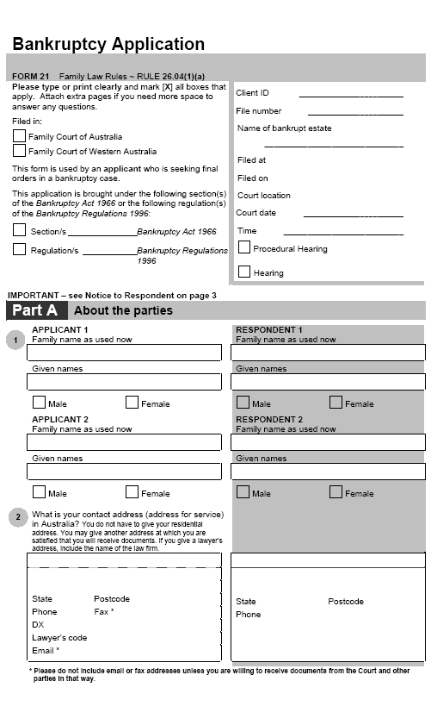
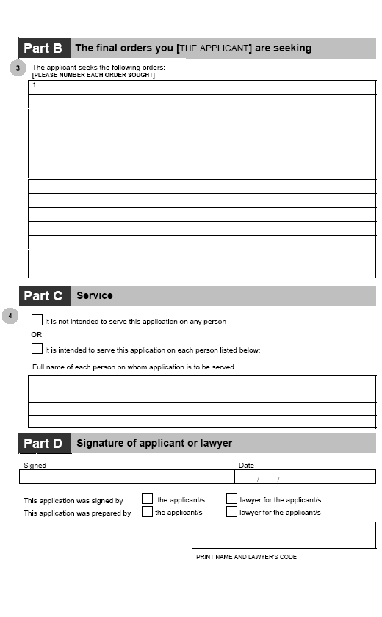

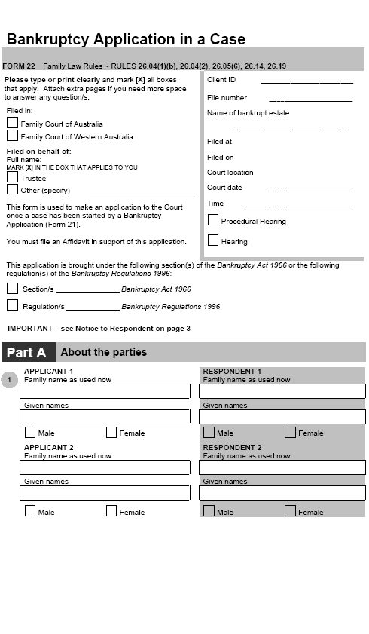
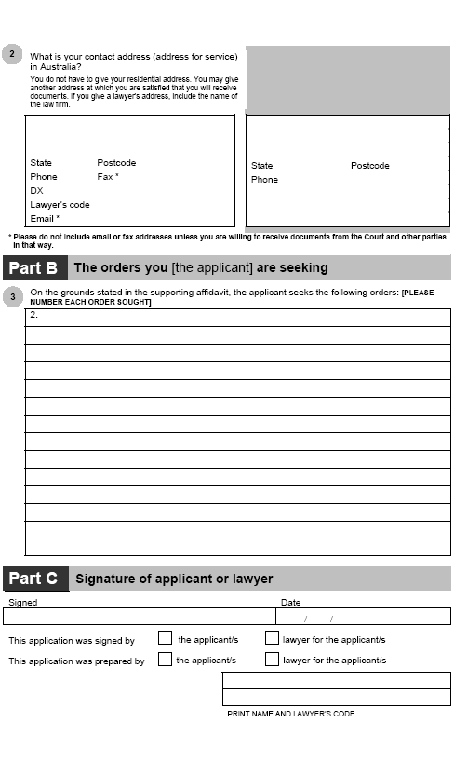

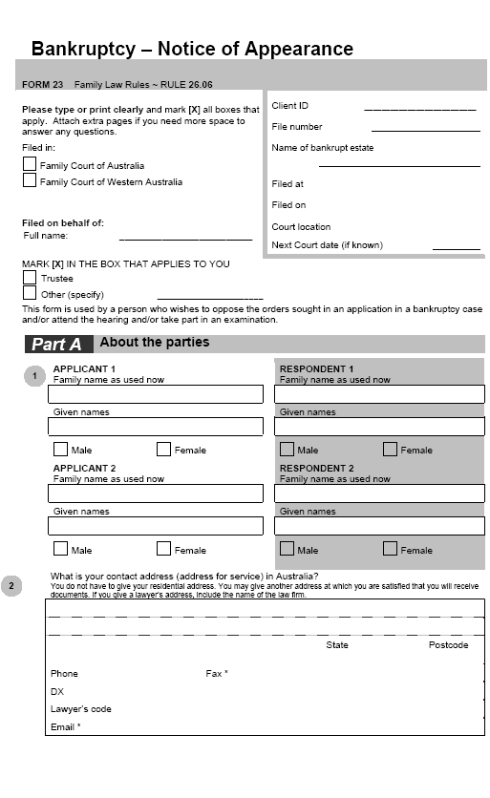
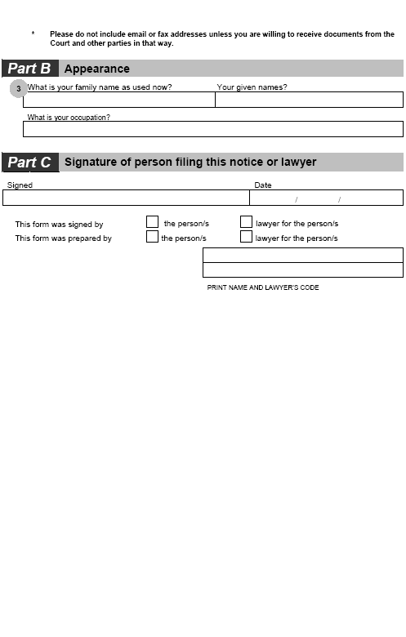
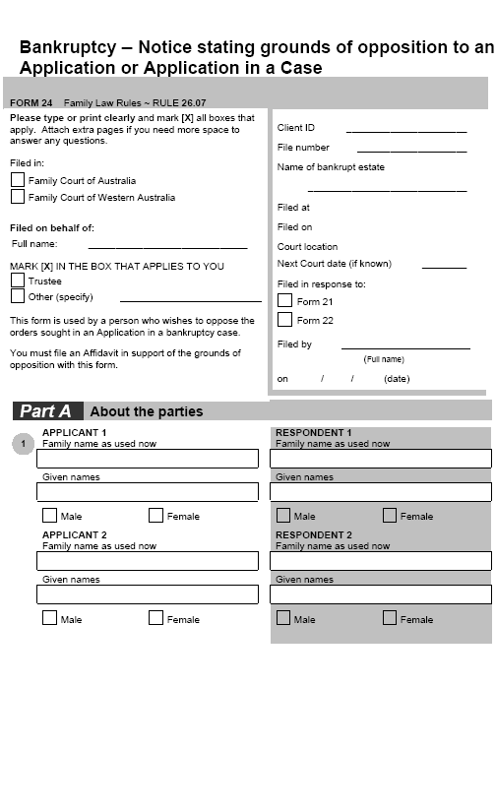
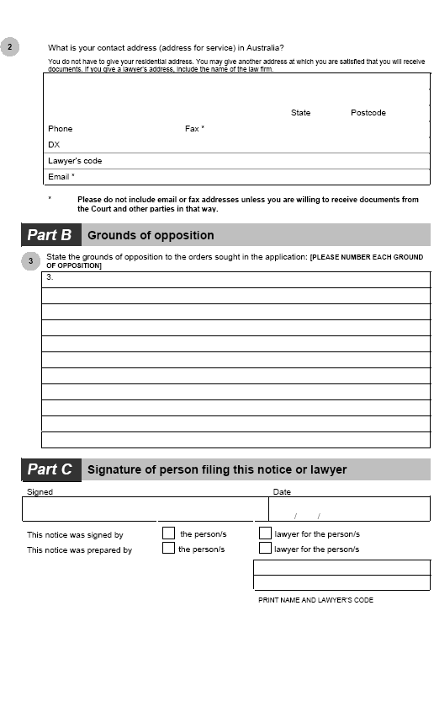
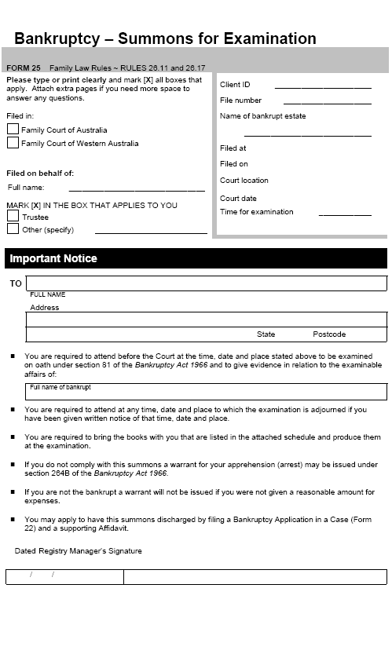
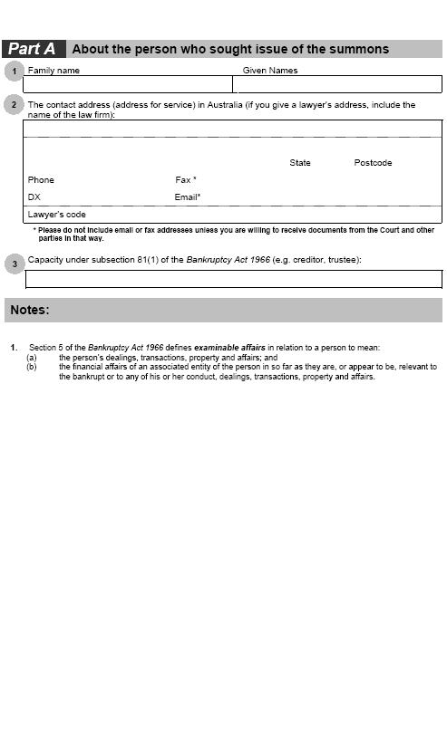
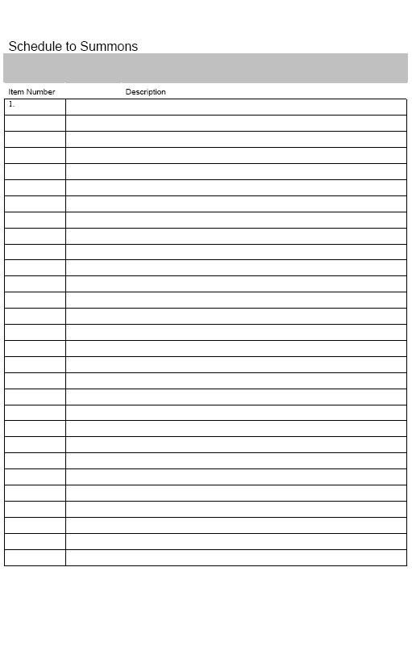
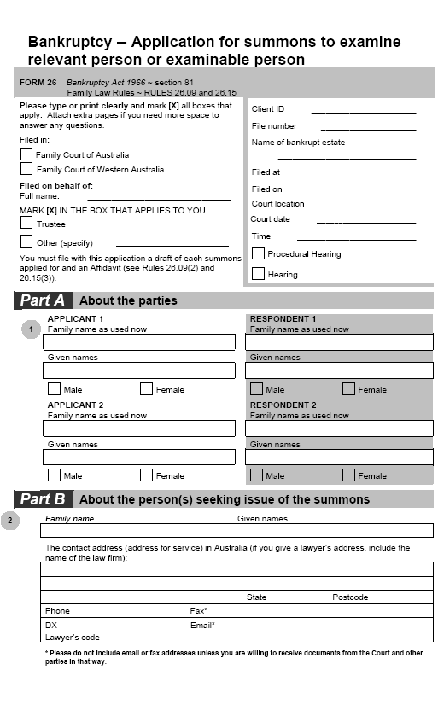
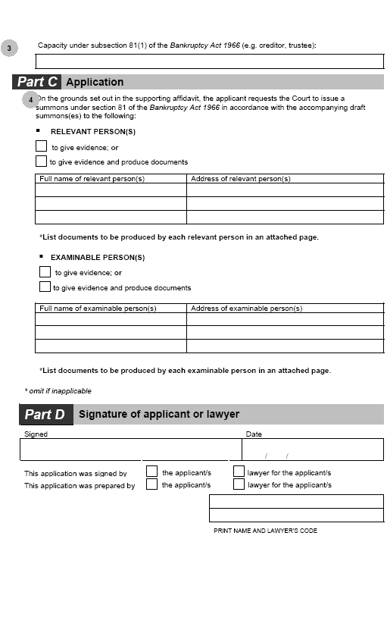
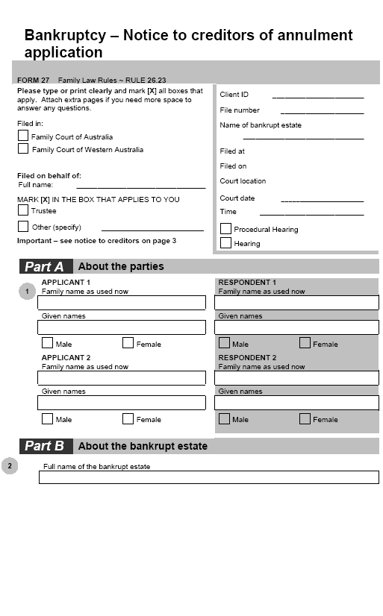
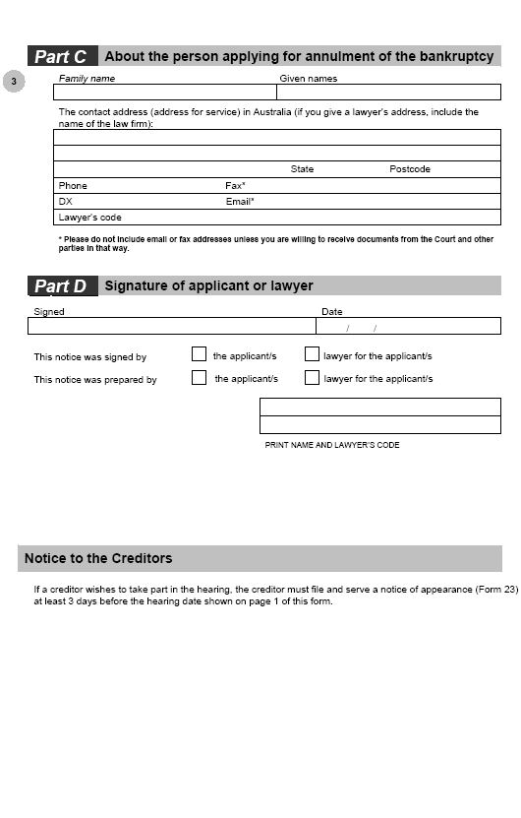
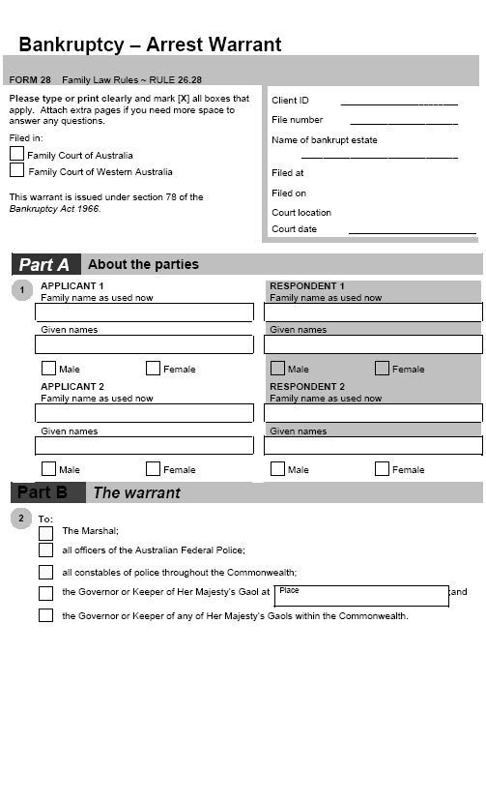
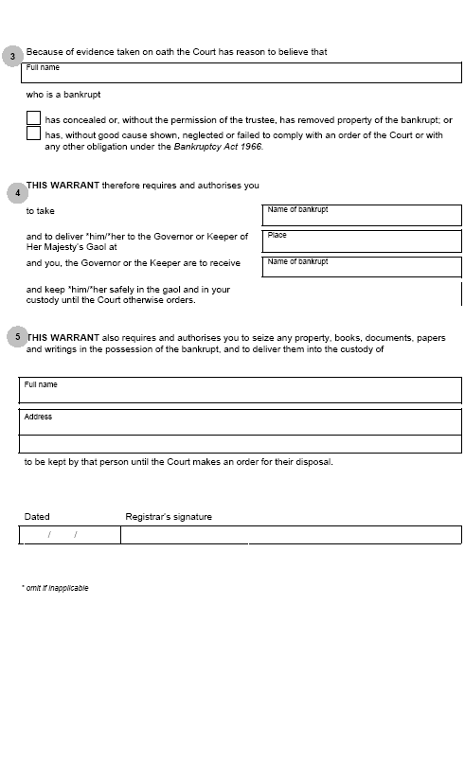
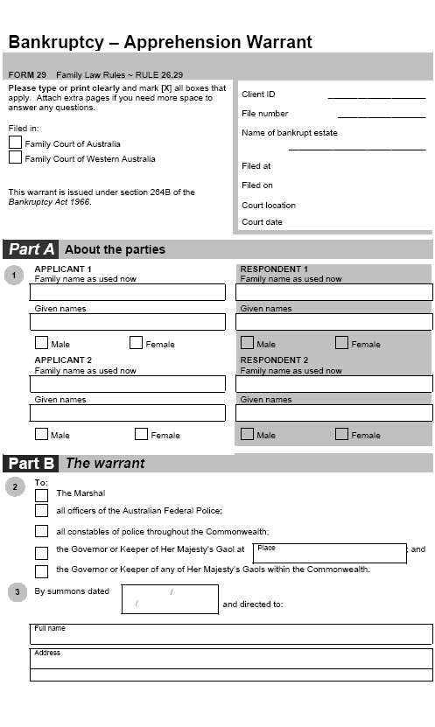
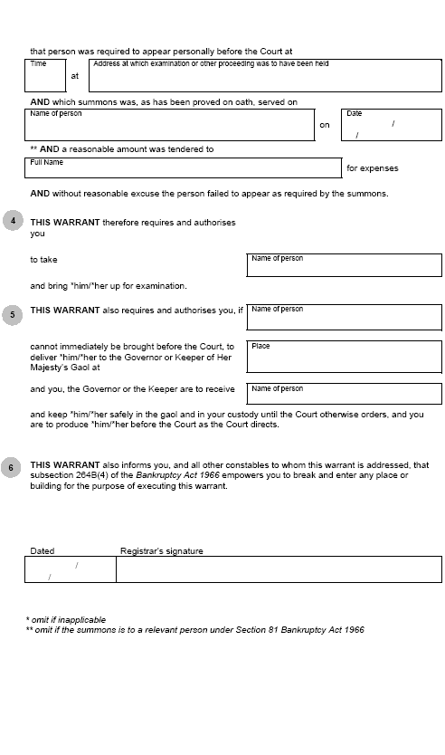
[60] Dictionary, definition of bankrupt
substitute
bankrupt has the meaning given by subsection 5 (1) of the Bankruptcy Act.
Bankruptcy Act means the Bankruptcy Act 1966.
bankruptcy case means a case in which a court has jurisdiction in bankruptcy under section 35 or 35B of the Bankruptcy Act.
[61] Dictionary, definition of divorce
omit
[62] Dictionary, definition of financial case, after paragraph (b)
insert
(ba) relating to the vested bankruptcy property in relation to a bankrupt party to a marriage;
[63] Dictionary, definition of property case
substitute
property case means a case in which orders (other than consent orders) are sought relating to:
(a) the property of the parties to a marriage or of either of them; or
(b) the vested bankruptcy property in relation to a bankrupt party to a marriage.
[64] Further amendments — application for divorce
The following provisions are amended by omitting ‘Application for Divorce’ and substituting ‘application for divorce’:
• paragraph 10.11 (2) (b)
• paragraph 13.17 (a)
• paragraph 15.37 (a)
• rule 18.06, Table 18.4, item 23, column 3.
[65] Further amendments — child support application or appeal
The following provisions are amended by omitting ‘Child Support Application or Appeal’ and substituting ‘child support application or appeal’:
• rule 2.02, Table 2.2, item 6, column 2
• subrule 2.03 (3), note
• rule 4.18, note 3
• subrule 4.19 (1)
• subrule 4.23 (1)
• subrule 4.25 (1)
• rule 9.02, note
• paragraph 12.01 (c)
• rule 13.07, note 1, paragraph (b)
• paragraph 13.17 (e)
• paragraph 13.19 (1) (c)
• paragraph 13.25 (c)
• paragraph 15.07 (1) (c)
• paragraph 15.21 (1) (b).
Note
1. All legislative instruments and compilations are registered on the Federal Register of Legislative Instruments kept under the Legislative Instruments Act 2003. See www.frli.gov.au.

