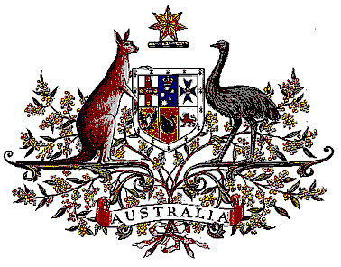

Veterans’ Entitlements Act 1986

Determination of Warlike Service
OPERATION PALATE II

I, De-Anne Kelly, Minister for Veterans’ Affairs, for the Minister for Defence determine that:
a. service rendered as a member of the Australian Defence Force assigned for service on Operation PALATE II on or after 27 June 2005 in the area of operations specified in paragraph b. is warlike service for the purposes of the definition of “warlike service” in subsection 5C(1) of the Veterans' Entitlements Act 1986; and
b. the area of operations comprises Afghanistan, including Afghanistan’s land territory, internal waters and superjacent airspace.

Dated 8th December 2005

DE-ANNE KELLY
Minister for Veterans’ Affairs
for the Minister for Defence

