COMMONWEALTH OF AUSTRALIA (Civil Aviation Regulations 1998), PART 39 - 105 CIVIL AVIATION SAFETY AUTHORITY
SCHEDULE OF AIRWORTHINESS DIRECTIVES

AIRWORTHINESS DIRECTIVE

For the reasons set out in the background section, the CASA delegate whose signature appears below issues the following Airworthiness Directive (AD) under subregulation 39.1 (1) of CAR 1998. The AD requires that the action set out in the requirement section (being action that the delegate considers necessary to correct the unsafe condition) be taken in relation to the aircraft or aeronautical product mentioned in the applicability section: (a) in the circumstances mentioned in the requirement section; and (b) in accordance with the instructions set out in the requirement section; and (c) at the time mentioned in the compliance section.

Airbus Industrie A319, A320 and A321 Series Aeroplanes

AD/A320/134 Fixed Lateral Cockpit Window 3/2002

Applicability: All Model A319, A320, and A321 aircraft, fitted with PPG Aerospace fixed lateral cockpit window part number NP-165313-1 or NP-165313-2 having a serial number below 95001H0001 (PPG Aerospace manufacturing date before January 1995).

Requirement: 1. Action in accordance with Airbus Industrie Service Bulletin A320-56-1009.

2. Windows found suspect must be re-inspected, and replaced if necessary, in accordance with Airbus Industrie Service Bulletin A320-56-1009.

Note: DGAC AD 2001-632(B) refers.

Compliance: 1. Within 500 flight hours after 21 March 2002, unless already accomplished.

2. Repeat at intervals not to exceed 500 flight hours, until replacement. This Airworthiness Directive becomes effective on 21 March 2002.
Background: The DGAC received an in-service report of outer glass ply separation from a fixed lateral cockpit window. Investigation revealed a deficient manufacturing process resulted in moisture ingress between the centre and outer glass ply.
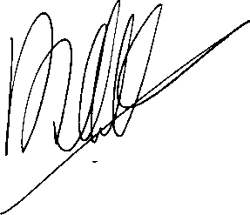

David Alan Villiers
Delegate of the Civil Aviation Safety Authority 8 February 2002

The above AD is notified in the Commonwealth of Australia Gazette on 27 February 2002.

Page 1 of 1

