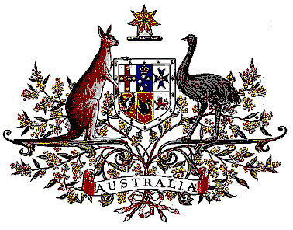

Veterans’ Entitlements Act 1986

Determination of Warlike Service
OPERATION TAMAR

I, Bruce Billson, Minister for Veterans’ Affairs, for the Minister for Defence:

  - revoke the determination made under paragraph 120(7) of the Veterans’ Entitlements Act 1986 (the Act) on 5 August 1994 in relation to service as part of the United Nations Assistance Mission for Rwanda as hazardous service; and
  - determine that:
    - service rendered as a member of the Australian Defence Force assigned for service on Operation TAMAR during the period 25 July 1994 to 16 January 1996 in the area of operations specified in subparagraph (ii) is warlike service for the purposes of the definition of “warlike service” in subsection 5C(1) of the Act; and
    - the area of operations comprises Rwanda and the areas in Uganda, Zaire (now known as the Democratic Republic of the Congo), Burundi and Tanzania that are not more than 50 kilometres from the border with Rwanda.
  - this Determination is taken to have commenced on
13 February 2006.

Dated 26th March 2006

BRUCE BILLSON
Minister for Veterans’ Affairs
for the Minister for Defence

