Vehicle Standard (Australian Design Rule 48/00 – Devices for Illumination of Rear Registration Plates) 2006
I, JAMES ERIC LLOYD, Minister for Local Government, Territories and Roads, determine this vehicle standard under subsection 7 (1) of the Motor Vehicle Standards Act 1989.

Dated 26 April 2026

[SIGNED]

James Eric Lloyd

Minister for Local Government, Territories and Roads

CONTENTS

0.1. NAME OF STANDARD 3
0.2. COMMENCEMENT 3
0.3. REPEAL 3
1. SCOPE 3
2. APPLICABILITY AND IMPLIMENTATION 3
3. DEFINITIONS 3
4. REQUIREMENTS 3
5. EXEMPTIONS AND ALTERNATIVE PROCEDURES 4
6. SUPPLEMENTARY GENERAL REQUIREMENTS 4
7. ALTERNATIVE STANDARDS 4
8. NOTES 4
ATTACHMENT A 5

0.1. NAME OF STANDARD
0.1.1. This Standard is the Vehicle Standard (Australian Design Rule 48/00 – Devices for Illumination of Rear Registration Plates) 2006.
0.1.2. This Standard may also be cited as Australian Design Rule 48/00 — Devices for Illumination of Rear Registration Plates.
0.2. COMMENCEMENT
0.2.1. This Standard commences on the day after it is registered.
0.3. REPEAL
0.3.1. This Standard repeals each vehicle standard with the name Australian Design Rule 48/00 — Devices for Illumination of Rear Registration Plates that is:
(a) made under section 7 of the Motor Vehicles Standard Act 1989; and
(b) in force at the commencement of this Standard.
0.3.2. This Standard also repeals each instrument made under section 7 of the Motor Vehicles Standard Act 1989 that creates a vehicle standard with the name Australian Design Rule 48/00 — Devices for Illumination of Rear Registration Plates, if there are no other vehicle standards created by that instrument, or amendments to vehicle standards made by that instrument, that are still in force at the commencement of this Standard.
- SCOPE
This Australian Design Rule (ADR) prescribes the photometric requirements for devices which illuminate the rear registration plate by reflection.
- APPLICABILITY AND IMPLIMENTATION
  - The circumstances under which rear registration plate lamps are mandatory, optional, or prohibited are set out in either ADRs 13/..., 19/…or 67/….
- DEFINITIONS
  - Refer to paragraph 1 of Appendix A.
- REQUIREMENTS
  - Devices complying with the technical requirements of Appendix A as varied by part 5 Exemptions and Alternative Procedures and part 6 Supplementary General Requirements shall be accepted as complying with this rule.
- EXEMPTIONS AND ALTERNATIVE PROCEDURES
  - The following provisions of Appendix A do not apply.
    - Section 2 Application for approval
Section 3 Markings
Section 4 Approval
Section 10 Conformity of production – partial (for particular deletions to the section refer to paragraphs 5.1.2)
Section 11 Penalties for non conformity of production
Section 12 Production definitely discontinued
Section 13 Names and addresses of technical services responsible for conducting approval tests, and of administrative departments
Annexes
Annex 1 Arrangements of approval marks
Annex 2 Communication concerning the approval (or refusal or withdrawal of approval or production definitely discontinued) of a type of illuminating device for rear registration plates pursuant to Regulation No. 4
    - Paragraphs 2.3 and 3.3 in Annex 7.
- SUPPLEMENTARY GENERAL REQUIREMENTS
The following general requirements are supplementary to the requirements of Appendix A:
  - The requirements and procedures set out in Annexes 6 and 7 of Appendix A are acceptable for the purposes of demonstrating compliance with the technical requirements of this rule
- ALTERNATIVE STANDARDS
  - The technical requirements of any of the editions of United Nations Economic Commission for Europe Regulation 4 UNIFORM PROVISIONS FOR THE APPROVAL OF DEVICES FOR THE ILLUMINATION OF REAR REGISTRATION PLATES OF MOTOR VEHICLES(EXCEPT MOTOR CYCLES) AND THEIR TRAILERS. from the edition incorporating amendments to the 00 series of amendments, are deemed to be equivalent to the technical requirements of this rule.
- NOTES
  - In place of Regulation No 48 where referenced in Appendix A, read ADR 13/00.
  - In place of Regulation No 37 where referenced in Appendix A, read ADR 51/00.
ATTACHMENT A
UN-ECE REGULATION NO. 4/00
UNIFORM PROVISIONS CONCERNING THE APPROVAL OF DEVICES FOR THE ILLUMINATION OF REAR REGISTRATION PLATES OF MOTOR VEHICLES (EXCEPT MOTOR CYCLES) AND THEIR TRAILERS
UNIFORM PROVISIONS FOR THE APPROVAL OF DEVICES FOR THE ILLUMINATION OF REAR REGISTRATION PLATES OF MOTOR VEHICLES (EXCEPT MOTOR CYCLES) AND THEIR TRAILERS
Regulation No. 4
CONTENTS
Regulation
1. Definitions
2. Applications for approval
3. Markings
4. Approval
5. General specifications
6. Colour of light
7. Angle of incidence
8. Measuring procedure
9. Photometric characteristics
10. Conformity of production
11. Penalties for non-conformity of production
12. Production definitely discontinued
13. Names and addresses of technical services conducting approval tests, and of administrative departments
Annexes
Annex 1 -Arrangement of approval marks
Annex 2 -Communication
Annex 3 -Measurement points for test purposes
Annex 4 -Minimum field of visibility of the surface to be illuminated
Annex 5 -Photometric measurement of lamps equipped with several light sources Annex 6 -Minimum requirements for conformity of production control procedures Annex 7 -Minimum requirements for sampling by an inspector
Regulation No. 4
UNIFORM PROVISIONS FOR THE APPROVAL OF DEVICES FOR THE ILLUMINATION OF REAR REGISTRATION PLATES OF MOTOR VEHICLES (EXCEPT MOTOR CYCLES) AND THEIR TRAILERS
1. DEFINITIONS
For the purpose of this Regulation:
1.1. "Rear registration plate lamp" means the device for the illumination of rear registration plates, hereinafter called "illuminating device", which illuminates the rear registration plate by reflection. For the approval of this device, the illumination of the space to be occupied by the plate is determined.
1.2. The definitions given in Regulation No. 48 and its series of amendments in force at the time of application for type approval shall apply to this Regulation.
2. APPLICATION FOR APPROVAL
The application for approval shall be submitted by the holder of the trade name or mark or by his duly accredited representative. It shall specify whether the device is intended to illuminate a wide plate (520 x 120 mm), tall plate (340 x 240 mm), plate for agricultural or forestry tractors (240 x 165 mm), or any combination of those plates. It shall be accompanied by the following, in respect of each type:
(a) drawings (three copies) in sufficient detail to permit identification of the type and showing geometrically the position in which the illuminating device is to be fitted in relation to the space to be occupied by the registration plate, and the outlines of the area adequately illuminated. The drawings must show the position intended for the approval number in relation to the circle of the approval mark;
(b) a brief technical specification stating the type and power of the lamp or lamps recommended by the manufacturer. This is not valid for lamps with non- replaceable light sources1/.
(c) two samples, equipped with the lamp or lamps recommended.
3. MARKINGS
Illuminating devices submitted for approval must bear:
(a) the trade name or mark of the maker or manufacturer of the illuminating device;
(b) a space of sufficient size for the approval mark; this space shall be shown in the drawings mentioned in paragraph 2(a) above.
(c) In the case of lamps with non-replaceable light sources the making of rated voltage and rated wattage.
4. APPROVAL
4.1. If the two samples of a type of illuminating device submitted in accordance with paragraph 2 above satisfy the provisions of this Regulation, approval shall be granted.
4.2. An approval number shall be assigned to each type approved. Its first two digits (at present 00 for the Regulation in its original form) shall indicate the series of amendments incorporating the most recent major technical amendments made to the Regulation at the time of issue of the approval. The same Contracting Party may not assign this number to another type of device covered by this Regulation, except in the case of an extension of the approval to a device differing only in the colour of the light emitted.
4.3. Notice of approval or of extension or refusal of approval of a type of illuminating device pursuant to this Regulation shall be communicated to the Parties to the 1958 Agreement applying this Regulation, by means of a form conforming to the model in Annex 2 to this Regulation.
4.4. Every illuminating device conforming to a type approved under this Regulation shall, in addition to the markings referred to in paragraph 3(a) and 3(c) above, bear an international approval mark in conformity with Annex 1, consisting of:
4.4.1. A circle surrounding the letter "E" followed by a number identifying the country which has granted approval;1/
4.4.2. An approval number, in the vicinity of the circle;
4.4.3. The following additional symbol: the letter "L";
4.4.4. The first two digits of the approval number which indicate the most recent series of amendments to this Regulation may be placed in the vicinity of the additional symbol L.
4.5. The mark and symbols referred to in paragraphs 4.4.1., 4.4.2. and 4.4.3. shall be indelible and shall be clearly legible even when the illuminating device is mounted on the vehicle.
4.6. When two or more lamps are part of the same unit of grouped, combined or reciprocally incorporated lamps, approval is granted only if each of these lamps satisfies the requirements of this Regulation or of another Regulation. Lamps not satisfying any one of those Regulations shall not be part of such a unit of grouped, combined or reciprocally incorporated lamps.
4.6.1. Where grouped, combined or reciprocally incorporated lamps comply with the requirements of several Regulations, a single international approval mark may be applied, consisting of a circle surrounding the letter "E" followed by the distinguishing number of the country which has granted the approval, an approval number and, if necessary, the required arrow. This approval mark may be placed anywhere on the grouped, combined or reciprocally incorporated lamps provided that:
4.6.1.1. It is visible after their installation;
4.6.1.2. No part of the grouped, combined or reciprocally incorporated lamps that transmits light can be removed without at the same time removing the approval mark.
4.6.2. The identification symbol for each lamp appropriate to each Regulation under which approval has been granted, together with the corresponding series of amendments incorporating the most recent major technical amendments to the Regulation at the time of issue of the approval, shall be marked:
4.6.2.1. Either on the appropriate light-emitting surface;
4.6.2.2. Or in a group, in such a way that each lamp of the grouped, combined or reciprocally incorporated lamps may be clearly identified (see three possible examples in Annex 1).
4.6.3. The size of the components of a single approval mark shall not be less than the minimum size required for the smallest of the individual marks by a Regulation under which approval has been granted.
4.6.4. An approval number shall be assigned to each type approved. The same Contracting Party may not assign the same number to another type of grouped, combined or reciprocally incorporated lamps covered by this Regulation.
4.6.5. The approval marking shall be clearly legible and indelible. It may be placed on an inner or outer part (transparent or not) of the device which cannot be separated from the transparent part of the device emitting the light. In any case the marking shall be visible when the device is fitted on the vehicle or when a movable part such as the hood or boot lid or a door is opened.
4.7. Annex 1 gives examples of arrangements of approval marks for a single lamp (figure 1) and for grouped, combined or reciprocally incorporated lamps (figure 2) with all the additional symbols referred to above.
5. GENERAL SPECIFICATIONS
5.1. Each sample shall conform to the lighting specifications set forth in paragraph 9 below3/.
Illuminating devices must be so designed that the entire surface to be illuminated is visible from the rear within the field of vision indicated in the drawing in Annex 4.
5.2. All measurements shall be carried out by adjusting the lamp or lamps of the illuminating device to the minimum light flux prescribed for the test voltage in the specification of the lamp or lamps for the device.
5.2.1. All measurements on lamps equipped with non-replaceable light sources (filament lamps and other) shall be made at 6.75 V, 13.5 V or 28.0 V respectively.
In the case of light sources supplied by a special power supply, the above test voltages shall be applied to the input terminals of that power supply. The test laboratory may require from the manufacturer the special power needed to supply the light sources.
5.3. For any rear registration plate illuminating device, except those equipped with filament lamp(s), the luminance values measured after one minute and after 30 minutes of operation shall comply with the minimum requirements.
The luminance distribution after one minute of operation can be calculated by applying at each test point the ratio of luminance values measured in one point after one minute and after 30 minutes of operation.
6. COLOUR OF LIGHT
The light of the lamp used in the illuminating device must be sufficiently colourless not to cause any appreciable change in the colour of the registration plate.
7. ANGLE OF INCIDENCE
The manufacturer of the illuminating device shall specify the position in which the device is to be fitted in relation to the space for the registration plate; the device must be so placed that the angle of incidence of the light on the surface of the plate does not exceed 82 degrees at any point on the surface to be illuminated, this angle being measured from the extremity of the device's illuminating area which is furthest from the surface of the plate. If there is more than one illuminating device, the foregoing requirement shall apply only to that part of the plate intended to be illuminated by the device concerned.
The device must be so designed that no light is emitted directly towards the rear, with the exception of red light if the device is combined or grouped with a rear lamp.
8. MEASURING PROCEDURE
Luminance measurements shall be made on a piece of clean white blotting paper with a minimum diffuse reflection factor of 70%, of the same dimensions as the registration plate, placed in the position normally occupied by it and 2 mm in front of its holder. Luminance measurements shall be made perpendicularly to the surface of the paper, at the points shown in Annex 3 according to the type of plate for which the device is intended, each point representing a circular area 25 mm in diameter.
9. PHOTOMETRIC CHARACTERISTICS
At each of the points of measurement shown in Annex 3, the luminance B shall be at least equal to 2.5 cd/m2.
The gradient of the luminance between the values B1 and B2, measured at any two points 1 and 2 selected from among those mentioned above, shall not exceed 2 x Bo/cm, Bo being the minimum luminance measured at the various points, that is to say:
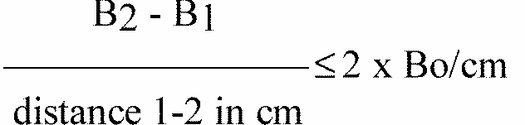
10. CONFORMITY OF PRODUCTION
The conformity of production procedures shall comply with those set out in the Agreement, Appendix 2 (E/ECE/324-E/ECE/TRANS/505/Rev.2), with the following requirements:
10.1. Devices for the illumination of rear registration plates (henceforth called devices), approved under this Regulation shall be so manufactured as to conform to the type approved by meeting the requirements set forth in paragraphs 5, 6 and 9 above. If there is more than one device necessary, then in the following text a device means a set of devices.
10.2. The minimum requirements for conformity of production control procedures set forth in annex 6 to this Regulation shall be complied with.
10.3. The minimum requirements for sampling by an inspector set forth in annex 7 to this Regulation shall be complied with.
10.4. The authority which has granted type approval may at any time verify the conformity control methods applied in each production facility. The normal frequency of these verifications shall be once every two years.
11. PENALTIES FOR NON-CONFORMITY OF PRODUCTION
11.1. The approval granted in respect of an illuminating device pursuant to this Regulation may be withdrawn if the requirements laid down above are not complied with.
11.2. If a Party to the Agreement which applies this Regulation withdraws an approval it has previously granted, it shall forthwith notify the other Contracting Parties applying this Regulation thereof by means of a communication form conforming to the model in Annex 2 to this Regulation.
12. PRODUCTION DEFINITELY DISCONTINUED
If the holder of the approval completely ceases to manufacture an illuminating device under this Regulation, he shall inform thereof the authority which granted the approval. Upon receiving the relevant communication that authority shall inform the other Parties to the Agreement which apply this Regulation thereof by means of a communication form conforming to the model in Annex 2 to this Regulation.
13. TRANSITIONAL PROVISIONS
13.1 Rear registration plate illuminating devices not equipped with filament lamps.
13.1.1. As from the date of entry into force of Supplement 8, no Contracting Party applying this Regulation shall refuse to grant approvals under this Regulation as amended by Supplement 8.
13.1.2. As from 36 months after the date of entry into force of Supplement 8, Contracting Parties applying this Regulation shall grant approvals only if the type of devices as described in paragraph 13.1. above meets the requirements of this Regulation as amended by Supplement 8.
13.1.3. Contracting Parties applying this Regulation shall not refuse to grant extensions of approvals to the preceding series of amendments to this Regulation.
13.1.4. Contracting Parties applying this Regulation shall continue to grant approvals to those types of devices as described in paragraph 13.1. above which comply with the requirements of this Regulation as amended by the preceding series of amendments during the 36 months' period which follows the date of entry into force of Supplement 8.
13.2. Fitting of rear registration plate illuminating devices described in paragraph 13.1. above on a vehicle.
13.2.1. As from the date of entry into force of Supplement 8, no Contracting Party applying this Regulation shall prohibit the fitting on a vehicle of devices described in paragraph 13.1. above approved under this Regulation as amended by Supplement 8.
13.2.2. Contracting Parties applying this Regulation shall continue to allow the fitting on a vehicle of devices described in paragraph 13.1. above approved to this Regulation as amended by the preceding series of amendments during the 48 months' period which follows the date of entry into force of Supplement 8.
13.2.3. Upon the expiration of a period of 48 months after the date of entry into force of Supplement 8, Contracting Parties applying this Regulation may prohibit the fitting of devices described in paragraph 13.1. above which do not meet the requirements of this Regulation as amended by Supplement 8 on a new vehicle for which type approval or individual approval was granted more than 24 months after the entry into force of Supplement 8 to this Regulation.
13.2.4. Upon expiration of a period of 60 months after the date of entry into force of Supplement 8, Contracting Parties applying this Regulation may prohibit the fitting of devices as described in paragraph 13.1. above which do not meet the requirements of this Regulation as amended by Supplement 8 on a new vehicle first registered more than 60 months after the date of entry into force of Supplement 8 to this Regulation.
14. NAMES AND ADDRESSES OF TECHNICAL SERVICES CONDUCTING APPROVAL TESTS, AND OF ADMINISTRATIVE DEPARTMENTS
The Parties to the Agreement which apply this Regulation shall communicate to the Secretariat of the United Nations the names and addresses of the technical services conducting approval tests and of the administrative departments which grant approval and to which forms certifying approval or refusal or withdrawal of approval, issued in other countries, are to be sent.
Annex 1
ARRANGEMENT OF APPROVAL MARKS
Figure 1 (Marking for single lamps)
Model A
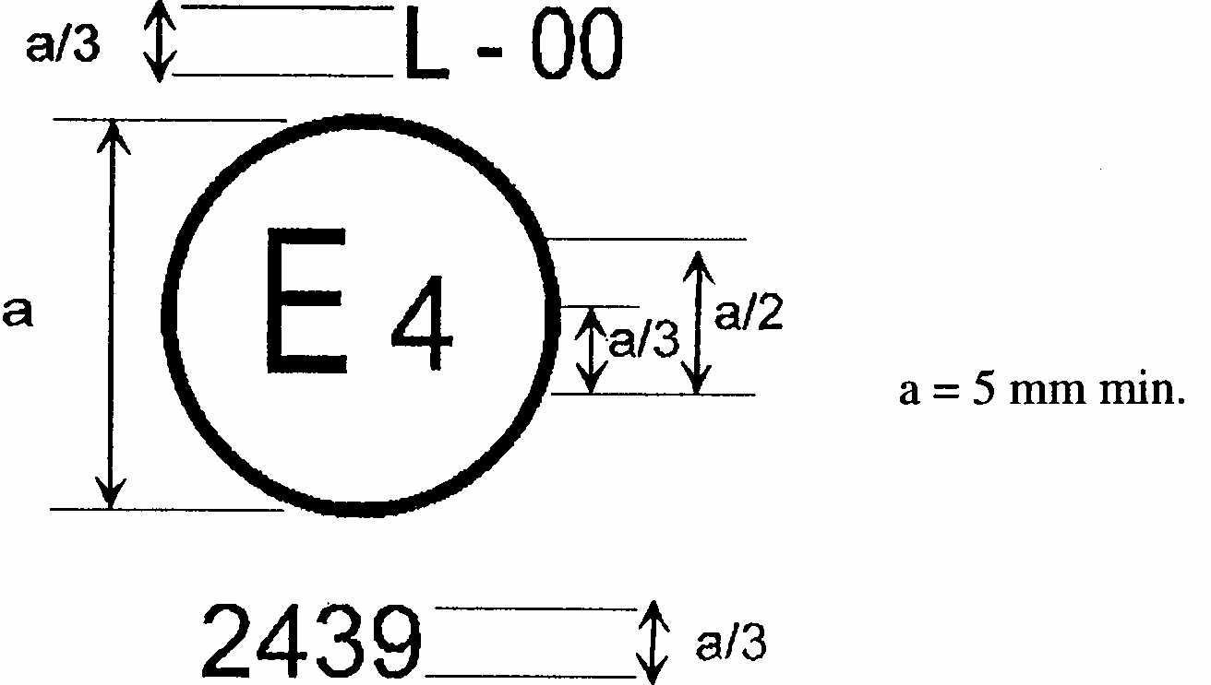
The device bearing the approval mark shown above is a device for the illumination of a vehicle's rear registration plate (L) approved in the Netherlands (E4) pursuant to Regulation No. 4 under approval number 2439. The approval number indicates that the approval was granted in accordance with the requirements of Regulation No. 4 in its original form or as amended by the respective supplements to the Regulation in its original form, as the case may be.
Figure 2
Simplified marking for grouped, combined or reciprocally incorporated lamps
(The vertical and horizontal lines schematize the shape of the light-signalling device. These are not part of the approval mark.)
Model B
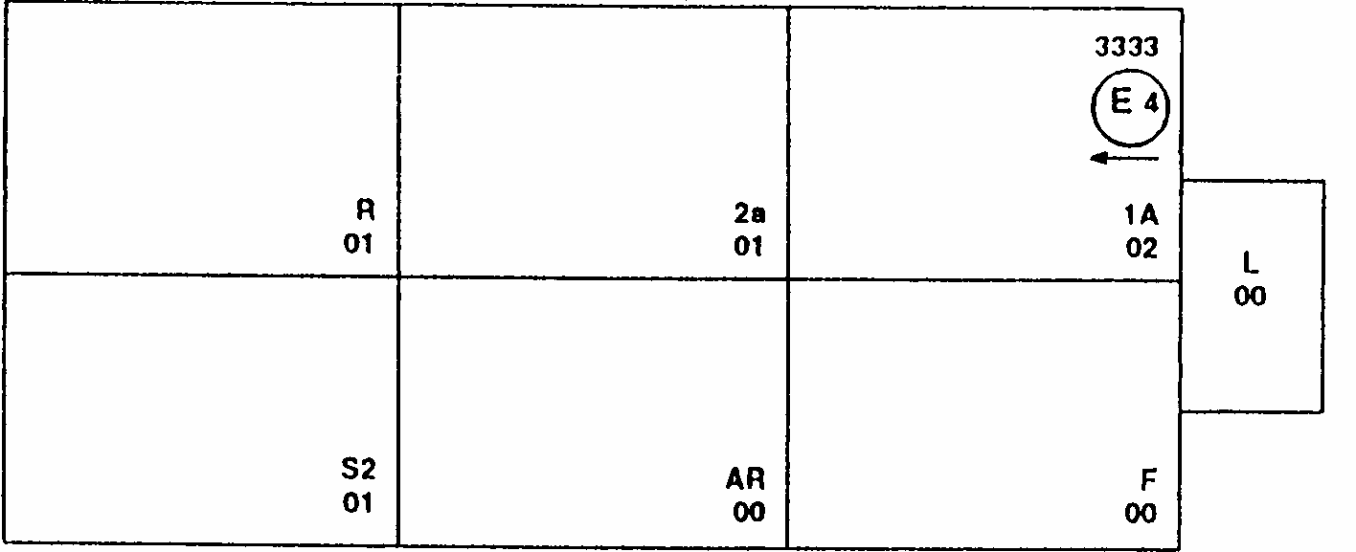
MODEL C
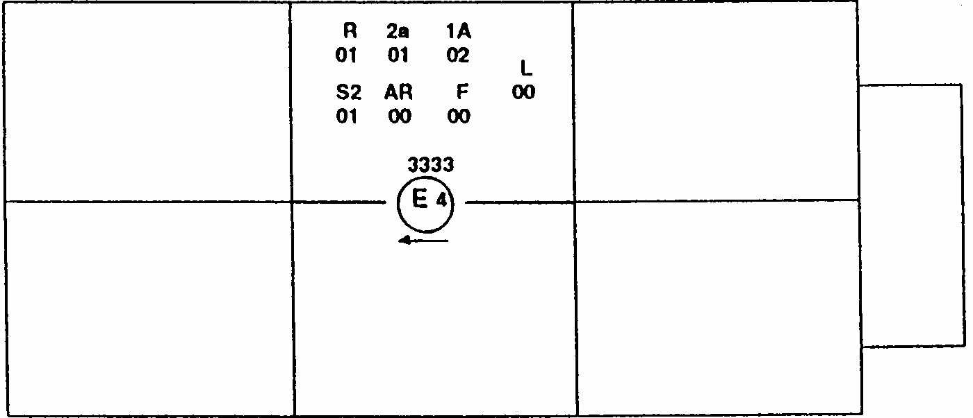
MODEL D
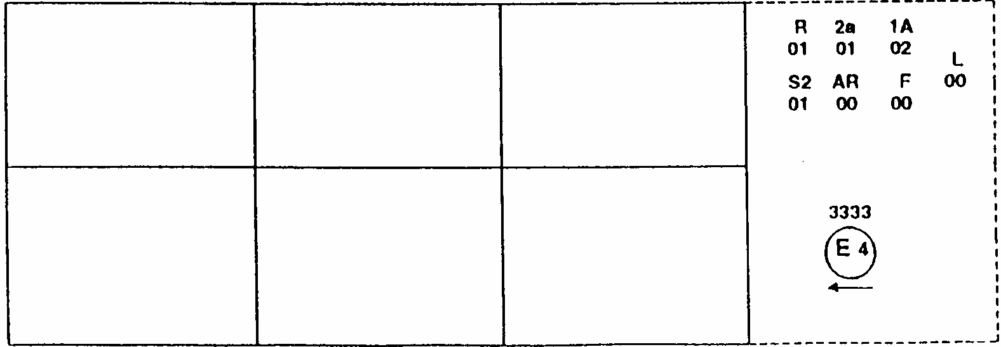
Note: The three examples of approval marks, models B, C and D represent three possible variants of the marking of a lighting device when two or more lamps are part of the same unit of grouped, combined or reciprocally incorporated lamps. This approval mark shows that the device was approved in the Netherlands (E4) under approval number 3333 and comprising:
A retro reflector of class IA approved in accordance with the 02 series of amendments to Regulation No. 3; A rear direction indicator of category 2a approved in accordance with the 01 series of amendments to Regulation No. 6;
A red rear position lamp (R) approved in accordance with the 01 series of amendments to Regulation No. 7; A rear fog lamp (F) approved in accordance with Regulation No. 38 in its original form;
A reversing lamp (AR) approved in accordance with Regulation No. 23 in its original form;
A stop lamp with two levels of illumination (S2) approved in accordance with the 01 series of amendments to Regulation No. 7;
A rear registration plate illuminating device (L) approved in accordance with Regulation No. 4 in its original form.
Annex 2
(maximum format: A4 (210 x 297 mm))
COMMUNICATION
Annex 3
MEASUREMENT POINTS FOR TEST PURPOSES

(a) devices for illuminating a tall plate (340 x 240 mm)
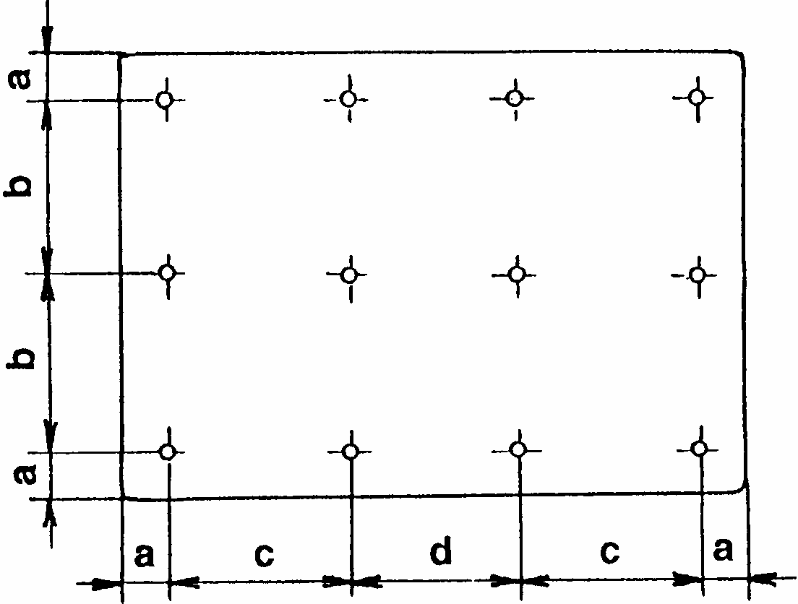

(b) devices for illuminating a wide plate (520 x 120 mm)
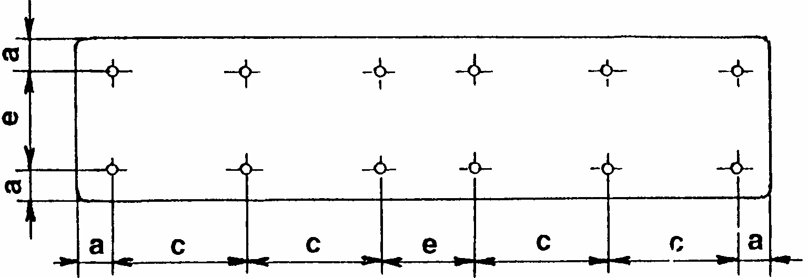

(c) devices for illuminating a plate for agricultural or forestry tractors (240 x 165 mm)
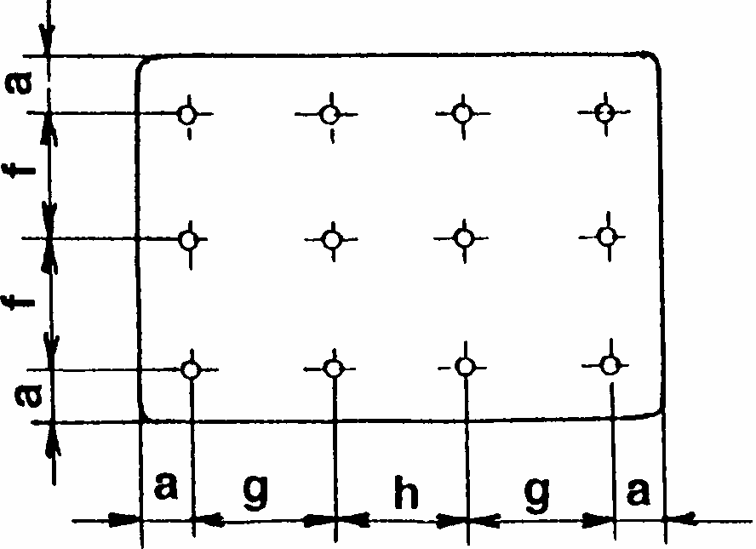
a = 25 mm b = 95 mm c = 100 mm d = 90 mm e =70 mm f = 57.5 mm g = 65 mm h = 60 mm
Note: In the case of devices for illuminating two or all of the plates, the measurement points used are obtained by combining the corresponding drawings above in accordance with the outline indicated by the make or manufacturer; however, if two measurement points are less than 30 mm apart, only one shall be used.
Annex 4
MINIMUM FIELD OF VISIBILITY OF THE SURFACE TO BE ILLUMINATED
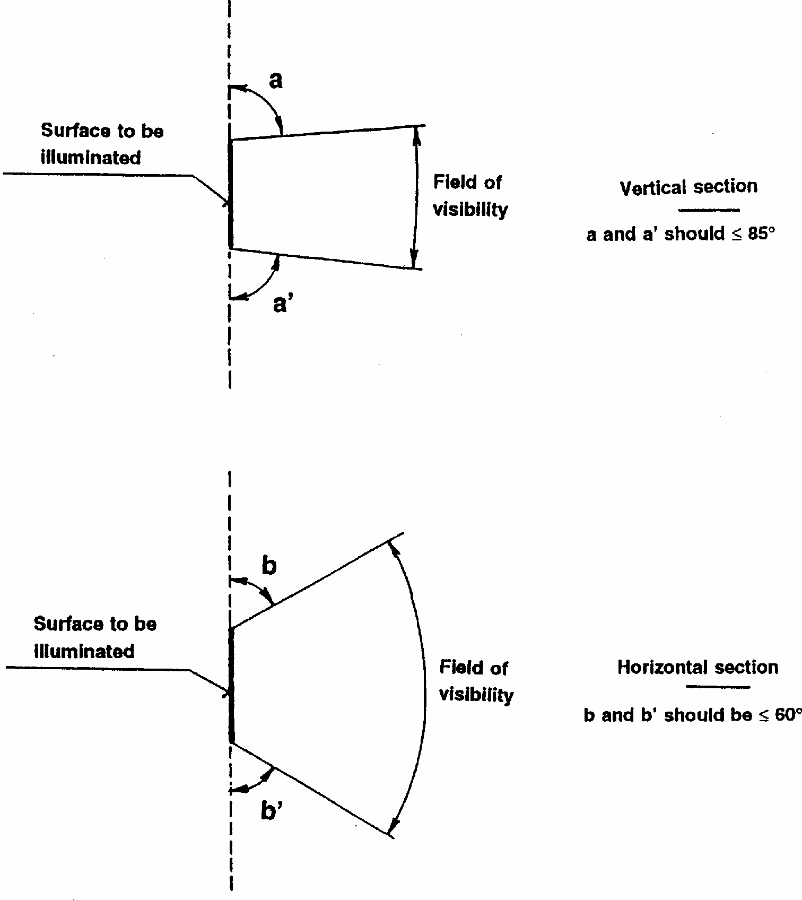
1. The field-of-visibility angles shown above relate only to the relative positions of the illuminating device and the space for the registration plate.
2. The field of visibility of the registration plate when mounted on the vehicle remains subject to the relevant national regulations.
3. The angles shown take account of the partial occultation caused by the illuminating device. They must be adhered to in the directions in which there is most occultation. The illuminating devices must be such as to reduce the areas partly occulted to the minimum strictly necessary.
Annex 5
PHOTOMETRIC MEASUREMENT OF LAMPS EQUIPPED WITH SEVERAL LIGHT SOURCES
1. The photometric performance shall be checked:
1.1. For non-replaceable light sources (filament lamps and other):
with the light sources present in the lamp, in accordance with paragraph 5.2.1. of this Regulation.
1.2. For replaceable filament lamps:
when equipped with mass production filament lamps at 6.75 V, 13.5 V or 28.0 V, the luminous intensity values produced shall lie between the maximum limit given in this Regulation and the minimum limit of this Regulation increased according to the permissible deviation of the luminous flux permitted for the type of filament lamp chosen, as stated in Regulation No. 37 for production filament lamps; alternatively a standard filament lamp may be used in turn, in each of the individual positions, operated at its reference flux, the individual measurements in each position being added together.
Annex 6
MINIMUM REQUIREMENTS FOR CONFORMITY OF PRODUCTION CONTROL PROCEDURES
1. GENERAL
1.1. The conformity requirements shall be considered satisfied from a mechanical and geometric standpoint, if the differences do not exceed inevitable manufacturing deviations within the requirements of this Regulation.
1.2. With respect to photometric performances, the conformity of mass-produced devices shall not be contested if, when testing photometric performances of any device chosen at random and equipped with a standard filament lamp, or when the lamps are equipped with non-replaceable light sources (filament lamps or other), and when all measurements are made at 6.75 V, 13.5 V or 28.0 V respectively:
1.2.1. no measured value deviates unfavourably by more than 20% from the values prescribed in this Regulation.
1.2.2. With respect to the gradient of luminance the unfavourable deviation may be: 2.5 x Bo/cm comparable to 20%
3.0 x Bo/cm comparable to 30%
1.2.3. If, in the case of a device equipped with a replaceable light source and if results of the test described above do not meet the requirements, tests on devices shall be repeated using another standard filament lamp.
2. MINIMUM REQUIREMENTS FOR VERIFICATION OF CONFORMITY BY THE MANUFACTURER
For each type of device the holder of the approval mark shall carry out at least the following tests, at appropriate intervals. The tests shall be carried out in accordance with the provisions of this Regulation.
If any sampling shows non-conformity with regard to the type of test concerned, further samples shall be taken and tested. The manufacturer shall take steps to ensure the conformity of the production concerned.
2.1. Nature of tests
Tests of conformity in this Regulation shall cover the photometric characteristics.
2.2. Method used in tests
2.2.1. Tests shall generally be carried out in accordance with the methods set out in this Regulation.
2.2.2. In any test of conformity carried out by the manufacturer, equivalent methods may be used with the consent of the competent authority responsible for approval tests. The manufacturer is responsible for proving that the applied methods are equivalent to those laid down in this Regulation.
2.2.3. The application of paragraphs 2.2.1. and 2.2.2. requires regular calibration of test apparatus and its correlation with measurements made by a competent authority.
2.2.4. In all cases the reference methods shall be those of this Regulation, particularly for the purpose of administrative verification and sampling.
2.3. Nature of sampling
Samples of devices shall be selected at random from the production of a uniform batch. A uniform batch means a set of devices of the same type, defined according to the production methods of the manufacturer.
The assessment shall in general cover series production from individual factories. However, a manufacturer may group together records concerning the same type from several factories, provided these operate under the same quality system and quality management.
2.4. Measured and recorded photometric characteristics
The sampled device shall be subjected to photometric measurements provided for in the Regulation.
2.5. Criteria governing acceptability
The manufacturer is responsible for carrying out a statistical study of the test results and for defining, in agreement with the competent authority, criteria governing the acceptability of his products in order to meet the specifications laid down for verification of conformity of products in paragraph 10.1. of this Regulation.
The criteria governing the acceptability shall be such that, with a confidence level of 95%, the minimum probability of passing a spot check in accordance with annex 7 (first sampling) would be 0.95.
Annex 7
MINIMUM REQUIREMENTS FOR SAMPLING BY AN INSPECTOR
1. GENERAL
1.1. The conformity requirements shall be considered satisfied from a mechanical and a geometric standpoint, in accordance with the requirements of this Regulation, if any, if the differences do not exceed inevitable manufacturing deviations.
1.2. With respect to photometric performance, the conformity of mass-produced devices shall not be contested if, when testing photometric performances of any device chosen at random and equipped with a standard filament lamp, or when the lamps are equipped with non-replaceable light sources (filament lamps or other), and when all measurements are made at 6.75 V, 13.5 V or 28.0 V respectively:
1.2.1. no measured value deviates unfavourably by more than 20% from the values prescribed in this Regulation.
1.2.2. With respect to the gradient of luminance the unfavourable deviation may be: 2.5 x Bo/cm comparable to 20%
3.0 x Bo/cm comparable to 30%
1.2.3. If, in the case of a device equipped with a replaceable light source and if results of the test described above do not meet the requirements, tests on devices shall be repeated using another standard filament lamp.
1.2.4. Devices with apparent defects are disregarded.
2. FIRST SAMPLING
In the first sampling four devices are selected at random. The first sample of two is marked A, the second sample of two is marked B.
2.1. The conformity is not contested
2.1.1. Following the sampling procedure shown in Figure 1 of this annex the conformity of mass-produced devices shall not be contested if the deviation of the measured values of the devices in the unfavourable directions are:
2.1.1.1. sample A
A1: one device.........................................................................................0%
one device not more than...............................................................20%
A2: both devices more than....................................................................0%
but not more than............................................................................20%
go to sample B
2.1.1.2. sample B
B1: both devices.......................................................................................0%
2.2. The conformity is contested
2.2.1. Following the sampling procedure shown in Figure 1 of this annex the conformity of mass-produced devices shall be contested and the manufacturer requested to make his production meet the requirements (alignment) if the deviations of the measured values of the devices are:
2.2.1.1. sample A
A3: one device not more than................................................................20%
one device more than......................................................................20%
but not more than............................................................................30%
2.2.1.2. sample B
B2: in the case of A2
one device more than.........................................................................0%
but not more than.............................................................................20%
one device not more than................................................................20%
B3: in the case of A2
one device........................................................................................0%
one device more than......................................................................20%
but not more than............................................................................30%
2.3. Approval withdrawn
Conformity shall be contested and paragraph 11 applied if, following the sampling procedure in Figure 1 of this annex, the deviations of the measured values of the devices are:
2.3.1. sample A
A4: one device not more than................................................................20%
one device more than.....................................................................30%
A5: both devices more than....................................................................20%
2.3.2. sample B
B4: in the case of A2
one device more than..........................................................................0%
but not more than...............................................................................20%
one device more than........................................................................20%
B5: in the case of A2
both devices more than....................................................................20%
B6: in the case of A2
one device...........................................................................................0%
one device more than.........................................................................30%
3. REPEATED SAMPLING
In the cases of A3, B2, B3 a repeated sampling, third sample C of two devices and fourth sample D of two devices, selected from stock manufactured after alignment, is necessary within two months' time after the notification.
3.1. The conformity is not contested
3.1.1. Following the sampling procedure shown in Figure 1 of this annex the conformity of mass-produced devices shall not be contested if the deviations of the measured values of the devices are:
3.1.1.1. sample C
C1: one device.........................................................................................0%
one device not more than................................................................20%
C2: both devices more than....................................................................0%
but not more than............................................................................20%
go to sample D
3.1.1.2. sample D
D1: in the case of C2
both devices....................................................................................... 0%
3.2. The conformity is contested
3.2.1. Following the sampling procedure shown in Figure 1 of this annex the conformity of mass-produced devices shall be contested and the manufacturer requested to make his production meet the requirements (alignment) if the deviations of the measured values of the devices are:
3.2.1.1. sample D
D2: in the case of C2
one device more than............................................................................0%
but not more than................................................................................20%
one device not more than...................................................................20%
3.3. Approval withdrawn
Conformity shall be contested and paragraph 11 applied if, following the sampling procedure in Figure 1 of this annex, the deviations of the measured values of the devices are:
3.3.1. sample C
C3: one device not more than.................................................................20%
one device more than.......................................................................20%
C4: both devices more than....................................................................20%
3.3.2. sample D
D3: in the case of C2
one device 0 or more than....................................................................0%
one device more than....................................................................20%
FIGURE 1
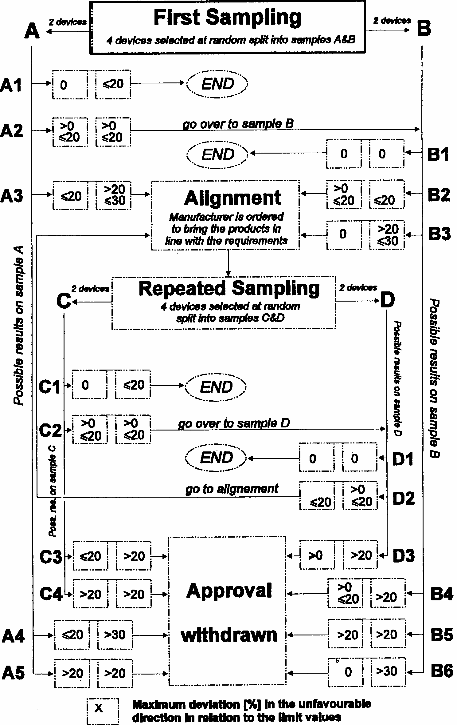

1/ A light source is defined in ISO 7227:1987 "Road vehicles - Lighting and light-signalling devices - Vocabulary" as an Emitter of visible and radiant energy.
1/ 1 for Germany, 2 for France, 3 for Italy, 4 for the Netherlands, 5 for Sweden, 6 for Belgium, 7 for Hungary, 8 for the Czech Republic, 9 for Spain, 10 for Yugoslavia, 11 for the United Kingdom, 12 for Austria, 13 for Luxembourg, 14 for Switzerland, 15 (vacant), 16 for Norway, 17 for Finland, 18 for Denmark, 19 for Romania, 20 for Poland, 21 for Portugal, 22 for the Russian Federation, 23 for Greece, 24 (vacant), 25 for Croatia, 26 for Slovenia, 27 for Slovakia, 28 for Belarus, 29 for Estonia, 30 (vacant), 31 for Bosnia and Herzegovina, 32 for Latvia, 33 (vacant), 34 for Bulgaria, 35-36 (vacant), 37 for Turkey, 38-39 (vacant), 40 for The former Yugoslav Republic of Macedonia, 41 (vacant), 42 for the European Community (Approvals are granted by its Member States using their respective ECE symbol) and 43 for Japan. Subsequent numbers shall be assigned to other countries in the chronological order in which they ratify or accede to the Agreement concerning the Adoption of Uniform Technical Prescriptions for Wheeled Vehicles, Equipment and Parts which can be Fitted and/or be Used on Wheeled Vehicles and Conditions for Reciprocal Recognition of Approvals Granted on the basis of these Prescriptions, and the numbers thus assigned shall be communicated by the Secretary-General of the United Nations to the Contracting Parties to the Agreement.
3/ These specifications are such as to ensure good visibility if the inclination of the registration plate does not exceed 30 degrees on either side of the vertical.

