Vehicle Standard (Australian Design Rule 55/00 – Headlamps for Motor Cycles) 2006
I, JAMES ERIC LLOYD, Minister for Local Government, Territories and Roads, determine this vehicle standard under subsection 7 (1) of the Motor Vehicle Standards Act 1989.

Dated 5 July 1905

[Signed]

James Eric Lloyd

Minister for Local Government, Territories and Roads

CONTENTS

0. legislative provisions 3
1. SCOPE 3
2. APPLICABILITY AND IMPLEMENTATION 3
3. DEFINITIONS 3
4. REQUIREMENTS 3
5. EXEMPTIONS AND ALTERNATIVE PROCEDURES 4
6. SUPPLEMENTARY GENERAL REQUIREMENTS 4
7. ALTERNATIVE STANDARDS 4
8. NOTES 5
APPENDIX A 6

- legislative provisions
  - NAME OF STANDARD
    - This Standard is the Vehicle Standard (Australian Design Rule 55/00 – Headlamps for Motor Cycles) 2006.
    - This Standard may also be cited as Australian Design Rule 55/00 — Headlamps for Motor Cycles.
  - COMMENCEMENT
    - This Standard commences on the day after it is registered.
  - REPEAL
    - This Standard repeals each vehicle standard with the name Australian Design Rule 55/00 — Headlamps for Motor Cycles that is:
(a) made under section 7 of the Motor Vehicle Standards Act 1989; and
(b) in force at the commencement of this Standard.
    - This Standard also repeals each instrument made under section 7 of the Motor Vehicle Standards Act 1989 that creates a vehicle standard with the name Australian Design Rule 55/00 — Headlamps for Motor Cycles, if there are no other vehicle standards created by that instrument, or amendments to vehicle standards made by that instrument, that are still in force at the commencement of this Standard.
- SCOPE
This Australian Design Rule (ADR) prescribes the photometric requirements for headlamps which are provided for motor cycles and other L-group vehicles treated as such.
- APPLICABILITY AND IMPLEMENTATION
  - The circumstances under which motorcycle headlamps lamps are mandatory, optional, or prohibited are set out in either ADRs 13/…, 19/… or 67/….
- DEFINITIONS
  - Refer to paragraph 2 of Appendix A.
- REQUIREMENTS
  - Devices complying with the technical requirements of Appendix A as varied by part 5 Exemptions and Alternative Procedures and part 6 Supplementary General Requirements shall be accepted as complying with this rule.
- EXEMPTIONS AND ALTERNATIVE PROCEDURES
  - The following provisions of appendix A do not apply.
    - Scope (including footnote 1)
Section 3 Application for approval of a headlamp
Section 4 Markings
Section 5 Approval
Section 8 Provisions concerning coloured lenses and filters
Section 9 Transitional provisions
Section 10 Conformity of production – partial (for particular deletions to the section refer to paragraph 5.1.2)
Section 11 Penalties for non conformity of production
Section 12 Production definitely discontinued
Section 13 Names and addresses of technical services responsible for conducting approval tests, and of administrative departments
Annexes
Annex 1 Communication concerning the approval (or refusal or withdrawal of approval or production definitely discontinued) of a type of headlamp pursuant to Regulation No. 57
Annex 2 Arrangements of approval marks
    - Paragraphs 2.3 and 3.3 in Annex 7.
- SUPPLEMENTARY GENERAL REQUIREMENTS
The following general requirements are supplementary to the requirements of Appendix A:
  - The requirements and procedures set out in Annexes 6 and 7 of Appendix A are acceptable for the purposes of demonstrating compliance with the technical requirements of this rule.
- ALTERNATIVE STANDARDS
  - The technical requirements of any of the editions of United Nations –Economic Commission for Europe (UN ECE) Regulation No. 57 - UNIFORM PROVISIONS CONCERNING THE APPROVAL OF HEADLAMPS FOR MOTOR CYCLES AND VEHICLES TREATED AS SUCH including the incorporating the 00 series of amendments are deemed to be equivalent to the technical requirements of this rule.
  - The technical requirements of ECE Regulation No. 72/00 – UNIFORM PROVISIONS CONCERNING THE APPROVAL OF HEADLAMPS FOR MOTORCYCLES EMITTING AN ASYMMETRICAL PASSING AND A DRIVING BEAM AND EQUIPPED WITH HALOGEN HEADLAMPS (HS1) incorporating the 00 series of amendments are deemed to be equivalent to the technical requirements of this rule.
  - The technical requirements of JIS D5500-1995 “Lighting and Signalling Equipment for Automobiles” FOR ASYMMETRIC Grade C1 headlamps shall be deemed to be equivalent to the technical requirements of this rule and
  - The technical requirements of SAE J584, December 1983 or SAE J584, April 1964 “Motorcycle Headlamps” shall be deemed to be equivalent to the technical requirements of this rule.

- NOTES
  - In place of Regulation No 48 where referenced in Appendix A, read ADR 13/00.
  - In place of Regulation No 37 where referenced in Appendix A, read ADR 51/00.
  - In place of Regulation No 53 where referenced in Appendix A, read ADR 19/02.
APPENDIX A

UN-ECE REGULATION NO. 57/00
UNIFORM PROVISIONS CONCERNING THE APPROVAL OF HEADLAMPS FOR MOTOR CYCLES AND VEHICLES TREATED AS SUCH
Regulation No. 57
UNIFORM PROVISIONS CONCERNING THE APPROVAL OF HEADLAMPS FOR MOTOR CYCLES AND VEHICLES TREATED AS SUCH
CONTENTS
REGULATION
1. Scope
2. Definitions
3. Application for approval of a headlamp
4. Markings
5. Approval
6. General specifications
7. Special specifications
8. Provisions concerning coloured lenses and filters
9. Transitional provisions
10. Conformity of production
11. Penalties for non-conformity of production
12. Modification and extension of approval of a type of headlamp
13. Production definitely discontinued
14. Names and addresses of technical services responsible for conducting approval tests and of administrative departments
ANNEXES:
Annex 1 - Communication concerning the approval (or refusal or withdrawal of approval or production definitely discontinued) of a type of headlamp pursuant to Regulation No. 57
Annex 2 - Arrangements of approval marks
Annex 3 - Photometric tests
Annex 4 - Tests for stability of photometric performance of headlamps in operation.
Annex 5 - Minimum requirements for conformity of production control procedures.
Annex 6 - Requirements for lamps incorporating lenses of plastic material testing of lens or material samples and of complete lamps
Appendix 1 -Chronological order of approval tests
Appendix 2 -Method of measurement of the diffusion and transmission of light
Appendix 3 -Spray testing method
Appendix 4 -Adhesive tape adherence test
Annex 7 - Minimum requirements for sampling by an inspector

Regulation No. 57
UNIFORM PROVISIONS CONCERNING THE APPROVAL OF HEADLAMPS FOR MOTOR CYCLES AND VEHICLES TREATED AS SUCH
1. SCOPE
This Regulation applies to the approval of headlamps using filament lamps and incorporating lenses of glass or plastic material */, which are provided for the equipment of motor cycles and vehicles treated as such.
2. DEFINITIONS
For the purpose of this Regulation,
2.1 "Lens" means the outermost component of the headlamp (unit) which transmits light through the illuminating surface;
2.2 "Coating" means any product or products applied in one or more layers to the outer face of a lens;
2.3 Headlamps different "types" are headlamps which differ in such essential respects as:
2.3.1 the trade name or mark;
2.3.2 marking of the headlamp as defined in paragraph 4.1.4 below;
2.3.3 the characteristics of the optical system;
2.3.4 the inclusion or the suppression of components capable of altering the optical effects by reflection, refraction or absorption and/or deformation during operation. A change in the colour of the beams emitted by headlamps whose other characteristics are not changed does not constitute a change of headlamp type. The same approval number shall accordingly be assigned to such headlamps.
2.3.5 the materials constituting the lenses and coating, if any.
3. APPLICATION FOR APPROVAL OF A HEADLAMP 1/
3.1 The application for approval shall be submitted by the owner of the trade name or mark or by his duly accredited representative.
3.2 Every application for approval shall be accompanied by:
3.2.1 drawings in triplicate in sufficient detail to permit identification of the type and representing a frontal view of the headlamp, with details of lens ribbing if any, and the cross-section; the drawings shall indicate the space reserved for the approval mark;
3.2.2 a brief technical description stating, in particular, the category or categories of the filament lamp provided (see annex 3, paragraph 6, to this Regulation);
3.2.3 two samples of the type of headlamp with colourless lenses. 2/
3.2.4 for the test of plastic material of which the lenses are made:
3.2.4.1 thirteen lenses;
3.2.4.1.1 six of these lenses may be replaced by six samples of material at least 60 x 80 mm in size, having a flat or convex outer surface and a substantially flat area (radius of curvature not less than 300 mm) in the middle measuring at least 15 x 15 mm;
3.2.4.1.2 every such lens or sample of material shall be produced by the method to be used in mass production;
3.2.4.2 a reflector to which the lenses can be fitted in accordance with the manufacturer's instructions.
3.3 The materials making up the lenses and coatings, if any, shall be accompanied by the test report of the characteristics of these materials and coatings if they have already been tested.
3.4 The competent authority shall verify the existence of satisfactory arrangements for ensuring effective control of the conformity of production before type approval is granted.
4. MARKINGS
4.1 Headlamps submitted for approval shall clearly, legibly and indelibly bear the following inscriptions:
4.1.1 the trade name or mark of the applicant;
4.1.2 externally and/or on the lens the indication of the exterior marking of the headlamp, visible when the headlamp is installed on the vehicle.
All units meeting the requirements of this Regulation which are so designed that the filament of the passing beam shall not be lit simultaneously with that of any other lighting function with which it may be reciprocally incorporated shall be marked with an oblique stroke (/) placed behind the passing lamp symbol in the approval mark.
4.1.3 on the back of the headlamp the indication of the S₁ and/or S₂ category of the admitted filament lamp;
4.1.4 the markings are listed in the following table:
Exterior marking of the headlamps | Indication of the category of filament lamp
MB  MB  MB | S  S₂  S₁/S₂
4.1.5 On headlamps incorporating a lens of plastic material, the group of letters "PL" shall be affixed near the symbol prescribed in paragraphs 4.1.2 and 4.1.4 above;
4.2 Moreover, they shall comprise, on the lens and on the main body3/, spaces of sufficient size for the approval mark and the additional symbols referred to in paragraph 4; these spaces shall be indicated on the drawings referred to in paragraph 3.2.1 above.
5. APPROVAL
5.1 If all the samples of a type of headlamp submitted pursuant to paragraph 3 above satisfy the requirements of this Regulation, approval shall be granted.
5.2 An approval number shall be assigned to each type approved. Its first two digits (at present 01 corresponding to the 01 series of amendments which entered into force on 28 February 1989) shall indicate the series of amendments incorporating the most recent major technical amendments made to the Regulation at the time of issue of the approval. The same Contracting Party shall not assign the same number to another type of headlamp except in the case of an extension of the approval to a headlamp differing only in the colour of the light emitted.
5.3 Notice of approval or of extension or refusal of approval of a type of headlamp pursuant to this Regulation shall be communicated to the Parties to the 1958 Agreement applying this Regulation, by means of a form conforming to the model in annex 1 to this Regulation.
5.4 Every headlamp conforming to a type approved under this Regulation shall bear in the spaces referred to in paragraph 4.2 above, in addition to the markings prescribed in paragraph 4.1.:
5.4.1 an international approval mark 4/ consisting of:
5.4.1.1 a circle surrounding the letter "E" followed by the distinguishing number of the country which has granted approval; 5/
5.4.1.2 an approval number.
5.4.2 In every case the relevant operating mode used during the test procedure according to paragraph 1.1.1.1 of annex 4 and the allowed voltage(s) according to paragraph 1.1.1.2 of annex 4 shall be stipulated on the approval certificates and on the notice transmitted to the countries which are Contracting Parties to the Agreement and which apply this Regulation.
In the corresponding cases the device shall be marked as follows:
On units meeting the requirements of this Regulation which are so designed that the filament of the passing beam shall not be lit simultaneously with that of any other lighting function with which it may be reciprocally incorporated, an oblique stroke (/) shall be placed behind the passing beam symbol in the approval mark.
5.5 The markings according to paragraph 5.4 shall be clearly legible and indelible.
5.6 Annex 2 to this Regulation gives an example of the arrangement of the approval mark.
6. GENERAL SPECIFICATIONS
6.1 Each sample of a type of headlamp shall conform to the specifications set forth in this paragraph and in paragraph 7 below and, if necessary, to those set forth in paragraph 8.
6.2 Headlamps shall be so designed and constructed that, in normal use, despite the vibrations to which they may be subjected, their satisfactory operation continues to be ensured and they retain the characteristics prescribed by this Regulation.
6.2.1 Headlamps shall be fitted with a device enabling them to be so adjusted on the vehicles as to comply with the rules applicable to them. Such device need not be fitted on components in which the reflector and the diffusing lens cannot be separated, provided the use of such components is confined to vehicles on which the headlamps setting can be adjusted by other means.
Where a headlamp providing a driving beam and a headlamp providing a passing beam, each equipped with its own lamp, are assembled to form a composite unit the adjusting device shall enable each optical system individually to be duly adjusted.
6.2.2 However, these provisions shall not apply to headlamp assemblies whose reflectors are indivisible. For this type of assembly the requirements of paragraph 7.3 of the present Regulation shall apply. Where more than one light source is used to provide the main beam, the combined functions shall be used to determine the maximum value of the illumination (E_{max}).
6.3 The parts intended for holding the filament lamp in the reflector shall be so made that, even in darkness, the filament lamp can be mounted in no other position than the correct one.
6.4 Complementary tests shall be done according to the requirements of annex 5 to ensure that in use there is no excessive change in photometric performance.
6.5 If the lens of the headlamp is of plastic material, tests shall be done according to the requirements of annex 6.
7. SPECIAL SPECIFICATIONS
7.1 The correct position of the lens in relation to the optical system shall be unequivocally marked and be locked against rotation in service.
7.2 For the measurement of the illumination produced by the headlamp, a measuring screen as described in annex 3 of this Regulation and a standard filament lamp (S1 and/or S2, Regulation No. 37) with a smooth and colourless bulb shall be used.
The standard filament lamp shall be adjusted to the applicable reference luminous flux according to values prescribed for these lamps.
7.3 The passing beam shall have a cut-off sufficiently sharp in order that satisfactory aiming can practically be achieved with its aid. The "cut-off" must be as straight and horizontal as possible over a range of at least 5 degrees on either side of the line v-v (see annex 3). When aimed according to annex 3, the headlamps shall meet the requirements specified in it.
7.4 The beam pattern shall not present any lateral variations detrimental to good visibility.
7.5 The illumination of the screen mentioned in paragraph 7.2 shall be measured by means of a photoelement having a useful area comprised within a square of 65 mm side.
8. PROVISIONS CONCERNING COLOURED LENSES AND FILTERS
8.1 Approval may be obtained for headlamps emitting either colourless or selective yellow light with an uncoloured filament lamp. Expressed in CIE trichromatic co-ordinates, the corresponding colorimetric characteristics for yellow glasses or filters are as follows: Selective-yellow filter (screen or lens)
Limit towards red y> 0.138 + 0.58 x
Limit towards greed y< 1.29 x -0.1
Limit towards white y< -x + 0.966
Limit towards special value y< -x + 0.992
which can also be expressed as follows:
dominant wave-length 575 - 585 n m
purity factor 0.90 - 0.98
The transmission factor must be > 0.78
The transmission factor shall be determined by using a light source with a colour temperature of 2,856 K. (Corresponding to illuminant A of the International Commission on Illumination (CIE)).
8.2 The filter must be part of the headlamp, and must be attached to it in such a way that the user cannot remove it either inadvertently or intentionally, with ordinary tools.
8.3 Observation concerning colour
Since any approval under this Regulation is granted, pursuant to paragraph 8.1 above, for a type of headlamp emitting either colourless light or selective-yellow light; article 3 of the agreement to which the Regulation is annexed shall not prevent the Contracting Parties from prohibiting headlamps emitting a beam of uncoloured or selective yellow light on vehicles registered by them.
9. TRANSITIONAL PROVISIONS
9.1 As from the date of entry into force of the 01 series of amendments to this Regulation no Contracting Party applying it shall refuse to grant approvals under this Regulation as amended by the 01 series of amendments.
9.2 As from 24 months after the date of entry into force mentioned in paragraph 9.1 above, Contracting Parties applying this Regulation shall grant approval only if the type of headlamp corresponds to the requirements of this Regulation as amended by the 01 series of amendments.
9.3 Existing MB-approvals granted under this Regulation before the date mentioned in paragraph 9.2 above shall remain valid.
However, Contracting Parties applying this Regulation may prohibit the fitting of devices which do not meet the requirements of this Regulation as amended by the 01 series of amendments.
9.3.1 On vehicles for which type approval or individual approval is granted more than 24 months after the date of entry into force mentioned in paragraph 9.1 above.
9.3.2 On vehicles first registered more than 5 years after the date of entry into force mentioned in paragraph 9.1 above.
10. CONFORMITY OF PRODUCTION
10.1 Headlamps approved under this Regulation shall be so manufactured as to conform to the type approved by meeting the requirements set forth in paragraph 7 above.
10.2 In order to verify that the requirements of paragraph 10.1 are met, suitable controls of the production shall be carried out.
10.3 The holder of the approval shall in particular:
10.3.1 ensure the existence of procedures for the effective control of the quality of products;
10.3.2 have access to the control equipment necessary for checking the conformity to each approved type;
10.3.3 ensure that data of test results are recorded and that related documents shall remain available for a period to be determined in accordance with the administrative service;
10.3.4 analyze the results of each type of test in order to verify and ensure the stability of the product characteristics, making allowance for variation of an industrial production;
10.3.5 ensure that, for each type of product, at least the tests prescribed in Annex 5 to this Regulation are carried out;
10.3.6 ensure that any collecting of samples giving evidence of non-conformity with the type of test considered shall give rise to another sampling and another test. All the necessary steps shall be taken to re-establish the conformity of the corresponding production.
10.4 The competent authority which has granted type approval may at any time verify the conformity control methods applicable to each production unit.
10.4.1 In every inspection, the test books and production survey records shall be presented to the visiting inspector.
10.4.2 The inspector may take samples at random to be tested in the manufacturer's laboratory. The minimum number of samples may be determined in the light of the results of the manufacturer's own checks.
10.4.3 When the quality level appears unsatisfactory or when it seems necessary to verify the validity of the tests carried out in the application of paragraph 10.4.2 above, the inspector shall select samples, to be sent to the technical service which has conducted the type approval tests, using the criteria of Annex 7.
10.4.4 The competent authority may carry out any test prescribed in this Regulation. These tests will be on samples selected at random without causing distortion of the manufacturer's delivery commitments and in accordance with the criteria of Annex 7.
10.4.5 The competent authority shall strive to obtain a frequency of inspection of once every two years. However, this is at the discretion of the competent authority and their confidence in the arrangements for ensuring effective control of the conformity of production. In the case where negative results are recorded, the competent authority shall ensure that all necessary steps are taken to re-establish the conformity of production as rapidly as possible.
10.5 Headlamps with apparent defects are disregarded.
11. PENALTIES FOR NON-CONFORMITY OF PRODUCTION
11.1 The approval granted in respect of a type of headlamp pursuant to this Regulation may be withdrawn if the requirements set forth above are not met or if a headlamp bearing the approval mark does not conform to the type approved.
11.2 If a Contracting Party to the Agreement applying this Regulation withdraws an approval it has previously granted, it shall forthwith so notify the other Contracting Parties applying this Regulation, by means of a communication form conforming to the model in annex 1 to this Regulation.
12. MODIFICATION AND EXTENSION OF APPROVAL OF A TYPE OF HEADLAMP
12.1 Every modification of the type of headlamp shall be notified to the administrative department which approved the type of headlamp. The department may then either:
12.1.1 Consider that the modifications made are unlikely to have an appreciable adverse effect and that in any case the headlamp still complies with the requirements; or
12.1.2 Require a further test report from the technical service responsible for conducting the tests.
12.2 Confirmation or refusal of approval, specifying the alterations shall be communicated by the procedure specified in paragraph 5.3 above to the Parties to the Agreement applying this Regulation.
12.3 The competent authority issuing the extension of approval shall assign a series number for such an extension and inform thereof the other Parties to the 1958 Agreement applying this Regulation by means of a communication form conforming to the model in annex 1 to this Regulation.
13. PRODUCTION DEFINITELY DISCONTINUED
If the holder of the approval completely ceases to manufacture a type of headlamp approved in accordance with this Regulation, he shall so inform the authority which granted the approval. Upon receiving the relevant communication that authority shall inform thereof the other Parties to the 1958 Agreement applying this Regulation by means of a communication form conforming to the model in annex 1 to this Regulation.
14. NAMES AND ADDRESSES OF TECHNICAL SERVICES RESPONSIBLE FOR CONDUCTING APPROVAL TESTS AND OF ADMINISTRATIVE DEPARTMENTS
The Parties to the 1958 Agreement applying this Regulation shall communicate to the United Nations Secretariat the names and addresses of the technical services responsible of conducting approval tests and of the administrative departments which grant approval and to which forms certifying approval or extension or refusal or withdrawal of approval, issued in other countries, are to be sent.
Annex 1
(maximum format: A4 (210 x 297 mm))
COMMUNICATION
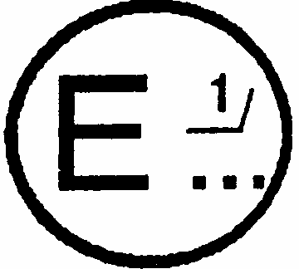
Issued by: Name of administration:
..................................
..................................
..................................

Concerning: 2/ APPROVAL GRANTED
APPROVAL EXTENDED
APPROVAL REFUSED
APPROVAL WITHDRAWN
PRODUCTION DEFINITELY DISCONTINUED
of a type of: headlamp pursuant to Regulation No. 57
Approval No.......... Extension No.............
1. Trade name or mark of the headlamp:
2. Manufacturer's name for the type of headlamp:
3. Manufacturer's name and address:
4. If applicable, name and address of the manufacturer's representative:
5. Submitted for approval on:
6. Technical service responsible for conducting approval tests:
7. Date of report issued by that service:
8. Number of report issued by that service:
9. Concise description:
Category as described by the relevant marking: MB, MB/ , MB PL, MB/PL 2/
Category of filament lamp: S1, S2, S1/S2 2/,
- Colour of light emitted: white/selective yellow 2/
10. Position of the approval mark:
11. Reason(s) for extension (if applicable):
12. Approval granted/refused, extended/withdrawn: 2/
13. Place:
14. Date:
15. Signature:
16. The list of documents deposited with the Administrative Service which has granted approval is annexed to this communication and may be obtained on request.
Annex 2
ARRANGEMENTS OF APPROVAL MARKS
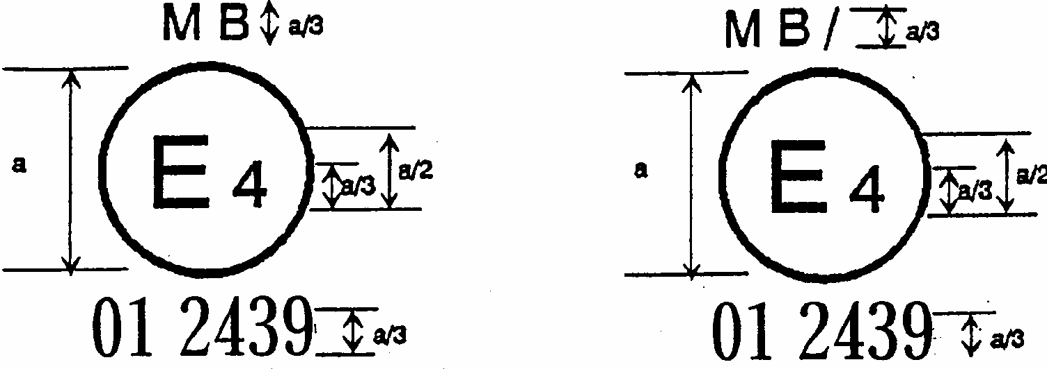
a = 12 mm min.
The headlamp bearing the above approval mark has been approved in the Netherlands (E 4) under approval number 012439. The approval number indicates that the approval was granted in accordance with the requirements of this Regulation as amended by the 01 series of amendments.
Note
The approval number must be placed close to the circle and either above or below the "E" or to left or right of that letter. The digits of the approval number must be on the same side of the "E" and face in the same direction. The use of Roman numerals as approval numbers should be avoided so as to prevent any confusion with other symbols.
Identification of a headlamp meeting the requirements of Regulation No. 57. The headlamp is so designed, that the filament of the passing beam
Left: can be lit together
Right: shall not be lit together simultaneously with driving beam and/or another reciprocally incorporated lighting function.
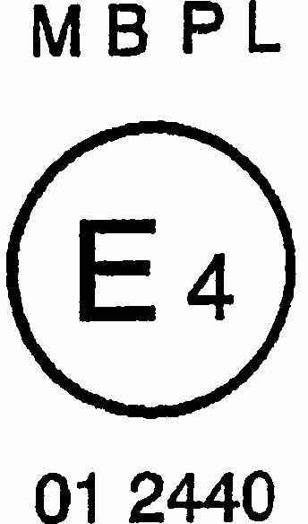
The headlamp bearing the above approval mark is a headlamp incorporating a lens of plastic material which has been approved in the Netherlands (E 4) under approval number 01 2440. The approval number indicates that the approval was granted in accordance with the requirements of this Regulation, as amended by the 01 series of amendments.
It is so designed, that the filament of the passing beam can be lit together simultaneously with the driving beam and/or another reciprocally incorporated lighting function.
Annex 3
PHOTOMETRIC TESTS
1. For aiming, the aiming screen shall be located at a distance of at least 10 m in front of the headlamp, the h-h line shall be horizontal. For measurement, the photoelement shall be located at a distance of 25 m in front of the headlamp and perpendicular to the line joining the filament of the filament lamp and the point HV.
2. Laterally, the headlamp shall be so aimed that the beam centre of the driving beam is on the vertical line v-v.
3. Vertically, the headlamp shall be so aimed that the "cut-off" of the passing beam is situated 250 mm below the line h-h.
4. The headlamp when aimed according to paragraphs 2 and 3 above, similar to the conditions of the driving beam, shall meet the following conditions:
4.1 the luminous centre of the driving beam shall be situated not more than 0.6 degrees above or below the line h-h;
4.2 the illumination of the driving-beam shall attain its maximum value E_{max}. in the centre of the entire beam pattern and decrease laterally;
4.3 the maximum illumination (E_{max}) of the driving beam shall be at least 32 lux.
4.3.1 32 lux for class MB headlamps;
4.4 the illumination produced by the driving beam shall meet the following values:
4.4.1 the point of intersection (HV) of lines h-h and v-v shall be situated within the isolux 90 % of maximum illumination;
4.4.2 starting from point HV, horizontally to the right and left, the illumination of the driving beam shall be not less than 12 lux for class MB-headlamps up to a distance of 1.125 m and not less than 3 lux to a distance of 2.25 m.
4.5 the illumination produced by the passing beam shall meet the following values: */
Measuring point | Class MB headlamp
Any point on and above the line h-h | < 0.7 lux
Any point on the line 50L-50R except 50 V */ | > 1.5 lux
Point 50 V | >3 lux
Any point on the line 25L-25R | > 3 lux
Any point in zone IV | < 1.5 lux

5. MEASURING AND AIMING SCREEN
(dimensions in mm for 25 m distance)
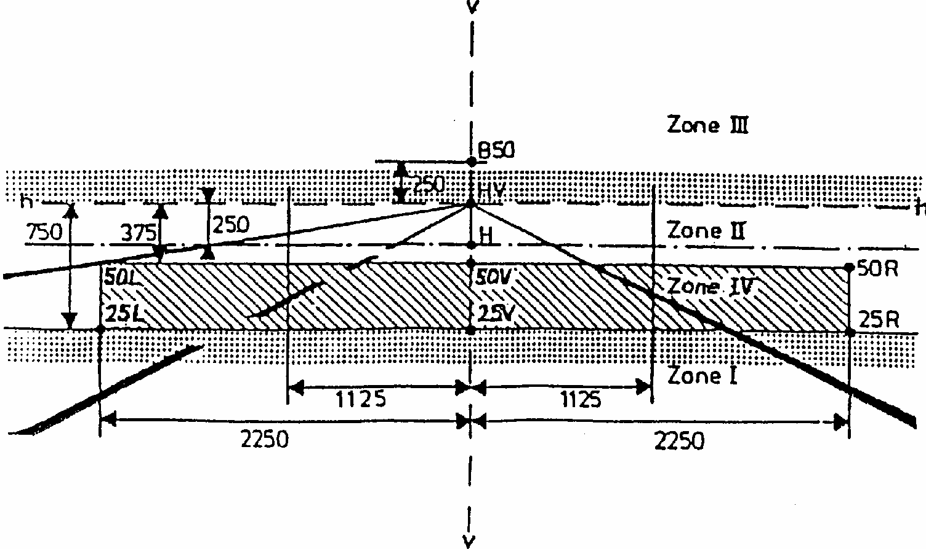
For the filament lamps, categories S1 or S2 according to Regulation No. 37 shall be used.
Annex 4
TESTS FOR STABILITY OF PHOTOMETRIC PERFORMANCE OF HEADLAMPS IN OPERATION
TESTS ON COMPLETE HEADLAMPS
Once the photometric values have been measured according to the prescriptions of this Regulation, in points for E_{max} for driving beam and HV, 50 R, 50 L, B 50 for passing beam a complete headlamp sample shall be tested for stability of photometric performance in operation. 'Complete headlamp' shall be understood to mean the complete lamp itself including those surrounding body parts and lamps which could influence its thermal dissipation.
1. TEST FOR STABILITY OF PHOTOMETRIC PERFORMANCE
The tests shall be carried out in a dry and still atmosphere at an ambient temperature of 23 degrees C+/-5 degrees C, the complete headlamps being mounted on a base representing the correct installation on the vehicle.
1.1 Clean headlamp
The headlamp shall be operated for 12 hours as described in subparagraph 1.1.1 and checked as prescribed in subparagraph 1.1.2.
1.1.1 Test procedure
The headlamp shall be operated for a period according to the specified time, so that:
1.1.1.1 (a) in the case where only one lighting function (driving or passing beam) is to be approved, the corresponding filament is lit for the prescribed time, 2/
(b) in the case of a reciprocally incorporated passing lamp and driving lamp (dual filament lamp or two filament lamps):
- If the applicant declares that the headlamp is to be used with a single filament lit 1/ at a time, the test shall be carried out in accordance with this condition, activating 2/each specified function successively for half the time specified in paragraph 1.1.
- In all other cases 1/ 2/, the headlamp, shall be subjected to the following cycle until the time specified is reached:
15 minutes, passing-beam filament lit
5 minutes, all filaments lit.
(c) in the case of grouped lighting functions all the individual functions shall be lit simultaneously for the time specified for individual lighting functions (a) also taking into account the use of reciprocally incorporated lighting functions (b), according to the manufacturer's specifications.
1.1.1.2 Test voltage
The voltage shall be adjusted so as to supply 90 % of the maximum wattage specified for filament lamps of category S in the Regulation No. 37.
The applied wattage shall in all cases comply with the corresponding value of a filament lamp of 12 V rated voltage, except if the applicant for approval specifies that the headlamp may be used at a different voltage.
1.1.2 Test results
1.1.2.1 Visual inspection
Once the headlamp has been stabilized to the ambient temperature, the headlamp lens and the external lens, if any, shall be cleaned with a clean, damp cotton cloth. It shall then be inspected visually; no distortion, deformation, cracking or change in colour of either the headlamp lens or the external lens, if any, shall be noticeable.
1.1.2.2 Photometric test
To comply with the requirements of this Regulation, the photometric values shall be verified in the following points:
Passing beam:
50 R, 50 L, B 50 HV
Driving beam:
Point of E_{max}
Another aiming may be carried out to allow for any deformation of the headlamp base due to heat (the change of the position of the cut-off line is covered in paragraph 2 of this annex):
A 10 % discrepancy between the photometric characteristics and the values measured prior to the test is permissible including the tolerances of the photometric procedure.
1.2 Dirty headlamp
After being tested as specified in subparagraph 1.1 above, the headlamp shall be operated for one hour as described in subparagraph 1.1.1, after being prepared as prescribed in subparagraph 1.2.1, and checked as prescribed in subparagraph 1.1.2.
1.2.1 Preparation of the headlamp
1.2.1.1 Test mixture
1.2.1.1.1. For headlamp with the outside lens in glass:
The mixture of water and a polluting agent to be applied to the headlamp shall be composed of:
9 parts by weight of silica sand with a particle size of 0-100 mu m,
1 part by weight of vegetal carbon dust (beechwood) with a particle size of 0-100 mu m, 0.2 part by weight of NaCMC 3/ , and
an appropriate quantity of distilled water, with a conductivity of < 1 mS/m.
The mixture must not be more than 14 days old.
1.2.1.1.2. For headlamp with outside lens in plastic material:
The mixture of water and polluting agent to be applied to the headlamp shall be composed of:
9 parts by weight of silica sand with a particle size of 0-100 mu m,
1 part by weight of vegetal carbon dust (beechwood) with a particle size of 0-100 mu m, 0.2 part by weight of NaCMC ^{3/},
13 parts by weight of distilled water with a conductivity of < 1 mS/m, and
2 +/- 1 parts by weight of surface-actant. 4/
The mixture must not be more than 14 days oid.
1.2.1.2 Application of the test mixture to the headlamp
The test mixture shall be uniformly applied to the entire light emitting surface of the headlamp and then left to dry. This procedure shall be repeated until the illumination value has dropped to 15-20 % of the values measured for each following point under the conditions described in this annex:
Point of E_{max} in driving beam, photometric distribution for a driving/passing lamp, Point of E_{max} in driving beam, photometric distribution for a driving lamp only,
B 50 and 50 V 5/ for a passing lamp only.
1.2.1.3 Measuring equipment
The measuring equipment shall be equivalent to that used during headlamp approval tests. A standard (reference) filament lamp shall be used for the photometric verification.
2. TEST FOR CHANGE IN VERTICAL POSITION OF THE CUT-OFF LINE UNDER THE INFLUENCE OF HEAT
This test consists of verifying that the vertical drift of the cut-off line under the influence of heat does not exceed a specified value for an operating passing lamp.
The headlamp tested in accordance with paragraph 1., shall be subjected to the test described in 2.1., without being removed from or readjusted in relation to its test fixture.
2.1 Test
The test shall be carried out in a dry and still atmosphere at an ambient temperature of 23 degrees C +/-5 degrees C.
Using a mass production filament lamp which has been aged for at least one hour the headlamp shall be operated on passing beam without being dismounted from or readjusted in relation to its test fixture. (For the purpose of this test, the voltage shall be adjusted as specified in paragraph 1.1.1.2). The position of the cut-off line in its horizontal part (between the vertical lines passing through point 50 L and 50R) shall be verified 3 minutes (r₃) and 60 minutes (r₆₀) respectively after operation.
The measurement of the variation in the cut-off line position as described above shall be carried out by any method giving acceptable accuracy and reproducible results.
2.2 Test results
2.2.1 The result in milliradians (mrad) shall be considered as acceptable for a passing lamp, only when the absolute value deltar_{I} = (r₃ - r₆₀) recorded on the headlamp is not more than 1.0 mrad (deltar_{I} < 1.0 mrad).
2.2.2 However, if this value is more than 1.0 mrad but not more than 1.5 mrad
(1.0 mrad < deltar_{I} < 1.5 mrad) a second headlamp shall be tested as described in 2.1 after being subjected three consecutive times to the cycle as described below, in order to stabilize the position of mechanical parts of the headlamp on a base representative of the correct installation on the vehicle:
Operation of the passing lamp for one hour (the voltage shall be adjusted as specified in paragraph 1.1.1.2),
Period of rest for one hour.
The headlamp type shall be considered as acceptable if the mean value of the absolute values delta r_{I} measured on the first sample and deltar_{II} measured on the second sample is not more than 1.0 mrad:
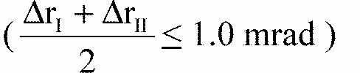
Annex 5
MINIMUM REQUIREMENTS FOR CONFORMITY OF PRODUCTION CONTROL PROCEDURES
1. GENERAL
1.1 The conformity requirements shall be considered satisfied from a mechanical and geometric standpoint, if the differences do not exceed inevitable manufacturing deviations within the requirements of this Regulation.
1.2 With respect to photometric performances, the conformity of mass-produced headlamps shall not be contested if, when testing photometric performances of any headlamp chosen at random and equipped with a standard filament lamp:
1.2.1 no measured value deviates unfavourably by more than 20 % from the values prescribed in this Regulation. For value in zone III, the maximum unfavourable deviation may be respectively:
0.3 lux equivalent 20 %
0.45 lux equivalent 30 %
1.2.2 and if for the driving beam, HV being situated within the isolux 0.75 E_{max},
a tolerance of + 20 % for maximum values and - 20 % for minimum values is observed for the photometric values at any measuring point specified in Annex 3, paragraphs 4.3 and 4.4 of this Regulation.
1.2.3 If the results of the tests described above do not meet the requirements, tests on the headlamp shall be repeated, using another standard filament lamp.
1.3 With respect to the verification of the change in vertical position of the cut-off line under the influence of heat, the following procedure shall be applied:
One of the sampled headlamps shall be tested according to the procedure described in paragraph 2.1 of Annex 4 after being subjected three consecutive times to the cycle described in paragraph 2.2.2 of Annex 4.
The headlamp shall be considered as acceptable if delta r does not exceed 1.5 mrad.
If this value exceeds 1.5 mrad but is not more than 2.0 mrad, a second headlamp shall be subjected to the test, after which the mean of the absolute values recorded on both samples shall not exceed 1.5 mrad.
1.4 The chromaticity coordinates shall be complied with when the headlamp is equipped with a filament lamp set to Standard A colour temperature.
The photometric performance of a headlamp emitting selective yellow light when equipped with a colourless filament lamp shall be the values contained in this Regulation multiplied by 0.84.
2. MINIMUM REQUIREMENTS FOR VERIFICATION OF CONFORMITY BY THE MANUFACTURER
For each type of headlamp the holder of the approval mark shall carry out at least the following tests, at appropriate intervals. The tests shall be carried out in accordance with the provisions of this Regulation.
If any sampling shows non-conformity with regard to the type of test concerned, further samples shall be taken and tested. The manufacturer shall take steps to ensure the conformity of the production concerned.
2.1 Nature of tests
Tests of conformity in this Regulation shall cover the photometric characteristics and the verification of the change in vertical position of the cut-off line under the influence of heat.
2.2 Methods used in tests
2.2.1 Tests shall generally be carried out in accordance with the methods set out in this Regulation.
2.2.2 In any test of conformity carried out by the manufacturer, equivalent methods may be used with the consent of the competent authority responsible for approval tests. The manufacturer is responsible for proving that the applied methods are equivalent to those laid down in this Regulation.
2.2.3 The application of paragraphs 2.2.1 and 2.2.2 requires regular calibration of test apparatus and its correlation with measurements made by a competent authority.
2.2.4 In all cases, the reference methods shall be those of this Regulation, particularly for the purpose of administrative verification and sampling.
2.3 Nature of sampling
Samples of headlamps shall be selected at random from the production of a uniform batch. A uniform batch means a set of headlamps of the same type, defined according to the production methods of the manufacturer.
The assessment shall in general cover series production from individual factories. However, a manufacturer may group together records concerning the same type from several factories, provided these operate under the same quality system and quality management.
2.4 Measured and recorded photometric characteristics
The sampled headlamp shall be subjected to photometric measurements at the points provided for in the Regulation, the reading being limited to points E_{max}, HV1/, in the case of the driving beam, and to points HV, 50 R, 50 L in the case of the passing beam (see figure in Annex 3).
2.5 Criteria governing acceptability
The manufacturer is responsible for carrying out a statistical study of the test results and for defining, in agreement with the competent authority, criteria governing the acceptability of his products, in order to meet the specifications laid down for the verification of conformity of products in paragraph 10.1 of this Regulation.
The criteria governing the acceptability shall be such that, with a confidence level of 95 %, the minimum probability of passing a spot check in
Annex 6
REQUIREMENTS FOR LAMPS INCORPORATING LENSES OF PLASTIC MATERIAL - TESTING OF LENS OR MATERIAL SAMPLES AND OF COMPLETE LAMPS -
1. GENERAL SPECIFICATIONS
1.1
The samples supplied pursuant to paragraph 3.2.4 of this Regulation shall satisfy the specifications indicated in paragraphs 2.1 to 2.5 below.
1.2 The two samples of complete lamps supplied pursuant to paragraph 3.2.3 of this Regulation and incorporating lenses of plastic material shall, with regard to the lens material, satisfy the specifications indicated in paragraph 2.6 below.
1.3 The samples of lenses of plastic material or samples of material shall be subjected, with the reflector to which they are intended to be fitted (where applicable), to approval tests in the chronological order indicated in table A reproduced in appendix 1 to this annex.
1.4 However, if the lamp manufacturer can prove that the product has already passed the tests prescribed in paragraphs 2.1-2.5 below, or the equivalent tests pursuant to another Regulation, those tests need not be repeated; only the tests prescribed in appendix 1, table B, shall be mandatory.
2. TESTS
2.1 Resistance to temperature changes
2.1.1 Tests
Three new samples (lenses) shall be subjected to five cycles of temperature and humidity (RH = relative humidity) change in accordance with the following programme: 3 hours at 40 degrees C +/- 2 degrees C and 85-95 % RH;
1 hour at 23 degrees C +/- 5 degrees C and 60-75 % RH;
15 hours at -30 degrees C +/- 2 degrees C;
1 hour at 23 degrees C +/- 5 degrees C and 60-75 % RH;
3 hours at 80 degrees C +/- 2 degrees C;
1 hour at 23 degrees C +/- 5 degrees C and 60-75 % RH;
Before this test, the samples shall be kept at 23 degrees C +/- 5 degrees C and 60-75 % RH for at least four hours.
Note: The periods of one hour at 23 degrees C +/- 5 degrees C shall include the periods of transition from one temperature to another which are needed in order to avoid thermal shock effects.
2.1.2 Photometric measurements
2.1.2.1 Method
Photometric measurements shall be carried out on the samples before and after the test. These measurements shall be made using a standard lamp, at the following points:
B 50 and 50 V for the passing beam of a passing lamp or a passing/driving lamp; Emax for the driving beam of a driving lamp or a passing/driving lamp.
2.1.2.2 Results
The variation between the photometric values measured on each sample before and after the test shall not exceed 10 % including the tolerances of the photometric procedure.
2.2 Resistance to atmospheric and chemical agents
2.2.1 Resistance to atmospheric agents
Three new samples (lenses or samples of material) shall be exposed to radiation from a source having a spectral energy distribution similar to that of a black body at a temperature between 5,500K and 6,000K. Appropriate filters shall be placed between the source and the samples so as to reduce as far as possible radiations with wave lengths smaller than 295 nm and greater than 2,500 nm. The samples shall be exposed to an energetic illumination of 1,200 W/m² +/- 200 W/m2for a period such that the luminous energy that they receive is equal to 4,500 MJ/m² +/- 200 MJ/m². Within the enclosure, the temperature measured on the black panel placed on a level with the samples shall be 50 degrees C +/- 5 degrees C. In order to ensure a regular exposure, the samples shall revolve around the source of radiation at a speed between 1 and 5 1/min.
The samples shall be sprayed with distilled water of conductivity lower than 1 mS/m at a temperature of 23 degrees C +/- 5 degrees C, in accordance with the following cycle: spraying: 5 minutes;
drying: 25 minutes.
2.2.2 Resistance to chemical agents
After the test described in paragraph 2.2.1 above and the measurement described in paragraph 2.2.3.1 below have been carried out, the outer face of the said three samples shall be treated as described in paragraph 2.2.2.2 with the mixture defined in paragraph 2.2.2.1 below.
2.2.2.1 Test mixture
The test mixture shall be composed of 61.5 % n-heptane, 12.5 % toluene, 7.5 % ethyl tetrachloride, 12.5 % trichlorethylene and 6 % xylene (volume %).
2.2.2.2 Application of the test mixture
Soak a piece of cotton cloth (as per ISO 105) until saturation with the mixture defined in paragraph 2.2.2.1 above and, within 10 seconds, apply it for 10 minutes to the outer face of the sample at a pressure of 50 N/cm², corresponding to an effort of 100 N applied on a test surface of 14 x 14 mm.
During this 10-minute period, the cloth pad shall be soaked again with the mixture so that the composition of the liquid applied is continuously identical with that of the test mixture prescribed.
During the period of application, it is permissible to compensate the pressure applied to the sample in order to prevent it from causing cracks.
2.2.2.3 Cleaning
At the end of the application of the test mixture, the samples shall be dried in the open air and then washed with the solution described in paragraph 2.3 (Resistance to detergents) at 23 degrees C +/- 5 degrees C.
Afterwards the samples shall be carefully rinsed with distilled water containing not more than 0.2 % impurities at 23 degrees C +/- 5 degrees C and then wiped off with a soft cloth.
2.2.3 Results
2.2.3.1 After the test of resistance to atmospheric agents, the outer face of the samples shall be free from cracks, scratches, chipping and deformation, and the mean variation in transmission
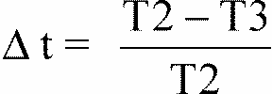
measured on the three samples according to the procedure described in appendix 2 to this annex shall not exceed 0.020 (delta_{tm} < 0.020).
2.2.3.2 After the test of resistance to chemical agents, the samples shall not bear any traces of chemical staining likely to cause a variation of flux diffusion, whose mean variation
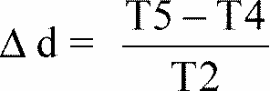
on the three samples according to the according to the procedure described in appendix 2 to this annex shall not exceed 0.020 (delta_{dm} < 0.020).
2.3 Resistance to detergents and hydrocarbons
2.3.1 Resistance to detergents
The outer face of three samples (lenses or samples of material) shall be heated to 50 degrees C +/- 5 degrees C and then immersed for five minutes in a mixture maintained at 23 degrees C +/- 5 degrees C and composed of 99 parts distilled water containing not more than 0.02 % impurities and one part alkylaryl sulphonate.
At the end of the test, the samples shall be dried at 50 degrees C +/- 5 degrees C. The surface of the samples shall be cleaned with a moist cloth.
2.3.2 Resistance to hydrocarbons
The outer face of these three samples shall then be lightly rubbed for one minute with a cotton cloth soaked in a mixture composed of 70 % n-heptane and 30 % toluene (volume %), and shall then be dried in the open air.
2.3.3 Results
After the above two tests have been performed successively, the mean value of the variation in transmission
measured on the three samples according to the according to the procedure described in appendix 2 to this annex shall not exceed 0.020 (delta_{dm} < 0.020).
2.3 Resistance to detergents and hydrocarbons
2.3.1 Resistance to detergents
The outer face of three samples (lenses or samples of material) shall be heated to 50 degrees C +/- 5 degrees C and then immersed for five minutes in a mixture maintained at 23 degrees C +/- 5 degrees C and composed of 99 parts distilled water containing not more than 0.02 % impurities and one part alkylaryl sulphonate.
At the end of the test, the samples shall be dried at 50 degrees C +/- 5 degrees C. The surface of the samples shall be cleaned with a moist cloth.
2.3.2 Resistance to hydrocarbons
The outer face of these three samples shall then be lightly rubbed for one minute with a cotton cloth soaked in a mixture composed of 70 % n-heptane and 30 % toluene (volume %), and shall then be dried in the open air.
2.3.3 Results
After the above two tests have been performed successively, the mean value of the variation in transmission
measured on the three samples according to the according to the procedure described in appendix 2 to this annex shall not exceed 0.010 (delta_{tm} < 0.010).
2.4 Resistance to mechanical deterioration
2.4.1 Mechanical deterioration method
The outer face of the three new samples (lenses) shall be subjected to the uniform mechanical deterioration test by the method described in appendix 3 to this annex.
2.4.2 Results
After this test, the variations: in transmission:
and in diffusion:
shall be measured according to the procedure described in appendix 2 in the area specified in paragraph 3.2.4.1.1 of this Regulation. The mean value of the three samples shall be such that:
delta_{tm} < 0.100;
delta_{dm} < 0.050.
2.5 Test of adherence of coatings, if any
2.5.1 Preparation of the sample
A surface of 20 mm x 20 mm in area of the coating of a lens shall be cut with a razor blade or a needle into a grid of squares approximately 2 mm x 2 mm. The pressure on the blade or needle shall be sufficient to cut at least the coating.
2.5.2 Description of the test
Use an adhesive tape with a force of adhesion of 2 N/(cm of width) +/- 20 % measured under the standardized conditions specified in appendix 4 to this annex. This adhesive tape, which shall be at least 25 mm wide, shall be pressed for at least five minutes to the surface prepared as prescribed in paragraph 2.5.1.
Then the end of the adhesive tape shall be loaded in such a way that the force of adhesion to the surface considered is balanced by a force perpendicular to that surface. At this stage, the tape shall be torn off at a constant speed of 1.5 m/s +/- 0.2 m/s.
2.5.3 Results
There shall be no appreciable impairment of the gridded area. Impairments at the intersections between squares or at the edges of the cuts shall be permitted, provided that the impaired area does not exceed 15 % of the gridded surface.
2.6 Tests of the complete lamp incorporating a lens of plastic material
2.6.1 Resistance to mechanical deterioration of the lens surface
2.6.1.1 Tests
The lens of lamp sample No. 1 shall be subjected to the test described in paragraph 2.4.1 above.
2.6.1.2 Results
After the test, the results of photometric measurements carried out on the lamp in accordance with this Regulation shall not exceed by more than 30 % the maximum values prescribed at point B 50 and not be more than 10 % below the minimum values prescribed at point 50 V.
2.6.2 Test of adherence of coatings, if any
The lens of lamp sample No. 2 shall be subjected to the test described in paragraph 2.5 above.
3. VERIFICATION OF THE CONFORMITY OF PRODUCTION
3.1 With regard to the materials used for the manufacture of lenses, the lamps of a series shall be recognized as complying with this Regulation if:
3.1.1 After the test for resistance to chemical agents and the test for resistance to detergents and hydrocarbons, the outer face of the samples exhibits no cracks, chipping or deformation visible to the naked eye (see paragraphs 2.2.2, 2.3.1 and 2.3.2);
3.1.2 After the test described in paragraph 2.6.1.1, the photometric values at the points of measurement considered in paragraph 2.6.1.2 are within the limits prescribed for conformity of production by this Regulation.
3.2 If the test results fail to satisfy the requirements, the tests shall be repeated on another sample of headlamps selected at random.
Annex 6 - Appendix 1
CHRONOLOGICAL ORDER OF APPROVAL TESTS
A. Tests on plastic materials (lenses or samples of material supplied pursuant to paragraph 3.2.4 of this Regulation).
 | Samples | Lenses or samples of material |  |  |  |  |  |  | Lenses
Tests | Limited photometry (para. 2.1.2) | 1 | 2 | 3 | 4 | 5 | 6 | 7 |  | 8 | 9 | 10 | 11 | 12 | 13
1.1 | Temperature change (para. 2.1.1) |  |  |  |  |  |  |  |  |  |  | x | x | x
1.1.1. | Limited photometry (para. 2.1.2) |  |  |  |  |  |  |  |  |  |  | x | x | x
1.1.2 | Transmission measurement |  |  |  |  |  |  |  |  |  |  | x | x | x
1.2.1 | Diffusion measurement | x | x | x | x | x | x | x |  | x | x
1.2.2 | Atmospheric agents (para. 2.2.1) | x | x | x |  |  |  | x |  | x | x
1.3 | Transmission measurement | x | x | x
1.3.1 | Chemicals agents (para. 2.2.2) | x | x | x
1.4 | Diffusion measurement | x | x | x
1.4.1 | Detergents (para. 2.3.1) |  |  |  | x | x | x
1.5 | Hydrocarbons (para. 2.3.2) |  |  |  | x | x | x
1.6 | Transmission measurement |  |  |  | x | x | x
1.7 | Deterioration (para. 2.4.1) |  |  |  |  |  |  | x |  | x | x
1.7.1 | Transmission measurement |  |  |  |  |  |  | x |  | x | x
1.7.2 | Diffusion measurement |  |  |  |  |  |  | x |  | x | x
1.8 | Adherence (para. 2.5) |  |  |  |  |  |  |  |  |  |  |  |  |  | x
B. Tests on complete lamps (supplied pursuant to paragraph 3.2.3 of this Regulation).
Test |  | Complete Lamp
 |  | Sample No.
 |  | 1 | 2
2.1 | Deterioration (para. 2.6.1.1) | x
2.2 | Photometry (para. 2.6.1.2) | x
2.3 | Adherence (para. 2.6.2) |  | x

Annex 6 - Appendix 2
METHOD OF MEASUREMENT OF THE DIFFUSION AND TRANSMISSION OF LIGHT
1. EQUIPMENT (see figure)
The beam of a collimator K with a half divergence
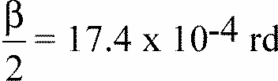
is limited by a diaphragm D_{T} with an opening of 6 mm against which the sample stand is placed.
A convergent achromatic lens L₂, corrected for spherical aberrations, links the diaphragm D_{T} with the receiver R; the diameter of the lens L₂ shall be such that it does not diaphragm the light diffused by the sample in a cone with a half top angle of beta/2 = 14 degrees .
An annular diaphragm D_{D} with angles
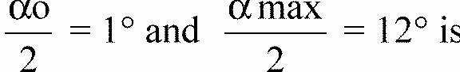
placed in an image focal plane of the lens L₂.
The non-transparent central part of the diaphragm is necessary in order to eliminate the light arriving directly from the light source. It shall be possible to remove the central part of the diaphragm from the light beam in such a manner that it returns exactly to its original position.
The distance L₂ D_{T} and the focal length F₂ 2/ of the lens L₂ shall be so chosen that the image of D_{T} completely covers the receiver R.
When the initial incident flux is referred to 1,000 units, the absolute precision of each reading shall be better than 1 unit.
2. MEASUREMENTS
The following readings shall be taken:
Reading | With sample | With central part of D_{D} | Quantity represented
T₁ | no | no | Incident flux in initial reading
T₂ | yes (before test) | no | Flux transmitted by the new material in a field of 24 degrees C
T₃ | yes (after test) | no | Flux transmitted by the tested material in a field of 24 degrees C
T₄ | yes (before test) | yes | Flux diffused by the new material
T₅ | yes (after test) | yes | Flux diffused by the tested material
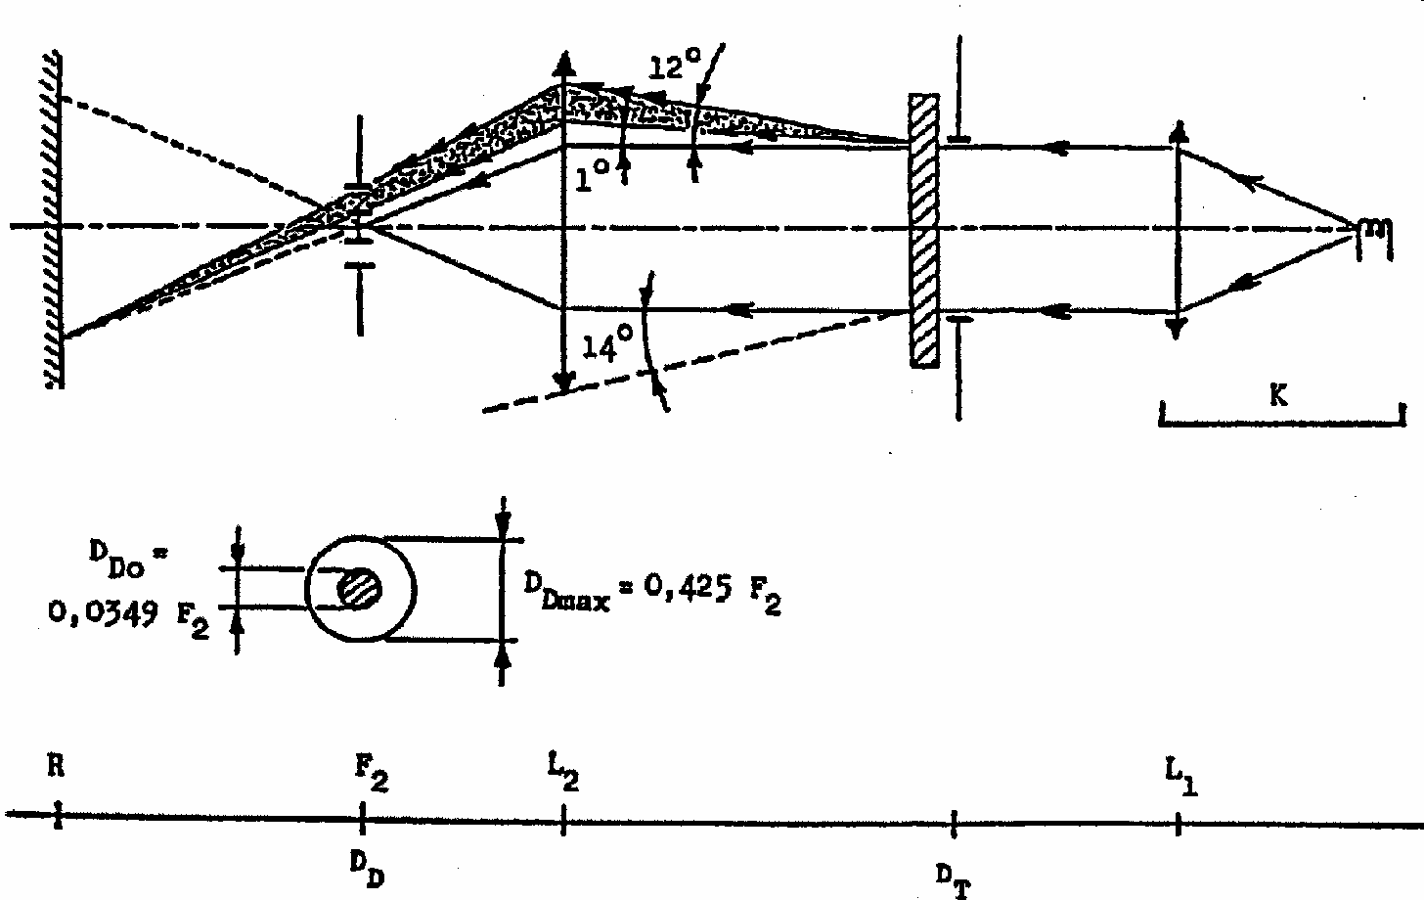

Annex 6 - Appendix 3
SPRAY TESTING METHOD
1. Test equipment
1.1 Spray gun
The spray gun used shall be equipped with a nozzle 1.3 mm in diameter allowing a liquid flow rate of 0.24 +/- 0.02 1/minute at an operating pressure of 6.0 bars - 0, + 0.5 bar. Under these operation conditions the fan pattern obtained shall be 170 mm +/- 50 mm in diameter on the surface exposed to deterioration, at a distance of 380 mm +/- 10 mm from the nozzle.
1.2 Test mixture
The test mixture shall be composed of:
Silica sand of hardness 7 on the Mohr scale, with a grain size between 0 and 0.2 mm and an almost normal distribution, with an angular factor of 1.8 to 2;
Water of hardness not exceeding 205 g/m3for a mixture comprising 25 g of sand per litre of water.
2. Test
The outer surface of the lamp lenses shall be subjected once or more than once to the action of the sand jet produced as described above. The jet shall be sprayed almost perpendicular to the surface to be tested.
The deterioration shall be checked by means of one or more samples of glass placed as a reference near the lenses to be tested. The mixture shall be sprayed until the variation in the diffusion of light on the sample or samples measured by the method described in appendix 2, is such that:
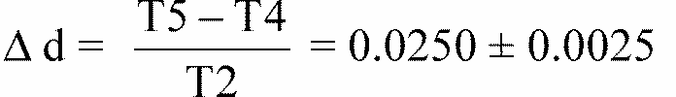
Several reference samples may be used to check that the whole surface to be tested has deteriorated homogeneously.
Annex 6 - Appendix 4
ADHESIVE TAPE ADHERENCE TEST
1. PURPOSE
This method allows to determine under standard conditions the linear force of adhesion of an adhesive tape to a glass plate.
2. PRINCIPLE
Measurement of the force necessary to unstick an adhesive tape from a glass plate at an angle of 90 degrees .
3. SPECIFIED ATMOSPHERIC CONDITIONS
The ambient conditions shall be at 23 degrees C +/- 5 degrees C and 65 +/- 15 % relative humidity (RH).
4. TEST PIECES
Before the test, the sample roll of adhesive tape shall be conditioned for 24 hours in the specified atmosphere (see para. 3 above).
Five test pieces each 400 mm long shall be tested from each roll. These test pieces shall be taken from the roll after the first three turns were discarded.
5. PROCEDURE
The test shall be under the ambient conditions specified in paragraph 3.
Take the five test pieces while unrolling the tape radially at a speed of approximately 300 mm/s, then apply them within 15 seconds in the following manner:
Apply the tape to the glass plate progressively with a slight lengthwise rubbing movement of the finger, without excessive pressure, in such a manner as to leave no air bubble between the tape and the glass plate.
Leave the assembly in the specified atmospheric conditions for 10 minutes.
Unstick about 25 mm of the test piece from the plate in a plane perpendicular to the axis of the test piece.
Fix the plate and fold back the free end of the tape at 90 degrees . Apply force in such a manner that the separation line between the tape and the plate is perpendicular to this force and perpendicular to the plate.
Pull to unstick at a speed of 300 mm/s +/- 30 mm/s and record the force required.
6. RESULTS
The five values obtained shall be arranged in order and the median value taken as the result of the measurement. This value shall be expressed in Newtons per centimetre of width of the tape.
Annex 7
MINIMUM REQUIREMENTS FOR SAMPLING BY AN INSPECTOR
1. GENERAL
1.1 The conformity requirements shall be considered satisfied from a mechanical and a geometric standpoint, in accordance with the requirements of this Regulation, if any, if the differences do not exceed inevitable manufacturing deviations.
1.2 With respect to photometric performance, the conformity of mass produced headlamps shall not be contested if, when testing photometric performances of any headlamp chosen at random and equipped with a standard filament lamp;
1.2.1 no measured value deviates unfavourably by more than 20 % from the values prescribed in this Regulation. For zone III the maximum deviation may be respectively:
0.3 lux equivalent 20 %
0.45 lux equivalent 30 %
1.2.2 and if, for the driving beam, HV being situated within the isolux 0.75 E_{max}, a tolerance of + 20 % for maximum values and - 20 % for minimum values is observed for the photometric values at any measuring point specified in Annex 3, paragraphs 4.3 and 4.4 of this Regulation.
1.2.3 If the results of the tests described above do not meet the requirements, tests on the headlamp shall be repeated using another standard filament lamp.
1.2.4 Headlamps with apparent defects are disregarded.
1.3 The chromaticity coordinates shall be complied with when the headlamp is equipped with a filament lamp set to Standard A colour temperature.
The photometric performance of a headlamp emitting selective yellow light when equipped with a colourless filament lamp shall be multiplied by 0.84.
2 FIRST SAMPLING
In the first sampling four headlamps are selected at random. The first sample of two is marked A, the second sample of two is marked B.
2.1 The conformity is not contested
2.1.1 Following the sampling procedure shown in Figure 1 of this Annex the conformity of mass-produced headlamps shall not be contested if the deviation of the measured values of the headlamps in the unfavourable directions are:
2.1.1.1 sample A
Al: one headlamp............................................................................0 %
one headlamp not more than ..................................................20 %
A2: both headlamps more than.......................................................0 %
but not more than....................................................................20 %
go to sample B
2.1.1.2 sample B
B1: both headlamps.........................................................................0 %
2.2 The conformity is contested
2.2.1 Following the sampling procedure shown in Figure 1 of this Annex the conformity of mass-produced headlamps shall be contested and the manufacturer requested to make his production meet the requirements (alignment) if the deviations of the measured values of the headlamps are:
2.2.1.1 sample A
A3: one headlamp not more than..................................................20 %
one headlamp more than........................................................20 %
but not more than....................................................................30 %
2.2.1.2 sample B
B2: in the case of A2
one headlamp more than.........................................................0 %
but not more than....................................................................20 %
one headlamp not more than..................................................20 %
B3: in the case of A2
one headlamp...........................................................................0 %
one headlamp more than.........................................................20 %
but not more than....................................................................30 %
2.3 Approval withdrawn
Conformity shall be contested and paragraph 11 applied if, following the sampling procedure in Figure 1 of this Annex, the deviations of the measured values of the headlamps are:
2.3.1 sample A
A4: one headlamp not more than ...............................................20 %
one headlamp more than.......................................................30 %
A5: both headlamps more than......................................................20 %
2.3.2 sample B
B4: in the case of A2
one headlamp more than.........................................................0 %
but not more than...................................................................20 %
one headlamp more than.......................................................20 %
B5: in the case of A2
both headlamps more than.....................................................20 %
B6: in the case of A2
one headlamp...........................................................................0 %
one headlamp more than........................................................30 %
3. REPEATED SAMPLING
In the cases of A3, B2, B3 a repeated sampling, third sample C of two headlamps and fourth sample D of two headlamps, selected from stock manufactured after alignment, is necessary within two months time after the notification.
3.1 The conformity is not contested
3.1.1 Following the sampling procedure shown in Figure 1 of this Annex the conformity of mass-produced headlamps shall not be contested if the deviations of the measured values of the headlamps are:
3.1.1.1 sample C
C1: one headlamp...........................................................................0 %
one headlamp not more than..................................................20 %
C2: both headlamps more than.......................................................0 %
but not more than....................................................................20 %
go to sample D
3.1.1.2 sample D
D1: in the case of C2
both headlamps........................................................................0 %
3.2 The conformity is contested
3.2.1 Following the sampling procedure shown in Figure 1 of this Annex the conformity of mass-produced headlamps shall be contested and the manufacturer requested to make his production meet the requirements (alignment) if the deviations of the measured values of the headlamps are:
3.2.1.1 sample D
D2: in the case of C2
one headlamp more than.........................................................0 %
but not more than....................................................................20 %
one headlamp not more than ..................................................20 %
3.3 Approval withdrawn
Conformity shall be contested and paragraph 11 applied if, following the sampling procedure in Figure 1 of this Annex, the deviations of the measured values of the headlamps are:
3.3.1 sample C
C3: one headlamp not more than.................................................20 %
one headlamp more than......................................................20 %
C4: both headlamps more than.....................................................20 %
3.3.2 sample D
D3: in the case of C2
one headlamp 0 or more than...................................................0 %
one headlamp more than........................................................20 %
4. CHANGE OF THE VERTICAL POSITION OF THE CUT-OFF LINE
With respect to the verification of the change in vertical positions of the cut-off line under the influence of heat, the following procedure shall be applied:
One of the headlamps of sample A after sampling procedure in Figure 1 of this Annex shall be tested according to the procedure described in paragraph 2.1 of Annex 4 after being subjected three consecutive times to the cycle described in paragraph 2.2.2 of Annex 4.
The headlamp shall be considered as acceptable if delta does not exceed 1.5 mrad.
If this value exceeds 1.5 mrad but is not more than 2.0 mrad, the second headlamp of sample A shall be subjected to the test after which the mean of the absolute values recorded in both samples shall not exceed 1.5 mrad.
However, if this value of 1.5 mrad on sample A is not complied with, the two headlamps of sample B shall be subjected to the same procedure and the value of delta_{r} for each of them shall not exceed 1.5 mrad.
Figure 1
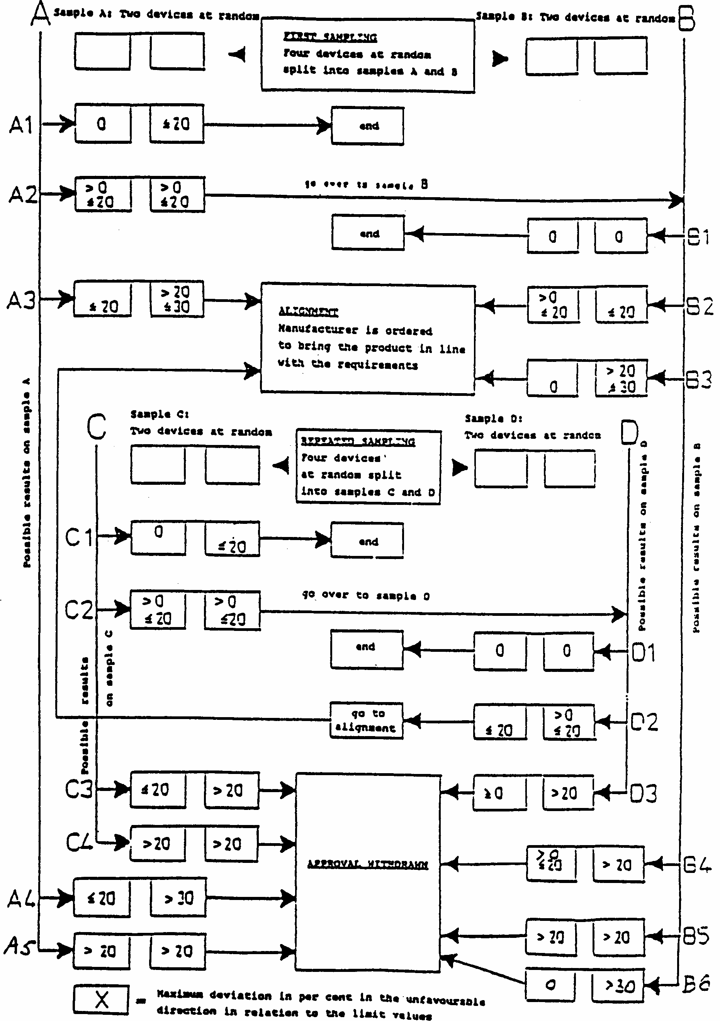

*/ Nothing in this Regulation shall prevent a Party to the Agreement applying this Regulation from prohibiting the combination of a headlamp incorporating a lens of plastic material approved under this Regulation with a mechanical headlamp-cleaning device (with wipers).
1/ Application for approval of a filament lamp, see Regulation No. 37.
2/ If it is intended to manufacture the headlamps with coloured lenses, two samples of coloured lenses shall be submitted in addition for testing of the colour only.
3/ The reflector is being considered as main body. If the lens cannot be detached from the main body of the headlamp, a space on the lens shall be sufficient.
4/ If different types of headlamps have an identical lens or an identical reflector, the lens and the reflector may bear the various approval marks of these types of headlamps, on condition that the approval number granted for the specific type submitted can be identified without ambiguity.
5/ 1 for Germany, 2 for France, 3 for Italy, 4 for the Netherlands, 5 for Sweden, 6 for Belgium, 7 for Hungary, 8 for the Czech Republic, 9 for Spain, 10 for Yugoslavia, 11 for the United Kingdom, 12 for Austria, 13 for Luxembourg, 14 for Switzerland, 15 (vacant), 16 for Norway, 17 for Finland, 18 for Denmark, 19 for Romania, 20 for Poland, 21 for Portugal, 22 for the Russian Federation, 23 for Greece, 24 (vacant), 25 for Croatia, 26 for Slovenia, 27 for Slovakia, 28 for Belarus and 29 Estonia, 30 (vacnat), 31 for Bosnia and Herzegovina, 32-36 (vacnat), 37 for Turkey, 38-39 (vacnat) and 40 for The former Yugoslav Republic of Macedonia. Subsequent numbers shall be assigned to other countries in the chronological order in which they ratify or accede to the Agreement Concerning the Adoption of Uniform Technical Prescriptions for Wheeled Vehicles, Equipment and Parts which can be Fitted and/or be Used on Wheeled Vehicles and the Conditions for Reciprocal Recognition of Approvals Granted on the Basis of these Prescriptions, and the numbers thus assigned shall be communicated by the Secretary-General of the United Nations to the Contracting Parties to the Agreement.
2^{1/} Distinguishing number of the country which has granted/extended/refused/withdrawn approval (see approval provisions in the Regulation). 2/ Strike out what does not apply.
*/ 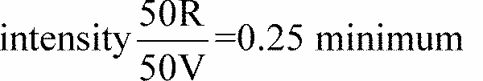
1/ Should two or more lamp filaments be simultaneously lit when headlamp flashing is used, this shall not be considered as being normal use of the filaments simultaneously.
2/ When the tested headlamp is grouped and/or reciprocally incorporated with signalling lamps, the latter shall be lit for the duration of the test.
3/ NaCMC represents the sodium salt of carboxymethylcellulose, customarily referred to as CMC. The NaCMC used in the dirt mixture shall have a degree of substitution (DS) of 0.6-0.7 and a viscosity of 200-300 cP for a 2 % solution at 20 degrees C.
4/ The tolerance on quantity is due to the necessity of obtaining a dirt that correctly spreads out on all the plastic lens.
5/ 50 V is situated 375 mm below HV on the vertical line v-v on the screen at 25 m distance.
1/ When the driving beam is reciprocally incorporated with the passing beam, HV in the case of the driving beam shall be the same measuring point as in the case of the passing beam.
2/ For L2 it is recommended to use a focal distance of about 80 mm.

