Vehicle Standard (Australian Design Rule 52/00 – Rear Fog Lamps) 2006
I, JAMES ERIC LLOYD, Minister for Local Government, Territories and Roads, determine this vehicle standard under subsection 7 (1) of the Motor Vehicle Standards Act 1989.

Dated 5 July 1905

[Signed]

James Eric Lloyd

Minister for Local Government, Territories and Roads

CONTENTS

0. legislative provisions 3
1. SCOPE 3
2. APPLICABILITY AND IMPLEMENTATION 3
3. DEFINITIONS 3
4. REQUIREMENTS 3
5. EXEMPTIONS AND ALTERNATIVE PROCEDURES 4
6. SUPPLEMENTARY GENERAL REQUIREMENTS 4
7. ALTERNATIVE STANDARDS 4
8. NOTES 4
APPENDIX A 5

- legislative provisions
  - NAME OF STANDARD
    - This Standard is the Vehicle Standard (Australian Design Rule 52/00 – Rear Fog Lamps) 2006.
    - This Standard may also be cited as Australian Design Rule 52/00 — Rear Fog Lamps.
  - COMMENCEMENT
    - This Standard commences on the day after it is registered.
  - REPEAL
    - This Standard repeals each vehicle standard with the name Australian Design Rule 52/00 — Rear Fog Lamps that is:
(a) made under section 7 of the Motor Vehicle Standards Act 1989; and
(b) in force at the commencement of this Standard.
    - This Standard also repeals each instrument made under section 7 of the Motor Vehicle Standards Act 1989 that creates a vehicle standard with the name Australian Design Rule 52/00 — Rear Fog Lamps, if there are no other vehicle standards created by that instrument, or amendments to vehicle standards made by that instrument, that are still in force at the commencement of this Standard.
- SCOPE
This Australian Design Rule (ADR) prescribes the photometric requirements for rear fog lamps which are used to make the vehicle more easily visible from the rear by emitting a red signal of greater intensity than the rear position (side) lamps.
- APPLICABILITY AND IMPLEMENTATION
  - The circumstances under which rear fog lamps are mandatory, optional, or prohibited are set out in either ADRs 13/…, 19/… or 67/….
- DEFINITIONS
  - Refer to paragraph 1 of Appendix A.
- REQUIREMENTS
  - Devices complying with the technical requirements of Appendix A as varied by part 5 Exemptions and Alternative Procedures and part 6 Supplementary General Requirements shall be accepted as complying with this rule.
- EXEMPTIONS AND ALTERNATIVE PROCEDURES
  - The following provisions of appendix A do not apply to this rule
    - Section 2 Application for approval
Section 3 Markings
Section 4 Approval
Section 10 Conformity of production
Section 11 Penalties for non conformity of production
Section 12 Production definitely discontinued
Section 13 Names and addresses of technical services responsible for conducting approval tests, and of administrative departments
Annexes
Annex 1 Communication concerning the approval (or refusal or withdrawal of approval or production definitely discontinued) of a type of illuminating device for rear registration plates pursuant to Regulation No. 38
Annex 2 Arrangements of approval marks
    - Paragraphs 2.3 and 3.3 in Annex 5.
- SUPPLEMENTARY GENERAL REQUIREMENTS
The following general requirements are supplementary to the requirements of Appendix A:
  - The requirements and procedures set out in Annexes 4 and 5 of Appendix A are acceptable for the purposes of demonstrating compliance with the technical requirements this rule.
- ALTERNATIVE STANDARDS
  - The technical requirements of any of the editions of United Nations –Economic Commission for Europe (UN ECE) Regulation No. 38 - UNIFORM PROVISIONS CONCERNING THE APPROVAL OF REAR FOG LAMPS FOR POWER DRIVEN VEHICLES AND THEIR TRAILERS, incorporating the 00 series of amendments are deemed to be equivalent to the technical requirements of this rule.
- NOTES
  - In place of Regulation No. 48 where referenced in Appendix A, read ADR 13/00
  - In place of Regulation No. 37 where referenced in Appendix A, read ADR 51/00.
APPENDIX A

UN-ECE REGULATION NO. 38/00
UNIFORM PROVISIONS CONCERNING THE APPROVAL OF FILAMENT LAMPS FOR USE IN APPROVED LAMP UNITS OF POWER DRIVEN VEHICLES AND THEIR TRAILERS
UNIFORM PROVISIONS CONCERNING THE APPROVAL OF REAR FOG LAMPS FOR POWER-DRIVEN VEHICLES AND THEIR TRAILERS
CONTENTS
REGULATION
1. Definitions
2. Application for approval
3. Markings
4. Approval
5. General specifications
6. Intensity of light emitted
7. Test procedure
8. Heat resistance test
9. Colour of light emitted
10. Conformity of production
11. Penalties for non-conformity of production
12. Production discontinued.
13. Names and addresses of technical services responsible for conducting approval tests, and of administrative departments.
ANNEXES
Annex 1 - Communication concerning the approval or extension or refusal or withdrawal of approval or production definitely discontinued of a type of rear fog lamps for power-driven vehicles and their trailers pursuant to Regulation No. 38
Annex 2 - Arrangement of the approval marks
Annex 3 - Photometric measurements
Annex 4 - Minimum requirements for conformity of production control procedures Annex 5 -Minimum requirements for sampling by an inspector

Regulation No. 38
UNIFORM PROVISIONS CONCERNING THE APPROVAL OF REAR FOG LAMPS FOR POWER-DRIVEN VEHICLES AND THEIR TRAILERS
1. DEFINITIONS
For the purpose of this Regulation,
1.1. "rear fog lamp" means a lamp used to make the vehicle more easily visible from the rear by giving a red signal of greater intensity than the rear position (side) lamps;
1.2. The definitions given in Regulation No.48 and its series of amendments in force at the time of application for type approval shall apply to this Regulation.
1.3. rear fog lamps of different "types" are rear fog lamps which differ in such essential respects as:
1.3.1. the trade name or mark;
1.3.2. the characteristics of the optical system;
1.3.3. the category of lamp.
2. APPLICATION FOR APPROVAL
2.1. The application for approval shall be submitted by the holder of the trade name or mark or by his duly accredited representative.
2.2. For each type of rear fog lamp, the application shall be accompanied by:
2.2.1. drawings (three copies) in sufficient detail to permit identification of the type of the rear fog lamp and showing geometrically the position in which the rear fog lamp is to be fitted to the vehicle; the axis of observation to be taken as the axis of reference in the tests (horizontal angle H = 0 degrees , vertical angle V = 0 degrees ); and the point to be taken as the centre of reference in the said tests;
2.2.2. A brief technical description stating, in particular, with the exception of lamps with non- replaceable lamp sources, the category or categories of filament lamps prescribed; this filament lamp category shall be one of those contained in Regulation No. 37.
2.2.3. two samples; if the rear fog lamp cannot be mounted indiscriminately on either side of the vehicle, the two samples submitted may be identical and may be suitable for mounting only on the right or only on the left side of the vehicle.
3. MARKINGS
The samples of a type of rear fog lamp submitted for approval shall:
3.1. bear the trade name or mark of the applicant; this marking must be clearly legible and be indelible;
3.2. bear a clearly legible and indelible marking showing the category of the filament lamp or lamps prescribed; this is not valid for rear fog lamps with non-replaceable light- sources.
3.3. provide adequate space for the approval mark and for the additional symbols prescribed in paragraph 4.3. below; the said space shall be shown in the drawings referred to in paragraph 2.2.1. above.
3.4. in the case of rear fog lamps with non-replaceable light sources bear the marking of rated voltage and rated wattage.
4. APPROVAL
4.1. If the two samples of a type of rear fog lamp meet the requirements of this Regulation, approval shall be granted.
4.2. An approval number shall be assigned to each type approved; the number so assigned may not subsequently be assigned by the same Contracting Party to another type of rear fog lamp covered by this Regulation. The first two digits of the approval number shall indicate the most recent series of amendments incorporated in the Regulation at the time of issue of the approval. Notice of approval or of refusal of approval of a type of rear fog lamp shall be communicated to the Parties to the Agreement which apply this Regulation by means of a form conforming to the model in annex 1 to this Regulation and of an attached drawing, supplied by the applicant for approval, in a format not exceeding A 4 (210 x 297 mm) and, if possible, on a scale of 1:1.
4.3. Every rear fog lamp conforming to a type approved under this Regulation shall bear in the space referred to in paragraph 3.3. above, in addition to the mark and the particulars prescribed in paragraphs 3.1 and 3.2. above:
4.3.1. an international approval mark consisting of:
4.3.1.1. a circle surrounding the letter "E" followed by the distinguishing number of the country which has granted the approval; 1/
4.3.1.2. an approval number;
4.3.2. the additional symbol "F".
4.3.3. the first two digits of the approval number which indicate the most recent series of amendments to this Regulation may be placed in the vicinity of the additional symbol "F".
4.4. The mark and the symbol referred to in paragraphs 4.3.1. and 4.3.2. shall be indelible and shall be clearly legible even when the rear fog lamp is fitted to the vehicle.
4.5. When two or more lamps are part of the same unit of grouped, combined or reciprocally incorporated lamps, approval is granted only if each of these lamps satisfies the requirements of this Regulation or of another Regulation. Lamps not satisfying any one of those Regulations shall not be part of such a unit of grouped, combined or reciprocally incorporated lamps.
4.5.1. Where grouped, combined or reciprocally incorporated lamps comply with the requirements of several Regulations, a single international approval mark may be applied, consisting of a circle surrounding the letter "E" followed by the distinguishing number of the country which has granted the approval, an approval number and, if necessary, the required arrow. This approval mark may be placed anywhere on the grouped, combined or reciprocally incorporated lamps provided that:
4.5.1.1. it is visible after their installation;
4.5.1.2. no part of the grouped combined or reciprocally incorporated lamps that transmits light can be removed without at the same time removing the approval mark.
4.5.2. The identification symbol for each lamp appropriate to each Regulation under which approval has been granted, together with the corresponding series of amendments incorporating the most recent major technical amendments to the Regulation at the time of issue of the approval, shall be marked:
4.5.2.1. either on the appropriate lamp-emitting surface;
4.5.2.2. or in a group, in such a way that each lamp of the grouped, combined or reciprocally incorporated lamps may be clearly identified (see three possible examples in annex 2).
4.5.3. The size of the components of a single approval mark shall not be less than the minimum size required for the smallest of the individual marks by a Regulation under which approval has been granted.
4.5.4. An approval number shall be assigned to each type approved. The same Contracting Party may not assign the same number to another type of grouped, combined or reciprocally incorporated lamps covered by this Regulation.
4.6. Annex 2 gives examples of arrangements of approval marks for a single lamp (figure 1) and for grouped, combined or reciprocally incorporated lamps (figure 2) with all the additional symbols referred to above.
5. GENERAL SPECIFICATIONS
5.1. Each sample shall conform to the specifications set forth in the paragraphs below.
5.2. Rear fog lamps shall be so designed and constructed that in normal use, despite the vibration to which they may then be subjected, they continue to function satisfactorily and retain the characteristics prescribed by this Regulation.
6. INTENSITY OF LIGHT EMITTED
6.1. The intensity of the light emitted by each of the two samples shall be not less than the minima and not greater than the maxima specified below and shall be measured in relation to the axis of reference in the directions shown below (expressed in degrees of angle with the axis of reference).
6.2. The intensity along the H and V axes, between 10 degrees to the left and 10 degrees to the right and between 5 degrees up and 5 degrees down, shall not be less than 150 cd.
6.3. The intensity of the light emitted in all directions in which the light(s) can be observed shall not exceed 300 cd per light.
6.4. In the case of a single light containing more than one light source, the lamp shall comply with the minimum intensity required when any one light source has failed and when all light sources are illuminated the maximum intensities shall not be exceeded.
6.5. The apparent surface in the direction of the reference axis shall not exceed 140 cm2.
6.6. Annex 3 gives particulars of the measurement method to be used in case of doubt.
7. TEST PROCEDURE
All measurements shall be carried out with uncoloured standard lamps of the types prescribed for the device, adjusted to produce the normal luminous flux prescribed for those types of lamps.
7.1. All measurements on lamps equipped with non-replaceable light sources (filament lamps and other) shall be made at 6.75 V, 13.5 V or 28.0 V respectively.
In the case of light sources supplied by a special power supply, the above test voltages shall be applied to the input terminals of that power supply. The test laboratory may require from the manufacturer the special power supply needed to supply the light sources.
8. HEAT RESISTANCE TEST
8.1. The lamp must be subjected to a one-hour test of continuous operation following a warm-up period of 20 minutes. The ambient temperature shall be 23 degrees +/- 5 degrees . The lamp used shall be a lamp of the category prescribed for the lamp, and shall be supplied with a current at a voltage such that it gives the specified average power at the corresponding test voltage.
8.2. Where only the maximum power is specified, the test shall be carried out by regulating the voltage to obtain a power equal to 90 % of the specified power. The specified average or maximum power referred to above shall in all cases be chosen from the voltage range of 6, 12 or 24 V at which it reaches the highest value.
8.3. After the lamp has been stabilized at the ambient temperature, no distortion, deformation, cracking or colour modification shall be perceptible.
9. COLOUR OF LIGHT EMITTED
The colour of the light emitted, which shall be measured by using a source of light at a colour temperature of 2854 degrees K,*/ must lie within the limits of the following trichromatic co-ordinates:
limit towards yellow:y < 0.335
limit towards purple:z < 0.008
However, for lamps equipped with non-replaceable light sources (filament lamps and other), the colorimetric characteristics should be verified with the light sources present in the lamp, in accordance with paragraph 7.1. of this Regulation.
10. CONFORMITY OF PRODUCTION
The conformity of production procedures shall comply with those set out in the Appendix 2 of the Agreement (E/ECE/324-E/ECE/TRANS/505/Rev. 2) with the following requirements:
10.1. Lamps approved under this Regulation shall be so manufactured as to conform to the type approved by meeting the requirements set forth in paragraphs 6. and 9. above.
10.2. The minimum requirements for conformity of production control procedures set forth in annex 4 to this Regulation shall be complied with.
10.3. The minimum requirements for sampling by an inspector set forth in annex 5 to this Regulation shall be complied with.
10.4. The authority which has granted type approval may at any time verify the conformity control methods applied in each production facility. The normal frequency of these verifications shall be once every two years.
11. PENALTIES FOR NON-CONFORMITY OF PRODUCTION
11.1. The approval granted for a type of rear fog lamp may be withdrawn if the foregoing requirements are not complied with or if a rear fog lamp bearing the mark referred to in paragraphs 4.3.1. and 4.3.2. does not conform to the type approved.
11.2. If a Contracting Party to the Agreement which applies this Regulation withdraws an approval it has previously granted, it shall forthwith notify the other Contracting Parties which apply this Regulation by means of a communication form conforming to the model in annex 1 to this Regulation.
12. PRODUCTION DEFINITELY DISCONTINUED
If the holder of the approval completely ceases to manufacture a type of rear fog lamp approved under this Regulation, he shall inform thereof the authority which granted the approval. Upon receiving the relevant communication, that authority shall inform the other Parties to the Agreement which apply this Regulation thereof, by means of a communication form conforming to the model in annex 1 to this Regulation.
13. NAMES AND ADDRESSES OF TECHNICAL SERVICES CONDUCTING APPROVAL TESTS, AND OF ADMINISTRATIVE DEPARTMENTS
The Contracting Parties to the Agreement which apply this Regulation shall communicate to the Secretariat of the United Nations the names and addresses of the technical services conducting approval tests and of the administrative departments which grant approval and to which forms certifying approval and refusal or withdrawal of approval, issued in other countries, are to be sent.
Annex 1
COMMUNICATION
(maximum format: A4 (210 x 297 mm))
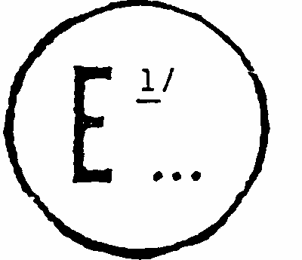
issued by:Name of administration:
.......................................
.......................................
.......................................

Concerning 2/ APPROVAL GRANTED
APPROVAL EXTENDED
APPROVAL REFUSED
APPROVAL WITHDRAWN
PRODUCTION DEFINITELY DISCONTINUED
of a type of rear fog lamp for power-driven vehicles and their trailers pursuant to Regulation No. 38
Approval No:.................................... Extension No.:...............................................
1. Trade name or mark of the device...........................................................................
2. Manufacturer's name for the type of device.............................................................
3. Manufacturer's name and address............................................................................
4. If applicable, name and address of the manufacturer's representative.....................
5. Submitted for approval on:.......................................................................................
6. Technical service responsible for conducting approval tests...................................
7. Date of reports issued by that service......................................................................
8. Number of reports issued by that service.................................................................
9. Concise description: 3/ .............................................................................................
Number and type(s) of lamp(s):...............................................................................
10. Position of the approval mark:..................................................................................
11. Reason(s) for extension (if applicable):...................................................................
12. Approval granted/extended/refused/withdrawn: 2/ .................................................
13. Place.........................................................................................................................
14. Date..........................................................................................................................
15. Signature...................................................................................................................
16. The list of documents deposited with the Administrative Service which has granted approval is annexed to this communication and may be obtained on request.................................................................
Annex 2
ARRANGEMENT OF APPROVAL MARKS
Figure 1 (Marking for single lamps)
Model A
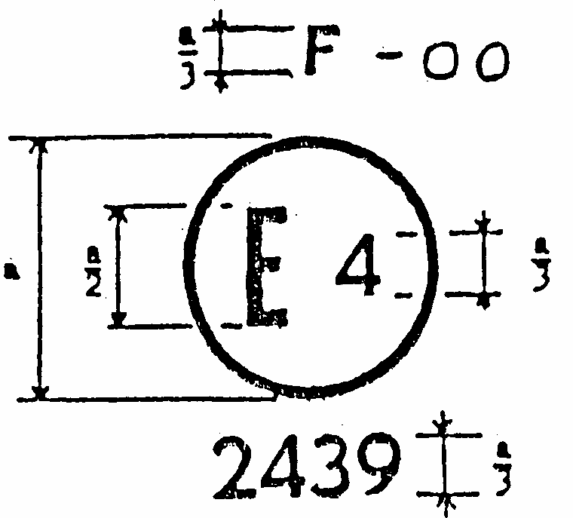
a = 5 mm min.
The device bearing the approval mark shown above is a rear fog lamp approved in the Netherlands (E4) pursuant to Regulation No. 38 under approval number 2439. The approval number indicates that the approval was granted in accordance with the requirements of Regulation No. 38 in its original version.
Figure 2
(Simplified marking for grouped, combined or reciprocally incorporated lamps.)
(The vertical an horizontal lines schematize the shape of the light-signalling device. These are not part of the approval mark.)
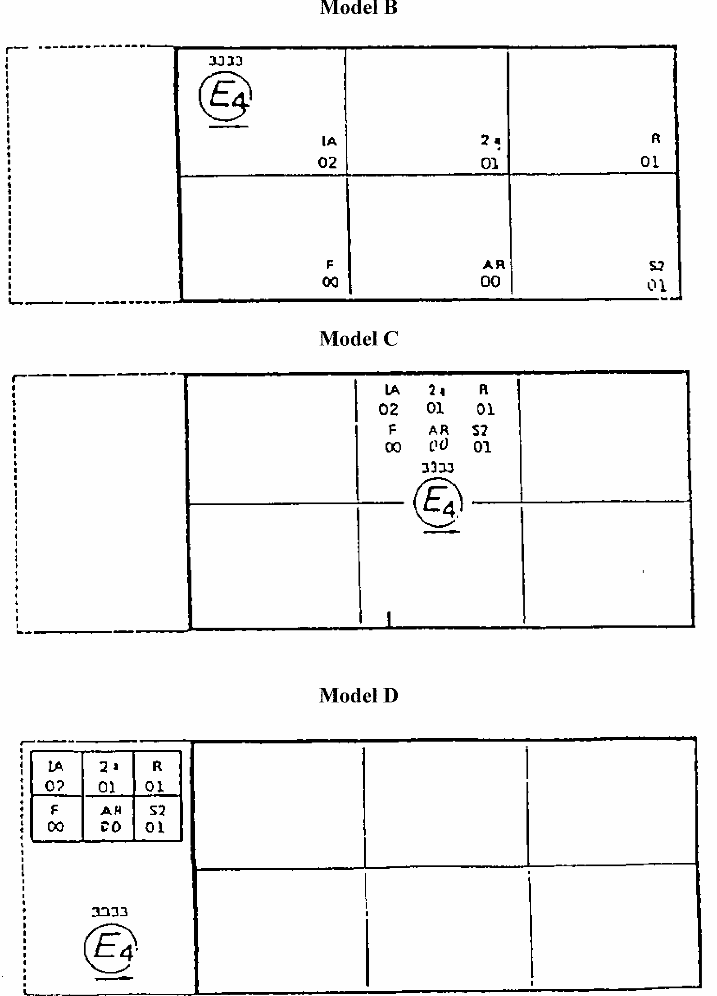
Note: The three examples of approval marks, models, B, C and D represent three possible variants of the marking of a lighting device when two or more lamps are part of the same unit of grouped, combined or reciprocally incorporated lamps. This approval mark shows that the device was approved in the Netherlands (E 4) under approval number 3333 and comprising:
A retro reflector of class IA approved in accordance with the 02 series of amendments to Regulation No. 3; A rear direction indicator of category 2a approved in accordance with the 01 series of amendments to Regulation No. 6;
A red rear position lamp (R) approved in accordance with the 01 series of amendments to Regulation No. 7; A rear fog lamp (F) approved in accordance with Regulation No. 38 in its original form;
A reversing lamp (AR) approved in accordance with Regulation No. 23 in its original form;
A stop lamp with two levels of illumination (S2) approved in accordance with the 01 series of amendments to Regulation No. 7.
Annex 3
PHOTOMETRIC MEASUREMENTS
1. When photometric measurements are taken, stray reflexions shall be avoided by appropriate masking.
2. In the event that the results of measurements are challenged, measurements shall be taken in such a way as to meet the following requirements:
2.1. the distance of measurement shall be such that the law of the inverse of the square of the distance is applicable;
2.2. the measuring equipment shall be such that the angle subtended by the receiver from the reference centre of the light is between 10' and 1 degrees ;
2.3. the intensity requirement for a particular direction of observation shall be satisfied if the required intensity is obtained in a direction deviating by not more than one-quarter of a degree from the direction of observation.
3. If visual examination of a light appears to reveal substantial local variations of intensity, a check shall be made to ensure that, outside the axes, no intensity measured within the rhombus defined by the extreme directions of measurement is below 75 cd (see diagram below).
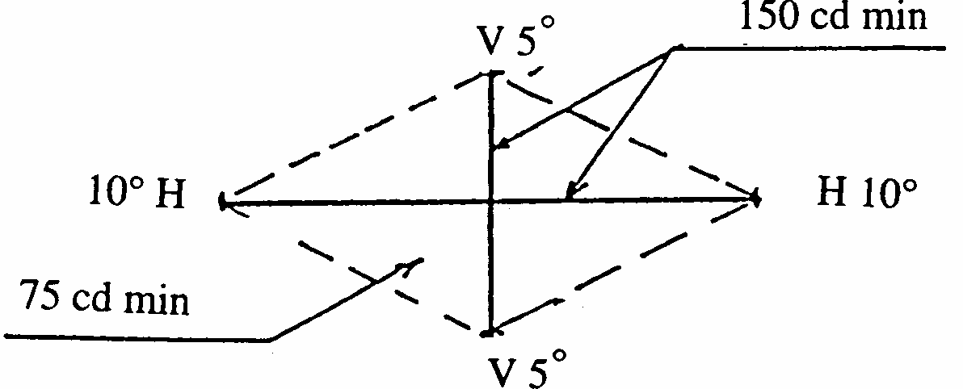
4. Photometric measurement of lamps equipped with several light sources The photometric performance shall be checked:
4.1. For non-replaceable light sources (filament lamps and other):
with the light sources present in the lamp, in accordance with paragraph 7.1. of this Regulation.
4.2. For replaceable filament lamps:
when equipped with mass production filament lamps at 6.75 V, 13.5 V or 28.0 V the luminous intensity values produced shall lie between the maximum limit given in this Regulation and the minimum limit of this Regulation increased according to the permissible deviation of the luminous flux permitted for the type of filament lamp chosen, as stated in Regulation No. 37 for production filament lamps; alternatively, a standard filament lamp may be used in turn, in each of the individual positions, operated at its reference flux, the individual measurements in each position being added together.
Annex 4
MINIMUM REQUIREMENTS FOR CONFORMITY OF PRODUCTION CONTROL PROCEDURES
1. GENERAL
1.1 The conformity requirements shall be considered satisfied from a mechanical and geometric standpoint, if the differences do not exceed inevitable manufacturing deviations within the requirements of this Regulation.
1.2. With respect to photometric performances, the conformity of mass-produced lamps shall not be contested if, when testing photometric performances of any lamp chosen at random and equipped with a standard filament lamp, or when the lamps are equipped with non-replaceable light sources (filament lamps or other), and when all measurements are made at 6.75 V, 13.5 V or 28.0 V respectively:
1.2.1. No measured value deviates unfavourably by more than 20% from the values prescribed in this Regulation.
1.2.2. If, in the case of a lamp equipped with a replaceable light source and if results of the test described above do not meet the requirements, tests on lamps shall be repeated using another standard filament lamp.
1.3. The chromaticity coordinates shall be complied with when the lamp is equipped with a standard filament lamp, or for lamps equipped with non-replaceable light sources (filament lamps or other), when the colorimetric characteristics are verified with the light source present in the lamp.
2. MINIMUM REQUIREMENTS FOR VERIFICATION OF CONFORMITY BY THE MANUFACTURER
For each type of lamp the holder of the approval mark shall carry out at least the following tests, at appropriate intervals. The tests shall be carried out in accordance with the provisions of this Regulation.
If any sampling shows non-conformity with regard to the type of test concerned, further samples shall be taken and tested. The manufacturer shall take steps to ensure the conformity of the production concerned.
2.1. Nature of tests
Tests of conformity in this Regulation shall cover the photometric and colorimetric characteristics.
2.2. Methods used in tests
2.2.1. Tests shall generally be carried out in accordance with the methods set out in this Regulation.
2.2.2. In any test of conformity carried out by the manufacturer, equivalent methods may be used with the consent of the competent authority responsible for approval tests. The manufacturer is responsible for proving that the applied methods are equivalent to those laid down in this Regulation.
2.2.3. The application of paragraphs 2.2.1. and 2.2.2. requires regular calibration of test apparatus and its correlation with measurements made by a competent authority.
2.2.4. In all cases the reference methods shall be those of this Regulation, particularly for the purpose of administrative verification and sampling.
2.3. Nature of sampling
Samples of lamps shall be selected at random from the production of a uniform batch. A uniform batch means a set of lamps of the same type, defined according to the production methods of the manufacturer.
The assessment shall in general cover series production from individual factories. However, a manufacturer may group together records concerning the same type from several factories, provided these operate under the same quality system and quality management.
2.4. Measured and recorded photometric characteristics
The sampled lamp shall be subjected to photometric measurements for the minimum values at the points listed in annex 3 and for the chromaticity coordinates provided for in paragraph 9. of the Regulation.
2.5. Criteria governing acceptability
The manufacturer is responsible for carrying out a statistical study of the test results and for defining, in agreement with the competent authority, criteria governing the acceptability of his products in order to meet the specifications laid down for verification of conformity of products in paragraph 10.1. of this Regulation.
The criteria governing the acceptability shall be such that, with a confidence level of 95%, the minimum probability of passing a spot check in accordance with annex 5 (first sampling) would be 0.95.
Annex 5
MINIMUM REQUIREMENTS FOR SAMPLING BY AN INSPECTOR
1. GENERAL
1.1. The conformity requirements shall be considered satisfied from a mechanical and a geometric standpoint, in accordance with the requirements of this Regulation, if any, if the differences do not exceed inevitable manufacturing deviations.
1.2. With respect to photometric performance, the conformity of mass-produced lamps shall not be contested if, when testing photometric performances of any lamp chosen at random and equipped with a standard filament lamp, or when the lamps are equipped with non-replaceable light sources (filament lamps or other), and when all measurements are made at 6.75 V, 13.5 V or 28.0 V respectively:
1.2.1. No measured value deviates unfavourably by more than 20% from the values prescribed in this Regulation.
1.2.2. If, in the case of a lamp equipped with a replaceable light source and if results of the test described above do not meet the requirements, tests on lamps shall be repeated using another standard filament lamp.
1.2.3. Lamps with apparent defects are disregarded.
1.3. The chromaticity coordinates shall be complied with when the lamp is equipped with a standard filament lamp, or for lamps equipped with non-replaceable light sources (filament lamps or other), when the colorimetric characteristics are verified with the light source present in the lamp.
2. FIRST SAMPLING
In the first sampling four lamps are selected at random. The first sample of two is marked A, the second sample of two is marked B.
2.1. The conformity is not contested
2.1.1. Following the sampling procedure shown in Figure 1 of this annex the conformity of mass-produced lamps shall not be contested if the deviation of the measured values of the lamps in the unfavourable directions are:
2.1.1.1. sample A
A1: one lamp...................................................................................0%
one lamp not more than...........................................................20%
A2: both lamps more than...............................................................0%
but not more than.....................................................................20%
go to sample B
2.1.1.2. sample B
B1: both lamps.................................................................................0%
2.1.2. or, if the conditions of paragraph 1.2.2. for sample A are fulfilled.
2.2. The conformity is contested
2.2.1. Following the sampling procedure shown in Figure 1 of this annex the conformity of mass-produced lamps shall be contested and the manufacturer requested to make his production meet the requirements (alignment) if the deviations of the measured values of the lamps are:
2.2.1.1. sample A
A3: one lamp not more than...........................................................20%
one lamp more than................................................................20%
but not more than....................................................................30%
2.2.1.2. sample B
B2: in the case of A2
one lamp more than...................................................................0%
but not more than.....................................................................20%
one lamp not more than........... ...............................................20%
B3: in the case of A2
one lamp...................................................................................0%
one lamp more than.................................................................20%
but not more than....................................................................30%
2.2.2. or, if the conditions of paragraph 1.2.2. for sample A are not fulfilled.
2.3. Approval withdrawn
Conformity shall be contested and paragraph 11. applied if, following the sampling procedure in Figure 1 of this annex, the deviations of the measured values of the lamps are:
2.3.1. sample A
A4: one lamp not more than...........................................................20%
one lamp more than................................................................30%
A5: both lamps more than..............................................................20%
2.3.2. sample B
B4: in the case of A2
one lamp more than..................................................................0%
but not more than.....................................................................20%
one lamp more than.................................................................20%
B5: in the case of A2
both lamps more than..............................................................20%
B6: in the case of A2
one lamp...................................................................................0%
one lamp more than................................................................30%
2.3.3. or, if the conditions of paragraph 1.2.2. for samples A and B are not fulfilled.
3. REPEATED SAMPLING
In the cases of A3, B2, B3 a repeated sampling, third sample C of two lamps and fourth sample D of two lamps, selected from stock manufactured after alignment, is necessary within two months' time after the notification.
3.1. The conformity is not contested
3.1.1. Following the sampling procedure shown in Figure 1 of this annex the conformity of mass-produced lamps shall not be contested if the deviations of the measured values of the lamps are:
3.1.1.1. sample C
C1: one lamp ...................................................................................0%
one lamp not more than...........................................................20%
C2: both lamps more than ...............................................................0%
but not more than.....................................................................20%
go to sample D
3.1.1.2. sample D
D1: in the case of C2
both lamps................................................................................0%
3.1.2. or, if the conditions of paragraph 1.2.2. for sample C are fulfilled.
3.2. The conformity is contested
3.2.1. Following the sampling procedure shown in Figure 1 of this annex the conformity of mass-produced lamps shall be contested and the manufacturer requested to make his production meet the requirements (alignment) if the deviations of the measured values of the lamps are:
3.2.1.1. sample D
D2: in the case of C2
one lamp more than...................................................................0%
but not more than....................................................................20%
one lamp not more than...........................................................20%
3.2.1.2. or, if the conditions of paragraph 1.2.2. for sample C are not fulfilled.
3.3. Approval withdrawn
Conformity shall be contested and paragraph 11. applied if, following the sampling procedure in Figure 1 of this annex, the deviations of the measured values of the lamps are:
3.3.1. sample C
C3: one lamp not more than...........................................................20%
one lamp more than.................................................................20%
C4: both lamps more than ............................................................20%
3.3.2. sample D
D3: in the case of C2
one lamp 0 or more than...........................................................0%
one lamp more than.................................................................20%
3.3.3. or, if the conditions of paragraph 1.2.2. for samples C and D are not fulfilled.
Figure 1
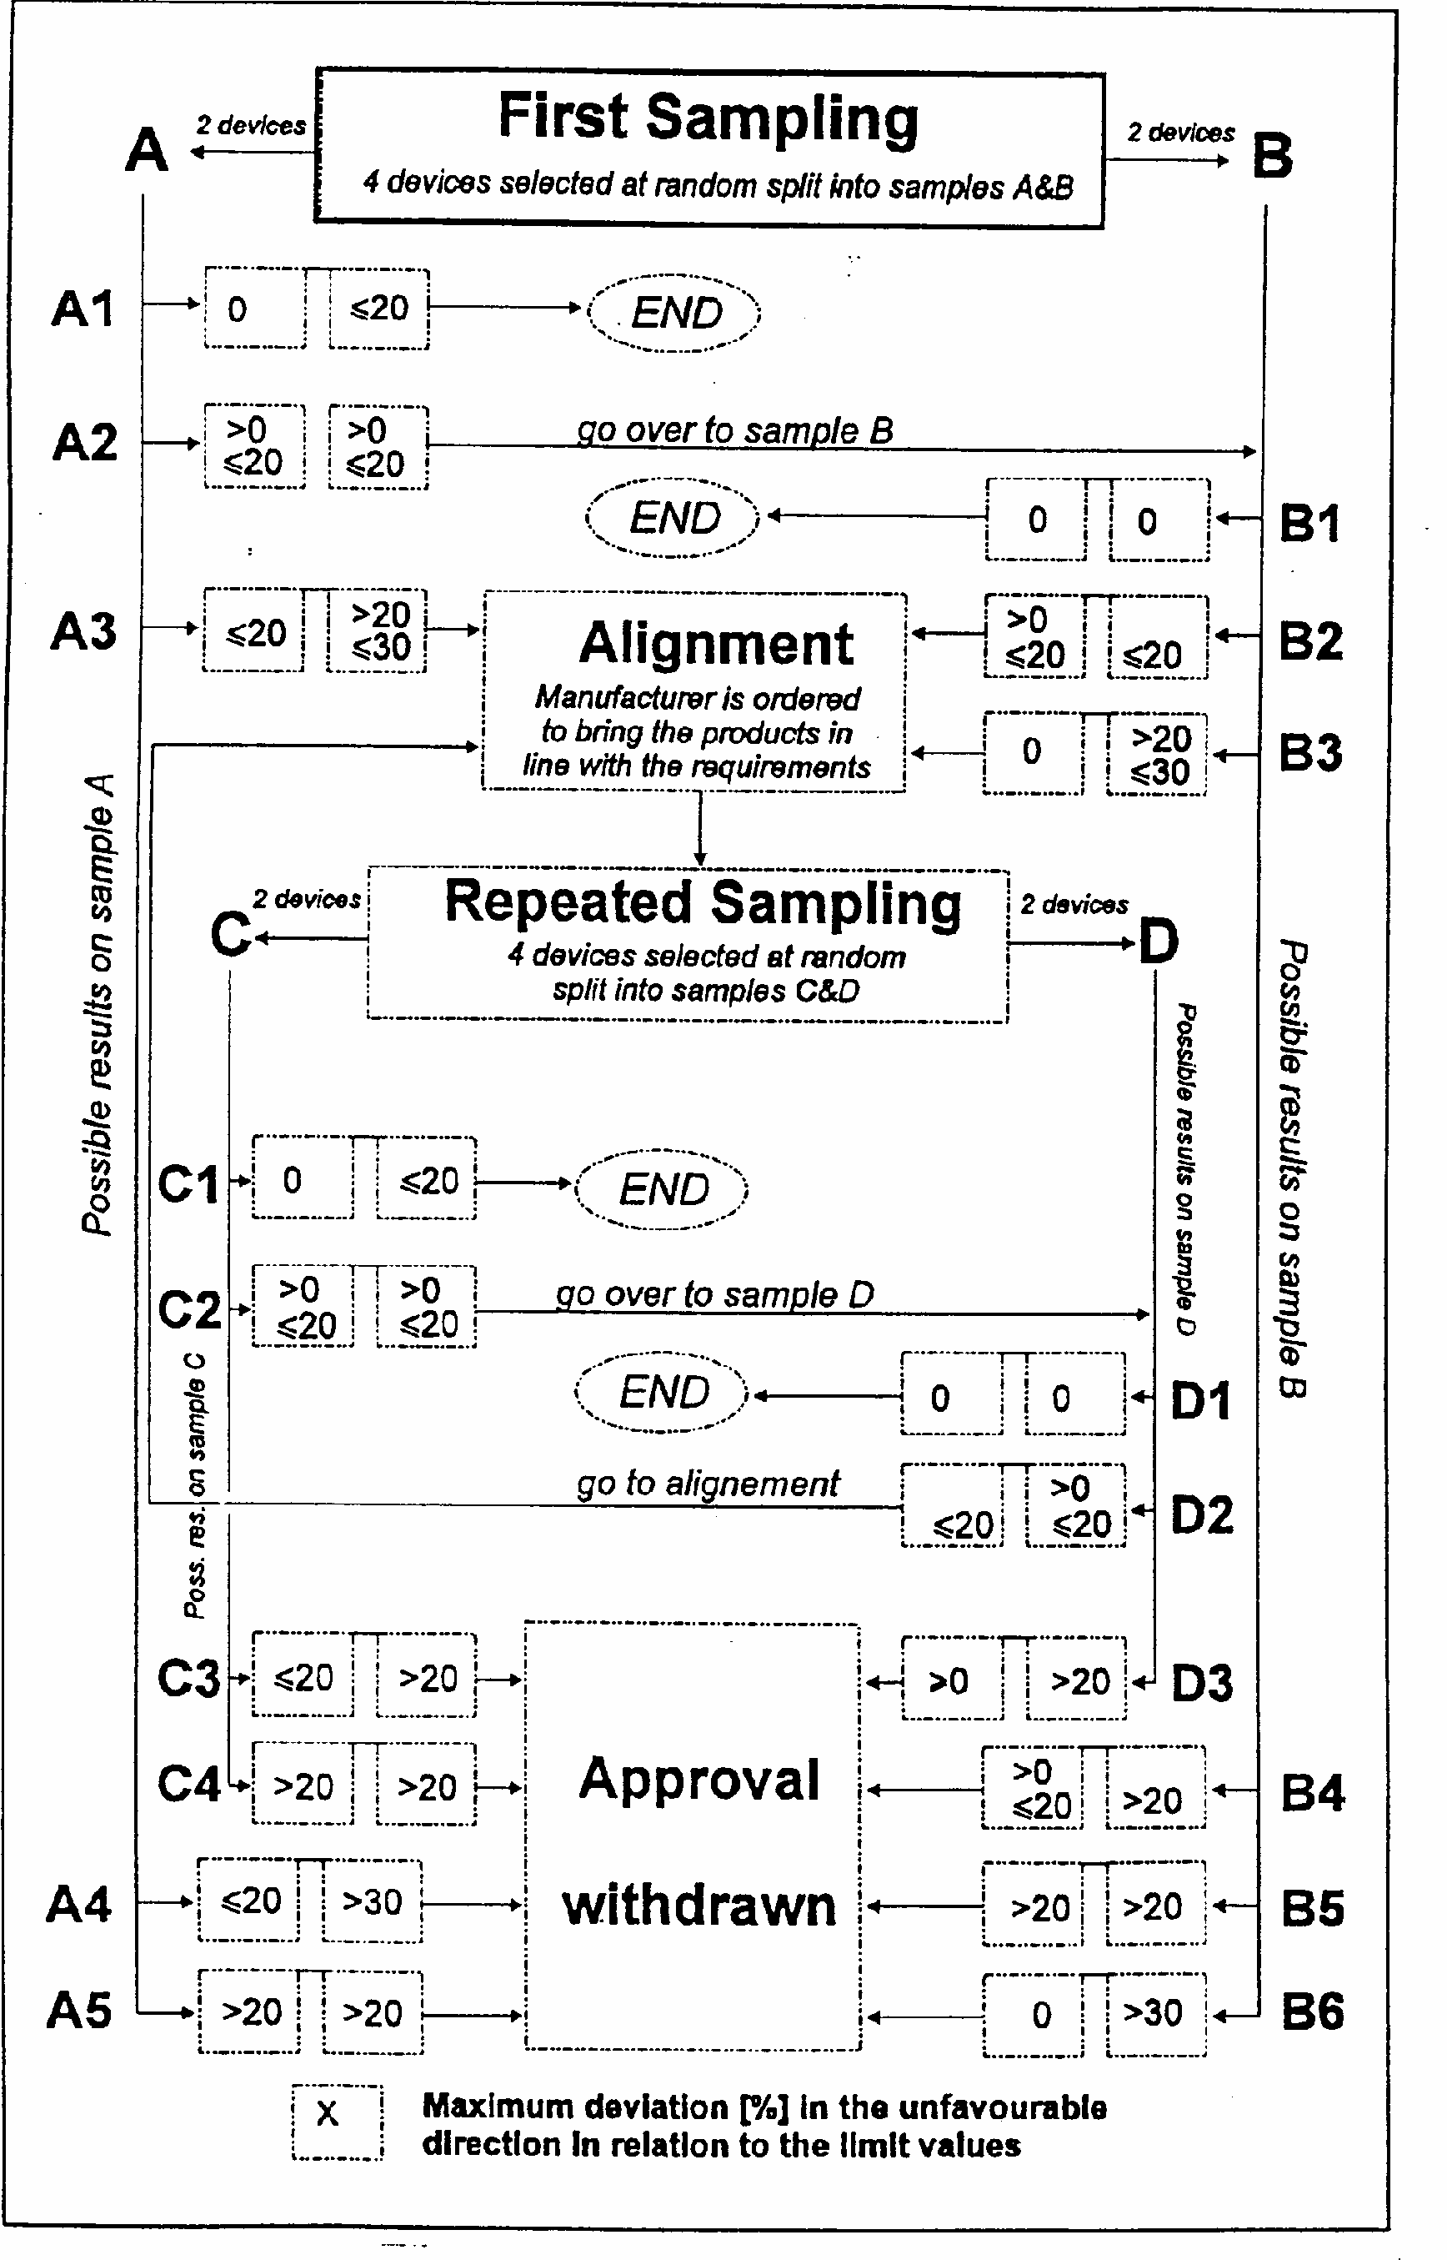

1/ 1 for Germany, 2 for France, 3 for Italy, 4 for the Netherlands, 5 for Sweden, 6 for Belgium, 7 for Hungary, 8 for the Czech Republic, 9 for Spain, 10 for Yugoslavia, 11 for the United Kingdom, 12 for Austria, 13 for Luxembourg, 14 for Switzerland, 15 (vacant); 16 for Norway, 17 for Finland, 18 for Denmark, 19 for Romania, 20 for Poland, 21 for Portugal, 22 for the Russian Federation, 23 for Greece, 24 (vacant), 25 for Croatia, 26 for Slovenia, 27 for Slovakia, 28 for Belarus, 29 for Estonia, 30(vacant), 31 for Bosnia and Herzegovina, 32-36 (vacant) and 37 for Turkey. Subsequent numbers shall be assigned for other countries in the chronological order in which they ratify or accede to the Agreement concerning the Recognition of Approval for Motor Vehicle Equipment and Parts, and the numbers thus assigned shall be communicated by the Secretary-General of the United Nations to the Contracting Parties to the Agreement.
*/ Corresponding to illuminaut A of the International Commission on Illumination (ICI),
2^{1/} Distinguishing number of the country which has granted/extended/refused/withdrawn approval (see approval provisions in the Regulation). 2/ Strike out what does not apply.
3/ For rear fog lamps with non-replaceable light sources indicate the number and the total wattage of the sealed-in light sources.

