Vehicle Standard (Australian Design Rule 75/00 – Headlamp Cleaners) 2006
I, JAMES ERIC LLOYD, Minister for Local Government, Territories and Roads, determine this vehicle standard under subsection 7 (1) of the Motor Vehicle Standards Act 1989.

Dated 5 July 2026

[Signed]

James Eric Lloyd

Minister for Local Government, Territories and Roads

CONTENTS

0. legislative provisions 3
1. SCOPE 3
2. APPLICABILITY AND IMPLEMENTATION 3
3. DEFINITIONS 3
4. REQUIREMENTS 3
5. EXEMPTIONS AND ALTERNATIVE PROCEDURES 3
6. SUPPLEMENTARY GENERAL REQUIREMENTS 4
7. ALTERNATIVE STANDARDS 4
8. NOTES 4
APPENDIX A 5

- legislative provisions
  - NAME OF STANDARD
    - This Standard is the Vehicle Standard (Australian Design Rule 75/00 – Headlamp Cleaners) 2006.
    - This Standard may also be cited as Australian Design Rule 75/00 — Headlamp Cleaners.
  - COMMENCEMENT
    - This Standard commences on the day after it is registered.
  - REPEAL
    - This Standard repeals each vehicle standard with the name Australian Design Rule 75/00 — Headlamp Cleaners that is:
(a) made under section 7 of the Motor Vehicle Standards Act 1989; and
(b) in force at the commencement of this Standard.
    - This Standard also repeals each instrument made under section 7 of the Motor Vehicle Standards Act 1989 that creates a vehicle standard with the name Australian Design Rule 75/00 — Headlamp Cleaners, if there are no other vehicle standards created by that instrument, or amendments to vehicle standards made by that instrument, that are still in force at the commencement of this Standard.
- SCOPE
  - This Australian Design Rule (ADRs) prescribes the requirements for the installation and testing of headlamp cleaners which are fitted to motor vehicles.
- APPLICABILITY AND IMPLEMENTATION
  - The circumstances under which headlamp cleaners are mandatory, optional, or prohibited are set out in either ADRs 13/…, 19/… or 67/….
- DEFINITIONS
  - Refer to paragraph 2 of Appendix A.
- REQUIREMENTS
  - Devices complying with the technical requirements of Appendix A as varied by part 5 Exemptions and Alternative shall be accepted as complying with this rule.
- EXEMPTIONS AND ALTERNATIVE PROCEDURES
  - The following provisions of appendix A do not apply.
    - Section 3 Application for approval
Section 4 Markings
Section 5 Approval
Section 8 Modifications of type and extension of approval
Section 9 Conformity of production
Section 10 Penalties for non-conformity of production
Section 11 Production definitely discontinued
Section 12 Names and addresses of technical services responsible for conducting approval tests and of administrative departments
Section 13 Transitional Provisions
Annex 1 Communication concerning the approval or extension or refusal or withdrawal of approval or production definitely discontinued of a type of headlamp cleaner pursuant to Regulation No.45
Annex 2 Examples of arrangements of approval marks
Annex 3 Arrangements of approval marks
- SUPPLEMENTARY GENERAL REQUIREMENTS
None
- ALTERNATIVE STANDARDS
  - The technical requirements of any of the editions of United Nations –Economic Commission for Europe (UN ECE) Regulation No. 45 - UNIFORM PROVISIONS CONCERNING THE APPROVAL OF HEADLAMP CLEANERS AND OF POWER DRIVEN VEHICLES WITH REGARD TO HEADLAMP CLEANERS incorporating the 01 series of amendments are deemed to be equivalent to the technical requirements of this rule.
- NOTES
  - In place of Regulation No 48 where referenced in Appendix A, read ADR 13/00.
  - In place of Regulation No 37 where referenced in Appendix A, read ADR 51/00.
APPENDIX A

UN-ECE REGULATION NO. 45/01
UNIFORM PROVISIONS CONCERNING THE APPROVAL OF HEADLAMP CLEANERS AND OF POWER DRIVEN VEHICLES WITH REGARD TO HEADLAMP CLEANERS
Regulation No. 45
UNIFORM PROVISIONS CONCERNING THE APPROVAL OF HEADLAMP CLEANERS AND OF POWER-DRIVEN VEHICLES WITH REGARD TO HEADLAMP CLEANERS
CONTENTS
REGULATION
1. Scope
2. Definitions
3. Application for approval
4. Markings
5. Approval
6. General specifications
7. Cleaning efficiency verification
8. Modifications of type and extension of approval
9. Conformity of production
10. Penalties for non-conformity of production
11. Production definitely discontinued
12. Names and addresses of the technical service responsible for conducting approval tests and of administrative departments
13. Transitional provisions
Annexes
Annex 1 - Communication concerning the approval or refusal or extension or withdrawal of approval or production definitely discontinued of a type of headlamp cleaner pursuant to Regulation No. 45
Annex 2 - Communication concerning the approval or refusal or extension or withdrawal of approval or production definitely discontinued of a vehicle type with regard to headlamp cleaners, pursuant to Regulation No. 45
Annex 3 - Arrangements of the approval marks
Annex 4 - Procedure for testing the performance of headlamp cleaners
Regulation No. 45
UNIFORM PROVISIONS CONCERNING THE APPROVAL OF HEAD -LAMP CLEANERS AND OF POWER-DRIVEN VEHICLES WITH REGARD TO HEADLAMP CLEANERS
1. SCOPE
This Regulation applies to the approval of headlamp cleaners and to the approval of a type of vehicle with regard to headlamp cleaners.
In this case it is possible, at the manufacturer's choice, to install a headlamp cleaner previously approved as a component, but this previous approval is not mandatory. 1/
2. DEFINITIONS
For the purposes of this Regulation:
2.1. 'Headlamp cleaner" means a complete device with which all or part of the light emitting surface of a headlamp can be cleaned;
2.2. 'Type of headlamp cleaners means headlamp cleaners which do not differ in such essential respects as: 2/
2.2.1. The trade name or mark;
2.2.2. The cleaning principle employed;
2.2.3. Different geometric dimensions of the headlamp, if this implies any modification of the components of the cleaners;
2.3. "vehicle type" means vehicles which do not differ in such essential respects as:
2.3.1. The type of headlamp cleaner;
2.3.2. The geometric arrangements of the headlamp cleaning equipment, if this implies any modification of its operation;
2.3.3. Capacity class of the fluid container;
2.4. "Approval of a vehicle" means approval of a vehicle type with regard to headlamp cleaners;
2.5. "Fluid container" means that part of the headlamp cleaner in which in the appropriate cases the cleaning fluid is stored;
2.6. "Cleaning efficiency" means the percentage of the intensity of illumination measured at a measuring point after cleaning with respect to the values measured with the sample totally clean;
2.7. "Cleaning period" means the period of time to fulfil the requirements specified in paragraph 7 below to be met, including any pre-treatment period.
3. APPLICATION FOR APPROVAL
3.1. The application for approval of a type of headlamp cleaner shall be submitted by the holder of the trade name or mark or by his duly accredited representative.
3.2. The application for approval of a vehicle type with regard to the headlamp cleaners shall be submitted by the vehicle manufacturer or by his duly accredited representative.
3.3. The application shall specify either the type number or the approval number of the headlamp(s) or the shapes and dimensions of the headlamp(s) for which the cleaner is intended and shall be accompanied by the undermentioned documents, in triplicate giving the following particulars:
3.3.1. Drawings showing in sufficient detail the installation to a vehicle, the relative attachment between the headlamp(s) and the wiper(s), nozzle(s), or corresponding parts, the position of the approval mark and the cleaning principle employed; where appropriate, the part of the illuminating surface of the headlamp relevant to the cleaner shall also be shown;
3.3.2. Either a specification of the type(s) or the approval number(s) of the headiomp(s) for which the cleaner is intended if only a part of the lens is cleaned or a specification of the main measures (diameter and radius of curvature of the lens) if the lens is cleaned uniformly;
3.3.3. A list, specifying the parts which constitute the headlamp cleaner and drawings thereof, (e.g. pumps, nozzles, valves, motors and wipers);
3.3.4. A brief technical description indicating the length of the cleaning period, the consumption of cleaning fluid during the cleaning period and the minimum capacity of the container provided;
3.3.5. A sample, complete with relevant headlamp(s) installed as described in paragraph 3.3.1., either on a suitable test fixture or on a vehicle representative of the type to be approved, in such a manner as to allow normal operation of the cleaner and the headlamp(s);
3.3.6. A separate complete headlamp cleaning device;
3.3.7. Instructions for the installation in case of approval of a headlamp cleaner;
3.3.8. If required by the technical service responsible for conducting approval tests, technical documentation and further samples.
4. MARKINGS
4.1. The headlamp cleaner shall on at least one main part bear the following marks clearly legible and indelible:
4.1.1. The trade name or mark;
4.1.2. In the case of electrically operated parts, the nominal voltage;
4.2. One main part of the cleaner submitted for approval shall bear a space of sufficient size for the approval mark; this space shall be shown in the drawing referred to in paragraph 3.3.1.
4.3. The vehicle submitted for approval shall bear a space of sufficient size for the approval mark, in accordance with annex 3 to this Regulation.
5. APPROVAL
5.1. The approval of a headlamp cleaner shall extend only to the operating principle employed for the cleaning of either the types or the shapes and functions of headlamps indicated in the application for approval;
5.2. If the type of headlamp cleaner or vehicle type submitted for approval pursuant to this Regulation meets the requirements of paragraphs 6 and 7 below, approval of that type of headlamp cleaner or vehicle shall be granted.
5.3. An approval number shall be assigned to each type approved. Its first two digits (at present 01 corresponding to the 01 series of amendments which entered into force on 9 February 1988) shall indicate the series of amendments incorporating the most recent major technical amendments made to the Regulation at the time of issue of the approval. The same Contracting Party may not assign the same number to another type of vehicle or headlamp cleaner.
5.4. Notice of approval, of extension or of refusal of approval of a vehicle type pursuant to this Regulation shall be communicated to the Parties to the Agreement applying this Regulation by means of a form conforming to the model in annex 1 to this Regulation and of drawings supplied by the applicant for approval, in a format not exceeding A4 (210 x 297 mm), or folded to that format, and on an appropriate scale.
Notice of approval, of extension or of refusal of approval of a type of headlamp cleaner shall be communicated to the Parties to the Agreement which apply this Regulation by means of a form conforming to the model in annex 2 to this Regulation and of drawings supplied by the applicant for approval, in a format not exceeding A4 (210 x 297 mm), or folded to that format, and on an appropriate scale.
5.5. There shall be affixed, conspicuously and in a readily accessible place specified on the approval form, to every vehicle or headlamp cleaner conforming to a type approved under this Regulation, an international approval mark consisting of:
5.5.1. A circle surrounding the letter "E" followed by the distinguishing number of the country granting approval; 3/
5.5.2. For a vehicle type, the number of this Regulation, followed by the letter R, a dash and the approval number to the right of the circle prescribed in paragraph 5.5.1;
5.5.3. For a vehicle type, the following additional symbol: a rectangle surrounding a figure expressing the capacity class of the fluid container; the class can be either 50 or 25 as stipulated in paragraph 6.5.2.1;
5.5.4. For a type of headlamp cleaner, an approval number.
5.6. If the vehicle conforms to a vehicle type approved, under one or more other Regulations annexed to the Agreement, in the country which has granted approval under this Regulation, the symbol prescribed in paragraph 5.5.1, need not be repeated; in such a case the regulation and approval numbers and the additional symbols of all the Regulations under which approval has been granted in the country which has granted approval under this Regulation shall be placed in vertical columns to the right of the symbol prescribed in paragraph 5.5.1.
5.7. The approval mark shall be clearly legible and be indelible.
5.8. For a vehicle type, the approval mark shall be placed either near the headlamps or close to or on the plate affixed by the manufacturer showing the characteristics of the vehicle.
5.9. Annex 3 to this Regulation gives examples of arrangements of approval marks.
6. GENERAL SPECIFICATIONS
6.1. The headlamp cleaner shall be designed and constructed to clean those parts of the light- emitting surface of the headlamp which distribute the passing beam and the driving beam so that at least the cleaning effect specified in paragraph 7 below is achieved.
6.2. The headlamp cleaner shall be furthermore so designed that:
6.2.1. When parts of the headlamp cleaner in the rest position(s) are on the headlamps' illuminating surface, the photometric values of the headlamps, and of the lamps which are grouped or reciprocally incorporated with the headlamp as submitted for test, measured at the points listed in the appropriate Regulation for which minimum values are specified, shall not be reduced by more than 5 % in any normal rest position(s) of those parts, with respect to those measured before installation of the cleaning device; in no case shall these values be less than the values prescribed in the Regulation in question;
6.2.1.1. Paragraph 6.2.1. is not applicable when the headlamp and the parts of the headlamp cleaner referred to in paragraph 6.2.1. form a complete assembly during the approval of the headland;
6.2.2. During operation, except in the rest position, the mechanical parts shall not cover more than:
6.2.2.1. 20 % of the illuminating surface of a passing lamp,
6.2.2.2. 10 % of the illuminating surface of a driving lamp not reciprocally incorporated with a passing lamp;
6.2.3. It is able to operate at all temperatures between -10 degrees C and +35 degrees C and to operate satisfactorily at speeds between 0 and 130 km/h (or the maximum speed of the vehicle if it is below 130 km/h); this shall not apply, however, if the cleaner is blocked by snow or ice; the cleaner shall remain undamaged if exposed to a temperature of -35 degrees C and of +80 degrees C respectively for a period of one hour;
6.2.4. In normal use, in spite of the vibration to which it may be subjected, its satisfactory operation continues to be ensured;
6.2.5. It will not be functionally damaged due to water, ice or snow accumulating on it during normal operation of the vehicle, even if the cleaning liquid is frozen; a temporary failure due to freezing or deposit of snow shall not be considered as damage, provided that the device can be made to work again by simple means;
6.2.6. A11 elements which may come into contact with the cleaning fluid must be resistant against a mixture consisting of 50 % methyl alcohol, ethyl alcohol or isopropyl alcohol and 50 % water;
6.2.7. Its parts do not hinder the adjustment of the headlamps or the inserting or changing of filament lamps; if necessary, the cleaner or parts of it may be detachable, if they can be removed with simple tools.
6.3. Parts of the headlamp cleaner which, in the rest position(s) and/or during operation, form part of the external surface of the vehicle, shall meet the following requirements:
6.3.1. The parts shall not exhibit, directed outwards, any pointed or sharp parts or any projections of such shape, dimensions, direction or hardness as to be likely to increase the risk or severity of bodily injury to a person hit or brushed by the bodywork;
6.3.2. No protruding part on the external surface shall have a radius of curvature of less than 2.5 mm; this requirement shall not apply to parts of a hardness not exceeding 60 shore A;
6.3.3. In cases where the cleaner comprises a wiper, paragraph 6.3.2. above shall not apply to the wiper blades or to any supporting members. However, these units shall be so made as to have no sharp angles or pointed or cutting parts of a non-functional nature. Any wiper shaft shall be furnished with a protective casing having a radius of curvature of not less than 2.5 mm and a surface of not less than 50 mm2;
6.3.4. In cases where the cleaner comprises a nozzle(s), paragraph 6.3.2. shall apply neither to the functional parts of the nozzle(s) nor to the non-functional parts if they protrude less than 5 mm;
6.3.5. The provisions of paragraphs 6.3.1., 6.3.2 and 6.3.3. above shall not apply to those parts of the headlamp cleaner which are located so that, in static conditions, they cannot be contacted by a sphere 100 mm in diameter.
6.4. The conformity with specifications of paragraphs 6.2.3., 6.2.4., 6.2.5. and 6.2.6. shall be certified by the applicant. In the case of doubt, the technical service responsible for conducting the approval tests can verify that these requirements have been met.
6.5. In case of approval of a vehicle the following requirements shall also be met:
6.5.1. Cleaning of all passing headlamps shall be compulsory. If there are more than two driving headlamps, the cleaning of one pair of these headlamps shall be sufficient;
6.5.2. If the cleaner has a fluid container this may be combined with the fluid container for the windscreen washers and the rear window washer and shall satisfy the following requirements:
6.5.2.1. The capacity of the fluid container shall be sufficient for at least 50 cleaning periods for headlamp cleaners of capacity class 50 and at lease 25 cleaning periods for headlamp cleaners of capacity class 25. If the container not only feeds the headlamp cleaner but also the windscreen washer and/or the rear window washer; this capacity shall be increased by one litre in all.
6.5.2.2. It shall be easy to check the level of the fluid, and the opening for filling shall be readily accessible;
6.5.3. Neither the cleaner nor any part of it shall prevent the adjustment of the headlamp and the replacement of the filament lamp. In case of need, the cleaner or part of it shall be removable with simple tools. No other prescribed or permissible lighting or light- signalling devices shall be impaired in their effectiveness either by parts or by the operation of the headlamp cleaner, except during the cleaning period; it must above all not systematically deposit any dirt when in normal service, on the light-emitting surfaces of other lighting or light-signalling devices;
6.5.4. The control of the cleaning device shall be operable from the drivers seat and may be coupled with the controls for other cleaning devices.
6.6. In the case where on a vehicle submitted for approval a headlamp cleaner previously approved as a component is fitted, only the requirements set forth in paragraphs 6.5 to 6.5.4. shall be verified.
7. CLEANING EFFICIENCY VERIFICATION
7.1. The efficiency of the cleaner shall be tested in accordance with the requirements of annex 4 to this Regulation. The cleaning efficiency at the points on the measuring screen which are specified below shall, after every cleaning period amount to at least 70 % for the passing lamp and driving lamp.
Diagram of Measuring Points on a Screen
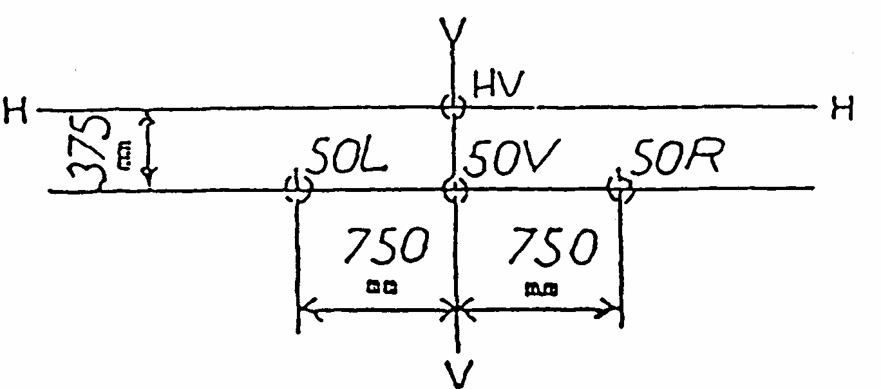
7.2. The measuring point shall be located as shown in the above sketch, on a screen situated 25 m from the headlamp and perpendicular to its axis.
7.3. Measuring points for the passing lamp
7.3.1. Headlamps approved in respect of the passing beam only (marking C or HC) Measuring points: 50 R(L) and 50 V. 4/
7.3.2. Headlamps approved in respect of the passing beam and the driving beam (marking CR, HCR, C+R, C+HR, HC+R or HC+HR)
Measuring points; 50 R(L) (and 50 V if in the same headlamps, different optic systems for the driving lamp and the passing lamp are provided).
7.4. Measuring point for the driving lamp
Measuring point: HV.
8. MODIFICATIONS OF TYPE AND EXTENSION OF APPROVAL
8.1. Every modification of a type of headlamp cleaner or a vehicle type shall be notified to the administrative department which issued the approval. The department may then either:
8.1.1. Consider that the modifications introduced are unlikely to have an appreciable adverse effect and that in any case the headlamp cleaner or the vehicle still complies with the requirements; or
8.1.2. Require a further test report from the technical service responsible for conducting the tests.
8.2. Confirmation or refusal of approval, specifying the alternations, shall be communicated by the procedure specified in paragraph 5.4. above to the Parties to the Agreement applying this Regulation.
8.3. The competent authority issuing the extension of approval shall assign a series number to each communication form drawn up for such an extension.
9. CONFORMITY OF PRODUCTION
9.1. Every vehicle or headlamp cleaner bearing an approval mark as prescribed under this Regulation shall conform to the type approved and satisfy the requirements of paragraphs 6 and 7 above.
9.2. In order to verify conformity as prescribed in paragraph 9.1. above, a vehicle or headlamp cleaner bearing the approval mark pursuant to this Regulation shall be taken from the production.
10. PENALTIES FOR NON-CONFORMITY OF PRODUCTION
10.1. The approval granted in respect of a type of headlamp cleaner or a vehicle type pursuant to this Regulation may be withdrawn if the requirements laid down in paragraph 9.1. above are not complied with or if the sample taken fails to pass the tests prescribed in paragraph 9.2. above.
10.2. If a Party to the Agreement applying this Regulation withdraws an approval it has previously granted, it shall forthwith so notify the other Contracting Parties applying this Regulation, by means of a form conforming to the model in annexes 1 or 2 to this Regulation.
11. PRODUCTION DEFINITELY DISCONTINUED
It the holder of the approval completely ceases to manufacture a type of headlamp cleaner or vehicle approved in accordance with this Regulation, he shall so inform the authority which granted the approval. Upon receiving the relevant communication, that authority shall inform thereof the other Parties to the Agreement applying this Regulation, by means of a form conforming to the model in annexes 1 or 2 to this Regulation.
12. NAMES AND ADDRESSES OF THE TECHNICAL SERVICES RESPONSIBLE FOR CONDUCTING APPROVAL TESTS AND OF ADMINISTRATIVE DEPARTMENTS
The Parties to the Agreement applying this Regulation shall communicate to the United Nations Secretariat the names and addresses of the technical services responsible for conducting approval tests and of the administrative departments which grant approval and to which forms certifying approval or extension or refusal or withdrawal of approval, issued in other countries, are to be sent.
13. TRANSITIONAL PROVISIONS
13.1. From the date of entry into force of the 01 series of amendments to this Regulation no Contracting Party applying this Regulation shall refuse approval under this Regulation as amended by the 01 series of amendments.
13.2. From 24 months after the date of entry into force of the 01 series of amendments Contracting parties applying this Regulation shall grant approvals for a type of headlamp cleaner or vehicle only if it meets the requirements of this Regulation as amended by the 01 series of amendments.
13.3. Existing approvals shall remain valid.
13.3.1. "However, Contracting Parties applying this Regulation may prohibit the fitting of headlamp cleaners which do not meet the requirements of this Regulation as amended by the 01 series of amendments on vehicles first brought into use more than five years after the date of entry into force of the 01 series of amendments."
13.3.2. "However, Contracting Parties applying this Regulation may prohibit vehicles which do not meet the requirements of this Regulation as amended by the 01 series of amendments to be brought into use more than five years after the date of entry into force of the 01 series of amendments."

Annex 1
(Maximum format: A4 (210 x 297 mm))

issued by: Name of administration:
............................
............................
............................

Communication concerning: APPROVAL
REFUSAL OF APPROVAL
EXTENSION OF APPROVAL
WITHDRAWAL APPROVAL
PRODUCTION DEFINITELY
DISCONTINUED.2/
of a type of headlamp cleaner pursuant to Regulation No. 45
Approval No. ................................... Extension No. ..................................
1. Cleanertype..............................................................................
2. Trade name or mark of headlamp cleaner…………………………………..
3. Manufacturer's name and address :..........................................................................
4. If applicable, name and address of manufacturer's representative:...........................
..................................................................................................................................
5. Approved for the following headlamps (type or approval number) and/or the shapes and dimensions of relevant headlamp:........................................................
6. Brief description of the cleaner:...............................................................................
7. Submitted for approval on:.......................................................................................
8. Technical service responsible for conducting approval tests:..................................
9. Date of report issued by that service:.......................................................................
10. Number of report issued by that service:.................................................................
11. Approval granted/refused/extended/withdrawn 2/
12. Position of the approval mark on the headlamp cleaner: .........................................
13. Place: ........................................................................................................................
14. Date: .........................................................................................................................
15. Signature:..................................................................................................................
16. "The following documents, bearing the approval number shown above, are available on request: .drawings showing the installation of the headlamp cleaner and its relative attachment for which this approval is valid;
drawings, diagrams and plans for the cleaner; ..... photographs.
Annex 2
(Maximum format: A4 (210 x 297 mm))

issued by: Name of administration:
.......................
.......................
.......................

Communication concerning: APPROVAL
REFUSAL OF APPROVAL
EXTENSION OF APPROVAL
WITHDRAWAL APPROVAL
PRODUCTION DEFINITELY
DISCONTINUED.2/
of a vehicle type with regard to headlamp cleaners, pursuant to Regulation No. 45
Approval No.......................... Extension No. ...................................
1. Trade name or mark of the vehicle:..........................................................................
2. Vehicle type:..............................................................................................................
3. Manufacturer's name and address :...........................................................................
4. If applicable, name and address of manufacturer's representative:..........................
................................................................................................................................
5. Trade name or mark of headlamp cleaner:...............................................................
6. Cleaner type:............................................................................................................
7. Headlamp cleaner(s) type approval number(s) (where the vehicle is equipped with a previously approved headlamp cleaner)................................................................
8. Approved for the following headlamps (type or approval number or shapes and dimensions) .............................................................................................................
9. Brief description of the cleaner.................................................................................
10. Capacity class of the fluid container: 25/50 ^{2/} .......................................................
11. Submitted for approval on:.......................................................................................
12. Technical service responsible for conducting approval tests:...................................
13. Date of report issued by that service:........................................................................
14. Number of report issued by that service:..................................................................
15. Approval granted/refused/extended/withdrawn ^{2/}:...................................................
16. Position of the approval mark on the vehicle:..........................................................
17. Place:.......................................................................................................................
18. Date:.........................................................................................................................
19. signature:..................................................................................................................
20. "The following documents, bearing the approval number shown above, are available on request: ..drawings showing the installation of the headlamp cleaner and its relative attachment for which this approval is valid;
drawings, diagrams and plans for the cleaner; ..... photographs.
Annex 3
ARRANGEMENTS OF THE APPROVAL MARKS
I. ARRANGEMENT OF THE APPROVAL MARK FOR A HEADLAMP CLEANER
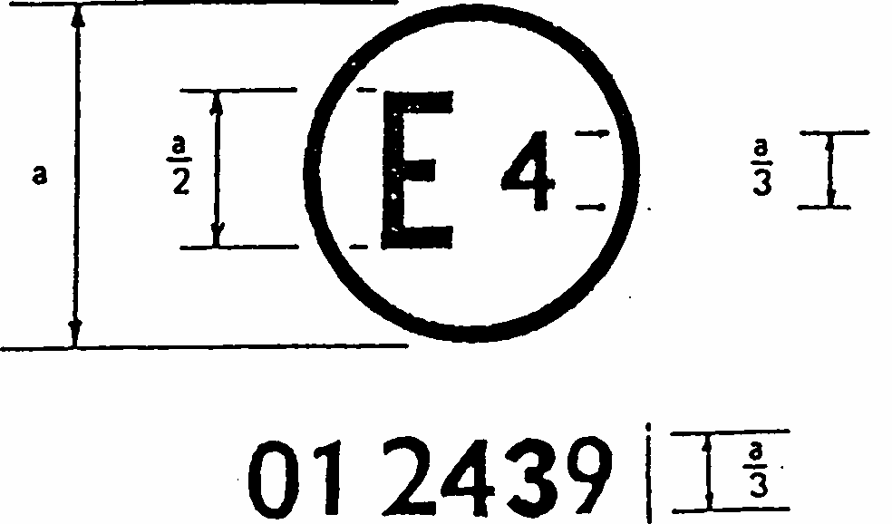
The above approval mark affixed to a headlamp cleaner indicates that the cleaner has been approved in the Netherlands (E 4) under the approval number 012439. The first two digits of the approval number indicate that the approval was granted in accordance with the requirements of Regulation No. 45 as amended by the 01 series of amendments.
Notes:
The approval number must be placed close to the circle and must be in a position either above or below the letter "E" or to the left or the right of that letter. The digits of the approval number must be on the same side of the letter "E" and face the same way. The competent authorities shall avoid using Roman numerals for approval, in order to prevent any confusion with other symbols.
II. ARRANGEMENTS OF APPROVAL MARKS FOR A VEHICLE WITH REGARD TO HEADLAMP CLEANERS
Model A
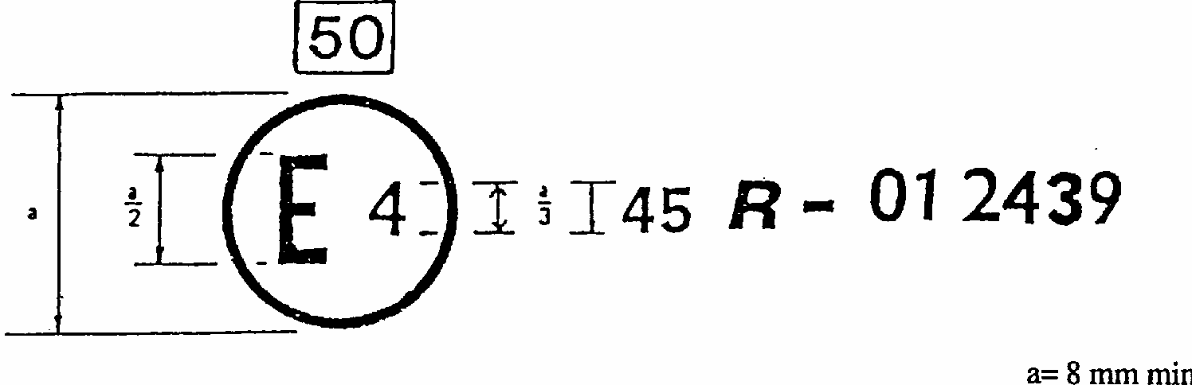
The above approval mark affixed to a vehicle shows that the vehicle type concerned has been approved in the Netherlands (E 4) pursuant to Regulation No. 45 under the approval number 012439. The first two digits of the approval number indicate that the approval was granted in accordance with the requirements of Regulation No. 45 as amended by the 01 series of amendments. The capacity class is 50.
Model B
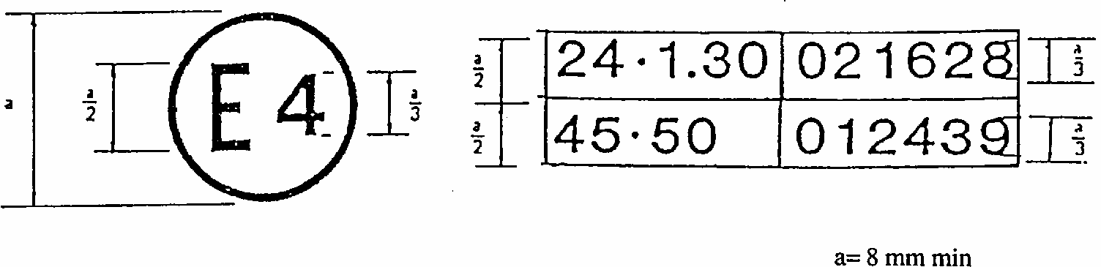
The above approval mark affixed to a vehicle shows that the vehicle type concerned has been approved in the Netherlands (E 4) pursuant to Regulations Nos. 24 and 45. 1/ The first two digits of the approval numbers indicate that, at the dates when the respective approvals were granted, Regulation No. 24 included already the 02 series of amendments and Regulation No. 45 included the 01 series of amendments. The capacity class is 50.
Annex 4
PROCEDURE FOR TESTING THE PERFORMANCE OF HEADLAMP CLEANERS
1. General comments
The tests shall be carried out in still air at an ambient temperature of 23 degrees C + 5 degrees C.
During the various phases of the test, precautions shall be taken to avoid a thermal shock to the headlamp glass.
If the manufacturer of the cleaning device has the intention to provide several positions of the cleaning device and the headlamps, only the headlamp in its worst position to the cleaning device must be tested. If a cleaning fluid is used the additional nozzles for the non-simulated side must be present on the test fixture for checking the fluid consumptions.
2. Test equipment
2.1. Test mixture
2.1.1. For headlamp with the outside lens in glass:
A mixture of water and polluting agent to be applied to the headlamp shall be composed of:
9 parts by weight of silica sand with a particle size of 0-100 microns corresponding to distribution prescribed in paragraph 2.1.3,
1 part by weight of vegetable carbon dust (beechwood) with a particle size of 0-100 microns,
0.2 parts by weight of NaCMC ^{1/}, and
an appropriate quantity of distilled water with a conductivity of < 1 mS/m.
2.1.2. For headlamp with the outside lens in plastic material:
The mixture of water and polluting agent to be applied to the headlamp shall be composed of:
9 parts by weight of silica sand with a particle size of 0-100 microns corresponding to distribution prescribed in paragraph 2.1.3,
1 part by weight of vegetable carbon dust (beechwood) with a particle size of 0-100 microns,
0.2 parts by weight of NaCMC 1/,
5 parts by weight of sodium chloride (pure at 99%)
13 parts by weight of distilled water with a conductivity of < 1 mS/m, and
2 +/- 1 parts by weight of surface-actant.
Particle size (in microns) | Particle size distribution (in %)
0 to 5 | 12 +/- 2
5 to 10 | 12 +/- 3
10 to 20 | 14 +/- 3
20 to 40 | 23 +/- 3
40 to 80 | 30 +/- 3
80 to 100 | 9 +/- 3
2.1.4. The mixture shall be fit for applying to the headlamp by the spray gun specified under 2.3 below. The mixture shall be used not earlier than two hours and not later than 24 hours after preparation. It shall be given into the gun immediately before use.
2.2. The photometric measuring equipment shall be equivalent to that used in connection with the approval of headlamps.
2.3. A power supply of sufficient capacity (during the cleaning period the voltage drop must not be more than 1%), a voltmeter for short time measurements (oscillograph), a spray gun at an operating pressure of about 500 kPa with a flow cup and a nozzle of 1.5 mm diameter.
2.4. If not tested on the vehicle, the headlamp(s) and the cleaner shall be mounted on a test fixture which reproduces the installation on the vehicle and permits normal operation of both cleaner and headlamp (s).
2.5. For the purpose of the test on electrically operated devices the power supply shall be adjusted in such a way that under load at the contacts of the largest consumer the voltage is 13.0 V in the case or 12 V systems and 27.0 V in the case of 24 V systems. As far as the measurements of illumination are concerned, they shall be carried out on the basis of the approval tests for the headlamps. In case of doubt only measurements performed with a standard filament lamp are valid.
3. Photometric measurements of the headlamp when clean
The light-emitting surface of the headlamp shall be clean and the headlamp cleaner shall be in the stationary position. The photometric measurements shall be made in compliance with the specifications of the relevant Regulation, as well as the measurements prescribed in paragraph 4 below. The illumination shall then be measured at the measuring points specified in paragraph 7 of this Regulation.
4. Evaluation of cleaning efficiency
4.1. After the headlamp(s) has been operated for 10 minutes the dirt mixture shall be applied evenly to its entire light-emitting surface using the spray gun mentioned above. The mixture shall then be dried either by operating the headlamp or using hot air. This procedure shall be repeated, if necessary until the luminous intensity in all measuring points has been reduced below 20 % of the values according to paragraph 3 of this annex. At least the luminous intensity in one of the several measuring points shall be between 15 and 20 %.
4.1.1. The values to be used during the tests for the duration of the cleaning period and the consumption of cleaning fluid during this period shall be the values declared by the manufacturer. The fluid consumption shall be measured as the mean value over several cleaning periods as specified by the manufacturer.
4.1.2. After the headlamp has cooled down and not later than two hours after the dirt has dried the headlamps shall be switched on and the headlamp cleaner shall be operated for the cleaning period specified by the manufacturer. This cleaning period shall not exceed 10 s.
4.2. If a cleaning fluid is used for the cleaning operation, the test shall be performed with distilled water with a conductivity of not more than 10 micros /cm.
4.3. If the cleaner is designed to be manually operated, the cleaning shall be accomplished with a maximum of five operations within the time-limit specified in paragraph 4.1.2. above.
4.4. Where the cleaner is not electrically operated, the operating conditions for the test shall be specified by the technical service in accordance with the manufacturer.
4.5. After the cleaning operation, the headlamp shall have been allowed to dry. Then the illumination at the measuring points shall be measured again as required in paragraph 3 above and values thus obtained shall comply with the requirements specified in paragraph 7 of this Regulation.
4.6. If the result of the measurements does not meet the requirements according to paragraph 4.5. above it is permitted, in the case of a headlamp cleaner operated with a cleaning fluid, to try to achieve better results by adjusting the jet of the fluid.

1/ Adherence to this Regulation is not incompatible with the existence of national regulations which do not accept vehicles approved with headlamp cleaners of capacity class 25.
2/ Headlamp cleaners shall not be considered as different in type because of differences in fluid consumption, cleaning period or the fitting of cleaning elements, provided that compliance with this Regulation is verified by the technical service responsible for the approval tests. This is also valid, if headlamps to be cleaned differ only by the filament lamp used, the design for left hand or right hand traffic, the colour of the light or by parts of the headlamp which do not influence the effectiveness of the headlamp cleaner. In the case of different filament lamps only the headlamp version with the highest power consumption is to be tested.
3/ 1 for Germany, 2 for France, 3 for Italy, 4 for the Netherlands, 5 for Sweden, 6 for Belgium, 7 for Hungary, 8 for Czech Republic, 9 for Spain, 10 for Yugoslavia, 11 for the United Kingdom, 12 for Austria, 13 for Luxembourg, 14 for Switzerland, 15 for (vacant), 16 for Norway, 17 for Finland, 18 for Denmark, 19 for Romania, 20 for Poland, 21 for Portugal, 22 for the Russian Federation, 23 for Greece, 24 (vacant), 25 for Croatia, 26 for Slovenia, 27 for Slovakia, 28 for Belarus, 29 for Estonia, 30 (vacant), 31 for Bosnia and Herzegovina, 32-36 (vacant) and 37 for Turkey. Subsequent numbers shall be assigned to other countries in the chronological order in which they ratify or accede to the Agreement concerning the Adoption of Uniform Conditions of Approval and Reciprocal Recognition of Approval for Motor Vehicle Equipment and Parts and the number thus assigned shall be communicated by the Secretary-General of the United Nations to the Contracting Parties to the Agreement.
4/ R refers to right-hand driving. L refers to left-hand driving.
2^{1/} Distinguishing number of the country which has granted/ extended/ refused/ withdrawn approval (see approval provisions in the Regulation). 2/ Strike out what does not apply.
2^{1/} Distinguishing number of the country which has granted/ extended/ refused/ withdrawn approval (see approval provisions in the Regulation). 2/ Strike out what does not apply.
1/ The first number is given merely as an example
1/ NaCMC represents the sodium salt of carboxymethylcellulose, customarily referred to as CMC. The NaCMC used in the polluting agent mixture shall have a degree of subsitution (DS) of 0.6-0.7 and a viscosity of 200-300 cP for a 2% solution at 20degreesC.

