Vehicle Standard (Australian Design Rule 74/00 – Side Marker Lamps) 2006
I, JAMES ERIC LLOYD, Minister for Local Government, Territories and Roads, determine this vehicle standard under subsection 7 (1) of the Motor Vehicle Standards Act 1989.

Dated 5 July 2026

[Signed]

James Eric Lloyd

Minister for Local Government, Territories and Roads

CONTENTS

0. legislative provisions 3
1. SCOPE 3
2. APPLICABILITY AND IMPLEMENTATION 3
3. DEFINITIONS 3
4. REQUIREMENTS 3
5. EXEMPTIONS AND ALTERNATIVE PROCEDURES 4
6. SUPPLEMENTARY GENERAL REQUIREMENTS 4
7. ALTERNATIVE STANDARDS 4
8. NOTES 4
APPENDIX A 5

- legislative provisions
  - NAME OF STANDARD
    - This Standard is the Vehicle Standard (Australian Design Rule 74/00 – Side Marker Lamps) 2006.
    - This Standard may also be cited as Australian Design Rule 74/00 — Side Marker Lamps.
  - COMMENCEMENT
    - This Standard commences on the day after it is registered.
  - REPEAL
    - This Standard repeals each vehicle standard with the name Australian Design Rule 74/00 — Side Marker Lamps that is:
(a) made under section 7 of the Motor Vehicle Standards Act 1989; and
(b) in force at the commencement of this Standard.
    - This Standard also repeals each instrument made under section 7 of the Motor Vehicle Standards Act 1989 that creates a vehicle standard with the name Australian Design Rule 74/00 — Side Marker Lamps, if there are no other vehicle standards created by that instrument, or amendments to vehicle standards made by that instrument, that are still in force at the commencement of this Standard.
- SCOPE
This Australian Design Rule (ADR) prescribes the photometric requirements of side marker lamps which are used to increase the visibility of the sides of road vehicles.
- APPLICABILITY AND IMPLEMENTATION
  - The circumstances under which side marker lamps are mandatory, optional, or prohibited are set out in either ADRs 13/…, 19/… or 67/….
- DEFINITIONS
  - Refer to paragraph 2 of Appendix A.
- REQUIREMENTS
  - Devices complying with the technical requirements of Appendix A as varied by part 5 Exemptions and Alternative Procedures and part 6 Supplementary General Requirements shall be accepted as complying with this rule.
- EXEMPTIONS AND ALTERNATIVE PROCEDURES
  - The following provisions of appendix A do not apply.
    - Section 3 Application for approval
Section 4 Markings
Section 5 Approval
Section 10 Modification of side-marker Lamp Type and extension of approval
Section 11 Conformity of production – partial (for particular deletions to the Section refer to paragraph 5.1.2)
Section 12 Penalties for non conformity of production
Section 13 Production definitely discontinued
Section 14 Names and addresses of Technical services responsible for conducting approval tests, and of administrative departments
Annexes
Annex 2 Communication concerning the approval (or refusal or withdrawal of approval or production definitely discontinued) of a type of side marker lamp SM1/SM2
Annex 3 Arrangements of approval marks
    - Paragraphs 2.3 and 3.3 in Annex 6
- SUPPLEMENTARY GENERAL REQUIREMENTS
The following general requirements are supplementary to the requirements of Appendix A:
  - The requirements and procedures set out in Annexes 6 and 7 of Appendix A are acceptable for the purposes of demonstrating compliance with the technical requirements of this rule.
- ALTERNATIVE STANDARDS
  - The technical requirements of any of the editions of United Nations –Economic Commission for Europe (UN ECE) Regulation No. 91 - UNIFORM PROVISIONS CONCERNING THE APPROVAL OF SIDE MARKER LAMPS FOR MOTOR VEHICLES AND THEIR TRAILERS incorporating the 00 series of amendments are deemed to be equivalent to the technical requirements of this Rule.
- NOTES
  - In place of Regulation No 48 where referenced in Appendix A, read ADR 13/00.
  - In place of Regulation No 37 where referenced in Appendix A, read ADR 51/00.
APPENDIX A

UN-ECE REGULATION NO. 91/00
UNIFORM PROVISIONS CONCERNING THE APPROVAL OF SIDE MARKER LAMPS FOR MOTOR VEHICLES AND THEIR TRAILERS
Regulation No. 91
UNIFORM PROVISIONS CONCERNING THE APPROVAL OF SIDE MARKER LAMPS FOR MOTOR VEHICLES AND THEIR TRAILERS
CONTENTS
REGULATION
1. Scope
2. Definitions
3. Application for Approval
4. Markings
5. Approval
6. General Specifications
7. Intensity of Light Emitted
8. Colour of Light Emitted
9. Test Procedure
10. Modification of Side-marker Lamp Type and Extension of Approval
11. Conformity of Production
12. Penalties for Non-conformity of Production
13. Production Definitely Discontinued
14. Names and Addresses of Technical Services Responsible for Conducting Approval Tests and of Administrative Departments
ANNEXES
Annex 1 - Minimum angles required for light distribution in space
Annex 2 - Communication
Annex 3 - Arrangements of approval marks
Annex 4 - Photometric measurements
Annex 5 - Colour of light emitted: Lights for tricromatic coordinates
Annex 6 - Minimum requirements procedures for conformity of production control procedures Annex 7 -Minimum requirements for sampling by an inspector

Regulation No. 91
UNIFORM PROVISIONS CONCERNING THE APPROVAL OF SIDE-MARKER LAMPS FOR MOTOR VEHICLES AND THEIR TRAILERS
1. SCOPE
This Regulation applies to the approval of side-marker lamps used to increase the visibility of the sides of road vehicles.
2. DEFINITIONS
2.1. The definitions given in Regulation No. 48 and the series of amendments in force at the time of application for type approval shall apply to this Regulation.
2.2. "Side-marker lamp" means a lamp used to indicate the presence of the vehicle when viewed from the side;
2.3. "Type, in relation to side-marker lamps, means side-marker lamps which do not differ in such essential respects as:
2.3.1. the trade name or mark;
2.3.2. the characteristics of the optical system (level of intensity light distribution angles, type of filament lamp, etc.).
3. APPLICATION FOR APPROVAL
3.1. The application for approval shall be submitted by the holder of the trade name or mark or by his duly accredited representative. It shall specify:
3.1.1. whether the side-marker lamp is intended to emit amber or red light.
3.2. For each type of side-marker lamp the application shall be accompanied by:
3.2.1. Drawings in triplicate, sufficiently detailed to permit identification of the type of lamp and showing geometrically in what position it is to be mounted on the vehicle; the direction of observation to be taken as the axis of reference in the tests (horizontal angle H = 0 degrees , vertical angle V = 0 degrees ); the point to be taken as the centre of reference in the said tests; the vertical and horizontal tangents to the illuminating surface and their distances from the centre of reference of the lamp. The drawings shall show the position intended for the approval number and the additional symbols in relation to the circle of the approval mark.
3.2.2. A brief technical specification stating, in particular, with the exception of lamps with non-replaceable light sources, the category or categories of filament lamps prescribed this filament lamp category shall be one of those contained in Regulation No. 37.
3.2.3. Two samples; if the application is made for side-marker lamps which are not identical but are symmetrical and suitable for mounting one on the left and one on the right side of the vehicle and/or. alternatively, one towards the front and one towards the rear. the two samples submitted may be identical and be suitable for mounting only on the right or only on the left side of the vehicle and/or, alternatively, only towards the front or only towards the rear.
4. MARKINGS
4.1. Side-marker lamps submitted for approval:
4.2. Must bear the trade name or mark of the applicant; this marking must be clearly legible and indelible;
4.3. Must bear a clearly legible and indelible marking indicating the category or categories of filament lamps prescribed; this is not valid for lamps with non-replaceable light sources;
4.4. Must comprise a space of sufficient size for the approval marking and the additional symbols prescribed in paragraph 5.4 below; this space shall be shown in the drawings mentioned in paragraph 3.2.1 above;
4.5. In the case of lamps with non-replaceable light sources, must bear the marking of rated voltage and rated wattage.
5. APPROVAL
5.1. If the two side-marker lamps submitted for approval pursuant to paragraph 3.2.3 above satisfy the provisions of this Regulation, approval shall be granted.
5.2. An approval number shall be assigned to each type approved. Its first two digits shall indicate the series of amendments incorporating the most recent major technical amendments made to the Regulation at the time of issue of the approval. The same Contracting Party shall not assign this number to another type of side-marker lamp covered by this Regulation except in the case of the extension of the approval to a side- marker lamp differing only in the colour of the light emitted.
5.3. Notice of approval or of extension or of refusal of approval of a type of side-marker lamp shall be communicated to the Parties to the Agreement which apply this Regulation, by means of a form conforming to the model in annex 2 to this Regulation.
5.4. Every side-marker lamp conforming to a type approved under this Regulation shall bear, in the space referred to in paragraph 4.4 above, and in addition to the markings prescribed in paragraphs 4.2 and 4.3 or 4.4 respectively:
5.4.1. an international approval mark consisting of:
5.4.1.1. a circle surrounding the letter "E" followed by the distinguishing number of the Country which has granted the approval, 1/ and
5.4.1.2. the approval number prescribed in paragraph 5.2 above.
5.4.2. The additional symbol "SM1" or "SM2."
5.4.3. The two digits of the approval number which indicate the series of amendments in force on the date of issue of the approval may be marked close to the above additional symbol.
5.5. The marks and symbols mentioned in paragraphs 5.4.1 to 5.4.3 above shall be indelible and clearly legible even when the device is mounted on the vehicle.
5.6. Where grouped, combined or reciprocally incorporated lamps have been found to comply with the requirements of several Regulations, a single international approval mark may be applied provided that such lamps are not grouped, combined or reciprocally incorporated with a lamp or lamps not satisfying any one of those Regulations.
5.6.1. The approval mark shall consist of a circle surrounding the letter "E" followed by the distinguishing number of the country which has granted the approval; an approval mark may be located anywhere on the grouped, combined or reciprocally incorporated lamps provided that:
5.6.1.1. It is visible after their installation;
5.6.1.2, No part of the grouped, combined or reciprocally incorporated lamps that transmits light can be removed without at the same time removing the approval mark.
5.7. The identification symbol for each lamp appropriate to each Regulation under which approval has been granted, together with the corresponding series of amendments incorporating the most recent major technical amendments to the Regulation at the time of issue of approval shall be marked;
5.7.1. either on the appropriate light-emitting surface, or
5.7.2. in a group, in such a way that each lamp may be clearly identified (see three possible models in example 2 shown in annex 3).
5.8. The size of the components of a single approval mark shall not be less than the minimum size required for the smallest of the individual marks under which the approval was granted.
5.9. An approval number shall be assigned to each type approved. The same Contracting Party shall not assign the same number to another type of assembly covered by this Regulation.
5.10. Annex 3 to this Regulation gives examples of arrangements of approval marks for a single lamp (example 1) and for an assembly (example 2).
5.11. Lamps grouped with a type of headlamp of which the lens is also used for another type of headlamps. The provisions laid down in paragraphs 5.6 to 5.9 above are applicable.
5.11.1. However, if different types of headlamps or units of lamps including a headlamp comprise the same lens, the latter may bear the different approval marks relating to these types of headlamps or units of lamps, provided that the main body of the headlamp, even if it cannot be separated from the lens, bears the approval marks of the actual functions. If different types of headlamps comprise the same main body, the latter may bear the different approval marks.
5.11.2. Annex 3 to this Regulation gives examples of approval marks relating to lamps which are grouped with a headlamp (example 3).
6. GENERAL SPECIFICATIONS
6.1. Each side-marker lamp submitted for approval shall conform to the specifications set out in paragraphs 7 and 8 of this Regulation.
6.2. Side-marker lamps shall be so designed and made that, in normal use, despite the vibrations to which they may then be subjected, their satisfactory operation continues to be ensured and they retain the characteristics prescribed by this Regulation.
7. INTENSITY OF LIGHT EMITTED
7.1. The intensity of the light emitted by each of the two samples submitted shall be:
 | Side marker lamp category |  | SM1 | SM2
7.1.1. | Maximum intensity | In the axis of reference | 4.0 cd | 0.6 cd
7.1.1. | Maximum intensity | Within the specified angular field, other than above | 0.6 cd | 0.6 cd
7.1.2. | Maximum intensity |  | 25.0 cd | 25.0 cd
7.1.3. | Angular field | Horizontal | +/- 45 deg. | +/- 30 deg.
7.1.3. | Angular field | Vertical | +/- 10 deg. | +/- 10 deg.
7.1.1. Minimum intensity
Refer to Table 7.1.
7.1.2. Maximum intensity
Refer to Table 7.1.
7.1.3. Angular field
Refer to Table 7.1.
7.1.4. In the case of a lamp containing more than one light source:
the lamp shall comply with the minimum intensity required when any one light source has failed; when all light sources are illuminated the maximum intensity specified may not be exceeded.
7.2. Outside the reference axis and within the angular fields defined in the diagrams in annex 1 to this Regulation, the intensity of the light emitted by each of the two side-marker lamps supplied must:
7.2.1. In each direction corresponding to the points in the light distribution table reproduced in annex 4 to this Regulation, be not less than the product of the minimum specified in paragraph 7.1 above by the percentage specified in the said table for the direction in question;
7.2.2. in no direction within the space from which the side-marker lamp is visible, exceed the maximum specified in paragraph 7.1 above;
7.2.3. The provisions of paragraph 2.2 of annex 4 to this Regulation on local variations of intensity must be observed.
7.3. Annex 4, to which reference is made in paragraph 7.2.1 above, gives particulars of the measurement methods to be used.
8. COLOUR OF LIGHT EMITTED
8.1. The side-marker lamp must emit amber light; however it can emit red, if the rearmost side-marker lamp is grouped or combined or reciprocally incorporated with the rear position lamp, the rear end-outline marker lamp, the rear fog lamp, the stop lamp, or is grouped with or has part of the light emitting surface in common with the rear retro- reflector.
8.2. The colour of the light emitted must be within the limits of the trichromatic co-ordinates prescribed for the colour in question in annex 5 to this Regulation.
9. TEST PROCEDURE
9.1. Measurements shall be carried out with a colourless standard filament lamp of the type recommended for the side-marker lamp and so regulated as to produce the reference luminous flux prescribed for this type of lamp, taking into account the provisions of paragraphs 9.2 below.
9.2. All measurements on lamps equipped with non-replaceable light sources (filament lamps and other) shall be made at 6.75 V, 13.5 V or 28.0 V respectively.
In the case of light sources supplied by a special power supply, the above test voltages shall be applied to the input terminals of that power supply. The test laboratory may require from the manufacturer the special power supply needed to supply the light sources.
10. MODIFICATION OF SIDE-MARKER LAMP TYPE AND EXTENSION OF APPROVAL
10.1. Any modification of a side-marker lamp type shall be notified to the administrative authority which approved the lamp. The authority may then either:
10.1.1. consider that the modifications are unlikely to have an appreciable adverse effects and that, in any case, the side-marker lamp still meets the requirements; or
10.1.2. require a further test report from the technical service responsible for conducting the tests.
10.2. Confirmation or refusal of approval, specifying the alterations, shall be communicated by the procedure specified in paragraph 5.3 above to the Parties to the Agreement which apply this Regulation.
10.3. The competent authority issuing the extension of approval shall assign a series number to each communication form drawn up for such an extension and inform thereof the other Parties to the Agreement applying this Regulation by means of a communication form conforming to the model in annex 2 to this Regulation.
11. CONFORMITY OF PRODUCTION
The conformity of production procedures shall comply with those set out in the Agreement, Appendix 2 (E/ECE/324-E/ECE/TRANS/505/Rev.2) , with the following requirements :
11.1. Any side-marker lamp approved according to this Regulation shall be so manufactured as to conform to the type approved by meeting the requirements set forth in paragraphs 7 and 8 above.
11.2. The minimum requirements for conformity of production control procedures set forth in annex 6 to this Regulation shall be complied with.
11.3. The minimum requirements for sampling by an inspector set forth in annex 7 to this Regulation shall be complied with.
11.4. The authority which has granted type approval may at any time verify the conformity control methods applied in each production facility. The normal frequency of these verifications shall be once every two years .
12. PENALTIES FOR NON-CONFORMITY OF PRODUCTION
12.1. The approval granted in respect of a side-marker lamp may be withdrawn if the foregoing conditions are not satisfied.
12.2. If a Party to the Agreement applying this Regulation withdraws an approval it has previously granted, it shall forthwith so notify the other Contracting Parties applying this Regulation, by means of a communication form conforming to the model in annex 2 to this Regulation.
13. PRODUCTION DEFINITELY DISCONTINUED
If the holder of an approval completely ceases to manufacture a side-marker lamp approved in accordance with this Regulation, he shall so inform the authority which granted the approval. Upon receiving the relevant communication, that authority shall inform the other Parties to the Agreement applying this Regulation, by means of a communication form conforming to the model in annex 2 to this Regulation.
14. NAMES AND ADDRESSES OF TECHNICAL SERVICES RESPONSIBLE FOR CONDUCTING APPROVAL TESTS AND OF ADMINISTRATIVE DEPARTMENTS
The Parties to the Agreement applying this Regulation shall communicate to the United Nations secretariat the names and addresses of the technical services responsible for conducting approval tests and of the administrative departments which grant approval and to which communication forms certifying approval or extension or refusal or withdrawal of approval, issued in other countries, are to be sent.
Annex 1
MINIMUM ANGLES REQUIRED FOR LIGHT DISTRIBUTION IN SPACE
Minimum vertical angles, SM1 and SM2:
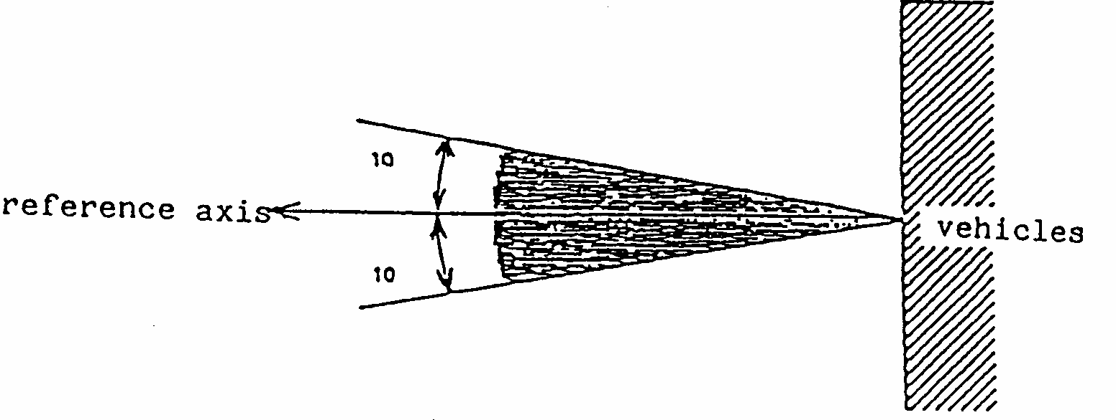
Minimum horizontal angles, SM1:
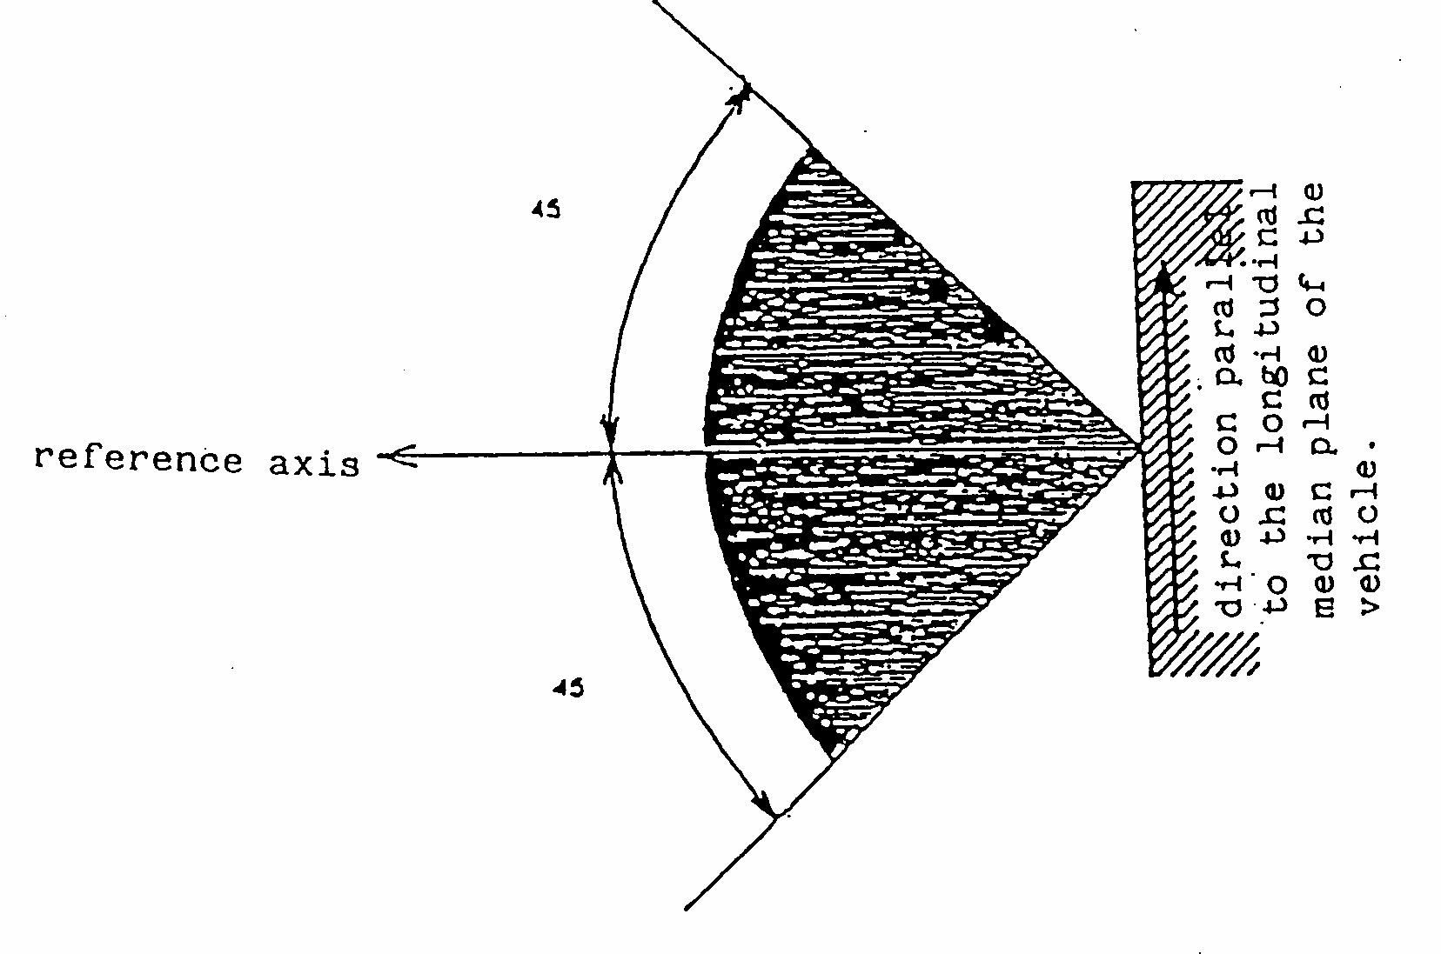
Minimum horizontal angles, SM2:
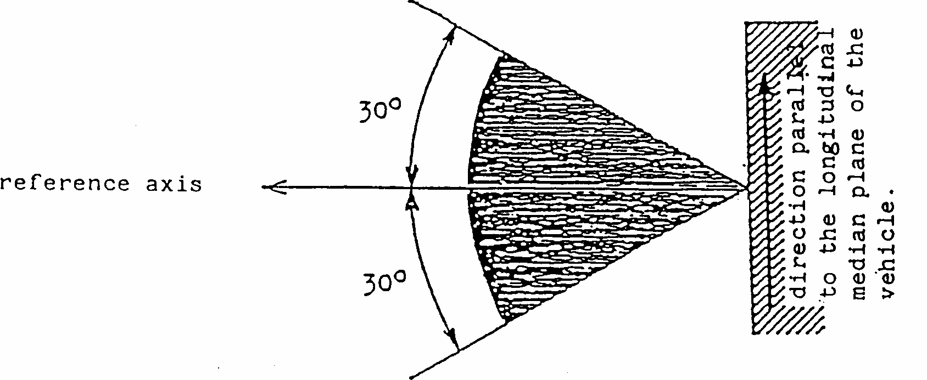
Annex 2
(Maximum format: A4 (210 x 297 mm))
COMMUNICATION

issued by: Name of administration
......................................
......................................
......................................

concerning: 2/ APPROVAL GRANTED
APPROVAL EXTENDED
APPROVAL REFUSED
APPROVAL WITHDRAWN
PRODUCTION DEFINITELY DISCONTINUED
of a type of side-marker lamp marked SM1/SM2 ^{2/} pursuant to Regulation. ...
Approval No. ................... Extension No. .....................
1. Trade name or mark of the side-marker lamp: .........................................................
2. Manufacturer's name for the type of side-marker lamp: ..........................................
3. Manufacturer's name and address: ...........................................................................
4. If applicable, name and address of the manufacturer's representative:
……………………………………………………………………........................
5. Submitted for approval on: ......................................................................................
6. Technical service responsible for conducting approval tests: .................................
7. Date of test report: ....................................................................................................
8. Number of test report: ...............................................................................................
9. Concise description 3/
Colour of light emitted: amber/red ^{2/}
Number and category of filament lamp(s): ...............................................................
10. Position of the approval mark: ..................................................................................
11. Reason(s) for extension (if applicable): ....................................................................
12. Approval granted/refused/extended/withdrawn:^{2/} ...................................................
13. Place:........................................................................................................................
14. Date:...........................................................................................................................
15. Signature:...................................................................................................................
16. The list of documents deposited with the Administrative Service which has granted approval is annexed to this communication and may be obtained on request.
Annex 3
ARRANGEMENTS OF APPROVAL MARKS
Example 1(a)
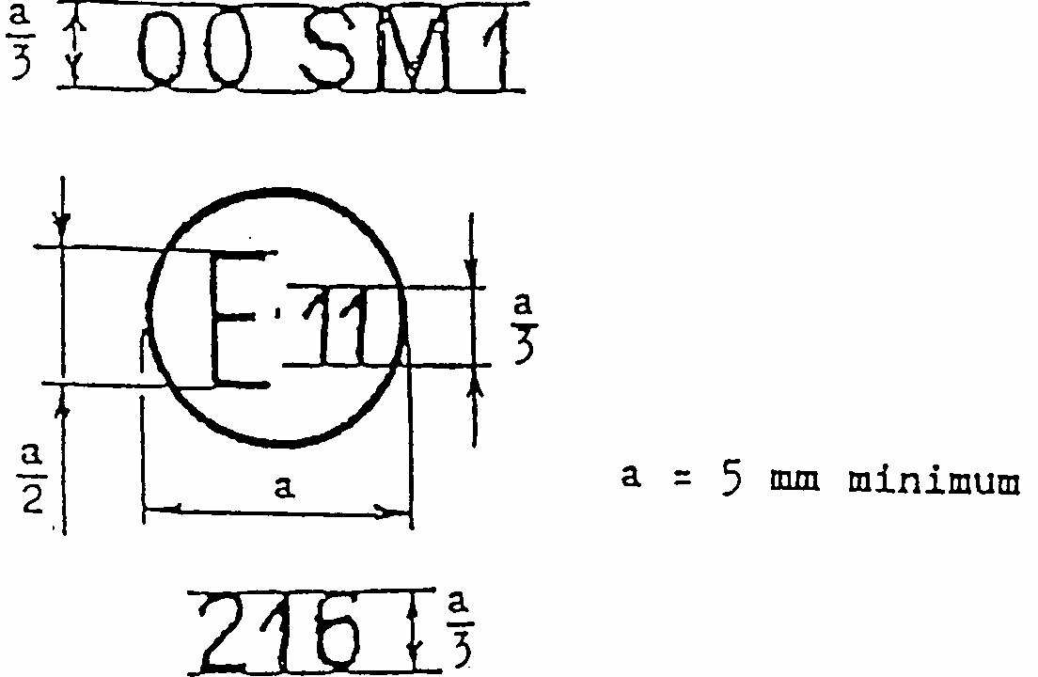
The device bearing the approval mark shown above is a side-marker lamp, approved in the United Kingdom (E 11) pursuant to Regulation No. 91 under the number 216.
Note: The number mentioned close to the symbol "SM1" indicates that the approval was granted in accordance with the requirements of this Regulation in its original form.
Example 1(b)
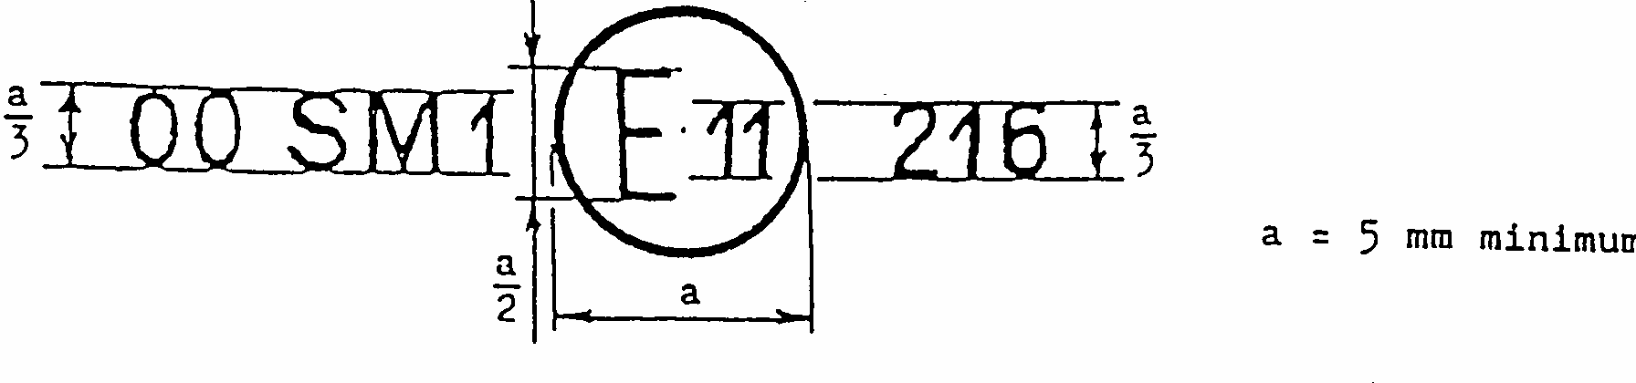
Example 2
Simplified marking for an assembly of several lamps that are part of the same unit
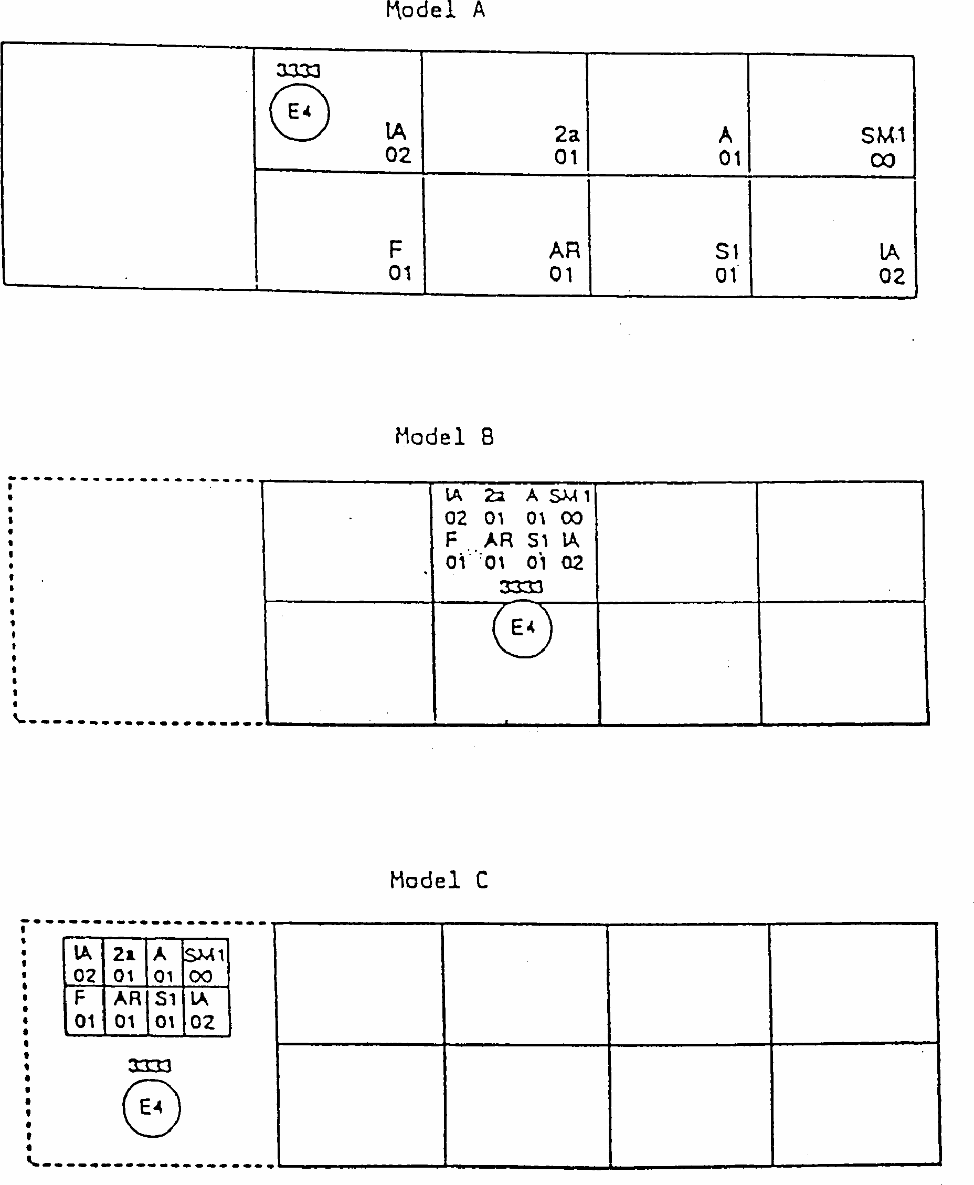
Note:
The three examples of approval mark, models A, B and C represent three possible variants of marking of a light-signalling device when two or more lamps are part of the same unit of grouped, combined or reciprocally incorporated lamps.
The approval mark shows that the device was approved in the Netherlands (E4) under the number 3333 and comprises:
A rear and a side retro-reflector of class IA approved in accordance with Regulation No. 3, 02 series of amendments;
A rear direction indicator lamp of category 2a approved in accordance with Regulation No. 6, 01 series of amendments;
A rear position lamp (R) approved in accordance with Regulation No. 7, 01 series of amendments;
A rear fog lamp (F) approved in accordance with Regulation No. 38. 01 series of amendments;
A reversing lamp (AR) approved in accordance with Regulation No. 23, 01 series of amendments;
A stop lamp (S1) approved in accordance with Regulation No. 7, 01 series of amendments;
A side-marker lamp (SM1) approved in conformity with the present Regulation in its original form. Lamp reciprocally incorporated as grouped with a headlamp
Example 3
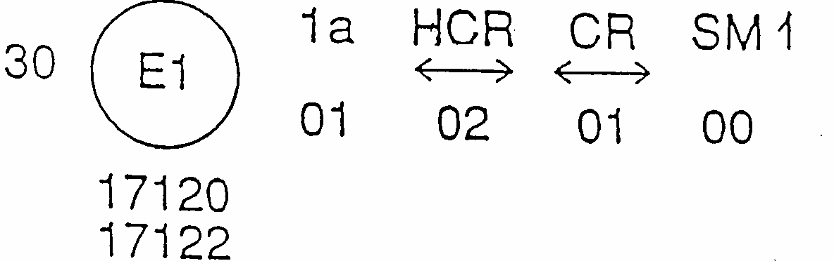
The above example corresponds to the marking of a lens intended to be used in different types of headlamps, namely:
Either: a headlamp with a passing beam designed for right-hand and left-hand traffic and a driving beam with a maximum intensity comprised between 86,250 and 101,250 candelas, approved in Germany (El) in accordance with the requirements of Regulation No. 8 as amended by the 02 series of amendments; which is reciprocally incorporated with a front direction indicator approved in accordance with the 01 series of amendments to Regulation No. 6 and grouped with a side-marker lamp in accordance with this Regulation in the original form.
or: a headlamp with a passing beam designed for right-hand and left-hand traffic and a driving beam approved in Germany (El) in accordance with the requirements of Regulation No. 1 as amended by the 01 series of amendments, which is reciprocally incorporated with the same front direction indicator and the same side- marker lamp as above.
or even: either of the above-mentioned headlamps approved as a single lamp.
The main body of the headlamp shall bear the only valid approval number, for instance:
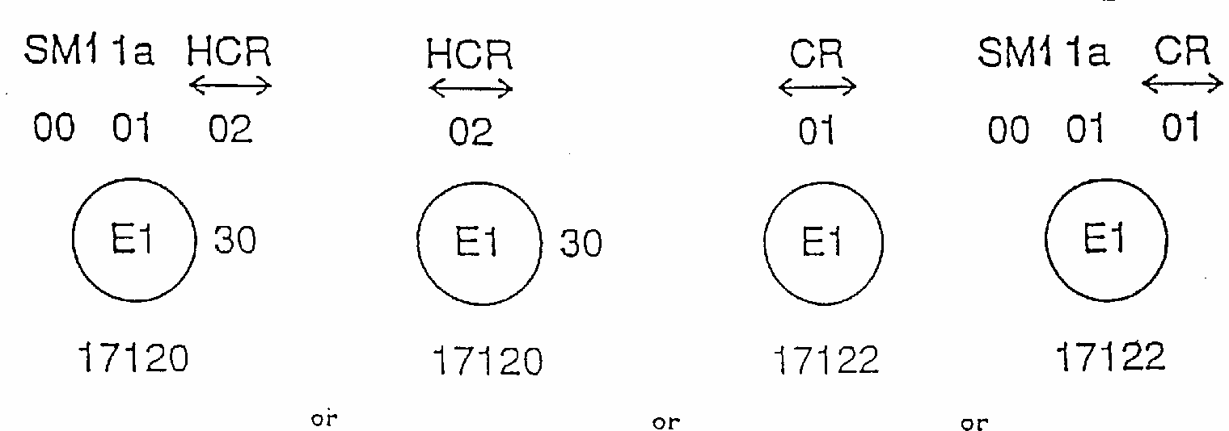

Annex 4
PHOTOMETRIC MEASUREMENTS
1. Measurement methods
1.1. During photometric measurement stray reflections shall be avoided by appropriate marking.
1.2. In case the results of measurements should be challenged, measurements shall be carried out in such a way as to meet the following requirements:
1.2.1. The distance of measurement shall be such that the law of the inverse of the square of the distance is applicable;
1.2.2. The measuring equipment shall be such that the angular aperture of the receiver viewed from the reference centre of the lamp is comprised between 10 minutes and 1 degree;
1.2.3. The intensity requirement for a particular direction of observation shall be deemed to be satisfied if that requirement is met in a direction deviating by not more than one-quarter of a degree from the direction of observation.
1.3. The direction H = 0 degrees and V = 0 degrees corresponds to the reference axis. (On the vehicle it is horizontal, perpendicular to the median longitudinal plane of the vehicle and oriented in the required direction of visibility). It passes through the centre of reference.
2. Tables of light distribution
2.1. SM1 category of side-marker lamps
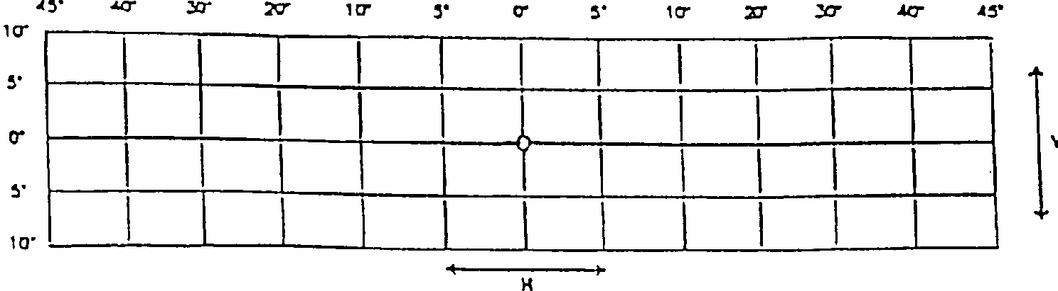
2.1.1. Minimum values:
0.6 cd at any point other than the reference axis, at which it shall be 4.0 cd.
2.1.2. Maximum values:
25.0 cd at any point
2.2. SM2 category of side-marker lamps
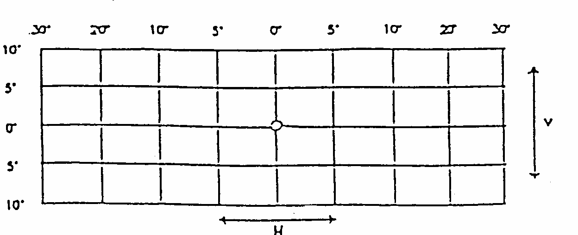
2.2.1. Minimum values:
0.6 cd, at any point
2.2.2. Maximum values:
25.0 cd, at any point
2.3. For SM1 and SM2 category of side-marker lamps it may be sufficient to check only five points selected by the test authority.
2.4. Within the field of light distribution shown above as a grid the light pattern should be substantially uniform, i.e. the light intensity in every direction within a part of the field formed by the grid lines shall meet at least the lowest minimum value applicable to the respective grid lines.
3. Photometric measurement of lamps equipped with several light sources
The photometric performance shall be checked:
3.1. For non-replaceable light sources (filament lamps and other):
with the light sources present in the lamp, in accordance with paragraph 9.2. of this Regulation.
3.2. For replaceable filament lamps:
when equipped with mass production filament lamps at 13.5V or 28V, the luminous intensity values produced shall lie between the maximum limit given in this Regulation and the minimum limit of this Regulation increased according to the permissible deviation of the luminous flux permitted for the type of filament lamp chosen, as stated in Regulation No. 37 for production filament lamps; alternatively, a standard filament lamp may be used in turn, in each of the individual positions, operated at its reference flux, the individual measurements in each position being added together.
Annex 5
COLOUR OF LIGHT EMITTED: LIGHTS FOR TRICHROMATIC COORDINATES
Amber: limit towards yellow: y < 0.429
limit towards red: y > 0.398
limit towards white: z < 0.007
Red: limit towards yellow: y < 0.335
limit towards purple: z < 0.008
For checking these colorimetric characteristics, a source of light at a colour temperature of 2,856 K, corresponding to illuminant A of the International Commission on Illumination (CIE), shall be used. However, for lamps equipped with non-replaceable light sources, (filament lamps and other), the colorimetric characteristics should be verified with the light sources present in the lamp, in accordance with paragraph 9.2. of this Regulation.
Annex 6
MINIMUM REQUIREMENTS FOR CONFORMITY OF PRODUCTION CONTROL PROCEDURES
1. GENERAL
1.1. The conformity requirements shall be considered satisfied from a mechanical and geometric standpoint, if the differences do not exceed inevitable manufacturing deviations within the requirements of this Regulation.
1.2. With respect to photometric performances, the conformity of mass-produced side- marker lamps shall not be contested if, when testing photometric performances of any side-marker lamp chosen at random and equipped with a standard filament lamp, or when the side-marker lamps are equipped with non-replaceable light sources (filament lamps or other) , and when all measurements are made at 6.75 V, 13.5 V or 28.0 V respectively:
1.2.1. no measured value deviates unfavourably by more than 20 % from the values prescribed in this Regulation.
1.2.2. If, in the case of a side-marker lamp equipped with a replaceable light source and if results of the test described above do not meet the requirements, tests on side-marker lamps shall be repeated using another standard filament lamp.
1.3. The chromaticity coordinates shall be complied with when the side-marker lamp is equipped with a standard filament lamp, or for side-marker lamps equipped with non- replaceable light sources (filament lamps or other), when the colorimetric characteristics are verified with the light source present in the side-marker lamp.
2. MINIMUM REQUIREMENTS FOR VERIFICATION OF CONFORMITY BY THE MANUFACTURER
For each type of side-marker lamp the holder of the approval mark shall carry out at least the following tests. at appropriate intervals. The tests shall be carried out in accordance with the provisions of this Regulation.
If any sampling shows non-conformity with regard to the type of test concerned, further samples shall be taken and tested. The manufacturer shall take steps to ensure the conformity of the production concerned.
2.1. Nature of tests
Tests of conformity in this Regulation shall cover the photometric and colorimetric characteristics.
2.2. Methods used in tests
2.2.1. Tests shall generally be carried out in accordance with the methods set out in this Regulation.
2.2.2. In any test of conformity carried out by the manufacturer, equivalent methods may be used with the consent of the competent authority responsible for approval tests. The manufacturer is responsible for proving that the applied methods are equivalent to those laid down in this Regulation.
2.2.3. The application of paragraphs 2.2.1. and 2.2.2. requires regular calibration of test apparatus and its correlation with measurements made by a competent authority.
2.2.4. In all cases the reference methods shall be those of this Regulation, particularly for the purpose of administrative verification and sampling .
2.3. Nature of sampling
Samples of side-marker lamps shall be selected at random from the production of a uniform batch. A uniform batch means a set of side-marker lamps of the same type, defined according to the production methods of the manufacturer.
The assessment shall in general cover series production from individual factories. However, a manufacturer may group together records concerning the same type from several factories, provided these operate under the same quality system and quality management.
2.4. Measured and recorded photometric characteristics
The sampled side-marker lamp shall be subjected to photometric measurements for the minimum values at the points listed in annex 4 and the chromaticity coordinates listed in annex 5, provided for in the Regulation.
2.5. Criteria governing acceptability
The manufacturer is responsible for carrying out a statistical study of the test results and for defining, in agreement with the competent authority, criteria governing the acceptability of his products in order to meet the specifications laid down for verification of conformity of products in paragraph 11.1. of this Regulation.
The criteria governing the acceptability shall be such that, with a confidence level of 95 %, the minimum probability of passing a spot check in accordance with annex 7 (first sampling) would be 0.95.
Annex 7
MINIMUM REQUIREMENTS FOR SAMPLING BY AN INSPECTOR
1. GENERAL
1.1. The conformity requirements shall be considered satisfied from a mechanical and a geometric standpoint, in accordance with the requirements of this Regulation, if any, if the differences do not exceed inevitable manufacturing deviations.
1.2. With respect to photometric performance, the conformity of mass-produced side-marker lamps shall not be contested if, when testing photometric performances of any side- marker lamp chosen at random and equipped with a standard filament lamp, or when the side-marker lamps are equipped with non-replaceable light sources (filament lamps or other) , and when all measurements are made at 6.75 V, 13.5 V or 28.0 V respectively:
l.2.1. no measured value deviates unfavourably by more than 20 % from the values prescribed in this Regulation.
1.2.2. If, in the case of a side-marker lamp equipped with a replaceable light source and if results of the test described above do not meet the requirements, tests on side-marker lamps shall be repeated using another standard filament lamp.
1.2.3. Side-marker lamps with apparent defects are disregarded.
1.3. The chromaticity coordinates shall be complied with when the side-marker lamp is equipped with a standard filament lamp, or for the side-marker lamps equipped with non-replaceable light sources (filament lamps or other), when the colorimetric characteristics are verified with the light source present in the side-marker lamp.
2. FIRST SAMPLING
In the first sampling four side-marker lamps are selected at random. The first sample of two is marked A, the second sample of two is marked B.
2.1. The conformity is not contested
2.1.1. Following the sampling procedure shown in Figure 1 of this annex the conformity of mass-produced side-marker lamps shall not be contested if the deviation of the measured values of the side-marker lamps in the unfavourable directions are:
2.1.1.1. sample A
A1: one side-marker lamp.............................................................. 0 %
one side-marker lamp not more than .....................................20 %
A2: both side-marker lamps more than..........................................0 %
but not more than...................................................................20 %
go to sample B
2.1.1.2. sample B
B1: both side-marker lamps ..........................................................0 %
2.1.2. or, if the conditions of paragraph 1.2.2. for sample A are fulfilled.
2.2. The conformity is contested
2.2.1. Following the sampling procedure shown in Figure 1 of this annex the conformity of mass-produced side-marker lamps shall be contested and the manufacturer requested to make his production meet the requirements (alignment) if the deviations of the measured values of the side-marker lamps are:
2.2.1.1. sample A
A3: one side-marker lamp not more than .....................................20 %
one side-marker lamp more than ...........................................20 %
but not more than ...................................................................30 %
2.2.1.2. sample B
B2: in the case of A2
one side-marker lamp more than .............................................0 %
but not more than ....................................................................20 %
one side-marker lamp not more than ....................................20 %
B3: in the case of A2
one side-marker lamp .............................................................0 %
one side-marker lamp more than ..........................................20 %
but not more than ..................................................................30 %
2.2.2. or, if the conditions of paragraph 1.2.2. for sample A are not fulfilled.
2.3. Approval withdrawn
Conformity shall be contested and paragraph 12 applied if, following the sampling procedure in Figure 1 of this annex, the deviations of the measured values of the side- marker lamps are:
2.3.1. sample A
A4 : one side-marker lamp not more than.....................................20 %
one side-marker lamp more than ..........................................30 %
A5: both side-marker lamps more than .........................................20 %
2.3.2. sample B
B4 : in the case of A2
one side-marker lamp more than .............................................0 %
but not more than ....................................................................20 %
one side-marker lamp more than............................................20 %
B5: in the case of A2
both side-marker lamps more than ......................................20 %
B6: in the case of A2
one side-marker lamp..............................................................0 %
one side-marker lamp more than............................................30 %
2.3.3. or, if the conditions of paragraph 1.2.2. for samples A and B are not fulfilled.
3. REPEATED SAMPLING
In the cases of A3, B2, B3 a repeated sampling, third sample C of two side-marker lamps and fourth sample D of two side-marker lamps, selected from stock manufactured after alignment, is necessary within two months' time after the notification.
3.1. The conformity is not contested
3.1.1. Following the sampling procedure shown in Figure 1 of this annex the conformity of mass-produced side-marker lamps shall not be contested if the deviations of the measured values of the side-marker lamps are :
3.1.1.1. sample C
C1: one side-marker lamp..............................................................0 %
one side-marker lamp not more than......................................20 %
C2: both side-marker lamps more than .........................................0 %
but not more than ...................................................................20 %
go to sample D
3.1.1.2. sample D
D1: in the case of C2
both side-marker lamps...........................................................0 %
3.1.2. or, if the conditions of paragraph 1.2.2. for sample C are fulfilled.
3.2. The conformity is contested
3.2.1. Following the sampling procedure shown in Figure 1 of this annex the conformity of mass-produced side-marker lamps shall be contested and the manufacturer requested to make his production meet the requirements (alignment) if the deviations of the measured values of the side-marker lamps are:
3.2.1.1. sample D
D2: in the case of C2
one side-marker lamp more than .............................................0 %
but not more than....................................................................20 %
one side-marker lamp not more than......................................20 %
3.2.1.2. or, if the conditions of paragraph 1.2.2. for sample C are not fulfilled.
3.3. Approval withdrawn
Conformity shall be contested and paragraph 12 applied if, following the sampling procedure in Figure 1 of this annex, the deviations of the measured values of the side- marker lamps are:
3.3.1. sample C
C3: one side-marker lamp not more than ......................................20 %
one side-marker lamp more than ...........................................20 %
C4: both side-marker lamps more than .......................................20 %
sample D
D3: in the case of C2
one side-marker lamp 0 or more than......................................0 %
one side-marker lamp more than............................................20 %
3.3.2. or, if the conditions of paragraph 1.2.2. for samples C and D are not fulfilled.
Figure 1
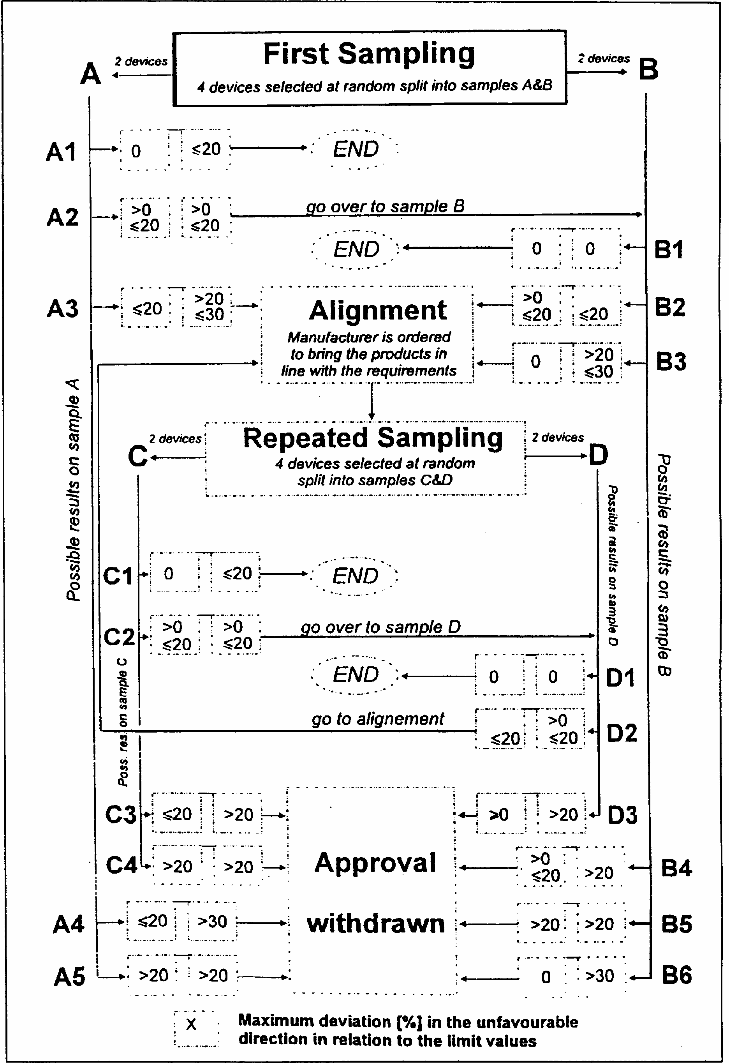

1/ 1 for Germany, 2 for France, 3 for Italy, 4 for the Netherlands, 5 for Sweden, 6 for Belgium, 7 for Hungary, 8 for the Czech Republic, 9 for Spain, 10 for Yugoslavia, 11 for the United Kingdom, 12 for Austria, 13 for Luxembourg, 14 for Switzerland, 15 (vacant), 16 for Norway, 17 for Finland, 18 for Denmark, 19 for Romania, 20 for Poland, 21 for Portugal, 22 for the Russian Federation, 23 for Greece, 24 (vacant), 25 for Croatia, 26 for Slovenia, 27 for Slovakia, 28 for Belarus, 29 for Estonia, 30-36 (vacant) and 37 for Turkey. Subsequent numbers shall be assigned to other countries in the chronological order in which they ratify the Agreement Concerning the Adoption of Uniform Conditions of Approval and Reciprocal Recognition of Approval for Motor Vehicle Equipment and Parts, or in which they accede to that Agreement, and the numbers thus assigned shall be communicated by the Secretary-General of the United Nations to the Contracting Parties to the Agreement.
2^{1/} Distinguishing number of the country which has granted/extended/refused/withdrawn approval (see approval provisions in the Regulation). 2/ Strike out what does not apply.
3/ For lamps with non-replaceable light sources indicate the number and the total wattage of the light sources.

