Vehicle Standard (Australian Design Rule 78/00 – Gas Discharge Light Sources) 2006
I, JAMES ERIC LLOYD, Minister for Local Government, Territories and Roads, determine this vehicle standard under subsection 7 (1) of the Motor Vehicle Standards Act 1989.

Dated 31 July 1905

[SIGNED]

James Eric Lloyd

Minister for Local Government, Territories and Roads

CONTENTS

0. legislative provisions 3
1. SCOPE 3
2. APPLICABILITY AND IMPLEMENTATION 3
3. DEFINITIONS 3
4. REQUIREMENTS 3
5. EXEMPTIONS AND ALTERNATIVE PROCEDURES 4
6. SUPPLEMENTARY GENERAL REQUIREMENTS 4
7. ALTERNATIVE STANDARDS 4
8. NOTES 4
APPENDIX A 5

- legislative provisions
  - NAME OF STANDARD
    - This Standard is the Vehicle Standard (Australian Design Rule 78/00 – Gas Discharge Light Sources) 2006.
    - This Standard may also be cited as Australian Design Rule 78/00 — Gas Discharge Light Sources.
  - COMMENCEMENT
    - This Standard commences on the day after it is registered.
  - REPEAL
    - This Standard repeals each vehicle standard with the name Australian Design Rule 78/00 — Gas Discharge Light Sources that is:
(a) made under section 7 of the Motor Vehicle Standards Act 1989; and
(b) in force at the commencement of this Standard.
    - This Standard also repeals each instrument made under section 7 of the Motor Vehicle Standards Act 1989 that creates a vehicle standard with the name Australian Design Rule 78/00 — Gas Discharge Light Sources, if there are no other vehicle standards created by that instrument, or amendments to vehicle standards made by that instrument, that are still in force at the commencement of this Standard.
- SCOPE
  - This Australian Design Rule(ADR) prescribes the dimensional, electrical and photometric requirements for gas-discharge light sources which ensure interchangeability and correct functioning when installed in a gas-discharge headlamp.
- APPLICABILITY AND IMPLEMENTATION
  - The circumstances under which gad discharge headlamps are mandatory, optional, or prohibited are set out in either ADRs 13/…, 19/… or 67/….
- DEFINITIONS
  - Refer to paragraph 2.1 of Appendix A.
- REQUIREMENTS
  - Devices complying with the technical requirements of Appendix A as varied by part 5 Exemptions and Alternative Procedures and part 6 Supplementary General Requirements shall be accepted as complying with this rule.
- EXEMPTIONS AND ALTERNATIVE PROCEDURES
  - The following provisions of appendix A do not apply to this rule
    - Section 2 Administrative provisions
Section 2.2 Application for approval
Section 2.3 Inscriptions
Section 2.4 Approval
Section 5 Penalties for non-conformity of production
Section 6 Production definitely discontinued
Section 7 Names and addresses of technical services responsible for conducting approval tests and of administrative departments
Annex 2 Communication concerning the approval or extension or refusal or withdrawal of approval or production definitely discontinued of a type of gas discharge light source pursuant to Regulation No.99
Annex 3 Examples of arrangements of the approval mark.
- SUPPLEMENTARY GENERAL REQUIREMENTS
The following general requirements are supplementary to the requirements of appendix A.
  - The requirements and procedures set out in Annexes 6, 7 and 8 of Appendix A are acceptable for the purposes of demonstrating compliance with the technical requirements of this rule.
- ALTERNATIVE STANDARDS
  - The technical requirements of any editions of the United Nations –Economic Commission for Europe (UN ECE) Regulation No. 99 - UNIFORM PROVISIONS CONCERNING THE APPROVAL OF GAS-DISCHARGE LIGHT SOURCES FOR USE IN APPROVED GAS-DISCHARGE LAMP UNITS OF POWER DRIVEN VEHICLES incorporating the 00 series of amendments are deemed to be equivalent to the technical requirements of this rule.
- NOTES
  - In place of Regulation No 48 where referenced in Appendix A, read ADR 13/00.
  - In place of Regulation No 37 where referenced in Appendix A, read ADR 51/00.
APPENDIX A

UN-ECE REGULATION NO. 99/00
UNIFORM PROVISIONS CONCERNING THE APPROVAL OF GAS-DISCHARGE LIGHT SOURCES FOR USE IN APPROVED GAS-DISCHARGE LAMP UNITS OF POWER DRIVEN VEHICLES

Regulation No. 99
UNIFORM PROVISIONS CONCERNING THE APPROVAL OF GAS-DISCHARGE LIGHT SOURCES FOR USE IN APPROVED GAS-DISCHARGE LAMP UNITS OF POWER-DRIVEN VEHICLES
CONTENTS
1. Scope
2. Administrative provisions
2.1. Definitions
2.2. Application for approval
2.3. Inscriptions
2.4. Approval
3. Technical requirements
3.1. Definitions
3.2. General specifications
3.3. Manufacture ..
3.4. Tests
3.5. Position and dimensions of electrodes, arc and stripes
3.6. Starting, run-up and hot restrike characteristics
3.7. Electrical characteristics
3.8. Luminous flux
3.9. Colour
3.10. UV-radiation
3.11. Standard gas-discharge light sources
4. Conformity of production
5. Penalties for non-conformity of production
6. Production definitely discontinued
7. Names and addresses of the technical services responsible for conducting approval tests, and of administrative departments
ANNEXES
Annex 1 - Sheets D1S/D2S
Sheets D1R/D2R
Annex 2 - Communication concerning the approval or extension or refusal or withdrawal of approval or production definitely discontinued of a type of gas-discharge light source pursuant to Regulation No. 99 Annex 3 -Example of arrangement of the approval mark
Annex 4 - Method of measurement of electrical and photometric characteristics
Annex 5 - Optical setup for the measurement of the position and form of the arc and of the position of the electrodes
Annex 6 - Minimum requirements for quality control-procedures by the manufacturer
Annex 7 - Sampling and compliance levels for manufacturer test records
Annex 8 - Minimum requirements for sampling by an inspector

Regulation No. 99
UNIFORM PROVISIONS CONCERNING THE APPROVAL OF GAS-DISCHARGE LIGHT SOURCES FOR USE IN APPROVED GAS-DISCHARGE LAMP UNITS OF POWER-DRIVEN VEHICLES
1. SCOPE
This Regulation applies to gas-discharge light sources shown in annex 1 and intended for use in approved gas-discharge lamp units of power-driven vehicles.
2. ADMINISTRATIVE PROVISIONS
2.1. Definitions
2.1.1. The term "category", is used in this Regulation to describe different basic designs of standardized gas-discharge light sources. Each category has a specific designation, as for example: "D2S".
2.1.2. Gas-discharge light sources of different "types" are gas-discharge light sources within the same category which differ in such essential respects as:
2.1.2.1. Trade name or mark; 1/
2.1.2.2. Bulb design, in so far as these differences affect the optical results;
2.1.2.3. Bulb colour. A yellow bulb or an additional yellow outer bulb, solely intended to change the colour but not the other characteristics of a gas-discharge light source emitting white light, does not constitute a change of type of the gas-discharge light source.
2.2. Application for approval
2.2.1. Application for approval shall be submitted by the owner of the trade name or mark, or by his duly accredited representative.
2.2.2. Every application for approval shall be accompanied (see also paragraph 2.4.2.) by:
2.2.2.1. Drawings in triplicate, sufficiently detailed to permit identification of the type;
2.2.2.2. A technical description including ballast identification;
2.2.2.3. Three samples of each colour which has been applied for;
2.2.2.4. One sample of the ballast.
2.2.3. In the case of a type of gas-discharge light source differing only by the trade name or mark from a type that has already been approved, it shall be sufficient to submit:
2.2.3.1. A declaration by the manufacturer that the type submitted is (except in the trade name or mark) identical to and has been produced by the same manufacturer as the type already approved, the latter being identified by its approval code;
2.2.3.2. Two samples bearing the new trade name and mark.
2.2.4. The competent authority shall verify the existence of satisfactory arrangements for ensuring effective control of the conformity of production before type approval is granted.
2.3. Inscriptions
2.3.1. Gas-discharge light sources submitted for approval shall bear on the cap:
2.3.1.1. The trade name or mark of the applicant;
2.3.1.2. The international designation of the relevant category;
2.3.1.3. The rated wattage; this need not be indicated separately if it is part of the international designation of the relevant category;
2.3.1.4. A space of sufficient size to accommodate the approval mark.
2.3.2. The space mentioned in paragraph 2.3.1.4. shall be indicated in the drawings accompanying the application for approval.
2.3.3. Other inscriptions than those covered by paragraphs 2.3.1. and 2.4.4. may be affixed on the cap.
2.3.4. The ballast used for the type approval of the light source shall be marked with type and trade mark identification and with the rated voltage and wattage, as indicated on the relevant lamp data sheet.
2.4. Approval
2.4.1. If all samples of a type of gas-discharge light source which are submitted in accordance with paragraphs 2.2.2.3. or 2.2.3.2. comply with the requirements of this Regulation when tested with the ballast according to paragraph 2.2.2.4., approval shall be granted.
2.4.2. An approval code shall be assigned to each type approved. Its first character shall indicate the series of amendments incorporating the most recent major technical amendments made to the Regulation at the time of issue of the approval.
This will be followed by an identification code comprising not more than two characters. Only the Arabic numerals and capital letters listed in footnote 2/ shall be used.
The same Contracting Party may not assign the same code to another type of gas- discharge light source. If the applicant so desires the same approval code may be assigned to both the gas-discharge light sources emitting white and yellow light (see paragraph 2.1.2.3.).
2.4.3. Notice of approval or of extension, or refusal or withdrawal of approval or production definitely discontinued of a type of gas-discharge light source pursuant to this Regulation shall be communicated to the Parties of the Agreement which apply this Regulation by means of a form conforming to the model in annex 2 to this Regulation and of a drawing, supplied by the applicant, for approval, in a format not exceeding A4 (210 x 297mm) and on a scale of at least 2 : 1.
2.4.4. To every gas-discharge light source conforming to a type approved under this Regulation there shall be affixed in the space referred to in paragraph 2.3.1.4., in addition to the inscription required under paragraph 2.3.1., an international approval mark consisting of:
2.4.4.1. A truncated circle surrounding the letter 'E' followed by the distinguishing number of the country granting approval; 3/
2.4.4.2. The approval code, placed close to the truncated circle.
2.4.5. If the applicant has obtained the same approval code for several trade names or marks, one or more of them will suffice to meet the requirements of paragraph 2.3.1.1.
2.4.6. The marks and inscriptions specified in paragraphs 2.3.1. and 2.4.3. shall be clearly legible and indelible.
2.4.7. Annex 3 to this Regulation gives an example of a type of approval mark.
3. TECHNICAL REQUIREMENTS
3.1. Definitions
3.1.1. "Gas-discharge light source": Light source in which the light is produced by a stabilized discharge arc.
3.1.2. "Ballast": Specific electrical supply for the gas-discharge light source.
3.1.3. "Rated voltage": Input voltage marked on the ballast.
3.1.4. "Rated wattage": Wattage marked on the gas-discharge light source and ballast.
3.1.5. "Test voltage": Voltage at the input terminals of the ballast for which the electrical and photometry characteristics of the gas-discharge light source are intended and are to be tested.
3.1.6. "Objective value": Design value of an electrical or photometry characteristic. To be achieved, within the specified tolerances, when the gas-discharge light source is energized by the ballast operated at the test voltage.
3.1.7. "Standard (etalon) gas-discharge light source": Special gas-discharge light source used for the testing of headlamps. It has reduced dimensional, electrical and photometric characteristics as specified on the relevant data sheet.
3.1.8. "Reference axis": An axis defined with reference to the cap and to which certain dimensions of the gas-discharge light source are referred.
3.1.9. "Reference plane": A plane defined with reference to the cap and to which certain dimensions of the gas-discharge light source are referred.
3.2. General specifications
3.2.1. Each sample submitted shall conform to the relevant specifications of this Regulation when tested with the ballast according to paragraph 2.2.2.4.
3.2.2. Gas-discharge light sources shall be so designed as to be and to remain in good working order when in normal use. They shall moreover exhibit no fault in design or manufacture.
3.3. Manufacture
3.3.1. The bulb of the gas-discharge light source shall exhibit no marks or spots which might impair their efficiency and their optical performance.
3.3.2. In the case of a coloured (outer) bulb, after an operating period of 15 hours with the ballast at test voltage, the surface of the bulb shall be lightly wiped with a cotton cloth soaked in a mixture of 70 volume % of n-heptane and 30 volume % of toluol. After five minutes, the surface shall be inspected visually. It shall not show any apparent changes.
3.3.3. Gas-discharge light sources shall be equipped with standard caps, complying with the cap data sheets of IEC Publication 61, third edition, as specified on the individual data sheets of annex 1.
3.3.4. The cap shall be strong and firmly secured to the bulb.
3.3.5. To ascertain whether gas-discharge light sources conform to the requirements of paragraphs 3.3.3. to 3.3.4., a visual inspection, a dimension check and, where appropriate, a trial fitting shall be carried out.
3.4. Tests
3.4.1. Gas-discharge light sources shall be aged as indicated in annex 4.
3.4.2. All samples shall be tested with the ballast, according to paragraph 2.2.2.4.
3.4.3. Electrical measurements shall be carried out with instruments of at least class 0.2. (0.2% full scale accuracy).
3.5. Position and dimensions of electrodes, arc and stripes
3.5.1. The geometric position of the electrodes shall be as specified on the relevant data sheet. An example of a method of measuring arc and electrodes position is given in annex 5. Other methods may be used.
3.5.1.1. The position and dimensions of the light source electrodes shall be measured before the ageing period, the gas-discharge light source unlit and using optical methods through the glass envelope.
3.5.2. The shape and the displacement of the arc shall conform to the requirements as given on the relevant data sheet.
3.5.2.1. The measurement shall be made after ageing with the light source supplied by the ballast at test voltage.
3.5.3. The position and dimension and transmission of the stripes shall comply with the requirements as given on the relevant data sheet.
3.5.3.1. The measurement shall be made after ageing with the light source supplied by the ballast at test voltage.
3.6. Starting, run-up and hot-restrike characteristics
3.6.1. Starting
When tested according to the conditions specified in annex 4, the gas-discharge light source shall start directly and remain alight.
3.6.2. Run-up
When measured according to the conditions specified in annex 4, the gas-discharge light source shall emit at least:
After 1 second : 25% of its objective luminous flux;
After 4 seconds: 80% of its objective luminous flux.
The objective luminous flux as indicated on the relevant data sheet.
3.6.3. Hot-restrike
When tested according to the conditions specified in annex 4, the gas-discharge light source shall restart directly after being switched-off for a period, as indicated on the data sheet. After one second the light source shall emit at least 80% of its objective luminous flux.
3.7. Electrical characteristics
When measured according to the conditions specified in annex 4, the voltage and wattage of the light source shall be within the limits given on the relevant data sheet.
3.8. Luminous flux
When measured according to the conditions specified in annex 4, the luminous flux shall be within the limits given on the relevant data sheet. In the case where white and yellow is specified for the same type, the objective value applied to light sources emitting white light, whereas the luminous flux of the light source emitting yellow light shall be at least 68% of the specified value.
3.9. Colour
3.9.1. The colour of the light emitted shall be white or yellow, as prescribed on the relevant data sheet.
3.9.2. In case of white light, the calorimetric characteristics, expressed in CIE chromaticity coordinates, shall lie within the limits given on the relevant data sheet which are to be within the area formed by the following limits:
Towards blue....................................................... ......x > 0.310
Towards yellow...........................................................x < 0.500
Towards green..............................................................y < 0.150 + 0.640x
Towards green...............................................................y < 0.440
Towards purple.................................................. ............y > 0.050 + 0.750x
Towards red.....................................................................y > 0.382
3.9.3. In case of yellow light, the calorimetric characteristics shall lie within the area formed by the following limits:
Towards red...................................................................y > 0.138 + 0.580 x
Towards green................................................................y < 1.29 x - 0.100
Towards white................................................................y > -x + 0.940
and y > 0.440
Toward spectral value .....................................................y < -x + 0.992
3.9.4. The colour shall be measured according to the conditions specified in annex 4, paragraph 10.
3.9.5. The minimum red content of the light of a gas-discharge light source emitting white light shall be such that:
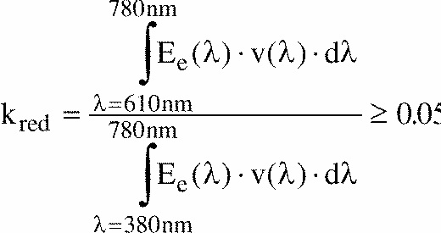
where:
E_{e}(lambda) [w] is the spectral distribution of the irradiance;
v(lambda) [l] is the spectral luminous efficiency;
(l) [nm] is the wave length.
This value shall be calculated using intervals of one nanometre.
3.10. UV-radiation
The UV-radiation of the gas-discharge light source shall be such that:
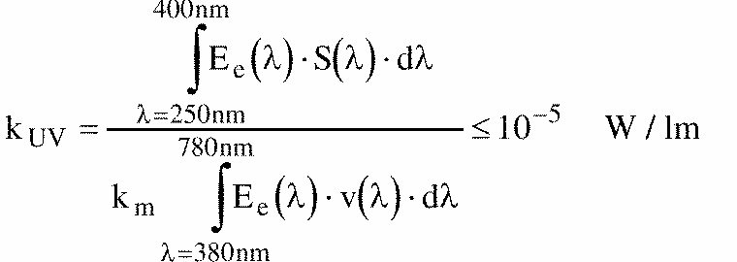
where:
s(l) [l] is the spectral weighting function;
km = 683 [lm/W] is the photometric radiation equivalent;
(For definitions of the other symbols see paragraph 3.9.5. above).
This value shall be calculated using intervals of one nanometre.
The UV - radiation shall be weighted according to the values as indicated in the following table:

lambda | s(lambda)
250 | 0.430
255 | 0.520
260 | 0.650
265 | 0.810
270 | 1.000
275 | 0.960
280 | 0.880
285 | 0.770
290 | 0.640
295 | 0.540
300 | 0.300
305 | 0.060
310 | 0.015
315 | 0.003
320 | 0.001
325 | 0.00050
330 | 0.00041
335 | 0.00034
340 | 0.00028
345 | 0.00024
350 | 0.00020
355 | 0.00016
360 | 0.00013
365 | 0.00011
370 | 0.00009
375 | 0.000077
380 | 0.000064
385 | 0.000053
390 | 0.000044
395 | 0.000036
400 | 0.000030
Wavelengths chosen are representative; other values should be interpolated. Values according to "IRPA/INIRC Guidelines on limits of exposure to ultraviolet radiation".
3.11. Standard gas-discharge light sources
Standard (etalon) gas-discharge light sources shall comply requirements applicable to type approval light sources and to the specific requirements as stated in the relevant data sheet.
In the case of a type emitting white and yellow light the standard light source shall emit white light.
4. CONFORMITY OF PRODUCTION
4.1. Gas-discharge light sources approved to this Regulation shall be so manufactured as to conform to the type approved by meeting the inscriptions and technical requirements set forth in paragraph 3 above and annexes 1 and 3 to this Regulation.
4.2. In order to verify that the requirements of paragraph 4.1. are met, suitable controls of the production shall be carried out.
4.3. The holder of the approval shall in particular:
4.3.1. ensure existence of procedures for the effective control of the quality of products,
4.3.2. have access to the control equipment necessary for checking the conformity to each approved type,
4.3.3. ensure that data of test results are recorded and that related documents shall remain available for a period to be determined in accordance with the administrative service,
4.3.4. analyse the results of each type of test, applying criteria of annex 7, in order to verify and ensure the stability of the product characteristics making allowance for variation of an industrial production,
4.3.5. ensure that for each type of gas-discharge light source, at least the tests prescribed in annex 6 to this Regulation are carried out,
4.3.6. ensure that any collecting of samples giving evidence of non-conformity with the type of test considered shall give rise to another sampling and another test. All the necessary steps shall be taken to re-establish the conformity of the corresponding production.
4.4. The competent authority which has granted type-approval may at any time verify the conformity control methods applicable to each production unit.
4.4.1. In every inspection, the test books and production survey records shall be presented to the visiting inspector.
4.4.2. The inspector may take samples at random which will be tested in the manufacturer's laboratory. The minimum number of samples may be determined according to the results of the manufacturer's own verification.
4.4.3. When the quality level appears unsatisfactory or when it seems necessary to verify the validity of the tests carried out in application of paragraph 4.4.2. above, the inspector shall select samples, to be sent to the technical service which has conducted the type approval tests.
4.4.4. The competent authority may carry out any tests prescribed in this Regulation. These tests will be on samples selected at random without causing distortion of the manufacturer's delivery commitments and in accordance with the criteria of annex 8.
4.4.5. The competent authority shall strive to obtain a frequency of inspection of once every two years. However, this is at the discretion of the competent authority and their confidence in the arrangements for ensuring effective control of the conformity of production. In the case where negative results are recorded, the competent authority shall ensure that all necessary steps are taken to re-establish the conformity of production as rapidly as possible.
5. PENALTIES FOR NON-CONFORMITY OF PRODUCTION
5.1. The approval granted in respect of a gas-discharge light source pursuant to this Regulation may be withdrawn if the prescribed conformity of production requirements are not met.
5.2. If a Contracting Party to the Agreement applying this Regulation withdraws an approval previously granted, it shall forthwith so notify the other Contracting Parties applying this Regulation, by means of the communication form conforming to the model in annex 2 to this Regulation.
6. PRODUCTION DEFINITELY DISCONTINUED
If the holder of the approval completely ceases to manufacture a gas-discharge light source type approved in accordance with this Regulation, he shall so inform the authority which had granted the approval. Upon receiving the relevant communication, that authority shall inform thereof the other Parties to the Agreement applying this Regulation by means of the communication form conforming to the model in annex 2 to this Regulation.
7. NAMES AND ADDRESSES OF THE TECHNICAL SERVICES RESPONSIBLE FOR CONDUCTING APPROVAL TESTS, AND OF ADMINISTRATIVE DEPARTMENTS
The Parties to the Agreement which apply this Regulation shall communicate to the Secretariat of the United Nations the names and addresses of the technical services responsible for conducting approval tests and of the administrative departments which grant approval and to which forms certifying approval or extension or refusal or withdrawal of approval, or production definitely discontinued, issued in other countries, are to be sent.
Annex 1
Categories D1S and D2S Sheet DlS/D2S/1
The drawings are intended only indicate the essential dimensions of the gas-discharge light source
Figure 1 Category D1S Type with cables Cap PK 32d-2
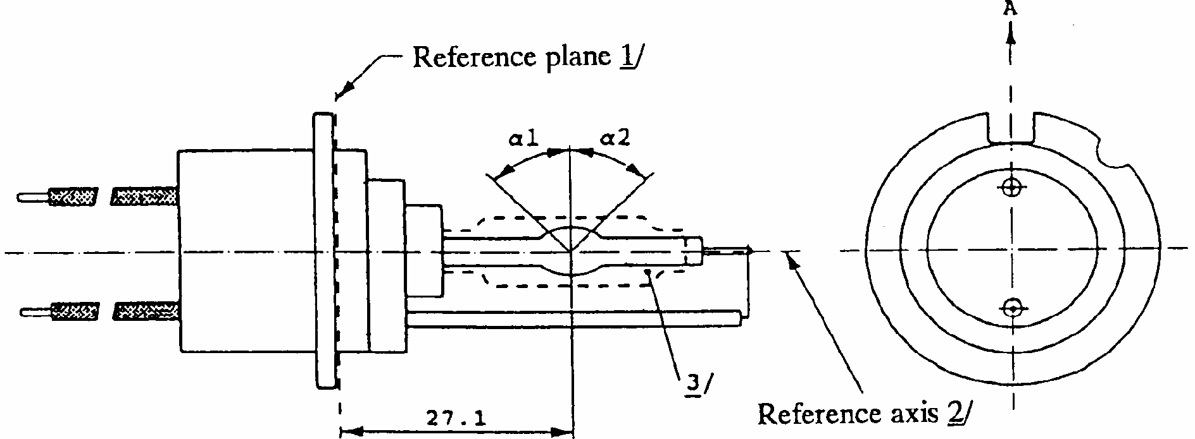
Figure 2 Category D2S Type with connector Cap P 32d-2
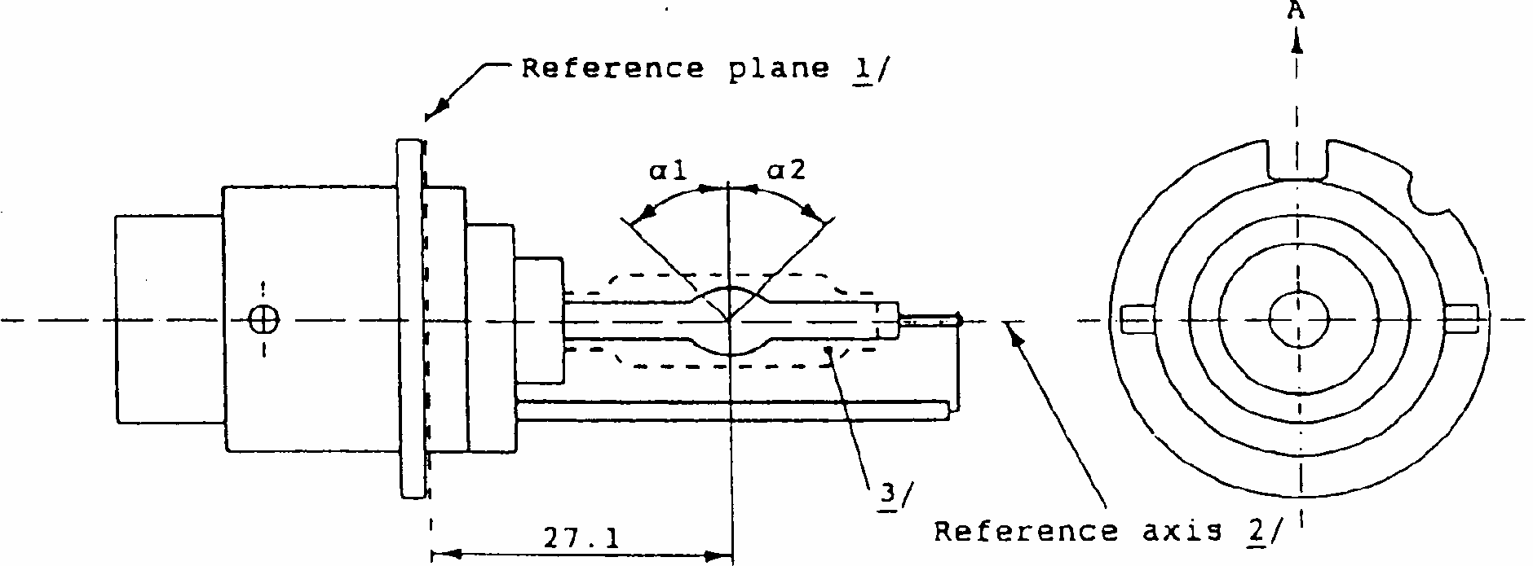

^{1/} The reference plane is defined by the position on the surface of the holder on which the three supporting bosses of the cap ring will rest.
^{2/} See sheet D1S/D2S/2.
^{3/} When measured at a distance of 27.1mm from the reference plane and with respect to the mid-point of the inner bulb, the outer bulb shall have an eccentricity of 1mm max.
DlS and D2S Sheet DlS/D2S/2
Figure 3 Definition of reference axis
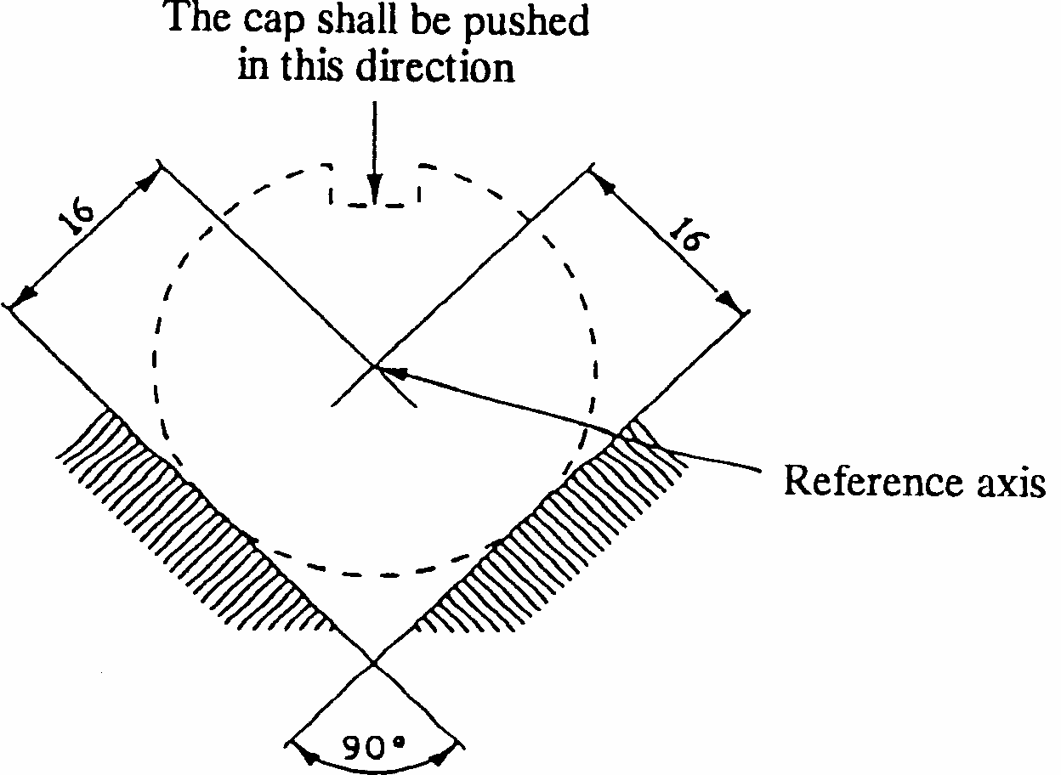
Figure 4 Maximum lamp outline
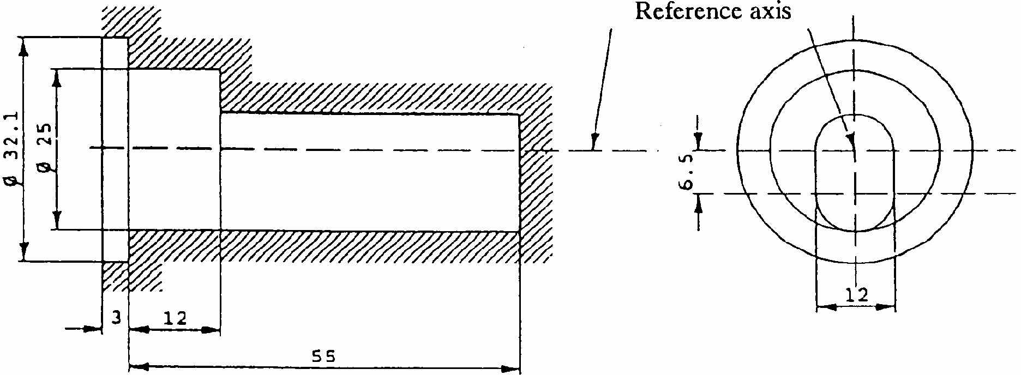
The reference axis is perpendicular to the reference plane and crosses the intersection of the two parallel lines as indicated in figure 3.

^{2/} Glass bulb and supports shall not exceed the envelope, as indicated in figure 4. The envelope is concentric with the reference axis.
Categories D1S and D2S Sheet DlS/D2S/3
Dimensions |  |  | Production light sources | Standard light sources
Position of the electrodes |  |  | Sheet D1S/D2S/4
Position and form of the arc |  |  | Sheet D1S/D2S/5
alpha1, alpha2 1/ |  |  | 55 degrees min. | 55 degrees min.
Category D1S: cap PK 32d-2 in accordance with IEC 61-1 (sheet 7004-111-1) Category D2S: cap P 32d-2 in accordance with IEC 61-1 (sheet 7004-111-1)
ELECTRIC AND PHOTOMETRIC CHARACTERISTICS
Rated voltage of the ballast |  | V | 12 2/ | 12
Rated wattage |  | W | 35 | 35
Test voltage |  | V | 13.5 | 13.5
Lamp voltage | Objective | V | 85 | 85
Lamp voltage | Tolerance | V | +/- 17 | +/- 8
Lamp wattage | Objective | W | 35 | 35
Lamp wattage | Tolerance | W | +/- 3 | +/- 0.5
Luminous flux | Objective | lm | 3,200 | 3,200
Luminous flux | Tolerance | lm | +/- 450 | +/- 150
Colour co-ordinates | Objective |  | x = 0.375 y = 0.375
Colour co-ordinates | Tolerance area 3/ |  | x > 0.345 y < 0.150 + 0.640 x  x < 0.405 y > 0.050 + 0.750 x
Hot restrike switch-off time |  |  | 10 | 10

Categories DlS and D2S Sheet DlS/D2S/4
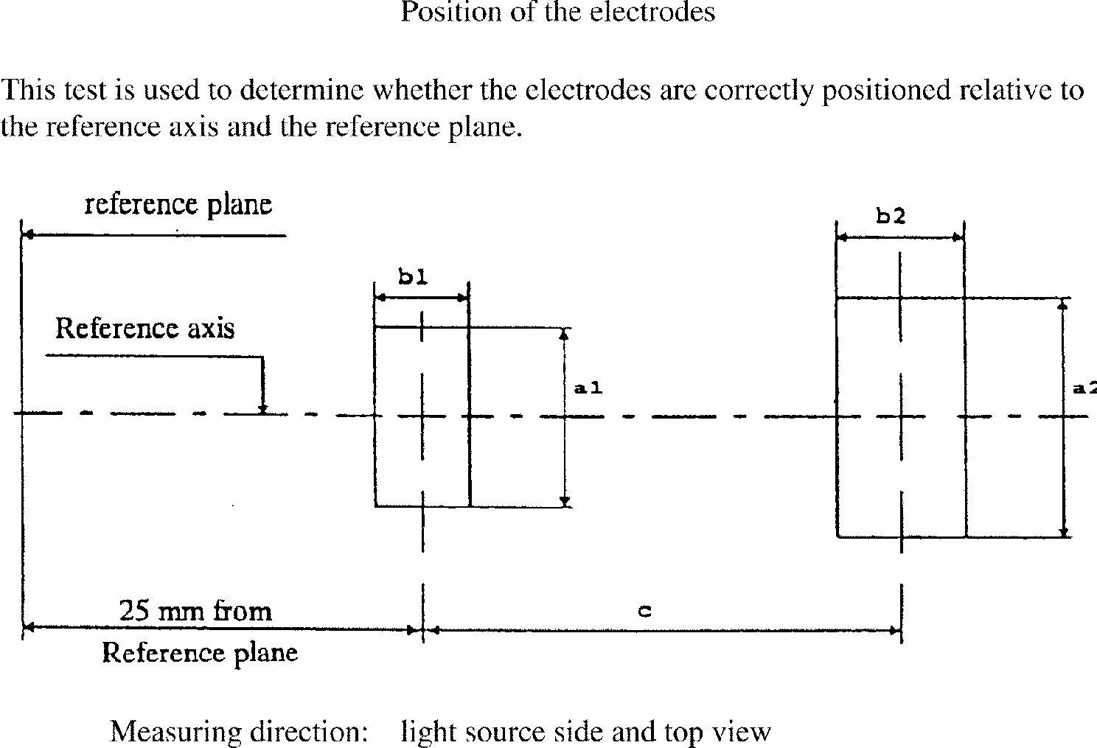
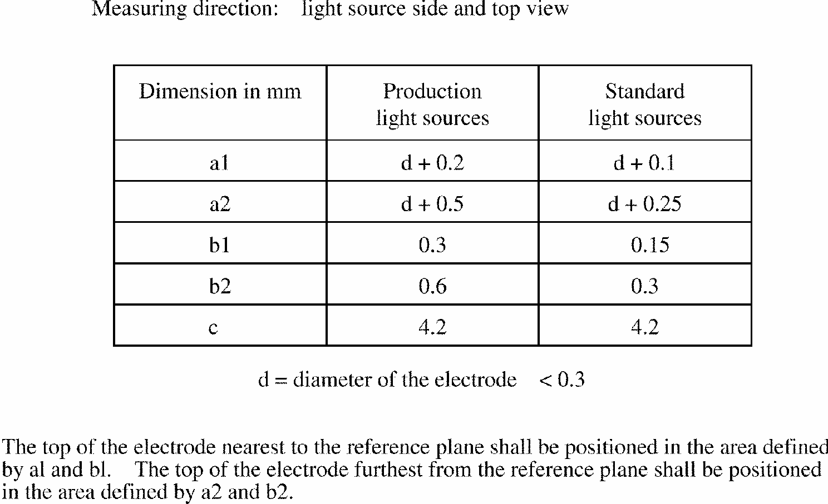
Categories DlS and D2S Sheet DlS/D2S/5
This test is used to determine the form of the arc and its position relative to the reference axis and plane by measuring its bending and diffusion in the cross section at a distance 27.1mm from the reference plane.
The form of the arc is for illustration purposes only.
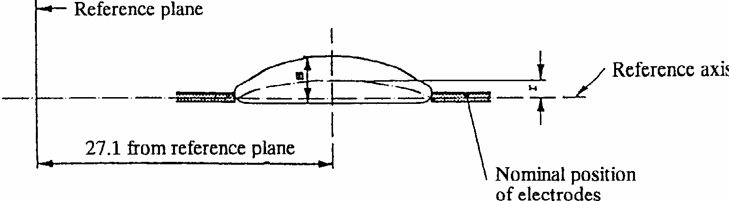
When measuring the relative luminance distribution in the central cross section as indicated in the drawing above, the maximum value shall be located within a distance r from the reference axis. The points of 20% of the maximum value shall be within s.
Dimension in mm | Production light sources | Standard light sources
r | 0.50 +/- 0.40 | 0.50 +/- 0.20
s | 1.10 +/- 0.40 | 1.10 +/- 0.25

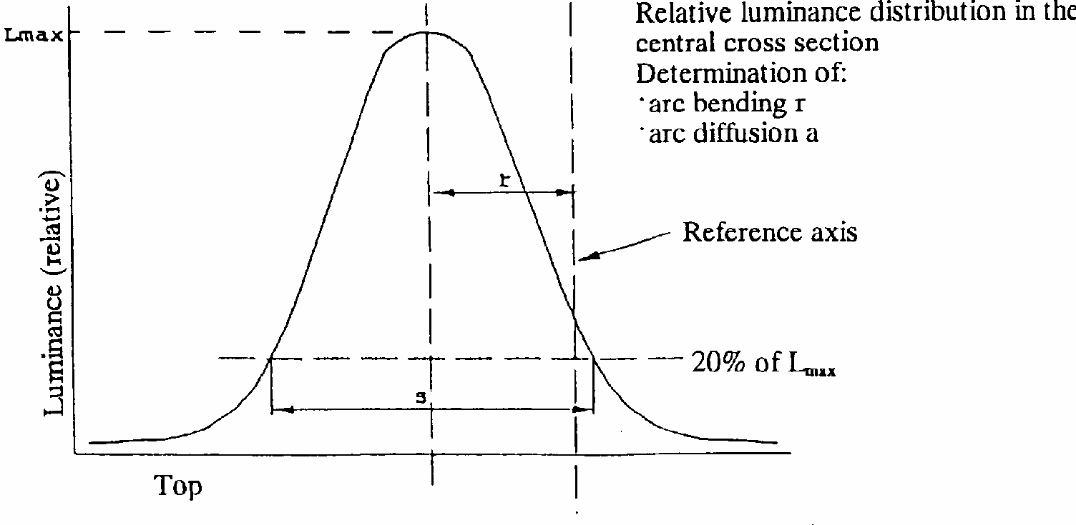
Categories D1R and D2R Sheet D1R/D2R/1
The drawings are intended only to indicate the essential dimensions of the gas-discharge light source
Figure 1 Category D1R Type with cables Cap PK 32d-3
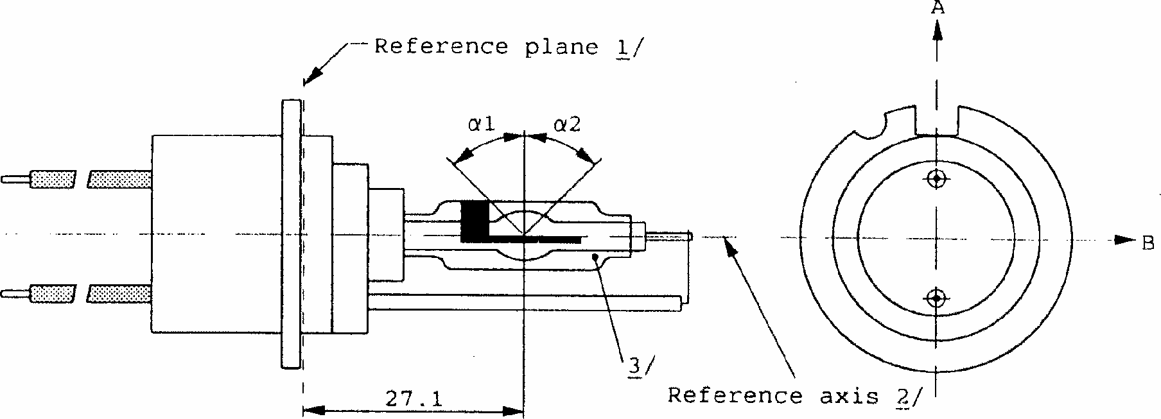

Category D2R Type with connector Cap P 32d-3

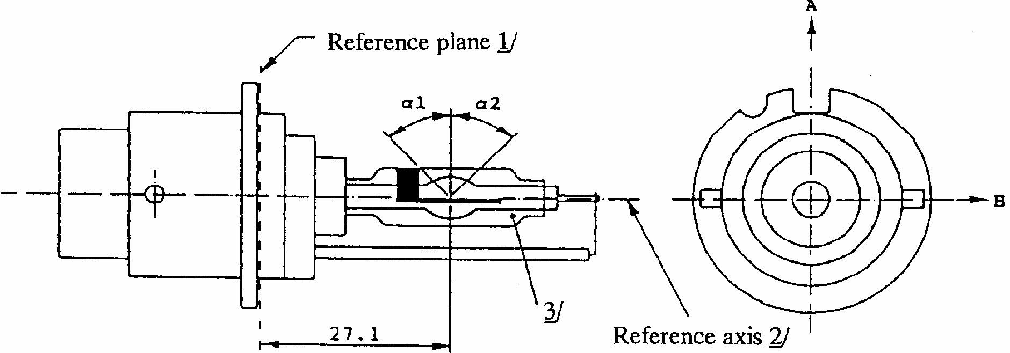

^{1/} The reference plane is defined by the positions on the surface of the holder on which the three supporting bosses of the cap ring will rest.
^{2/} See sheet D1R/D2R/2.
^{3/} With respect to the reference axis, when measured at a distance of 27.1mm from the reference plane the eccentricity of the outer bulb shall be less than +/- 0.5mm in direction B and less than + 1mm - 0.5mm in direction A.
Categories D1R and D2R Sheet D1R/D2R/2
Figure 3 Definition of reference axis 1/
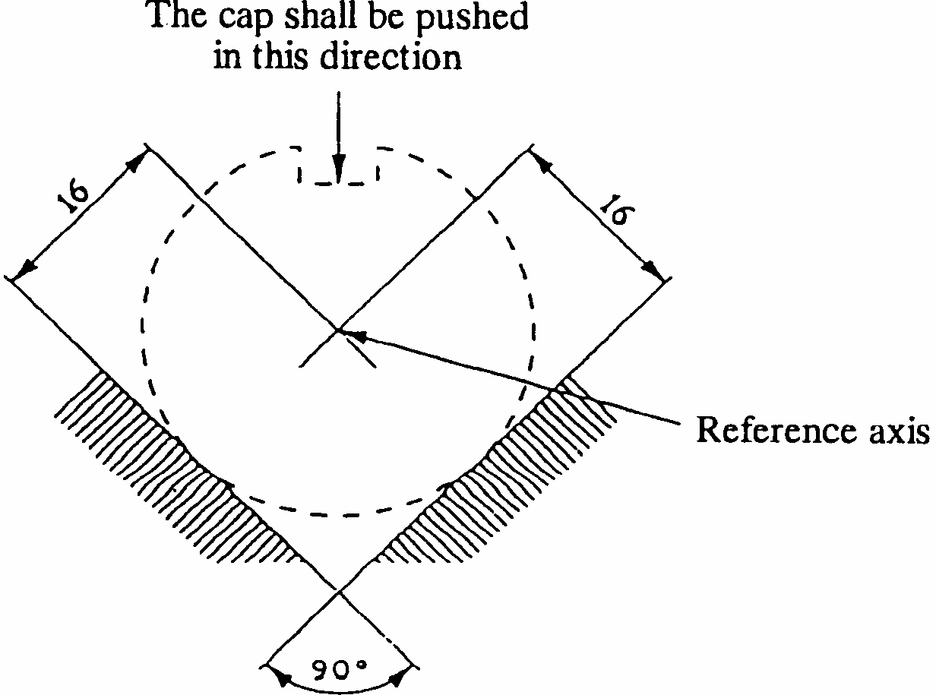
Figure 4 Maximum lamp outline 2/

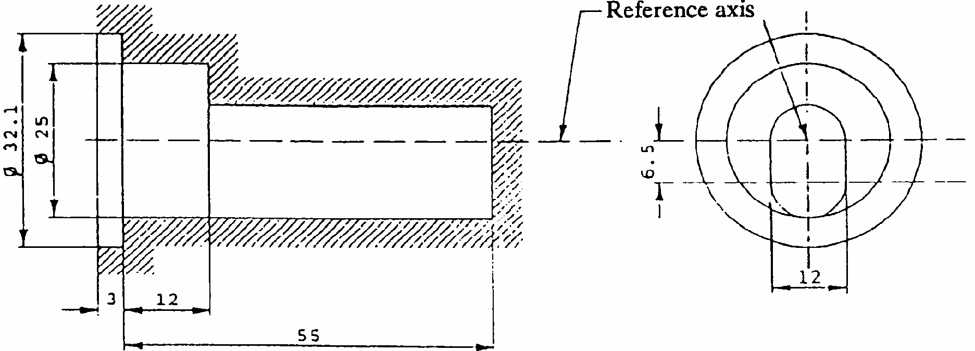
Categories D1R and D2R Sheet D1R/D2R/3

Dimensions |  |  | Production light sources | Standard light sources
Position of the electrodes |  |  | Sheet D1R/D2R/4
Position and form of the arc |  |  | Sheet D1R/D2R/5
Position of the black stripes |  |  | Sheet D1R/D2R/6
alpha1 ^{1/} |  |  | 45 degrees +/- 5 degrees
alpha2 1/ |  |  | 45 degrees min
Category D1R: cap PK32d-3 in accordance with IEC 61-1 (sheet 7004-111-1) Category D2R: cap P32d-3 in accordance with IEC 61-1 (sheet 7004-111-1)
ELECTRIC AND PHOTOMETRIC CHARACTERISTICS
Rated voltage of the ballast |  | V | 12 2/ | 12
Rated wattage |  | W | 35 | 35
Test voltage |  | V | 13.5 | 13.5
Lamp voltage | Objective | V | 85 | 85
Lamp voltage | Tolerance | V | +/- 17 | +/- 8
Lamp wattage | Objective | W | 35 | 35
Lamp wattage | Tolerance | W | +/- 3 | +/- 0.5
Luminous flux | Objective | lm | 2800 | 2800
Luminous flux | Tolerance | lm | +/- 450 | +/- 150
Colour co-ordinates | Objective |  | x = 0.375 y = 0.375
Colour co-ordinates | Tolerance area 3/ |  | x > 0.345 y < 0.150 + 0.640 x  x < 0.405 y > 0.050 + 0.750 x
Hot restrike switch-off time |  |  | 10 | 10

Categories D1R and D2R Sheet D1R/D2R/4
Position of electrodes
This test is used to determine whether the electrodes are correctly positioned relative to the reference axis and the reference plane.
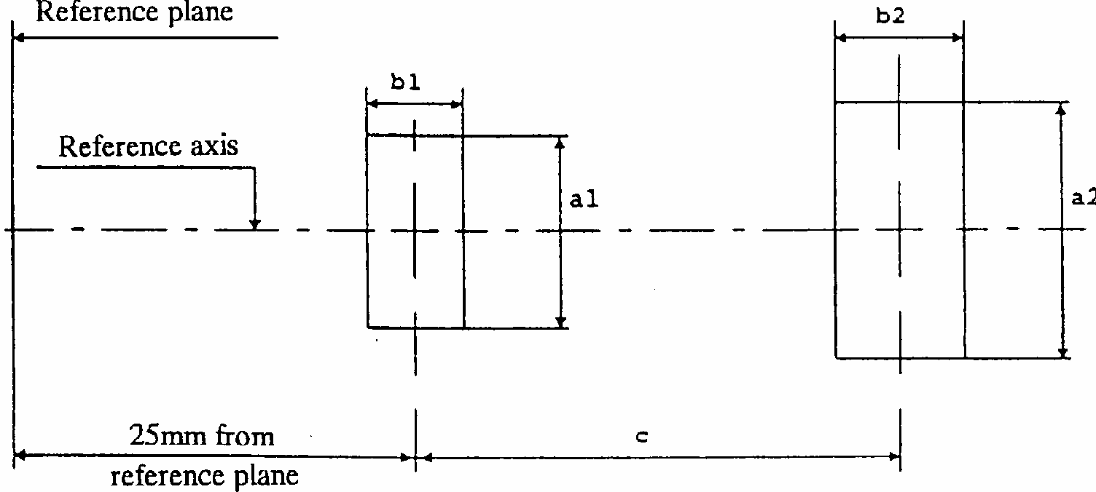
Measuring direction A and B as defined on sheet D1R/D2R/1
Dimension in mm | Production light sources | Standard light sources
a1 | d + 0.5 | d + 0.2
a2 | d + 0.7 | d + 0.35
b1 | 0.4 | 0.15
b2 | 0.8 | 0.3
c | 4.2 | 4.2
d = diameter of the electrode < 0.3
The top of the electrode nearest to the reference plane shall be positioned in the area defined by a1 and b1. The top of the electrode furthest from the reference plane shall be positioned in the area defined by a2 and b2.
Categories D1R and D2R Sheet D1R/D2R/5
Position and form of the arc
This test is used to determine the form and sharpness of the arc and its position relative to the reference axis and plane by measuring its bending and diffusion in the central cross section D and by measuring stray light intensities in zone A and at lines B and C.
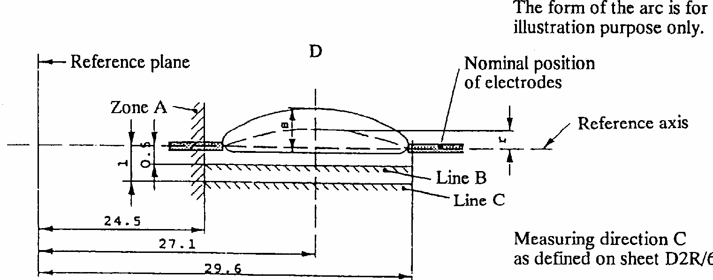
When measuring the relative luminance distribution in the central cross section D as indicated in the drawing above, the maximum value L_{max} has the distance r from the reference axis. The points of 20% of L_{max} have the distance s, as shown in the drawing below.
Dimension in mm | Production light sources | Standard light sources
r | 0.50 +/- 0.25 | 0.50 +/- 0.20
s | 1.10 +/- 0.25 | 1.10 +/- 0.25

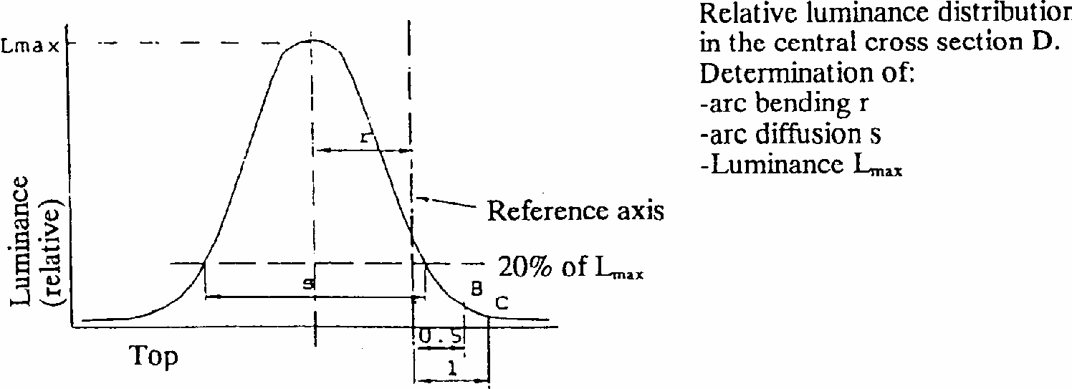
When measuring the luminances from measuring direction B as defined on sheet D1R/D2R/6 with a set-up as outlined in Annex 5, however with a circular field of 0.2Mmm diameter, the relative luminance expressed as a percentage of L_{max} (at cross section D) shall be:
Zone A <4.5 %
Line B <15 %
Line C <5.0 %
The area of zone A is defined by the black coating, the outer bulb and a plane at 24.5mm from the reference plane.
Categories D1R and D2R Sheet D1R/D2R/6
Position of the black stripes
This test is used to determine whether the black stripes are correctly positioned relative to the reference axis and the reference plane.
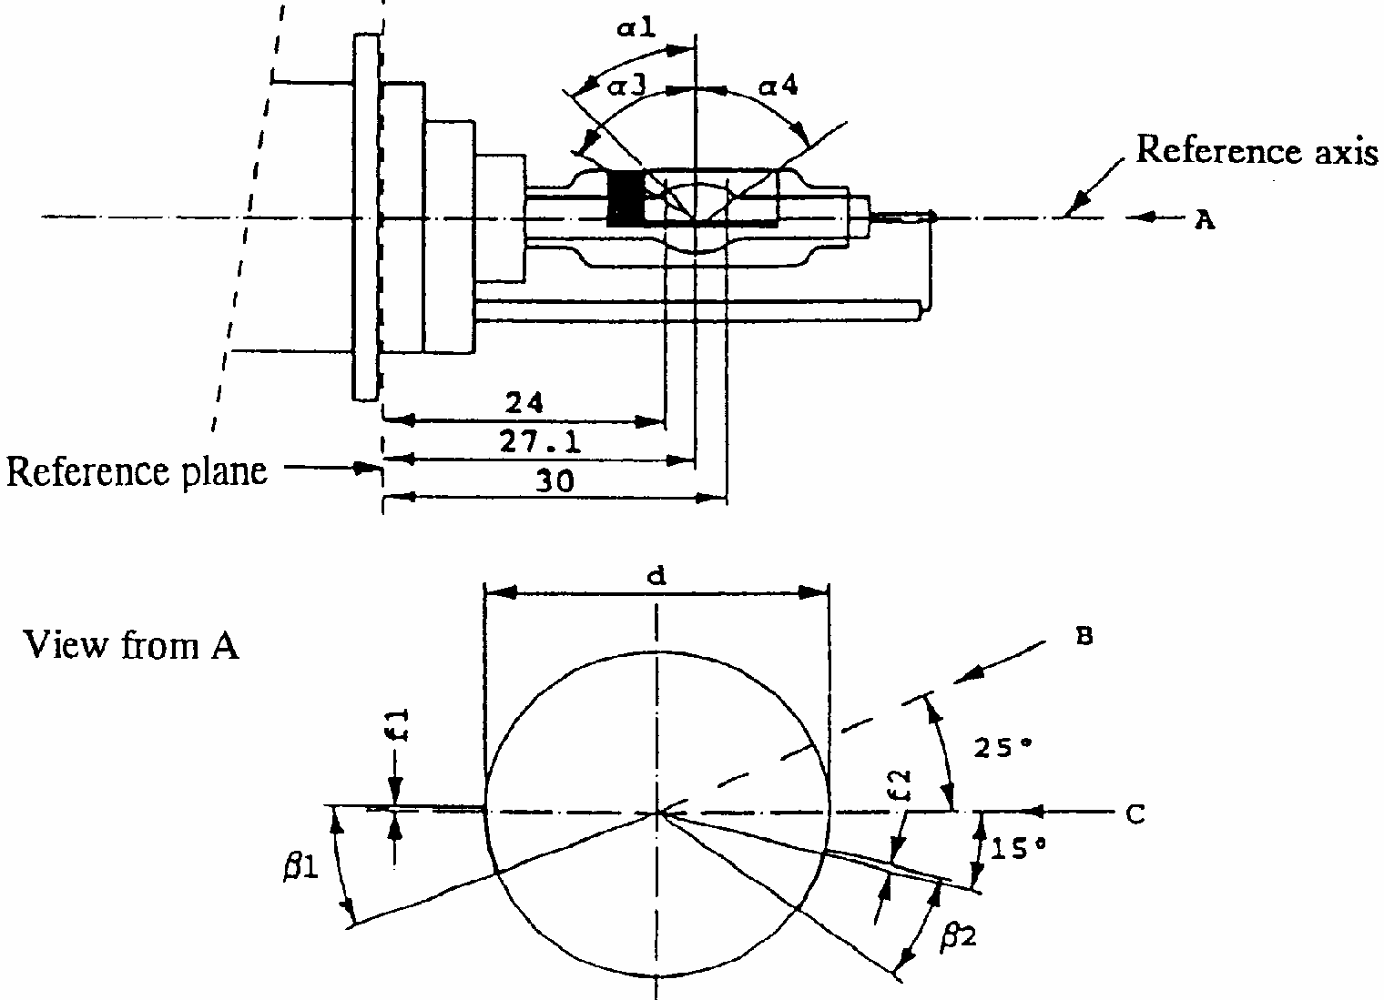
When measuring the luminance distribution of the arc in the central cross section as defined on sheet D1R/ D2R/5, after having turned the light source so that the black stripe is covering the arc, the measured luminance shall be < 0.5% of L_{max}.
In the area defined by alpha1 and alpha3 the black coating may be replaced by any other means which prevents light transmission through the specified area.
Dimensions | Production light sources | Standard light sources
alpha1 | 45 degrees +/- 5 degrees
alpha3 | 70 degrees min
alpha4 | 65 degrees min
beta1/24, beta1/30, beta2/24, beta2/30 | 25 degrees +/- 5 degrees
f1/24, f2/24 1/ | 0.15 +/- 0.25 | 0.15 +/- 0.2
f1/30 ^{1/} | f1/24mv +/- 0.15 2/ | f1/24mv +/- 0.1
f2/30 ^{1/} | f2/24mv +/- 0.15 ^{2/} | f2/24mv +/- 0.1
f1/24mv - f2/24mv | +/- 0.3 max | +/- 0.2 max
d | 9 +/- 1

Annex 2
COMMUNICATION
(Maximum format : 210 x 297mm)
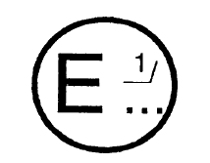
issued by: Name of administration
.........................
.........................
.........................

concerning: APPROVAL GRANTED 2/
APPROVAL EXTENDED
APPROVAL REFUSED
APPROVAL WITHDRAWN
PRODUCTION DEFINITELY DISCONTINUED
of a type of gas-discharge light source pursuant to Regulation No. 99
Approval No. ......................... Extension No. ..............................
1. Gas-discharge light source - category ......................................................................
- rated wattage ...............................................................................
2. Trade name or mark ..................................................................................................
3. Manufacturer's name and address .............................................................................
4. If applicable, name and address of manufacturer's representative ...........................
5. Brand and type number of the ballast .......................................................................
6. Submitted for approval on .........................................................................................
7. Technical service responsible for conducting approval tests ....................................
8. Date of report issued by that service .........................................................................
9. Number of report issued by that service ....................................................................
10. Approval granted/extended/refused/withdrawn 2/ ..................................................
11. Place ............
12. Date .............
13. Signature .....
14. The attached drawing No. .... shows the entire light source.
Annex 3
EXAMPLE OF ARRANGEMENT OF THE APPROVAL MARK
(see paragraph 2.4.3.)
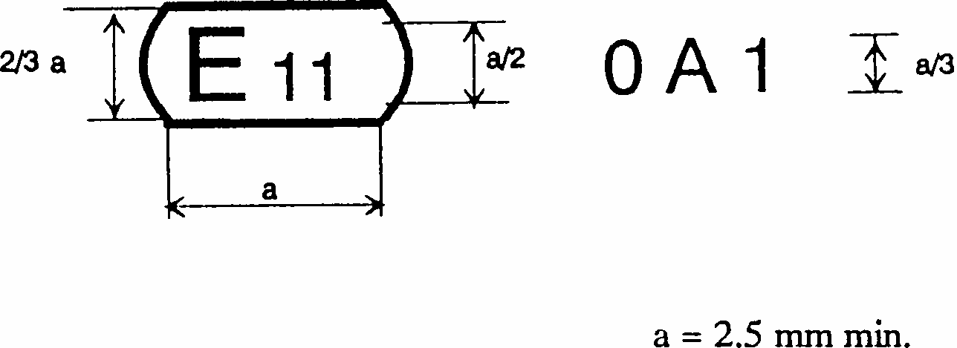
The above approval mark affixed to a gas-discharge light source indicates that the light source has been approved in the United Kingdom (E11) under approval code 0Al. The first character of the approval code indicates that the approval was granted in accordance with the requirements of Regulation No. 99 in its original form.
Annex 4
METHOD OF MEASUREMENT OF ELECTRICAL AND PHOTOMETRIC CHARACTERISTICS
1. General
For starting, run-up and hot-restrike tests and for the measurement of electrical and photometric characteristics, the gas-discharge light source shall be operated in free air with an ambient temperature of 25 +/- 5 degrees C.
2. Ballast
All tests and measurements shall be carried out with the ballast submitted in accordance with paragraph 2.2.2.4. of this Regulation. The power supply used for the starting and run-up tests shall be sufficient to secure the quick rise of the high current pulse.
3. Burning position
The burning position shall be horizontal within +/- 10 degrees with the lead wire down. Ageing and testing positions shall be identical. If the lamp is accidentally operated in the wrong direction, it shall be re-aged before measurements begin. During ageing and measurements no electrically conducting objects shall be allowed within a cylinder having a diameter of 32mm and a length of 60mm concentric with the reference axis and symmetrical to the arc. Moreover stray magnetic fields shall be avoided.
4. Ageing
With the exception of the starting test, all tests shall be carried out with light sources which have been aged for a minimum of 15 cycles having the following switching cycle: 45 minutes on, 15 seconds off, 5 minutes on, 10 minutes off.
5. Supply voltage
All tests shall be carried out at test voltage as indicated on the relevant data sheet.
6. Starting test
The starting test shall be applied to light sources which have not been aged and have not been used for a period of at least 24 hours prior to the test.
7. Run-up test
The run-up test shall be applied to light sources which have not been used for a period of at least 1 hour prior to the test.
8. Hot restrike test
The light source shall be started and be operated with the ballast at test voltage for a period of 15 minutes. The supply voltage to the ballast shall then be switched off for a switch-off period as indicated on the relevant data sheet, and be switched on again.
9. Electrical and photometric test
Before any measurement, the light source shall be stabilized for a period of 15 minutes.
10. Colour
The colour of the light source shall be measured in an integrating sphere using a measuring system which shows the CIE chromaticity co-ordinates of the received light with a resolution of +/- 0.002. The following figure shows the colour tolerance area for colour white and the restricted tolerance area for the gas-discharge light sources DlS, D2S AND D2R.
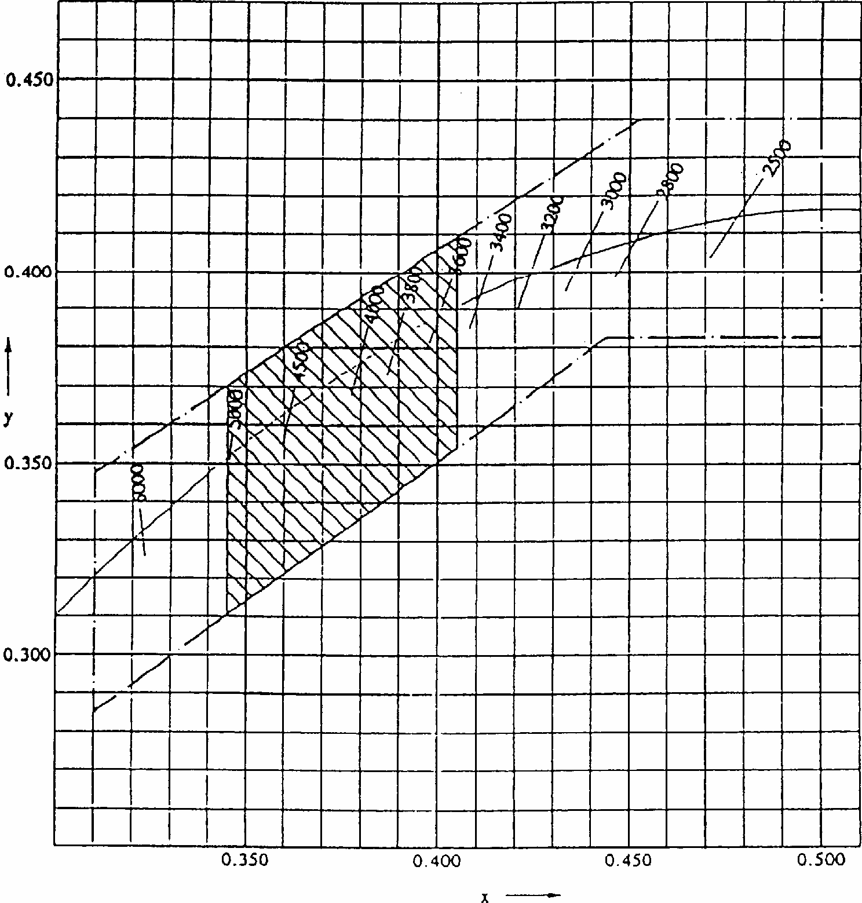
Annex 5
OPTICAL SETUP FOR THE MEASUREMENT OF THE POSITION AND FORM OF THE ARC AND OF THE POSITION OF THE ELECTRODES 1/
The gas-discharge light source shall be positioned as shown in figure 1 on sheet DlS/D2S/1 respectively sheet D2R/l.
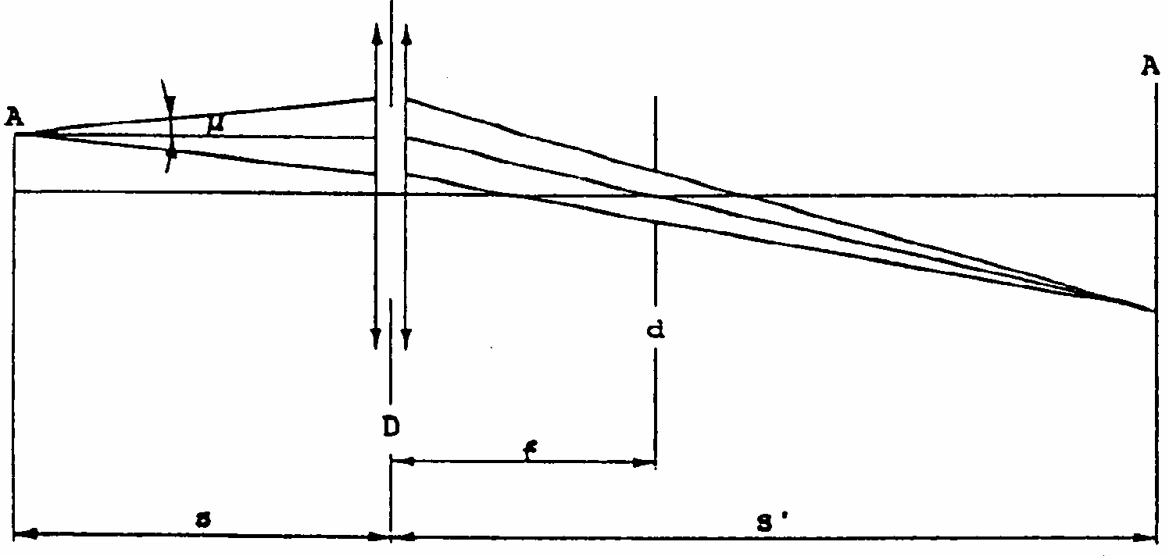
An optical system shall project a real image A' of the arc A with a magnification of preferably M = s'/s = 20 on a screen. The optical system shall be aplanatic and achromatic. In the focus-length f of the optical system a diaphragm d shall cause a projection of the arc with nearly parallel observation directions. To get the angle of the half divergence not larger than mu = 0.5 degrees the diameter of the focus-diaphragm with respect to the focus-length of the optical system shall be not more than d = 2f tan (mu).
The active diameter of the optical system shall be not more than:
D = (1 + 1/M)d + c + (bl + b2)/2. (c, bl and b2 are given on sheet DlS/D2S/4 respectively sheet D2R/4).
A scale on the screen shall enable measurement of the position of the electrodes. The calibration of the arrangement advantageously can be done by using a separate projector with a parallel beam in connection with a gauge whose shadow is projected to the screen. The gauge shall show the reference axis and the plane parallel to the reference plane and at distance "e" mm from it. (e = 27.1 for DlS, D2S and D2R).
In the plane of the screen a receiver has to be mounted movable in a vertical direction on a line corresponding to the plane at "e" from the reference plane of the gas-discharge light source.
The receiver shall have the relative spectral sensitivity of the human eye. The size of the receiver shall be not more than 0.2Mmm in the horizontal direction and not more than 0.025Mmm in the vertical direction. (M = the magnification.) The range of the measurable movement shall be such that the required measures of the arc bending r and arc diffusion s can be measured.
Annex 6
MINIMUM REQUIREMENTS FOR QUALITY CONTROL PROCEDURES BY THE MANUFACTURER
1. GENERAL
The conformity requirements shall be considered satisfied from a photometric (including UV-radiation), geometrical, visual and electrical standpoint if the specified tolerances for production gas-discharge light sources in the relevant data sheet of annex 1 and the relevant data sheet for the caps are met.
2. MINIMUM REQUIREMENTS FOR VERIFICATION OF CONFORMITY BY THE MANUFACTURER
For each type of gas-discharge light source the manufacturer or the holder of the approval mark shall carry out tests, in accordance with the provisions of this Regulation, at appropriate intervals.
2.1. Nature of tests
Tests of conformity of these specifications shall cover their photometrical, geometrical and optical characteristics.
2.2. Methods used in tests
2.2.1. Tests shall generally be carried out in accordance with the methods set out in this Regulation.
2.2.2. The application of paragraph 2.2.1. requires regular calibration of test apparatus and its correlation with measurements made by a competent authority.
2.3. Nature of sampling
Samples of gas-discharge light sources shall be selected at random from the production of a uniform batch. A uniform batch means a set of gas-discharge light sources of the same type, defined according to the production methods of the manufacturer.
2.4. Inspected and recorded characteristics
The gas-discharge light sources shall be inspected and test results recorded following the grouping of characteristics as listed in annex 7, table 1.
2.5. Criteria governing acceptability
The manufacturer or the holder of the approval is responsible for carrying out a statistical study of the test results in order to meet the specifications laid down for verification of conformity of products in paragraph 4.1. of this Regulation. Compliance shall be assured if the level of acceptable non- compliance per grouping of characteristics given in table 1 of annex 7 is not exceeded. This means that the number of gas-discharge light sources not complying with the requirement for any grouping of characteristics of any gas-discharge light source type does not exceed the qualifying limits in the relevant tables 2, 3 or 4 of annex 7.
Note: Each individual gas-discharge light source requirement shall be considered as a characteristic.
Annex 7
SAMPLING AND COMPLIANCE LEVELS FOR MANUFACTURER TEST RECORDS
Table 1 - Characteristics
Grouping of characteristics | Grouping */ of test records between gas-discharge light source types | Minimum 12 monthly sample per grouping*/ | Acceptable level of non- compliance discharge  characteristics (%)
Marking, legibility and durability | All types with the same external dimensions | 315 | 1
Bulb quality | All types with the same bulb | 315 | 1
External dimensions (excluding cap) | All types of the same category | 315 | 1
Position and dimensions of arc and stripes | All types of the same category | 200 | 6.5
Starting, run-up and hot- restrike | All types of the same category | 200 | 1
Lamp voltage and wattage | All types of the same category | 200 | 1
Luminous flux, colour and UV-radiation | All types of the same category | 200 | 1
Table 2
Qualifying limits for acceptance based on different numbers of test results for each grouping of characteristics are listed in table 2 as maximum number of non- compliances. The limits are based on an acceptable level of 1% of non-compliances, assuming an acceptance probability of at least 0.95.
Number of test results of each characteristics | Qualifying limits for acceptance
-200 | 5
201 - 260 | 6
261 - 315 | 7
316 - 370 | 8
371 - 435 | 9
436 - 500 | 10
501 - 570 | 11
571 - 645 | 12
646 - 720 | 13
721 - 800 | 14
801 - 860 | 15
861 - 920 | 16
921 - 990 | 17
991 - 1,060 | 18
1,061 - 1,125 | 19
1,126 - 1,190 | 20
1,191 - 1,249 | 21
Table 3
Qualifying limits for acceptance based on different number of test results for each grouping of characteristics are listed in table 3 given as maximum number of non- compliances. The limits are based on an acceptable level of 6.5% for non-compliances, assuming an acceptable probability of at least 0.95.
Number of lamps in records | Qualifying limit | Number of lamps in records | Qualifying limit | Number of lamps in records | Qualifying limit
-200  201 - 213  214 - 227  228 - 240  241 - 254  255 - 268  269 - 281  282 - 295  296 - 308  309 - 322  323 - 336  337 - 349  350 - 363  364 - 376  377 - 390  391 - 404  405 - 417  418 - 431  432 - 444  445 - 458  459 - 472  473 - 485  486 - 499  500 - 512  513 - 526  527 - 540  541 - 553  554 - 567  568 - 580  581 - 594  595 - 608 | 21  22  23  24  25  26  27  28  29  30  31  32  33  34  35  36  37  38  39  40  41  42  43  44  45  46  47  48  49  50  51 | 609 - 621  622 - 635  636 - 648  649 - 662  663 - 676  677 - 689  690 - 703  704 - 716  717 - 730  731 - 744  745 - 757  758 - 771  772 - 784  785 - 798  799 - 812  813 - 825  826 - 839  840 - 852  853 - 866  867 - 880  881 - 893  894 - 907  908 - 920  921 - 934  935 - 948  949 - 961  962 - 975  976 - 988  989 - 1 002 1,003 - 1,016  1,017 - 1,029 | 52  53  54  55  56  57  58  59  60  61  62  63  64  65  66  67  68  69  70  71  72  73  74  75  76  77  78  79  80  81  82 | 1,030 - 1,043  1,044 - 1,056  1,057 - 1,070  1,071 - 1,084  1,085 - 1,097  1,098 - 1,111  1,112 - 1,124  1,125 - 1,138  1,139 - 1,152  1,153 - 1,165  1,166 - 1,179  1,180 - 1,192  1,193 - 1,206  1,207 - 1,220  1,221 - 1,233  1,234 - 1,249 | 83  84  85  86  87  88  89  90  91  92  93  94  95  96  97  98

Table 4
Qualifying limits for acceptance based on different numbers of test results for each grouping of characteristics are listed in table 4 given as a percentage of the results, assuming an acceptance probability of at least 0.95.
Number of test results of each characteristic | Qualifying limits shown as a percentage of results.  Acceptable level of 1% of non- compliances. | Qualifying limits shown as a percentage of results.  Acceptable level of 6.5% of non- compliances.
1,250  2,000  4,000  6,000  8,000  10,000  20,000  40,000  80,000  100,000  1,000,000 | 1.68  1.52  1.37  1.30  1.26  1.23  1.16  1.12  1.09  1.08  1.02 | 7.91  7.61  7.29  7.15  7.06  7.00  6.85  6.75  6.68  6.65  6.55

Annex 8
MINIMUM REQUIREMENTS FOR SAMPLING BY AN INSPECTOR
1. The conformity requirements shall be considered satisfied from a photometric, geometrical, visual and electrical standpoint if the specified tolerances for production gas-discharge light sources in the relevant data sheet of annex 1 and the relevant data sheet for the caps are met.
2. The conformity of mass-produced gas-discharge light sources shall not be contested if the results are in agreement with paragraph 5 of this annex.
3. Conformity shall be contested and the manufacturer requested to make the production meet the requirements if the results are not in agreement with paragraph 5 of this annex.
4. If paragraph 3 of this annex is applied, a further sample of 250 gas-discharge light sources, selected at random from a recent production run, shall be taken within two months.
5. Compliance approved or disapproved shall be decided according to the values in table 1. For each grouping of characteristics gas-discharge light sources shall be either accepted or rejected according to the values in table 1 */.
Table 1
 | 1% **/ |  | 6.5% **/
 | Accept **/ | Reject | Accept | Reject
First sample size: 125  If the number of non-conforming units is greater than 2 (11) and less than 5 (16) take a second sample size of 125 and assess the 250 | 2  6 | 5  7 | 11  26 | 16  27

1/ Gas-discharge light sources bearing the same trade name or mark but produced by different manufacturers are considered as being of different types. Gas-discharge light sources produced by the same manufacturer differing only by the trade name or mark may be considered to be of the same type
2/ 0 1 2 3 4 5 6 7 8 9 A B C D E F G H J K L M N P R S T U W X Y Z
3/ 1 for Germany, 2 for France, 3 for Italy, 4 for the Netherlands, 5 for Sweden, 6 for Belgium, 7 for Hungary, 8 for the Czech Republic, 9 for Spain, 10 for Yugoslavia, 11 for the United Kingdom, 12 for Austria, 13 for Luxembourg, 14 for Switzerland, 15 (vacant), 16 for Norway, 17 for Finland, 18 for Denmark, 19 for Romania, 20 for Poland, 21 for Portugal, 22 for the Russian Federation, 23 for Greece, 24 (vacant), 25 for Croatia, 26 for Slovenia, 27 for Slovakia, 28 for Belarus, 29 for Estonia, 30 (vacant), 31 for Bosnia and Herzegovina, 32-36 (vacant), 37 for Turkey, 38-39 (vacant) and 40 for The former Yugoslav Republic of Macedonia. Subsequent numbers shall be assigned to other countries in the chronological order in which they ratify or accede to the Agreement Concerning the Adoption of Uniform Technical Prescriptions for Wheeled Vehicles, Equipment and Parts which can be Fitted and/or be Used on Wheeled Vehicles and the Conditions for Reciprocal Recognition of Approvals Granted on the Basis of these Prescriptions, and the numbers thus assigned shall be communicated by the Secretary-General of the United Nations to the Contracting Parties to the Agreement.
1/ The part of the bulb within the angles alphal and alpha2 shall be the light- emitting part. This part shall be as homogenous in form as possible and shall be optically distortion free. This applies to the whole bulb circumference within the angles alphal and alpha2.
2/ Application voltages of ballasts may differ from 12V.
3/ See annex 4.
1/ The reference axis is perpendicular to the reference plane and crosses the intersection of the two parallel lines as indicated in figure 3.
2/ Glass bulb and supports shall not exceed the envelope, as indicated in figure 4. The envelope is concentric with the reference axis.
1/ The part of the bulb within the angles alphal and alpha2 shall be the light- emitting part. This part shall be as homogenous in form as possible and shall be optically distortion free. This applies to the whole bulb circumference within the angles alphal and alpha2.
2/ Application voltages of ballasts may differ from 12V.
3/ See annex 4.
1/ /"f1/ . . "means dimension f1 to be measured at the distance from the reference plane indicated in mm after the stroke.
2/ /" . . /24mv" means the value measured at a distance of 24mm from the reference plane.
2^{1/} Distinguishing number of the country which has granted/extended/refused/withdrawn approval (see approval 2/ Strike out what does not apply.
1/ This method is an example of a measurement method: any method with equivalent measurement accuracy may be used.-----------
*/ The assessment shall in general cover series production gas-discharge light sources from individual factories. A manufacturer may group together records concerning the same type from several factories, provided these operate under the same quality system and quality management.
**/ The gas-discharge light sources shall be inspected and test results recorded following the grouping of characteristics as listed in annex 7, table 1.-------------

