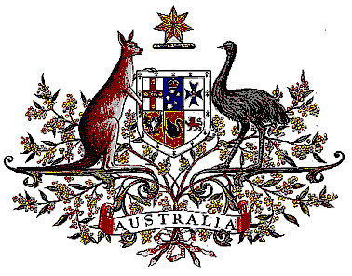

Veterans’ Entitlements Act 1986

Determination of Hazardous Service

I, Bruce Billson, Minister for Veterans’ Affairs, for the Minister for Defence:

  - revoke the Determination made under paragraph 120(7)(b) of the Veterans’ Entitlements Act 1986 (the Act) on 17 May 1991 in relation to service by a member of the Australian Defence Force (ADF) or a member of the ADF serving on exchange or secondment with a foreign Defence Force in the operational area described in Item 10 of schedule 2 (in column 1) of the Act during the period 2 August 1990 to and including 9 June 1991; and
  - determine that:
    - service rendered:
      - as a member of the Australian Defence Force while proceeding on Defence Force duty from Australia to the specified area, being service commencing on the day on which the member departed from the last port of call in Australia or the 2 August 1990, whichever is the latter, is hazardous service for the purposes of the definition of “hazardous service” in paragraph 120(7) of the Act, and
      - as a member of the Defence Force serving on exchange or secondment with a foreign Defence Force while proceeding on duty in the course of that exchange or secondment form a place outside the specified area to the specified area, being service commencing on the day on which the member departed from the last port of deployment for that area or the 2 August 1990, whichever is the latter, is hazardous service for the purposes of the definition of “hazardous service” in paragraph 120(7) of the Act.
    - the specified area comprises the following countries and sea areas:
      - Bahrain, Oman, Qatar, Saudi Arabia, the United Arab Emirates and the Island of Cyprus;
      - the sea areas contained within the Gulf of Suez, the Gulf of Aqaba, the Red Sea, the Gulf of Aden, the Persian Gulf and the Gulf of Oman;
      - the sea area contained within the Arabian Sea north of the boundary formed by the joining of each of the following points to the next:
        - 20° 30´ North 70° 40´ East
        - 14° 30´ North 67° 35´ East
        - 8° 30´ North 60° 00´ East
        - 6° 20´ North 53° 52´ East
        - 5° 48´ North 49° 02´ East
      - the sea area contained within the Suez Canal and the Mediterranean Sea east of 30° E.
  - This Determination is taken to have commenced on 2 August 1990.

Dated 19 July 2006

BRUCE BILLSON
Minister for Veterans’ Affairs
for the Minister for Defence

