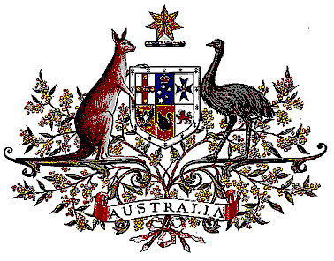

Veterans’ Entitlements Act 1986

Determination of Hazardous Service

I, Bruce Billson, Minister for Veterans’ Affairs, for the Minister for Defence:

  - revoke the Determination made under paragraph 120(7)(b) of the Veterans’ Entitlements Act 1986 (the Act) on 22 October 1991 in relation to:
    - service with Allied Forces providing humanitarian aid to Kurdish refugees in Iraq and in the area of Turkey south of latitude 38° north;
    - service afloat after 8 June 1991 in Royal Australian naval or allied naval units deployed in the following areas: the waters of the Arabian Gulf, the Gulf of Oman, the Northern Arabian Sea, the Gulf of Aden and the Red Sea bounded to the south and east by the following coordinates:
25° 00° North - 61° 50° East
20° 00° North - 61° 50° East
11° 50° North - 51° 17° East
    - service with the United Nations Special Commission for the Destruction of Weapons of Mass Destruction in Iraq, whilst actually in Iraq; and
  - determine:
    - that service rendered:
      - as a member of the Australian Defence Force as part of Operation HABITAT on or after 7 May 1991 in the specified area, is hazardous service for the purposes of the definition of “hazardous service” in paragraph 120(7) of the Act, and
      - the specified area comprises Iraq and in the area of Turkey south of latitude 38° north, and
    - that service rendered:
      - as a member of the Australian Defence Force afloat in Royal Australian naval or allied naval units deployed in the specified area after 8 June 1991 and before 1 April 1996 is hazardous service for the purposes of the definition of “hazardous service” in paragraph 120(7) of the Act, and
      - the specified area comprises the waters of the Arabian Gulf, the Gulf of Oman, the Northern Arabian Sea, the Gulf of Aden and the Red Sea bounded to the south and east by the following coordinates:
25° 00° North - 61° 50° East
20° 00° North - 61° 50° East
11° 50° North - 51° 17° East
    - that service rendered:
      - as a member of the Australian Defence Force as part of Operation BLAZER with the United Nations Special Commission for the Destruction of Weapons of Mass Destruction in the specified area on or after 2 July 1991 is hazardous service for the purposes of the definition of “hazardous service” in paragraph 120(7) of the Act, and
      - the specified area comprises Iraq.
  - This Determination is taken to have commenced on 7 May 1991.

Dated 19 July 2006

BRUCE BILLSON
Minister for Veterans’ Affairs
for the Minister for Defence

