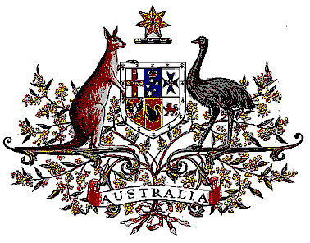

Veterans’ Entitlements Act 1986

Determination of Hazardous Service

I, Bruce Billson, Minister for Veterans’ Affairs, for the Minister for Defence:

  - revoke the Determination made under paragraph 120(7)(b) of the Veterans’ Entitlements Act 1986 (the Act) on 25 September 1992 in relation to service in the waters of the Gulf of Iran and the Gulf of Oman west of the line joining Rass-Al-Hadd and the southern end of the Iran Pakistan border, and the countries littoral to those waters, to a maximum distance inland of 50 km from the high water mark, between 17 November 1986 and 28 February 1989; and
  - determine that:
    - service rendered as a member of the Australian Defence Force during the period 17 November 1986 and 28 February 1989 in the specified area, is hazardous service for the purposes of the definition of “hazardous service” in paragraph 120(7) of the Act, and
    - the specified area comprises the waters of the Gulf of Iran and the Gulf of Oman west of the line joining Rass-Al-Hadd and the southern end of the Iran Pakistan border, and the countries littoral to those waters, to a maximum distance inland of 50 km from the high water mark.
  - This Determination is taken to have commenced on 17 November 1986.

Dated 19 July 2006

BRUCE BILLSON
Minister for Veterans’ Affairs
for the Minister for Defence

