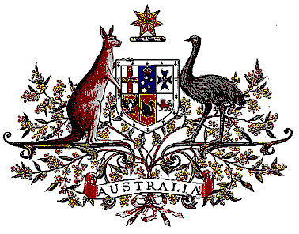

Veterans’ Entitlements Act 1986

Determination of Hazardous Service

I, Bruce Billson, Minister for Veterans’ Affairs, for the Minister for Defence:

  - revoke the Determination made under paragraph 120(7)(b) of the Veterans’ Entitlements Act 1986 (the Act) on 1 August 1994 in relation to service in Mozambique as part of the United Nations humanitarian operations on or after 12 July 1994; and
  - determine that:
    - service rendered as a member of the Australian Defence Force as part of the United Nations humanitarian operations on or after 12 July 1994 in the specified area, is hazardous service for the purposes of the definition of “hazardous service” in paragraph 120(7) of the Act, and
    - the specified area comprises Mozambique.
  - This Determination is taken to have commenced on 12 July 1994.

Dated 19 July 2006

BRUCE BILLSON
Minister for Veterans’ Affairs
for the Minister for Defence

