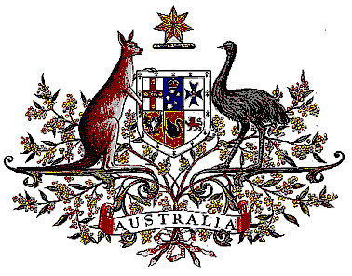

Veterans’ Entitlements Act 1986

Determination of Hazardous Service

I, Bruce Billson, Minister for Veterans’ Affairs, for the Minister for Defence:

  - revoke the Determination made under paragraph 120(7)(b) of the Veterans’ Entitlements Act 1986 (the Act) on 23 February 1996 in relation to service in those international waters, contiguous ports and waters used for international navigation contained with the Arabian Gulf, the Gulf of Oman and the Northern Arabian Sea with an eastern extremity of 61 degrees, 50 minutes East and a southern extremity of 20 degrees North; and
  - determine that:
    - service rendered as a member of the Australian Defence Force on or after 1 April 1996 in the specified area, is hazardous service for the purposes of the definition of “hazardous service” in paragraph 120(7) of the Act, and
    - the specified area comprises those international waters, contiguous ports and waters used for international navigation contained with the Arabian Gulf, the Gulf of Oman and the Northern Arabian Sea with an eastern extremity of 61 degrees, 50 minutes East and a southern extremity of 20 degrees North.
  - This Determination is taken to have commenced on 1 April 1996.

Dated 19 July 2006

BRUCE BILLSON
Minister for Veterans’ Affairs
for the Minister for Defence

