National Capital Plan 1990 (December 1990)
made under the
Australian Capital Territory (Planning and Land Management) Act 1988
Compilation No. 23
Compilation date: 8 February 2018
Includes amendments up to: F2018L00092
Registered: 13 February 2018
This compilation is in 4 volumes
Volume 1: [Introduction, Governance, Part One–Part Four]
Volume 2: [Part Four(A) 4.0–4.6]
Volume 3: [Part Four(A) 4.7–4.10]
Volume 4: [Part Four(A) 4.11–4.26, Appendices A and B and Endnotes]
Each volume has its own contents

About this compilation
This compilation
This is a compilation of the National Capital Plan 1990 (December 1990) that shows the text of the law as amended and in force on 8 February 2018 (the compilation date).
The notes at the end of this compilation (the endnotes) include information about amending laws and the amendment history of provisions of the compiled law.
Uncommenced amendments
The effect of uncommenced amendments is not shown in the text of the compiled law. Any uncommenced amendments affecting the law are accessible on the Legislation Register (www.legislation.gov.au). The details of amendments made up to, but not commenced at, the compilation date are underlined in the endnotes. For more information on any uncommenced amendments, see the series page on the Legislation Register for the compiled law.
Application, saving and transitional provisions for provisions and amendments
If the operation of a provision or amendment of the compiled law is affected by an application, saving or transitional provision that is not included in this compilation, details are included in the endnotes.
Editorial changes
For more information about any editorial changes made in this compilation, see the endnotes.
Modifications
If the compiled law is modified by another law, the compiled law operates as modified but the modification does not amend the text of the law. Accordingly, this compilation does not show the text of the compiled law as modified. For more information on any modifications, see the series page on the Legislation Register for the compiled law.
Self-repealing provisions
If a provision of the compiled law has been repealed in accordance with a provision of the law, details are included in the endnotes.

Contents
4.11 JERRBOMBERRA WETLANDS PRECINCT CODE 1
4.12 LAKE BURLEY GRIFFIN AND FORESHORES PRECINCT CODE 10
4.13 ACTON PENINSULA PRECINCT CODE 20
4.14 DIPLOMATIC PRECINCT (YARRALUMLA, DEAKIN AND O’MALLEY) CODE 35
4.15 MAIN AVENUES AND APPROACH ROUTES PRECINCT CODE 43
4.16 AUSTRALIAN INSTITUTE OF SPORT PRECINCT CODE 52
4.17 AUSTRALIAN NATIONAL UNIVERSITY PRECINCT CODE 68
4.18 CSIRO (BLACK MOUNTAIN) PRECINCT CODE 80
GENERAL CODES 83
4.19 DESIGN AND SITING GENERAL CODE 83
4.20 SIGNS GENERAL CODE 92
4.21 TELECOMMUNICATIONS GENERAL CODE 101
SPECIAL REQUIREMENTS FOR NATIONAL LAND OUTSIDE DESIGNATED AREAS 105
4.22 Special Requirements for National Land 105
PART FOUR(b) – SPECIAL REQUIREMENTS FOR TERRITORY LAND 106
4.23 Main Avenues 108
4.24 Approach Routes 110
4.25 City Centre 110
4.26 Kingston Foreshore 114
4.27 Haig and Telopea Parks 117
Appendix A – Land use definitions 121
Appendix B – General definitions 132
ENDNOTES 137
Endnote 1—About the endnotes 137
Endnote 2—Abbreviation key 138
Endnote 3—Legislation history 139
Endnote 4—Amendment history 143
List of figures
Figure 108: Jerrabomberra Wetlands Precinct location 2
Figure 109: Land use for the Jerrabomberra Wetlands Precinct 5
Figure 110: Jerrabomberra Wetlands Precinct – Policy zones 6
Figure 111: Lake Burley Griffin and Foreshores Precinct location 10
Figure 112: Land use for the Lake Burley Griffin and Foreshores Precinct 13
Figure 113: Acton Peninsula Precinct location 21
Figure 114: Land use for the Acton Peninsula Precinct 23
Figure 115: Acton Peninsula – Urban structure 25
Figure 116: Acton Peninsula – Landscape character 27
Figure 117: Acton Peninsula – Built form 29
Figure 118: Acton Peninsula – Heritage 31
Figure 119: Acton Peninsula – Transport and movement 33
Figure 120: Yarralumla and Deakin Diplomatic Precinct location 36
Figure 121: O’Malley Diplomatic Precinct location 37
Figure 122: Land use for the Yarralumla and Deakin Diplomatic Precinct 39
Figure 123: Land use for the O’Malley Diplomatic Precinct 40
Figure 124: Main Avenues location 43
Figure 125: Approach Routes location 45
Figure 126: Federal Highway road design characteristics 48
Figure 127: Federal Highway landscape realms and patterns 50
Figure 128: Australian Institute of Sport Precinct location 53
Figure 129: Land use for the Australian Institute of Sport Precinct 56
Figure 130: Australian Institute of Sport – Spatial definition and guidelines 66
Figure 131: Australian Institute of Sport Precinct Plan 67
Figure 132: Australian Institute of Sport – Pedestrian Spine 67
Figure 133: Australian National University Precinct location 69
Figure 134: Land use for the Australian National University Precinct 72
Figure 135: Australian National University - campus structure 74
Figure 136: Australian National University - Restricted Development Zones 74
Figure 137: Australian National University - Indicative building heights 76
Figure 138: Australian National University - Heritage items 77
Figure 139: CSIRO (Black Mountain) Precinct location 81
Figure 140: Land use for the CSIRO (Black Mountain) Precinct 82
Figure 141:Territory Land subject to Special Requirements 107
Figure 142: City Centre area subject to Special Requirements 111
Figure 143: Kingston Foreshore area subject to Special Requirements 115
Figure 144: Haig Park area subject to Special Requirements 118
Figure 145: Telopea Park area subject to Special Requirements 119

4.11 JERRBOMBERRA WETLANDS PRECINCT CODE

4.11.1 Precinct location
The Jerrabomberra Wetlands Precinct is bound by the Molonglo River to the north, Lake Burley Griffin to the west and Dairy Road to the east. The southern boundary of the Precinct skirts the western section of Jerrabomberra Creek where it drains to Lake Burley Griffin, and proceeds in a westerly direction in the vicinity of the rail line to its point of intersection with Dairy Road.
Figure 108 illustrates the location of the Jerrabomberra Wetlands Precinct.
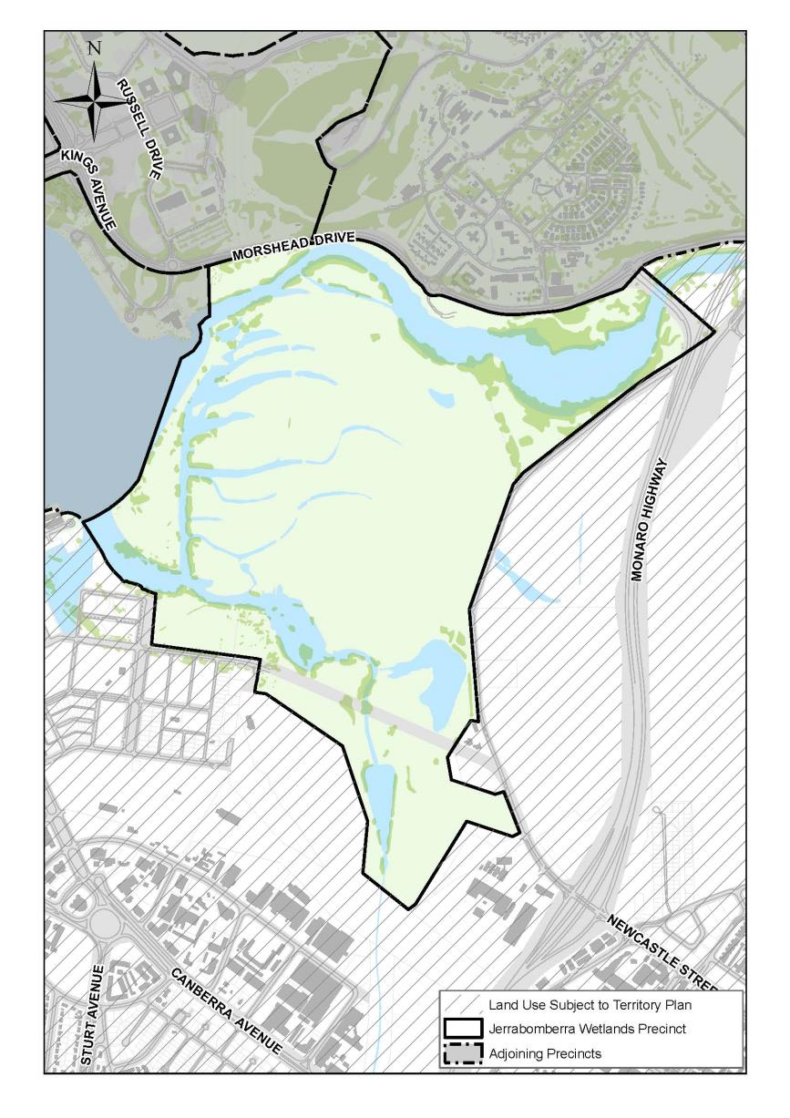
Figure 108: Jerrabomberra Wetlands Precinct location

4.11.2 Background
The Jerrabomberra Wetlands were formed following the filling of Lake Burley Griffin and the expansion of a natural wetland that had developed on the floodplain of the Molonglo River. The wetland and other habitats support a wide range of aquatic wildlife including over 170 species of birds, some of which are protected under international treaties.
The Jerrabomberra Wetlands are situated in the heart of the National Capital and are an integral part of the parkland system that has been developed around Lake Burley Griffin. The lake provides a key landscape element which unites the city and provides the setting for many of the buildings of the Central National Area as well as being a focus for a wide range of activities for Canberra residents and tourists.
The Jerrabomberra Wetlands are located close to the centre of Canberra, and therefore are close to a large population centre and tourist destination. This provides a unique opportunity to develop the area's potential as a nature education and interpretation centre. This would enable residents, tourists and international visitors to develop their understanding about conservation and wetland ecology as part of their enjoyment of the National Capital.
The challenge of the Jerrabomberra Wetlands is to ensure that a significant ecological resource in the centre of Canberra is protected and maintained while being used sensitively for residents and tourists in ways which enrich their experience of the National Capital and develop greater community awareness and appreciation of the natural environment.

4.11.3 Objectives for Jerrabomberra Wetlands Precinct
- Define and maintain Jerrabomberra Wetlands as a protected wildlife refuge, in a National Capital and urban context, with facilities designed to realise the area's potential as a significant conservation and education resource for Canberra residents, tourists and international visitors.
- Protect Jerrabomberra Wetland’s ecological resources, geomorphological features and aquatic conditions, and maintain a diversity of wetland and other habitats for wildlife conservation.
- Provide for the use of Jerrabomberra Wetlands as a significant educational resource which promotes educational activities appropriate to the area such as nature appreciation, fosters public awareness about wetland ecosystems, and facilities interpretation about birds and other aquatic wildlife. The area is also to be available for scientific research related to wetland environments.
- Maintain and enhance the rural and floodplain landscape character and strengthen the perception and appreciation of the Jerrabomberra Wetlands and its surroundings as an integral part of the landscape of Lake Burley Griffin and the setting for the National Capital.
- Facilitate recreational use, education and interpretation programmes, and informal and quiet enjoyment of the area's natural qualities while protecting Jerrabomberra Wetlands as a significant conservation resource in an urban setting. A range of facilities should be provided from Visitor Information Centres and bird-hides to information signs and paths.
- Provide for the continuation of current essential urban service infrastructure (electricity, water supply, sewerage). Any future proposal for new or upgraded services will be required to demonstrate that there are no prudent or feasible alternatives to locating new infrastructure within Jerrabomberra Wetlands Nature Reserve. If this can be demonstrated, works will be required to protect the nature conservation core areas and all reasonable measures to minimise adverse impacts must be taken.
- Facilitate planning, development and management of the Jerrabomberra Wetlands as a part of the National Capital Open Space System and in a manner which sustains specific uses consistent with conservation of its wetlands habitats, protects it from the impacts of external land uses, and ensures the wetlands are maintained and used in the broader context of planning for the whole of the Molonglo River and Jerrabomberra Creek floodplain and the Lake Burley Griffin Technical and Management Guidelines.

4.11.4 Land use for Jerrabomberra Wetlands Precinct
Land use for the Jerrabomberra Wetlands Precinct should be in accordance with Figure 109.
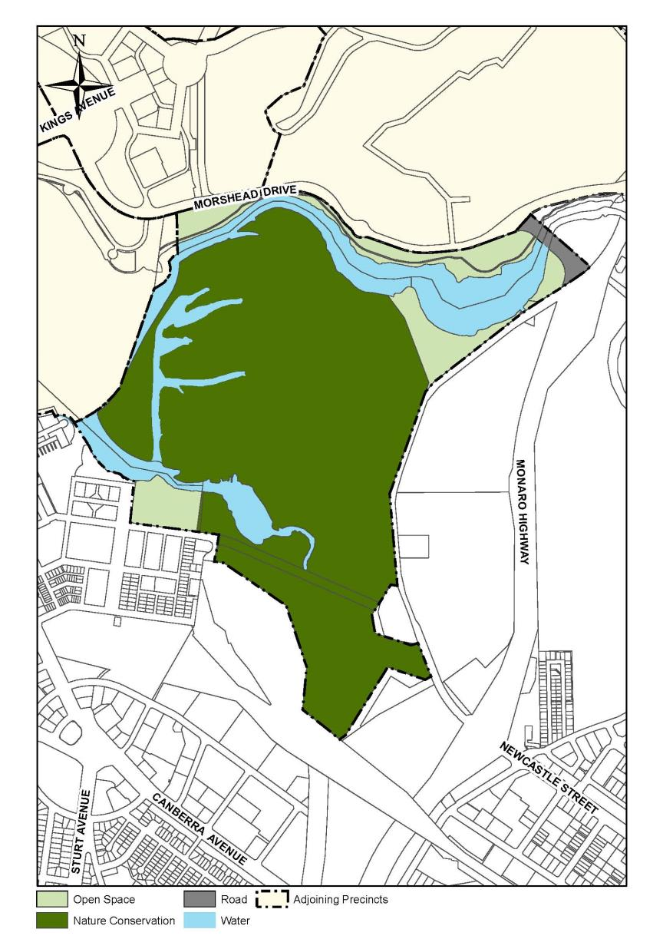
Figure 109: Land use for the Jerrabomberra Wetlands Precinct

4.11.5 Detailed conditions of planning, design and development
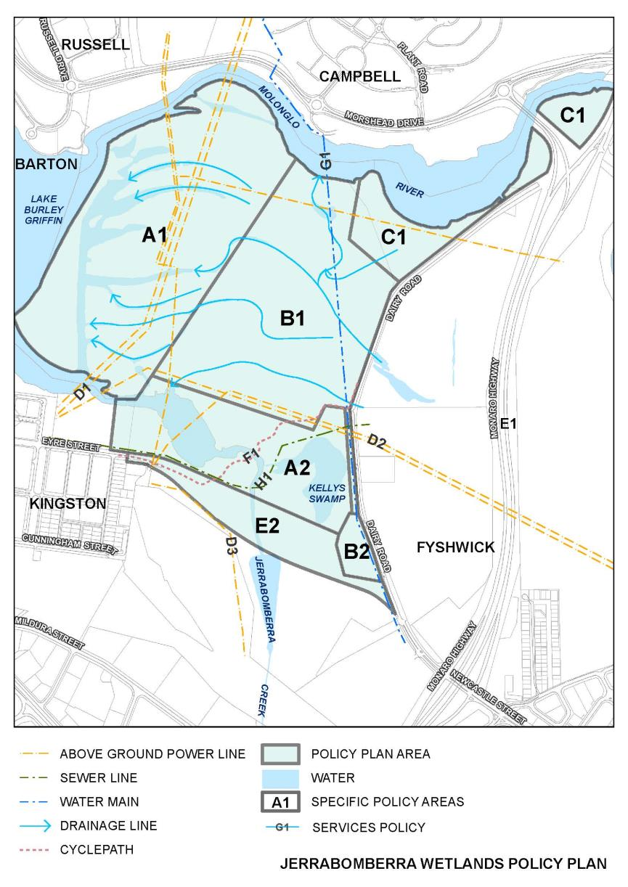
Figure 110: Jerrabomberra Wetlands Precinct – Policy zones

Nature Conservation Core Area (A1 and A2)
The existing wetland habitat is significant both for its nature conservation value and its potential for public viewing and interpretation in an urban location. The Nature Conservation Core Area is primarily identified for conservation and protection of wetland habitat and associated wildlife, where carefully controlled public access can be provided for interpretative and educational activities. Within the Core Area zoning can provide for bird refuge areas with general public access excluded, and for other areas where public facilities and access is provided. Overall, emphasis will be placed on habitat diversity rather than significant increases in general waterbird populations in order to minimise the risk of birdstrike to aircraft using Canberra Airport.

A1: Jerrabomberra Backwaters
This area is to be maintained as a wildlife refuge area with a diversity of habitats for aquatic wildlife and particularly birdlife, and protected from uncontrolled access from Lake Burley Griffin and adjacent lands. Controlled access for public interpretation, consistent with the area's refuge status, may be provided from Area A2. Existing access track to be retained for management purposes only.

A2: Jerrabomberra Pool and Kelly's Swamp Environs
This area is to be maintained and developed as a diverse habitat for waterbirds with facilities for public access, viewing and interpretation including information centres, hides and display areas to enable people to view wildlife at reasonably close quarters and understand about wetland ecology. The Jerrabomberra land fill area is to be rehabilitated and landscaped with a particular emphasis on creating habitat for land birds.

Wetland Buffer Zone (B1 and B2)
Dairy Flat provides a distinctive rural landscape with an open, grazed floodplain as the foreground to views of the Central National Area. There is an opportunity to preserve this character within a rural buffer zone which complements and protects the Nature Conservation Core Area. Some of the former farm buildings and land adjacent to Kelly's Swamp are used for educational purposes.

B1: Dairy Flat West
This area is to be maintained as a rural buffer zone to protect the Wetlands and the agricultural landscape character of the Dairy Flat floodplain. The ephemeral wetland area near Molonglo Reach is to be maintained and used for public interpretation.
The option for the development of further aquatic habitats for conservation and/or recreation purposes is to be retained. This would be subject to advice from the relevant Australian Government agency that this would not increase the risk of birdstrikes to aircraft.

B2: Dairy Flat Centre
Use of the buildings and land adjacent to Kelly's swamp is to continue as an educational facility consistent with the area's additional role as part of the buffer zone to the Nature Conservation Core Area.

Recreation area (C1)
The tree-lined margins of the Molonglo River are an important habitat component of the wetland complex. There could be some low intensity recreation and public access compatible with protection of the birdlife and habitats associated with these riverine areas.

C1: Molonglo Reach Recreation
The southern bank of Molonglo Reach to be developed and used as an informal riverside area with controlled public access. Wildlife habitat, including the marginal, riverine vegetation, is to be protected and maintained for birdlife and other semi-aquatic fauna. The north-eastern portion may be more intensively developed with picnic facilities.

High and Low Voltage Distribution Sub-Transmission Lines (Areas D1, D2, D3 and D4)
A number of high and low voltage lines cross Jerrabomberra Wetlands/Dairy Flat as key elements in the provision of electricity supply to Canberra. They have a visual effect on the landscape and views across Lake Burley Griffin to the Central National Area and can present a hazard to waterbirds. These environmental effects should be minimised when opportunities arise, but this will depend upon the extent and timing of developments in adjacent areas and the degree to which some lines can be removed.

D1: Causeway to City East and Bruce
The two existing 132 kV lines linking the Causeway substation to the City East and Bruce substations are to be retained.

D2: Existing Causeway to Oaks Estate
The existing 66 kV line and adjacent 11 kV line are to be retained temporarily to provide an 11 kV link between Kingston and Fyshwick, after which they are to be removed.

D3: Causeway to Gilmore 132 Kv Sub-Transmission Line Easement
An easement is required for a 132 kV line connecting the Causeway and Gilmore substations.

D4: 11 Kv Distribution Lines
Further work is to be undertaken to minimise the impact of the 11kV distribution lines.

Cycleway (Area E1)
The completion of the recreation cycleway system and Lake Burley Griffin is an important objective. It requires the construction of a cycleway in or adjacent to the area covered by these conditions.

E1: Lake Burley Griffin Cycleway System
A cycleway is to be established in order to complete the system around the Lake and to provide a connection to Fyshwick. The route is to be determined following further analysis, but would not pass through Area A1. It would pass through Area A2 in a manner which would be compatible with protection of the area's nature conservation and interpretation values. It would cross Jerrabomberra Creek east of Jerrabomberra Pool with much of its length being in the eastern portion of Area B1.

Water Supply (Area F1)
The bulk supply main carrying domestic water between Googong Reservoir and North Canberra crosses the wetland buffer area.

F1: Googong Bulk Supply Main
The existing bulk supply water main connecting Googong Reservoir and North Canberra is to be retained.

Sewerage (Area G1)
A sewerage rising main exists between the Fyshwick Sewerage Plant and Kingston. Its operation has not been satisfactory in recent years and its replacement is required.

G1: Fyshwick to Kingston Sewerage Rising Main
Use of the Fyshwick to Kingston sewerage rising main is to continue with upgrading to more efficient operation using a similar route.

4.12 LAKE BURLEY GRIFFIN AND FORESHORES PRECINCT CODE

4.12.1 Precinct location
The Lake Burley Griffin Foreshores Precinct comprises of Lake Burley Griffin and the areas of central parkland and open space surrounding it. These areas include Grevillea Park, Black Mountain Peninsula and Yarramundi Reach on the northern foreshores, and Bowen Park, Weston Park, Lennox Gardens and Yarralumla Beach on the southern foreshores. Other key sites included in the Precinct include the Governor-General’s estate, and the National Zoo and Aquarium.
Figure 111 illustrates the location of the Lake Burley Griffin and Foreshores Precinct.
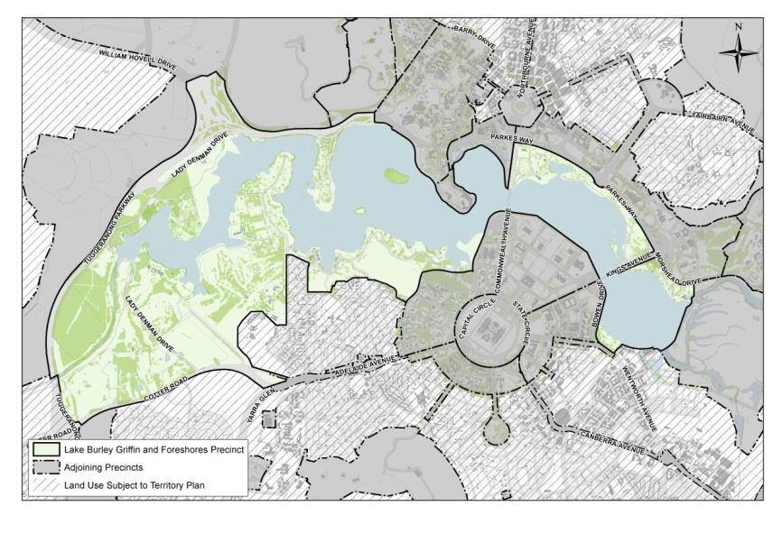
Figure 111: Lake Burley Griffin and Foreshores Precinct location

4.12.2 Background
Lake Burley Grifﬁn is an integral part of the design of Canberra and a vital and key element in the plan for the National Capital. The lake is not only one of the centrepieces of Canberra’s plan in its own right but also forms the immediate foreground of the Parliamentary Zone.
Lake Burley Grifﬁn has become an important recreational resource for Canberra’s residents and visitors, but there is a need to identify ways in which the lake can be used to further unify the city as a whole both functionally and in landscape terms.
The National Capital Authority will support the development of recreational, tourist and National Capital uses of the Lake and its foreshores. A well deﬁned system of lakeside drives, park access roads and public transport access should be maintained so that residents and visitors can get to the lake and its parks without disturbing nearby areas unduly.
The lakeside pedestrian path/cycle way around the entire lake needs to be completed. The link around the eastern part of the lake is to be built in a manner which does not compromise the conservation values of the Jerrabomberra Wetlands. A ferry service from the ferry terminal to the Parliamentary Zone and other tourist nodes will be supported if it is commercially feasible.
The Lake Burley Grifﬁn and Foreshores Precinct is part of the National Capital Open Space System. The principle and policies set out in section 3.2 will apply as well as the principle and policies below.

4.12.3 Objectives for Lake Burley Griffin and Foreshores
- To conserve and develop Lake Burley Griffin and Foreshores as the major landscape feature unifying the National Capital’s central precincts and the surrounding inner hills and to provide for National Capital uses and a diversity of recreational opportunities.
- Lake Burley Griffin and Foreshores should remain predominantly as open space parklands while providing for existing and additional National Capital and community uses in a manner consistent with the areas’ national symbolism and role as the city’s key visual and landscape element.
- Lake Burley Griffin and Foreshores are intended to provide a range of recreational, educational and symbolic experiences of the National Capital in both formal and informal parkland settings with particular landscape characters or themes. These should be maintained and further developed to create a diversity of landscape and use zones which are integrated into the landscape form of the city and reﬂect the urban design principles for the National Capital.
- The water quality and hydraulic operation of the lake should be maintained in a manner designed to protect Lake Burley Griffin and Foreshore’s visual and symbolic role.

4.12.4 Land use for Lake Burley Griffin and Foreshores
Land use for the Lake Burley Griffin and Foreshores Precinct should be in accordance with Figure 112 and as detailed below. The range of uses permitted in Lake Burley Grifﬁn and Foreshores will be the following:
  - Aquatic Recreation Facility
  - Club (related to lake use only)
  - Community Facility
  - Landscape Buffer
  - National Capital Use
  - Outdoor Education Establishment
  - Park
  - Pathway Corridor
  - Public Utility
  - Reserve
  - Restaurant
  - Restricted Access Open Space
  - Road
  - Single Dwelling Housing (Block 6 Section 4 Yarralumla only)
  - Scientiﬁc Research Establishment
  - Tourist Facility (not including a service station)

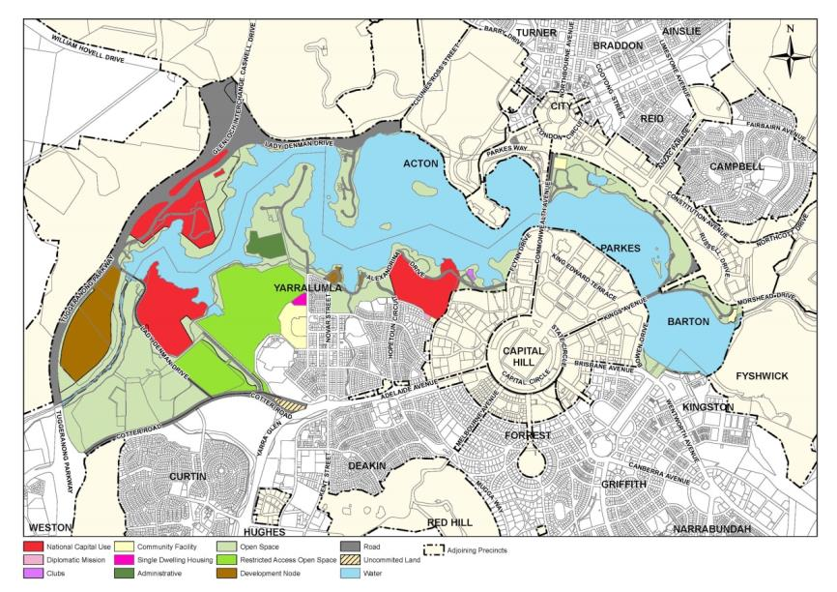
Figure 112: Land use for the Lake Burley Griffin and Foreshores Precinct

4.12.5 Detailed conditions of planning, design and development

Parkland recreation
The following areas are to be generally available for public recreation and free public access:
- Commonwealth Park
- Kings Park
- Grevillea Park
- Bowen Park
- Lennox Gardens
- Weston Park
- Black Mountain Peninsula
- Yarralumla Beach
For significant recreational events public access restrictions may be imposed in respect of limited parts of the above areas for limited periods and entry fees may be charged for access to those parts set aside for the event. In deciding specific proposals the National Capital Authority will require continuity of access to the beaches and shores of Lake Burley Griffin and will consider the need for access to other public facilities such as cycle paths, toilets, picnic shelters and children’s playgrounds.
Some Commercial concessions such as refreshments and other facilities for visitors will be allowed in these areas but only when they are compatible with the recreation use.
The policies are to provide parkland with particular landscape character or themes for particular areas so as to achieve a diversity of recreation settings, some of which will be less developed than others.
Commonwealth Park will continue to be developed as an intensely used horticultural park for informal recreation and for major group and festive activities. Stage 88 Music Bowl has been developed in Commonwealth Gardens near Nerang Pool and Commonwealth Park will be linked to Kings Park by a pedestrian promenade along the Lake foreshore.
The north western part of Commonwealth Park will be developed for detailed horticultural display, including a conservatory and walled and scented gardens. Another kiosk refreshment room / restaurant may also be built in Commonwealth Park. The development of Kings Park will be reviewed in the context of pressures on Commonwealth Park.
Grevillea Park, Bowen Park and Lennox Gardens are to be major lakeside vantage points and special landscape parks with emphasis on seasonable landscape effects. In Grevillia Park and Lennox Gardens, sites may be provided for small scale developments which relate directly to the recreational use and enjoyment of the Lake.
Weston Park, Yarralumla Beach, Black Mountain Peninsula and Acton Park will continue to be predominantly urban recreation parks with beachside swimming, special playgrounds, and barbecue areas. Beachside recreation areas are to be extended in suitable places. Development is to be limited to small scale items that help recreation and tourism. They may include commercial concessions for kiosks, refreshment rooms, restaurants, other entertainment, and hire facilities as appropriate to the area.
This will not include the development of private licensed clubs or the extension of facilities other than those that already exist at the Canberra Yacht Club.
New clubhouses or boatsheds for rowing or canoe clubs may be located on the western side of Black Mountain Peninsula if they cannot be accommodated in Yarralumla Bay. The buildings will be subject to design controls to ensure that they fit in with the landscape of the Lake.
Regatta Point Exhibition must be retained for use as a tourist exhibition site, with allowance for commercial concessions for kiosks, refreshment rooms and restaurants as appropriate to the area.

The Lake
The policy is to allow all users of the Lake access to all its waters and its foreshore (except as may have been agreed under provisions of the Lakes Ordinance) while minimising the problem of conflicting demands. It may therefore be necessary to:
- Limit the facilities and number of access points for some activities, and restrict launching areas to specific sections of the Lake where there will be no danger to swimmers
- Restrict parking so that it does not prevent the enjoyment of any area or downgrade the appearance of the lakeshore.
These steps will be considered in the light of any potential conflict of uses and with due consideration for questions of hydraulics and water quality.
In Yarramundi and Tarcoola reaches and in Westlake, the degree of diverse natural shoreline and good water quality are to be maintained. The shoreline macrophyte areas which are important fish and waterbird habitats in Yarramundi Inlet and Nursery Bay are to be protected.
Yarramundi Reach is to accommodate a rowing course as well as other boating. Westlake and West Basin are to remain the main areas for sailing, sailboarding and beachside swimming. Moorings for Yachts are to be provided in selected locations and consideration may be given to constructing a marina in Lotus Bay. The formal national capital character of the Lake as a key element of the Griffin Plan is to be fully expressed in the Central Basin, while East and West Basins are to respond to the architectural character of the central area.
Existing facilities for the floating gate in Yarramundi Inlet (used to operate Scrivener Dam) are to be retained.
Molonglo River is to provide a quiet backwater for boating, fishing and birdwatching. The tree-lined banks and marginal habitats for waterbirds, fish and aquatic mammals are to be protected. Upstream of Dairy Road Bridge, the Molonglo River may be used for power boats and water skiing.
The masses of submerged aquatic plants between Springbank Island and Acton Peninsula are to be controlled and the Lake may be deepened here if necessary. Macrophyte beds in East Basin may be retained as a means of controlling algae.
Ferry wharfs may be provided in various places. Fishing and viewing platforms may also be provided in selected locations.

Development nodes
Development is to be limited to uses related to recreation and tourism and may include commercial concessions for kiosks, refreshment rooms or restaurants, other tourist purposes, and fire facilities, subject to agreements made under the provisions of the Lakes Ordinance. Tourist accommodation will not be permitted at Acton Park or Yarralumla Bay.
The types of use and development are to conform to the guidelines for lakeshore development set out below and will be subject to stringent conditions to ensure that development harmonises with the surrounding areas. In all cases public access to the lakeshore will be preserved.
Development of Blocks 1 and 2 Molonglo Valley is to be limited to a zoo and associated tourist facilities. The development is to be generally screened from the Tuggeranong Parkway with the site having an appropriate open woodland landscape character.
Buildings and structures will be subject to design controls to ensure that they are of high quality complementary to the Lake Burley Griffin western foreshores landscape and are generally unobtrusive when viewed from the Tuggeranong Parkway.
The National Capital Authority will require a Master Plan to be submitted and approved before the proposal to perform works is submitted to the National Capital Authority.

Conservation
Yarramundi Reach’s natural shoreline and key wetland waterbird and aquatic mammal breeding habitat in Warrina, Yarramundi and Acacia Inlets will be conserved and protected.
The following sites of significance around the Lake will be given special consideration to protect them in the most appropriate way, and conservation plans will be prepared for key sites:
- Jerrabomberra Wetlands
- Blundells Cottage
- Acton Geological Site
- Black Mountain Peninsula
- Stirling Park
- Government House
- Westbourne Woods
- Canberra Incinerator
- Acacia, Yarramundi and Warrina Inlet Wetlands
- Commonwealth Park Geological Site

Location specific

ACT Hospice site
Development of the site for the ACT Hospice, on the northern foreshore of East Basin, is to be integrated with the landscape of the foreshore. The landscape of the site should be of an open parkland character consistent with that of Grevillea Park. The plantings near Morshead Drive should be predominantly native as a backdrop to the deciduous trees along the Lake edge. There should be limited views into the site from Menindee Drive with predominant views from the development being to East Basin and the Molonglo River. The site, which is exclusively for the use of the ACT Hospice, is to be set back from the Lake edge to allow for public recreation and free public access along the immediate Lake foreshore. The site is to be the subject of detailed Site Planning, Design and Development Conditions, in accordance with the Guidelines for Lakeshore Development and the Guidelines for Siting of Buildings in the Lake Flood Zone as set out below. The Design and Siting General Code is also applicable to development, however, in the event of any contradictions the Detailed Conditions below take precedence.

Detailed site planning, design and development conditions

Visual impact
The foreshore of East Basin is an important landscape vantage-point with emphasis on seasonal landscape effects. Development on the site should therefore be designed to blend with the surrounding environment.

Built form
Buildings are to be of a domestic scale and designed to avoid the appearance of a large building mass, when viewed from the Lake and from adjoining land. Buildings are to be single storey construction.
Roof forms are to be flat or gently sloping with a view to keeping the height of the buildings as low as practicable.

Materials
Materials and colours selected for buildings should be compatible with the adjoining ‘Boat House by the Lake’ building and be inconspicuous to achieve a high degree of integration with the setting.

Siting
Buildings on the site should be positioned as far as practicable away from the adjacent development so that each development appears in its own landscape setting.
Buildings should be sited to ensure that members of the public are not deterred from moving freely through the foreshore public open space.

Siting and access
Parking areas are to be generally located to the north of the site with a clearly identified safe entry point off Menindee Drive.
Parking for the development is to be provided at a minimum rate of one space per bed plus one space per staff member.

Service areas
Service areas are to be located on the northern/eastern side(s) of the development and should be screened from view.

Environmental impact
Works designed for the site are to have regard for environmental impacts of the development.
Adverse impacts on the Jerrabomberra Wetlands (a protected habitat for migratory birds) are to be avoided;
A Conservation Management Plan, that records any heritage values and provides relevant management recommendations, is to be prepared.

Off-site works
An all weather pedestrian pathway is to be provided and maintained along the southern edge of the site within the public open space reserve. This work is to be carried out at the same time as the first stage of the hospice development.

Landscape
The landscape treatment is to reflect the seasonal planting scheme applying to the Grevillea Park land with deciduous planting on the site towards the Lake edge and native planting towards the Morshead Drive side of the site.
The existing plantings on the site should be retained as far as practicable. In particular the poplar stand and other plantings adjacent to the ‘Boat House by the Lake’ should be retained as far as practicable, as part of the site landscape.

Site establishment works
A site establishment plan is to be provided as part of the application for works approval. That plan is to show where materials are to be stored and how significant existing trees are to be protected throughout the construction phase. The arrangements should minimise any disruption to the general access by the public along the foreshore area and to the operation of the ‘Boat House by the Lake’ restaurant.
Refer to the Jerrbomberra Wetlands Precinct Code which applies in Area D.
Refer to the Design and Siting General Code which apply to all blocks.

Guidelines for Lakeshore Development and the Guidelines for Siting of Buildings in the Lake Flood Zone
The normal mode of operation of the flood gates should be to release flow at Scrivener Dam at approximately the same rate as the inflow to the Lake from all sources less losses. This will maintain a nearly constant Lake level in East Basin equal to the normal Lake level of RL555.93.
  - The Guideline for Lakeshore Development Sites follow.

Commercial concessions
The placement, form and colour of buildings and/or structures on any land leased for these developments are to be subject to detailed site planning standards to ensure that the development is in harmony with the Lake landscape and does no harm to the environment of the Lake. Public access is to be maintained around such buildings and between the buildings and the lakeshore.

Boatsheds, clubhouses and other recreational or community development directly related to the use of the Lake
The placement, form and colour of buildings on any land leased for these developments will be subject to detailed site planning standards to ensure that the development is in harmony with the Lake landscape and does no harm to the environment of the Lake. Public access is to be maintained around such buildings and between the buildings and the lakeshore.

Major lakeside buildings, special national capital attractions and other tourist developments
The placement, form and colour of buildings on any land used for these developments will be subject to detailed site planning standards to ensure that the development is in harmony with the Lake landscape and does no harm to the environment of the Lake.

Lake maintenance and boat servicing
The placement, form and colour of buildings on any land used for these developments will be subject to detailed site planning standards to ensure that they are in harmony with the lakeside setting.
The Guideline for Siting of Buildings in the Lake Flood Zone will be as set out below.

Siting Policies
Buildings in the Lake flood zone will be subject to the following controls:
- Residential Areas: All habitable floors are to be above the 100 year flood level.
- Commercial Areas: Walkways, service areas, basements are to be above the 100 year flood level.
- Institutional Areas: Walkways, service areas, basement carparks are to be above the 100 year flood level.
- Archives, reference collections, etc. are to be above the 500 year flood, with the establishment of emergency measures to safeguard collections in the event of a more extreme flood.
Structures should be designed and sited so that they do not make flood levels worse, upstream or downstream. They should be capable of withstanding the forces created by flood water pressure and prevent accumulation of flood debris, in accordance with the requirements of the Building Ordinance.
Floating structures must be securely and suitably anchored or be capable of rapid removal to safe anchorage in the event of a very large flood; otherwise they could be a danger to the flood gates on Scrivener Dam.

4.13 ACTON PENINSULA PRECINCT CODE

4.13.1 Precinct location
Acton Peninsula Precinct is bounded by Lake Burley Griffin to the east, south and west with the boundary to the ANU precinct forming the northern boundary west of Lawson Crescent.
Figure 113 illustrates the location of the Acton Peninsula Precinct.
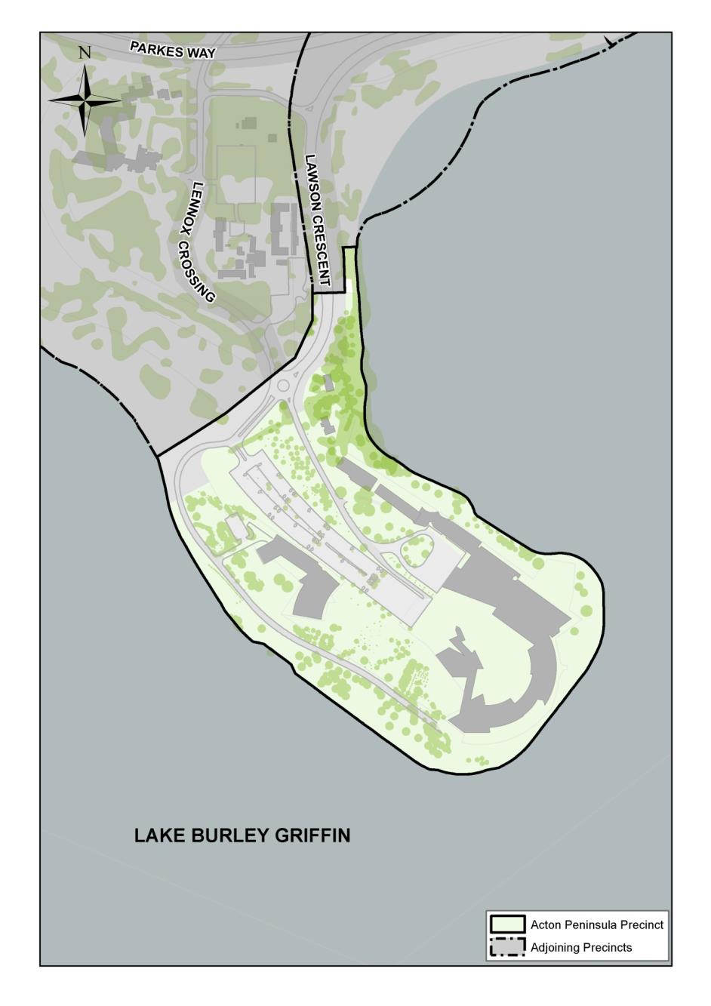
Figure 113: Acton Peninsula Precinct location

4.13.2 Background
Acton Peninsula's national significance is derived from its importance in the Griffin Plan and its demonstration of the unique relationship between the city and the landscape in the National Capital. The Peninsula visually connects Black Mountain to the Lake and provides a landscape edge and setting to the West Basin of Lake Burley Griffin.
This is further enhanced by Acton Peninsula's historical and cultural importance in the development of the Australian Capital Territory. The Peninsula was the first site settled by Europeans in the Canberra region and was the administrative centre for the development of the National Capital until after World War II.
Its national significance is reinforced through its proximity to the Parliamentary Zone which enables direct views of the National Library, National Gallery, and the High Court of Australia.

4.13.3 Objectives for Acton Peninsula Precinct
As a place of national significance, Acton Peninsula has an important functional and symbolic role within the National Capital. Activities and uses should contribute to vitality and viability of the city. They should build upon the magnificent setting; preserving and enhancing the existing landform, landscape, heritage and lake frontage. Uses also should demonstrate the Peninsula's relationship to the rest of the Central National Area.
To meet these goals, developments on Acton Peninsula should achieve the following objectives:
- express the importance of the location and the role of the Peninsula in the National Capital
- reinforce the visual connection to Parliament House, the Parliamentary Zone, City Centre and to the Brindabella Mountains
- ensure Acton Peninsula remains accessible to all Australians
- express the activities and operations of the various institutions as well as the importance of each location
- acknowledge the importance of, and maintain, the existing landscape setting
- create an urban form which responds to the landscape and topography
- protect the qualities and features of places of heritage significance
- encourage the design of sustainable, energy-efficient, environmentally responsive, human scaled, timeless architecture and landscape.

4.13.4 Land use for Acton Peninsula Precinct
Land use for the Acton Peninsula Precinct should be in accordance with Figure 114.
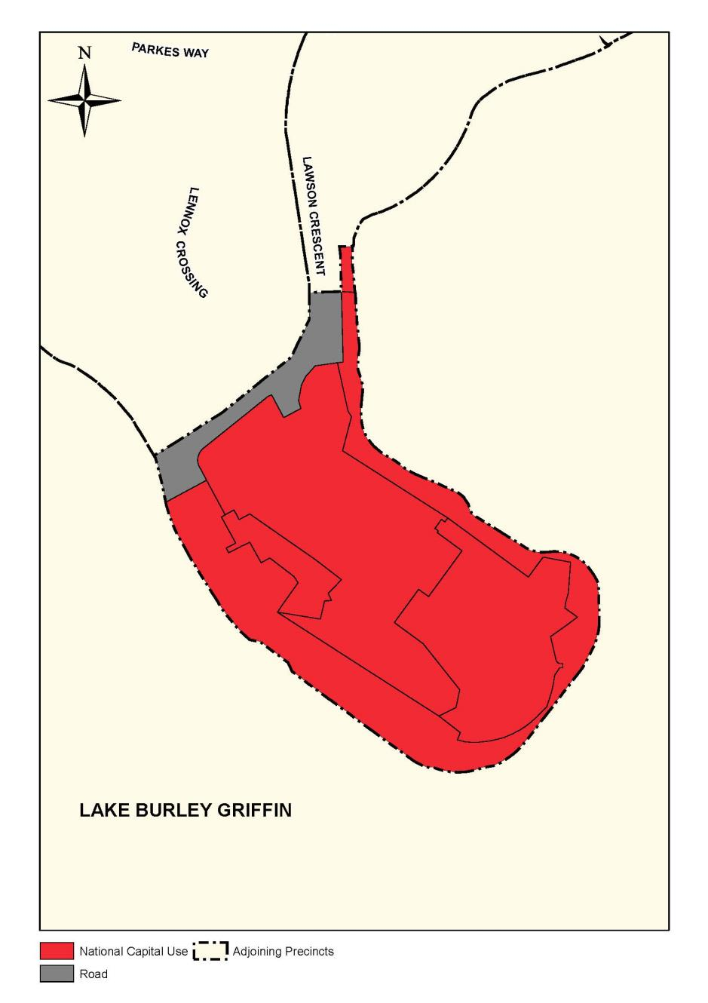
Figure 114: Land use for the Acton Peninsula Precinct
The permitted land use for Acton Peninsula (east of Lawson Crescent) is National Capital Use. Facilities which provide for local ceremonial or other cultural activities which complement and are ancillary to National Capital Uses on the site may be permitted.
The following uses are permitted for the ‘Medical Superintendent’s Residence’, ‘H Block’, ‘Former Isolation Ward’ and ‘Limestone House’:
- Consulting Rooms
- Research Facility
- Educational Establishment
- Office
- Restaurant.

4.13.5 Detailed conditions of planning, design and development

General
Acton Peninsula should contribute to the urban fabric by providing a location for National Capital Uses requiring a less formal setting than the National Triangle.
Design and development should ensure that the built form and open space are properly integrated, that Canberra's urban structure is recognised, and that the site's natural features are encapsulated in the development.
The character and quality of the built form and open space on Acton Peninsula should reflect the national importance of the site, demonstrate an environmental sensitivity, and epitomise leading practice in Australian design and construction.

Urban structure (refer Figure 115)
The built form and site development should respond both to the character of the contextual landscape (i.e. the eucalypt woodland of Black Mountain and the exotic vegetation of West Basin) and to the specific landscape qualities and elements of the Peninsula. These include, but are not restricted to, such elements as identified heritage sites and trees, and significant views to City Hill, the Parliamentary Zone and Parliament House.
The overall configuration and disposition of the built form, circulation systems and the open space must respond to the key natural and cultural features of the site, incorporating these elements where appropriate.
The siting and design of the principle circulation systems and the buildings on the Peninsula must respond principally to the axis of King Edward Terrace and secondarily to the City Hill alignment.
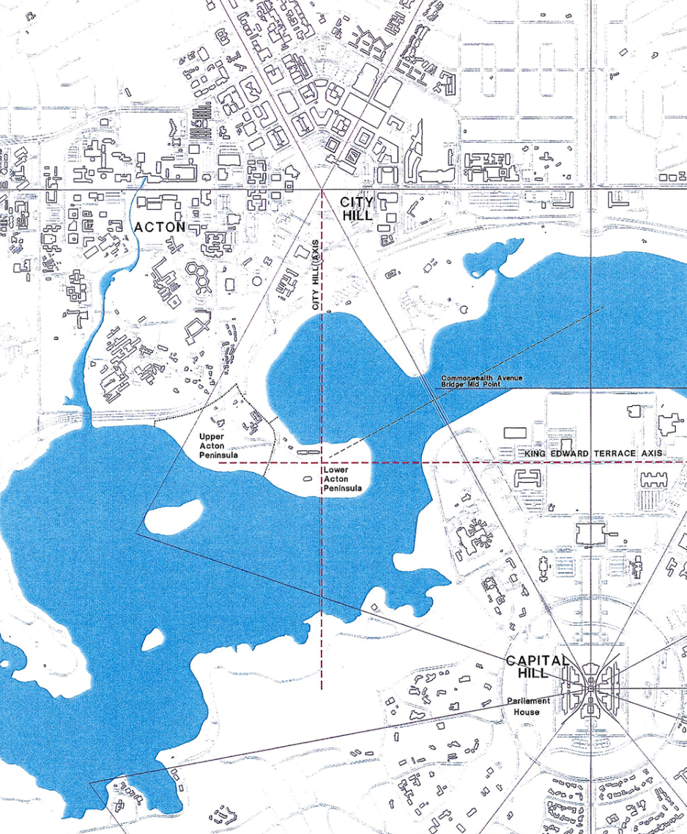
Figure 115: Acton Peninsula – Urban structure

Open space
The development of the Peninsula should establish a clear hierarchy of spaces which will support a variety of visitor activities and experiences and which will create a logical sequence in visitor circulation.
Landscape and open space design should provide a visual extension of the Black Mountain vegetation along the western side of the Peninsula.
Landscape and open space design should extend the exotic landscape treatment around West Basin.
Development on the foreshore should encourage a variety of recreational opportunities.
Buildings should be separated by contiguous open space.
Opportunities for interaction between Lake Burley Griffin and development proposals should be maximised.
Development on the Peninsula must contribute positively to the contiguous system of parks and open space around Lake Burly Griffin.
The principle circulation system, the siting of buildings and the development of key public spaces must be designed to incorporate key natural and cultural features on the site as well as to take full advantage of the main vistas to City Hill, the Parliamentary Zone and Parliament House.
The siting of buildings and the detailed design of the open space must respond to the microclimate of the site to provide wind protection, winter sun and summer shade.

Landscape character (refer Figure 116)
The contribution of the existing landscape setting should be recognised.
Existing plant species are to form a significant component of the landscape design for the Peninsula.
The predominant character of the landscape development must complement the landscape character of Black Mountain and West Basin.
Development must not damage remnant native vegetation.
Predominantly exotic species are to be used on the eastern side of the Peninsula within a defined theme.
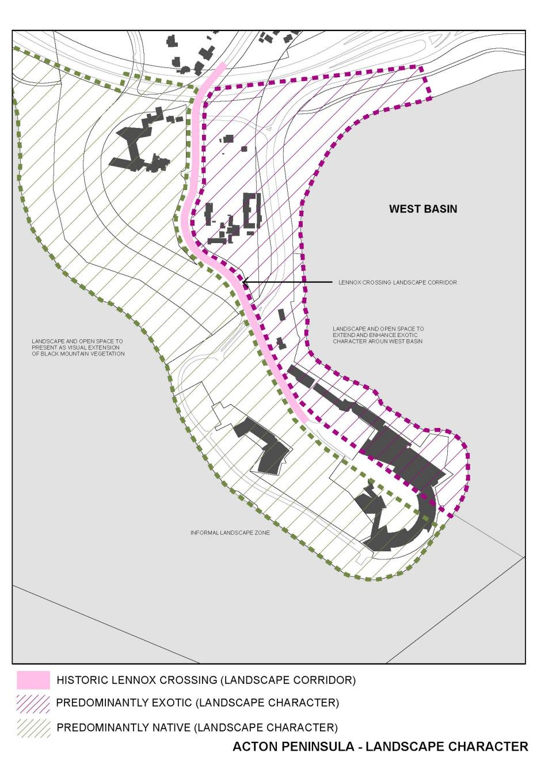
Figure 116: Acton Peninsula – Landscape character

Built form (refer Figure 117)
Any new development should be designed to take advantage of the views between the Peninsula and City Hill, Commonwealth Avenue, the Parliamentary Zone, and Parliament House. Opportunities for visitors to enjoy views toward the Brindabella Mountains and the western Lake should also be provided.
The siting of buildings should respond to the alignments of the former Lennox Crossing, King Edward Terrace and City Hill axes, as depicted in Figure 115 and Figure 117.
Design should respond to the site topography, views, landmarks, vegetation, orientation, microclimate, drainage and services.
The architecture and landscape design should contribute positively to the unique identity of the Peninsula.
Buildings should be consolidated into precincts.
The massing and bulk of large structures should be modulated to reduce their apparent scale and impact.
The built form should emphasise the natural terrain.
The scale and proportion of all structures should integrate the built form harmoniously into the site and environs.
Buildings should be energy efficient, utilising leading practice passive design strategies.
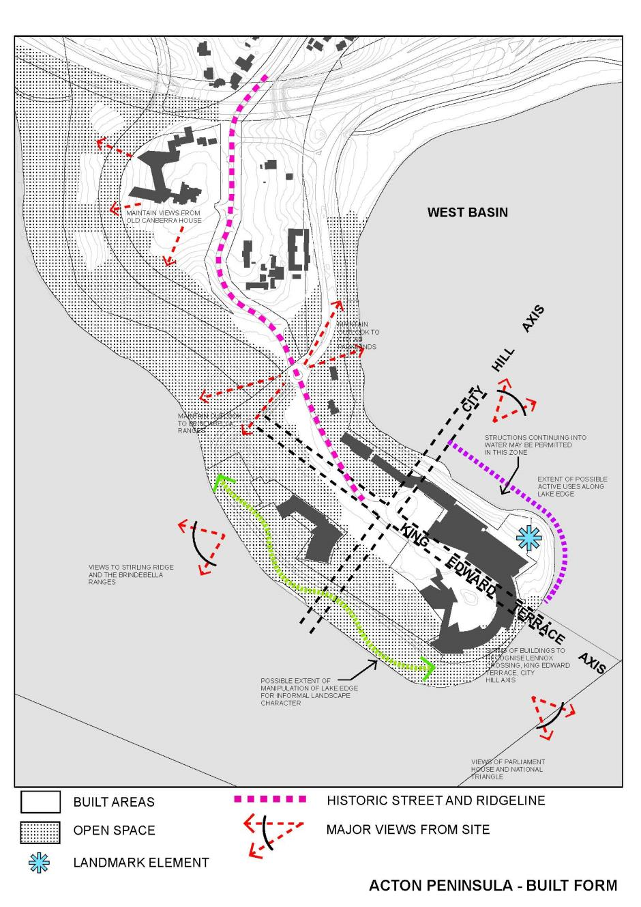
Figure 117: Acton Peninsula – Built form

Building height
Buildings are not to protrude above the tree canopy and will be limited in height to a maximum of 16 metres above natural ground level.
A landmark structure or building element in excess of 16 metres high may be considered at the end of the lower Peninsula in the locality indicated on Figure 117.
No building or structure exceeding RL 617 in height will be permitted.

Building design
Finished floor levels of each building must comply with requirements of Guideline for Lakeshore Development Sites and Guideline for Siting of Buildings.
Buildings must respond to the climate through use of devices such as sun shades which add depth and modelling to the building faces and maximise energy efficiency.
Roof forms (including mechanical plant, service systems and the like) are to be integrated with the design of the buildings.
Lift overruns and roof mounted plant and other structures are permitted only if contained within an enclosure appropriate to the roof form.

Material and finishes
Building materials, finishes and details should be high quality reflecting the national significance of the site and its uses.
Materials must be low maintenance, durable, with a design life in excess of 50 years.
Highly reflective wall or roof materials are not permitted.
The lower portions of buildings from ground to first floor level must be well articulated and modulated to provide scale and shelter for people circulating around the buildings.
The size and detailing of the material in the lower portions of the buildings must similarly be of an appropriate human scale to provide richness and interest.

Heritage (refer Figure 118)
Developments on Acton Peninsula must respond to and incorporate recommendations and management practices prepared as part of a Conservation Management Plan for the protection and/or conservation of elements considered of significant natural and cultural heritage.
The historic Lennox Crossing landscape corridor should be maintained.
The cultural and historic importance of the area should be acknowledged.
Where appropriate, future developments should incorporate key heritage elements on the Peninsula.
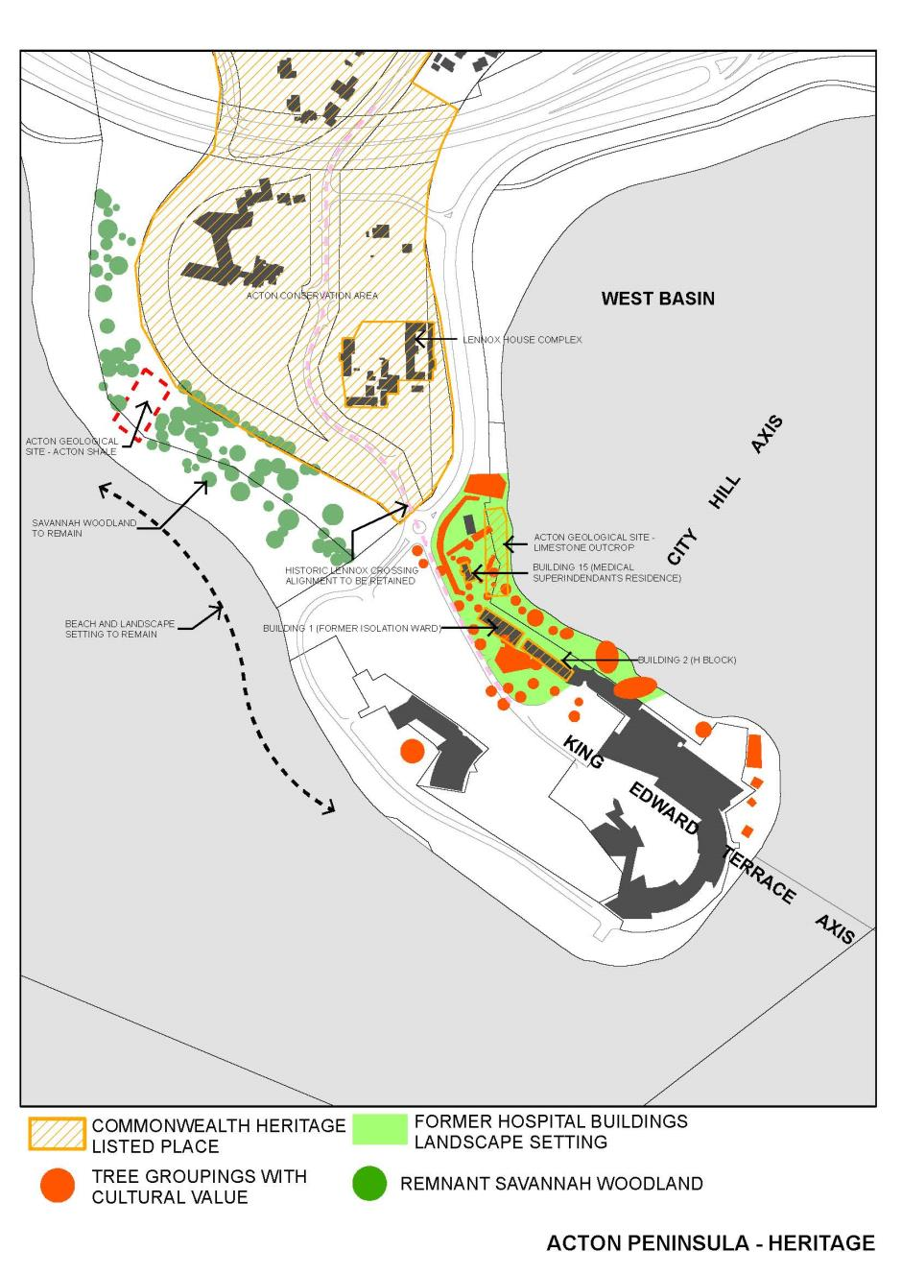
Figure 118: Acton Peninsula – Heritage

Transport and movement (refer Figure 119)
Acton Peninsula should be accessible and relevant to all Australians.
A clear hierarchy of roads and paths which creates a logical, legible and safe visitor circulation and site servicing pattern should be provided.
The local road and path system should provide a legible and safe network for cyclists and pedestrians.
Public access to the entire foreshore should be maintained. Continuous pedestrian access is required around the Lake edge of the Peninsula.
Cycle access between west Lake Burley Griffin and West Basin must be maintained.
Pathways are to meet current accessibility requirements.
Lawson Crescent is to be maintained as the main access road to the site.
Separate service and public access roads are to be provided.
Facilities suitable for future ferry or water taxi services to Acton Peninsula should be provided. Jetty facilities must have direct pedestrian links to the main building entry(s).
Impacts of surface parking should be minimised by use of parking structures, landscaping and basement parking.
Provision for public transport terminals, stations, alignments and parking should be made.
Servicing access should meet emergency and functional needs.

Car parking
Proponents of new developments on the lower Peninsula are required to provide on-site car parking to meet 95 percentile demand as agreed by the National Capital Authority.
The impact of car parking on the Peninsula is to be minimised by use of structured and/or underground parking and through effective use of landscaping.
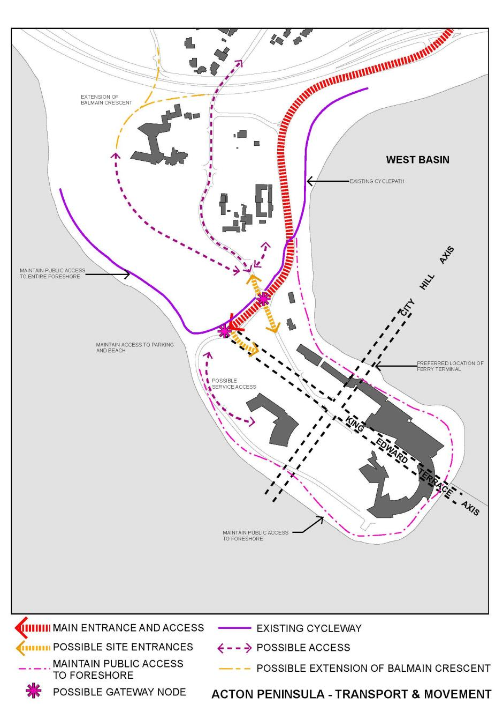
Figure 119: Acton Peninsula – Transport and movement

Detailed site development
There should be a positive relationship between buildings and the landscape with the all main building entries and exits to be from a ‘natural’ ground level. Elevated entries are to be minimised.
A minimum three per cent gradient away from the base of all buildings is to be established.
Surface drainage must be collected and dissipated on site. Appropriate measures to reduce runoff to the Lake are to be provided.
Overall the developed landscape must be one that has an efficient energy budget and one that can be effectively and easily maintained and managed.

4.14 DIPLOMATIC PRECINCT (YARRALUMLA, DEAKIN AND O’MALLEY) CODE

4.14.1 Precinct location
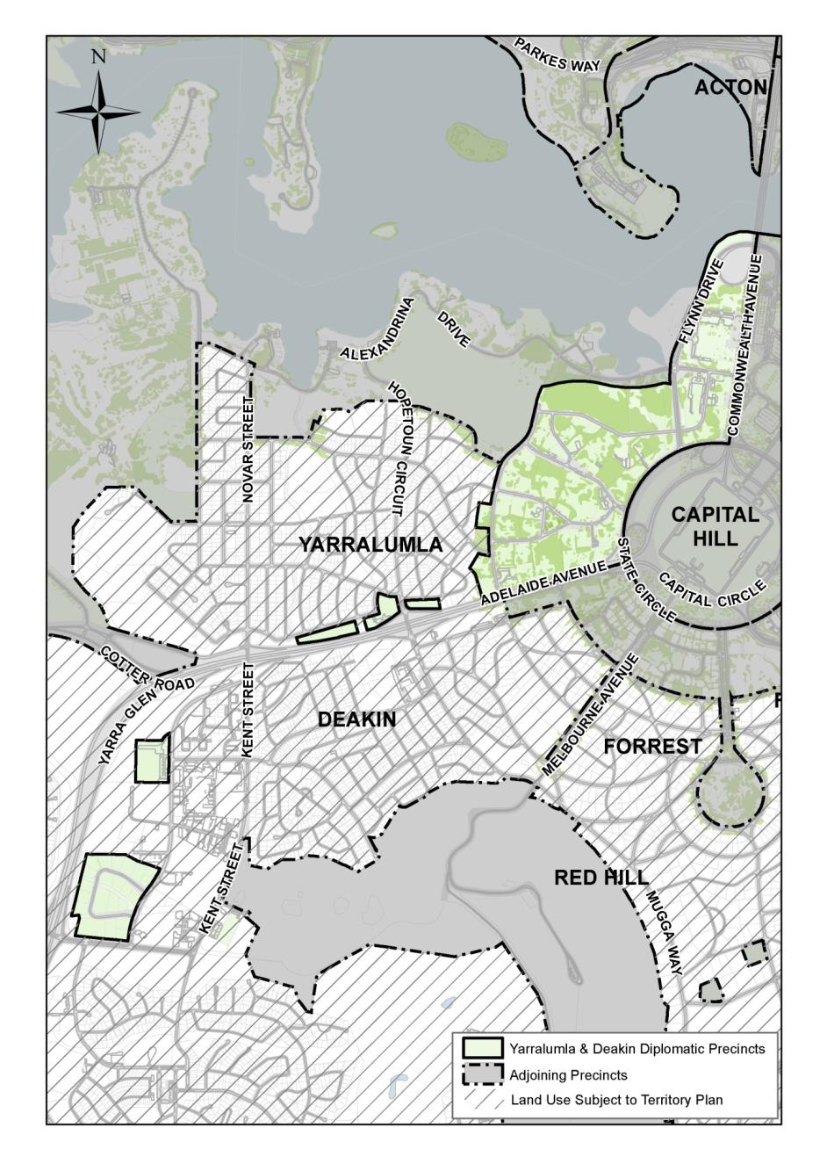
Figure 120: Yarralumla and Deakin Diplomatic Precinct location
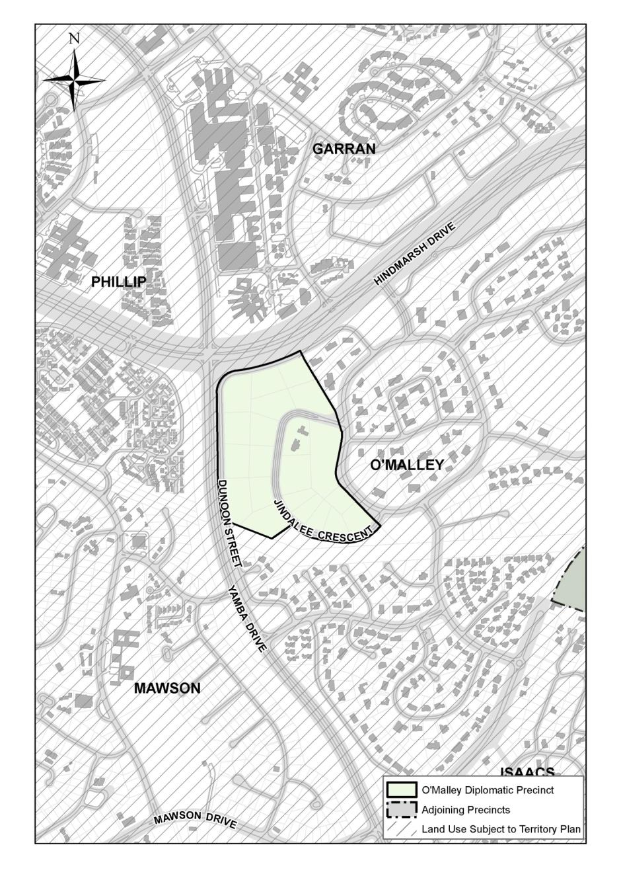
Figure 121: O’Malley Diplomatic Precinct location
The Diplomatic Precinct is comprised of three separate areas:
- Yarralumla
- Deakin
- O’Malley.
A number of diplomatic sites are also located in Red Hill (Figure 27 and Figure 28) and are subject to this Precinct Code.

4.14.2 Background
Australian’s international obligations in regard to diplomatic missions are outlined in the Vienna Convention on Diplomatic Relations. Under this convention, Australia has an obligation to facilitate the acquisition of, or assist in obtaining, accommodation for diplomatic missions and for their protection.
The Diplomatic Precinct is of special significance to the National Capital and a symbol of Australia’s international cooperation. The National Capital Authority manages Canberra’s diplomatic estate on behalf of the Australian Government.

4.14.3 Objectives for the Diplomatic Precinct (Yarralumla, Deakin and O’Malley)
- Diplomatic missions are established in places which are prestigious, have good access to Parliament House and other designated diplomatic areas, and meet security requirements.
- Diplomatic missions are planned and designed to establish a distinct character and setting reflecting their national and international significance.
- Diplomatic missions add visual interest and character to the suburb in which they are located.
- Buildings and landscaping demonstrate an appreciation of the architectural style and landscape of the surrounding environs while representing the finest architectural thought of the corresponding nation.
- Security arrangements required for diplomatic missions are unobtrusive and designed to relate to the surrounding context.

4.14.4 Land use for the Diplomatic Precinct (Yarralumla, Deakin and O’Malley)
Land use for the Diplomatic Precinct (Yarralumla, Deakin and O’Malley) Precinct should be in accordance with Figure 122 and Figure 123.
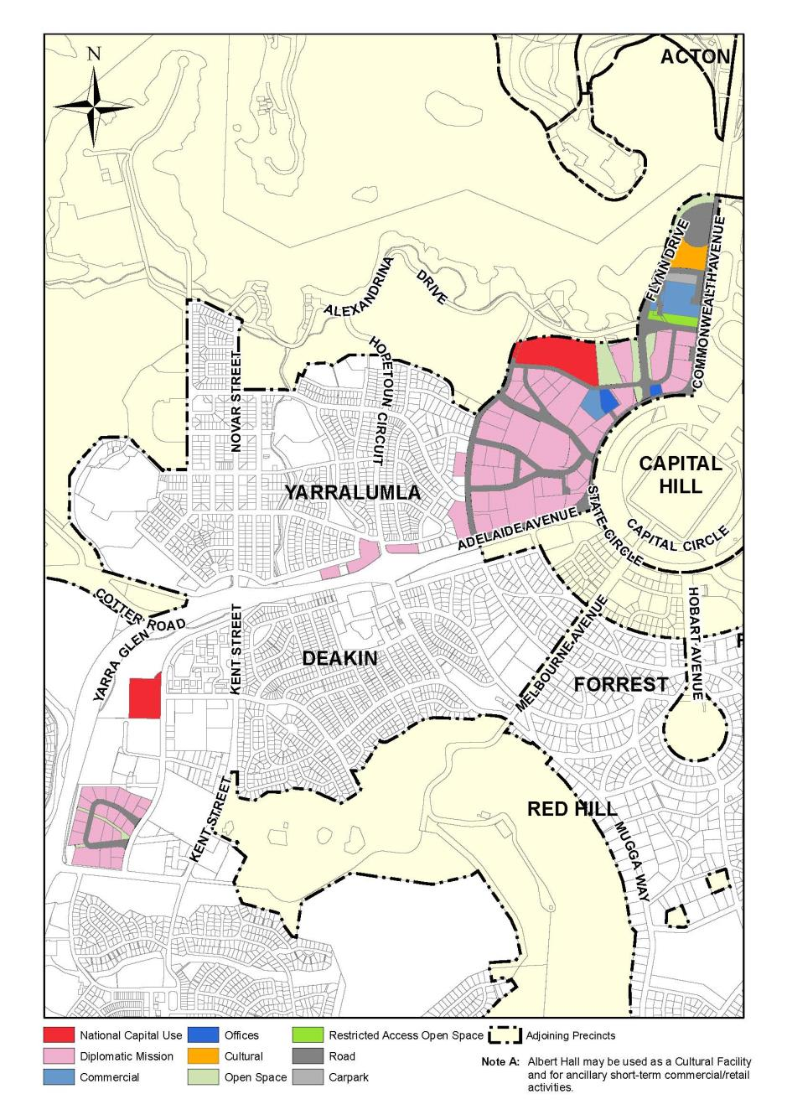
Figure 122: Land use for the Yarralumla and Deakin Diplomatic Precinct

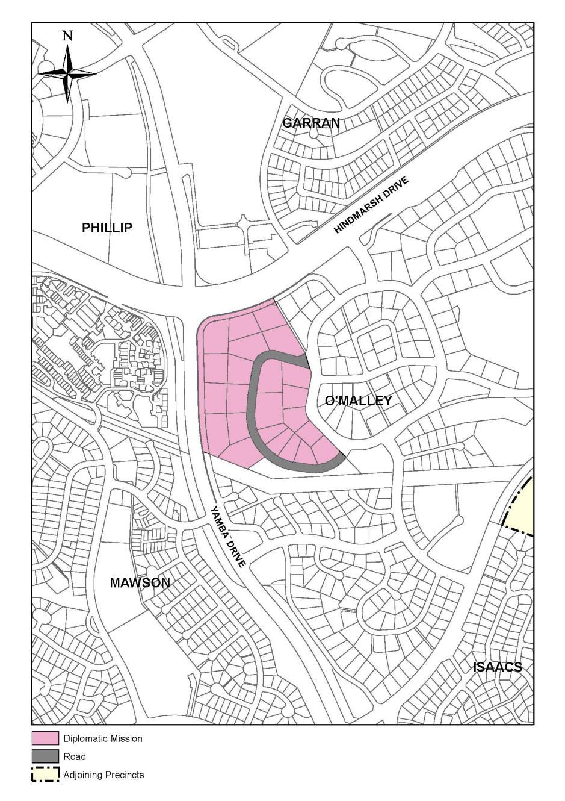
Figure 123: Land use for the O’Malley Diplomatic Precinct

4.14.5 Detailed conditions of planning, design and development

General
The planning and development of each site should be of a high quality, preferably exhibiting a distinctive design character reflecting the architecture of the country.

Building form and envelope
Large bulky building form is to be avoided. The building by its form should follow the slope of the land, rather than contrasting with it.
The height of any building should not exceed two storeys above natural ground level.
The plot ratio should not exceed 0.35.
Externally exposed plumbing and mechanical plant including duct work will not be permitted. All mechanical plant and equipment should be contained within buildings or service yards and should be suitably screened from public view.
The design, material and colour of building roofs are of particular importance and should be sympathetic with that of surrounding development.

Architectural requirements
All buildings and structures on site are to exhibit a high degree of architectural quality in their design and use of materials. All buildings and structures must also enhance the prestigious setting with substantial landscaped gardens.
Traditional architectural styles are encouraged in the Diplomatic Precinct where buildings contribute to the distinct character of such areas and reflect their national and international significance.
Highly reflective materials for roofs and walls, including mirrored glazing, are not permitted.

Landscape design
Landscape design for individual blocks should seek to enhance the visual quality of the area and integrate the building with its landscape setting.
Landscaping should only be carried out in accordance with a Landscape Plan approved by the National Capital Authority.

Boundary treatment
Boundary fencing should relate to the architectural and landscape design of the diplomatic mission. The character of the architecture should be reflected in the design of the fence and gateway. Chain link, mesh or timber palings will not be accepted. Security fencing should be located inside the boundary treatment.

Car parking
All car parking for staff and visitors should be accommodated wholly within the site.
Car parking areas should be landscaped to minimise their visual impact. The layout of proposed parking areas should be included in the Landscape Plan.
Garages and car ports will not be permitted forward of the building lines established along the frontage of individual blocks. All covered vehicle parking must be consistent in character with the architectural style of the main building, matching materials and finishes.

Plant and equipment
All mechanical plant and equipment (including air conditioning units) should be contained within buildings or located within service enclosures appropriately screened from street frontages.

Security
Perimeter security elements should be incorporated into streetscape or landscape design where possible. Perimeter security elements should be minimised, unobtrusive, and designed to relate to the surrounding context.
Security measures within site boundaries should complement the architecture and landscape design of the mission.

4.15 MAIN AVENUES AND APPROACH ROUTES PRECINCT CODE

4.15.1 Precinct Location
The Main Avenues covered by this Precinct Code are identified in Figure 124 and the Approach Routes identified in Figure 125.
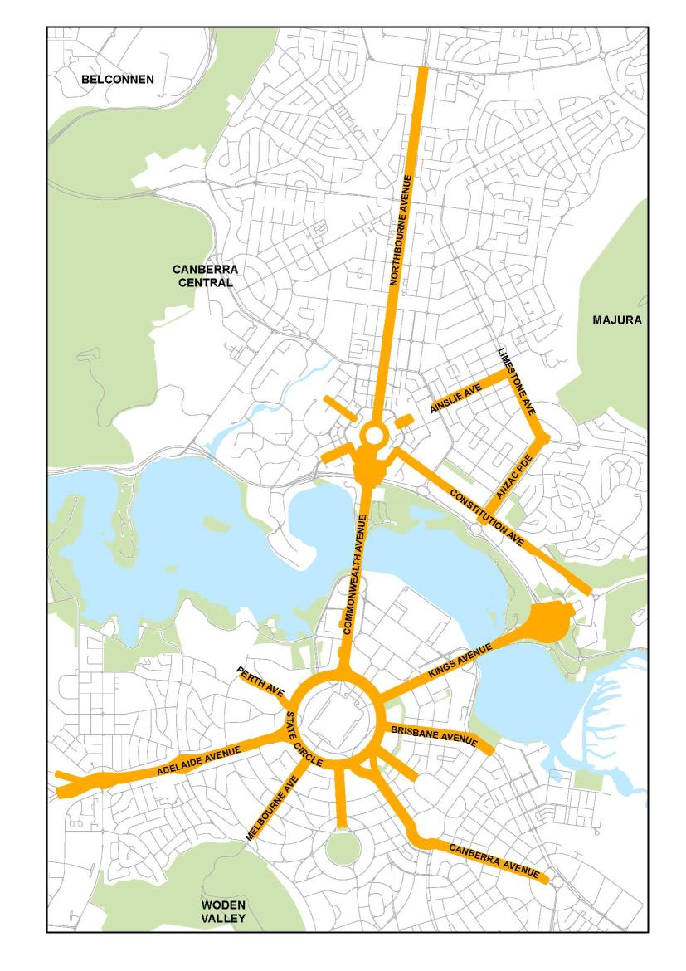
Figure 124: Main Avenues location
The Main Avenues include the land within the boundaries of the reservations of the following roads:
- Adelaide Avenue
- Ainslie Avenue
- Anzac Parade
- Brisbane Avenue
- Canberra Avenue (to Hume Circle)
- Commonwealth Avenue
- Constitution Avenue
- Edinburgh Avenue
- Hobart Avenue
- Kings Avenue
- Limestone Avenue (south of Ainslie Avenue)
- Melbourne Avenue
- Northbourne Avenue
- Perth Avenue
- State Circle
- Sydney Avenue
- University Avenue
The Approach Routes include the land within the boundaries of the reservations of the following roads:
- Barton Highway
- Canberra Avenue from Hume Circle to the ACT border
- Fairbairn Avenue
- Federal Highway
- Monaro Highway through to Morshead Drive
- Morshead Drive/Pialligo Avenue to the ACT border
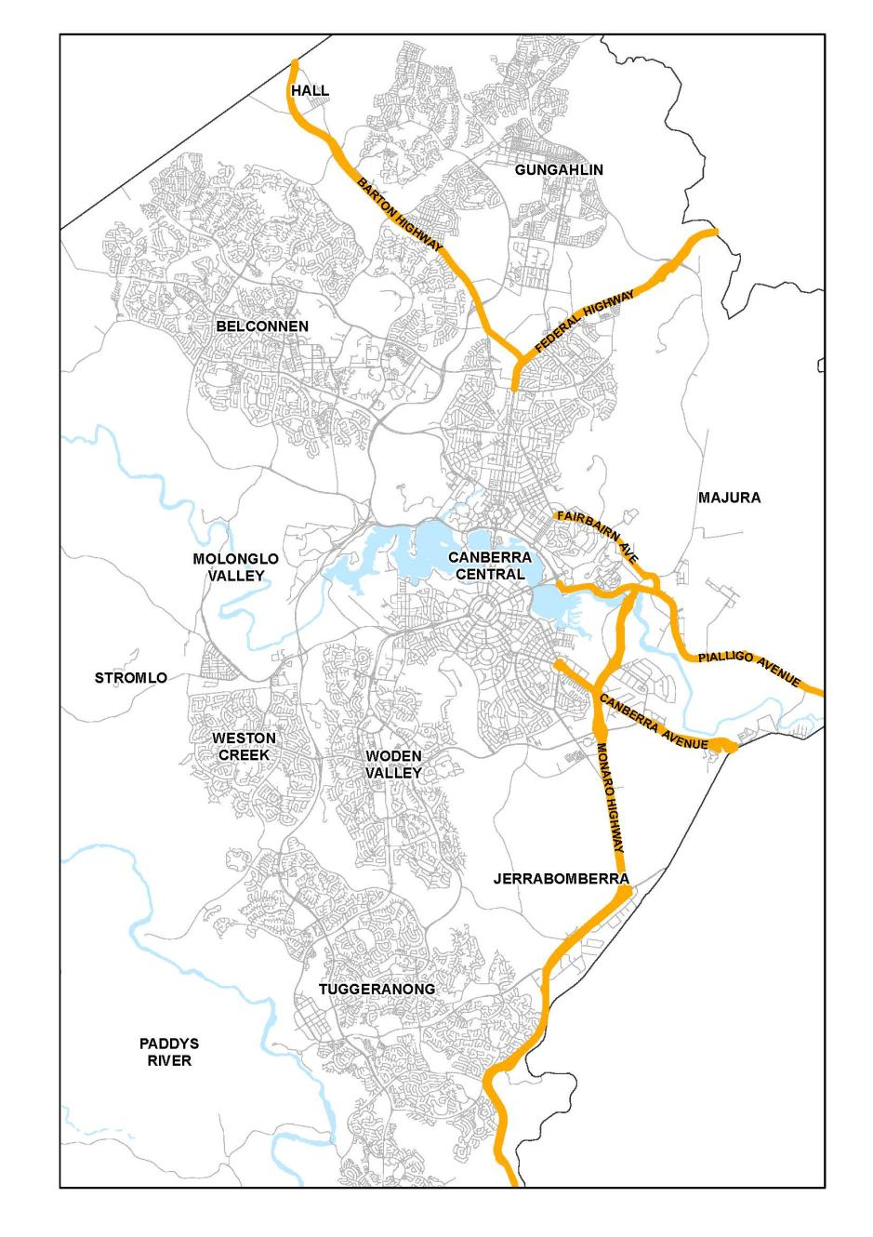
Figure 125: Approach Routes location

4.15.2 Background
Canberra’s main avenues and approach routes have historically been subject to rigorous planning scrutiny, and care has been taken to ensure that suitably high standards of development and landscaping have been observed.
A traveller’s first perception of a city’s character is gained upon approach and arrival. When arriving in Canberra it is important that the traveller is immediately aware of the special symbolic and functional significance of the National Capital.
Design policies are concerned with achieving awareness of this special significance through the following:
- marking the boundary of the ACT
- establishing a clear and identifiable route from the boundary to the symbolic centre of the city, by providing visual cues and strong structural links eg. avenue planting
- building up expectations by progressively formalising the design character as travellers approach the Central National Area
- enhancing views to recognisable and popular images of the National Capital so as to further build expectation and define the approach
- ensuring that the structure, detailing and signage is consistent along each approach route into the National Capital.
To create an identifiable approach, which increases in formality as it gets closer to the Central National Area, and which clearly signifies the symbolic and functional roles of the National Capital:
- buildings which enhance the approach route function should front these roadways
- the main avenues are to be enhanced in their formal character and maintained to the highest standards.
Main avenues and approach routes have also previously been identified as ‘Areas of Special National Concern’ in a 1964 Cabinet decision subsequently incorporated in the gazetted planning policies for Canberra. It is important that development within the road reservations, including signs and landscaping continues to be subject to high standards of design and landscaping and continues to recognise the importance of these routes as introductions to the National Capital.

4.15.3 Objectives for Main Avenues and Approach Routes
- Establish and enhance the identity of the approaches to the Central National Area as roads of national significance and, where relevant, as frontage roads for buildings which enhance the National Capital function and as corridors for a possible future inter-town public transport system.
- Ensure that works within the road reservations are carried out to the highest standards, by maintaining and enhancing landscaping, and by facilitating the flow of traffic as far as possible.
- Reinforce and, where possible, express the integrity of the Griffin Plan’s visual structure by strengthening the geometry and form of main avenues, vistas and public spaces.
- Improve the urban design and streetscape qualities of the Main Avenues as approaches to the Central National Area.

4.15.4 Detailed conditions of planning, design and development

General
Traffic is to be managed to ensure the continued effective function of the Main Avenues and Approach Routes. The Main Avenues will provide access to fronting buildings where practicable, and where traffic safety and flows are not adversely affected.

Landscaping
The Main Avenues and Approach Routes will be developed and maintained as high quality landscaped corridors. In built-up areas, the established design theme of verges and medians and formal tree plantings will be maintained. In areas of intensive pedestrian use, high quality paving is to be used.

Signs
Signs will generally comprise traffic, directional and visitor information signs, and unnecessary repetition will be avoided. Commercial roadside signs are not permitted in road reservations, except on bus shelters. Non-commercial signs may be permitted where they comply with the requirements for signs set out in the Signs General Code.

Streetscape design
A streetscape hierarchy, that complements the road hierarchy, should be established. This hierarchy should give primacy to main avenues, emphasise continuity along their length through avenues of appropriately scaled trees, consistent pedestrian pavement materials, street furniture and lighting.
Development should generally be constructed to the street boundary to define and enclose streets and create continuous street frontage while allowing variations in individual buildings and uses.
A limited palette of high quality pedestrian pavement materials, street furniture and lighting will be used. Pavement and landscape design should have an elegant, simple and bold design emphasising the geometry and formality of the main avenues.
Streetscapes are to be well lit for pedestrians and optimise security and safety for night time use.

Approach Route – Federal Highway

Location
Development within the Federal Highway Approach Route from its intersection with Stirling Avenue to the ACT border is to comply with the detailed conditions.

Objectives
The objective is to heighten the traveller’s first perception of approach and arrival in order to enhance recognition of the special symbolic and functional significance of the National Capital. These detailed conditions are concerned with achieving awareness of this special significance through the following:
- marking the boundary of the ACT
- establishing a clear and identifiable route from the border to the Central National Area, the symbolic centre of the city, by providing visual cues and strong structural links
- building up expectations by progressively formalising the design character as travellers approach the Central National Area
- enhancing views to recognisable and popular images of the National Capital so as to further build expectation and define the approach
- ensuring that the structure, detailing and signage is consistent along each approach route into the National Capital.

Policies

Border Identification and Marker
Ensure the identification of the ACT by the placement of a marker at a safe and appropriate location, possibly in conjunction with a visitor lay-by. The marker should be similar in form and design to the existing marker but should also include heraldic features which signify the symbolic and functional role of the city and which establishes a relationship to signs and institutions in the Parliamentary Zone. There should be clear lateral views to the border marker; and
Introduce specialty lighting to highlight the ACT marker. If practical, up-lighting of the border marker and adjacent tree canopy should be used.
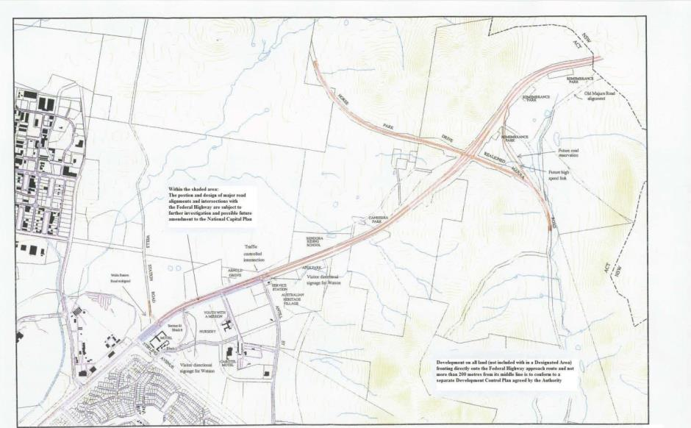
Figure 126: Federal Highway road design characteristics

Road Design Characteristics

Access Limitations
From Antill Street to the intersection with the realigned Majura Road, access will not be permitted on the southern side of the highway except to Apex Park. From the intersection with the realigned Majura Road to the ACT border, no access will be permitted except to a visitor lay-by.
On the northern side of the Federal Highway, access will be permitted only in the short term to ‘Arnold Grove’, ‘Bendora Riding School’, the AGL lease, and ‘Canberra Park’ while longer term access is expected to be provided from within Gungahlin.

Intersection Design
The continuity of the north/south carriageway driver experience should be reinforced. The Majura Road/Horse Park Drive grade separated intersection should reinforce the visual dominance of the Federal Highway, to maximise views and ensure the least disruption to the landform.

Medians and Verges
Medians and verges are to provide the opportunity for reinforcement of landscape themes and realms. Medians should be of a sufficient width to accommodate the appropriate landscape treatments for each landscape realm and pattern and generally be not less than 20 metres wide.

Carriageways
Roadworks are to minimise the impact on the existing topography. Cuts and fills associated with the design and construction of the highway and associated roadworks are to be kept to a minimum. The highway is to be designed to ‘fit’ within the landscape and topography.
Where possible, the two carriageways are to be designed independently and separated both vertically and horizontally so as to ensure integration into the topography.
Road surfaces should be of asphaltic concrete with a clean edge, unless other materials are shown to be more appropriate.

Lighting
Where provided, lighting should reinforce the design intent of the Federal Highway as a ‘rural’ highway road. Further, the colour temperature of the lights should be such that the true colours and features of the landscape are perceived. Light spillage is to be minimised to prevent unnecessary night sky illumination.

Equestrian Trails
Ensure the design of the highway incorporates appropriately located and connected underpasses for equestrian use and facilitates the continuation of existing equestrian trails; and
Enhance where possible, the trail concept with provisions for additional facilities at appropriate locations.

Signs
Ensure informative, well presented, factually correct and relevant visitor information is displayed on signs and boards and plays a key role in informing the visitor.
Ensure information signage conforms to a uniform standard for Approach Routes. All signs which are not essential to be read from the road, such as interest group signs, are to be located in a visitor lay-by.
Information appropriate for inclusion in visitor lay-by signage includes:
- natural landscape – environment information regarding the distinctive natural landscape and features
- cultural/historical landscape – information regarding Aboriginal history and influences and early European settlement and impact
- siting of Canberra – diagrammatic development of Canberra, basic structure of Canberra’s layout including important features and elements, monuments and institutions
- community organisations and relevant local information.
Visitor directional signage, other than in the visitor lay-by, will be permitted where shown on Figure 126 assist identification of destinations between Antill Street and Stirling Avenue, Watson.
No other visitor information signs will be permitted along the highway.

Visitor Lay-By
Ensure access to a visitor lay-by at a convenient location for visitors.

Landscape

General
The policy is:
- to ensure Canberra’s unique setting within the natural landscape is reflected in the sensitive design and landscape treatment for the highway which reinforces the perception of the National Capital
- to recognise the significance of views to the surrounding hills and ensure engineering structures respect the landform and landscape patterns.
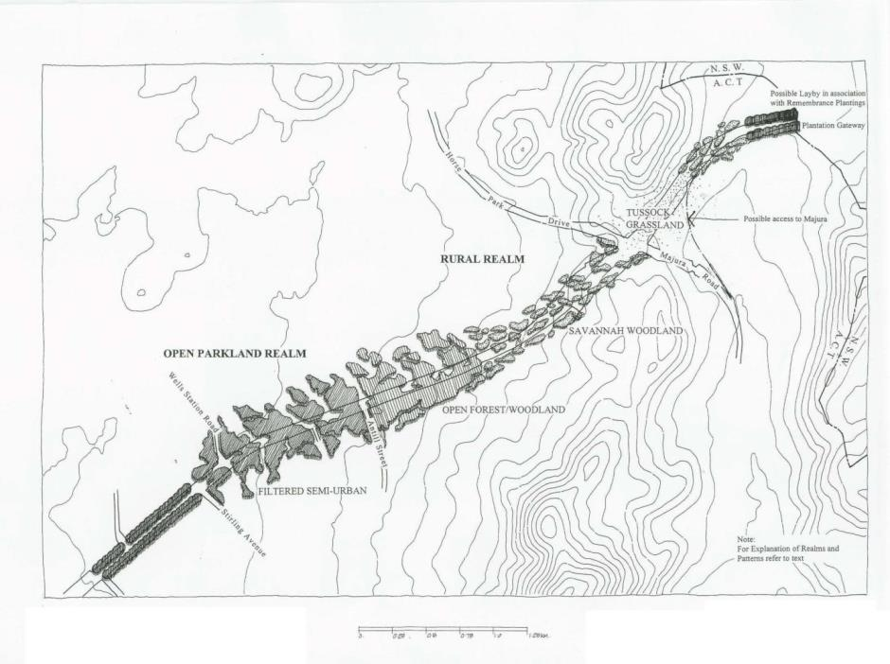
Figure 127: Federal Highway landscape realms and patterns

Major Landscape Realms
The Federal Highway is divided into two broad realms for the purposes of detailing landscape patterns. They are a Rural Realm and an Open Parkland Realm (see Figure 127 ‘Federal Highway landscape realms and patterns).
- Rural Realm: identifies the location of Canberra and establishes the setting of the ‘bush capital’. The pastoral setting is a cultural and historical reminder and recognises that the colour and scale of the landscape are important in creating an identifiable and memorable image. Views to the Gungahlin ranges and Black Mountain should be maintained and enhanced.
- Open Parkland Realm: emphasises reflection of the rural landscape, (but with a designed park-like landscape quality), and introduces the visitor to the planned ‘garden city’ image. Planting and development patterns are to allow filtered horizontal views.

Landscape Patterns
Driver experience should be modulated through a series of distinct landscape patterns which identifies a change in landscape character from an informal planting, open, rolling, rural landscape to a regular planted, closed, dense canopy pattern of the semi-urban landscape. Landscape patterns apply as set out in Figure 127.
To assist the understanding of the landscape patterns and where they apply, the highway has been broken into sections starting at the ACT border.
- Plantation Gateway (0.0–0.4 km): creates an introduction and announces the imminent arrival of the visitor in Canberra by establishing appropriately designed tree planting that relates to the rural landscape, but is distinct in character. Within the road reserve, the policy is to develop a formal plantation in the verge and median of the highway.
- Savannah Woodland (0.4–0.8 km): reinforces the existing woodland character by maintaining and enhancing the indigenous eucalypts in small groups and individual specimens in the median and verges, and ensures the character is of an open canopy giving a parkland appearance.
- Tussock Grassland (0.8–1.4 km): establishes a grassland community and complements the savannah woodland character of adjacent sections of the highway. It does this through broad scale planting of road verges with native grasses and herbaceous plants with low grasses in medians.
- Savannah Woodland (1.4–2.8 km): reinforces the rural pastoral character by planting and protecting indigenous eucalypts in small groups and individual specimens in the median and verges, generally widely spaced, leaving an open canopy and giving a parkland appearance. Residential views are to be screened and views opened up along open space corridors.
- Open Forest/Woodland (2.8–4.0 km): reinforces the open forest character of this part of the highway. The policy is to resolve secondary access to rural properties while maintaining continuity of the approach route, and to allow short, filtered horizontal views. Median planting is to be informal and should reinforce existing native planting as well as introducing grouped accent planting.
- Filtered Semi-Urban (4.0–5.4 km): creates a transition from woodland to the contrasting closed corridor section of Northbourne Avenue and develops a ‘secondary’ gateway with designed avenue planting to create a strong contrast with the rural landscape as the introduction to urban Canberra. Direct views should focus along the approach route. The built form should be screened through the use of plant material.

Cultural Landscape Features
The policy is to maintain the significance of the Remembrance Parks through enhancement of their location and access in association with a visitor lay-by, by providing interpretative material, and by the possible extension of areas for planting.

4.16 AUSTRALIAN INSTITUTE OF SPORT PRECINCT CODE

4.16.1 Precinct location
The Australian Sports Commission (ASC) is commonly referred to as the Australian Institute of Sport (AIS). The AIS is located in the suburb of Bruce in the ACT. The campus consists of approximately 75 hectares and is bound to the north and east by Masterman Street, to the west by Braybrooke Street, and to the south by Battye Street and the hills and ridges that abut Gungahlin Drive.
Figure 128 illustrates the location of the Australian Institute of Sport Precinct.
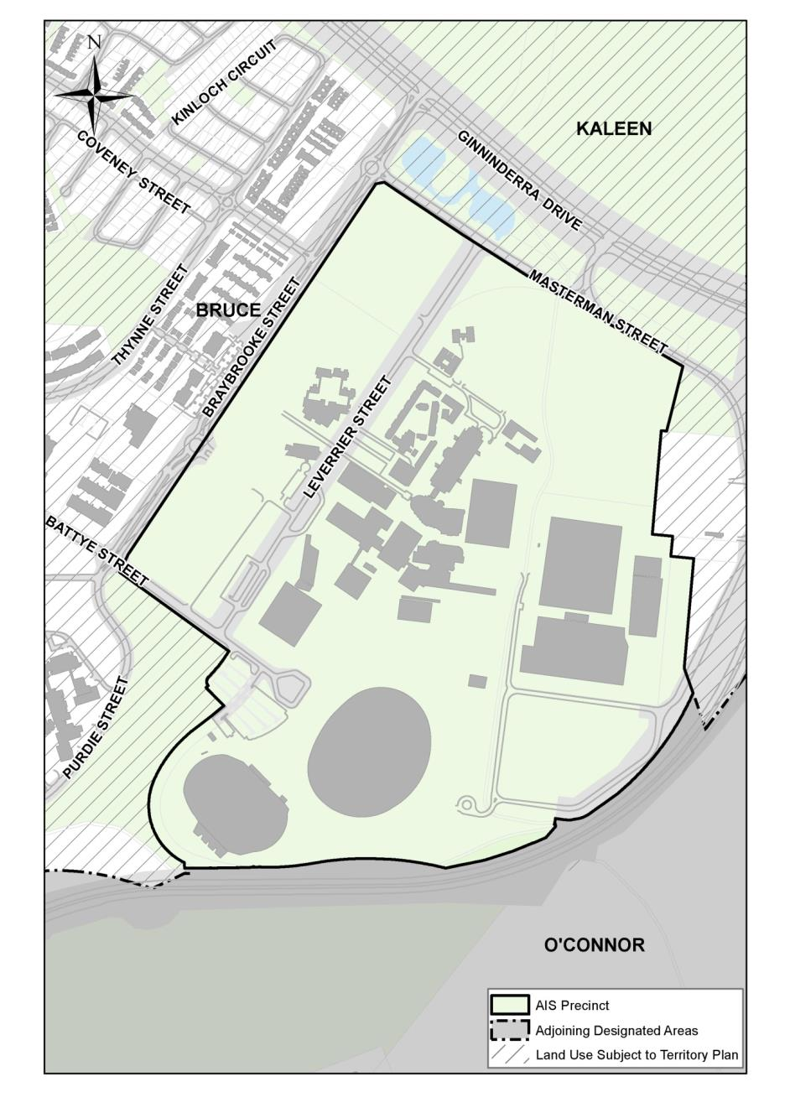
Figure 128: Australian Institute of Sport Precinct location

4.16.2 Background
The ASC is the Australian Government’s leading sport agency that develops, supports and invests in sport at all levels. The AIS campus creates and maintains the physical environment that supports the ASC’s objectives to make Australian sport stronger – to get more people playing sport and to help athletes pursue their dreams.

4.16.3 Objectives for Australian Institute of Sport Precinct
The framework that has been formulated by the AIS as part of a wider master planning process includes the following planning themes:

Sporting intent
The planning and design policies of the AIS Bruce campus provide a place that actively facilitates world leading outcomes for high performance sport and greater participation in sport for the wider community. The campus must be planned, built and maintained in a manner that enhances the AIS’s leadership of sport.

Functional elements
The AIS campus enables the delivery of activities consistent with the Australian Sports Commission Act 1989 and provides a range of land uses that support the AIS's sporting intent. This includes the following sport related functions:
- Daily training environment for high performance sport
- Research and Innovation
- Scientific capability and support services
- Learning
- Residential accommodation
- Commercialisation including events
- Administration
- Site infrastructure
- Support services
- Community activities.

Infrastructure
Management of the campus includes the provision and maintenance of appropriate infrastructure to support the functional requirements of the campus with capacity and flexibility for future growth including the provision of the following:
- Environmentally sustainable landscaping, reflecting contemporary design and environmental standards
- Energy efficient utilities
- Communication systems
- Safety elements such as security, lighting, and wayfinding
- Roadways, footpaths and hardstandings.

Built form
Planning allows for an attractive, welcoming campus that complements and enhances the natural landscape and integrates the essential elements for sporting and support facilities in the built environment.

Landscape
The Landscape Masterplan must be prepared that expresses the national sporting endeavour and achievement through a positive use of contemporary Australian design. It should incorporate a palette of native and exotic plantings, maintaining key open spaces and corridors, water capture and reuse, dry grasslands and shrubs. Any building development proposals will incorporate the key hard and soft landscape design elements.

Transport and movement
The campus is integrated into the adjoining road infrastructure to ensure safe egress and car parking for athletes, staff and visitors. The campus Traffic Impact Assessment informs traffic flow and parking in addition to strengthening the use of public transport and cycling and reducing bicycle/vehicle/pedestrian conflicts.

Sustainability
The AIS campus will be developed and managed in a way that ensures high standards of environmental sustainability and social inclusion with campus environmental management based on the international standards for environmental management systems.

Heritage
The AIS’ capability to identify and manage its buildings and artefacts of cultural and potential heritage value will be enhanced. Any new development will be integrated sympathetically within the campus to enhance the overall environment, commensurate with the endorsed ASC Heritage Strategy.

4.16.4 Land use for Australian Institute of Sport Precinct
Land use for the Australian Institute of Sport Precinct should be in accordance with Figure 129.
Land use on the AIS campus is predominantly National Capital Use which is principally focussed on providing for high performance sporting activity and supporting services, including administration and residential accommodation. In addition, commercial and entertainment facilities, open space, roads, pathways and parking areas are permitted.
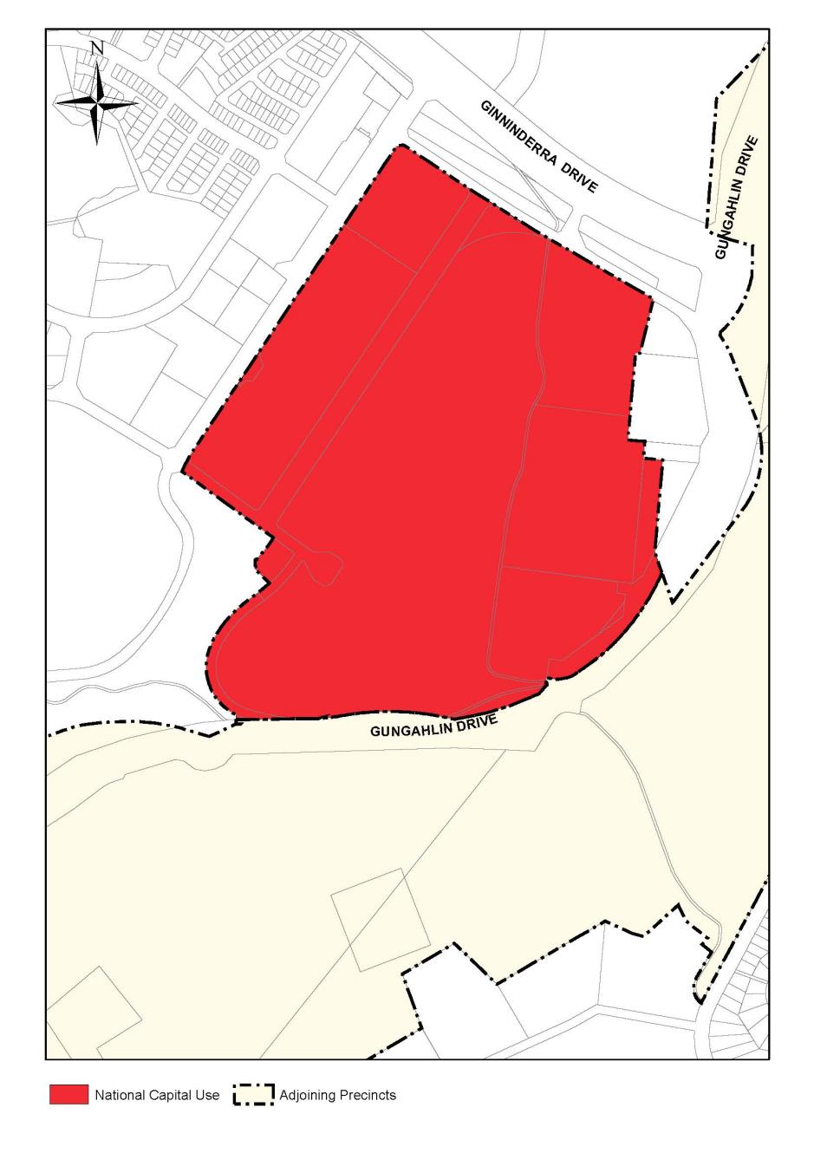
Figure 129: Land use for the Australian Institute of Sport Precinct

4.16.5 Detailed conditions of planning, design and development

General
Broadly, planning and design of the AIS Bruce campus will:
- Provide a consistent urban design character which expresses national sporting endeavour, achievement and lifestyles through a positive use of contemporary Australian design, which is innovative, cost effective and energy efficient.
- Ensure a continuity of a campus style development of individual pavilion type buildings based mainly on orthogonal plan form geometry aligned with the north-north-east orientation of the Main Pedestrian Spine. Variations in this site planning and built form geometry may be approved to meet specific functional needs, subject to overall compliance with the detailed conditions of planning, design and development of this Precinct Code.
- Functional relationship between uses must be considered while siting buildings/facilities on the site and should be in accordance with the ‘Specific’ detailed conditions of planning, design and development of this Precinct Code. Figure 130 shows the spatial relationship among various uses/facilities in the core area of the AIS and provides guidelines for possible new development or development extensions within the area.

Sporting intent
The development of the AIS Bruce campus will reflect the emerging needs of our national sporting organisations, peak national sporting bodies, state institutes and academies of sport, Federal and State sporting departments and the sport business sector. In achieving this, the AIS facilities will be recognised as world-class Centres of Excellence.

Building Design, Materials and Colour
Buildings should correspond to the architectural language of existing adjacent development for their external expression in terms of choice of materials, detailing, construction logic, structural expression and scale of elements. Some variation in the architectural design may be considered - especially where the design expresses the specific function of the building, but such variation should be within the limits of an overall consistency.
Wherever possible, external building materials should adhere to the existing range of types, finishes and colours, in order to encourage visual coherence between buildings. Sympathetic variations in colours and materials between individual buildings may be considered. However, strongly defined contrasts in colour of architectural features should generally be avoided.
Within these parameters, more prominent design and colour treatment may be considered for special facilities (such as visitor arrival, reception, exhibition, display and signage facilities) where increased visual emphasis is integral to their function.
All external façades must be of high quality durable low maintenance materials. Highly reflective external materials should not be used.

Landscape design
Landscaping of the site should be in accordance with a comprehensive landscape plan prepared for the site which aims to ensure the following:
- Consistency in the site landscape design should be maintained.
- Wherever possible significant existing vegetation should be retained and blended with the landscape design. Care should be taken during construction to protect the trees to be retained.
- Landscaping should provide screens, as appropriate, against the large masses of buildings and paved areas to minimise their visual impact on the adjacent areas, and especially the open spaces.
- External paving materials, fencing, screening, lighting and related outdoor furniture should ensure visual coherence and consistency over the entire site.

Traffic Circulation and Parking Provision
Provisions for vehicular access/egress and parking accommodation should be made in accordance with the requirements of the National Capital Authority after consideration of relevant ACT Government standards. In this regard, the traffic impacts of new development or development extensions in the area must be taken into consideration.
A Traffic Management Plan should be prepared for the AIS in accordance with the relevant ACT Government standards and must be agreed to by relevant ACT authorities. The plan should address management issues related to possible conflicts in traffic circulation of different kinds of traffic (vehicular, pedestrian and service vehicle) and the provision and management of car parking within and adjacent to the AIS.
Pedestrian links between various facilities should be ensured and expanded, connecting on site facilities, carparking areas and transport access points with the primary destinations, including the Stadia, Visitor Centre and Main Administration Zone.
The existing main pedestrian spine should play an increased role in the pedestrian network of the campus and its expansion over time. Detailing of the pedestrian spine should generally be in accordance with Figure 132.

Environmental Considerations
Adverse environmental impacts from on-site developments, on adjacent land and development, should be identified and redressed to the fullest extent practicable in accordance with the requirements of the National Capital Authority after consideration of relevant ACT Government standards.

Temporary/Short Term Uses
The design, materials and colours of temporary buildings should be sympathetic to the surrounding buildings and the landscape and must ensure some level of consistency with adjacent development in terms of detailing and the colour treatment.

Lighting
Where practicable, all outdoor lighting, including security and car park lighting must be designed and sited to minimise light pollution. Outdoor lighting must use full cut-off light fittings. Any up-lighting of buildings should be carefully designed to keep night time overspill and glare to a minimum.

Specific
The area covered by this Precinct Code has been divided into five distinct precincts. Precincts 3, 4 and 5 have been further divided into two zones each as shown in Figure 131. The precinct and zone specific requirements/controls are given below.

PRECINCT 1: Main Entry and Administration

Purpose and general characteristics
The purpose of this precinct is to accommodate the central administration and formal public arrival and visitor functions of the AIS in a distinctive manner that is appropriate to the National status and functions of the Institute.
This precinct is characterised as the main public address and administrative centre for the Campus and is geographically central to existing AIS built facilities. Its function is reflected in the character of the existing building, landscaping, external works and direct links to adjacent door facilities.
This precinct is related most directly to adjacent indoor sports facilities and the temporary administration annex located on the main pedestrian spine.
Development within the precinct should incorporate vehicular arrival, covered setdown and limited visitor parking and also include appropriate landscaping, urban furniture, artworks and signage. Vehicular access through the area should be restricted and most parking, apart from short stay visitor parking, should be provided outside the precinct.

Building Character
The existing character and scale of buildings within the precinct should generally be maintained. However, localised height increases may be considered to allow added locational emphasis for the entry areas. Existing setbacks from Leverrier Street and the Main Pedestrian Spine are to be maintained.
Buildings within this precinct should be limited to a maximum of three storeys or 12 metres to parapet or eaves level, in order to maintain scale with existing development. The frontages with Leverrier Street and the main pedestrian spine should have a maximum height of two storeys or 8.5 metres to maximise winter sun penetration to the spine.

Landscape Character
To complement the scale of development, a strong structure planting framework should be considered for Leverrier Street; with more detailed planting focusing on building entry, public arrival and assembly-areas. Structure planting, street and avenue planting should be predominantly native species to reflect National landscape content and the existing Eucalyptus planting in portions of Leverrier Street.
Landscape planting within the precinct should mainly be exotic trees and shrub species with irrigated grass areas, including a majority of deciduous trees to maximise winter sun penetration.

Precinct 2: Residential Accommodation

Purpose and General Characteristics
The purpose of this precinct is to accommodate all on site AIS residential needs in an attractive and secure living environment, separate from training and event facilities and general public areas. The needs include housing for resident and visiting athletes and staff, as well as related residential facilities for external training, education, exchange, visitor and event programs.
This precinct is characterised as the main accommodation area for the Campus and the centre of social and community activity for resident athletes and staff. Dining hall, indoor recreation and concessional uses are conveniently located within the existing four storey development, whose wings form semi enclosed residential ‘courts’. The precinct is directly related to the indoor and outdoor sports facilities to the east and principally accessed via the main pedestrian spine.
Development within the precinct should incorporate housing support uses, including residential reception and administration, resident concessions, library and educational resource facilities. All accommodation should be provided within an integrated three to four storey medium density development that conserves the residential capacity and amenity of the site.

Building Character
The existing residential character and scale of the precinct should be maintained and developed through a series of new residential courts and associated support facilities. Existing setbacks from Leverrier Street and the Main Pedestrian Spine are to be maintained.
New buildings along the eastern Leverrier Street frontage must be sited to align with the existing residential building on that frontage and should hold critical corners with appropriate building mass. Buildings along the Main Pedestrian Spine must address the spine and be sited to define and reinforce the linear pedestrian space as shown in Figure 130.
The detailed face brickwork character of the existing housing should not to be repeated, except for extensions or modifications to the existing blocks. A more contemporary and cost effective design idiom should be considered, while maintaining consistency with the housing type, scale, materials and colour.
Buildings within this precinct should be limited to a maximum of four storeys in order to maintain the scale of existing housing and retain the residential capacity of the site. Adjoining the main pedestrian spine, a maximum height of three storeys needs to be maintained. An average height of three to four storeys is required across the area.
New buildings along the western frontage of Leverrier Street should be sited to complement the existing residential buildings on the eastern frontage, present appropriate building mass and assist with noise reduction in the vicinity of residential accommodation areas.

Landscape Character
The external landscape character of the zone is determined largely by its extended frontages with the Main Pedestrian Spine and Leverrier Street, both of which should be developed as fully landscaped informal malls.
To complement the scale of the residential courts and sports halls, a strong structure planting framework should be provided for Leverrier Street and the Pedestrian Spine, with more detailed planting focusing on building entry, public arrival and assembly areas.
Landscapes within the residential courts should focus on passive outdoor uses and residential amenity, with a predominance of deciduous tree planting to maximise winter sun penetration.
Native tree and shrub planting, with dryland grass should be considered for Leverrier Street, to maintain its existing landscape character, while the Pedestrian Spine and Residential arrival zone are to be principally exotic tree and shrub species with irrigated grass areas.

Precinct 3: Main Indoor Facilities

3A. Indoor Arena Zone - South

Purpose and General Characteristics
The purpose of this zone is to provide for major indoor sporting and entertainment venues involving large public attendances and requiring associated public facilities. These venues include the main indoor stadium and various sports halls.
This zone is almost fully developed and generally characterised by large wide span structures in an open landscape setting. This area is the main focus of public involvement in AIS indoor facilities. The zone relates most directly to the adjacent indoor and outdoor facilities of zones 3B and 4A, and the main parking areas west of Leverrier Street. Internal pedestrian access is principally via the central pedestrian spine.

Building Character
New development within this zone should generally seek to retain the character to existing facilities and be part of an integrated building and landscape group. Alterations and additions to existing structures should closely adhere to the design intent of the original, including form, materials and colours. It should allow the existing main structures ‘pavilion’ character to be maintained in all views, particularly from Leverrier Street. Within this general context, any new facility must have a distinctive design and siting approach either as a complementary secondary element for existing prominent structures or as a separate pavilion, where such visual prominence is justified by function or scale.
The buildings within this zone share an orthogonal relationship to each other and Leverrier Street and constitute a well balanced group within a carefully designed landscape setting. This relationship between the buildings and landscaping should generally be maintained for all new development within the zone.
Apart from the Indoor Stadium, the buildings are mainly two to three storeys in height but differ markedly in scale due to extensive earth mounding, part basements and elevated roof structures. Generally, new development should not exceed the height of adjacent facilities within the zone.

Landscape Character
The landscape character of the zone is predominantly open grassed areas, mounding and paving, which allow open views between facilities and serve as a foil to the large scale sculptural quality of the major Sports Halls. This landscape character and visibility is important for visitor and tourist activities and should be retained in new development, subject to screening and micro-climate needs of building entry, parking, service areas and pedestrian links.

3B. Indoor Facilities Zone - East

Purpose and General Characteristics
The purpose of this zone is to provide comprehensive indoor training, practice and competition facilities for the AIS, together with associated Sports Science, Medicine, Seminar and support facilities. The main AIS Services Centre is also located in this zone.
This zone is extensively developed with few significant vacant sites remaining. The zone is characterised by a mix of large sports halls and support buildings, with relatively contained outdoor landscape areas. The zone is an integral part of the main pedestrian spine and its buildings should consistently maintain a high design standard.
This zone extends full length of the pedestrian spine. It houses a wide range of sports and has active links with most on site facilities. It is strongly related to the outdoor training facilities zone 4B, which provides close support for related indoor activities. Vehicular and service access is provided from the north and west, however, all general access is via the pedestrian spine. This access arrangement should be maintained for new development within the zone.

Building Character
Buildings within the zone are mainly of two to three storey height, but differ markedly in scale due to attached structures and architectural modelling. New development should not exceed the height of adjacent facilities, except where localised height adjustment is necessary to accommodate special design requirements.
New development should be similar in character to existing facilities and be part of an integrated building and landscape group. Alterations or additions to existing structures must closely adhere to the design intent of the original, including form, materials and colours.
New buildings should have a distinctive siting and design approach that defines and reinforces the new pedestrian plaza connecting the existing and the northern extension of the Main Pedestrian Spine. Existing building height and open space relationships are important for outdoor amenity in this area and will require detailed consideration in any new building works.

Landscape Character
The landscape character of the zone stems from its contained pedestrian environment, continuous interface with the pedestrian spine and a diverse mix of semi mature exotic tree and shrub planting. This existing character of landscaping should be maintained and enhanced for new developments in the zone.
Local stormwater drainage, service access and road work changes for future extension of the zone (to the north) should ensure integration with the Pedestrian Spine and cycleway landscape. An integrated landscape planting strategy should be considered for this zone and the (extended) pedestrian spine as a whole.

Precinct 4: Main Outdoor Facilities

4A. Outdoor Stadium and Athletics Zone

Purpose and General Characteristics
The purpose of this zone is to:
- provide a major outdoor stadium to accommodate large sporting and spectator events
- provide the main outdoor training and competition venue for AIS track and fields sports
- accommodate related public assembly, crowd control, transport and parking facilities
- allow for expanded spectator capacity to house exceptional demands from unique events
- allow for progressive upgrading of athlete, spectator and media facilities.
The zone is characterised by the large earth formed amphitheatre and main grandstand of the stadium, with its associated lighting towers, ticketing booths, electronic score board and crowd assembly areas. Extensive landscape mounding and planting surrounding the stadium provide a suitable landscape transition with adjacent areas. The athletics area to the south is characterised by relatively modest scale support facilities. The area is most closely related to adjacent spectator access and parking areas, including general parking off Battye and Leverrier Streets and unsealed overflow parking areas to the east.
Careful management is required to ensure design coordination of miscellaneous structures, outbuildings and storage, and also a unified and cohesive landscape framework for the zone.

Building Character
The main buildings and grandstand of the stadium have a dominant structural character and are well integrated with secondary facilities despite a significant difference in scale. The complex relates well to the adjacent Indoor Stadium which employs similar materials, earth mounding and cable supported structure.
The main buildings are visually removed from the adjacent stadia facilities and quite different in character and style. This character should be reflected in any upgrading or new facilities development works. The number of secondary structures/facilities should be limited and grouped wherever possible to minimise their impact on the architecture and landscape of the main facilities. Such support facilities should be integrated with the main stadium or its extensions and the surrounding landscape through appropriate architectural and landscape solutions.
Apart from the main stadium structures, most buildings are and should be limited to single storey. Special consideration should be given to special use structures, such as viewing, judging and media coverage towers, lighting towers, scoreboards and the like, which exceed this limit or may be obtrusively sited in prominent locations.

Landscape Character
The landscape character of this zone is strongly influenced by the scale of the stadium facility and extensive native planting in the main approach from the west. Perimeter planting should be considered to provide a more coherent landscape structure consistent with surrounding bushland.

4B. Outdoor Training Facilities Zone - East

Purpose and General Characteristics
The purpose of this zone is to allow for intensive outdoor training in close support with the adjoining indoor sports halls (to the west) and to accommodate operational and support facilities required for intensive usage programs.
The area is most closely related to the indoor facilities zone 3B and is characterised by hard surfaced team and field sport enclosures, incorporating diverse training, spectator, shelter, storage and maintenance facilities. Minor facilities may be considered in this zone, provided the outdoor amenity of adjoining uses is not impaired. Careful management is required to ensure design coordination of miscellaneous structures, outbuildings and storage, and to implement a unified and cohesive landscape framework.

Building Character
The area is generally limited to small single storey support facilities. The number of structures should be limited and grouped, wherever possible, to minimise their impact in the landscape. Buildings or other structures should be integrated with the landscape by the use of levels, banks, landscape screens and tree planting.
All buildings or structures should be limited to one storey or a maximum height of 3.5 metres above finished ground level. Special consideration needs to be given to special use structures, such as viewing and judging towers, sight board and safety net enclosures, which exceed this limit. Where possible, the siting of obtrusive structures should avoid visually prominent locations and obstruction of adjacent facilities.

Landscape Character
The landscape character of this zone is strongly influenced by hard landscape elements and limited opportunity for larger scale planting and screening between facilities. Perimeter planting should to be extended to provide a more coherent landscape structure, improved screening and microclimate conditions.

Precinct 5: Eastern Support and Parking Areas

5A. Playing and Practice Fields Zone

Purpose and General Characteristics
The purpose of this zone is to provide for the majority of more space extensive outdoor practice and training activities. The zone allows for expansion of more intensive outdoor training facilities related to Activity Zones 3B, 4A and 4B. It may also allow for overflow temporary parking associated with major events in AIS.

Building Character
The area should be maintained as an open landscape area with limited single storey low key support facilities carefully designed and sited within the landscape setting. Support structures will need to be grouped wherever possible to minimise visual impact on the landscape. All buildings/structures should be integrated into the landscape by the use of levels, banks, landscape screens and tree planting.

Landscape Character
The landscape character of this zone should be established through tree planting generally in extended groups to meet wind break and visual backdrop requirements of the practice areas.

5B. Parking Zone - East

Purpose and General Characteristics
The purpose of this zone is to provide for peak car and bus parking in relation to major spectator events.
The area is characterised by unsealed grassed surface used for intensive but generally intermittent event parking.

Building Character
Generally no buildings or support structures are to be considered in this zone and the area to be used solely for parking. Minor support structures, if considered, should be carefully designed and sited avoiding visually prominent locations and ensuring that they have minimum visual impact on the landscape setting.

Landscape Character
The landscape character of this zone should be maintained with additional landscaping to be considered for providing screening, visual containment and wind protection, and to better relate to the adjacent O'Connor Ridge Nature Park. Tree planting generally needs to be in extended groups to meet windbreak and enclosure requirements. More open groupings are also required to relieve the expanse of the parking areas and to provide a landscape transition consistent with the surrounding native vegetation.
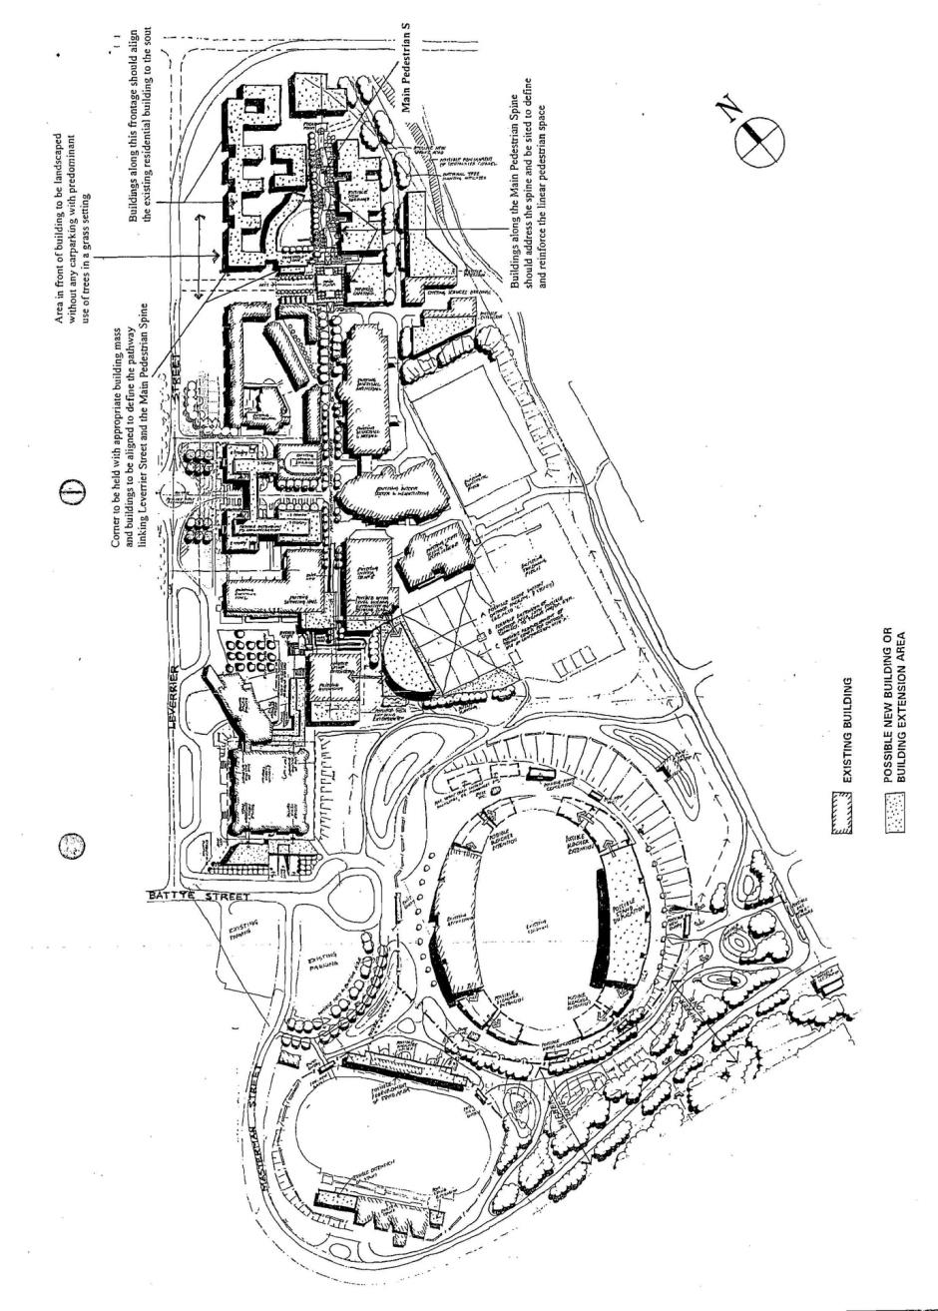
Figure 130: Australian Institute of Sport – Spatial definition and guidelines
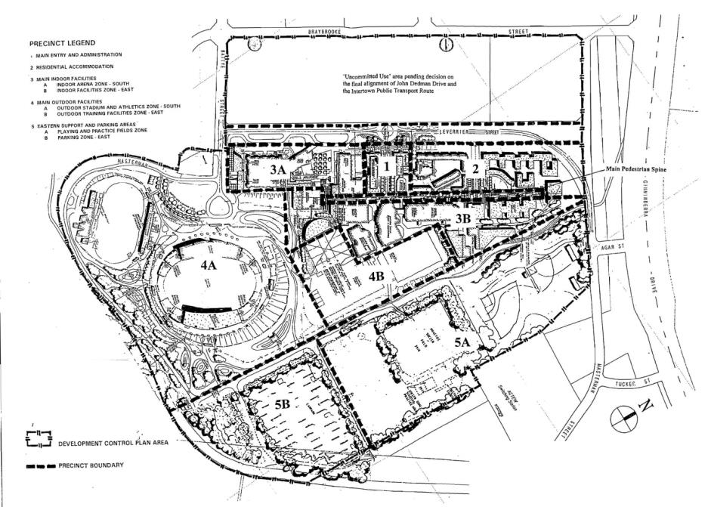
Figure 131: Australian Institute of Sport Precinct Plan
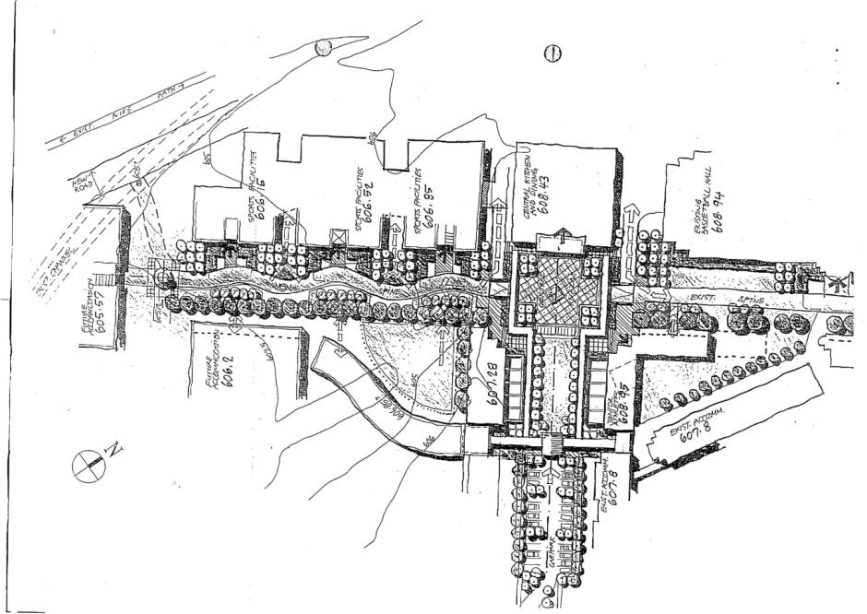
Figure 132: Australian Institute of Sport – Pedestrian Spine

4.17 AUSTRALIAN NATIONAL UNIVERSITY PRECINCT CODE

4.17.1 Precinct location
The campus of the Australian National University at Acton is located on a large area of land in Central Canberra, within the National Central Area. The campus is located on the western edge of the city centre and is bound to the south by Lake Burley Griffin and Parkes Way, to the west by Clunies Ross Street and Black Mountain, and to the north by Barry Drive and the residential area of Turner.
Figure 133 illustrates the location of the Australian National University Precinct.

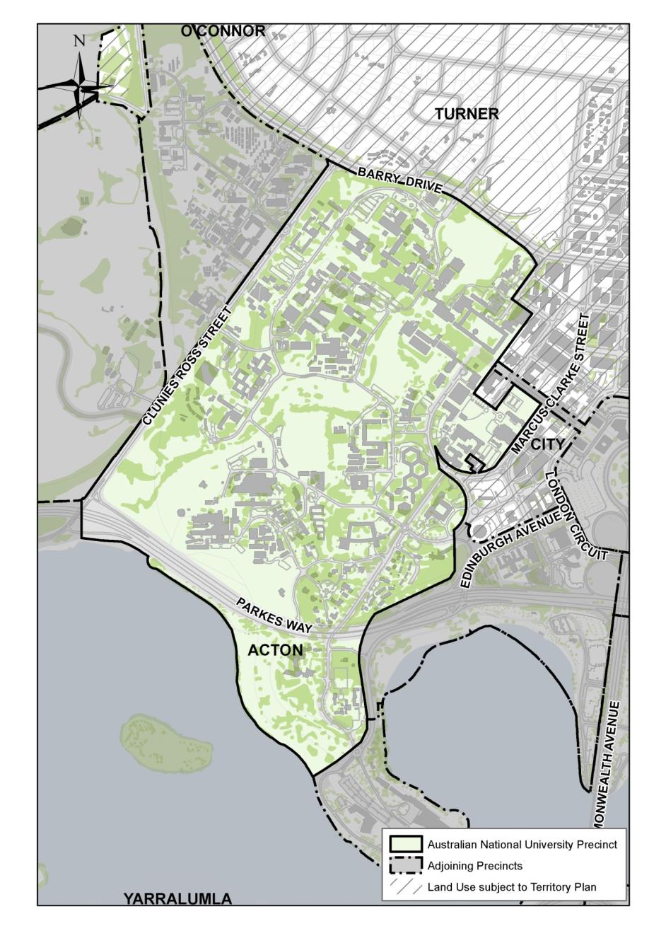
Figure 133: Australian National University Precinct location

4.17.2 Objectives for the Australian National University Precinct
The ANU’s vision is to be Australia’s finest university.
The Acton campus creates and maintains the physical environment that supports the University’s overall vision and to provide for ‘a great University set in a delightful campus’. The objectives that have been formulated by the University as part of a wider master planning process are identified under the following planning themes:

Academic intent
Ensure the campus is planned, built and maintained in a manner that enhances the University’s academic endeavours. The primary role of the campus is to provide a place that actively facilitates world leading research and education.

Functional elements
Ensure a range of compatible land uses that address the University’s needs for academic research, teaching, student accommodation and services, open space, parking, road access and cultural activity. The land use pattern is one of mixed-uses supporting the principal centred on an academic theme, but permitting a range of ancillary or associated activities on campus that serve this core land use.

Campus structure
The Acton campus has developed a number of distinct local areas with their own character and values. These are linked by several unifying landscaped corridors, walkways and waterway such as University Avenue, Acton Ridge Walk and Sullivans Creek. The objective is to reinforce these unifying elements as well as enhance the different characteristics of individual areas on campus through landscaping and building style. A related objective is to integrate the campus with the city centre.

Built form
Retain the ‘building in a landscape’ character of the campus, but recognise the need for some taller buildings in selected locations to facilitate growth in university floor space without loss of important green spaces and heritage places.

Heritage
Conserve, enhance and interpret the heritage values of the campus in the context of a modern, dynamic research and teaching campus.

Landscape
Retain the ‘building in a landscape’ character of the campus, through protection of the landscape setting and the three major ‘landscape axes’: University Avenue, Sullivans Creek and the Acton Ridge.

Transport and movement
Encourage walking, cycling and public transport as preferred ways of arriving and moving through the campus. Further develop the network of dedicated pathways, and relocate surface car parking from central areas to peripheral multi-level car parks.

Infrastructure
Ensure the campus is adequately serviced with a range of well maintained, appropriate infrastructure.

A living campus
- Create a safe and attractive campus with on-site student residential accommodation being a significant component of the educational experience.
- Ensure a diverse range of accommodation along with a range of other social, retail, commercial, sporting, entertainment and cultural facilities providing for different life stages in order to maintain a diverse and vibrant community.
- Ensure there is an attractive and convenient wayfinding system for visitors to campus.

Sustainability
Ensure the campus is developed and managed in a way that ensures high standards of environmental sustainability, and that the campus is also seen as part of wider environmental sustainability initiatives in adjacent areas.

4.17.3 Land use for the Australian National University Precinct
Land use on the Acton campus will be dominated by academic activity, supported by a range of ancillary uses including university related administration, open space, residential accommodation for students and researchers, commercial accommodation for University visitors, cultural and entertainment facilities, personal, retail and commercial services to meet daily needs of the campus population, as well as roads, pathways and parking areas.
Figure 134 illustrates the permitted land use for the Australian National University Precinct.
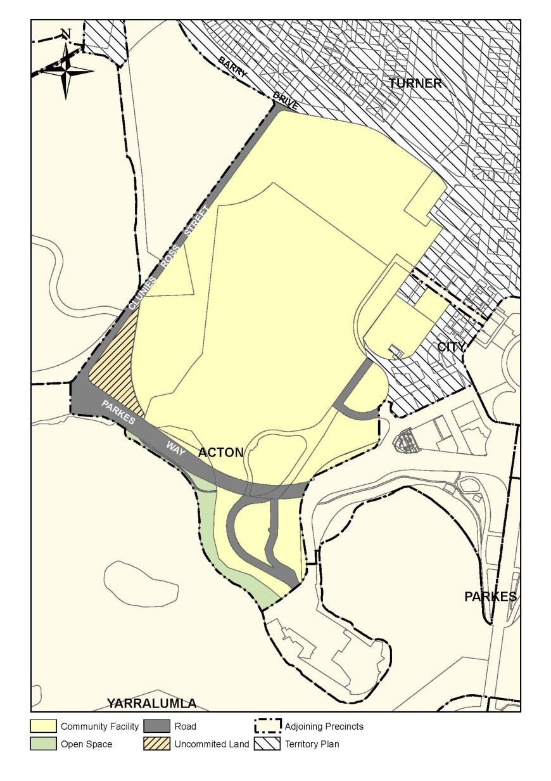
Figure 134: Land use for the Australian National University Precinct

4.17.4 Detailed conditions of planning, design and development
The following principles are provided to assist with decisions about future development on the campus. They provide a ‘high level’ guide to future development and will inform more detailed local area master plans and other campus wide policies (for example, parking and signage) that will be prepared by the University.

Academic intent
- Development should incorporate design solutions that address emerging trends in education and delivery of academic services, including improved physical linkages between research, learning and other centres.
- All buildings should have clearly identifiable frontages.
- Co-location of related functions will be a primary consideration for siting of new development.

Functional elements
- New buildings must improve functional connections, operational efficiency and access for students, staff and the community within precincts and connect to surrounding networks.
- New buildings and major building refurbishments whose primary use is requires active frontages must be designed to provide a welcoming and lively community experience.
- Development proposals must demonstrate that the design and siting will enliven the campus and its sense of identity, and improve spatial qualities and environmental values.

Campus structure
- Siting of new development should create strong linkages, both physical and visual, with the City Centre, CSIRO, Australian National Botanic Gardens, Black Mountain, Lake Burley Griffin and Acton Peninsula.
- New development should enhance and activate the campus structure as set out in Figure 135 through the establishment and/or reinforcement of gateways and entrances, movement networks (roads, pathways and shared zones), edges, knowledge clusters and hubs, and key public and ceremonial spaces.
- Core activities of the university, such as teaching and learning spaces, libraries and major venues are to be located to concentrate activity along main pedestrian paths to provide safe access by day and night.
- Building design must address perimeter streets with active frontages and provide strong connections and linkages to surrounding areas and networks.
- Significant development is not permitted within the restricted development zones identified in Figure 136.
- The exact boundary of the hatched development area in Figure 136 along University Avenue between Sullivan’s Creek and Childers Avenue will be determined through a separate masterplan process. A student gathering space is to be retained in the precinct.
- Some structures, such as signage, paths, lighting, a grandstand in conjunction with a sporting oval, may be permitted in the nominated restricted development zones provided it is considered to be ancillary to and compatible with the main purpose of the area.
- Any development within the restricted development zones must not significantly adversely impact on the landscape, environmental and heritage values of the campus.

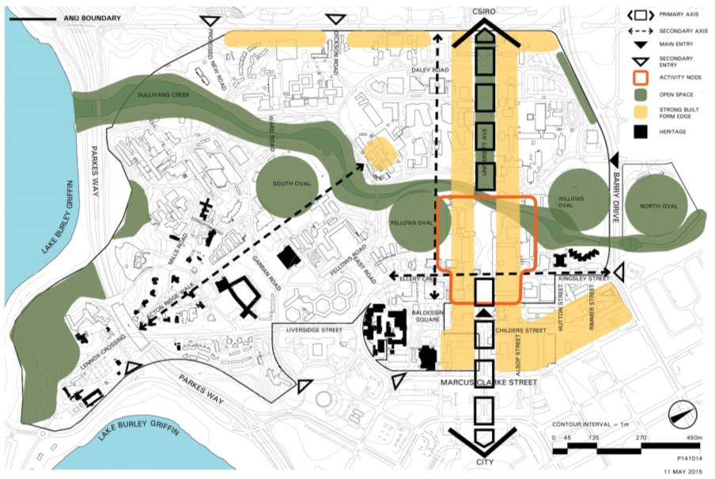
Figure 135: Australian National University - campus structure
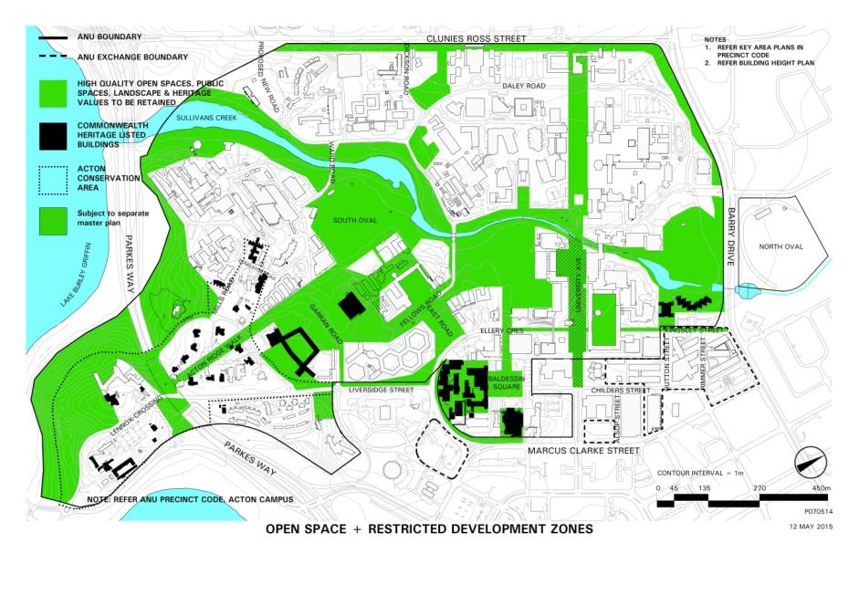
Figure 136: Australian National University - Restricted Development Zones

Built form and height
- Building form should be configured with a high resolution of the overall design and the design details, and use enduring and enriching building materials.
- Building design must respect and contribute positively to the landscape setting of the campus.
- Building edges are to address and define external open spaces to enclose courtyards and overlook movement corridors.
- Buildings should be orientated to allow maximum solar access.
- All new development should incorporate design elements to achieve a high standard of sustainability, biodiversity, green recreation, and open space.
- Building heights are to be in accordance with Figure 137. Where a height range is provided, suggests indicative permitted height limits (for example, a height limit of 4-6 storeys requires development to be where possible a minimum of four storeys and a maximum of six storeys). Some discretion is permitted where funding for new works from bequest or other sources are not sufficient to achieve the desired height range.
- Built form along key walkways such as University Avenue must ensure that adequate sunlight is available for pedestrian and cyclist movement and should limit overshadowing, especially during mid-winter mid-day period.
- Buildings along Clunies Ross Street must not be designed to create a continuous wall of development, but must be separated and orientated to permit views into and from the campus, and variable in height to create visual interest and gateway markers.
- Where taller buildings are located to provided gateway elements or visual markers, there should be no loss of pedestrian amenity in public spaces.
- Buildings adjacent to heritage places must reflect, respect and interpret the character of the heritage place.
- Buildings along Liversidge Street are to be configured to protect the landscape character of the campus as seen from important vantage points at ground level, such as Commonwealth Avenue Bridge.
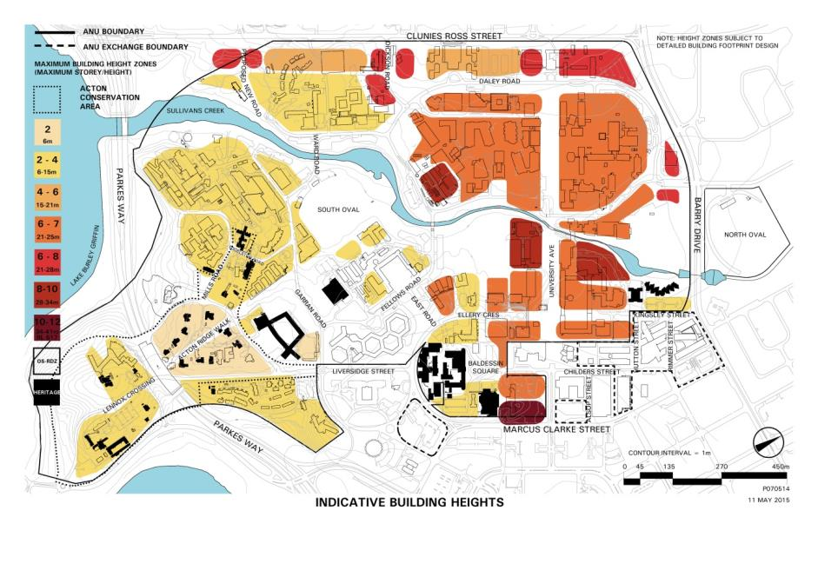
Figure 137: Australian National University - Indicative building heights

Heritage
- The design of new buildings will respond to the heritage context, in terms of landscape setting, bulk, form, scale, colour, texture and materials. Architectural imitation will be avoided and new work will be readily identifiable as such, but contextually respectful.
- Where a proposal has the potential to affect a heritage place or the Acton Conservation Area as identified on Figure 138, a Heritage Impact Assessment should be undertaken to identify possible impacts upon heritage values of a place and recommend mitigation measures.
- New development must be integrated sensitively within the campus and enhance important natural and developed features.
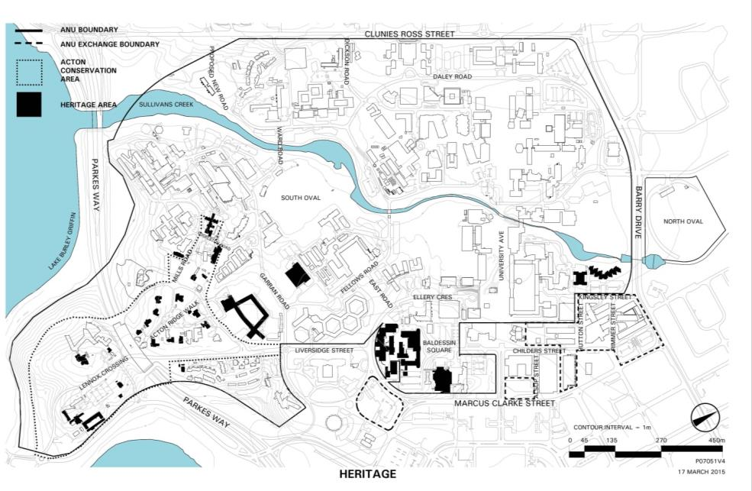
Figure 138: Australian National University - Heritage items

Landscape
- The overall natural and open landscape setting of the campus is to remain the major defining element. Development proposals must demonstrate that the building design achieves this aim.
- Landscape design for the spaces surrounding buildings should be compatible with the character of the immediate precinct. Landscape design should frame legible pedestrian linkages and attractive spaces between buildings.
- Landscaping for new development near Sullivans Creek will reinforce its significance as a green spine through the campus and enhance the biodiversity and visual character of the creek line.
- Key open spaces and landscaped corridors are to be retained without significant development to protect their role as important open space ‘lungs’ and habitat areas on campus. The landscape character around the periphery of the campus, which provides a distinctive sense of place that announces the University, is to be retained and reinstated as part of any planning and construction for new development.
- Proposed landscaping must reflect the intended landscape structure for the university as shown in Figure 136.

Transport and movement
- New development must accommodate circulation systems to ensure that campus users can move safely about the campus, with priority given to pedestrians, cyclists and public transport access.
- All new development will address parking generated by the development as well as any parking spaces removed by the development.
- Extra provision of cycle lockup facilities will be required to support development that removes existing parking spaces.
- Design measures are to be adopted which separate different traffic modes providing safe and consistent surface standards where the pavement width clearly identifies the function and hierarchy of the path/road.
- New roads and road upgrades are to integrate with adjacent landscape areas by including design measures such as swales rather than hard-edge kerbs and gutters.
- Principal, Major and Minor Entries to the campus are to be well defined, and internal connections are to be legible and accessible.

Infrastructure
- New and upgraded physical infrastructure including utility and communication services must be provided on campus to meet improved service standards and changing user requirements.
- Street lighting must be designed and sited to improve pedestrian, bicycle and vehicle safety on campus, and avoid increased light pollution.
- General campus lighting must provide aesthetic interest and accentuate key structural elements of the campus (for example, University Avenue). New buildings are to make provision to support solar and wind generation systems, and incorporate efficient energy and water systems. Roof-top solar and wind generation systems are permitted.

A living campus
- New residential development is permitted on campus to increase levels of activation.
- Where possible and appropriate, the new student accommodation will be accompanied by a range of personal, commercial and safe outdoor spaces at ground level of these buildings.
- New development must incorporate Crime Prevention Through Environmental Design principles to encourage a campus that is safe, secure and welcoming for all users and visitors day and night.
- New development must incorporate design measures which recognise the value of existing cultural facilities and social spaces.
- New development involving health, social welfare, child care and student services facilities is to be sited in the core areas of the campus in close proximity to transport services and parking, and where possible, be co-located with other administrative or services functions.
- All new development must incorporate ‘equity of access’ as a fundamental planning and design objective. This will include pathways designed to Australian Standards for disability access, and building entries facing major walkways.
- Artwork associated with new buildings or individual placements is to be encouraged in the public realm.

Sustainability
- New buildings and other works on the University campus must incorporate measures to reduce energy use and greenhouse gas emissions, reduce total water use, and encourage use of sustainable transport. Measures may include solar and wind energy generation systems, grey and black water systems, cycling and pedestrian facilities and amenities.
- To assist in maintaining the landscape character of the campus, vegetation losses must be balanced with new assets such as protection zones and plantings.

4.18 CSIRO (BLACK MOUNTAIN) PRECINCT CODE

4.18.1 Precinct location
The CSIRO (Black Mountain) Precinct is located at the foot of Black Mountain and is bound by Barry Drive to the north and north east, Clunies Ross Street to the east and south east, and Black Mountain to the west and south west.
Figure 139 illustrates the location of the CSIRO (Black Mountain) Precinct.
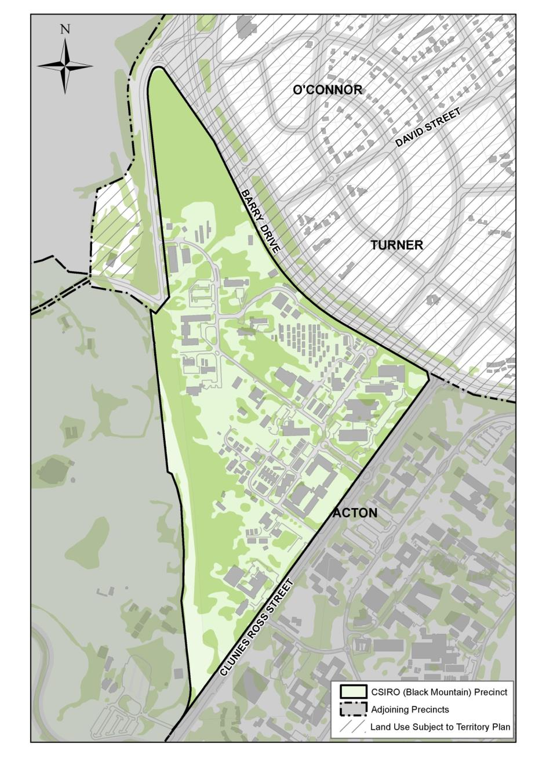
Figure 139: CSIRO (Black Mountain) Precinct location

4.18.2 Land use for the CSIRO (Black Mountain) Precinct
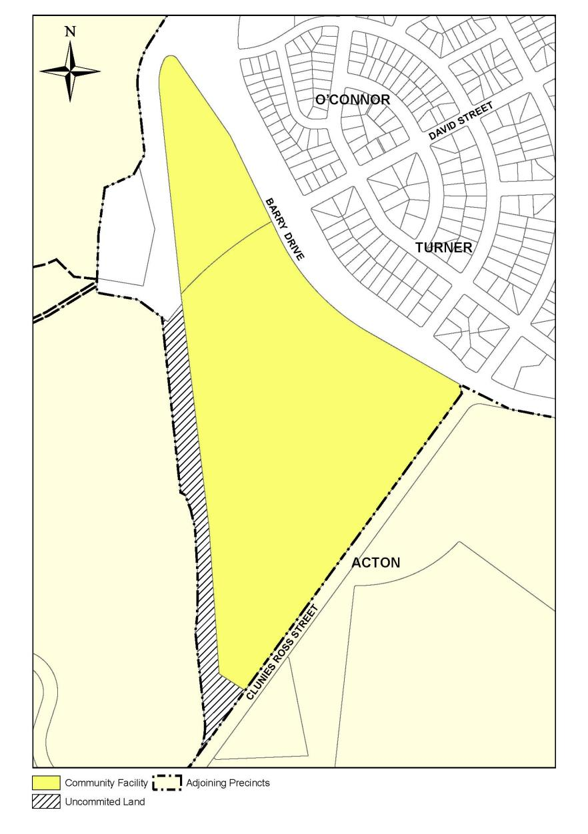
Figure 140: Land use for the CSIRO (Black Mountain) Precinct

4.18.3 Detailed conditions of planning, design and development
This precinct is subject to the provisions of the Design and Siting General Code.

GENERAL CODES

4.19 DESIGN AND SITING GENERAL CODE

4.19.1 Application
This code applies to works within the following precincts and areas:
- The Parliamentary Zone
- Deakin/Forrest
- Barton
- Australian National Botanic Gardens
- CSIRO Black Mountain
- Australian National University
- Australian Defence Force Academy and Royal Military College Duntroon
- Inner Hills
- Yarralumla, Deakin, Red Hill and O’Malley Diplomatic Precincts.

4.19.2 Background
The broad aim that will be applied by the National Capital Authority in the exercise of its obligations under the Act may be derived from the paragraphs which follow.
The National Capital Authority subscribes to the belief that an individual should, in the ordering of his own affairs, suffer the minimum restrictions and inconveniences imposed by administrative controls. On the other hand, Canberra is a unique city. As a National Capital it has special purpose and character and this imposes responsibilities on persons planning the city and obligations on those carrying out development in it. This is particularly the case within Designated Areas.
In exercising control over development within Designated Areas, the National Capital Authority is guided by a desire to have quality, character and permanence consistent with the concept of a National Capital in all construction. It seeks to develop an atmosphere of civil dignity and domestic amenity. Its aim is to ensure that development in all forms will not take away from but rather add to the value of the total investment in Canberra. That is to say, development must complement and enrich its surroundings.

4.19.3 Detailed conditions of planning, design and development

Conditions for detached houses

Introduction
In relation to a detached house, the objectives of the policies are to provide for the residential amenity of the occupants of the house and the maintenance of amenity of adjoining houses and to ensure that an acceptable environmental quality is obtained in the neighbourhood.
The National Capital Authority expects the builders and owners of houses in Designated Areas to take advantage of opportunities provided by the conditions for achieving a harmonious and satisfying environment for living.

General conditions

Performance and quantitative standards
The quantitative standards contained in these conditions are objective guides to the performance standards adopted by the National Capital Authority.
Compliance with the quantitative standards will therefore not necessarily result in works approval unless the performance standards have, in the opinion of the National Capital Authority, also been achieved.
On the other hand, works approval may be given under special circumstances when the performance standards can be achieved without complete compliance with the quantitative standards.

Group schemes
One objective of offering leases in a group is to encourage a high standard of compatibility and amenity in the design and siting of buildings erected on the leases. Buildings should be related by careful siting and choice of materials, colour and roof lines. Amenity will be served by siting buildings to enable privacy and quietness and to limit the adverse effects of climate and maximise its advantages.
When buildings to be erected on leases, however offered, are planned as a group, the general conditions may be varied to the extent required to give effect to a proposal acceptable to the National Capital Authority.
For the purpose of these conditions, two adjoining leases may be considered as a group on the application of the lessees.

Conditions established prior to the offer or grant of lease
Any special design and siting requirements contained in the conditions of lease, or in the conditions of building approval, or in any plan or document that is exhibited or otherwise made available for public inspection prior to the offer or grant of a lease, will constitute the National Capital Authority’s conditions in respect of the development of a lease and will over-ride any other condition stated herein with which it may conflict. If considered by the National Capital Authority to be relevant such requirements will apply to any subsequent alteration, extension or rebuilding. The general conditions will also apply with the exception of those that are modified by any special design and siting requirements notified prior to the offer or grant of a lease.

Rebuilding
The National Capital Authority will consider a proposal for rebuilding or any major alteration of an existing building which materially alters the bulk or appearance of the building, only if it is accompanied by a plan indicating a scheme of comprehensive development of the block in accordance with the policies for the area in which the block is located.

Garages and carports
If it is not intended to erect a garage or carport at the time of lodging a plan for a new detached house, the plan should show by means of a dotted line the place where a garage or carport could be erected.

Buildings in relation to front boundaries

Preamble
Since Canberra’s inception the garden city concept has been an integral part of the residential environment. This has been achieved by an emphasis on the landscaping of streets and front gardens and upon the avoidance of structures in front of dwellings discordant with the suburban streetscape. These principles underlie the performance and quantitative standards which follow.

Performance standards
The planning objectives in requiring buildings to be set back given distances from front property boundaries are:
- to enable a building to be sited so that its occupants can, as far as possible, be assured of an outlook that will not be obstructed by neighbouring buildings that might otherwise be erected closer to the front property boundary
- to provide an area adjacent to the street or open space for landscape treatment so that the garden character which is a major environmental feature of suburban Canberra can be preserved and maintained
- in certain circumstances, to protect the sight lines of drivers of motor vehicles.

Quantitative standards

One storey buildings
The building line of a one storey building may be more than but not less than 6 metres from the front property boundary.

Buildings of more than one storey
The building line of buildings of more than one storey may be more than but not less than 7.5 metres from the front property boundary.

Corner blocks
Each corner block will have two building lines. The building line in respect to the major frontage must be in accordance with one storey buildings and Buildings of more than one storey above. The building line in respect to the minor frontage must be not less than 4.5 metres in the case of a one storey building and not less than 6 metres in the case of a two storey building.

Structures in front of buildings
- Except where provided for below, no structure, including fences, car shelters or clothes hoists, but excluding lighting posts, letter boxes and retaining walls of a reasonable height will be permitted between a minimum building line and a front property boundary.
- Where a pedestrian walkway abuts a block along the side boundary, a fence or wall not exceeding 1.2 metres in height may be permitted.
- Walls and/or fences not exceeding 1.2 metres in height may be erected along frontage boundaries abutting pedestrian walkways.
- Walls and/or fences not exceeding 1.2 metres in height may be permitted between the building line and a frontage boundary abutting a designated open space, where in the National Capital Authority’s opinion the proposed fence or wall will create no adverse affect on the landscape character of the open space.
- Walls, including gates, may be erected to enclose or partly enclose a courtyard in front of the minimum building line provided that:
  - The courtyard so formed must not at any point traverse more than one half of the width of the block measured at the same point and must be a minimum distance of 3.0 metres from the front property boundary.
  - The walls and gates must not exceed a height of 1.8 metres above natural ground level
  - Materials must be the same as or similar to those of the main building
  - The walls and gates must be at least partially screened and softened in appearance by landscape planting to the satisfaction of the National Capital Authority
  - For corner blocks a courtyard may be provided in respect of each property frontage.
- Gates may be permitted abutting front property boundaries, provided they are incorporated in existing hedges. Gates in hedges must not exceed 1.8 metres in height or such lesser height as the National Capital Authority may determine in a particular case having consideration for the nature of the hedge. For the purpose of this condition a hedge must be well established and vigorous at the time of lodgement of an application for a gate.

Building in relation to side boundaries

Performance standard
Requirements for side distances are intended to achieve the following objectives:
- to allow adequate light and ventilation and to preserve the privacy of neighbours
- in some cases to provide a space wide enough for vehicles to pass by the house on one side at least
- to provide access for fire control and to inhibit the easy escape of fire
- to create a spatial separation between detached buildings for reasons of civic design.

Quantitative standards

One storey buildings
The minimum distance between the side walls of a one storey building and the side boundary of a block will be a combined distance of 4.5 metres with a minimum distance on any one side of 1.8 metres.

Buildings of more than one storey
The minimum distance between the side wall of a building of more than one storey and the side boundary will be H/2 for an effective frontage of up to 23 metres, plus an additional 0.5 metres for every 3 metres of effective frontage over 23 metres, provided that the distance between the side wall and the boundary is at least 3 metres.
H = Height of building
‘Height of building’ means the difference between the mean natural ground level of that length of the side boundary which is adjacent to the building and the highest point or points of the parapet, eaves or fascia in the case of flat roofs or roofs pitched at less than 45 degrees. Where the roof is pitched at more than 45 degrees the highest point will be measured to a line midway between the top of the eaves or fascia and the ridge.

Buildings in relation to rear boundaries

Performance standard
Requirements for rear distances are intended to allow adequate light and ventilation to preserve the privacy of neighbours and to ensure the provision of a service yard.

Quantitative standards
The minimum distance between the rear wall of a single storey building and the rear property boundary must be 4 metres and the corresponding distance for a 2 storey building must be 7.5 metres.

Plot Ratio

Performance standard
The application of a plot ratio is intended to place an upper limit on the amount of floor space in a building development on a site.

Quantitative standard
The plot ratio must not be greater than 0.35 for a block larger than 550 square metres or 0.4 for a block smaller than 450 square metres provided that a building or buildings with floor space of up to 192 square metres may be erected on a block larger than 450 square metres.

Garages, carports and outbuildings

Performance standard
Exceptions to the above policies with respect to setbacks and building lines of garages, carports and outbuildings are permitted in certain circumstances to achieve greater opportunities for use of the lessee’s block, without adversely affecting the neighbouring blocks.

Quantitative standards

Building to side or rear boundaries behind rear wall of main buildings
A garage, carport or outbuilding may be erected behind the rear wall of the main building on or adjacent to the side or rear boundary if the walls on or adjacent to that boundary have no perforations and are of an approved material. The wall should not exceed a mean of 2.5 metres in height measured from the natural ground level and must not exceed 24 square metres in area.

Building to side boundary alongside main building
- A carport may be erected beside a building on or adjacent to a side boundary and may be enclosed on the side by a wall constructed of brick, masonry or other similar material approved by the National Capital Authority provided that the wall does not exceed a mean of 2.5 metres in height measured from the natural ground level, nor 18 square metres in area.
- A garage may be erected on or adjacent to a side boundary provided that there is not less than 1.8 metres between the garage and the main building erected on the block and provided that the wall on or adjacent to the boundary has no perforations and is constructed of brick or masonry or other similar material approved by the National Capital Authority and does not exceed a mean of 2.5 metres in height measured from the natural ground level nor 18 square metres in area.

Garages in front of the building line
In special circumstances, for example, where a block has a gradient of more than 1 in 10, the National Capital Authority may approve the erection of a garage in front of the building line.

Walls and fences
Walls and fences may be erected on or adjacent to the side or rear boundaries (but behind the front building line) to a height of 1.8 metres above natural ground level. Proposals for walls or fences in excess of that height will be subject to special consideration.

Height

Quantitative standards
Detached houses must not be more than two storeys in height. Although certain sites enable the inclusion of basement and/or attic storeys, designs should not be adapted to take advantage of any allowance for basement and attic in circumstances where the design is unsuitable both in relation to the site and the neighbouring buildings.

External appearance of buildings

Performance standard
The external treatment of buildings including materials, colours and general standard of finish, must ensure that the buildings, walls, etc. are appropriate to and not discordant with the general development and amenity of the locality.

Quantitative standards

Roofs
Permanently highly reflective metal roofs will not be approved. Tiled roofs having a strong pattern or marked colour contrast will not be approved.

Structures above roofs
- Except as provided for below, structures above roofs are not permitted.
- Structures necessary under the ACT building regulations, and solar energy devices, may be permitted. Proposals may be subject to conditions in respect of type, position, size, height or appearance.
- External television antennae affixed at the rear of the main building in the least conspicuous position when viewed from public areas, may be permitted to extend no more than 1.5 m above the highest point of the roof.
- External television antennae not meeting the requirements of (c) above may be permitted where the need for the proposal for reasonable reception of Canberra channels is established by a report from an appropriately qualified technician.
- A radio transmitter mast or aerial should be on a freestanding structure at the rear of the main building in the least conspicuous position when viewed from public areas.

Conditions for buildings other than detached houses

General conditions

Conditions established prior to the offer or grant of lease
Any special design and siting requirements contained in the conditions of lease, or in the conditions of building approval, or in any plan or document that is exhibited or otherwise made available for public inspection prior to the offer or grant of a lease, will constitute the National Capital Authority’s conditions in respect of the development of a lease and will over-ride any other condition stated herein with which it may conflict. If considered by the National Capital Authority to be relevant such requirements will apply to any subsequent alteration, extension or rebuilding. The general conditions will also apply with the exception of those that are modified by any special design and siting requirements notified prior to the offer or grant of a lease.

Re-building
The National Capital Authority will consider a proposal for re-building or any major alterations of an existing building which materially alters the bulk or appearance of the building, only if it is accompanied by a plan indicating a scheme of comprehensive development of the block in accordance with announced policies for the area in which the block is located.

Relationship between neighbouring buildings
The height, bulk, form, siting and character of building proposals in relation to neighbouring buildings, roads and landscape must not be conducive to congestion of parking and road facilities in the locality, and must ensure a harmonious relationship with adjoining buildings. To implement this general policy, it is necessary for the following design and siting controls to be exercised. In special circumstances, it may be necessary for the National Capital Authority to determine additional conditions to those set out hereunder.

Coverage
Unless otherwise specifically provided for, the area occupied by buildings including any out-buildings on a block should not exceed one-half of the total area of the block.

Height
Generally, the height of any building should not exceed two storeys.

Plot ratio
The Plot Ratio must not be greater than 0.40 for residential buildings other than detached houses, and 1.00 for commercial and industrial buildings, unless otherwise specifically provided for.

Building line and setbacks
The design and siting conditions for detached houses with respect to set backs from the front, side and rear boundaries will apply to residential buildings other than detached houses.
The building lines and set backs for commercial and industrial buildings will be such distances as may be approved in particular circumstances.

External appearance of buildings
The external treatment of buildings, including materials, colours and general standards of finish must ensure that the buildings, walls, fences and other ancillary structures are appropriate to and not discordant with the general development and amenity of the locality.
To implement this general condition it is necessary for the following design and siting conditions to be exercised. In special circumstances, it may be necessary for the National Capital Authority to determine additional design and siting conditions to those set out hereunder.

Roofs
Permanently highly reflective metal roofs will not be approved.
Generally, tiled roofs having a strong pattern or marked colour contrast will not be approved.

Structures above roofs
The design and siting conditions for detached houses with respect to structures above roofs will apply to buildings other than detached houses.

Façades
All façades of commercial and industrial buildings and returns should be of durable and low maintenance material and be subject to approval in respect of proportions, fenestrations, materials and colours having regard to the building itself and its relationship to adjoining buildings.

Screening walls
Generally, where service areas are visible from the road or a public reserve a screening wall or fence will be required. Where a commercial or industrial building is not constructed along the full frontage of the block, a screen wall with gates may be required between the building and the front and/or side boundaries of the block.

Structures in front of buildings
Generally no structures are to be erected between the building line and the front property boundary.

Landscaping and other matters
In order to satisfy the objectives contained in the general conditions it may be necessary for the National Capital Authority to require the submission of acceptable landscape proposals as a condition of approval.

Siting of buildings
The siting of buildings on blocks must ensure adequate space for access, internal circulations, parking, off-street loading, light, air and landscaping. To implement this general condition it is necessary for the following design and siting conditions to be exercised. In special circumstances, it may be necessary for the National Capital Authority to determine additional design and siting conditions to those set out hereunder.

Access
Vehicular entrances and exits for all blocks must be of sufficient width having regard to their probable use and be located in a position which, in the opinion of the National Capital Authority, is not hazardous to traffic safety and not likely to create traffic congestion.

Internal circulation
Where appropriate, adequate provision must be made for internal vehicular circulation on sites leased for residential buildings other than detached houses and for commercial and industrial buildings.

Parking
Off-street parking spaces, open or enclosed, must be provided for all new buildings and enlargements or conversions of existing buildings in accordance with the following provisions:
Type of Building | Minimum parking space requirement
Residential Building | Two spaces per dwelling unit if such unit is designed for family accommodation and one space per dwelling unit plus adequate space for visitor parking if such unit is designed for single accommodation.
Motels, Hotels Guest Houses, | One space per bedroom and/or rooming unit.
Commercial and Industrial Building | 1 space per 100 square metres GFA.
Institutional | To be determined for each building proposal depending on use, building floorspace, employees, visitors and location.
Alternative parking requirements may be considered where supported by a traffic and parking assessment and where agreed by the National Capital Authority.

Off-street loading
In order to satisfy the objectives contained within the general conditions, it may be necessary for the National Capital Authority to require that facilities for loading and unloading of goods be provided wholly within the boundaries of the block.

4.20 SIGNS GENERAL CODE

4.20.1 Application
This code applies to proposals for signage within Designated Areas.
For the purposes of this code, signs are defined as:
any writing (including letter, word or numeral); pictorial representation (including illustration or decoration); emblem (including device, symbol or trademark); flag (including banner or pennant); or any other figure of similar character; which:
- is a structure or any part thereof, or is attached to, painted on, or in any other manner represented on a building or other structure
- is used to announce, direct attention to, or advertise
- is visible from outside a building. A sign must include writing, representation or other figure of similar character within a building only when illuminated and located in a window.
but for the purposes of these conditions does not include:
- traffic or similar regulatory devices, legal notices, or warnings at railway crossings
- temporary signs announcing a campaign, drive or event of political, civic, philanthropic, educational or religious organisations
- memorial signs or tablets
- signs denoting architect, engineer or contractor when placed on construction sites and not exceeding 0.5m² in area or combined signs denoting architect, engineer and contractor not exceeding 2.5m² in area
- signs required to be maintained by law or governmental order or regulation, with a total surface area not exceeding 1.0m² on any block
- temporary signs displayed for the purpose only of advertising premises for sale or lease, providing such signs have a total surface area not exceeding 0.5 m²
- small signs displayed for the direction or convenience of the public, including signs which identify rest rooms, freight entrances, or the like, with a total surface area not exceeding 0.5m² on any block
- temporary signs displayed for the purpose only of advertising a group development provided such signs have a total surface area not exceeding 2.5 m².

4.20.2 Background
Carefully designed and positioned signs, in addition to fulfilling their roles of informing, directing and advertising, may positively enhance and enliven Canberra’s major commercial and tourist areas and aid in giving imageability and form to the city. Conversely, insensitive or poorly designed and constructed signs may detract from the architectural appearance of buildings and adversely affect the pleasantness and general amenity of an area to a marked degree.
Emphasis should be placed on constructive dialogue between the National Capital Authority and applicants to achieve standards of design and construction commensurate with the amenity and sensitivity of the locality of a particular application. Residential development is regarded as being vulnerable to the impact of signage and prescribed standards are considered appropriate to ensure that there is no diminution of residential amenity.

4.20.3 Detailed conditions of planning, design and development

General conditions
- The type, position, size, appearance, illumination, animation, content or other characteristics of any proposed sign must ensure a quality and character of appearance both by day and night which, in the opinion of the National Capital Authority, befits the National Capital.
- The National Capital Authority will refuse to approve any sign where it is of the opinion that the type, position, size, appearance, illumination, animation, content or other characteristics of the sign may adversely affect:
- the amenity of the locality or neighbourhood with particular regard to nearby residential development
- the architectural character or appearance of a building
- traffic safety
- a ‘place’ within the meaning of and subject to the provisions of the relevant Commonwealth heritage legislation.
- The National Capital Authority will refuse to approve any sign which it considers offensive.
- The National Capital Authority will not grant approval of an application with the respect to the external design and siting of any structure or sign unless such structure or sign would comply with all other relevant policies or conditions of this Plan.
- The National Capital Authority may, either unconditionally or subject to such terms and conditions as it deems necessary, modify or waive the provisions of the sections that follow, where it is of the opinion that the application of the same to or in respect of any particular sign would be impracticable or unreasonable and provided that the requirements of the ‘General conditions’ herein are satisfied.
- Any application for the use, construction or erection on or above the roof or top of any building of any device, advertisement, sky sign, sign, signal or structure of the nature of a sign or signal, excepting flags and flag poles, will not be approved where the proposal would alter any silhouette of the building by extension beyond or above the walls, parapet or roof of the building, lift tower or plant room.
- Animated or flashing signs and signs illuminated by exposed lamps or neon tubes as distinct from backlighting or floodlighting, will generally not be approved.

Signs in residential areas
- Signs on blocks used for:
- residential purposes, including approved home businesses
- purposes approved following lease variation procedures
- institutional or recreation purposes within residential areas
may be approved if such signs:
- are not animated or flashing
- are not illuminated by exposed lamps or neon tubes as distinct from backlighting or floodlighting
- are restricted in content to the name and nature of the permitted occupation or institution
- do not exceed aggregate surface areas of 0.2m² per residential unit and 0.8m² per site. Signs depicting block layouts are exempted from this standard and will be considered separately
- in respect of residential blocks, are affixed to the building façade at ground storey level only and are not located on fascias, awnings or free standing on the site.

Signs on commercial and industrial buildings and on institutional and other buildings not located within residential areas
- Signs above first storey level, signs facing residential development nearby or on the opposite side of the street within residential neighbourhoods which may be visible from residential buildings nearby, must not be animated or flashing or be illuminated by exposed lamps or neon tubes as distinct from backlighting or floodlighting.
- Subject to (1) above, signs located at ground level and first storey levels including signs projecting from buildings at these levels and signs on or under awnings, will not be restricted provided that:
  - they are consistent with the ‘General conditions’ of this code
  - the clearance between the pavement level and any sign projecting from a building or affixed to an awning, must not be less than 2.5 metres.
- Signs above above first storey level will be restricted in content to the name of the building and the name, insignia and type of activity of the principal occupant. Such signs must not project from the building and must constitute only separate characters and/or symbols individually affixed to or represented on the building façade. Generally there will not be more than one sign on each face of the building above first storey level.

Freestanding signs
- Freestanding signs may be approved on business leases provided that:
  - unnecessary repetition or multiplicity is avoided
  - sign content is restricted to the name, insignia and type of business activity combined with the advertising of the principal product or services being offered on the site
  - the height of freestanding signs must not exceed four metres within residential neighbourhoods and six metres in other locations
  - the surface area of freestanding signs must not exceed 3m² within residential neighbourhoods and 6m² in other locations except that the maximum surface area of a sign identifying a shopping centre must be determined having regard to the particular circumstances and merits of a proposal.
- Freestanding signs may be approved on sites used for recreational, institutional, educational or other similar purposes provided that:
- sign content is restricted to the name, insignia and type of activity
- within residential neighbourhoods there must not be more than one freestanding sign per site
- unnecessary repetition or multiplicity is avoided
- subject to Freestanding signs (1(iv)) above, the surface area of a freestanding sign must not exceed 3m² and the height must not exceed 4 metres.
- Freestanding signs must not be animated or flashing or be illuminated by exposed lamps or neon tubes as distinct from backlighting or floodlighting.

Signs on unleased land

Real estate road sign
Real estate signs which direct the public to sites currently for sale or lease may be placed on the verge of roadways subject to the removal of the signs at the end of each day. Such signs should generally:
- be of an A-frame structure
- be located further than 20 metres from a road intersection
- not be located on Main Avenues adjacent to the Parliamentary Zone, on Anzac Parade or on the approaches to the Prime Minister’s Lodge or the Governor-General’s residence
- have a surface dimension not greater than 900 mm width and 1200 mm height and a maximum height above ground level of 1500 mm
- be firmly secured to the ground while on display
- not be animated
- display direction to the property for sale or lease and the agent’s name with the agent’s name/logo occupying an area of not greater than 50 per cent of the sign
- not have a highly reflective surface.

Hawkers’ signs
Hawkers’ signs in Designated Areas may only be displayed where they:
- are not within the National Triangle or on Main Avenues or Approach Routes (except in relation to events or otherwise approved by the National Capital Authority or on or near construction sites)
- are not less than one kilometre from other hawkers
- include one sign of moderate scale at the site of standing and not more than one additional sign on each side of the road approaching the site
- are approved by a relevant agency of the ACT Government as being safe from a traffic point of view
- have a surface dimension not greater than 900 mm width and 1200 mm height and a maximum height above ground level of 1500 mm
- do not have highly reflective surfaces
- are removable and only displayed on site during hours of operation.

Community roadside signs
Community roadside signs, which advertise local events not subject to an entry or site fee, may be placed on the verge of roadways or other unleased lands, subject to their removal at the end of the advertised event. Each community organisation may only display a maximum of six movable signs for one week prior to the advertised event. Such signs should generally:
- be of an A-frame structure
- be located further than 20 metres from a road intersection
- not be located on Main Avenues adjacent to the Parliamentary Zone, Anzac Parade and the approaches to the Prime Minister’s lodge and the Governor-General’s residence
- have a surface dimension not greater than 900 mm width and 1200 mm height and a maximum height above ground level of 1500 mm
- be firmly secured to the ground while on display
- not be animated
- only contain the name of the organisation and information related to the forthcoming event
- not impede maintenance activities such as mowing of grass
- not be offensive
- not have a highly reflective surface or be iridescent in colour.

Flags and banners
Subject to traffic safety assessment by the relevant ACT Government agency flags and banners may be displayed within road reserves. Such signs should generally comply with the following:
- approval may be granted by the National Capital Authority for the display of event banners and flags where these are of a standard which is consistent with the values of the National Capital and are not in the form of a commercial advertising sign
- banners may be suspended across Northbourne Avenue and London Circuit from vertical supports
- banners on light poles are not permitted in Anzac Parade
- the use of light poles for the flying of banners is to meet the requirements of the ACT Government’s policy in respect of the use of its assets
- when erected on Territory Land flags and banners may only be installed by direct arrangement with an agency or contractor of the ACT Government
- the erection of flags in any location is not to be in conflict with the flag protocols administered by the Australian Government
- flags and banners identifying the ACT Visitor Information Centre are permitted in the road verge adjacent to the centre, but not in the median
- banners on light poles should not compromise existing landscapes
- the use of commercial wording or sponsorship acknowledgment is limited to no more than 20 per cent of the banner
- all costs associated with the design, manufacture, installation and removal of banners or flags are to be met by the applicant
- materials used in flags and banners must be able to withstand the effects of rain, sun and wind without colours running or fading or fabrics tearing due to wind loads
- materials used in flags and banners are not to be highly reflective
- flags and banners may be displayed for up to two weeks before an event, during an event and for no more than 48 hours after the event.

Major events signs

Changing events signs
Signs promoting or describing an event at an institution may be erected and displayed on approved structures, or in an approved manner, without further approval subject to the following criteria being met:
- the signs are erected and displayed for specific periods during the display, program or event
- the content of the sign is not offensive and relates to its context
- commercial wording or sponsorship acknowledgment occupies no greater than 20 per cent of the sign.

Groups of signs for events
Groups of signs, promoting a major event conducted for more than two days, may be displayed where such signs are of a similar type to an approved sign without the need for separate approval of each sign where:
- they seek to promote an event or program of special significance and broad community interest
- they are not displayed in Anzac Parade or adjacent to the Prime Minister’s Lodge or the Governor-General’s residence
- they are not displayed in the median of road reserves
- the contents of the signs are not offensive and harmonise with the landscape
- they are not garish or iridescent
- they are not highly reflective
- commercial wording or sponsorship acknowledgment occupies no greater than 20 per cent of the sign
- promotional signs are displayed for no longer than two weeks prior to the event
- directional signs are only displayed during the days of the event
- they are removed within 48 hours of the conclusion of the event.

Services and commercial directional signs

Services signs
Signs that provide direction to service outlets such as emergency services, food, accommodation, service stations, pharmacies, religious centres, and the like should meet the following conditions:
- signs for services located away from Main Avenues and Approach Routes, should be generally in the form of internationally recognised symbols and not include business names
- service signs on sites fronting Main Avenues and Approach Routes should only be located on the site on which the service is provided
- service venues are to be shown in a list of places and on a services location map agreed to by the National Capital Authority.

Commercial directional signs
Signs to provide direction to business centres may only include the name of the relevant Town Centre, Group Centre or Local Centre.
Signs to business activities outside of commercial centres may be erected in the form of finger boards and should comply with the following:
- there are to be no more than five commercial directional signs as finger boards attached to poles at any one location
- the signs are to be erected by, and remain the property of, the ACT Government
- the display of the signs is to be managed so as to be kept in an orderly fashion and in good repair
- the signs should conform to Section 3 of the Australian Standard 1742.5 – 1997: Street name and community facility name signs.

Site identification signs
Signs erected in public places to identify the name of the places such as parks, squares, walks, historic sites, open spaces and the like should comply with the following:
- signs in the National Capital Open Space System should be consistent in design in terms of style, size and materials used and should be part of a hierarchy of signs which reinforces the significance of the Open Space System. The hierarchy of such signs should be for primary signs at the site entry and secondary signs comprising:
  - directional signs
  - destination indicators
  - place name signs
  - interpretive signs
- sponsorship signs or sponsorship names on signs are not permitted on Main Avenues or Approach Routes, in the National Capital Open Space System, in the Parliamentary Zone (except where such signs comply with a comprehensive Project or Precinct Signage Plan approved by the National Capital Authority), near the Prime Minister’s Lodge or the Governor General’s residence
- markers or signs identifying places may include dedication information or historic information about the place on or near where the sign is located
- site identification signs are to be erected by, and remain the property of, the Australian Government (on National Land) or the ACT Government on (Territory Land).

Tourist destination signs
Signs, which direct the public to major tourist sites and places, should generally comply with the following:
- tourist drives may be identified by a system of numbers and colours on standard signs placed along the drives with detailed information of attractions along the route available for visitors in published form at visitor information centres
- tourist drive numbers should be incorporated in new tourist destination signs or may be fixed as a separate sign beneath destination signs or traffic signs
- groups of attractions, located at a single destination, may be identified by displaying the group destination name on a series of signs which lead up to that destination
- tourist destination signs, other than tourist route signs, are to be at the last major turn-off to the venue
- individual attractions may be identified as features of this centre on a single sign on arrival at the centre
- sponsorship will not be permitted on tourist destination signs other than those which have naming rights for the destination
- the signs should conform to the Australian Standard 1742.6 – 1990: Service and tourist signs for motorists
- the main entry points to the Parliamentary Zone may be signalled by distinctive signs such as banners or place signs located in the verges of the Main Avenues
- the signs are to be erected by, and remain the property of, the ACT Government
- excessive repetition of tourist destination signs should be avoided
- signs are to be painted metal and all single-sided signs are to be painted on the visible reverse side
- a system of standard symbols, lettering and colour schemes should be followed in directing the travelling public to tourist venues.

Advertising signs on street furniture
Advertising signs may be displayed on bus shelters subject to the following:
- only one advertising sign will be permitted on each bus shelter
- the sign is to be of a dimension not exceeding 1.5 metres by 1 metre
- the sign may be side illuminated
- the sign structure is to be an integral part of the design of the shelter on which it is displayed
- such signs are not permitted in Anzac Parade or on bus shelters in Commonwealth, Kings and Constitution Avenues or the area bounded by these Avenues.

Tourist and radio identification signs
Tourist and visitor information radio identification signs will be considered where they comply with the following:
- a single radio station notice may be displayed on a single pole
- for multiple station identification in one location the design is to be in the form of a combined notice board which may display up to five radio station frequencies
- the signs may be located in the Visitor Information Centre at Regatta Point and within car parks of major institutions which function as tourist attractions
- tourist radio identification signs displaying only the frequency of a station may be permitted in the information lay-bys on Approach Routes but not elsewhere on the Main Avenues and Approach Routes
- the signs are to be painted metal structures with white lettering on a blue background showing only the frequency and the broadcaster identification letters or numbers.

Billboards
Billboards are not permitted on unleased land in Designated Areas.

Tourist information signs
Tourist information signs on Approach Routes, other than tourist directional signs, are to comply with the following:
The hierarchy of signs on Approach Routes is to include:
- a border marker sign which is a single purpose sign to mark the border between the ACT and NSW. Such markers may be on either side of the road at the border
- a City of Canberra identification sign, of a scale less than that of the border sign, may placed in the road verge away from and following the border sign
- tourist information lay-bys may contain a number of pedestrian scale sign boards displaying:
  - a guide map of the Territory
  - welcoming messages in different languages
  - changeable signs advertising major events in Canberra
  - signs directing visitors to the Visitor Information Centre at Regatta Point
- Visitor Information Centre signs which identify the distances to the Centre and use the internationally recognised information symbol.

4.21 TELECOMMUNICATIONS GENERAL CODE

4.21.1 Background
These policies apply to the installation and erection of telecommunications facilities, being facilities subject to the Telecommunications Act 1997. The policies for telecommunications facilities consist of General Policies and Specific Policies.
General Policies are broadly based and define the key objectives and general policies for the design and siting of telecommunications infrastructure throughout the ACT. Carriers, service providers and individuals will need to take account of the General Policies when installing facilities within the ACT.
Specific Policies define the conditions and standards for the siting of telecommunications infrastructure within Designated Areas.

4.21.2 Facilities subject to these policies
The following are subject to the Telecommunications General Code requirements:
- ground based towers, antenna masts and headframes
- underground and aerial cabling
- rooftop antennas, headframes and associated structures
- microwave or satellite antennas or dishes (this includes both ground and rooftop mounted installations)
- any equipment structures (buildings and fenced enclosures) associated with the above.

4.21.3 Objectives
The objectives of the Telecommunications General Code are to:
- ensure that the operation of a functional telecommunications service meets community expectations and does not adversely affect the character of Canberra as the National Capital, including the landscape setting of the city and the national significance of land specified in this Plan as Designated Areas.
- minimise environmental and visual impacts arising from the construction, operation, maintenance, decommissioning and removal, and site rehabilitation of telecommunications infrastructure.

4.21.4 Detailed conditions of planning, design and development

Erection of Telecommunications Structures
- Site Selection – Sites where a tower, mast or antenna will be visually incongruous should be avoided wherever possible. Where a choice of site exists, low rise, small scale residential areas should be avoided and commercial, industrial or transport related land with existing utility structures such as lighting columns or other vertical structures should be selected. Where practicable, sites having environmental, nature conservation or heritage significance, and sites of community concern such as schools, childcare centres or where a facility may interfere with existing emergency or safety equipment, should be avoided.
- Choice of antenna location and mast sharing – The mounting of antennas on a building or an existing mast is the preferred way of accommodating a new facility. Where there are several antenna mounting and locational options, care is to be taken to choose the most appropriate option that has the least visual impact on the community and surrounds.
- Electromagnetic Energy (EME) Standard – all telecommunication facilities must comply with current industry standards in respect to EME emissions and their impact on surrounding land uses.
- Ameliorative Actions – Wherever possible, sites should be either screened from the most prominent views or have a backdrop of trees, buildings or high ground. Ideally sites should have both a well-screened foreground and background keeping to a minimum the height of mast and antenna exposed to view. Where parts of an antenna or mast are exposed, they are to be finished in a colour that is not highly reflective and that minimises their intrusiveness.
- Decommissioning and Restoration – When a facility is no longer required, or is to be superseded by a replacement facility, the facility is to be removed from a site within a period of three months and the site is to be left in a condition satisfactory to the National Capital Authority. A site remediation plan may be required to ensure that the site is restored appropriately.

Rollout of Cable
- Method of rollout dependent on site sensitivity – For any proposal to rollout telecommunications cable, the method of rollout should be considered in relation to the sensitivity of the site. Underground cabling is the preferred method given the importance of Designated Areas.
- Co-location to minimise impacts – For any proposal to rollout telecommunications cables in areas where an existing public utility is in place, the method of rollout should be considered in relation to the existing utility infrastructure. In new subdivisions, or areas where underground infrastructure already exists, the rollout of telecommunications cable should be co-located with existing cable or undertaken in a similar manner.
- Avoiding duplication – As far as practicable and where the technology permits, cable rollout should be carried out in a coordinated fashion to avoid duplication. A proliferation of overhead telecommunications cables should be avoided in situations where a single cable is capable of delivering the proposed telecommunications service. In cases where more than one cable is proposed, carriers should demonstrate that the use of a single cable is not practical for technical, environmental or economic reasons.

Large scale facilities
- Large-scale facilities, such as towers and masts will only be approved where no other alternative exists and where the proposal does not create any significant disruption to the visual environment.
- No additional towers and masts will be approved on Red Hill, Mount Mugga, Black Mountain, Isaacs Ridge, Mount Pleasant or Mount Ainslie which:
- break the natural skyline
- significantly impact on the side slopes.
(This does not preclude the use of existing masts and towers subject to a detailed assessment of the impact of any additional antennas.)

Ground level facilities
Ground level facilities such as equipment shelters and electrical equipment boxes are to be located in the least conspicuous position and are to be screened from public view. Such facilities will generally not be permitted in front of buildings.

Satellite and Microwave Dishes
Roof top mounted dishes will be considered only where it can be demonstrated that a ground level location is not available or is technically unsuitable. In considering roof mounted facilities, any impact on the following must be avoided:
- active pedestrian streets and urban spaces
- key public spaces
- building frontages
- heritage buildings.

Roof mounted facilities
Roof mounted facilities should, as far as practical, be incorporated within, or integrated with, structures on the roof in a purpose designed roofscape. Where no other structure exists above the roof line, and it is practical to do so, the proposed facility should be set back from the parapet line of the building or integrated into the building design to minimise the visual impact.

Cable Rollout
Approval for overhead cable rollout will only be given where overhead services already exist and where the National Capital Authority is of the opinion that the proposed cable will not impact adversely on the locality.

Procedure
The National Capital Authority may withhold approval in any particular case where it is of the opinion that the proposed facility would impact adversely on the appearance of the building and locality to an unacceptable degree.
The current Australian industry standard for Electromagnetic Energy (EME) will be used as the basis for determining acceptable EME emissions. All proposals must meet the current Australian industry standard for EME.
Applicants should seek any required clearances for access and development prior to an application being submitted to the National Capital Authority. It should be noted that the Conservator of Flora and Fauna is responsible for approving licences over land identified in the Territory Plan as Public Land.

Community consultation
Public notification may be required by the National Capital Authority where it is of the opinion that facilities will create a high visual impact. Facilities defined as Low-impact facilities in the Telecommunications Act 1997 are not subject to notification.
Where public notification of a proposal is required by the National Capital Authority, the applicant will advertise the proposal in the principal newspaper circulating in the locality. The advertisement (the content of which must be agreed to by the National Capital Authority) will invite interested parties to submit written comments to the National Capital Authority. The period within which submissions may be lodged will be specified and will be not less than 14 days from the date of the advertisement. Any comments received by the National Capital Authority will be provided to carriers for their response and will be used in the final assessment of the proposal.

Information Requirements for Applications to the National Capital Authority
The detail and level of information required should reflect the specific nature of each proposal, its context and its likely impact. Accordingly, the emphasis and detail will be much less for Low-impact Facilities. Applicants are encouraged to consult with the National Capital Authority before a proposal is submitted to better determine the extent of detail required for each proposal. The following information will be required for applications to the National Capital Authority:
- A description of the proposal and location of the proposed activity, including the purpose and need for the facility, design drawings (plan and elevation) of the facility including antenna(s), towers and ground installation, and the description of material and finishes
- A description of any visual impacts from the proposal, including design and siting factors, the extent and nature of visual impact, and the scale of the impact
- Details of any electromagnetic emission levels
- A description of any environmental impacts arising from the construction and maintenance of the facility, including any impacts concerning flora and fauna, noise, health, electronic interference on community infrastructure such as emergency and safety equipment, erosion and run-off control, construction of access and power supply, and heritage and archaeological aspects
- Evidence that a range of sites has been investigated and that the site and type of installation is the least visually obtrusive within technical operational requirements. Separate evidence from an independent source, may be required where the National Capital Authority is concerned about the visual or environmental impact of a proposal
- A description of any mitigation measures (safeguards and contingency plans where relevant) to be undertaken to help prevent or reduce the actual or potential impacts
- An indication that the land lessee has been advised of the proposed activity.

SPECIAL REQUIREMENTS FOR NATIONAL LAND OUTSIDE DESIGNATED AREAS

4.22 Special Requirements for National Land

4.22.1 Background
It is in the interests of the National Capital that all National Land achieve a quality of development which reflects Canberra’s significance as the National Capital, and that proposals be assessed in relation to the provisions of the Plan.

4.22.2 Special Requirements
Development, including subdivision and leasing proposals, of all National Land not included in a Designated Area of this Plan, is to conform to Development Control Plans agreed by the National Capital Authority. Development Control Plans are to meet the following requirements:
- Adverse environmental impacts from on-site developments, on adjacent land and development, must be identified and redressed to the extent practicable.
- Adequate provision should be made where appropriate for visitors to sites.
- Functional relationships between uses within and external to the site must be provided for.
- Consistency in the external design and site layout of buildings and landscaping will be sought.
- Satisfactory arrangements must be made for parking accommodation and vehicular access and egress. Traffic impacts of development will be taken into account.
Development proposals for National land, including subdivision, and proposals to lease National Land, will be subject of consideration by the National Capital Authority who will assess proposals to ensure they are not inconsistent with the provisions of the Plan and relevant Development Control Plan.

PART FOUR(b) – SPECIAL REQUIREMENTS FOR TERRITORY LAND
Explanatory Statement
Part Four(b) sets out Special Requirements for Territory Land, for areas where the requirements are desirable in the interests of the National Capital.
In areas where Special Requirements apply, any development proposal is administered by the Territory planning authority in compliance with the Special Requirements specified in this part of the Plan.
In some cases, a Development Control Plan is required to be prepared. Development Control Plans may be prepared by either the National Capital Authority or the Territory planning authority, or undertaken jointly by agreement. Such plans are subsequently administered by the Territory.
Development Control Plans may be maps, drawings, photographs, specifications and written statements. They should include sufficient detail for the guidance and management of development in the area, and may include design, siting, scale, purpose, timing and phasing, construction, landscaping and other relevant matters.

Figure 141 illustrates Territory Land subject to Special Requirements.
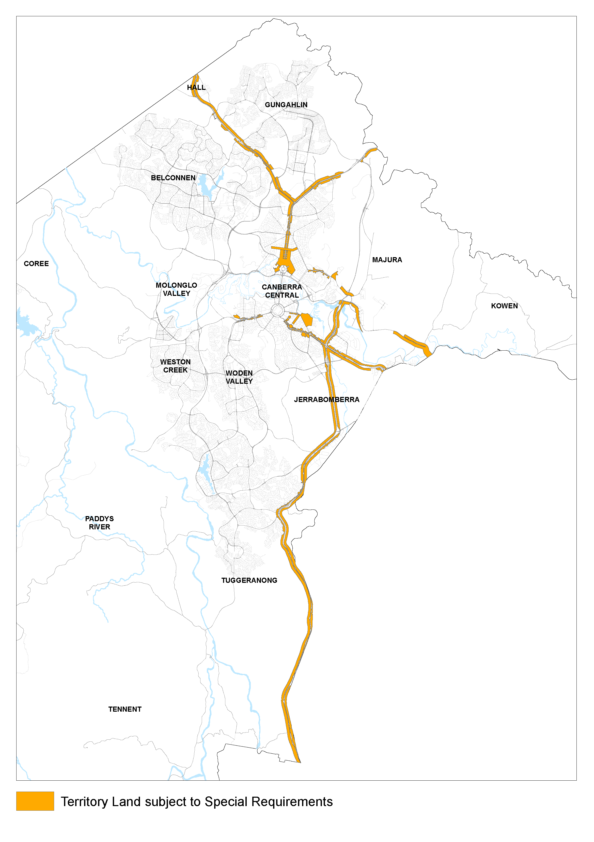
Figure 141: Territory Land subject to Special Requirements

4.23 Main Avenues

Special Requirements for Main Avenues
It is in the interests of the National Capital that development flanking main avenues in the city is of a type and quality that will enhance the role and status of the city. For the purposes of Special Requirements the Main Avenues are:
- Northbourne Avenue, between Antill/Mouat Streets and Barry Drive/ Cooyong Street
- Adelaide Avenue, outside the Central National Area
- Canberra Avenue, between Hume Circle and the Central National Area
- Brisbane Avenue outside the Central National Area
- Constitution Avenue.
These Special Requirements apply to development on land (not included within Designated Areas) adjacent to the Main Avenues identified above.

Special Requirements
Development, except in relation to Northbourne Avenue, is to conform to Development Control Plans (agreed by the National Capital Authority) which seek to secure the integrity of the Main Avenues as approaches to the Parliamentary Zone and ensure that the setting, buildings and purposes of development enhance that function.
Development Controls Plans and (in relation to Northbourne Avenue) development, must:
- make provision for national uses, offices for national associations, tourist accommodation and residential development
- seek high standards of building design and finish. External materials should be predominantly light in tone and require little maintenance. Continuous glass façades should be avoided. Criteria for controlling the use of reflective glass should be incorporated
Development Control Plans must:
- incorporate the following where Main Avenues are the final approaches to the Parliamentary Zone:
  - building height controls, to ensure that buildings are at least three storeys in height unless specifically shown otherwise in an agreed Development Control Plan. Plant and equipment must be enclosed and integrated with the form and design of the building. Any rooftop plant must be contained within maximum height limits.
  - building setbacks to be 10 metres unless specifically shown otherwise in an agreed Development Control Plan. The area in front of the building line is to be landscaped, and exclusive of parking. Minor encroachment of basement parking into this area may be considered where this would not detract from the quality of the landscape treatment and where the parking is located beneath a driveway or other paved area. Canopies may cover set-down areas forward of the building line. Minor encroachment by balconies, awnings and porticos may be considered if the materials and designs are such that the visual integrity of the building line is retained
    - for Main Avenues with predominantly commercial frontages:
  - see Main Avenues – Northbourne Avenue for location specific requirements
  - provide that buildings adjacent to Main Avenues other than Northbourne Avenue may be up to four storeys, plus plantrooms, in height.
Note:
Where these maximum heights are already exceeded by existing buildings, extensions or rebuilding up to the height of the existing building may be permitted.
  - for Main Avenues having predominantly landscaped frontages, generally provide for buildings to not exceed the height of the established tree canopy (typically three to four storeys)
  - consider parking, vehicle access, and the traffic impacts of development. Access from and to the Avenues may be permitted where practicable and where traffic safety will not be affected adversely.

Location specific

Northbourne Avenue
For Northbourne Avenue, the requirement for a Development Control Plan has been met by the passage of Variation No. 96 to the Territory Plan. The integrity of the approach to the Parliamentary Zone remains an objective, however, and Special Requirements for development continue to be necessary in other areas.

Building Height
- ensure that buildings adjacent to Northbourne Avenue are not less than 3 storeys, however for special non-commercial uses such as a tourist information centre exceptions to this requirement may be considered.
- plant and equipment must be enclosed and integrated with the form and design of the building. Any rooftop plant must be contained within maximum height limits.,
- ensure that the parapets of buildings adjacent to Northbourne Avenue are not higher than 25 metres above natural ground level except for the two ‘landmark nodes’ at the intersections of Mouat/Antill Streets and Macarthur/Wakefield Avenues with Northbourne Avenue where parapets may be up to 32 metres above natural ground level
Where the maximum heights are already exceeded, existing buildings, extensions or rebuilding up to the height of the existing building may be permitted.

Building Setbacks
- for Northbourne Avenue, ensure building setbacks are 10 metres except for the east side of the Avenue between Wakefield Avenue and Ipima Street and for the ‘landmark nodes’ where Northbourne Avenue is crossed by Mouat/Antill Streets and Macarthur/Wakefield Avenues, where increased building setbacks may be permitted
The area in front of the building setback is to be landscaped, and exclusive of parking. Minor encroachment of basement parking into this area may be considered where this would not detract from the quality of the landscape treatment and where the parking is located beneath a driveway or other paved area. Canopies may cover set-down areas forward of the building line. Minor encroachment by balconies, awnings and porticos may be considered if the materials and designs are such that the visual integrity of the building line is retained.

4.24 Approach Routes
It is in the interests of the National Capital that development flanking Approach Routes to the city is of a type and quality complementary to the role and status of the city. Special Requirements apply to the following Approach Routes:
- the Barton and Federal Highways from the ACT borders to their junction with Northbourne Avenue, and extending to include Northbourne Avenue north of Antill Street/Mouat Street
- the Monaro Highway from the ACT border through to Morshead Drive
- Canberra Avenue from the ACT border to Hume Circle
- Pialligo Avenue from the ACT border to Morshead Drive
- Fairbairn Avenue
These Special Requirements apply to development on all land (not included within Designated Areas) which fronts directly onto the Approach Routes AND is not more than 200 metres from their middle lines.

Special Requirements
Development along the identified Approach Routes is to conform to Development Control Plans agreed by the National Capital Authority, which seek to enhance the surrounding predominantly rural character and landscape outside the urban areas. As the Approach Routes enter the built up areas, the emphasis will shift to a more formal character.

4.25 City Centre
Figure 142 shows the area of the City Centre subject to Special Requirements.
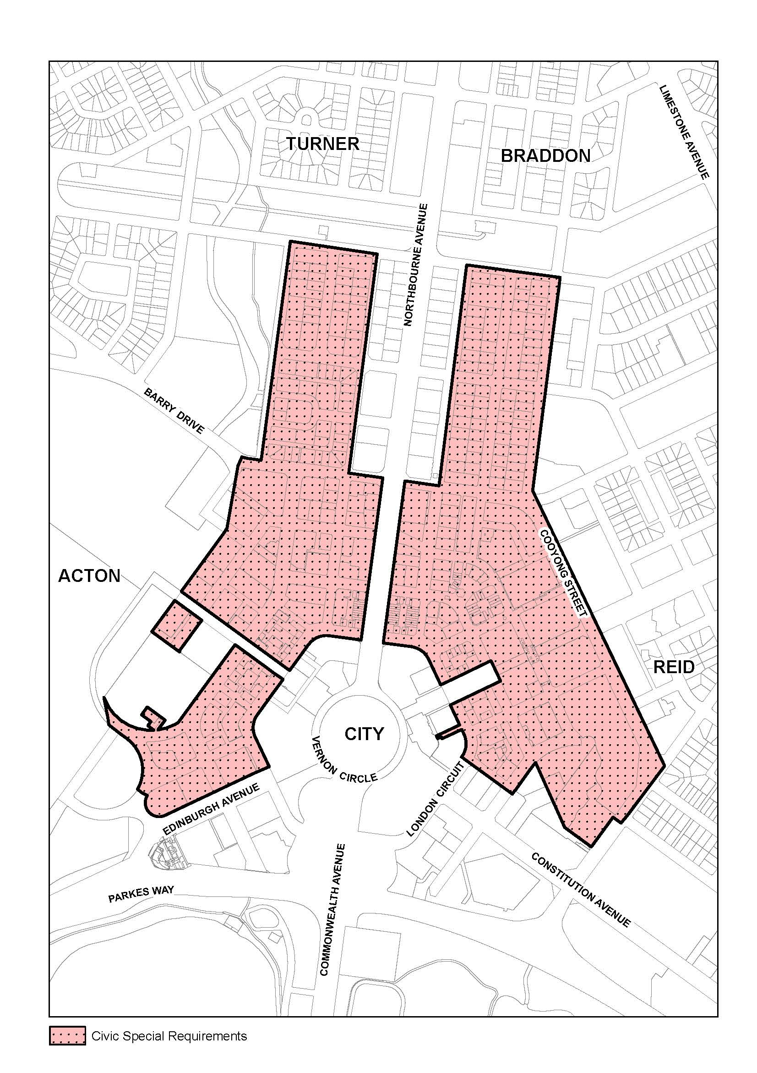
Figure 142: City Centre area subject to Special Requirements

National interest in City Centre
City Centre, as part of Canberra’s central area (which includes the Parliamentary Zone and therefore has a dual national capital and local role), and as the dominant metropolitan centre, has a special role in the context of the Plan. The functional and symbolic relationship between City Centre and the Parliamentary Zone is critical. Because of this both the Territory and Commonwealth Governments have a legitimate interest in its future planning and development. The Territory interest relates mainly to City Centre’s role as the prime commercial and retail centre and as a location for Territory administration, major private sector business, regional and metropolitan head offices, recreational and entertainment, tourist accommodation and important cultural community activities.
The Commonwealth’s interest in City Centre is different and is related to:
- maintaining the geometry and intent of the plan for City Centre which is integral to the integrity of the Griffin Plan as a work of national and international significance and the role of the Griffin Plan as the principal organising framework for City Centre and the Central National Area.
- its location at the apex of the National Triangle, the centrepiece of Griffin’s Plan. The point of the apex is City Hill which will ultimately become the symbolic and geographical centre of City Centre as it develops to the south and west.
- its position as a visible and identifiable element within the ‘amphitheatre’ ie the central basin, which contains Canberra Central. It is a major component of the vista north from Parliament House and other parts of the Parliamentary Zone. Consequently, it can not be considered separate or isolated in a visual sense from these key national capital elements. Existing policies on height and colour have also ensured that City Centre is seen as a cohesive and homogeneous mass when viewed from various vantage points within and on the edge of this amphitheatre
- its location straddling the most important entrance route to Canberra (i.e. Northbourne Avenue) in general and the Parliamentary Zone in particular.
- the nature of the topography surrounding Canberra Central (rolling hills and sweeping horizontals) the predominance of the landscaping, and the comparatively low profiles or silhouettes of the majority of the features of the Central Basin, which demands that development in City Centre does not overwhelm or detract from key national capital features (the Parliament House in particular) in terms of height, bulk, colours and materials.
- the Main Avenues converging on City Centre provide important strategic corridors linking major centres of Commonwealth and municipal activity in the Central National Area – for example Government, University, Defence and City Centre administration. These Main Avenues are suitable for the development of higher densities of retail, employment and residential activity to support key public transport corridors and provide the principal visual and symbolic connections between the city and the landscape.
National Capital interests in City Centre can be summarised as:
- overall consideration of height, colour, materials, and architectural and environmental quality, aimed at ensuring that City Centre’s continued development is of a harmonious and high quality nature, consistent with its role and its location within the Central Basin in general, and its relationship with the Central National Area in particular.
- specific interest in areas within London Circuit because of their critical importance at the apex of the National Triangle.
- specific interest in the avenues which form axes terminating on City Hill. They have symbolic importance on Griffin’s Plan in visually connecting the city to its natural setting, and their treatment and their landscaping should be of a high standard.
- particular interest in ensuring that City Centre’s future development conforms with the metropolitan strategies for a decentralised distribution of employment as set out in employment location policies of the Plan.
City Centre has a multi-faceted role as the most important metropolitan centre, as the apex of the National Triangle, a location astride an important entrance route to Canberra and the Parliamentary Zone, and a significant element in the physical structure of central Canberra.
It is in the interests of the National Capital that the development of City Centre balances these roles.

Principles for City Centre
City Centre’s continued development should recognise its metropolitan significance and role, achieve a satisfactory relationship between City Centre and other development and features of the Central area, and meet the following principles:
- Future development and redevelopment in City Centre should aim both to reinforce City Centre’s role as the prime metropolitan centre, and contribute to a diverse, lively and attractive character.
- The design of buildings and the amenity and environmental quality of the main public spaces should result in an accessible, attractive, high quality and distinctive centre consistent with City Centre’s role as the major metropolitan centre and its location at one point of the National Triangle, Griffin’s major organising element of the Central National Area.

Policies for City Centre
The following Policies apply within those areas of City Centre identified in Figure 142.

Transport and movement
Long term impacts of development must be taken into account. Measures for discouraging through traffic from using the City Centre road network in peak periods must be considered. Future demand for car parking should be met by the construction of structured car parks in locations that service needs throughout City Centre while aiming to minimise congestion, and/or by on-site provision of parking spaces. Vehicle access and traffic management throughout the area should seek to maintain the ease and comfort of moving around the city, catering to a diversity of pedestrian, cycle, vehicular and public transport modes.

Urban Design
- The symbolic importance of the Main Avenues radiating from City Hill (Northbourne, Ainslie, Constitution, Edinburgh and University Avenues) and their role as the main public transport corridors should be complemented through the landscape and architectural treatment on abutting blocks.
- The design and development of City Centre should continue to reflect the geometry and fine grain pattern of streets and blocks of the Griffin Plan.
- The design and development of streets should provide a continuous planting of large scale street trees and high quality landscape character that fosters a compact, connective and pedestrian-friendly environment for central city living.
- The massing, height, colours and materials used for buildings in City Centre should result in a harmonious and high quality urban design outcome with a recognisable city edge.
- Buildings in City Centre must be of permanent construction.
- The height of buildings in City Centre may be less than but not more than nine storeys provided that:
- plant rooms and other service elements may be allowed above this height subject to being set back from the building edges and screened from street level view.
- one or more taller building(s) per section up to a maximum height of RL617 will be considered only in accordance with an approved comprehensive design for the whole section. Comprehensive section designs should seek to use building height to emphasise and reinforce the geometry of the Griffin Plan and the symbolic Main Avenues radiating out from City Hill.
- where an existing building exceeds the height limitations set out above it will be permissible to consider rebuilding to the same height as the existing building or lower.

4.26 Kingston Foreshore
Figure 143 shows the area of Kingston Foreshore subject to Special Requirements.
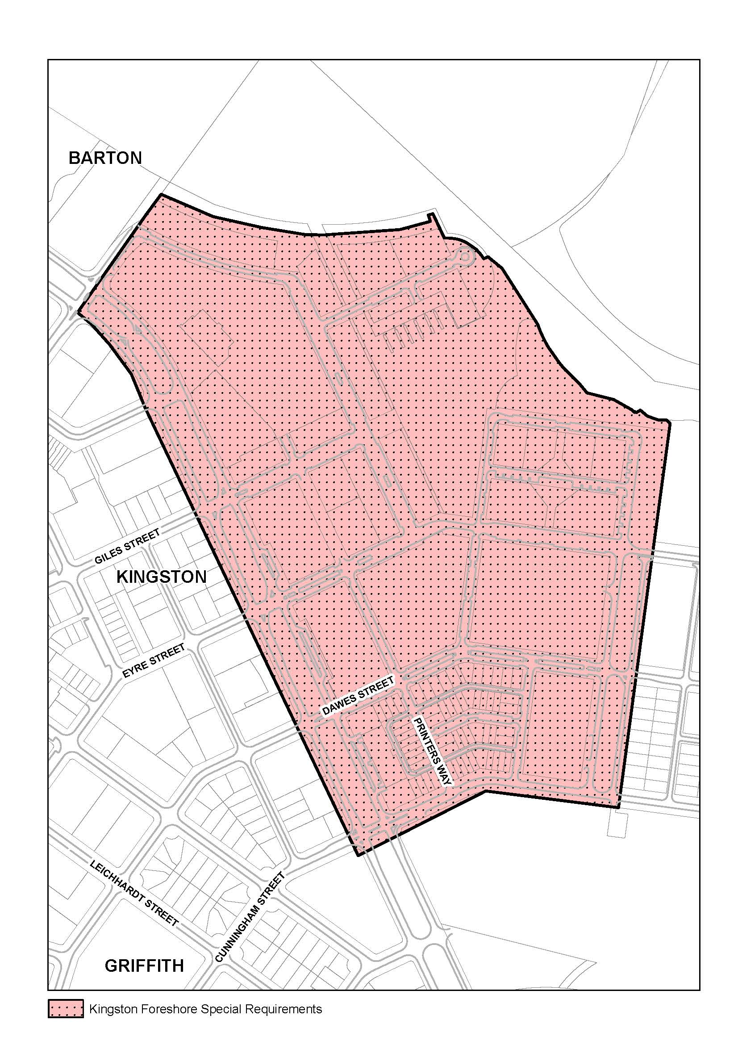
Figure 143: Kingston Foreshore area subject to Special Requirements
The Commonwealth’s interest in Kingston Foreshore is to ensure the Lake Burley Griffin Foreshore in East Basin continues to be developed as a major landscape feature helping to unify the National Capital’s central precincts.
The Kingston Foreshore area forms a prominent urban environment when viewed from within and across East Basin, and from key tourist vantage points such as from Mount Ainslie and Mount Pleasant. Ensuring a notable visual quality, as part of the lake foreshores vista, will be important to maintaining the unity of the central precincts of the National Capital.
The Kingston Foreshore area, which is subject to the following Special Requirements, is that land at Kingston bounded by Bowen Park, Wentworth Avenue (and including the Avenue), Cunningham Street, The Causeway through to Jerrabomberra Creek, Jerrabomberra Creek and a line approximately seven metres behind the wall of Lake Burley Griffin (refer Figure 143).
Development in the Kingston Foreshore area (the ‘area’) is to retain a working boat harbour and lake maintenance facility and conform to the following Aesthetic Principles.

Foreshore Precinct Landscape
The landscape of the precinct adjacent to the Lake Burley Griffin foreshore Designated Area should be of an open space parkland character consistent with that in Bowen Park. The landscape should permit views into the development through informal tree planting and should include landscape treatment of a high quality allowing for pedestrian and cycleway movement through the area.
The edge of Jerrabomberra Creek should be landscaped as open space allowing for pedestrian movement and have a character not inconsistent with the role of the Creek as the edge to the Jerrabomberra Wetlands.

Built form and materials

Massing of building development addressing the lake edge
The massing of building development directly addressing the lake edge is to be articulated and modulated to present a varied appearance and avoid an apparent unbroken wall of development when viewed from the lake.

Colour
The colour scheme of development is to be generally light in tone. Some highlighting with darker colours may be acceptable where these do not present the dominant colour scheme when viewed from or across the Lake.

Roofs
A variety of roof forms, materials and colours should be introduced into the area.

Building Height
The overall height of buildings in the area is to be generally consistent with that of the tree canopy of mature trees in the area. This can be achieved through buildings being a maximum of four storeys except for some taller buildings or focal elements where these do not significantly impact on the landscape of the area or detract from the massing of the Kingston Powerhouse building.

Materials and Finishes
Materials on buildings and structures near the Lake edge are to be of a durable and low maintenance nature with a high quality in the materials used. Buildings fronting the Lake edge should generally avoid the use of highly reflective materials.

Lighting
Outdoor lighting in the area should generally use full cut-off light fittings and up-lighting of buildings and structures should be carefully designed to keep night time overspill lighting to a minimum.
The overall lighting impact should not compete in prominence with the lighting of the National Triangle. The area should be lit predominantly with high pressure sodium light sources for streets and mercury vapour for pedestrian routes. Lake frontage external lighting should use metal halide sources.

Wentworth Avenue
The landscape of Wentworth Avenue is to create a strong balanced planting regime of trees along the Avenue in terms of the species used and spacing. Planting used on both sides should generally be consistent in terms of type and spacing.
The landscape of the median area is to be progressively upgraded to a character consistent with that of Telopea Park being large canopy trees in a grass setting. Car parking in the median may be permitted in the short term pending the phasing out of such parking consistent with the implementation of a parking strategy for the Kingston area which does not involve parking in the median of the Avenue.
The design of street furniture (including lighting) used in the Avenue should generally be consistent with the design of such facilities used on other major Avenues leading to the centre of the National Capital. Signage in the Avenue should be limited to traffic control signs and to direct the public to commercial centres in Kingston and the foreshore area.
Developments along the Avenue should address the Avenue but should generally have vehicular access from a road other than directly from the Avenue. Development having direct vehicular access to the Avenue should include a predominantly landscaped frontage treatment exclusive of parking but may include canopies covering set down areas. The landscape of the frontage should respond to the pattern of movement systems created from the Kingston Centre to the foreshore area.

4.27 Haig and Telopea Parks
Figure 144 shows Haig Park.
Figure 145 shows Telopea Park
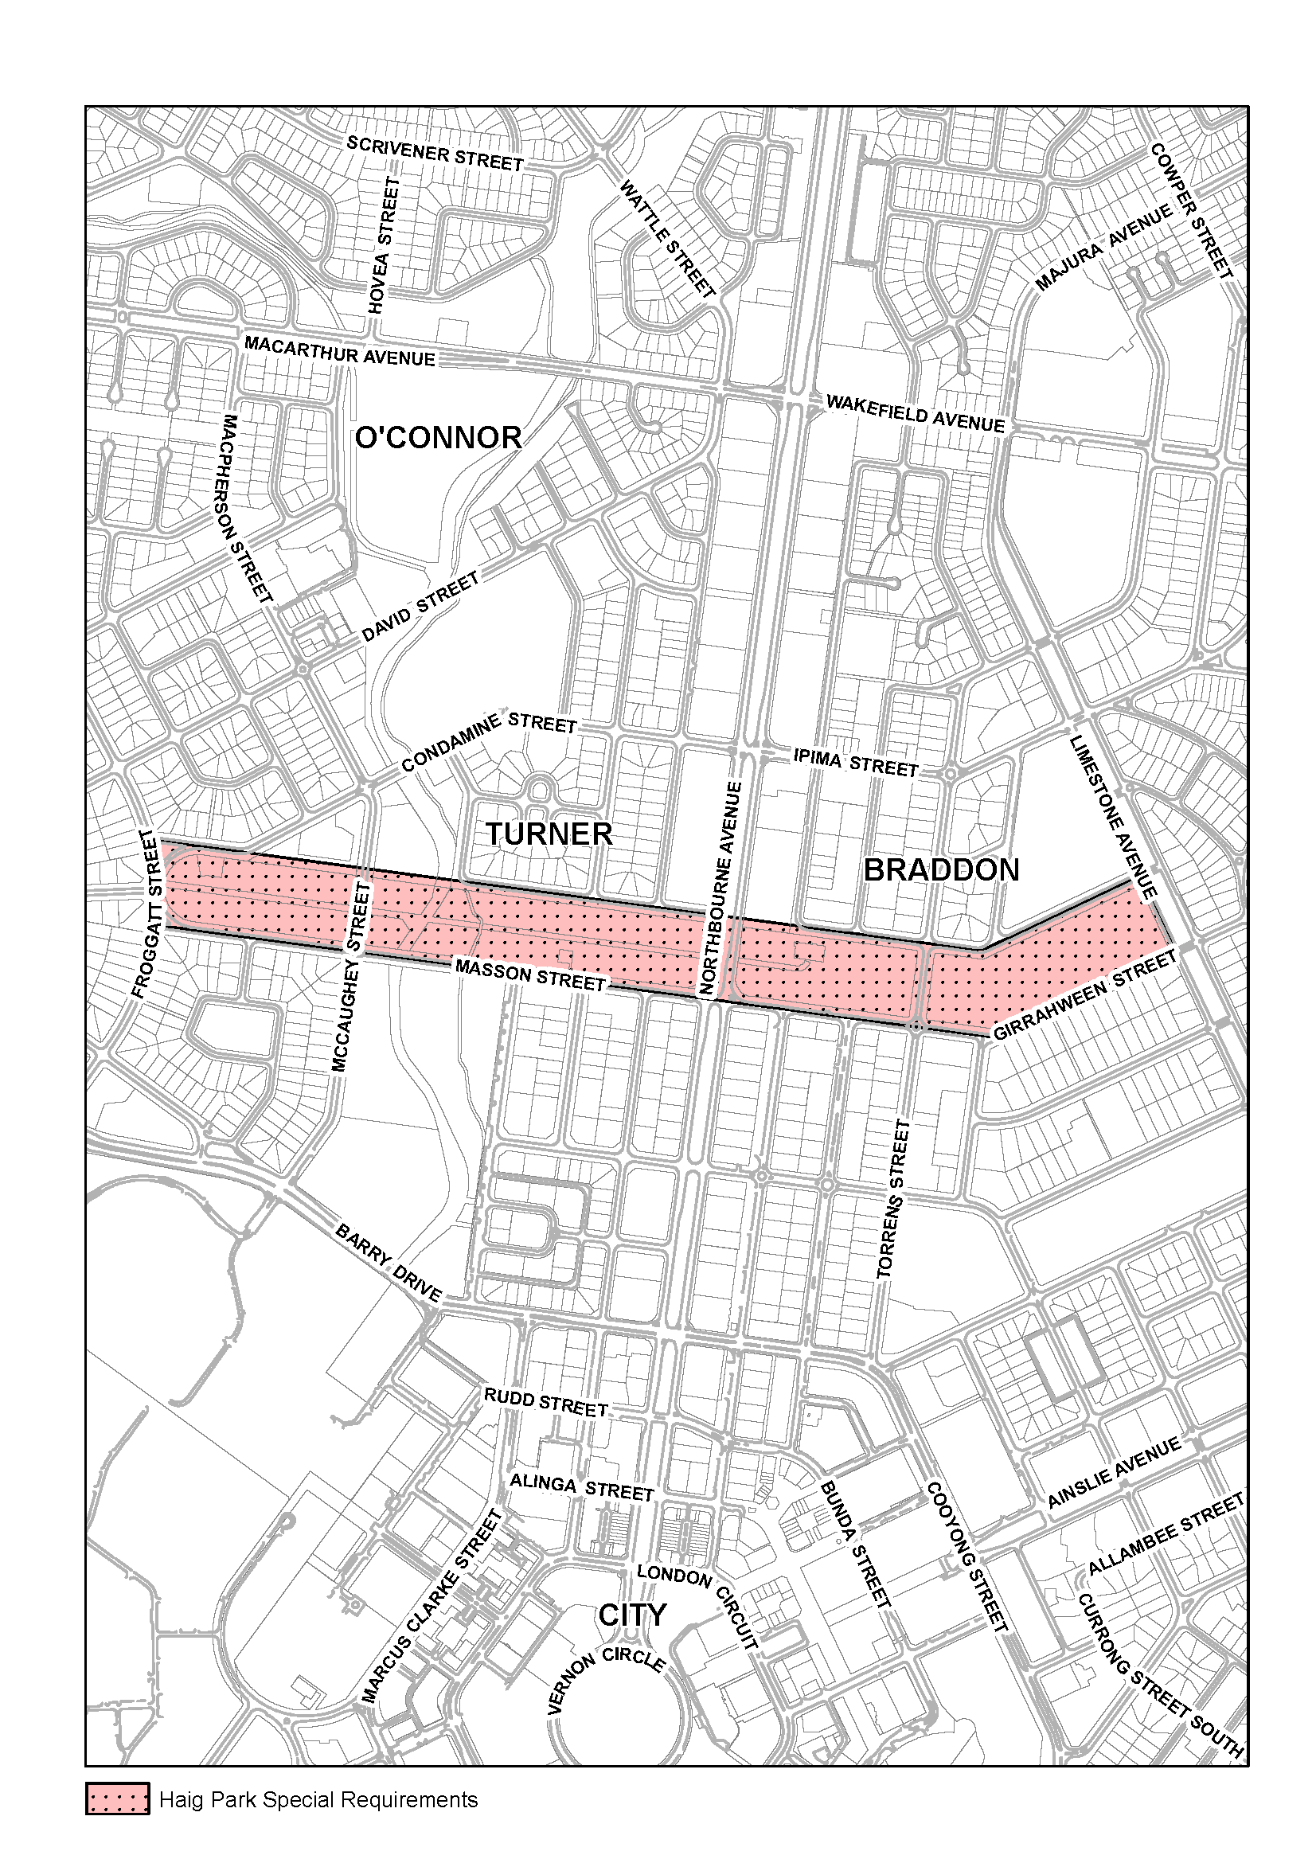
Figure 144: Haig Park area subject to Special Requirements
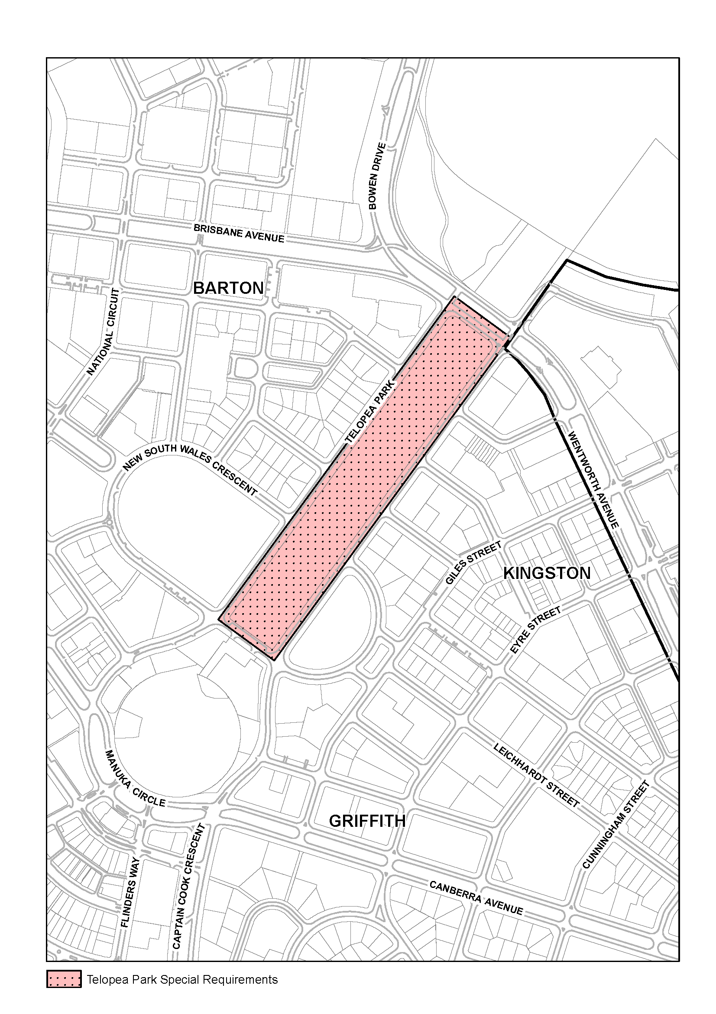
Figure 145: Telopea Park area subject to Special Requirements
It is in the interests of the National Capital to ensure that important open space places are conserved.
Development of land within open space places must conform with Development Control Plans agreed by the Authority. The Plans are to meet the following:
- to conserve landscape and environmental qualities, having regard to the historic and aesthetic importance of the area the following requirements will apply:
- historical context will be considered and established planting patterns respected.
- functional linkages to other open space elements should be enhanced.
- Utility of the areas for recreation should be optimised to the extent possible within aesthetic constraints. Provision should be made for appreciation and use of the areas by visitors to the city.

Appendix A – Land use definitions
Administrative Use
The use of any land, building or other structure for the purpose of a Court, House of Assembly, Territory Administration Centre, City Hall, Information Centre or other civic administration activities.
Administrative and Utility Services
Any of the following uses:
- Administrative Use
- Community Protection Facility
- Defence Installation
- Public Utility
as herein defined.
Advanced Technology Park
An industrial park containing uses primarily involved in the research, development, manufacture, processing, assembly and marketing of advanced technology and scientific products including allied goods and services and supporting processes.
Agriculture
The use of land for the cultivation of any plants, fruit, vegetable or flower (including berries or vines) or keeping, breeding and raising of livestock or any other living thing for commercial production but excludes any cultivation or animal husbandry carried out mainly for the enjoyment of, or consumption by, the owner(s) or occupier(s) of the land or any other purpose defined.
Animal Care Facility
A building or place used for the purpose of caring, boarding, breeding or raising predominantly domestic or household animals and may include an animal boarding establishment, kennel or veterinary hospital as defined.
Aquatic Recreation Facility
A building or place used for a sporting, exercise, pastime or leisure activity, whether operated for gain or not which includes uses based on or adjacent to a water feature, such as a boat shed, boat landing facility, wharf, swimming facility and the like.
Bank
Any premises used or intended for use for the purpose of carrying on the business of taking custody of money and includes a private trading or saving bank, but does not include a Cooperative Society as herein defined.
Bar
Any premises or part of a premises primarily used or intended for use for the sale of alcoholic beverages and spirits to members of the public for consumption on the premises, subject to the issue of an on-licence pursuant to the relevant legislation.
Botanic Garden
A reserve established and managed as a botanic garden in accordance with the provisions of the National Parks and Wildlife Conservation Act 1975.
Café
Any premises used or intended for use for the preparation and sale to the public of food and non-alcoholic beverages for consumption on the premises or elsewhere and includes take-away food, fast food and snack bars and the like.
Car Park
A structure or an area other than part of a road which is allocated for the parking of motor vehicles.
Caravan Park/Camping Ground
Land used for the placement of caravans or tents for the purpose of temporary accommodation and includes cabins for overnight and holiday accommodation, amenity buildings, recreational and entertainment facilities, manager’s office and residence, and shops which cater for the occupants of the caravan park/camping ground.
Casino
A building or place used by the public for the purposes of entertainment and gambling in accordance with the provision of any laws proclaimed in relation thereto.
Child Care Centre
A building or place, without provision for residential care, used for the purpose of supervising or caring for children of any age throughout a specified period of time in any one day which:
- caters for two or more children not related to the owner or operator of the child care centre
- may or may not include an educational function but not where this is a principle purpose
- may or may not operate for the purpose of gain.
Church Associated Building
A building used for the activities by religious organisations other than for religious worship or for offices and may include the residential use by a minister of religion.
Church Use
The use of land for religious activities of religious organisations, groups and members of the public including places of worship and church-associated buildings.
Club
A meeting place for persons associated, or for a body incorporated, for a social, sporting, athletic, literary, political or other like purpose, and includes premises in respect of which a club licence is held in accordance with the provisions of the relevant liquor licensing regulations.
Commercial Accommodation
A building or place used for use for the purpose of providing temporary accommodation and includes a hotel, motel, guest house, caravan park/camping ground, serviced apartment, serviced house and the like.
Commercial Roadside Sign
A sign, other than real estate temporary directional signs, erected within road reservations to advertise goods and services or nearby commercial events, such as auctions or sales, and includes placards, sandwich boards, posters and the like.
Communications Facility
A facility for the purpose of transmitting air-borne signals using radio masts, towers, satellite disks and the like, includes telecommunication facilities and television/radio broadcasting facilities.
Community Facility
Any of the following uses as herein defined:
- Educational Establishment
- Scientific Research Establishment
- Cultural Facility
- Hospital, Health Centre
- Institutional Use
- Church Use
- Social/Community Facility.
Community Protection Facility
Any premises used or intended for use for the purpose of providing emergency services and protection for the community including such uses as a fire station, ambulance station, police station or civil defence depot, but does not include a corrections facility as defined.
Consulting Rooms
A building or place used for the provision of health care services (including dental, optical and veterinary services) to members of the public.
Cooperative Society
A building society or a credit union formed pursuant to the provisions of the relevant ACT legislation.
Corrections Facility
A building or place used for the safe confinement or safe custody of persons so confined as the result of legal process and includes attendance centres established for persons sentenced to serve periods of community service.
Cultural Facility
A building or place used or intended for use for the purpose of cultural activities and may include a library, museum, theatre, concert hall, art gallery other than a gallery operated for the principal purpose of selling or trading in art works.
Defence Installation
A building or place operated by the Department of Defence or the armed forces of Australia and includes Department of Defence offices, offices associated with national security and defence communication facilities, but does not include facilities associated with military aviation.
Diplomatic Mission
Any building, parts of buildings and the land ancillary thereto leased specifically for use for the purpose of an embassy, a high commission, a legation, or a consulate. This includes chanceries or diplomatic mission, and combined chanceries and residences.
Dwelling
A room or suite of rooms occupied or used or so constructed or adapted as to be capable of being occupied or used as a separate domicile and includes outbuildings, if any, that are normal to the enjoyment and exclusive use of the dwelling.
Educational Establishment
A building or place used for the purpose of tuition or training, whether or not for the purposes of gain, and includes:
- a school
- a tertiary institution, being a university, a college or advanced education teachers college, technical college or other specialist college providing formal education beyond secondary education
- or any other training or education centre including road safety education centres, adult education centres for continuing education, or sheltered workshops; and may include associated residential accommodation.
Extractive Industry
A building or place used in the course of an industry or undertaking for the mining or extraction of sand, gravel, turf, soil, rock, stone or similar substances and including, when carried out on land from which any such substance is extracted on land adjacent thereto, the treatment of any such substance and the manufacture of products from any such substance; the term does not include Agriculture as herein defined.
Forestry
Land used for arboriculture, silviculture, forest protection, cutting, dressing and preparation other than in a sawmill or planing mill of wood and other forest products and the establishment of roading required, for the removal of wood and forest products and for forest production.
General Farming
A form of agriculture utilising traditional methods of farming practice including open grazing of animals on pasture or plant cultivation in open fields or gardens.
Hazardous Industry
An industry which by reason of the process involved, or the method of manufacture or the materials used or produced represents a significant source of hazard to human health or life or property, for any reason, and includes any building or place in which hazardous goods or materials are stored and handled.
Health Centre
A building or place used for the medical care (including diagnosis, preventative care and counselling) of out-patients only and may include medical or dental clinics, family planning clinics, first aid station or other professional or paramedical health care services.
Home Business
The use of residential land for carrying on a profession, trade, occupation or calling on the land.
Hospital
A building or place used for the medical care (including diagnosis, preventative care and counselling) of in-patients whether or not out-patients are also provided with care or treatment, and may include associated residential accommodation.
Hotel
A building or place in possession of a general licence in accordance with the provisions of the relevant liquor licencing laws, which provides accommodation for visitors and others.
Indoor Recreation Facility
A recreation facility devoted to facilities and equipment for indoor recreation purposes, including squash courts, indoor sports stadium, fitness centre, gymnasium and the like.
Industry
The use of land for the principal purpose of manufacturing, assembling, altering, repairing, renovating, ornamenting, finishing, cleaning, washing, winning of minerals, dismantling, processing, or adapting of any goods or any articles.
Institutional Use
The use of land as a benevolent home, convalescent home, hospital, nursing home, aged persons home, home for persons who are physically or mentally handicapped, or a remand, penal or reformative establishment.
Intensive Farming
Any form of agriculture which predominantly and usually takes place within the confines of a building or buildings, such as are commonly known as feedlots, piggeries, or poultry farming establishments, trout farms or greenhouses.
Landscape Buffer
The treatment of land for the specific purpose of:
- enhancing or protecting the amenity of neighbouring land
- meeting engineering or environmental standards by
- screen planting or shelter belt planting
- acoustic treatment including mounds etc.
- amenity landscaping
- other landscaping required to supplement adjoining areas.
Light Industry
Any industry in which the processes carried on, the transportation involved or the machinery or materials used do not interfere with the amenity of the locality by reason of noise, vibration, smell, fumes, smoke, vapour, steam, soot, ash, dust, waster water, waste products, grit, oil or otherwise.
Mobile Home Park
The use of land to accommodate mobile homes or caravans, whether temporary or permanent, and includes amenity buildings used for the personal comfort or convenience of or enjoyment of leisure by persons using a mobile home or caravan for residential accommodation in the Mobile Home Park, and may include a Caravan Park/Camping Ground.
Motel
A building or buildings used primarily for the temporary accommodation of persons travelling by motor vehicle where common facilities including meals are provided for persons accommodated in the motel or the public generally, and whether or not these facilities are licensed.
National Association Office
Any premises used by the headquarters of an establishment, organisation or association instituted on a national basis for the promotion of some political, professional, commercial, religious, charitable, educational, social welfare or philanthropic object.
National Capital Use
The use of any land, building or structure for the purpose of a work of special status and national interest. This includes the National Library, the National Gallery, the High Court, the National Archives, the National Museum of Australia, the Australian War Memorial, the Prime Minister’s Residence, the Governor-General’s Residence, the Australian National University, the Australian National Botanic Gardens, Commonwealth Offices needing prestigious locations, national memorials, National Association Offices as herein defined, a hospitality house or a Commonwealth Government conference centre and the like.
National Use
Any of the following uses as herein defined:
- Diplomatic Mission
- Parliamentary Use
- National Capital Use.
Nature Conservation Area
An area declared or intended to be declared under relevant ACT legislation to be a Reserve area and may include a Wilderness Area as herein defined.
Offensive Industry
An industry which, by reason of the process involved or the method of manufacture or the nature of the materials or goods used, produced or stored, is required to be isolated from other buildings, when all measures to reduce or minimise impact have been employed.
Office
Any premises used for the purpose of administration (including commercial and public administration), and clerical, technical, professional or like business activities.
Open Space
Land intended for use primarily for public recreation, conservation or amenity purposes and which may include facilities for the enjoyment or convenience of the public.
Outdoor Education Establishment
Land used or intended for use as an education centre for children or adults where the primary focus is on the natural and/or cultural resources of the area. It may include a residence where this is necessary for the protection or management of the primary facility.
Outdoor Recreation Facility
The outdoor use of land for recreation, exercise or leisure including sportsgrounds, riding schools, stadiums, showgrounds, racecourses, equestrian centres, motor racing, and similar activities. The term includes the activities of sporting clubs such as rifle clubs, and group or organised camping activities of schools, churches, scouts, guides, YMCA, Outward Bound and the like.
Overnight Camping
Land which is open to the public for holiday and recreational use of tents for overnight accommodation; the term includes any land together with any amenity building erected thereon which is used or intended for use in conjunction with such land.
Park
Land open to the public which:
- has been or is intended to be ornamentally laid out or prepared
- is maintained so as to preserve or enhance its natural beauty including its flora and fauna and geological or physiographic features
- has been or is intended to be prepared or maintained as a grassed area either with or without trees or shrubs
and which is intended for use for open-air recreation; the term includes any facilities provided on such land for the enjoyment or convenience of the public, being:
  - kiosks or amphitheatres for band-stands or light refreshment booths
  - picnicking areas, public lookouts, routes for nature study or other trails, footways, cycle ways, equestrian trails
  - information and display areas for the promotion of such land
  - shelters and other conveniences
  - playgrounds
  - associated car parks
  - cycle way
but does not include any activity associated with a Recreation Facility or playing field other than the occasional taking part in a game, sport or form of athletics on an informal basis.
Parliamentary Use
Any use directly associated with the function of Parliament, including the Parliament House.
Public Transport Facility
The use of land for the assembly, transport or dispersal of passengers travelling by any form of public transport, whether or not such public transport is provided by a public or private agency, and include facilities for the manoeuvring and temporary layover of public transport vehicles and driver amenities.
Pathway Corridor
Any public land used for the primary purpose of providing for the movement of pedestrians and cyclists.
Personal Service Establishment
Any premises used or intended for use for the purposes of barbering, skin care, non-professional health and/or body care, photography, and like activities, but does not include any premises used or intended for use for a purpose elsewhere herein specifically defined.
Place of Assembly
A building or place used for the following entertainment purposes.
- a trade fair or exhibition
- an auditorium or convention centre
- reception rooms, including any premises not being part of a hotel, managed by a proprietor, and available for the use of parties on formal or ceremonious occasions, but not for unhosted use on general occasions for entertainment purposes.
Place of worship
A building or place used or intended for use for the primary purposes of religious worship and associated activities by a congregation, religious group or members of the public whether or not the premises are also used for religious instruction, tuition or training and may include use for other community activities.
Public Utility
The use of land for the following utility undertakings:
- headwork and network undertakings for the provision of sewerage and drainage services or the reticulation of water, electricity, or gas except for gas manufacture and storage
- communication facilities, including postal facilities, telecommunication facilities, television/radio broadcasting facilities, and air navigation communication facilities
- municipal uses, including street cleaning depots, public toilets, parks and gardens depots, works depots and associated uses.
Quarry
Land used or intended for use for the purpose of extractive industry as herein defined.
Recreation
Land used or intended for use for the public appreciation and use of the natural and cultural environment, scenic and special features where the provision of facilities is minimal.
The term includes any facilities provided on such land for the enjoyment or convenience of the public, being:
- kiosks or light refreshments booths
- picnicking areas, public lookouts, routes for nature study or other trails, footways, cycle ways, equestrians trails
- information and display areas for the promotion of such land
- shelters and other conveniences.
Reserve
Land declared as a Reserve under Section 51 of the ACT Nature Conservation Act 1980, the ACT Public Parks Act 1928, or other relevant ACT legislation for special purpose reserves.
Residential
The use of land for the primary purpose of providing shelter for human habitation together with such outbuildings as are incidental to and ordinarily associated with the residential use of the land.
Restaurant
A building or place used for the primary purpose of providing food for consumption on the premises whether or not the premises are licensed to sell liquor and whether or not entertainment is provided. The use includes tea rooms, cafés, bistros and the like.
Restricted Access Open Space
Land used for recreation, exercise or leisure activity, whether operated for gain or not and where public access to the facility may be restricted to certain times.
Retail
The selling of goods and providing personal services in any quantity and by any means other than by wholesale and includes retail shops, restaurants, drink establishments, drive-in facilities, bulky retailing, bulk landscape supplies, vehicle sales, service stations, retail plant nurseries and produce markets.
Retail Plant Nursery
A building or place used for the propagation and sale to members of the public of plants, shrubs, trees and garden supplies but does not include the bulk sale of sand, soil, screenings and other such garden materials.
Road
Any way or street, whether in existence or under reserve, open to the public which is provided and maintained for the passage of vehicles, persons and animals and which may include footpaths, community paths, bus lay-bys, turning areas or trafﬁc controls.
Scientiﬁc Research Establishment
A building or place used for the purposes of scientiﬁc research including the development of electronic technology, biotechnology or other scientiﬁc disciplines for application to commerce, industry, or government and which may include scientiﬁc laboratories, meteorological uses, observatories and facilities operated by the Commonwealth Scientiﬁc and Industrial Research Organisation or private organisations.
Serviced Apartments
Establishments with five or more units which mostly comprise self-contained units at the same location, and which are available on a unit/apartment basis to the general public for a minimum of one night. The units should have full cooking facilities (i.e. hot plates and oven/microwave), refrigerator and bath/shower and toilet facilities; all bed linen and towels should be provided, and daily servicing (i.e. cleaning and bed making) must be available through the on-site management, although this service may not necessarily be used.
Single Dwelling Housing
Any area of residential land used for the purpose of a single dwelling only.
Social/Community Facility
A building or place used by a public authority or a body of persons associated for the purpose of providing for the social welfare of the community which may include:
- meeting rooms, neighbourhood centres, recreation, child minding (including care and ancillary education), cultural activities, social functions and the like
- a community club being a building or place used by persons sharing like interests, but not including a licensed club
whether or not that building or place is used for another purpose including associated administration.
Special Development
Land set aside to be used for commercial and community/recreation/tourist activities directly related to the use of the river.
Tourist Centre
A location identiﬁed for Tourist Facilities.
Tourist Facility
The use of land for the purpose of providing entertainment, recreation, cultural or similar facilities for use mainly by the general touring or holidaying public. This may include a restaurant, café, bar, service station, tourist accommodation (including motel) and the retail sale of crafts, souvenirs, antiques and the like.
Transport Facility
The use of land or a building for or associated with the movement of goods and people by road, rail and air.
Waterfront Promenade
An accessible public space bordering the lake, intended primarily for walking and cycling.
Wilderness Area
A spacious area of land containing features of the natural environment of particular signiﬁcance which is substantially undisturbed by European settlement and which may be an area declared or intended to be declared under relevant ACT legislation to be a wilderness

Appendix B – General definitions

NB. Place Names and Proper Nouns where used in the Plan have the meaning ordinarily given them or as deﬁned by or under relevant legislation, gazettals or regulations.
ACT Government
The body politic established under the Australian Capital Territory (Self Government) ACT 1988 and includes the Executive of that body, and agencies established by it, whether by enactment or otherwise.
Amenity
Those qualities or conditions associated with a site, or locality, that are conducive to its better enjoyment for any permitted use.
Arterial Roads
Roads which provide principally for intra and inter-town traffic collection and distribution are arterial roads. The main elements are shown on the General Policy Plan. The arterial road network in the Territory comprises two elements – the arterial roads within Canberra's urban areas, which are major traffic collectors and distributors, and the network of peripheral parkways which serves to carry traffic between towns along routes lying largely at the periphery of the built-up areas.
Attic
Any floor area built wholly or partly in the roof of a building but an attic will not be regarded as a storey if it is wholly contained within a roof pitched at the level of the ceiling of the storey next below the attic.
Backlighting
In relation to a sign; the internal illumination of a sign box and the internal illumination of individual letters or characters comprising a sign, provided that the sign box, letter or character is constructed of translucent and not transparent materials.
Billboard
A sign erected for the purpose of advertising products or services which are not being offered on a site on which the sign is erected.
Canberra Central
Comprises the Inner North and Inner South areas of Canberra, includes Canberra City at its centre.
City
The division of City defined by registered survey for land administration and the legal description of land parcels. Broadly, commencing at the intersection of Kingsley Street and Barry Drive, land bound by Barry Drive, Cooyong Street, Coranderrk Street, Parkes Way, Edinburgh Avenue, Hales Street, the eastern portion of McCoy Circuit, Ellery Crescent, Childers Street (including the land on the north-east side of Childers Street to Hutton Street), Hutton Street and Kingsley Street.
Commonwealth Authority
a. a body, whether corporate or not, established by or under a law of the Commonwealth other than the Self-Government Act
b. any other body, whether corporate or not, established by the Commonwealth
c. an ofﬁce established by, or appointment made under, a law of the Commonwealth other than the Self-Government Act
d. an appointment made by the Commonwealth.
Conservation Plan
A statement setting out all the processes of looking after a place so as to retain its cultural or natural signiﬁcance, including maintenance, presentation, restoration, reconstruction and adaptation or a combination of more than one of these.
Defined Activity Centre
Those sites identified as primary activity centres for the location of major employment generating land uses. Includes town centres and industrial areas, but does not include group or local centres.
Designated Area
An area of land identified as having the special characteristics of the National Capital under Section 10(1) of the Australian Capital Territory (Planning and Land Management) Act 1988. For the purposes of the Plan Designated Areas are referred to as Designated Areas.
Development Control Plan
A plan prepared for the guidance and control of development including design, siting, scale, purpose, timing and phasing, construction, landscaping and other relevant matters. The plan may include maps, drawings, photographs, speciﬁcations and written statements.
Gross Floor Area
With respect to detached houses, is the sum of the gross areas of the floor or floors of a building or buildings, measured from the external faces of exterior walls or form the centre lines of walls separating two buildings. Without attempting to be exhaustive, gross floor area includes garages and any area capable of being adapted for use as anything other than the storage of goods, and floor space in interior balconies or mezzanines and external balconies which are used as corridors. In the event of no garage or carport being shown on the plan, there will be included in the calculation of the floor space, 15 square metres floor space for the first 150 square meters of gross floor space shown on the plan and 1 square metre of floor space for every 10 square metres of floor space for every 10 square metres over 150 square metres. In the case of a commercial, multi-unit residential, industrial or business building floor space does not include any areas used for elevator shafts or stairwells, fixed mechanical plant or car parking.
External balconies in multi-unit residential buildings are excluded from gross floor area calculations where two or fewer sides are enclosed. Where three sides are enclosed, the balcony will be included in gross floor area calculations.
Height of Building
The difference between the mean natural ground level of that length of the side boundary which is adjacent to the building and the highest point or points or the parapet, eaves or fascia in the case of flat roofs or roofs pitched at less than 45 degrees. Where the roof is pitched at more than 45 degrees the highest point will be measured to a line midway between the top of the eaves or fascia and the ridge.
Height of Sign
The difference between ground level and the highest point of the sign.
Heritage Place
Includes places listed under either Commonwealth or Territory legislation, or those under the National Capital Authority’s heritage register maintained under the Environment Protection and Biodiversity Conservation Act 1999.
Land Acquisition Act
The Act for the time being in force relating to the acquisition of land by the Commonwealth and associated matters.
Lanyon Bowl Area
Lanyon Bowl Area is approximately 5000 hectares, located in the Murrumbidgee Valley 20 kilometres south of Canberra, comprising the visual catchment of the Lanyon Homestead complex and defined as the land bound by a line commencing at the Castle Hill trig; then south-west and south-east along the watershed boundary of Sawyers Gully to the Tennant trig; then generally north-east in a straight line to toward the Murrumbidgee River at Tharwa; then eastwards directly to an peak of 729m ASL; then along the ridgeline to a peak of altitude 858m ASL immediately north of the Gigerline trig; then north-east along the crest of the range to the Rob Roy trig; then north along the ridgeline to the Big Monks trig; then via straight lines to Tharwa Drive then Lanyon Hill trig and then a straight line to the commencement point.’
Management
In relation to land, includes care, control and maintenance.
National Triangle
The land bounded by Constitution Avenue, Kings Avenue and Commonwealth Avenue.
Parking Space
An unobstructed hardstanding or manoeuvring area of 28m² open or enclosed. However, an area of less than 28m2, but in no event less than 19m2 may be considered as one space, when the layout and design of the parking are adequate to permit convenient access and manoeuvring. In no event, except for detached houses, must the dimensions of any parking space be less than 5.5m long and 2.6m wide.
Pedestrian Walkway
A strip of land, whether paved or unpaved, which is designated by the National Capital Authority as being set aside for the purpose of foot traffic between two or more places.
Plot Ratio
The gross floor area in a building, divided by the area of the site.
Rear Property Boundary
The boundary line of a block located furthermost from the front property boundary. In the case of blocks which have not more than two property boundaries, there will be deemed to be one front boundary and one side boundary.
Site
Block of land, excepting blocks which include an access driveway or right of way, in which case the area contained within the access driveway or right of way will not be included in the area of the block for the purpose of the calculation of the site area.
Storey
That portion of any building including any portion used for the parking of vehicles or any portion capable of being adapted for use as anything other than storage or the installation of fixed mechanical plant or equipment which is situated between any floor level and the floor level above, or, if there is no floor above, and the ceiling above.
Surface Area
In relation to a sign; the entire area within a single continuous perimeter enclosing the extreme limit of writing, representation, emblem, or any figure or similar character, together with any material or colour form an integral part of the display or used to differentiate such sign from the background against which it is placed. In any event, the supports or uprights on which such sign is supported will not be included in determining the surface area of a sign.
The surface area of a double-faced sign must include only one of the sides when:
i. the sides are back to back
ii. the sides are divergent but display identical writing or other representation in substantially different directions.
Any additional side of a multi-faced sign will be included in the assessment of surface area.
Management Plan
A plan, including statements or programs, setting out the objectives, actions, works, standards and procedures for the care, control, maintenance and protection of land, and for the activities for which the land is used.
National Capital Plan
The Plan prepared by the National Capital Authority under Part III of the Australian Capital Territory (Planning and Land Management) Act 1988 and includes a stage or part of that Plan. May also be referred to as the Plan.
National Land
Has the meaning given by Section 27 of the Australian Capital Territory (Planning and Land Management) Act 1988.
Parliamentary Precincts
The area of land speciﬁed by the Parliamentary Precincts Act 1988.
Parliamentary Zone
The area of land speciﬁed by the Parliament Act 1974.
Plan
Unless the context otherwise requires, the National Capital Plan.
Policy Plan
A plan prepared for the purposes of setting out land uses for an area, whether existing or intended, or to deal with a class or classes of land use within an area.
Special Requirements Area
An area of land speciﬁed in the Plan under Section 10(2) (d) of the Australian Capital Territory (Planning and Land Management) Act 1988.
Territory Land
Any land that is not National Land as described by Section 28 of the Australian Capital Territory (Planning and Land Management) Act 1988.
Territory Plan
The plan referred to in Section 25 of the Australian Capital Territory (Planning and Land Management) Act 1988.
Territory Planning Authority
The authority referred to in Section 25 of the Australian Capital Territory (Planning and Land Management) Act 1988.
Works
Includes:
a. the construction, alteration, extension or demolition of buildings or structures
b. landscaping
c. tree-felling
d. excavations
but excludes anything done inside buildings or structures.

Endnotes

Endnote 1—About the endnotes
The endnotes provide information about this compilation and the compiled law.
The following endnotes are included in every compilation:
Endnote 1—About the endnotes
Endnote 2—Abbreviation key
Endnote 3—Legislation history
Endnote 4—Amendment history
Abbreviation key—Endnote 2
The abbreviation key sets out abbreviations that may be used in the endnotes.
Legislation history and amendment history—Endnotes 3 and 4
Amending laws are annotated in the legislation history and amendment history.
The legislation history in endnote 3 provides information about each law that has amended (or will amend) the compiled law. The information includes commencement details for amending laws and details of any application, saving or transitional provisions that are not included in this compilation.
The amendment history in endnote 4 provides information about amendments at the provision (generally section or equivalent) level. It also includes information about any provision of the compiled law that has been repealed in accordance with a provision of the law.
Editorial changes
The Legislation Act 2003 authorises First Parliamentary Counsel to make editorial and presentational changes to a compiled law in preparing a compilation of the law for registration. The changes must not change the effect of the law. Editorial changes take effect from the compilation registration date.
If the compilation includes editorial changes, the endnotes include a brief outline of the changes in general terms. Full details of any changes can be obtained from the Office of Parliamentary Counsel.
Misdescribed amendments
A misdescribed amendment is an amendment that does not accurately describe the amendment to be made. If, despite the misdescription, the amendment can be given effect as intended, the amendment is incorporated into the compiled law and the abbreviation “(md)” added to the details of the amendment included in the amendment history.
If a misdescribed amendment cannot be given effect as intended, the abbreviation “(md not incorp)” is added to the details of the amendment included in the amendment history.

Endnote 2—Abbreviation key
ad = added or inserted | o = order(s)
am = amended | Ord = Ordinance
amdt = amendment | orig = original
c = clause(s) | par = paragraph(s)/subparagraph(s)
C[x] = Compilation No. x | /sub-subparagraph(s)
Ch = Chapter(s) | pres = present
def = definition(s) | prev = previous
Dict = Dictionary | (prev…) = previously
disallowed = disallowed by Parliament | Pt = Part(s)
Div = Division(s) | r = regulation(s)/rule(s)
ed = editorial change | reloc = relocated
exp = expires/expired or ceases/ceased to have | renum = renumbered
effect | rep = repealed
F = Federal Register of Legislation | rs = repealed and substituted
gaz = gazette | s = section(s)/subsection(s)
LA = Legislation Act 2003 | Sch = Schedule(s)
LIA = Legislative Instruments Act 2003 | Sdiv = Subdivision(s)
(md) = misdescribed amendment can be given | SLI = Select Legislative Instrument
effect | SR = Statutory Rules
(md not incorp) = misdescribed amendment | Sub-Ch = Sub-Chapter(s)
cannot be given effect | SubPt = Subpart(s)
mod = modified/modification | underlining = whole or part not
No. = Number(s) | commenced or to be commenced

Endnote 3—Legislation history
Name | Registration | Commencement | Application, saving and transitional provisions
National Capital Plan - Amendment No. 1 - City Sections 10 (Part), 37 and 62 | 14 Dec 2007  (F2007B01565) | 6 Nov 1991 | —
National Capital Plan - Amendment No. 2 | 14 Dec 2007  (F2007B01566) | 13 Dec 1991 | —
National Capital Plan - Amendment No. 4 - Harcourt Hill | 17 Dec 2007  (F2007B01584) | 9 Nov 1992 | —
National Capital Plan - Amendment No. 6 - West Belconnen | 17 Dec 2007  (F2007B01589) | 10 Dec 1992 | —
National Capital Plan - Amendment No. 3 - Duntroon and York Park Master Plans | 24 Dec 2007  (F2007B01583) | 14 July 1993 | —
National Capital Plan - Amendment No. 7 - Kingston Redevelopment | 17 Dec 2007  (F2007B01590) | 25 Aug 1993 | —
National Capital Plan - Amendment No. 8 - General | 17 Dec 2007  (F2007B01591) | 26 Oct 1993 | —
National Capital Plan - Amendment No. 9 - Hotel Kurrajong | 17 Dec 2007  (F2007B01592) | 22 Dec 1993 | —
National Capital Plan - Amendment No. 11 - General | 14 Feb 2008  (F2008B00022) | 16 Nov 1994 | —
National Capital Plan - Amendment No. 13 - Symonston | 14 Feb 2008  (F2008B00024) | 8 Mar 1995 | —
National Capital Plan - Amendment No. 12 - Russell | 14 Feb 2008  (F2008B00023) | 17 Jun 1996 | —
National Capital Plan - Amendment No. 16 - Australian National Botanic Gardens | 15 Feb 2008  (F2008B00026) | 10 Dec 1996 | —
National Capital Plan - Amendment No. 14 - Broadacre | 14 Feb 2008  (F2008B00025) | 11 Dec 1996 | —
National Capital Plan - Amendment No. 19 - Federal Highway | 19 Feb 2008  (F2008B00027) | 18 June 1997 | —
National Capital Plan - Amendment No. 20 - Acton Peninsula | 19 Feb 2008  (F2008B00028) | 5 Dec 1997 | —
National Capital Plan - Amendment No. 22 - Ginninderra Drive | 19 Feb 2008 (F2008B00030) | 6 Mar 1998 | —
National Capital Plan - Amendment No. 28 - Blackall Place, Barton | 21 Feb 2008 (F2008B00036) | 19 May 1999 | —
National Capital Plan - Amendment No. 23 - Canberra Centre Consolidation | 19 Feb 2008 (F2008B00031) | 27 May 1999 | —
National Capital Plan - Amendment No. 26 - Acton House | 20 Feb 2008 (F2008B00034) | 27 May 1999 | —
National Capital Plan - Amendment No. 21 - Telecommunications Facilities Policies | 19 Feb 2008 (F2008B00029) | 16 June 1999 | —
National Capital Plan - Amendment No. 24 - Special Requirements for Northbourne Avenue | 19 Feb 2008 (F2008B00032) | 21 July 1999 | —
National Capital Plan - Amendment No. 36 - ACT Hospice | 26 Feb 2008 (F2008B00046) | 24 Nov 1999 | —
National Capital Plan - Amendment No. 27 - Open Space [Park] - Public Accessibility | 21 Feb 2008 (F2008B00035) | 16 Feb 2000 | —
National Capital Plan - Amendment No. 31 - Land Use - Part sections 29 and 30 Forrest | 22 Feb 2008 (F2008B00039) | 13 Mar 2000 | —
National Capital Plan - Amendment No. 35 - Joint Staff College of Weston Creek | 26 Feb 2008 (F2008B00043) | 11 Apr 2000 | —
National Capital Plan - Amendment No. 29 - Kingston Foreshore | 21 Feb 2008 (F2008B00037) | 11 Apr 2000 | —
National Capital Plan - Amendment No. 37 - Rural Leases - Districts of Tennent and Booth | 27 Feb 2008 (F2008B00048) | 15 June 2000 | —
National Capital Plan - Amendment No. 25 - Signs Policy | 20 Feb 2008 (F2008B00033) | 20 June 2000 | —
National Capital Plan - Amendment No. 30 - Canberra Airport | 21 Feb 2008 (F2008B00038) | 29 Sept 2000 | —
National Capital Plan - Amendment No. 32 - Australian National University Boundary Changes | 22 Feb 2008 (F2008B00040) | 14 June 2001 | —
National Capital Plan - Amendment No. 33 - Parliamentary Zone Review | 22 Feb 2008 (F2008B00041) | 18 Sept 2001 | —
National Capital Plan - Amendment No. 41 - Gungahlin Drive Extension | 28 Feb 2008 (F2008B00047) | 4 Mar 2003 | —
National Capital Plan - Amendment No. 43 - Campbell Park Offices | 28 Feb 2008 (F2008B00049) | 5 Mar 2003 | —
National Capital Plan - Amendment No. 46 - Gungahlin Drive Extension - Black Mountain Nature Reserve | 28 Feb 2008 (F2008B00051) | 27 Aug 2003 | —
National Capital Plan - Amendment No. 45 - Block 11 and Part Block 14 Section 49 Symonston - Quamby | 28 Feb 2008 (F2008B00050) | 19 Nov 2003 | —
National Capital Plan - Amendment No. 34 - Uriarra Forestry Settlement | 22 Feb 2008 (F2008B00042) | 28 Jul 2004 | —
National Capital Plan - Amendment 48 - Signs Policies - Flexibility Provisions and Sponsorship Signs in the Parliamentary Zone | 7 Mar 2005 (F2005L00505) | 8 Mar 2005 | —
National Capital Plan - Amendment 49 - Civic Principles and Policies | 7 Mar 2005 (F2005L00542) | 8 Mar 2005 | —
National Capital Plan - Amendment 44 - Office Employment Location Policies | 8 Mar 2005 (F2005L00580) | 9 Mar 2005 | —
National Capital Plan - Amendment 39 - Deakin/Forrest Residential Area | 30 May 2005 (F2005L01290) | 31 May 2005 | —
National Capital Plan - Amendment 42 - York Park Master Plan | 13 Sept 2005 (F2005L02596) | 14 Sept 2005 | —
National Capital Plan - Amendment 52 - Zoo Expansion (Part Block 1502 Belconnen) | 14 June 2006 (F2006L01820) | 15 June 2006 | —
National Capital Plan - Amendment 54 - Parliamentary Zone (Section 55 Parkes) | 6 Sept 2006 (F2006L03001) | 7 Sept 2006 | —
National Capital Plan - Amendment 55 - Block 16 Section 28 City (Australian National University) | 7 Sept 2006 (F2006L03008) | 8 Sept 2006 | —
National Capital Plan - Amendment 56 - The Griffin Legacy - Principles and Policies | 5 Dec 2006 (F2006L03950) | 6 Dec 2006 | —
National Capital Plan - Amendment 59 - City Hill Precinct | 5 Dec 2006 (F2006L03952) | 6 Dec 2006 | —
National Capital Plan - Amendment 60 - Constitution Avenue | 5 Dec 2006 (F2006L03955) | 6 Dec 2006 | —
National Capital Plan - Amendment 61 - West Basin | 5 Dec 2006 (F2006L03970) | 6 Dec 2006 | —
National Capital Plan - Amendment 66 - Diplomatic Mission Yarralumla | 2 Aug 2007 (F2007L02317) | 3 Aug 2007 | —
National Capital Plan - Amendment 67 - Provisions for Mobile Home Park | 12 Oct 2007 (F2007L04060) | 13 Oct 2007 | —
National Capital Plan - Amendment 63 - Molonglo and North Weston | 9 Oct 2008 (F2008L03633) | 10 Oct 2008 | —
National Capital Plan - Amendment 57 - Blocks 12 & 13 Section 9 Barton | 14 Oct 2009 (F2009L03763) | 14 Oct 2009 | —
National Capital Plan - Amendment 70 - Section 87 and Part Sections 83 and 85 Fyshwick and Appendix E | 10 Mar 2010 (F2010L00623) | 10 Mar 2010 | —
National Capital Plan - Amendment 73 - Block 6 Section 4 Yarralumla (Westridge House) | 30 Nov 2011 (F2011L02505) | 30 Nov 2011 | —
National Capital Plan - Amendment 74 - Section 5 Campbell | 5 Dec 2012 (F2012L02324) | 5 Dec 2012 | —
National Capital Plan – Amendment 76 – Policy 4.4(d) for Urban Areas | 5 Dec 2012 (F2012L02325) | 5 Dec 2012 | —
National Capital Plan - Amendment 75 - Australian Defence Force Academy and Royal Military College Duntroon Master Plan | 9 Jan 2013 (F2013L00036) | 9 Jan 2013 | —
National Capital Plan - Amendment 81 - Removal of Outdated and Unnecessary Policy Material | 16 May 2013 (F2013L00782) | 16 May 2013 | —
National Capital Plan - Amendment 79 - Removal of West Basin Pedestrian Bridge | 19 June 2013 (F2013L01054) | 19 June 2013 | —
National Capital Plan - Amendment 77 - Elm Grove campsite (Part Block 624 Gungahlin) | 25 June 2013 (F2013L01149) | 25 June 2013 | —
National Capital Plan - Amendment 80 - Yarramundi Reach | 25 June 2013 (F2013L01151) | 25 June 2013 | —
National Capital Plan - Amendment 82 - Amtech Estate | 28 Feb 2014 (F2014L00206) | 28 Feb 2014 | —
National Capital Plan - Amendment 84 - Pialligo Section 9 Part Block 4 and Section 12 Part Block 2 | 28 Feb 2014 (F2014L00207) | 28 Feb 2014 | —
National Capital Plan – Amendment 86 – Revised National Capital Plan | 5 May 2016 (F2016L00669) | 5 May 2016 | —
National Capital Plan – Amendment 87 – Relocation of Indicative Sites for Landmark Buildings (Knowles Place) | 10 Mar 2017 (F2017L00206) | 10 Mar 2017 (s 2) | —
National Capital Plan - Amendment 88 - Blocks 3 and 15 Section 22 Barton | 8 Feb 2018 (F2018L00092] | 8 Feb 2018 (s 2) | —

Endnote 4—Amendment history
The amendment history in the following table contains amendments made to the National Capital Plan (December 1990) commencing after 5 May 2016, the date the plan was omitted and replaced by the National Capital Plan - Amendment 86 - Revised National Plan (F2016L00669).

Provision affected | How affected
National Capital Plan (December 1990) | rs F2016L00669
Part Four(A)
4.4 | am F2018L00092
4.6 | am F2017L00206

The amendment history in the following table contains provisions that were amended prior to the National Capital Plan (December 1990) being omitted and replaced by the National Capital Plan - Amendment 86 - Revised National Plan (F2016L00669) on the 5 May 2016.

Provision affected | How affected
Foreword
Foreword | am F2007B01566
Introduction
Introduction | am F2007B01566; F2007B01584; F2007B01589; F2008B00024; F2008B00026; F2008B00027; F2008B00030; F2008B00031; F2008B00043; F2008B00037; F2008B00038; F2008B00040; F2008B00047; F2008B00049; F2008B00051; F2008B00050; F2008B00042; F2005L00580; F2006L03950; F2008L03633; F2010L00623; F2013L00036; F2014L00207
Pt One - Principles, Policies and Standards, Designated Areas, Special Requirements
1. The Central National Area
1. | am F2008B00022; F2006L03950
1.1 | am F2007B01566; F2008B00022; F2008B00026; F2008B00037; F2008B00038; F2008B00040; F2008B00041; F2008B00049; F2006L03952
1.2 | am F2007B01566; F2011L02505; F2013L00782
1.3 | am F2007B01583; F2008B00038
renum 1.6 | F2006L03952
1.3 | ad F2006L03952
1.4 | am F2007B01565; F2007B01566; F2007B01583; F2007B01591; F2007B01592; F2008B00022; F2008B00023; F2008B00026; F2008B00028; F2008B00036; F2008B00031; F2008B00034; F2008B00046; F2008B00035; F2008B00039; F2008B00037; F2008B00038; F2008B00040; F2008B00041; F2008B00049; F2005L01290; F2005L02596; F2006L01820; F2006L03008
renum 1.7 | F2006L03952
1.4 | ad F2006L03970
1.5 | ad F2006L03955
 | am F2012L02324
1.7 | am F2006L03952; F2006L03955; F2006L03970; F2007L02317; F2009L03763; F2011L02505; F2012L02324; F2013L00036; F2013L00782; F2013L01151
2. Main Avenues and Approach Routes
2.1 | am F2008B00037
2.2 | am F2008B00027; F2008B00033
2.3 | am F2007B01566
 | rs F2008B00032
 | am F2008B00037
3. Office Employment Location
3. Employment Location | rs F2005L00580
3.1 | am F2007B01566
 | rs F2005L00580
3.2 | am F2007B01583
 | rs F2005L00580
3.3 | am F2007B01583
 | rs F2005L00580
4. Urban Areas
4.1 | am F2008B00038; F2008L03633; F2013L00782
4.4 | am F2008B00024; F2008B00038; F2008L03633; F2012L02325; F2014L00206
4.5 | am F2007B01566; F2008B00024; F2008B00032; F2008B00037; F2005L00542; F2005L00580; F2014L00206
5. Broadacre Areas
5.1 | am F2008B00038
5.2 | am F2007B01589; F2007B01591; F2008B00025; F2008B00038; F2008B00049; F2005L00580; F2007L04060
5.3 | am F2008B00038
7. Urban Design
7.3 | am F2007B01583; F2007B01590
8. National Capital Open Space System
8.1 | am F2008B00038
8.3 | am F2008B00038
8.5 | am F2007B01566; F2007B01584; F2007B01591; F2008B00026; F2008B00029; F2008L03633; F2013L01149
8.6 | am F2007B01591; F2008B00026; F2008B00027; F2008B00051; F2008B00050; F2008L03633; F2013L00782
8.7 | am F2007B01591; F2008L03633
9. Rural Areas
9.1 | am F2008B00038
9.3 | am F2007B01591; F2008B00038
12. Infrastructure
12.3 | am F2008B00029; F2013L00782
12.4 | ad F2008B00029
Pt Two - Administration and Implementation
Development and Management of National Land | am F2007B01566; F2013L00782
Gazetted Policies of the Former National Capital Development Commission | rep F2013L00782
Planning Appeals | rep F2013L00782
Review Process for Aspects of the Plan | am F2008B00041; F2013L00782
Pt Three - Background Notes | rep F2013L00782
The Future of the Capital | am F2005L00580
 | rep F2013L00782
Canberra and the Region | rep F2013L00782
Commonwealth Funding and the National Capital Plan | rep F2013L00782
Appendices
Appendix A | am F2007B01566; F2007B01591; F2008B00024; F2008B00026; F2008B00033; F2008B00038; F2007L04060; F2008L03633; F2011L02505
Appendix B | am F2008B00022
Appendix C | rep F2013L00782
Appendix D | rep F2013L00782
Appendix E | am F2010L00623
 | rep F2013L00782
Appendix F | am F2008L03633
Appendix G | am F2008B00048
Appendix H | am F2007B01583; F2008B00029; F2008B00033; F2005L00505
Appendix J | am F2013L00782
Appendix K | rep F2013L00782
Appendix L | am F2007B01566
Appendix M | rs F2005L01290
Appendix N | rs F2005L01290
Appendix Q | rep F2008B00038
Appendix R | ad F2007B01566
 | rep F2013L00782
Appendix S | ad F2007B01565
 | rep F2006L03952
Appendix T | ad F2007B01583
 | am F2008B00023; F2008B00026; F2008B00028; F2008B00041; F2005L02596; F2006L03001; F2006L03952; F2006L03955; F2006L03970; F2012L02324; F2013L00036; F2013L01054
Appendix U | ad F2007B01583
 | am F2009L03763
Appendix V | ad F2007B01584
Appendix W | ad F2007B01589
 | rep F2013L00782
Appendix X | ad F2008B00027

