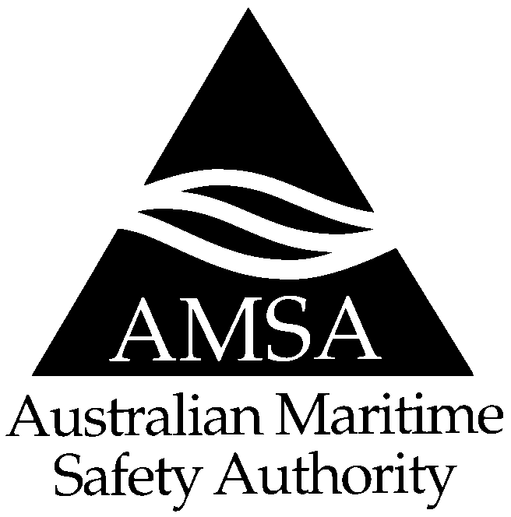

MARINE ORDERS

Miscellaneous

Amendments

Order No 15 of 1999
Pursuant to Section 425(1AA) of the Navigation Act 1912, I hereby make this Order:
- repealing Marine Orders, Part 1; and
- amending various parts of Marine Orders,
to come into effect on 1 July 1999.
Clive Davidson
Chief Executive
17 June 1999

Table of Contents

1 General amendments
2 Amendments to Part 14
3 Amendments to Part 46
4 Amendments to Part 47
5 Amendments to Part 51
6 Amendment to Part 58

1 General amendments
1.1 In every part of Marine Orders, including this Part:
(a) headings and sub-headings are part of the Part;
(b) each Appendix is part of the Part;
(c) a note included in the text and printed in italics is not part of the Part.
1.2 Definition of General Manager
In every Part of Marine Orders, other than Part 58 (International Safety Management Code), in which General Manager is defined, the definition therein is replaced by the following definition:
General Manager means the person occupying the position of General Manager, Maritime Operations, in AMSA.
1.3 Definition of Chief Marine Surveyor
In every Part of Marine Orders in which Chief Marine Surveyor is defined, the definition therein is replaced by the following definition:
Chief Marine Surveyor means the person occupying the position of Manager, Marine Services—Ship Inspection Programs, in AMSA or, in respect of any particular purpose under this Part, a suitable qualified person authorised by the Manager, Marine Services—Ship Inspection Programs, for that purpose.
1.4 Definition of Manager
In every Part of Marine Orders in which Manager is defined, the definition therein is replaced by the following definition:
Manager means the person occupying the position of Manager, Marine Services—Personnel and Qualifications, in AMSA or, in respect of any particular purpose under this Part, a suitably qualified person authorised by the Manager, Marine Services—Personnel and Qualifications, for that purpose.

2 Amendments to Part 14
2.1 Every reference in Marine Orders, Part 14 (Accommodation) to Assistant Manager is to be read as a reference to Manager.
2.2 The definition of Assistant Manager is deleted and replaced by the following definition of Manager:
Manager means the person occupying the position of Manager, Marine Services—Personnel and Qualifications, in AMSA or, in respect of any particular purpose under this Part, a suitably qualified person authorised by the Manager, Marine Services—Personnel and Qualifications, for that purpose.

3 Amendments to Part 46
3.1 Every reference in Marine Orders, Part 46 (Off-shore Supply Vessels) to Assistant Secretary is to be read as a reference to Chief Marine Surveyor.
3.2 Every reference in Marine Orders, Part 46 (Off-shore Supply Vessels) to Chief Naval Architect is to be read as a reference to Chief Marine Surveyor.
3.3 The definition of Assistant Secretary is deleted and replaced by the following definition of Chief Marine Surveyor:
Chief Marine Surveyor means the person occupying the position of Manager, Marine Services—Ship Inspection Programs, in AMSA or, in respect of any particular purpose under this Part, a suitable qualified person authorised by the Manager, Marine Services—Ship Inspection Programs, for that purpose.

4 Amendments to Part 47
4.1 Every reference in Marine Orders, Part 47 (Off-shore Industry Mobile Units) to Assistant Secretary, other than in Provision 29, is to be read as a reference to Chief Marine Surveyor.
4.2 Every reference in Provision 29 of Marine Orders, Part 47 (Off-shore Industry Mobile Units) to Assistant Secretary is to be read as a reference to Manager.
4.3 Every reference in Marine Orders, Part 47 (Off-shore Industry Mobile Units) to Chief Naval Architect is to be read as a reference to Chief Marine Surveyor.
4.4 Every reference in Marine Orders, Part 47 (Off-shore Industry Mobile Units) to prescribed authority is to be read as a reference to Chief Marine Surveyor.
4.5 The definition of Assistant Secretary is deleted and replaced by the following definition of Chief Marine Surveyor:
Chief Marine Surveyor means the person occupying the position of Manager, Marine Services—Ship Inspection Programs, in AMSA or, in respect of any particular purpose under this Part, a suitable qualified person authorised by the Manager, Marine Services—Ship Inspection Programs, for that purpose.
4.6 The following definition of Manager is added:
Manager means the person occupying the position of Manager, Marine Services—Personnel and Qualifications, in AMSA or, in respect of any particular purpose under this Part, a suitably qualified person authorised by the Manager, Marine Services—Personnel and Qualifications, for that purpose.

5 Amendments to Part 51
5.1 Every reference in Marine Orders, Part 51 (Fishing vessels) to Assistant Secretary is to be read as a reference to Chief Marine Surveyor.
5.2 Every reference in Marine Orders, Part 51 (Fishing vessels) to Chief Naval Architect is to be read as a reference to Chief Marine Surveyor.
5.3 Every reference in Marine Orders, Part 51 (Fishing vessels) to Director is to be read as a reference to Manager.
5.4 The definition of Assistant Secretary is deleted and replaced by the following definition of Chief Marine Surveyor:
Chief Marine Surveyor means the person occupying the position of Manager, Marine Services—Ship Inspection Programs, in AMSA or, in respect of any particular purpose under this Part, a suitable qualified person authorised by the Manager, Marine Services—Ship Inspection Programs, for that purpose.
5.5 The definition of Director is deleted and replaced by the following definition of Manager:
Manager means the person occupying the position of Manager, Marine Services—Personnel and Qualifications, in AMSA or, in respect of any particular purpose under this Part, a suitably qualified person authorised by the Manager, Marine Services—Personnel and Qualifications, for that purpose.

6 Amendment to Part 58
In Marine Orders, Part 58 (International Safety Management Code), the definition of General Manager is replaced by the following:
General Manager means the person occupying the position of General Manager, Maritime Safety and Environmental Strategy, in AMSA.

