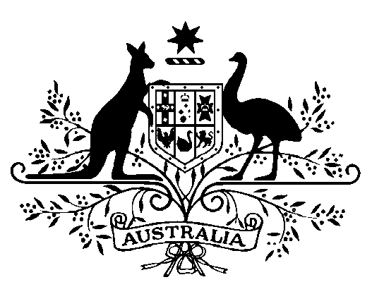

National Parks and Wildlife Conservation Act 1975

PROCLAMATION

I, WILLIAM PATRICK DEAN, Governor-General of the Commonwealth of Australia, acting with the advice of the Federal Executive Council, under subsection 7(2) of the National Parks and Wildlife Conservation Act 1975:

- declare the area specified in the Schedule to be a Park; and

- assign to the Park the name “Macquarie Island Marine Park”; and

- specify that the subsoil extending to a depth of 100 metres below the sea-bed within the declared area is within the Park.

Signed and sealed with the
Great Seal of Australia
on 20th October 1999

William Deane

Governor-General

By His Excellency’s Command

Robert Hill
Minister for the Environment and Heritage

Schedule

Macquarie Island Marine Park

All of that area within the Southern Ocean contained within and bounded as follows*:
- commencing at the point of Latitude 53°47’00’’ South and Longitude 159°05’00’’ East;
- then proceeding in an easterly direction along the parallel of latitude to its intersection with the outer edge of the EEZ** closest to Longitude 164°11’17’’ East;
- then in a generally southerly and westerly direction along the outer edge of the EEZ to the point closest to Latitude 58°26’56” South and Longitude 158°35’16’’ East;
- then in a generally northerly direction along the geodesic to the point on the seaward limit of Coastal Waters*** around Bishop and Clerk Islands closest to Latitude 55°07’20” South and Longitude 158°35’16” East;
- then anticlockwise around the seaward limit of Coastal Waters around Bishop and Clerk Islands to the point closest to Latitude 55°06’50” South and Longitude 158°35’21” East;
- then in a generally northerly direction along the geodesic to the point on the seaward limit of Coastal Waters around Macquarie Island closest to Latitude 54°45’03’’ South and Longitude 158°41’24’’ East;
- then anti-clockwise around the seaward limit of Coastal Waters around Macquarie Island to the point closest to Latitude 54°29’23’’ South and Longitude 158°46’29’’ East;
- then in a generally northerly direction along the geodesic to the point on the seaward limit of Coastal Waters around Judge and Clerk Island closest to Latitude 54°21’25’’ South and Longitude 158°54’22’’ East;
- then anti-clockwise around the seaward limit of Coastal Waters around Judge and Clerk Islands to the point closest to Latitude 54°21’29’’ South and Longitude 159°05’00’’ East; and
- then in a generally northerly direction along the geodesic to the point of commencement.
* All geographic coordinates are expressed in terms of the World Geodetic System 1984 (“WGS84”).
** The “EEZ” is the Exclusive Economic Zone declared in relation to Australia and its external territories under the Seas and Submerged Lands Act 1973 (proclamation dated 26 July 1994 published in the Commonwealth of Australia Gazette No. S290 on 29 July 1994). It commences at the outer limit of the territorial sea (12 nautical miles from the territorial sea baselines established under the Seas and Submerged Lands Act 1973) and extends generally to 200 nautical miles from the baselines. In relation to Macquarie Island it is in part less than 200 nautical miles to take account of the pending maritime delimitation with New Zealand. The outer limit of the EEZ may be varied as a result of an agreement with New Zealand on the maritime boundary. If the outer limit of the EEZ around Macquarie Island is varied for that reason the boundaries of the proposed Macquarie Island Marine Park may be varied accordingly.
*** Coastal waters” are defined in relation to each of the States and the Northern Territory by the Coastal Waters (State Powers) Act 1980 and Coastal Waters (Northern Territory Powers) Act 1980. They comprise: the territorial sea extending out to 3 nautical miles from the territorial sea baselines established under the Seas and Submerged Lands Act 1973; and the waters on the landward side of those baselines that are not within the States or the Northern Territory. Macquarie Island, Bishop and Clerk Islands and Judge and Clerk Islands are parts of the State of Tasmania.

