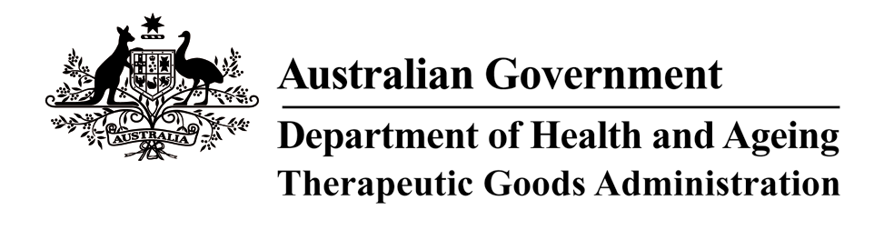

Therapeutic Goods Act 1989

THERAPEUTIC GOODS ORDER NO. 69A
Amendment to Therapeutic Goods Order No. 69 –
General requirements for labels for medicines

I, NGAIRE BRYAN, delegate of the Minister for Health and Ageing for the purposes of the exercise of the Minister’s powers under section 10 of the Therapeutic Goods Act 1989 and acting under that section, having consulted with the Therapeutic Goods Committee in accordance with subsection 10(4) of that Act, hereby AMEND Therapeutic Good Order
No. 69 General requirements for labels for medicines, made on 27 August 2001, in the manner set out below.

1. Immediately before clause 1 Application and exemptions, INSERT the following headings and text:

Introduction
The purpose of a medicine label is to provide information about the product such as its identity, potency, content, storage, expiry date, registration status and sponsor. Medicine labels also include other information not required by the Order, but which may be required by other legislative instruments or for commercial purposes. These include items such as signal headings (eg. Prescription only, pharmacist only), bar codes and sponsor’s logos.

For non-prescription medicines, the aim is that the information on the label is presented in such a way that consumers can:

- choose an appropriate medicine on their own;
- use the medicine safely and effectively;
- readily find the information they need, understand it and act on it appropriately; and
- access further information, if they want to know more about the medicine.

Although there may be various means of achieving the aim stated above, products with labels that have been designed in accordance with the industry code of practice entitled Labelling Code of Practice: Designing usable non-prescription medicine labels for consumers, published by the Communications Research Institute of Australia Inc. and accessible from the Therapeutic Goods Administration web site (http://www.tga.gov.au) should achieve this aim.

The mandatory aspects of the Order for all medicines are contained in clauses 1 – 7 inclusive and the Schedules to the Order. All medicine labels must comply with Clauses 1 – 7 and the Schedules to the Order, regardless of whether they have been designed in accordance with the industry Code of Practice.

- Under clause 2 ‘Interpretation’,

INSERT (in appropriate alphabetical order) the following new definition:

‘Required Advisory Statements for Medicine Labels’ means the document of that name, published by the Therapeutic Goods Administration on its web site (http://www.tga.gov.au), dated 1 July 2004.

DELETE the current definition of ‘warning statements’; and
REPLACE with the following new definition:

‘warning statements’ means:
(a) any labelling requirements specified in the Required Advisory Statements for Medicine Labels;
- any warning statements specified in the standard that applies to the
goods;
- a warning statement where incorrect route or method of
administration may be hazardous;
- any warning required by the Secretary, Department of Health and
Ageing to be included as a condition of registration/Listing in relation
to the goods;
- any warning statement specified in the Regulations that applies to
the goods;
- any warning statements specified in the Poisons Standard.

This Order takes effect on 1 July 2004.

Dated this 30 day of June 2004.

[signed]
Ngaire Bryan
Delegate of the Minister for Health and Ageing

