

MARINE ORDERS

Part 32

Cargo Handling Equipment

Issue 2

Order No 14 of 1997
Pursuant to Section 425(1AA) of the Navigation Act 1912, I hereby make this Order repealing Marine Orders, Part 32, Issue 1, and substituting the attached Marine Orders, Part 32, Issue 2, to come into operation on 1 February 1998.
P M McGrath
Chief Executive
22 December 1997

Table of Contents

1 Definitions
2 Purpose
3 Application
4 Exemptions & equivalents
5 Transitional
6 Review of decisions
7 Control
8 Penal provisions
9 Person in charge
10 Loading and unloading
11 Access to a ship or compartment
12 Marking of cargo mass
13 Powers and functions of surveyors
14 Safe working load
15 Testing, thorough examination, inspection and certification
16 Register of materials handling equipment and certificates of test
17 Maintenance and repairs
Appendix 1 Protective fencing
Appendix 2 Lighting
Appendix 3 Safe atmosphere
Appendix 4 Personnel cradle
Appendix 5 Test and thorough examination procedures (materials handling equipment)
Appendix 6 Safe use of materials handling equipment
Appendix 7 Cargo spaces
Appendix 8 Motors in cargo spaces
Appendix 9 Requirements for derricks
Appendix 10 Requirements for cranes
Appendix 11 Crane and derrick controls and brakes
Appendix 12 Operator's cabin and access
Appendix 13 Mechanical stowing appliances and other vehicles
Appendix l4 Requirements for patent handling systems
Appendix l5 Requirements for cargo gear
Appendix l6 Unitised cargo
Appendix 17 Ladders
Appendix 18 Signalling
Appendix 19 Marking of mass
Appendix 20 Australian standards: guide in determining SWL
Appendix 21 Actuating force: control equipment
Appendix 22 Approved splices in wire rope
Appendix 23 Forms

Previous issue
Part 32, Issue 1, Order No 12 of 1986
⎯Amendment, Order No. 5 of 1992

1 Definitions
1.1 In this Part, unless the contrary intention appears, the following definitions apply:
AMSA means the Australian Maritime Safety Authority;
bulk cargo means any material other than liquid or gas in any combination of particles, granules or other like fragmentation or aggregation which is loaded directly into a cargo space of a ship without any other form of containment;
bulk carrier means a ship designed and constructed for the carriage of bulk cargo;
cargo includes:
(a) ship's stores, provisions, equipment and fuel;
(b) mails;
(c) passengers' baggage;
(d) material for the repair of a ship or for the fitting of a cargo space or material and equipment used for securing cargo;
(e) mechanical stowing appliances and transport equipment when carried as cargo or being handled by means of cranes or derricks.
cargo gear means an article of equipment for use with a crane or derrick in loading or unloading cargo, that:
(a) is not riveted, welded or otherwise permanently attached to the crane or derrick or ; and
(b) is designed to be detachable from the crane or derrick,
and includes any wire rope, fibre rope, sling, net, clamp, grab, loose gear, magnetic lifting device, vacuum lifting device, patent cargo handling system or self unloading system but does not include transport equipment or packaging;
Note: Pallets are not subject to the testing and certification requirements of this Part. They should, however, be constructed to a recognised standard (see Appendix 20), be suitable for the load to be conveyed, be in good condition and, unless intended for once only use, be marked with the owner's name or insignia.
cargo space means a space in a ship intended for the carriage of cargo and includes any trunkway and hatchway to that space;
Chief Marine Surveyor means the Manager (Survey Operations) in AMSA, or, in respect of any particular purpose under this Part, a person authorised by the Manager (Survey Operations) for that purpose;
closed container means a container that totally encloses its contents by permanent structures;
Note: A container that has small ventilation openings may be accepted as a closed container if the openings are satisfactorily sealed against the ingress of sparks.
competent person means a person having practical and theoretical knowledge and relevant experience, sufficient to enable that person to detect and evaluate any defects and any weaknesses that may affect the intended performance of the equipment;
Note: Chief Officers, Chief Engineer Officers and Second Engineer Officers are considered to be competent persons in relation to the carrying out of thorough annual examinations, and other inspections, of unclassed cargo gear and lifting appliances.
container and container corner fittings have the same meaning as in Marine Orders, Part 44 (Safe Containers);
crane includes a derrick crane except where the context otherwise requires, but excludes a machinery space crane which is subject to the requirements of Appendix 4 of Marine Orders, Part 20 (Ship Machinery);
derrick crane means a derrick fitted with operating winches and two span tackles of such design that the derrick can be topped and slewed while hoisting a load;
derrick includes, unless the context otherwise requires, the supporting structure and positioning devices, such as mast, king post, sampson post, stay, lugs, goosenecks, eyebolts, topping lift, guys, preventers and winches;
fibre rope means a rope constructed of natural or synthetic fibre only and includes rope or flat-woven webbing constructed of natural or synthetic fibres;
hatchway means an aperture in a deck of a ship providing access to a cargo space for loading or unloading;
IBC means intermediate bulk container;
illumination means illumination in the horizontal plane at a height of one metre above a working surface;
inspection, in relation to materials handling equipment, for the purposes of 15 of this Part, means a careful visual examination including, if necessary, dismantling, to assess the condition of the assembly or article for any deformation, distortion, damage, wear, corrosion or any other defect impairing its operational reliability;
intermediate bulk container means a cargo receptacle:
(a) constructed of rigid, semi-rigid or flexible materials, or a combination of such materials;
(b) designed to be lifted by materials handling equipment, by means of either integral or detachable devices; and
(c) having a capacity, of not less than 0.25 cubic metres and not more than 3 cubic metres;
loading means conveying cargo from a location outside a ship to a location on board a ship, or transferring cargo between locations on board a ship, and includes associated operations such as lashing and securing of cargo and inserting clamps and pins in securing devices;
loose gear means an item of equipment by means of which a load may be attached to a crane or derrick, which does not form an integral part of the crane or derrick, and includes any block, shackle, hook, swivel, connecting plate, ring, chain block or hoist, chain or overhauling weight and the component parts of a pallet bar, lifting beam, lifting frame, spreader, tray, tub or other cargo receptacle other than an intermediate bulk container or transport equipment;
materials handling equipment means an article or an integrated assembly of articles designed to convey or for use in conveying cargo and includes cargo gear, a crane, derrick, cargo lift, side loading platform, mechanical loading appliance and mechanical stowing appliance;
mechanical stowing appliance means a wheeled or tracked machine or vehicle designed to convey or move cargo and includes any lift truck, straddle truck, side-loader, tractor, bulldozer, front-end loader, trailer and truck;
owner, in relation to shore equipment used in loading or unloading a ship, includes the person having possession of the equipment for the purpose of the loading or unloading operation;
pallet means a load-carrying platform having 2 interconnected decks separated to permit the entry of lifting equipment, such as fork arms, tines, bars or slings;
person in charge means a person appointed under 9 of this Part;
personnel cradle means a cradle, cage, box platform or similar appliance for use in conveying persons to work locations at or near the top of a container, barge or similar transport equipment or to cargo stowed on board a ship;
portable means capable of being lifted manually by one person or 2 persons in conjunction;
prescribed person means the surveyor in charge of the nearest AMSA survey office;
proof load, in relation to materials handling equipment, means the proof load for that equipment determined in accordance with this Part;
responsible person means a person who, in relation to materials handling equipment, is competent and qualified and:
(a) is responsible to:
(i) the manufacturer of that equipment;
(ii) a classification society in pursuance of a scheme of classification or certification of such equipment; or
(iii) a competent testing establishment,
for carrying out any testing and associated thorough examination and issuing certificates of test in respect of that equipment as required by this Part; or
(b) is responsible to:
(i) the owner or master of the ship, where that equipment is the ship's equipment; or
(ii) the owner, where that equipment is shore equipment; or
(iii) a classification society in pursuance of a scheme of classification or certification of such equipment,
for carrying out thorough examinations, other than those associated with testing, of that equipment required by this Part or for determining the safe working load of cargo gear that is not required to be permanently marked with a SWL;
Note: In respect of testing, thorough examination associated with testing, and certification of equipment, a responsible person should be a suitably qualified person who has been appointed or authorised by a classification society, or an organisation dedicated to the test and certification of materials handling equipment.
returnable cargo unit means a packaging, into which cargo is packed, intended to convey cargo from consignor to consignee and that:
(a) is designed to be handled as a single unit;
(b) is not a freight container or intermediate bulk container;
(c) is fitted with integral lifting attachments;
(d) is intended for return and subsequent re-use; and
(e) may or may not be collapsible;
runner means a wire rope used for hoisting or lowering a load;
safe working load means, in relation to an article of materials handling equipment, the load that a responsible person considers is the maximum load that may be imposed on that article in order to allow an adequate margin of safety in the normal operation of that article;
self unloading system means, in relation to the handling of bulk cargoes, an arrangement of devices and equipment on board a ship, designed so that unloading is effected without recourse to the use of grabs, tubs or similar items of loose gear in conjunction with cranes or derricks;
shipborne barge means an independent, non-self-propelled vessel, specifically designed and equipped to be lifted in a loaded condition and stowed on board a ship;
ship equipment means materials handling equipment carried or installed on board a ship;
shore crane means a crane that is shore equipment and includes any equipment operated or controlled from the cabin of that crane, being:
(a) permanently attached ancillary equipment; or
(b) detachable equipment designed for use with the crane;
shore equipment means materials handling equipment that is not ship equipment and includes a floating crane;
specialised handling system means a method of loading or unloading cargo that employs specialised materials handling equipment designed to dispense with manual handling of cargo by sling, tray, tub, pallet or similar cargo gear, and includes reclaiming devices, conveyor belts, and the handling of multiple units connected together by twistlocks, banding or strapping, or similar appliances, that have not been individually tested and marked in accordance with this Part;
SWL means safe working load;
testing establishment means an establishment equipped for the testing and examination of cargo gear;
thorough examination means a detailed visual examination in accordance with 15.2.10;
transport equipment means equipment of a permanent character that facilitates the transport of a combination or aggregation of cargo as a single unit and includes containers, intermediate bulk containers, returnable cargo units and shipborne barges, but does not include cargo gear;
tray means an article of materials handling equipment designed for repeated use in conveying cargo, that has attachments by which it may be hoisted or otherwise conveyed but does not include transport equipment or a pallet; and
unloading means to convey cargo located on board a ship to a location outside the ship, and includes associated operations such as unlashing of cargo and removing clamps and pins from securing devices.
1.2 In this Part, a reference to the date on which a ship was built means the date on which not less than 50 tonnes or one per cent of the proposed total mass of the structural material of the ship, whichever is the less, has been assembled.
1.3 In this Part:
(a) headings and sub-headings are part of the Part;
(b) each Appendix is part of the Part;
(c) a note included in the text and printed in italics is not part of the Part.

2 Purpose
This Part:
(a) for the purposes of paragraphs 425(1)(a), 283D(1)(b) and 283E(1)(b) of the Navigation Act, prescribes matters providing for and in relation to the inspection and testing of machinery and appliances for the loading and unloading of ships, off-shore industry vessels and off-shore industry mobile units;
(b) for the purposes of paragraphs 425(1)(b), 283D(1)(b) and 283E(1)(b) of the Navigation Act, prescribes matters providing for and in relation to the prevention of the use of defective machinery or appliances for the loading or unloading of ships, off-shore industry vessels and off-shore industry mobile units;
(c) for the purposes of paragraphs 425(1)(c), 283D(1)(b) and 283E(1)(b) of the Navigation Act, prescribes matters providing for and in relation to the protection of the health and the security from injury of persons engaged in the loading or unloading of ships, off-shore industry vessels and off-shore industry mobile units;
(d) for the purposes of paragraph 283E(1)(c)(xiii) of the Navigation Act, makes provision for or in relation to the transfer of persons and goods to or from off-shore industry mobile units, including the provision, maintenance and use of cranes and other lifting devices and equipment;
(e) gives effect, in whole or in part, to the following instruments of the International Labour Organisation:
(i) Convention No. 27, Marking of Weight (Packages Transported by Vessels), 1929;
(ii) Convention No. 152, Occupational Safety and Health (Dock Work), 1979;
(iii) Recommendation No.160, Occupational Safety and Health (Dock Work), 1979;
(iv) ILO Code of Practice: Safety and Health in Dock Work.

3 Application
This Part applies to and in relation to:
(a) the loading or unloading of any ship at a port in Australia or in an external territory of Australia;
(b) the loading or unloading at any port of a ship to which Part II of the Navigation Act applies; and
(b) the loading or unloading of an off-shore industry mobile unit.
Note 1: This Part regulates the use of materials handling equipment whether ship or shore equipment where that equipment is used for loading or unloading.
Note 2: By virtue of section 283K of the Navigation Act, the provisions of this Part do not have effect to the extent that they are inconsistent with a valid direction given under section 101 of the Petroleum (Submerged Lands) Act 1967

4 Exemptions and equivalents

4.1 Exemptions
4.1.1 The Chief Marine Surveyor may, upon written application and if satisfied that persons will not thereby be endangered, exempt a ship or class of ships from compliance with a provision of this Part to the extent specified and subject to such conditions as that officer thinks fit.
4.1.2 A prescribed person may, upon written application and if satisfied that persons will not thereby be endangered, allow any provision of this Part to be dispensed with for the purpose of a loading or unloading operation, to the extent specified and subject to such conditions as that officer thinks fit.

4.2 Equivalents
Where a provision of this Part requires a particular fitting, material, appliance or apparatus, or type thereof to be fitted or carried in a ship or a particular provision to be made in a ship, the Chief Marine Surveyor may allow any other fitting, material, appliance or apparatus, or type thereof, to be fitted or carried, or any other provision to be made, if that officer is satisfied that the other fitting, material, appliance or apparatus, or type thereof, or provision, is at least as effective as that required by that provision of this Part.

5 Transitional
5.1 A test or examination conducted for the purposes of and in accordance with Issue 1 of this Part, is to be taken to be a test, thorough examination or inspection, as appropriate, conducted in accordance with this Issue of this Part.
5.2 A certificate issued or recognised for the purposes of and in accordance with Issue 1 of this Part is to be taken to be a certificate issued pursuant to this Issue of this Part.

6 Review of Decisions
6.1 Reviewable decisions
Application may be made to the Administrative Appeals Tribunal for a review of a decision:
(a) by the Chief Marine Surveyor or a prescribed person, refusing, restricting or imposing a condition on an exemption or dispensation under 4.1;
(b) by the Chief Marine Surveyor, refusing to allow under 4.2 a particular fitting, material, appliance or apparatus, or type thereof, to be fitted or carried in a ship or a particular provision to be made in a ship;
(c) by a surveyor, prohibiting the use of equipment under 13.2.1;
(d) by a surveyor, requiring that a package, article of cargo or a mechanical stowing appliance be weighed under 13.3;
(e) by a surveyor, in relation to the nomination of a weighing instrument under 13.3;
(f) by a surveyor, prohibiting a loading or unloading operation under 13.4.1;
(g) by the Chief Marine Surveyor, refusing to approve a patent handling system under 1.4 of Appendix 14;
(h) by the Chief Marine Surveyor, refusing to accept an alternative method under 3.2 of Appendix 22.
6.2 Statements to accompany notices
If a person making a decision referred to in 6.1 gives to a person whose interests are affected by the decision notice in writing of the decision, the notice must:
(a) include a statement to the effect that, if the person is dissatisfied with the decision, application may, subject to the Administrative Appeals Tribunal Act 1975, be made to the Administrative Appeals Tribunal for review of the decision; and
(b) except where subsection 28 (4) of that Act applies, also include a statement to the effect that the person may request a statement under section 28 of that Act.
6.3 Validity of decisions
Failure to comply with 6.2 in relation to a decision does not affect the validity of that decision.

7 Control
7.1 A person must not knowingly:
(a) make a false certificate, false entry in a register or other false representation in relation to a matter to which this Part applies;
(b) mark an article of cargo, a package or an article of materials handling equipment with a false gross mass or a false maximum gross mass; or
(c) mark an article of materials handling equipment with a false safe working load.
7.2 A marking or representation is not considered to be false if the actual mass of the item in question is less than the declared mass or, if no mass is declared, the SWL or maximum gross mass marked on the item.

8 Penal provisions
8.1 The following provisions of this Part are penal provisions: 7, 9.1.2, 9.1.3, 9.1.6, 9.2.3, 10.1, 10.2, 10.3.1, 10.3.3, 10.3.4, 10.6.1, 10.6.2, 11.1, 11.2.1, 11.2.2, 11.3, 12, 13.1.1, 13.1.2, 13.2.2, 13.4.2, 14.1, 16.1.1, 16.1.2, 16.1.3, 16.2.3, 17.1, 17.2, 17.4, 17.5, 17.6.1 and 17.6.2.
8.2 Failure to comply with 12 constitutes an offence by the shipper of the article.
8.3 Failure to comply with 17.1, 17.6.1 or 17.6.2 constitutes an offence by:
(a) in the case of ship equipment⎯the owner, agent and master of the ship; and
(b) in the case of shore equipment⎯the owner of the equipment.
Note: Regulation 4 of the Navigation (Orders) Regulations provides:
'4. A person who contravenes a provision of an order made under subsection 425(1AA) of the Act that is expressed to be a penal provision is guilty of an offence and is punishable, upon conviction:⎯
(a) if the offender is a natural person—by a fine not exceeding $2,000; or
(b) if the offender is a body corporate—by a fine not exceeding $5,000.'

9 Person In Charge
9.1 Identifying the person in charge
9.1.1 A person, other than the master, undertaking to load or unload a ship at a port in Australia must, before commencement of that undertaking, appoint a person or persons in charge of the undertaking.
Note: Where the 'person' undertaking loading or unloading is a firm or company, that firm or company must make the appointment.
9.1.2 A person making an appointment under 9.1.1 must provide to the master of the ship written notification of the appointment or appointments.
9.1.3 A person in charge must enter in a logbook:
(a) the time at which he or she commences each period of duty as person in charge; and
(b) the time of termination of each such period of duty.
9.1.4 Notwithstanding 9.1.1 and 9.1.3 but subject to 9.1.7, a person who has commenced a period of duty in charge of loading or unloading of a ship is deemed to remain person in charge for the purposes of this Part:
(a) until that person has directed loading or unloading of the ship to cease and has made an entry to that effect in the logbook; or
(b) until another person appointed in accordance with 9.1.1 has commenced a period of duty as person in charge and has made an entry to that effect in the logbook.
9.1.5 Not more than one person at a time is to be person in charge.
9.1.6 A person must not be appointed as the person in charge unless that person is:
(a) well experienced in all aspects of the type of loading or unloading to be undertaken; and
(b) capable of directing all tasks relevant to the loading or unloading.
9.1.7 A person appointed in accordance with 9.1.1, being unable to direct the loading or unloading of a ship at any time during his or her period of duty, may appoint a person qualified in accordance with 9.1.6 to direct the loading or unloading during the period of that inability, and such qualified person is deemed to be the person in charge for that period for the purposes of this Part.
Note: Provisions 9.1.3 and 9.1.4 apply to a delegated person in charge.
9.1.8 Where cargo is being loaded or unloaded by crew of the ship, the master will for the purposes of this Part be deemed to be the appointed person in charge.
Note: Loading includes transfer of cargo within a ship.
9.2 Functions and duties of person in charge
9.2.1 It is the function of the person in charge to direct the tasks relevant to the loading or unloading of the ship and to ensure that they are carried out in a safe and orderly manner.
9.2.2 It is the duty of the person in charge to take all reasonable steps necessary to discharge his or her function, and in particular to ensure as far as practicable that:
(a) all operations are performed in compliance with this Part;
(b) the materials handling equipment of the ship has been tested, thoroughly examined and inspected as required by this Part;
(c) persons are not engaged in loading or unloading unless they have been given adequate instruction and training concerning the risks involved and precautions to be taken;
(d) all persons are reasonably protected against accidental injury arising from the loading or unloading of the ship, and from movement of unsecured cargo or other objects on the ship;
(e) persons not engaged in the loading or unloading of the ship or having any other proper function in connection with the loading or unloading, do not remain:
(i) in the vicinity of cargo-handling operations; or
(ii) on any deck where roll-on/roll-off loading or unloading is taking place,
unless such person has the permission of the master or a person authorised by the master to give such permission; and
(f) if a workplace becomes unsafe or there is a risk of injury to health, effective measures are taken to protect the workers until the place has been made safe again.
Note: Effective measures may include fencing, flagging defective machinery, tagging switches or valves not to be used, cessation of work.
9.2.3 If, in connection with the loading or unloading of a ship:
(a) a person receives an injury requiring referral to a hospital; or
(b) a component of materials handling equipment fails in operation, whether or not any person is thereby injured,
the person in charge must notify a surveyor at the nearest AMSA survey office within four hours after the incident by the most expeditious means available and must make a written report to the surveyor within 72 hours of the occurrence in accordance with Form MO-32/5 in Appendix 23.
Note: Compliance with 9.2.3 does not require use of Form MO-32/5 provided the information specified by that form is included in the report.

10 Loading and Unloading
10.1 Person in charge to direct loading and unloading
A person must not, to any extent, load or unload a ship unless that person does so under the direction of the person in charge.
10.2 Loading and unloading to comply with this Part
A person must not:
(a) to any extent, load or unload a ship;
(b) use or operate any materials handling equipment in connection with the loading or unloading of a ship;
(c) direct or purport to authorise any other person to load or unload a ship to any extent, or operate materials handling equipment in connection with the loading or unloading of a ship; or
(d) use or direct or purport to authorise any other person to use in connection with the loading or unloading of a ship, except in the event of an emergency, any means of passage or access,
otherwise than in compliance with or as provided by this Part.
10.3 Use of equipment
10.3.1 Subject to 10.3.2, a person who:
(a) is under 18 years of age; or
(b) does not possess the necessary aptitudes and experience,
must not:
(c) operate any mechanical stowing appliance, crane or winch; or
(d) give directional signals to a driver of a crane, winch or other mechanical stowing appliance; or
(e) have responsibility for attending to cargo falls on winch ends or winch drums; or
(f) perform tasks involving hoisting, lowering or otherwise adjusting derrick gear or other materials handling equipment.
10.3.2 Provision 10.3.1 does not apply to:
(a) a member of the crew of the ship being loaded or unloaded; or
(b) a person under training while properly supervised.
10.3.3 A person must not operate power operated hatch covers unless that person is:
(a) a member of the crew of the ship being loaded or unloaded; or
(b) a person authorised to do so by the officer in charge of the loading or unloading operation.
10.3.4 A person, other than a member of the crew of the ship, must not operate ship's side, bow or stern doors, 'tween deck bulkhead doors, ramps, retractable car decks or similar ship equipment unless that person has been specifically authorised by the Master of the ship to do so.
10.4 Protective clothing
A person must not load or unload a ship unless that person wears protective clothing and other protective equipment appropriate for the loading or unloading operation, for the duration of the operation.
Note: It is the responsibilities of employers to define the protective clothing to be worn in any particular circumstances.
10.5 Operations to or from a barge or lighter
Cargo must not be loaded into a ship from a manned barge or lighter, or unloaded from a ship into a manned barge or lighter, unless there is provided on the barge or lighter, at least one lifebuoy with at least 30 metres of buoyant line attached.
10.6 Removal of equipment
10.6.1 A person must not, during the loading or unloading of a ship, remove or otherwise interfere with any fencing, safety device, gangway, means of access, ladder, lighting, hatchway cover, materials handling equipment, stage, mark, life-saving appliance or other article or fitting provided in connection with loading or unloading for the purpose of compliance with this Part, except:
(a) in the event of an emergency; or
(b) as directed by the master or an officer of the ship, or by the person in charge.
10.6.2 Any item referred to in 10.6.1 removed as permitted by that provision, must be replaced as soon as there is no longer any reason for its removal, by the person effecting or directing the removal, as appropriate.
Note: It is a fundamental responsibility of every person engaged in loading or unloading a ship to do so with proper regard for their own safety and that of other persons. The fact that a person in charge is directing the operation or that the provisions of this Part are being correctly applied does not relieve a person of that fundamental responsibility.
10.7 Reporting of risks
If persons engaged in the loading or unloading of a ship have reason to believe that a risk exists and those persons are unable reasonably to remove the risk themselves, the situation must be reported to the person in charge as soon as practicable.

11 Access to a ship or compartment
11.1 Means of passage
A person passing to or from a ship during loading or unloading of the ship, if that person is on foot, must not use a means other than a means of access complying with Marine Orders, Part 23 (Equipment—Miscellaneous and Safety Measures).
11.2 Safe atmosphere
11.2.1 Appropriate and reasonable precautions must be taken by the owner or master of a ship to prevent access by persons to a space that has an unsafe atmosphere.
11.2.2 Appropriate and reasonable precautions must be taken by the owner or master of a ship to prevent access by persons to a space that has been fumigated until the atmosphere in that space has been determined to be safe.
Note 1: A licensed fumigator (a person licensed under relevant State or Territory laws to fumigate enclosed spaces using substances hazardous to human life), an appropriately qualified chemist or a person who has successfully completed an appropriate training course could make the required determination.
Note 2: Where the safety of the atmosphere may be reduced as a result of cargo operations, such as in a ro-ro vehicle deck, the master should ensure that ventilation machinery is operating so as to provide at least the minimum required number of changes of air in the space.
11.3 Obstructions
The owner or master of a ship must ensure that any part of the ship's structure that could be an obstruction to vehicular traffic, such as stanchions and pillars, is made conspicuous by markings of sharply contrasting colours and, if necessary, adequately lit.

12 Marking of cargo mass
12.1 An article of cargo, a package, a container, a portable tank, an intermediate bulk container, a returnable cargo unit or other unitised articles of cargo of one tonne gross mass or more, to be loaded on a ship at a port in Australia, must be marked with its gross mass in accordance with Appendix 19 by the shipper of that article, package or unitised cargo.
12.2 If the actual gross mass is not marked on an article of transport equipment, it is deemed that the shipper has declared that the actual gross mass is equal to the maximum gross mass or, in the case of a flexible intermediate bulk container, the SWL marked on the item.

13 Powers and functions of surveyors
13.1 Inspection
13.1.1 The master of a ship or the owner of shore equipment, as appropriate must permit a surveyor to inspect materials handling equipment to which this Part applies, at any reasonable time.
13.1.2 The master of a ship or the owner of shore equipment must, at the request of a surveyor, produce for inspection the register of materials handling equipment and any certificate issued by a responsible person in accordance with this Part in respect of that equipment.
13.2 Defect notice
13.2.1 If a surveyor is satisfied that materials handling equipment is defective, he must give written notice of the defect to the master or the owner of shore equipment as appropriate, and to the person in charge, and may prohibit the use of such equipment for loading or unloading a ship.
Note: Material handling equipment is defective if, inter alia, it has not been tested, thoroughly examined, or inspected as required by this Part.
13.2.2 Materials handling equipment prohibited from use under 13.2.1 must not be used for loading or unloading until:
(a) the defect specified in the notice has been rectified; and
(b) the prohibition has been withdrawn by a surveyor.
13.3 Weighing of cargo or appliance
A surveyor may, for any purpose of this Part, require the weighing of a package, an article of cargo or a mechanical stowing appliance and may for that purpose nominate the weighing instrument.
13.4 Unsafe arrangements
13.4.1 If a surveyor considers that a loading or unloading operation is or will be unsafe, whether or not the other provisions of this Part are complied with, he or she may give written direction to the person in charge and, if appropriate, to the master of the ship, prohibiting the loading or unloading operation.
13.4.2 If a direction in accordance with 13.4.1 is given, loading or unloading must not take place until the surveyor is satisfied that the operation is safe and the direction is withdrawn.
Note: The giving or withdrawal of a prohibition notice does not affect action that may be taken in respect of an Australian ship under the Occupational Health and Safety (Maritime Industry) Act 1993.

14 Safe working load
14.1 Drawings
The owner of a ship on which a crane or derrick is installed for use in loading or unloading the ship must keep on board the ship at all times a drawing or drawings in accordance with Appendixes 9 and 10 of all cranes and derricks so installed.
14.2 Determination and marking
An article of materials handling equipment must not be used in loading or unloading a ship unless a responsible person, having regard to the design, strength, material of construction and proposed use of the article, has:
(a) determined the safe working load of the article; and
(b) marked the safe working load and associated information on the article, in accordance with this Part.
14.3 SWL standards
In determining the safe working load of an article of materials handling equipment, the responsible person is to be guided by:
(a) the relevant Australian Standard specified in Appendix 20 of this Part; or
(b) an appropriate national standard established by a signatory member body of the International Organization for Standardization (ISO) or, in the case of electrical equipment, an affiliate body of the International Electrotechnical Commission (IEC).
14.4 Maximum load
An article of materials handling equipment must not be used to handle a load exceeding the safe working load of that equipment, for the purpose of loading or unloading a ship, except in accordance with Appendix 6.
Note: The mass of any loose gear, spreader, equalising beam and such like attachments is to be taken into account in calculating the load on derricks or cranes.

15 Testing, thorough examination, inspection and certification
15.1 General
15.1.1 Every item of materials handling equipment, and every sling or lifting device forming an integral part of a load, must be of good design and construction, of adequate strength for the purpose to which it is used and, if appropriate, properly installed.
15.1.2 Except as otherwise provided by this Part, materials handling equipment must not be used for loading or unloading unless:
(a) it has been tested, thoroughly examined, certificated and inspected, in accordance with this Part;
(b) the current record of examination and inspection in the appropriate register of material handling equipment indicates that the equipment is fit for use; and
(c) it appears in all respects to be fit for such use.
15.1.3 If materials handling equipment tested and examined in accordance with this Part is considered satisfactory by the responsible person, he or she is to issue the appropriate certificate specified in Appendix 23.
15.1.4 If materials handling equipment inspected in accordance with this Part is considered satisfactory by the competent person, he or she is to record the inspection in the appropriate register of materials handling equipment.
15.2 Items other than wire and fibre ropes, nets and slings
15.2.1 Materials handling equipment for use in loading or unloading a ship must be tested and thoroughly examined by a responsible person in accordance with Appendix 5 of this Part:
(a) before being put into use for the first time; and
(b) following renewal or repair of any stress bearing part, except when the renewal is pursuant to a routine maintenance schedule.
15.2.2 In addition to the requirements of 15.2.1, and subject to 15.2.6, 15.2.7, 15.2.8 and 15.2.9, materials handling equipment for use in loading or unloading a ship must subsequently:
(a) be tested and thoroughly examined in accordance with Appendix 5 of this Part by a responsible person at intervals not exceeding five years; and
(b) be thoroughly examined at intervals not exceeding twelve months by:
(i) in the case of equipment under survey with a classification society⎯a responsible person; and
(ii) in any other case⎯a competent person.
Note: Items of equipment permanently attached to lifting gear, including lower cargo blocks, ponder balls and cargo hooks dedicated to use with a specific crane or derrick, and forming part of the assembly are not considered loose gear and need not be separately tested at the five yearly testing of the crane, derrick or cargo lift to which they are attached.
15.2.3 In addition to the initial and quinquennial test and thorough examination, and annual thorough examination, an inspection of materials handling equipment must be made by a competent person at intervals not exceeding 6 months.
15.2.4 In relation to ship equipment, a test and thorough examination required by 15.2.2(a) may be postponed, for a period of not more than six months, if the postponement will enable the test and examination to be carried out concurrently with a scheduled survey of the ship, provided that a responsible person certifies in writing that, in his or her opinion, the equipment may be safely operated during the period of postponement.
15.2.5 If the design of specialised materials handling equipment or heavy lift equipment is such that, in the opinion of a responsible person, the equipment cannot reasonably be tested or retested in the manner specified in Appendix 5, or the equipment would require unnecessary dismantling, the periodic test and thorough examinations required by 15.3 may be dispensed with, provided that:
(a) the manufacturer's equipment specification, schedule of examination and maintenance manual are available to the responsible person;
(b) examination and maintenance procedures have been carried out in compliance with the manual and recorded in the appropriate register of materials handling equipment by a competent person; and
(c) the equipment is fit for use.
15.2.6 Provisions 15.2.1 and 15.2.2 do not apply to an intermediate bulk container or a returnable cargo unit having permanently attached fittings for handling, provided that:
(a) its design and construction conforms to a container or unit that has been type tested in accordance with the appropriate provisions of Appendix 5, or an equivalent national or international standard;
(b) the container or unit is permanently marked with evidence of compliance with that standard or is otherwise certificated and the certificate of type test indicating fitness for use, is available to the person in charge; and
(c) the container or unit has been properly maintained by a competent person and is fit for use.
Note: IBCs and returnable cargo units used for the transport of dangerous goods are required to comply with a more stringent test procedure than those intended for non-dangerous goods and may require secondary protection such as carriage in a freight container. IBCs for dangerous goods must be marked in accordance with the International Maritime Dangerous Goods Code.
15.2.7 Provisions 15.2.1 and 15.2.2 do not apply to a mechanical stowing appliance:
(a) being shore equipment; or
(b) being ship equipment for use solely in or on the ship, provided the appliance complies with Provision 3 of Appendix 13.
15.2.8 Provisions 15.2.1 and 15.2.2 do not apply to a specialised cargo handling system:
(a) being:
(i) shore equipment; or
(ii) ship equipment for use solely in or on the ship and there is on board details of the manner by which the safe working load has been established, a description of the method by which cargo should be handled and details of any limitations on the use of the equipment or any of its component parts; and
(b) if the system includes items of loose gear, they have been inspected by a competent person as required by Provision 15.2.3.
15.2.9 Provision 15.2.2(a) does not apply to loose gear and other cargo gear except where specific provision is made in 15.2.6, 15.2.7 or 15.2.8.
15.2.10 A person carrying out a thorough examination must make a detailed visual examination of all separable and non-separable components and, in the case of wire ropes, of the internal and external parts of the rope. The extent of the opening up necessary to determine the condition of the separable components such as blocks, shackles, swivels, derrick boom heel or socket, gooseneck, sheaves, bearings and braking arrangements, is to be such as is considered necessary by the person carrying out the examination. In the case of cranes and derricks, the thorough examination must include deck eyes, derrick head bands or fittings, temporary or permanent stays, mast bands or eyes, cleats, spans and ropes, jib, pillar, slewing ring and other gearing mechanisms. The thorough examination is to assess the condition of the assembly or article for any deformation, distortion, damage, wear, corrosion or any other defect impairing its operational reliability, which is to be supplemented, when deemed necessary by the person conducting the thorough examination, by other means to assess the condition and operational reliability of the integrated assembly or article including hammer testing, ultrasonic or magnetic particle testing or other appropriate non-destructive testing method.
15.3 Wire ropes
15.3.1 An inspection of wire ropes must be made by a competent person at intervals not exceeding:
(a) for a wire rope which does not pass over a sheave or a winding drum⎯12 months;
(b) for a wire rope which passes over a sheave or winding drum⎯6 months.
15.3.2 A wire rope may only be used if:
(a) a responsible person has issued a certificate in respect of the rope in accordance with Form MO-32/4 in Appendix 23;
(b) a competent person has inspected the rope, externally and, as far as practical, internally, in the period required by 15.3.1(a) or (b) immediately preceding the proposed use and found that the rope is not worn, corroded or otherwise defective to a degree that renders it unfit for the proposed use;
(c) the rope is free from knots and kinks;
(d) the rope complies with the structural requirements specified in Appendix 15; and
(e) evidence, based on prototype testing, that any terminal or end fitting on the rope complies with Appendix 5 is recorded in the appropriate register of materials handling equipment.
15.3.3 If a constituent wire in a rope is broken, the following requirements apply:
(a) the rope must be inspected by a competent person within one month prior to its intended use, to determine if the rope is fit for use;
(b) the competent person must record the result of the inspection in the appropriate materials handling register; and
(c) the rope must not be used unless the competent person has determined that the rope continues to be fit for use.
15.3.4 A wire rope must not be used if the total number of broken wires visible in a length of the rope equal to ten times its diameter exceeds 5% of the number of wires constituting the rope.
15.4 Fibre ropes
Provisions 15.1.2(a) and (b) do not apply to fibre rope.
15.5 Nets and Slings
15.5.1 Provisions 15.1.2(a) and (b) do not apply to nets and slings manufactured in accordance with Appendix 15.
15.5.2 It is the responsibility of the shipper to ensure that, where slings are fitted to cargo ashore for the purpose of pre-slinging the cargo, the slings are in a fit state for use.
15.5.3 Expendable or disposable slings must not be reused and must be marked as such.

16 Register of materials handling equipment and
certificates of test
16.1 Register requirements
16.1.1 The master of a ship must keep on the ship a register of those items of materials handling equipment that form part of the equipment of the ship.
16.1.2 The owner of each item of shore-based materials handling equipment must keep a register of such equipment at the place where it is normally stored.
16.1.3 Particulars of all tests, thorough examinations, inspections, heat treatment and any maintenance, repair or replacement of materials handling equipment to which this Part applies, must be recorded in the register of materials handling equipment by the responsible person or competent person supervising or carrying out the work.
16.1.4 A register of materials handling equipment may be kept in any convenient form, provided each entry is clearly legible and is authenticated by the responsible person.
Note: Suitable registers are available for this purpose from AMSA survey offices.
16.1.5 Unless the equipment is under survey and inspection pursuant to a scheme of classification and certification by a classification society, there must be on board evidence that a terminal connection fitted to a wire rope used for hoisting a load on a crane or derrick is of a design on which prototype tests have shown that the strength of the terminal and its attachment to the rope is not less than 95% of the breaking load of the rope for a rope up to and including 50mm in diameter or 90% of the breaking load of the rope for a rope exceeding 50mm in diameter.
16.2 Certificate requirements
16.2.1 A certificate of test of materials handling equipment manufactured in Australia must be in accordance with the appropriate form for that equipment, as specified in Appendix 23.
16.2.2 A certificate of test in respect of materials handling equipment manufactured in a country other than Australia and tested or thoroughly examined in a country other than Australia by a responsible person, will be acceptable as a certificate of test for the purposes of this Part provided that the certificate contains information substantially equivalent to that required by 16.2.1.
16.2.3 All certificates of test and other relevant certificates, that are:
(a) current in respect of equipment to which this Part applies; and
(b) required by this Part to be kept, made available or furnished to a person,
must be kept with, or near at hand to, the register of materials handling equipment.
16.2.4 A requirement of this Part to keep, make available or furnish a certificate of test in respect of materials handling equipment type-tested in accordance with this Part or being manufactured outside the State or Territory in which the equipment is used may be complied with by keeping, making available or furnishing a certified copy of the prescribed certificate.
16.2.5 A requirement of this Part to keep or furnish a certificate of test in respect of wire rope or chain, where such equipment is a portion only of a greater manufactured length, may be complied with by keeping or furnishing a certified copy of the prescribed certificate issued by or for the manufacturer of that equipment.

17 Maintenance and repairs
17.1 General
Materials handling equipment, mechanical ventilation equipment, lighting and other equipment used in loading and unloading, must at all times be:
(a) properly maintained; and
(b) used only for its intended purpose.
17.2 Ship machinery
Whenever ship machinery is supplying power to materials handling equipment or other equipment being used in or in relation to loading or unloading, the master must ensure that a qualified person experienced in the operation and maintenance of the ship machinery is present on the ship.
17.3 Safety arrangements
17.3.1 If maintenance or repair work is carried out during loading or unloading, the person in charge must ensure that all persons are reasonably protected against accidental injury arising from the maintenance or repair work.
17.3.2 For the purpose of 17.3.1, the person in charge must assess the danger in the maintenance or repair work and must take into account the presence or likely presence of noxious gases, fumes, dust, radiation, excessive noise or other nuisance that could obstruct, interfere with or distract a person engaged in the loading or unloading.
17.4 Repairs to be competent
A person must not carry out repair work on materials handling equipment unless that person is:
(a) competent in the repair of that type of equipment; and
(b) equipped to perform that repair.
17.5 Heat treatment
A chain, ring, hook, shackle, swivel, connecting plate or overhauling weight that is subject to stress must not be used in loading or unloading after repair unless it has, if necessary, been subjected under the supervision of a responsible person to a process of heat treatment appropriate to its design and material to restore the mechanical properties of the material or to relieve any stress.
17.6 Verification
17.6.1 Repaired materials handling equipment must be tested or thoroughly examined in accordance with 15 before being put to use, unless the repair is:
(a) the normal periodic replacement of an individual component by a component having the same technical specification; or
(b) a minor repair to a non load bearing component.
17.6.2 Repaired materials handling equipment must not be put to use, until:
(a) the equipment is certified safe to use, in accordance with 15; or
(b) in the case of a repair referred to in 17.6.1, the repair is recorded in the register of materials handling equipment.
* * * * * *

Appendix 1
Protective fencing

1 Upper decks
1.1 Loading or unloading must not be carried out unless all upper decks to which persons have access for the purpose of loading or unloading are securely fenced on each outer edge with a bulwark or guardrails to a height of at least one metre above the deck and are so designed, constructed and placed as to prevent a person from accidentally falling overboard.
1.2 Bulwarks or guardrails for the purpose of 1.1 must be continuous except that sections may be removed for the purpose of a loading or unloading operation to the minimum extent necessary for that purpose.
1.3 An open hatchway on the uppermost deck must, unless entirely surrounded by coamings to a height of 750 mm, be securely fenced on all sides in accordance with 5, except that:
(a) an intermediate rail is not required where the hatch coaming is between 400 mm and 750 mm in height; and
(b) fencing is not required for the side of a hatchway where suitable fencing is fitted between the hatchway corners and the side of the ship.
1.4 Except as specified elsewhere in this Part, access to a cargo working area on a ship, including hold accesses, crane or winch operating positions, hatchman's position or any other location required to be occupied by persons engaged in loading or unloading, must afford a minimum passageway width of 550 mm.

2 Deck cargo
Where cargo other than transport equipment is stowed on the upper decks of a ship, loading or unloading must not be carried out, unless:
(a) if the cargo is stowed adjacent to a bulwark, guardrail or hatch coaming in a position where any person requires access for the purpose of loading or unloading, and the bulwark, rail or hatch coaming is not of sufficient height to prevent such person from falling overboard or into an open hold, temporary fencing of adequate height and strength is provided; and
(b) safe access is provided to any winch, crane, hatchman's position or any other location required to be occupied by persons engaged in loading or unloading, such access:
(i) having a surface as level and compact as is practicable;
(ii) being provided with appropriate steps or ladders at changes of level; and
(iii) being guarded as necessary by temporary fencing.

3 Cargo spaces
3.1 Except for the loading or unloading of transport equipment, loading or unloading must not be carried out in a cargo space where there is a risk of a person falling a distance of 2 metres or more, unless netting, or fencing in accordance with 5, is installed to prevent a person falling.
3.2 Loading or unloading must not be carried out using a mechanical stowing appliance in any cargo space where an unprotected opening exists into which the appliance could fall.

4 Machinery moving parts
4.1 Moving parts of machinery, steam pipes and live electrical conductors in and adjacent to areas on a ship where loading or unloading is being carried out must be so guarded, fenced or otherwise enclosed as to prevent accidental access, except where such part, pipe or conductor, by virtue of its position or construction, presents no risk of injury to a person or damage to property.
4.2 Removal of guards around machinery, including parts of mechanical stowing appliances, mechanised hatch covers or other power operated equipment, steam pipes, electrical conductors or the like must only be done by a person authorised by the master, and only after that person has advised the person in charge of such intended action.
4.3 Where such guards are removed, adequate precautions must be taken by the person removing the guard to ensure the safety of persons in the vicinity. The person in charge must not require or permit unauthorised persons under his or her control to approach the area where the guard has been removed until advised by a person authorised by the master that it is safe to do so.
4.4 Where a safety device is removed or rendered inoperative, measures must be
taken by the person removing the device or rendering it inoperative to ensure that the relevant equipment cannot be used, except as required by this Part, or inadvertently started, until the device has been replaced or its operation restored.

5 Fencing
Temporary fencing, for the purposes of this Appendix, must:
(a) comprise at least 2 parallel rails, ropes or chains, the top rail, rope or chain being at a height of at least one metre above and substantially parallel to the walking surface, and the intermediate rail, rope or chain being about midway between the top rail, rope or chain and the walking surface;
(b) if constructed of rope or chain, be provided with means for keeping the rope or chain as taut as is practicable;
(c) be continuous except that a section may be removable for the purpose of loading or unloading to the minimum extent necessary for that purpose; and
(d) where enclosing a hatchway, be supported by metal stanchions spaced not more that 2 metres apart, which, if fitted into sockets in the deck, must be equipped with a securing device ensuring that each stanchion remains in position.
* * * * * *

Appendix 2
Lighting
Loading or unloading must not be carried out unless:
(a) all places on board or adjacent to the ship in loading or unloading work areas have an illumination of at least 20 lux;
(b) the illumination of ladders that provide access to the ship, accommodation ladders and gangways is at least 20 lux;
(c) the illumination of other areas and spaces, including cargo hold access spaces, that provide access to places at which loading or unloading is carried out is at least 8 lux;
(d) the level of light in adjacent areas is reasonably uniform;
(e) any artificial lighting employed does not endanger the health or safety of persons engaged in loading or unloading, or the safety of the ship or of the cargo; and
(f) any artificial lighting employed is so arranged that glare and dazzle is minimised and the formation of heavy shadow that may conceal a danger in cargo handling or access is prevented.
Note: For practical assessment purposes a level of 8 lux may be approximated as equivalent to the illumination of a surface in bright moonlight and a level of 20 lux may be approximated as equivalent to the illumination necessary for a lightly used corridor or passageway as specified by Australian Standard AS 1680.
* * * * * *

Appendix 3
Safe Atmosphere
Loading or unloading must not be carried out in a cargo space in which the atmosphere is liable to be contaminated by harmful concentrations of dust or toxic gas, or in which there is liable to be an oxygen deficiency, unless adequate precautions have been taken to protect persons engaged in the loading or unloading, including, where necessary, the provision and use of suitable respiratory equipment and protective clothing.
Note 1: If any space in a ship is to be entered for the purposes of loading or unloading that space should have been adequately ventilated prior to entry being permitted. Where any doubt exists as to an acceptable level of hazard, the advice of a competent chemist should be obtained and the space should be tested for oxygen deficiency and levels of toxic and other airborne contaminants, which should be measured against the currently accepted exposure standards for those contaminants specified in the table of exposure standards in "Exposure Standards for Atmospheric Contaminants in the Occupational Environment: Guidance Note and National Exposure Standard" (NOHSC:3008(1995)). It should be noted that for certain contaminants, such as benzene and asbestos, any positive level of contamination is unacceptable.
Note 2: To ensure that an acceptable level of risk is maintained, it may be necessary to test the atmosphere at periodic intervals.
Note 3: A dry cargo hold is not a confined space for the purposes of Australian Standard AS 2865 (Clause 6.2D). However, this standard may be applicable to other spaces in which persons are required to work for the purposes of loading and unloading.
Note 4: Additional precautions to be taken where a mechanical stowing appliance is used in an enclosed space are prescribed in Appendix 13.
* * * * * *

Appendix 4
Personnel Cradle

1 Construction
1.1 A personnel cradle must not be used for the carriage of a person in loading or unloading a ship, unless it:
(a) is enclosed on all sides to a height of not less than one metre above the surface of the interior floor by fencing and a gate or gates;
(b) has a least 2 gates separated as widely as practicable from each other, except that a cradle designed to be handled by a crane of a type referred to in 2(b) need have one gate only;
(c) is attached to a fall, or lifting frame at four points, by shackles, safety hooks, or twist locks with a secondary means of attachment, in a manner that will prevent accidental disconnection; and
(d) has handholds inside the cradle fencing;
(e) is permanently marked, on each side, with its designed gross operating mass.
1.2 For the purposes of this Appendix, fencing must be of sheeting material or wire netting attached to stanchions and rails. The floor must be of solid construction of sheeting material or close fitting timber. The fencing and floor must provide sufficient strength to support twice the total mass of persons and equipment the cradle is designed to accommodate.
1.3 For the purpose of this Appendix, a gate must be so designed and fitted as to:
(a) provide safe passage to and from the personnel cradle;
(b) be capable of being securely closed, in a manner that maintains the continuity of strength of the stanchions and rails referred to in 1.2;
(c) open only inwards; and
(d) be capable of being locked shut to prevent accidental opening.

2 Suitable crane
A personnel cradle containing a person may be hoisted or lowered only by means of:
(a) a gantry crane using mechanically-operated locks, pins or similar devices controlled from the operator's cabin, provided the attitude taken up by the personnel cradle, on lifting, is such that the angle between the horizontal plane and the plane of the floor of the personnel cradle does not exceed 5° for any condition of loading; or
(b) any other crane complying with the other requirements of this Part, provided:
(i) that hoisting, lowering, luffing and slewing of the crane is under the control of a competent crane driver at all times and a safe speed is maintained during each of these operations;
(ii) that the crane is fitted with motion-limiting devices, that automatically interrupt operating power and hold the crane and its load stationary in the event of failure of operating controls for hoisting, lowering, luffing or slewing;
(iii) that the crane is fitted with a clearly identified emergency stop control, situated in a readily accessible position which, when activated, interrupts the operating power so that the hoisting, lowering, luffing and slewing machinery is held stationary; and
(iv) that, unless the crane has been in use for loading or unloading immediately prior to hoisting a personnel cradle, it is demonstrated to be safe for the purpose by hoisting a load at least equal to twice the designed gross operating mass of the cradle.
Note 1: 'Immediately prior' may be regarded as allowing short breaks in the work such as may be occasioned by meal breaks.
Note 2: See also 7 of Appendix 6.

3 Procedure
The following requirements apply to the hoisting or lowering of a personnel cradle by a crane referred to in 2(b):
(a) each person in the cradle must be provided with a suitable safety harness and safety lines;
(b) if necessary, means must be provided to restrain the cradle from spinning or swinging whilst suspended;
(c) there must be direct visual communication between the crane driver and personnel in the cradle or other equally effective means of communication;
(d) where the operating machinery has more than one gear setting, the lowest speed gear must be engaged;
(e) the crane must be so operated that:
(i) steady motion is achieved; and
(ii) the cradle floor is maintained in a substantially horizontal plane;
(f) unless the crane is fitted with an effective 'dead man' control system that automatically stops crane operation in the event of the crane driver becoming incapacitated, a second driver must be stationed in or near the driving control cabin ready to take over the controls in an emergency; and
(g) a competent person must remain at the crane controls at all times whilst the cradle is suspended or occupied by a person or persons.
* * * * * *

Appendix 5
Test and thorough examination procedures
(materials handling equipment)

1 Cranes and derricks
1.1 Proof load
1.1.1 Where a crane or derrick is tested, the proof load must not be less than the applicable load specified in Table 1, except that where a hydraulic crane is tested in accordance with 15.2.1(b) or 15.2.2(a) of this Part, and it is not practical for the crane to raise the full test load, a reduced test load may be accepted but in no case is this to be less than the SWL x 1.1.
Table 1
SWL of derrick gear or crane  (tonnes) | Proof load
Not more than 20 | SWL x 1.25
More than 20 but not more than 50 | SWL + 5 tonnes
More than 50 | SWL x 1.1
1.1.2 Where derricks in union purchase are tested, the proof load specified in Table 1 must be based on the SWL of the derricks when rigged in union purchase, as stated on the drawing or drawings specified by Appendix 9.
1.1.3 For the purpose of a test of a crane or derrick, the load imposed on any accessory block, topping lift, shackle, preventer, guy or other accessory part must not exceed the SWL of that part by more than the proportion by which the proof load exceeds the SWL of the crane or derrick
1.2 Application of proof load
1.2.1 The proof load for a test of a crane (including a derrick crane), derricks in union purchase, and the initial test of a derrick, must be applied by hoisting movable weights.
1.2.2 The proof load for a test of a derrick or derrick crane, following renewal of a part or repair, must be applied by hoisting movable weights, or by means of a spring or hydraulic balance or similar appliance.
1.2.3 The proof load must be applied:
(a) with the derrick boom or crane jib at its minimum working angle, measured from the horizontal plane. The minimum working angle (or load radius in the case of a crane or derrick crane) must be stated in the certificate of test; or
(b) in the case of a variable length jib crane, with the jib at its maximum and minimum, and at a length approximately midway between maximum and minimum. The maximum and minimum operating lengths must be stated in the certificate of test.
1.3 Structural test with movable weights
Where a crane or derrick is tested with movable weights, after the movable weights are hoisted:
(a) the crane or derrick must be swung at slow speed to the extremities of its slewing arc;
(b) in the case of a jib crane with a travelling capability, the crane must be moved the entire length of its travelling track at slow speed with the jib extended to the maximum working outreach perpendicular to its direction of travel on one side of its travelling track, and again, with the jib similarly extended to the other side;
(c) in the case of a bridge or gantry crane with a travelling capability the crane must be moved the entire length of its travelling track with the hoist at one extremity of the traversing span, and again, with the hoist at the other extremity;
(d) in the case of a bridge or gantry crane without a travelling capability, the crane must be made to move the weights from one extremity of its traversing span to the other; and
(e) in the case of a derrick crane, in addition to (a), the derrick crane is to be luffed at slow speed to its maximum operating angle measured from the horizontal plane, then returned at slow speed to its minimum operating angle.
1.4 Structural test with spring or hydraulic balance
Where a derrick is tested with a spring or hydraulic balance, or similar appliance, the proof load must be applied, for a period of not less than five minutes, at the minimum working angle at each extremity of its working arc and in its midship position.
1.5 Operational test of crane
A crane must undergo an operational test, including testing of its limit switches, by hoisting a load at least equal to the SWL while carrying out all motions occurring in normal operations, such as hoisting, luffing, slewing and travelling, using its full range of speeds. All brakes must be tested in accordance with 2.3.
1.6 Structural test of derrick gear in union purchase
For the purpose of testing derrick gear in union purchase, the proof load must be manoeuvred throughout the working range of the gear, rigged over one side of the ship and hoisted to a level that:
(a) makes the angle between the runners close to, but not in excess of, 120°, or
(b) such lesser angle as is specified in the drawing or drawings specified in Appendix 9,
and again, with the gear rigged over the opposite side of the ship.
1.7 Thorough examination
Following testing of a crane or derrick, the crane or derrick and all accessory gear must be thoroughly examined for damage or permanent deformity, and overload limit switches reset.
2 Winches
2.1 Span gear winches
If a derrick is fitted with a span gear winch, the winch must be tested while the derrick is supporting the proof load at its lowest working angle by in turn subjecting each sprocket to the resultant load.
2.2 Topping and main winches
Upon completion of the tests with the proof load, each winch must be tested with the SWL suspended from the derrick head, and the derrick placed in various positions such that each winch serving the derrick is subjected to loading whilst having the maximum working length of rope layers upon its drum.
2.3 Brake test of winches
After completion of the proof load tests of a derrick, a load equal to the SWL for that derrick is to be hoisted then, with the derrick slewed outboard to each side of the ship and with the derrick amidships, lowered at the normal lowering speed of the winch for a distance of approximately 3 metres. The winch is then to be braked sharply and the load brought to a halt. It is then to be demonstrated that a load equal to the SWL of the derrick can be held stationary by the winch brake when the winch drive is switched off.
3 Cargo lifts and mechanical ramps
3.1 Proof load
Where a cargo lift or mechanical ramp is tested, the proof load must be not less than the applicable load specified in Table 2.
Table 2
SWL of lift or ramp  (tonnes) | Proof load
Not more than 20 | SWL x 1.25
More than 20 but not more than 50 | SWL + 5 tonnes
More than 50 | SWL x 1.1
3.2 Application of proof load
For the purpose of testing, a cargo lift or mechanical ramp must be hoisted and lowered through its full range of travel with the proof load consisting of movable weights distributed in accordance with the designed operating requirements.
3.3 Thorough examination
Following testing, a cargo lift or mechanical ramp and its accessory gear must be thoroughly examined for damage or permanent defects.
4 Blocks, chains, rings, hooks, shackles, swivels, connecting plates, overhauling weights
4.1 Proof load for single sheave block
The proof load for a single sheave block is four times the block's SWL.
4.2 Method of application of proof load for single sheave block
The block is to be suspended head down by a wire (or chain in the case of a chain block) passing around its sheave. A mass equal to four times the SWL is to be secured to the block's head fitting, and lifted from the ground.
Note: The test may be carried out in any other manner provided that the same stress is applied to the block. Where a single sheave block is provided with a becket, the test must be done with a part of the supporting wire secured to the becket, to avoid overstressing the sheave or pin.
4.3 Proof load for multiple sheave block
4.3.1 Where a multiple sheave block is tested, the proof load must be not less than the applicable load specified in Table 3.
Table 3
SWL of block  (tonnes) | Proof load
Not more than 25 | SWL x 2.0
More than 25 but not more than 160 | (SWL x 0.933) + 27 tonnes
More than 160 | SWL x 1.1
4.3.2 The multiple sheave block is to be rove in its normal operating condition and the proof load is to be applied to the head fitting of the block to be tested.
Note: Testing of a multiple sheave block normally requires the use of a second block or an equivalent arrangement for the rope.
4.4 Proof load for chain, etc
Where a chain, ring, hook, shackle, swivel, connecting plate or overhauling weight is tested, the proof load must be not less than the applicable load specified in Table 4.
Table 4
SWL of article  (tonnes) | Proof load
Not more than 25 | SWL x 2
More than 25 | (SWL x 1.22) + 20 tonnes
4.5 Other articles
Hand operated blocks used with pitched chains, their associated chains, and any permanently attached rings, hooks, swivels and associated shackles must be subjected to a proof load not less than SWL x 1.5, unless tested in conjunction with the articles referred to in 4.1, 4.3 or 4.4.
4.6 Thorough examination
Following testing of an article referred to in 4.1, 4.3, 4.4 or 4.5 of this Appendix, the article must be thoroughly examined for permanent deformation, cracks, flaws or other defects including, in the case of a block, the head fitting, sheave or sheaves, axle, crosshead, becket and other parts.
5 Trays, crates, tubs, grabs, other receptacles for loading
or unloading cargo, and personnel cradles
5.1 Proof load
Where a personnel cradle, tray, crate, tub, grab or other receptacle for use in loading or unloading cargo other than a container or returnable cargo unit referred to in 8 or 9 of this Appendix is tested, the proof load must be not less than the applicable load specified in Table 5 and must be wholly supported by the bottom surface of the receptacle.
Table 5
SWL of article  (tonnes) | Proof load
Not more than 3 | SWL x 2
More than 3 but not more than 12 | SWL + 3 tonnes
More than 12 but not more than 20 | SWL x 1.25
More than 20 | SWL + 5 tonnes
5.2 Thorough examination
Following testing of an article referred to in 5.1, the article must be thoroughly examined for permanent deformation or other damage or defects.
6 Lifting beams, spreaders, lifting frames, magnetic
lifting devices and vacuum lifting devices
6.1 Proof load
Where a lifting beam, spreader, lifting frame, magnetic lifting device or vacuum lifting device is tested, the proof load must be not less than the applicable load specified in Table 6, and must be attached in the manner for which the article is designed.
Table 6
SWL of article  (tonnes) | Proof load
Not more than 10 | SWL x 2
More than 10 but not more than 160 | (SWL x 1.04) + 9.6 tonnes
More than 160 | SWL x 1.1
6.2 Thorough examination
Following testing of an article referred to in 6.1, it must be thoroughly examined for permanent deformation or other damage or defects.
7 Ropes and terminal or end fittings
7.1 Wire ropes
7.1.1 Samples from wire rope as manufactured are to be tested to destruction in accordance with Australian Standard AS 3569 ⎯ Steel Wire Ropes, or other applicable national standard. Wire ropes supplied to ships for loading and unloading purposes, including topping lifts, preventers and standing rigging, are to be provided with a certificate in accordance with Form MO⎯32/4 in Appendix 23.
7.1.2 The Safe Working Load (SWL) specified in the certificate is to be calculated according to the following:
SWL = | Minimum breaking tensile load of sample  Applicable Safety Factor
7.1.3 The applicable safety factor (SF) is to be not less than the figure obtained from the following formula:
SF = | 10 000  (SWL x 8.85) + 1910
provided that the safety factor need not exceed 5 for SWLs up to 10 tonnes weight, and must be at least 3 for SWLs of 160 tonnes weight and more.
7.2 Fibre Ropes
7.2.1 Samples from fibre rope as manufactured are to be tested to destruction in accordance with Australian Standard AS 4143.1 ⎯ Methods of Test for Fibre Ropes, or other applicable national standard. Fibre ropes supplied to ships for loading and unloading purposes, including topping lifts, preventers and standing rigging, are to be provided with a certificate in accordance with Form MO⎯32/4 in Appendix 23.
7.2.2 The SWL specified in the certificate is to be calculated according to the following:
SWL = | Minimum breaking tensile load of sample  Applicable Safety Factor
7.2.3 The applicable safety factor (SF) is to be not less than that given in table A1 of Australian Standard AS 4142.1 ⎯ Fibre Ropes Part 1: Care and Safe Usage.
7.3 Terminal or end fittings
7.3.1 Where a wire rope has a terminal or end fitting, a specimen of that terminal or end fitting must have been tested when fitted to a sample of that type and size of wire rope, and found capable of withstanding a test load as follows:
(a) for ropes of a diameter of 50 mm or less⎯95% of the minimum breaking load of the rope;
(b) for ropes of a diameter above 50 mm⎯90% of the minimum breaking load of the rope.
7.3.2 A certificate specifying the type and size of terminal or end fitting, the type and size of wire rope to which it was fitted, and the result of the above test, is to be supplied with each such terminal or end fitting, or set of identical terminal or end fittings.
8 Intermediate bulk containers
8.1 Type-testing procedures
The following tests, as appropriate, must be applied in type-testing an intermediate bulk container:
(a) for a flexible intermediate bulk container:
(i) top-lift test: The container, packed with a suitable substance to the designed filling level and having the lifting straps positioned and held according to the intended lifting method, is to be subjected to a force, exerted through a flat pressure plate located centrally over the contents in such a way that the plate is not in contact with the fabric of the container, such that the total aggregate load exerted on the lifting straps is equal to the test load specified in 8.2;
(ii) Cyclic top-lift test: Using the apparatus for the top-lift test, the container is to be subjected to a force equal to the test load specified in 8.2, applied and then removed, the process being repeated as specified in 8.2 with a dwell period between each cycle;
(b) for a rigid intermediate bulk container:
a rigid intermediate bulk container must be subjected to top lift or bottom lift tests, as appropriate, if designed to be top lifted or bottom lifted, as specified in Section 26 of the International Maritime Dangerous Goods Code for that type of rigid intermediate bulk container;
(c) for all types of intermediate bulk container:
(i) an intermediate bulk container must be subjected to a stacking test, if designed to be stacked, as specified in Section 26 of the International
Maritime Dangerous Goods Code for that type of intermediate bulk container;
(ii) an intermediate bulk container must be subjected to a drop test, as specified in Section 26 of the International Maritime Dangerous Goods Code for that type of intermediate bulk container, but the height through which the container is to be dropped is to be 500 ± 10 mm.
8.2 Test load and application
8.2.1 The test loads and repeat tests specified for the purpose of 8.1 are:
(a) for a top-lift test:
(i) for a single-trip intermediate bulk container—SWL x 5; and
(ii) for a multi-trip intermediate bulk container—SWL x 6; and
(b) for a cyclic top-lift test:
(i) for a single-trip intermediate bulk container—SWL x 2 with the test being repeated 30 times plus a final test SWL x 5; and
(ii) for a multi-trip intermediate bulk container—SWL x 4 with the test being repeated 70 times plus a final test SWL x 6,
the dwell time not exceeding 30 seconds.
8.2.2 An intermediate bulk container will pass the type-test if there is:
(a) no leakage or sifting from the container; and
(b) no breakage or serious deformation of its lifting arrangements, to the extent that the container cannot be lifted with safety using those arrangements.
9 Other returnable cargo units
9.1 Where a returnable cargo unit is type-tested, the proof load must be not less than SWL x 5.
9.2 A unit referred to in 9.1 will pass the type-test if there is:
(a) no loss of contents from the unit; and
(b) no breakage or serious deformation of the unit.
* * * * * *

Appendix 6
Safe use of materials handling equipment

1 Maximum permissible load
1.1 Except when under test, and subject to 1.2 and 1.3, an article of materials handling equipment must not be subjected to a load greater than its SWL.
1.2 When a single sheave block is rigged as a double whip or gun tackle, so that the load is suspended from its head fitting, the load which may be lifted is twice the SWL marked on the block .
1.3 A crane or derrick may be used to hoist a load exceeding the SWL of the crane or derrick as an occasional lift, not in the course of normal operations, provided:
(a) the crane or derrick has a SWL not more than 50 tonnes;
(b) the crane or derrick has been inspected by a responsible person who is satisfied that the crane or derrick and its associated equipment is fit to carry the excess load;
(c) written permission of the master or owner in the case of ship equipment or the owner in the case of shore equipment has been obtained;
(d) the prescribed person has approved the handling of that occasional lift on a report by a surveyor; and
(e) the load does not exceed the proof load for the crane or derrick gear.
1.4 In the case of equipment with a SWL of 50 tonnes or more, 1.3(b) to (e) must be complied with and, in addition:
(a) the crane or derrick must be classed;
(b) the classification society must concur with the overloading; and
(c) the method of loading must be such that the safety of the ship and persons on it would not be imperilled by breakage of any part of the equipment, including purchase or topping lift wires.
2 Unsafe factors
An article of materials handling equipment must not be rigged, reeved or used:
(a) in such a manner or under such conditions as to involve risk of injury to persons or damage to property;
(b) if the article is in such deteriorated condition or is so damaged that it may be unsafe to use; or
(c) otherwise than in accordance with this Part.
3 Suspended load
A load, other than, for example, a spreader or cargo lifting beam, must not be left suspended from, or supported by, a derrick, crane or mechanical stowing appliance unless, during the time it is suspended or supported, a qualified person is at the control position of the equipment engaged in the operation.
4 Cargo space lookout
Where persons are in a cargo space in connection with loading or unloading, whether or not a crane or derrick is being used, there must be a lookout who:
(a) has a good view of the space;
(b) is able to see potential dangers to the persons in the space; and
(c) is able to communicate with the persons in the space,
and who must warn persons in the space of any perceived danger.
Note: The cargo space lookout may be a person with other duties, such as a hatchmen or the crane driver, provided that the person is capable of performing all assigned duties effectively.
5 Securing of shackles
A crane or derrick gear that is ship equipment, must not be used in loading or unloading unless shackles and other similar devices to be used with the crane or derrick gear that are situated aloft and are not readily accessible, are effectively secured against accidental dislodgment or release.
6 Dragging of a load
A load must not be dragged by means of a runner leading from a derrick or a crane if there is a risk that the SWL of any component of the derrick, crane or associated cargo gear would be exceeded.
Note: Risk is considered to exist:
(a) when the lead would be direct from the derrick head or jib of the crane except when the nature of the cargo, its location and the nature of the surface over which it is to be dragged are such as to cause no likelihood of fouling of the load.
(b) when the load is more than one third of the SWL of the derrick or crane unless measures are taken to prevent overloading or unless the particular method has been shown to be safe.
7 Hoisting or lowering a person
Except in the case of access to a mobile offshore drilling unit or for the removal of an injured person from a cargo space, a person must not be hoisted or lowered in the course of cargo operations by means of a crane or derrick other than in a personnel cradle.
8 Use of wrought iron
An article of materials handling equipment must not be used in loading or unloading if any part of that article that would support the load, either directly or indirectly, is made of wrought iron.
9 Use of grabs
A grab intended for use in loading or unloading bulk cargoes and which is to be attached to a ship's crane or derrick must be:
(a) permanently marked with its tare mass, cubic capacity and SWL;
(b) suitable for the material to be loaded or unloaded; and
(c) fit for use.
* * * * * *

Appendix 7
Cargo spaces

1 Hatchway covers and hatchway beams
1.1 A ship equipped with hatchway covers that are not mechanically operated must not be loaded or unloaded unless:
(a) it is provided with cargo gear suitable for removing and replacing beams supporting hatchway covers, other than sliding or rolling beams, without the need for a person to stand on a beam;
(b) except where all the hatchway covers of that part of the ship are interchangeable, each hatchway cover is plainly marked to indicate the deck and hatchway to which the cover belongs and its position on the hatchway;
(c) hatchway covers and hatchway beams are in good condition and are well fitting and secure when in position;
(d) each hatchway cover that is intended to be lifted by hand, is fitted with handgrips appropriate to the size and weight of the cover and of sufficient size to provide an adequate hand grip;
(e) each hatchway cover, other than those intended to be lifted by hand, is provided with safe means for removal and replacement; and
(f) each hatchway cover or hatchway beam when correctly positioned in the hatchway is of such fit that any horizontal movement in the direction of its length will not result in it overlapping its end supports by less than 65 mm in the case of a hatchway cover and 75 mm in the case of a hatchway beam.
1.2 A hatchway cover must not be used in the construction of a cargo stage or platform or for any purpose other than the covering of a hatchway.
1.3 A hatchway cover, hatchway beam or tarpaulin removed from a hatchway must:
(a) be so placed or secured that it cannot fall into the hold if dislodged;
(b) if placed on the uppermost deck, be so positioned that there is at least one continuous safe walkway of at least 750 mm in width in a fore and aft direction and a similar walkway in an athwartships direction from the hatchway to the side of the ship over which cargo is being loaded or unloaded; and
(c) subject to 1.4, if placed on a deck, be so positioned that there is a space of at least 750 mm between the hatchway cover, beam or tarpaulin and the
hatchway.
1.4 If the structure of the ship or the stowage of cargo makes compliance with 1.3(c) impracticable, fencing or safety lines must be rigged in such manner that persons engaged in loading or unloading or handling hatchway covers or beams can work in safety.
1.5 Loading or unloading must not be conducted through a hatchway fitted with mechanically operated hatchway covers, unless the covers are effectively secured in the stowed position.
1.6 A mechanical stowing appliance must not be operated on a hatchway cover unless the cover is of sufficient strength or is sufficiently reinforced as to support the axle loading of the appliance when engaged in handling cargo.
1.7 Cargo must not be loaded onto a hatchway cover unless the cover is of sufficient strength or is sufficiently reinforced to support that cargo.
1.8 Loading or unloading must not be conducted through a hatchway which has been only partially uncovered unless:
(a) sufficient hatchway covers and hatchway beams have been removed to allow cargo to pass through the opening without risk of striking the remaining covers or beams; and
(b) beams or covers adjacent to the opening are effectively secured to prevent accidental dislodgment.

2 Unused hatchways
An open hatchway not in use for the passage of cargo must, except where the disuse is due to a meal break or other short interruption, be securely fenced to a height of one metre in accordance with Appendix 1 or be completely covered by means of hatchway covers or by a tent effectively secured to the hatch coaming or other substantial part of the ship, unless:
(a) the hatchway is entirely surrounded by coamings to a height of at least 750 mm; or
(b) the hatchway is otherwise inaccessible.
3 Stages and platforms
A cargo stage or platform must not be used in the loading or unloading of a ship unless it is:
(a) of substantial construction, adequately supported and, where necessary, securely fastened;
(b) of a size sufficient for the intended purpose;
(c) provided with fencing in accordance with Appendix 1 on each side not used for receiving or delivering cargo, except where the height of the stage or platform does not exceed 1.5 metres above the deck or where access is required;
(d) provided with a safe means of access including, where necessary, a ladder;
(e) provided with a surface affording a safe foothold for persons on it; and
(f) fixed in a substantially horizontal plane that provides a safe working surface in the event that a mechanical stowing appliance is intended to be operated on it.
4 Cranes and derricks
4.1 Loading or unloading must not be carried out in a cargo space where 2 or more cranes or sets of derricks are working simultaneously and separately unless:
(a) a separate hatchman is provided for each crane or set of derricks; and
(b) where work is to be carried out at different levels, a net or other equivalent protection is rigged in such manner as to prevent persons and cargo falling from the upper level.
4.2 Where a hatchman is required, he or she must be provided with a safe operating area on deck or, when necessary, on deck cargo, at a location that affords adequate visibility for the hatchman to carry out his or her function. When necessary, on a ship with a high hatch coaming, a suitable platform in accordance with 3 of this Appendix, must be provided for the use of the hatchman in order to provide adequate visibility, except that fencing is not required on the coaming side of the platform where the height of the top of the hatch coaming above the floor of the platform exceeds 750 mm.
Note: On some ships a suitable clear space is not available. In these circumstances it may be appropriate for an occasional exemption to be issued in accordance with provision 4.1.2 of this Part.
5 Bulk cargo
Bulk cargo must not be loaded into or unloaded from a cargo space unless means are provided enabling persons to escape from that space in case of emergency.
6 Accesses, openings, ladders, coamings and passageways
6.1 Requirement for access
Loading or unloading must not be carried out in a cargo space, the depth of which, measured from the level of the uppermost deck of the space to the bottom of the space, exceeds 1.5 metres, unless:
(a) at least one unobstructed and safe means of access is maintained from the uppermost deck of the space to the level at which such loading or unloading is to take place; or
(b) where the access prescribed by (a) is unavoidably obstructed by cargo, safe access is provided by one portable ladder complying with Appendix 17.
6.2 Access to include opening and ladder
A means of access must:
(a) include an access opening and an adjacent permanent ladder, both situated clear of the hatchway through which cargo is loaded or unloaded; and
(b) be so located, that a person using it will not enter the space defined by vertical projection of the uppermost hatchway upwards or downwards.
6.3 Size of access etc
An access opening must be:
(a) arranged to give an opening clear of all obstructions of not less than 600 mm in length and breadth within the coaming and continuing to the deck below on an axis parallel to the ladder, provided that on a ship built before 1 August 1998, the clear opening need only be 550 mm by 550 mm;
(b) where necessary, provided with fittings so arranged and located adjacent to the opening, as to afford a secure handhold and foothold to persons using the opening.
6.4 Cover to access to be capable of being secured open
A cover or closing appliance fitted to an access opening must be so arranged as to be capable of being secured in the open position.
6.5 Ladders
6.5.1 The permanent ladder adjacent to an access opening, must be:
(a) where the vertical distance between the upper surface of adjacent decks or between deck and the bottom of the cargo space is not more than 6 metres, either a vertical ladder or an inclined ladder complying with Appendix 17;
(b) where the vertical distance between the upper surfaces of adjacent decks or between deck and the bottom of the cargo space is more than 6 metres an inclined ladder or ladders complying with Appendix 17; and
(c) so designed and arranged that the risk of damage from the cargo loading or discharging gear is minimised.
6.5.2 In ships not having a 'tween deck, the uppermost 2.5 metres of a cargo space measured clear of overhead obstructions, and the lowest 6 metres may have vertical ladders complying with Appendix 17, providing the vertical extent of the inclined ladder or ladders connecting the vertical ladders is not less than 2.5 metres.
6.6 Shaft tunnels
Shaft tunnels passing through cargo holds must be provided with ladders or steps at each end of the hold so that persons may cross the tunnels easily and safely.
6.7 Two means of access to be provided in certain ships
A cargo space in a ship built on or after 1 August 1998, other than a ship used exclusively as a bulk carrier or as a cellular container ship, must be provided with at least two means of access. Where possible, these should be arranged diagonally within the hold, separated as far apart longitudinally, and as far apart athwartships, as possible. One such means of access must be maintained in compliance with 6.1 at all times during loading or unloading. A ship built before 1 August 1998 may alternatively comply with 6.2 of Appendix 7 of Issue 1 of this Part.
6.8 Bulk carrier accesses
6.8.1 In a bulk carrier, a cargo space requiring personnel access for the purpose of loading or unloading must be provided with:
(a) a means of access, including an inclined ladder complying with 3 or 4 of Appendix 17; and
(b) in the case of a ship built on or after 17 November 1986, a second means of access.
6.8.2 The second means of access referred to in 6.8.1(b):
(a) may be an inclined ladder complying with 3 or 4 of Appendix 17; or
(b) may be formed, regardless of the depth of the cargo space, from a series of staggered vertical ladders complying with 2 of Appendix 17 linking platforms complying with 6 of Appendix 17.
6.9 Access in cellular container ships
In a cellular container ship, only one means of access to a cargo space is required. This may utilise lengths of staggered vertical ladder complying with 2 of Appendix 17 fitted between adjacent transverse webs or stringers which serve as working platforms or passageways within the cargo space, provided that:
(a) no ladder exceeds 6 metres in length; and
(b) the passageways between ladders are not less than 550 mm in width.
6.10 Coamings
6.10.1 Where a coaming exceeding 450 mm in height above the deck surface is fitted to an access opening, steps, cleats or rungs must be fitted inside the coaming to form a continuation of the access ladder:
(a) to within 450 mm from the top of the coaming;
(b) providing a foothold:
(i) not less than 300 mm in width; and
(ii) with tread depth in the case of a step, and a clearance from the coaming in the case of a rung or cleat, of not less than 150 mm;
(c) spaced at equal intervals corresponding to the steps or rungs of the access ladder; and
(d) so constructed as to prevent slipping.
6.10.2 Where a coaming exceeds 900 mm in height above the deck, steps or cleats must be provided outside the coaming suitable for use by a person climbing over the coaming to enter or leave the hatch.
6.11 Passageways
Where a means of access to a cargo space includes a passageway, such passageway must have a vertical clearance of 2 metres and a width of 750 mm except that, in entrance doorways and openings through structural members such as bulkheads or web-frames, width may be reduced to 550 mm and the vertical clearance may be reduced by the height of any sill. Such sill must not be more than 450 mm in height.
6.12 Ladder platforms
6.12.1 Platforms referred to in 6.7.2(b) must comply with 6 of Appendix 17 and be spaced not more than 6 metres apart vertically. They must be fitted so that the upper end of each section of ladder extends at least 1000 mm above, and provides access to, a platform displaced to one side of the ladder. Hand grips in line with the ladder rungs, and at the same spacing, or a pair of vertical hand grips in line with the ladder stiles, may be provided in lieu of the ladder extension above the level of the platform.
Note: Hand grips, or additional hand grips, may be displaced to one side of the ladder stiles where this will assist persons transferring from ladder to platform or vice versa.
6.12.2 A landing platform complying with 6.12.1 must be provided where there is a change in slope or a change in alignment of adjacent sections of a permanent ladder, other than in the lowest 6 metres of the cargo space or where any section of a ladder terminates at a deck or bottom of the space.
6.13 Portable ladders
6.13.1 Where a portable ladder is provided for access to a cargo space through a hatchway, the following requirements apply:
(a) safe passage must be provided from the deck to the hatch coaming;
(b) safe and unobstructed passage must be provided across the coaming; and
(c) where a coaming is of such a width that a secure hand grasp cannot be obtained, adequate handholds must be provided at the top of the coaming.
6.13.2 Where a portable ladder is in use in a hatchway as a means of access, no cargo may be loaded or unloaded through that hatchway and no materials handling equipment may be operated in or at that part of the space served by the ladder when any person is on or about to mount the ladder.
7 Passageways for vehicles and pedestrians
7.1 Passageways of adequate width must be left to permit the safe passage of vehicles and mechanical stowing appliances.
7.2 If necessary and practical, separate passageways must be provided for vehicular and pedestrian use.
* * * * * *

Appendix 8
Motors in cargo spaces

1 General
An internal combustion engine, except an engine in a vehicle carried as cargo, or an electric motor on a mechanical stowing appliance or on an appliance used for loading and unloading, must not be operated in a cargo space during loading or unloading unless it is in good order and condition and, in the case of an internal combustion engine, it complies with the following:
(a) (i) a spark ignition engine must demonstrate under test at idling speed that the exhaust gas from the engine does not contain more than 0.2% (2000 ppm) by volume of carbon monoxide; and
(ii) the exhaust gas from a compression ignition engine under acceleration does not exhibit excessive black smoke.
Note: For a spark ignition engine exhaust gas testing standards are:
Instrument⎯carbon monoxide analyser complying with Australian Standard AS 2094.
Method of test⎯in accordance with Australian Standard AS 2095.1.
(b) the engine and its fitting must be so constructed, as to prevent variation in the settings required to achieve compliance with (a) during normal operation and so constructed as to discourage unauthorised interference;
(c) the engine must not be used with a quality of fuel other than that with which it has been tested unless the engine is first tested again for use with the other quality of fuel;
(d) where the engine is capable of being used with more than one type of fuel, the fuel line from the tank or tanks containing fuel in respect of which a test in accordance with (a) has not been conducted, must be disconnected and such fuel tank sealed;
(e) the fuel line must be constructed of solid drawn copper or steel or other equivalent material, capable of withstanding a pressure of 1.7 megapascals and joints in the fuel line must be made without the use of soft solder;
(f) an engine must not be used below deck except in the following circumstances:
(i) it is a spark ignition engine and has been tested for compliance with (a)(i) within a period of 72 hours immediately preceding the use; or
(ii) it is a compression ignition engine the fuel injectors have been cleaned in accordance with the manufacturers instructions; or
(iii) it is in a vehicle solely used for transporting people or a maintenance vehicle.
(g) in respect of an engine powered by liquid petroleum gas fuel:
(i) the valves on all liquid petroleum gas bottles must be accessible and protected against damage; and
(ii) the vaporiser of the engine must be of such a type that gas cannot be discharged into the manifold at a pressure above atmospheric pressure.
2 Fire precautions
An internal combustion engine or an electric motor must not be used in a cargo space in connection with loading or unloading, unless there is provided in that space a fire extinguisher suitable for extinguishing a fire in the engine or motor, designed, tested and marked:
(a) in the case of a foam type fire extinguisher, in accordance with Australian Standard AS 1841.1 and AS 1841.4;
(b) in the case of a carbon dioxide type fire extinguisher, in accordance with Australian Standard AS 1841.1 and AS 1841.6;
(c) in the case of a vaporising liquid fire extinguisher, in accordance with Australian Standard AS 1841.1 and AS 1841.7, and
(d) in the case of a dry powder type fire extinguisher, in accordance with that part of Australian Standard AS 1841.1 and AS 1841.5 that relates to an extinguisher in which a mixture of dry powder and expellant is stored under pressure,
or in the case of a ship registered in a country other than Australia, a suitable fire extinguisher of a standard equivalent to (a), (b), (c) or (d), as appropriate.
Note: Safety requirements of the Navigation Act apply whether a ship is at sea or in port. It should be ensured that in providing the required fire extinguisher, another area of the ship is not rendered unsafe in terms of the Safety Convention or other survey requirements.
3 Fuelling
3.1 An internal combustion engine of a mechanical stowing appliance or other vehicle for use in loading or unloading, must not be fuelled in a cargo space unless:
(a) the fuel has a flashpoint of 43° C or greater; or
(b) the fuel is contained in a cylinder designed to be attached to the appliance or vehicle and directly coupled to its fuel system.
3.2 A petrol engined vehicle, being part of the cargo of the ship that is intended to be driven off the ship under its own power, shall not be fuelled in a cargo space unless:
(a) the method of fuelling is such that the likelihood of spillage is minimised;
(b) the amount of fuel transferred to the vehicle is not more than 5 litres; and
(c) not more than 2 vehicles are concurrently fuelled in the space.
* * * * * *

Appendix 9
Requirements for derricks

1 Drawings
1.1 The drawing or drawings of derrick gear required by 14.1 of this Part must:
(a) illustrate the general arrangement of the ship and location of each derrick and each winch;
(b) state the dimensions of each derrick, showing the safe working load of the derrick and of each article of cargo gear connected to it and the least angle from the horizontal at which the derrick may be used;
(c) identify derricks that can be used in union purchase rig, specify the limits of the sectors in the horizontal plane within which the derricks are to be placed, the maximum limit of outreach for each such derrick, the positions of the preventer guys, the safe working load of the rig when used within the specified limits, the safe working load of each article of cargo gear connected in the rig and include the force diagrams used to estimate the load on each article of equipment;
(d) identify the derricks that can be used with a lower cargo block or other multiple purchase arrangements either as a single derrick or in union purchase rig, specify the limits of the sectors in the horizontal plane within which the derricks are to be used or placed, the maximum limit of outreach of each derrick, the positions of the preventer guy or guys, the safe working load of the derrick or derrick rig when used within the specified limits, the safe working load of each article of cargo gear connected in the rig and include the force diagrams used to estimate the load on each article of equipment; and
(e) specify the dimensions of each mast, post or other piece of structure to which derricks are attached, with details of any supporting stays.
1.2 Derricks must not be used in loading or unloading unless the information specified in 1.1 is readily available to the person in charge.
2 Use of stays
Derricks must not be used in loading or unloading unless all necessary stays,
including backstays and preventer stays, to counteract loads on masts and derrick
posts, other than stays such as shoulder stays necessarily disconnected to enable loading or unloading operations to proceed, are correctly fitted and kept taut and secure during loading and unloading.
3 Securing of guys in way of deck cargo
When deck cargo is stowed against and above a ship's rails or bulwarks, a wire rope pendant or a chain extending from a ring bolt or other anchorage on the ship must be provided:
(a) of sufficient length to enable derrick guys and preventers to be attached without the need for a person engaged in loading or unloading to go overside; and
(b) having a safe working load not less than the safe working load of the derrick guy or preventer with which it is to be associated.
4 Permanent attachments to a derrick
A derrick must not be used in loading or unloading unless all permanent attachments to the derrick, such as a ring bolt, eyebolt, padeye, lug, band or heel connection or fitting:
(a) are of suitable material and construction; and
(b) have strength appropriate to the maximum load which may be imposed on that attachment in accordance with the information specified in 1.1.
5 Securing of guys to a derrick
For the purpose of loading or unloading, each guy, guy block, preventer guy or similar rope must be individually secured to a derrick at a permanent attachment complying with 4, no more than one connection being made to each such attachment except that, in the case of a preventer guy, an eye that has been formed in one end by splicing may be placed around the derrick head in such manner that the eye is unlikely to be dislodged during loading or unloading.
6 Restriction of movement of heel blocks
Where a derrick heel block is subject to movement in the vertical plane between load and no-load positions, the derrick must not be used unless the block is fitted with a device constraining that movement consistent with safe operation.
7 Securing of runner
A runner must not be used in loading or unloading unless the end of the runner attached to the winch drum:
(a) is effectively secured to the drum in a manner that will not damage any part of the runner; and
(b) is secured otherwise than by means of fibre rope.
Note: The method used to secure a runner to a winch should be by shackle or clamp-type socket or similar, any of which should provide a strength equivalent to 50% of that of the runner. The number of complete turns remaining on the drum of the winch when the complete working length of rope has been paid out should not be less than:
(a) in the case of an ungrooved drum⎯three; and
(b) in the case of a grooved drum⎯two.
8 Markings required
8.1 A derrick for use in loading or unloading must be marked with:
(a) its safe working load for each operating condition in accordance with 1.1; and
(b) the lowest angle to the horizontal at which the derrick may safely be used, in accordance with 1.1.
8.2 The marking of the safe working load or loads of a derrick must be:
(a) where the derrick is to be used as a single derrick:
(i) the letters 'SWL' followed by numerals indicating the safe working load and letters identifying the units of mass in which the safe working load is expressed; and
(ii) where there is more than one operating condition, an oblique stroke separating the units of mass for each such condition.
(b) where the derrick is to be used in union purchase rig:
(i) the letters 'SWL(u)' followed by numerals indicating the safe working load and letters identifying the units of mass in which the safe working load is expressed; and
(ii) where there is more than one operating condition in union purchase rig, an oblique stroke separating the units of mass for each such condition.
Note: Examples of markings are:
(a) 'SWL xt', 'SWL x/yt' .
(b) 'SWL(u) xt', 'SWL(u) x/yt'.
8.3 Markings must be placed on the derrick or on a plate near the heel of the derrick and the letters and numerals must be not less than 77 mm in height, of proportional breadth and must be of a light colour on a dark background or a dark colour on a light background.
9 Union purchase rig
Derricks must not be used in union purchase rig unless:
(a) they are rigged in accordance with the drawings specified by 1.1;
(b) each derrick is fitted with a preventer guy of wire rope, or wire rope coupled to a length of chain, having a safe working load commensurate with the stresses imposed on the derrick during loading and unloading; and
(c) the guys used to position the derricks are kept taut during loading or unloading.
10 Angle between runners of union purchase rig
When loading or unloading by derricks in union purchase rig, the angle included by
the ends of runners at the hook assembly measured in the plane of the runners must
not be permitted to exceed 120° or such lesser angle as is specified in accordance
with 1.1.
* * * * * *
Appendix 10
Requirements for cranes

1 Drawings
1.1 The drawing or drawings of cranes required by 14.1 of this Part, must:
(a) illustrate the general arrangement of the ship and location of each crane;
(b) include instructions for operating and maintaining:
(i) each type of crane on board; and
(ii) combination arrangements, if any,
stating the safe working load of each crane and of each article of cargo gear attached to each crane;
(c) define the operating limits within which the safe working load of each crane applies; and
(d) indicate the stowage position of each crane.
1.2 A crane must not be used in loading or unloading unless the information specified in 1.1 is readily available to the person in charge.

2 Limiting devices
2.1 Subject to 2.3 and 2.4, a crane used in loading or unloading must be provided with effective motion-limiting devices to prevent movement of the crane, and of a load being handled, beyond the designed range of operations of the crane.
2.2 A motion-limiting device must be so designed as to:
(a) be automatic in operation; and
(b) in the case of a crane other than a derrick crane, take effect by interrupting the operating power so that the crane and its load are held stationary.
Note: A power-interrupting arrangement is acceptable on a derrick crane, but is not mandatory.
2.3 Provision 2.1 does not apply to traversing, travelling or slewing motions of a
crane installed before 17 November 1986, where compliance would be unreasonable
or impracticable, but in such case, the crane must not be operated beyond its safe limits.
2.4 If a motion limiting device in accordance with 2.1 is not provided on a derrick crane, the derrick crane must, where possible, be provided with other devices, which may include a visual or audible alarm, to warn the operator that the crane or load is approaching a limit of the designed range of operations of the crane or its load.

3 Markings required
3.1 A crane for use in loading or unloading must be marked with:
(a) its safe working load shown in accordance with 1.1(b); and
(b) where the safe working load varies with the outreach of the crane, the safe working load for each specified outreach.
3.2 The marking of the safe working load or loads and outreach of a crane or derrick crane must be:
(a) numerals indicating the safe working load and letters identifying the units of mass in which the safe working load is expressed; and
(b) where 3.1(b) applies:
(i) numerals indicating the number of metres of outreach, followed by the letter 'm', and
(ii) an oblique stroke separating the information relating to each specified outreach.
3.3.1 Markings must, as appropriate, be placed conspicuously:
(a) on:
(i) an external part of the structure of the crane; or
(ii) on the derrick crane or on a plate near the heel of the derrick crane; and
(b) in the driver's cabin within easy view of the driver.
3.3.2 External markings must be not less than 77 mm in height and of proportional breadth, and must be of a light colour if on a dark background, and of a dark colour if on a light background.
3.3.3 Where the safe working load varies with the outreach of the crane, means must be provided to enable the driver to ascertain the outreach of the crane at any time, and the corresponding safe working load.
4 Track-mounted cranes
4.1 A bridge or gantry crane must not be used in loading or unloading unless, in addition to the other applicable requirements of this Appendix:
(a) it is so designed and constructed that it will not collapse or overturn in the event of breakage of a wheel, failure of an axle, or derailment;
(b) it is fitted with locking devices or other means by which the crane can maintain its position when exposed to wind pressure;
(c) it is fitted with tracks of adequate strength, properly laid, maintained in good condition and provided with stops at the ends of the trackways;
(d) it is electrically bonded and earthed to the ship's structure;
(e) locking devices on overside extensions are engaged;
(f) where more than one crane is located on the same trackway, each crane is fitted with a device to prevent collision; and
(g) track wheels that are at deck level are fitted with foot guards,
and the arrangements specified in 4.2 to 4.5 are complied with.
4.2 A minimum clear passageway of 550 mm must be provided on deck between the structure of a track-mounted crane and the ship's bulwark or side rails, or between the structure and hatch coamings, except that in the case of a ship built before 17 November 1986, if such passageway is not provided, access by persons to the deck area over which the crane may travel must be prevented.
Note: On an existing ship a catwalk attached to the structure of the crane and fitted with guard-rails would provide a passageway satisfying 4.2.
4.3 A bridge or gantry crane must be fitted with:
(a) unless the crane is mounted on tracks more than 2 metres above the deck, an acoustic warning device that emits an audible sound before travelling motion is commenced and continues to sound until travelling motion has ceased;
(b) a horn or similar acoustic warning device capable of being sounded by the crane operator; and
(c) an emergency stop switch, clearly labelled and positioned so that it can be readily operated by persons at deck level.
4.4 An access ladder on a track-mounted crane so located that a person using it could fall into an open cargo space or over the ship's side, must comply with Appendix 12, but in such manner that access to the bottom of the ladder is not impeded.
4.5 Where the operator's cabin of a track-mounted crane travels with the horizontal movement of a load, arrangements or procedures must be provided enabling the operator to safely leave the cabin in the event of power failure or other emergency.
Note: A suitable arrangement would be mobile or portable access or means of returning the cabin to the point of access.
4.6 A track-mounted crane installed on a ship before 17 November 1986 must comply with 4.1, 4.3, 4.4 and 4.5, so far as is technically practicable.
* * * * * *

Appendix 11
Crane and derrick controls and brakes
1 Controls
Crane and winch controls must comply with the following:
(a) they must be so located that the operator, at the operating position:
(i) has sufficient room to operate the controls safely;
(ii) has an unrestricted view of the load and operation area, or of a hatchman;
(iii) remains clear of the load and ropes; and
(iv) is at no time during the loading or unloading operation sited beneath a load;
(b) they must be so located that the driver is not placed in the bight of the runner in the vicinity of the heel block of a derrick;
(c) they must have upon them, or adjacent to them, clear markings to indicate their purpose and mode of operation;
(d) they must be provided, where necessary, with a suitable locking device to prevent accidental movement or displacement;
(e) each control must be exercisable by the force specified in Appendix 21 for that type of control, or less;
(f) where possible, control handles must move in the direction of the resultant load movement;
(g) control wheels must rotate clockwise for winding in a rope and anticlockwise for paying out a rope;
(h) the distance through which a control is required to move for the full range of operations of that control must not exceed:
(i) for hand levers, 600 mm; and
(ii) for foot pedals, 250 mm,
the distance being measured at the midpoint of the designed handgrip or footrest for the control; and
(i) brake pedals must have a non-slip surface.
2 Brakes
2.1 A winch must not be used in loading or unloading unless:
(a) a braking system is fitted for arresting the motion of each drum on which a rope is wound, capable of exerting a restraining torque of not less than 1.5 times the maximum static torque that would be transmitted to the brake by a suspended load equal to the maximum safe working load of the derrick served by the winch;
(b) when the winch is under load, all brakes are capable of arresting the motion of the drum that they serve, smoothly and without snatching; and
(c) if the winch is driven by an internal combustion engine, the winch is so constructed that the load cannot fall by its own weight when the engine is disconnected.
2.2 A crane must not be used in loading or unloading, unless:
(a) it is fitted with a braking or speed-regulating system capable of arresting each type of motion of the crane:
(i) smoothly and without snatching; and
(ii) in the shortest possible time consistent with safe working;
(b) the braking system for arresting the hoisting and luffing motions of the crane is capable of exerting a restraining torque not less than 1.5 times the maximum static torque transmitted to the braking system by a suspended load equal to the maximum safe working load of the crane. The system must operate automatically when the controls are placed in the stop position;
(c) brake systems are activated automatically upon the failure of the power drive or the control system and provision has been made for the lowering of a load in the event of such a failure; and
(d) the braking system is such that the controller does not allow any load to fall at a speed in excess of the design speed.
3 Electrically powered equipment
Electrically powered cranes or winches must not be used in loading or unloading unless:
(a) the operating modes of the controls for the crane or winch are separated by a neutral, stop or off position;
(b) the braking system automatically comes into operation when there is a significant drop in the supply of electrical power; and
(c) there is provided conveniently close to the operator an emergency or isolating switch by means of which the power supply to the winch, or to hoisting,
luffing, slewing, travelling or traversing motors may be shut down without affecting lighting, indicators, electromagnetic lifting devices, cargo hook or
twist lock controls, and without affecting other circuits not controlling the
motion of the load or the crane.
4 Gear transmission
A winch fitted with more than one transmission ratio must be provided with a positive means of locking the gear shifting device or devices.
- Information on defined limits
A crane must not be used in loading or unloading unless there is provided in a position conveniently visible to the driver:
(a) where the crane is a jib crane:
(i) operating instructions in English, for the range of outreach over which the luffing motion may be used and the safe working load for outreach distance within that range; and
(ii) except where the safe working load does not vary within the range of the crane, a device or instrument that continuously indicates the outreach;
(b) where the crane is designed to operate within defined limits of list or trim:
(i) instructions in English for the operation of the crane within those limits; and
(ii) a device or instrument that indicates whether or not the crane is within those limits; and
(c) where the crane is provided with gearing or other devices for changing the speed range in the hoisting motion, instructions in the English language stating the safe working load for each operating speed range.
6 Remote controls
A crane, or winches associated with a derrick crane controlled externally by remote controls, must not be used in loading or unloading a ship unless the operation of the controls provides compliance with 1. Remote controls using radio or acoustic
transmission of control orders and equipment state must not be used if the system can
be affected by extraneous transmissions.

Appendix 12
Operator's cabin and access
1 Operator's cabin
A crane, other than a crane fitted with remote controls in accordance with 6 of Appendix 11, must not be used in loading or unloading unless, where the crane is provided with a cabin, the cabin:
(a) provides the operator with a clear and unrestricted view of the load and area of operation or of a hatchman, from the operating position of the crane;
(b) affords the operator ready access to the operating position and to all necessary controls and switches;
(c) is adequately heated in cold weather by means that do not emit noxious or objectionable fumes;
(d) is adequately ventilated by mechanical means;
(e) is equipped with a suitable seat and, where necessary, footrests;
(f) if fitted with an access door, allows the door to be operated from both inside and outside the cabin, has an opening at least 550 mm wide and 1850 mm high (including any sill, the height of which must not exceed 450 mm), and, where the door is of a type which may become so obstructed as to prevent rescue in case of emergency, allows access to the cabin through a second opening;
(g) is constructed of fire-proof materials;
(h) in the case of an electrically operated crane or a crane in which electrical equipment connected with the crane's operation is installed, contains:
(i) a carbon dioxide type fire extinguisher complying with Australian Standard AS 1841.6; or
(ii) a dry powder type fire extinguisher complying with Australian Standard AS 1841.5 that relates to an extinguisher in which a mixture of dry powder and expellant is stored under pressure; or
(iii) a suitable fire extinguisher of an equivalent type and standard;
(i) has been so designed that noise and vibration remain within acceptable limits;
(j) shields the operating position and seat from the effects of radiated heat from the driving mechanism
(k) where the crane is capable of hoisting a load to the level of the operating position, is fitted with windows of laminated glass, toughened safety glass or a material offering equivalent protection; and
Note: Only windows that are at risk from being struck by a swinging load need to be fitted with safety glazing materials. .
(l) is provided with illumination operable from the control position.
Note: Safety requirements of the Navigation Act apply whether a ship is at sea or in port. It should be ensured that in providing the required fire extinguisher, another area of the ship is not rendered unsafe in terms of the Safety Convention or other survey requirements.
2 Access to operating position
2.1.1 Access to the operating position of a crane must be provided by means of:
(a) a spiral stairway ladder complying with 4 of Appendix 17; or
(b) an inclined ladder or ladders complying with 3 of Appendix 17; or
(c) a vertical ladder or ladders complying with 2 of Appendix 17; or
(d) any combination of (a), (b) or (c).
2.1.2 The top of any access opening in a crane pedestal must be at least 1850 mm above the deck. If a sill is fitted, it must not exceed 450 mm in height. The clear width of the opening must be at least 550 mm
2.2 Where access is installed inside the structure of the crane or crane pedestal, a reliable means of emergency escape must be provided outside the structure unless:
(a) there is no machinery sited in the access way;
(b) the access route is provided with lighting;
(c) any electrical wiring in the access way, other than for light fittings, is contained in sealed metal conduit; and
(d) any electrical equipment in the access way is contained in properly secured metal boxes.
Note 1: 'Properly secured' means that to open the box it is necessary to use a screwdriver, spanner or special tool.
Note 2: An appropriate escape provision may be considered to include:
(a) fixed ladders in conjunction with platforms or landings;
(b) fixed rungs with a landing ledge, together with handrail, leading to a vertical ladder;
(c) a wire rope ladder, permanently secured at its upper end.
Note 3: Instructions for use of the means of escape should be provided.
2.3.1 A vertical external access ladder, other than an emergency escape ladder, that
is:
(a) of a height exceeding 3 metres; or
(b) of any length if the crane can be located so that a person using the ladder could fall into a cargo space, overboard or onto a deck lower than that on which the ladder originates,
must be fitted with a ladder cage which would substantially prevent such a fall, unless the ship's structure provides equivalent protection.
2.3.2 For the purposes of 2.3.1, a ladder cage should consist of cage hoops and longitudinal strips, of adequate strength, fitted substantially in accordance with the following specifications:
(a) cage hoops uniformly spaced at intervals not exceeding 900 mm, so that
(i) where the top of the ladder terminates at the edge of a platform or deck, the topmost cage hoop is attached to the upper guard-rail; or
(ii) where the top of the ladder terminates at an access opening in a platform or deck, the topmost cage hoop is fitted just below the level of the platform, except that where the cage longitudinals are secured to the platform or deck, the topmost hoop may be sited not more than 900 mm below the platform or deck; and
(iii) the lowest cage hoop is located not less than 2 metres and not more than 2.2 metres above the deck or platform adjacent to the base of the ladder;
(b) cage longitudinals, secured to the cage hoops, suitably spaced to prevent a person falling away from the ladder;
(c) a rear half of the cage approximately semi-circular in shape;
(d) a minimum clear internal width of 550 mm and a maximum clearance between the ladder rungs and the back of the cage of 750 mm; and
(e) does not hinder use of the ladder rungs or handholds.
2.4 A platform on a crane must be adequate for the purpose and, except as provided by 2.6, must comply with 6 of Appendix 17.
2.5 If a ladder gives access to a crane through an opening in a platform on the crane:
(a) the ladder stringers must extend at least one metre above the floor level of the platform or handgrips must be provided to that height;
(b) the end of each stringer must be provided with adequate lateral support; and
(c) the top step or rung of the ladder must not exceed one tread pitch below the floor of the platform.
2.6 A platform providing access around or along a crane must;
(a) have a minimum breadth of 550 mm; and
(b) provide safe access to and from the crane at any operating angle of luff or slew of the crane.
2.7 A ladder giving access to the operator's position of a crane must be located in relation to any access opening in the floor of a platform or walkway, so that the ladder:
(a) in either fore and aft direction or stowed position of the jib, must not be positioned over the opening, and
(b) must not pass over the hole while the crane is slewing.
2.8.1 An internal access opening in the floor of a crane cabin must be provided with:
(a) in the case of a crane where the access ladder passes through a machinery space and is not separated from that space by a solid steel, or other fire and smoke resistant, barrier⎯a solid hinged cover; and
(b) in any other case⎯an expanded metal, hinged cover.
2.8.2 Provision 2.8.1 applies to cranes installed on ships built after 11 August 1997, and to all cranes when an existing cover is replaced.
2.9 Provisions 2.1, 2.3, 2.4, 2.5, 2.7 and 2.8 do not apply to derrick cranes.
Provisions 2.2 and 2.6 apply to derrick cranes so far as their application may be relevant and practical.
2.10 A crane installed on a ship before 17 November 1986 must comply with 2.2
to 2.7 inclusive so far as is technically practicable taking into account the ship's structural arrangements.
3 Weather protection
A winch must be provided with adequate weather protection for the driver at the operating position.
* * * * * *

Appendix 13
Mechanical stowing appliances and other vehicles
1 In cargo spaces
A mechanical stowing appliance or other vehicle powered by an internal combustion engine must not be used in a cargo space during loading or unloading unless that cargo space is provided with natural or mechanical ventilation that is adequate to prevent the accumulation of harmful concentrations of gases, fumes and vapours.
Note: To ensure a safe atmosphere is maintained, where necessary, periodic testing of the atmosphere in that space should be carried out by a person experienced in testing for atmospheric contaminants using equipment appropriate for the detection of the products of combustion of hydrocarbon fuels. See Notes to Appendix 3.
2 Dangerous goods
2.1 Definitions
2.1.1 In this Appendix:
Code means the International Maritime Dangerous Goods Code;
Dangerous Goods means goods identified as dangerous goods by Class, Division or Compatibility Group, as relevant, in the Code or in accordance with Marine Orders Part 41;
Formed Sulphur means sulphur which has been formed by a slating, prilling, pelletising or granulating process, and excludes refined sulphur, molten sulphur, and sulphur in lump, coarse powder or dust form; and
2.1.2 A reference to a Class of Dangerous Goods includes any dangerous goods required to carry a subsidiary risk label relating to that class.
2.2 Class 1
2.2.1 In relation to class 1 dangerous goods, under deck stowage requirements for which are specified by the IMDG Code to be category II—type A (Magazine), a mechanical stowing appliance or other vehicle must not be used:
(a) in handling such goods; or
(b) in a cargo space in which such goods are stowed unless stowed in accordance with the Code and the stowage magazine is securely closed.
2.2.2 In relation to class 1 dangerous goods, other than those referred to in 2.2.1, an unpowered mechanical stowing appliance may be used in loading and unloading, provided that in the case of goods specified by the IMDG Code to be of compatibility group A, J or L, the forks or tines of the appliance must be made of or coated with spark resistant material, ensuring that frictional sparks cannot be generated by those surfaces of the appliance.
2.2.3 In relation to class 1 dangerous goods specified by the IMDG Code to be division 1.2 goods of compatibility group B, or goods of compatibility group J or L, a powered mechanical stowing appliance shall not be used in loading or unloading, other than a fork lift vehicle having:
(a) motive power provided by batteries carried on the vehicle, that can be overridden by a manual control;
(b) solid-state electronic controls for all functions including traction, hoisting, side lift and mast tilt (no resistance type controls);
(c) traction power transmitted by mechanical gearing to the front wheels of the vehicle
(d) hoist, side shift and mast tilt power transmitted by hydraulic means enabling the vehicle to travel and hoist simultaneously;
(e) pneumatic or semi-pneumatic rubber tyres complying with the relevant standards specified by the Tyre and Rim Association of Australia Standards Manual as applying at the date of commencement of this Part, at least 2 of the tyres being electrically conductive with a resistance of not less than 5 x 104 ohms and not more than 25 x 104 ohms when measured between the wheel hub and a conductive plate on which the wheel rests;
(f) single metal wheels, the configuration being 4 on a rectangular base;
(g) power-assisted steering pivoting the rear wheels which are to be remote from the load;
(h) pedal hydraulic brakes and a separate parking brake, all complying with clause 13 of Australian Standard AS 1915;
(i) all electrical equipment including controls and lights, protected in compliance with International Protection 64 (IP64) of Australian Standard AS 1939:
(j) a normal operating temperature not exceeding 135° Celsius (temp T4) in an ambient temperature of 40° Celsius when tested in accordance with clause 15 of Australian Standard AS 1915;
(k) the following durable and conspicuous markings
(i) identification of manufacturer or Australian agent;
(ii) temperature class as determined in accordance with Australian Standard AS 1915;
(iii) hazardous area classification as determined in accordance with Australian Standard AS 2430.1;
(iv) gross mass of the vehicle; and
(v) safe working load,
and complying with the following provisions of Australian Standard AS 1915:
(l) clause 8—battery and battery container;
clause 9—plug and socket connectors;
clause 10—electrical protection; and
clause 11—cabling.
Note 1: For the purpose of 2.2.3(i) of this Appendix the operational environment of the vehicle is taken to be a class II hazardous area as defined in Australian Standard AS 2430.2.
Note 2: Ignition temperatures for flammable liquids, gases and volatile solids are given in NFPA publication 325M which is available for inspection at Standards Australia libraries at Sydney and Melbourne.
2.2.4 In relation to class 1 dangerous goods specified by the IMDG Code to be division 1.1 or division 1.2 goods of compatibility group D, or division 1.3, 1.4 or 1.5 goods other than those of compatibility groups J or L, a fork lift vehicle powered by batteries carried on the vehicle may be used in loading or unloading provided the vehicle complies with Australian Standard AS 2359.1 for a class II hazardous area.
2.2.5 A powered mechanical stowing appliance carrying class 1 dangerous goods in a ship must be operated only on electrically conductive surfaces to ensure continuous earthing of the appliance
2.2.6 Provisions 2.2.3, 2.2.4 and 2.2.5 do not apply in relation to the loading or unloading of class 1 dangerous goods packed in a closed container.
2.2.7 Freight containers packed with Dangerous Goods of Class 1, other than those in Division 1.4 Compatibility Group S, must not be lifted by means of tyne pockets.
2.3 Class 2, 3, 4, 5 and 9
2.3.1 A cargo space containing goods of classes 2.1 or 3, except where such goods are contained in a closed freight container, is considered to be a Zone 1 hazardous area. A powered mechanical stowing appliance must not be operated in such an area unless it complies with Australian Standard AS 2359.1 for a Zone 1 hazardous area.
2.3.2 Subject to 2.3.3, a powered mechanical stowing appliance must not be used in loading and unloading dangerous goods of classes 4, 5 and 9, other than dangerous goods of classes 4.3 and 5.2, unless the appliance complies with Australian Standard AS 2359.1 for a class II hazardous area.
Note: Provision 2.3.2 does not apply to those ammonium nitrate fertilisers, type B, which are designated non-hazardous by the IMDG Code.
2.3.3 A powered mechanical stowing appliance may be used in the loading or unloading of bulk formed sulphur provided:
(a) in relation to cargo spaces:
(i) the cargo space is sufficiently ventilated, including, if necessary, mechanical ventilation of adequate capacity, to prevent the accumulation of sulphur dust;
(ii) ventilator motors, if fitted, are dust protected; and
(iii) the quantity and dispersion of sulphur dust is effectively retarded by
means of a fine fresh water spray applied when necessary.
(b) in relation to mechanical stowing appliances:
(i) the engine is in good order and condition;
(ii) the air-intake, if fitted, is provided with a suitable filter;
(iii) the engine is so protected that when operating continuously under load no exposed surface has a temperature which exceeds 175o C and all bare heated surfaces are protected from accumulation of dust;
(iv) the exhaust system, if any, is protected from ingress or accumulation of dust;
(v) rotating electrical equipment, such as a starter motor or alternator, is
totally enclosed and either unventilated or pipe ventilated; and
(vi) exposed parts of the engine, including any exhaust system, are to be cleaned daily and before restarting using a natural bristle brush or by
other equally effective means.
3 Ship equipment
A mechanical stowing appliance that is ship equipment for use solely in or on the ship, for loading and unloading must:
(a) be of good design and construction and of adequate strength for its intended use;
(b) comply with an appropriate national or international standard;
(c) be provided with a manual that is available to the person in charge that
specifies the performance criteria of the appliance and the safety and maintenance procedures for its proper operation, unless a responsible person has certified that the appliance meets criteria that will ensure its safe operation and that certificate is made available to the person in charge;
(d) be maintained in accordance with the requirements, and at intervals, specified by the manufacturer, a record of servicing being kept on board the ship; and
(e) not be overdue for maintenance and is fit for use;
(f) have a spark arrester fitted on the exhaust of an internal combustion engine
(g) have bare heated surfaces of the engine or motor that are liable to ignite spilled fuel suitably protected;
(h) carry a suitable fire extinguisher of a standard specified in 2 of Appendix 8;
(i) be fitted with an effective:
(i) service brake; and
(ii) parking brake;
(j) where the appliance is fitted with more than one operating position, have all appropriate controls for operating the appliance provided at each position;
(k) comply with Appendix 21 in respect of the maximum forces required for actuating the controls for operating the appliance;
(l) except where prevented by low headroom, be equipped with overhead guards
to prevent injury to the driver from falling objects;
(m) have its safe working load marked on it in a durable and readily visible
manner; and
(n) be provided with means for promptly cutting off power in an emergency.
4 Inertia precautions
4.1 When a mechanical stowing appliance is not in use or is unattended:
(a) the engine or motor must be stopped, the brake applied or the wheels blocked, forks (if fitted), fully lowered and, if possible, operating controls locked; and
(b) the appliance must be so positioned as to not obstruct a passageway or access.
4.2 When cargo is being placed upon, or removed from, a powered truck or trailer truck that is a mechanical appliance used in connection with loading or unloading, the truck must be secured against movement by the application of brakes or the blocking of wheels.
5 Warning signs for ramps
5.1 Where a laden mechanical stowing appliance is required to travel down a ramp with a grade in excess of 8%, warning signs must be placed at the top of the ramp.
5.2 The warning signs must require the driver to engage low gear, and must indicate the steepness of the gradient.
Note: The warning signs G9-23A and W5-39A in AS 1742.2, or equivalent signs recommended by the appropriate Flag State road authority, are acceptable warning signs.
* * * * * *

Appendix 14
Requirements for specialised handling systems
1.1 A specialised handling system shall not be used in loading or unloading a ship, unless the person in charge has ensured that appropriate safety precautions are given effect in and near the area of operation of the system to protect all persons against accidental injury arising from its use.
1.2 For the purpose of 1.1, appropriate safety precautions include:
(a) fencing, approximately one metre high, of wooden hurdles or rope stretched
taut to be placed on shore at least 3 metres from, and on each side of, the path
of the load, such that the fenced area extends far enough from the ship's side to ensure that persons do not inadvertently pass under suspended or swinging loads
(b) where ropes are used for fencing, strips of coloured material to be placed at 2 metre intervals;
(c) a warning notice approximately one metre by 500 mm clearly marked 'BEWARE—CARGO PASSING OVERHEAD—NO ENTRY' in prominent lettering to be placed both on the ship and on the shore in conspicuous and adequately illuminated positions;
(d) the working area in the ship's cargo space or spaces and on shore to be sufficient to permit persons to move to a place of safety while a load is being hoisted or landed; and
(e) access to the ship to be provided clear of the fenced area.
1.3 A specialised handling system must not be used in loading or unloading a ship, unless there is made available to the person in charge, the manufacturer's specification and operating instructions, including:
(a) details of the manner by which the safe working load has been established and the safety factor used;
(b) a description of the method by which cargo should be handled and the mode of operation of any control mechanisms, including the means for cutting off
power in an emergency; and
(c) any limitations on the use of the equipment or any of its component parts,
and, unless the system is operated in the manner prescribed by, and within the limitations of, the manufacturer's specification and instructions.
1.4 A specialised handling system controlled externally by light, sound or radio signals, without direct mechanical connection, must not be used in loading or unloading without the approval of the Chief Marine Surveyor.
* * * * * *

Appendix 15
Requirements for cargo gear
1 Chains
1.1 A chain must not be used in loading or unloading:
(a) for slinging a heavy load of iron, steel or similar material, unless packing material is used to prevent:
(i) damage to the chain by reason of direct contact with any sharp edges of the load, or
(ii) slipping of the load by reason of a low coefficient of friction between chain and load; or
(b) if the chain is knotted..
1.2 Provision 1.1(a)(ii) does not apply when chain slings are used in conjunction with a spreader bar so that the load is substantially horizontal when hoisted and the chains are manufactured from a higher tensile alloy steel such as chain designated as quality grade S or T in Australian Standard AS 2321
2 Wire rope
2.1 A wire rope must not be used in loading or unloading, unless
(a) in the case of a rope for use other than as a guy pendant, a preventer guy, a stay or a net or sling
(i) it contains at least 114 constituent wires; and
(ii) any fibre material in its construction is strand or rope core only;
(b) in the case of a runner or purchase, it comprises one continuous length without joins;
(c) any thimble or loop splice fitted to the rope complies with Appendix 22; and
(d) it is free from knots or kinks.
2.2 Where a constituent wire in a rope is broken, that rope must not be used unless:
(a) the rope has been inspected, in that condition, by a responsible person within the period of one month immediately preceding that use;
(b) the total number of visible broken constituent wires in a length of the rope equal to 10 times its diameter does not exceed 5% of the wires constituting the rope; and
(c) there is no more than one broken wire immediately adjacent to a compressed metal ferrule.
2.3 A wire may not be used in loading or unloading, other than in emergency, if it is subjected to variations in loading and continuity of strength depends on the use of wire rope grips.
3 Slings and nets
A sling or net must not be used in loading or unloading unless:
(a) it is made of chain, wire rope or fibre rope that complies with the requirements of this Part;
(b) in the case of a sling other than an endless sling, it is fitted with eyes, rings, links or shackles that provide safe connection to a lifting hook;
(c) the splices of the sling or net, being a sling or net of fibre rope construction, have at least 4 tucks of strands in each splice, and
(d) the sling or net is prevented by suitable means from being damaged by sharp edges on loads
4 Hooks
4.1 A hook must not be used in loading and unloading unless:
(a) it is of a construction and shape which prevents displacement of the load from the hook; or
(b) it is fitted with a device which prevents a load from becoming detached,
and the load is attached in a manner which precludes dislodgment during hoisting or lowering.
4.2 Subject to 4 3, a hook must not be used in loading or unloading:
(a) to hoist banded cargo, including cotton, wool, cork, gunny and other baled cargo, by means of the hook being applied directly to the strap or bands; or
(b) to hoist a drum or barrel by means of the hook being applied to the rim or a chine, unless the hook is of a suitable shape for that purpose and the construction and condition of the drum or barrel is such that hoisting may be carried out safely.
4.3 Provision 4.2 does not apply:
(a) in breaking out cargo from a stow; or
(b) in relation to a system of cargo handling in which metal bands or straps are used that are intended for use in hoisting the cargo, where the metal bands or straps are of adequate strength and the cargo is handled in accordance with the manufacturer's specification and operating instructions.
5 Lifting devices
5.1 A container lifting frame fitted with an arrangement of twist locks must not be used in loading or unloading unless:
(a) a device is fitted that gives the driver of the hoisting crane or derrick or a hatchman, as appropriate, a visual indication of whether or not the twist locks are in the locked position; and
(b) where practicable, a device is fitted that prevents the frame, when attached to a container from being hoisted if any twist lock is not in the locked position.
5.2 A vacuum lifting device must not be used in loading or unloading unless:
(a) it is fitted with a gauge or other instrument, clearly marked to indicate the least vacuum at which the device may be used with safety, that gives the driver of the hoisting crane or derrick or a hatchman, as appropriate, a visual indication of the state of the vacuum;
(b) it is designed to automatically give an audible warning to the driver of the hoisting crane or derrick, the hatchman if any, and any other person in the vicinity, when the vacuum is 80 per cent or less of its designed operating value or if the vacuum-inducing pump ceases to operate; and
(c) it is fitted with equipment that, in the event of failure of the vacuum-inducing pump, will maintain sufficient vacuum to support a suspended load equal to the safe working load of the device for a sufficient time for that load to be lowered from the maximum height of lift to a safe location.
5.3 A magnetic lifting device must not be used in loading or unloading, unless:
(a) it is provided with an alternative power supply that comes into operation immediately in the event of failure of the main power;
(b) only scrap metal or pig iron is being handled; or
(c) it is used for other cargo-handling operations of such a nature that there is no person in the vicinity other than the driver of the crane or derrick.
6 Intermediate bulk containers
6.1 An intermediate bulk container must not be used in loading or unloading unless:
(a) all separable component parts of the lifting arrangements, if any, such as shackles or hooks, have been individually tested, examined and certificated; and
(b) if designed to be used once only, it has not previously carried cargo.
Note: A single use of a container includes filling and transporting the container from the point of filling by one or more modes of transport, to the point where it is emptied of its contents.
6.2 An intermediate bulk container must not be hoisted otherwise than in accordance with its designed lifting arrangement or by means of a cargo net or tray or other means giving adequate support
7 Prescribed markings
7.1 Safe working load
An article of cargo gear must not be used in loading or unloading unless:
(a) where the article is a block, chain or chain sling, ring, hook, shackle, swivel, clamp, pallet bar, connecting plate, multi-leg sling, synthetic webbing flat sling, round sling, can hook or similar article or an overhauling weight that is subject to stress, the safe working load is marked on it;
(b) where the article is a cargo tray, crate, tub, grab or other similar receptacle, or an intermediate bulk container, the safe working load for which the article has been tested is marked upon it;
(c) where the article is a lifting beam, lifting frame or vacuum or magnetic lifting device, the safe working load for which the article has been tested and the tare mass of the complete article are marked upon it; and
(d) where the article is a personnel cradle, the safe working load for which it has been tested and the maximum number of persons it is designed to carry are marked upon it.

Note 1: For the purpose of 7.1(d), the mass of a person is taken to be 75 kilograms.
Note 2: The SWL marked on a multi-legged sling should be:
(a) in the case of a two-legged sling, the SWL when the included angle between the legs is 90°;
(b) in the case of a three-legged sling, the SWL when the included angle between any two legs is 90°; and
(c) in the case of a four-legged sling, the SWL when the included angle between any two diagonally opposite legs is 90°.
If a sling is purpose-designed for a particular load, the SWL to be marked is for the sling in its designed operating alignment.
Note 3: Natural fibre ropes and rope slings are not required to be marked for SWL.
7.2 Distinguishing mark or number
7.2.1 An article of cargo gear intended for repeated use that is required to be marked with the safe working load, contents or load for which it has been tested, must be marked in a conspicuous place with an identification mark.
7.2.2 For the purpose of 7.2.1, an article of cargo gear may be identified by using a batch mark or number, where that mark is verified by a test certificate.
7.3 Intermediate bulk containers and returnable cargo units
An intermediate bulk container or returnable cargo unit conforming to a container or unit referred to in 15.2.6 must be marked with:
(a) the name and address of the manufacturer or supplier;
(b) the manufacturer's product specification or identification;
(c) the date of manufacture (month and year);
(d) the safe working load;
(e) where type-testing has been conducted in Australia, the date of the type-test;
(f) in the case of a container intended for use once only, the words 'single trip'; and
(g) lifting instructions, which may be diagrammatic.
7.4 Method of marking
Marking of an article of cargo gear for any purpose of this Part must be done:
(a) in a form that is durable; and
(b) directly on the article in a place and in a manner that will not give rise to stress in the article, except that
(i) where the material is too hard to accept marking; or
(ii) direct marking would be likely to affect the safe use of the article,
the marking must be made on a tablet or disc permanently attached to the article.
* * * * * *

Appendix 16
Unitised cargo

1 Access to containers or shipborne barges
1.1 Access provided to or near the top of a container or barge stowed on a ship for the purpose of loading or unloading must be by means of:
(a) a fixed walkway; or
(b) a personnel cradle complying with Appendix 4; or
(c) a portable ladder complying with 7 of Appendix 17, except that where extension of the ladder beyond the work level is impractical, the ladder need not so extend nor need the ladder be secured at its upper resting position provided that the ladder is held steady while it is being used; or
(d) by other means affording equivalent safety.
Note: A scissor-lift or elevating platform complying with 6 of Appendix 17 may be used for access to the top of containers or shipborne barges provided that:
(a) the appliance stands on a firm surface;
(b) in the elevated position it affords stable access; and
(c) it has means of preventing involuntary vertical or horizontal movement.
1.2 Where securing devices, such as lashing bars, lashing wires and rigging screws are to be manually attached to, or removed from, stacks of containers stowed on a ship, a minimum distance of 550 mm in breadth between adjacent ends of containers must be provided at all times.
Note: It is recommended that a working space be provided that is clear of all obstructions over a width of at least 550mm.
1.3 Where the stow of containers extends to the side of the ship, and the Cargo Securing Manual requires that the containers at the side of the ship be secured by lashing devices such as lashing bars, lashing wires and rigging screws, a platform with dimensions, clear of all lashing points and attachments, not less than 550 mm by 550 mm, must be provided extending to the side of the ship at a height convenient for the persons required to secure or release the lashing devices.
2 Roll-on/Roll-off operations
2.1 A ship must not be loaded or unloaded by the roll-on/roll-off method unless there is on board and available to the person in charge:
(a) details of the maximum total load, the maximum axle loadings and maximum wheel loadings permitted on decks, internal ramps and cargo lifts;
(b) an instruction manual for the ship's vehicular access ramp or ramps between the ship and the shore which includes the following data:
(i) permitted tidal variations, where appropriate;
(ii) allowable list and trim conditions for the ship; and
(iii) the number and spacing of vehicles and maximum loadings for which the ramp is designed with details of vehicle weights, axle loadings, disposition of loads, tyre print dimensions and number and spacing of wheels; and
(c) details of the capabilities of mechanical stowing appliances that are ship equipment including their ability to negotiate ramps.
Note: It is a responsibility of the person in charge to ensure that the criteria specified in the information required by 2.1(a), (b)(iii) and (c) are not exceeded. It is a responsibility of the master to ensure that a ship's vehicular access ramp is not used when tidal or list or trim conditions exceed the permitted limits
2.2 An access ramp between ship and shore must not be used in roll-on/roll-off loading or unloading unless:
(a) the surface of the ramp is
(i) suitable for use by wheeled vehicles;
(ii) of non-slip material or construction;
(iii) kept clear of significant deposits of grease or oil spillage which may impair frictional resistance of the ramp surface;
(b) the sides of the ramps are adequately protected to prevent a vehicle being driven over or otherwise falling from the edge of the ramp;
(c) the ramp projects sufficiently, having regard to tidal and other movement, over the landing area on shore in the case of a shipborne ramp or over the landing area on the ship in the case of a shore operated ramp;
(d) if a pedestrian access is provided on the ramp, it complies with 8.1.5 of
Marine Orders, Part 23 (Equipment—Miscellaneous and Safety Measures);
(e) where the access ramp is of a size permitting more than one lane of traffic, the direction for traffic flow in each lane is indicated; and
(f) except in the case of a ramp used only for the loading or unloading of motor vehicles, the slope of the ramp does not exceed a gradient of 1 in 10, unless the person in charge is satisfied that mechanical stowing appliances used in loading or unloading the ship are capable of safely negotiating a steeper slope when laden provided the gradient does not exceed that specified in the operating instructions for the mechanical stowing appliances.
2.3 The operator of a mechanical stowing appliance manoeuvring at the stowage location of a load must be guided by another person whenever, due to the size or shape of the load, such guidance is necessary to ensure safety in handling.

3 Cargo lifts and mechanical hoists
A cargo lift or mechanical hoist fitted in a ship must not be used in loading or unloading, unless it is provided with audible and visible warning signals that commence operation before the lift or hoist begins motion and continue to operate during motion.

4 Shipborne barges
A shipborne barge must not be loaded on or unloaded from a ship, unless it:
(a) is constructed in accordance with the requirements of a survey authority or a classification society;
(b) is marked with its allowable stacking weight, tare weight and maximum permissible gross weight; and
(c) has been examined in accordance with the inspection procedures specified by the survey authority or classification society.
* * * * * *

Appendix 17
Ladders

1 General
A permanently fitted ladder must not be used for access to a cargo space by persons required for loading or unloading of that space or for access to a crane unless the ladder is designed and constructed in accordance with sound engineering principles, it substantially complies with the requirements of this Appendix, and it is fit for use.

2 Vertical ladders
2.1 The following requirements apply to a vertical ladder:
(a) the inclination of the ladder to the horizontal must exceed 70° except that, in way of sloping ends of holds in a bulk carrier, the ladder may be at a lesser angle to the horizontal for a length of ladder not exceeding 6 metres;
(b) the rungs must be spaced at equal intervals of not more than 350 mm and not less than 250 mm and provide a foothold for a width of not less than 300 mm;
(c) the rungs of the ladder must be formed from solid metal bars having:
(i) a circular cross section, or
(ii) a square cross section with one diagonal vertical;
(d) the rungs must be as follows:
(i) bars of a circular cross section having a minimum diameter of 25 mm; or
(ii) bars of a square cross section having sides of a minimum of 22 mm;
(e) the ladder must provide a secure handhold; and
(f) the side rails of the ladder must be in a vertical plane.
2.2 On ships built after 1 August 1998, the maximum vertical length between platforms of a vertical ladder outside a cargo space (for example in a crane pedestal) is 6 metres.

3 Inclined ladders
The following requirements apply to an inclined ladder:
(a) the ladder must be inclined at an angle to the horizontal not greater than 65°;
(b) the steps of the ladder must be spaced at equal intervals of not more than 350 mm and not less than 250 mm and provide a foothold for a width of not less than 450 mm;
(c) the steps of the ladder must be formed from chequered steel plate, with the leading edge rounded, or a satisfactory equivalent or from solid metal bars having:
(i) a circular cross section; or
(ii) a square cross section with one diagonal vertical;
(d) the steps must be as follows:
(i) steel plate or the like having a bearing surface of not less than 115 mm in depth; or
(ii) bars of a circular cross section having a minimum diameter of 25 mm; or
(iii) bars of a square cross section having sides of a minimum of 22 mm;
(e) the steps, if constructed of metal bars, must consist of two or more parallel bars arranged on the same horizontal plane, with the distance between the centres of adjacent bars being not less than 65 mm and not more than 75 mm;
Note: If, on a ship built before 1 August 1998, the steps of an inclined ladder do not meet the requirements of (e), that ladder may continue to be used provided that the gap between adjacent bars of any step does not exceed 50 mm. Any replacement ladder must meet the requirements of (e).
(f) the side rails of the ladder must be in a vertical plane; and
(g) the ladder must be fitted on each side with:
(i) a metal handrail of not less than 25 mm diameter; or
(ii) a suitably tensioned steel wire rope of not less than 8 mm diameter encased in PVC tubing of not less than 25 mm diameter,
substantially supported so that the handrail is parallel to the ladder through points measured l metre vertically above the centre of the steps, the horizontal distance separating the handrails being not less than 550 mm and not more than 750 mm.

4 Spiral stairways
An inclined ladder may be arranged in the form of a spiral stairway and must comply with 3, except that:
(a) the depth of tread at mid-width of each step must be an arc of at least 150 mm concentric with the perimeter of the spiral stairway; and
(b) one rail only, on the outer perimeter of the spiral, need be fitted.

5 Clearances
A ladder must have clearances that enable a person to use it with safety.
Note 1: Access space in front of the rungs of a vertical ladder should normally be a clear space of 760 mm x 760 mm, with no obstructions intruding into the space. It is recognised, however, that the ship’s structure may not always permit these clearances in a trunked accessway. In no case, however, should the clearance be reduced below 550 mm x 550 mm. If there are obstructions (such as stiffeners or deck plates protruding into the clear space) reducing clearance to less than 650 mm from the ladder to the opposite wall, the protrusion should be plated over or otherwise protected. Similarly, lamp fittings in a trunked accessway should be sited in corners only, with minimum possible projection. Clearances behind the ladder should be at least 150 mm from the centre of the tread or the rung. At least 75 mm should be provided for hand clearance on each side of the ladder and around vertical hand grips.
Note 2: Access space in front of the rungs of an inclined ladder should be not less than 1850 mm measured vertically above the centre of each step. At least 75mm should be provided around the hand rails for hand clearance. There should be a gap of 35 mm behind the tread to minimise build up of material that may impair the foothold.

6 Landing platforms
A landing platform must:
(a) provide a minimum area of 750 mm in length and 750 mm in breadth measured in the horizontal plane, clear of ladders and obstructions, such as the opening arrangement of any door or hatch;
Note: This space must be increased if necessary where a door opening on to a platform would unduly restrict the available space.
(b) be fitted with a handrail at a height of one metre above the platform surface and an intermediate rail about midway between the top rail and the platform on each side, except in way of a ladder;
(c) have a surface of a non-slip construction;
(d) except in way of a ladder, be fitted with a vertical plate at least 50 mm in height above the walking surface around the periphery of the platform; and
(e) have a head clearance of not less than 2 metres measured vertically above the surface of the platform.

7 Portable ladders
A portable ladder must not be used by persons engaged in loading or unloading a ship, unless it is:
(a) of substantial construction, made in one continuous length without means of extension and in good condition;
(b) not more than 6.5 metres in length;
(c) placed on a firm and level surface and so positioned that it has a slope of between 70° and 80° to the horizontal; and
(d) secured at its upper resting position, which position should be at least one metre below the top of the ladder: alternatively the ladder must be held steady while it is being used.
Note: For the purposes of 7, a timber portable ladder designed and constructed in accordance with Australian Standard AS 1892.2, or a metal ladder complying with Australian Standard AS 1892.1 is suitable.
* * * * * *

Appendix 18
Signalling

1 Provision of hatchman
Loading or unloading by means of a crane or derrick must not be carried out unless:
(a) the driver has an unrestricted view of the load at all times during loading or unloading; or
(b) a hatchman is employed for each crane or set of derricks who is clearly visible to the driver(s).

2 Signals to be used
In order to convey an instruction to the driver of a crane or derrick, a hatchman must use only the following signals:
Union purchase
UP  First finger pointing. Rest of hand closed. The whole hand to be moved to indicate upward movement. | 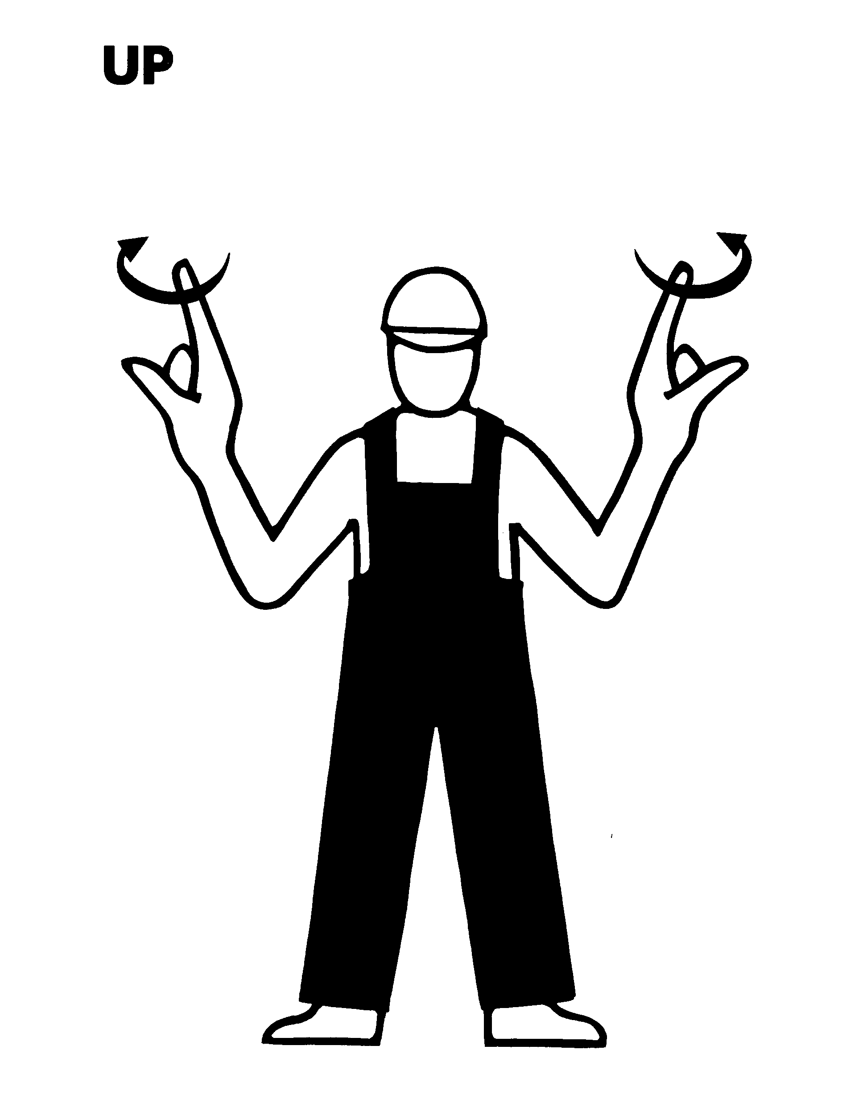
DOWN  Hand fully extended. Palm down Move downward. | 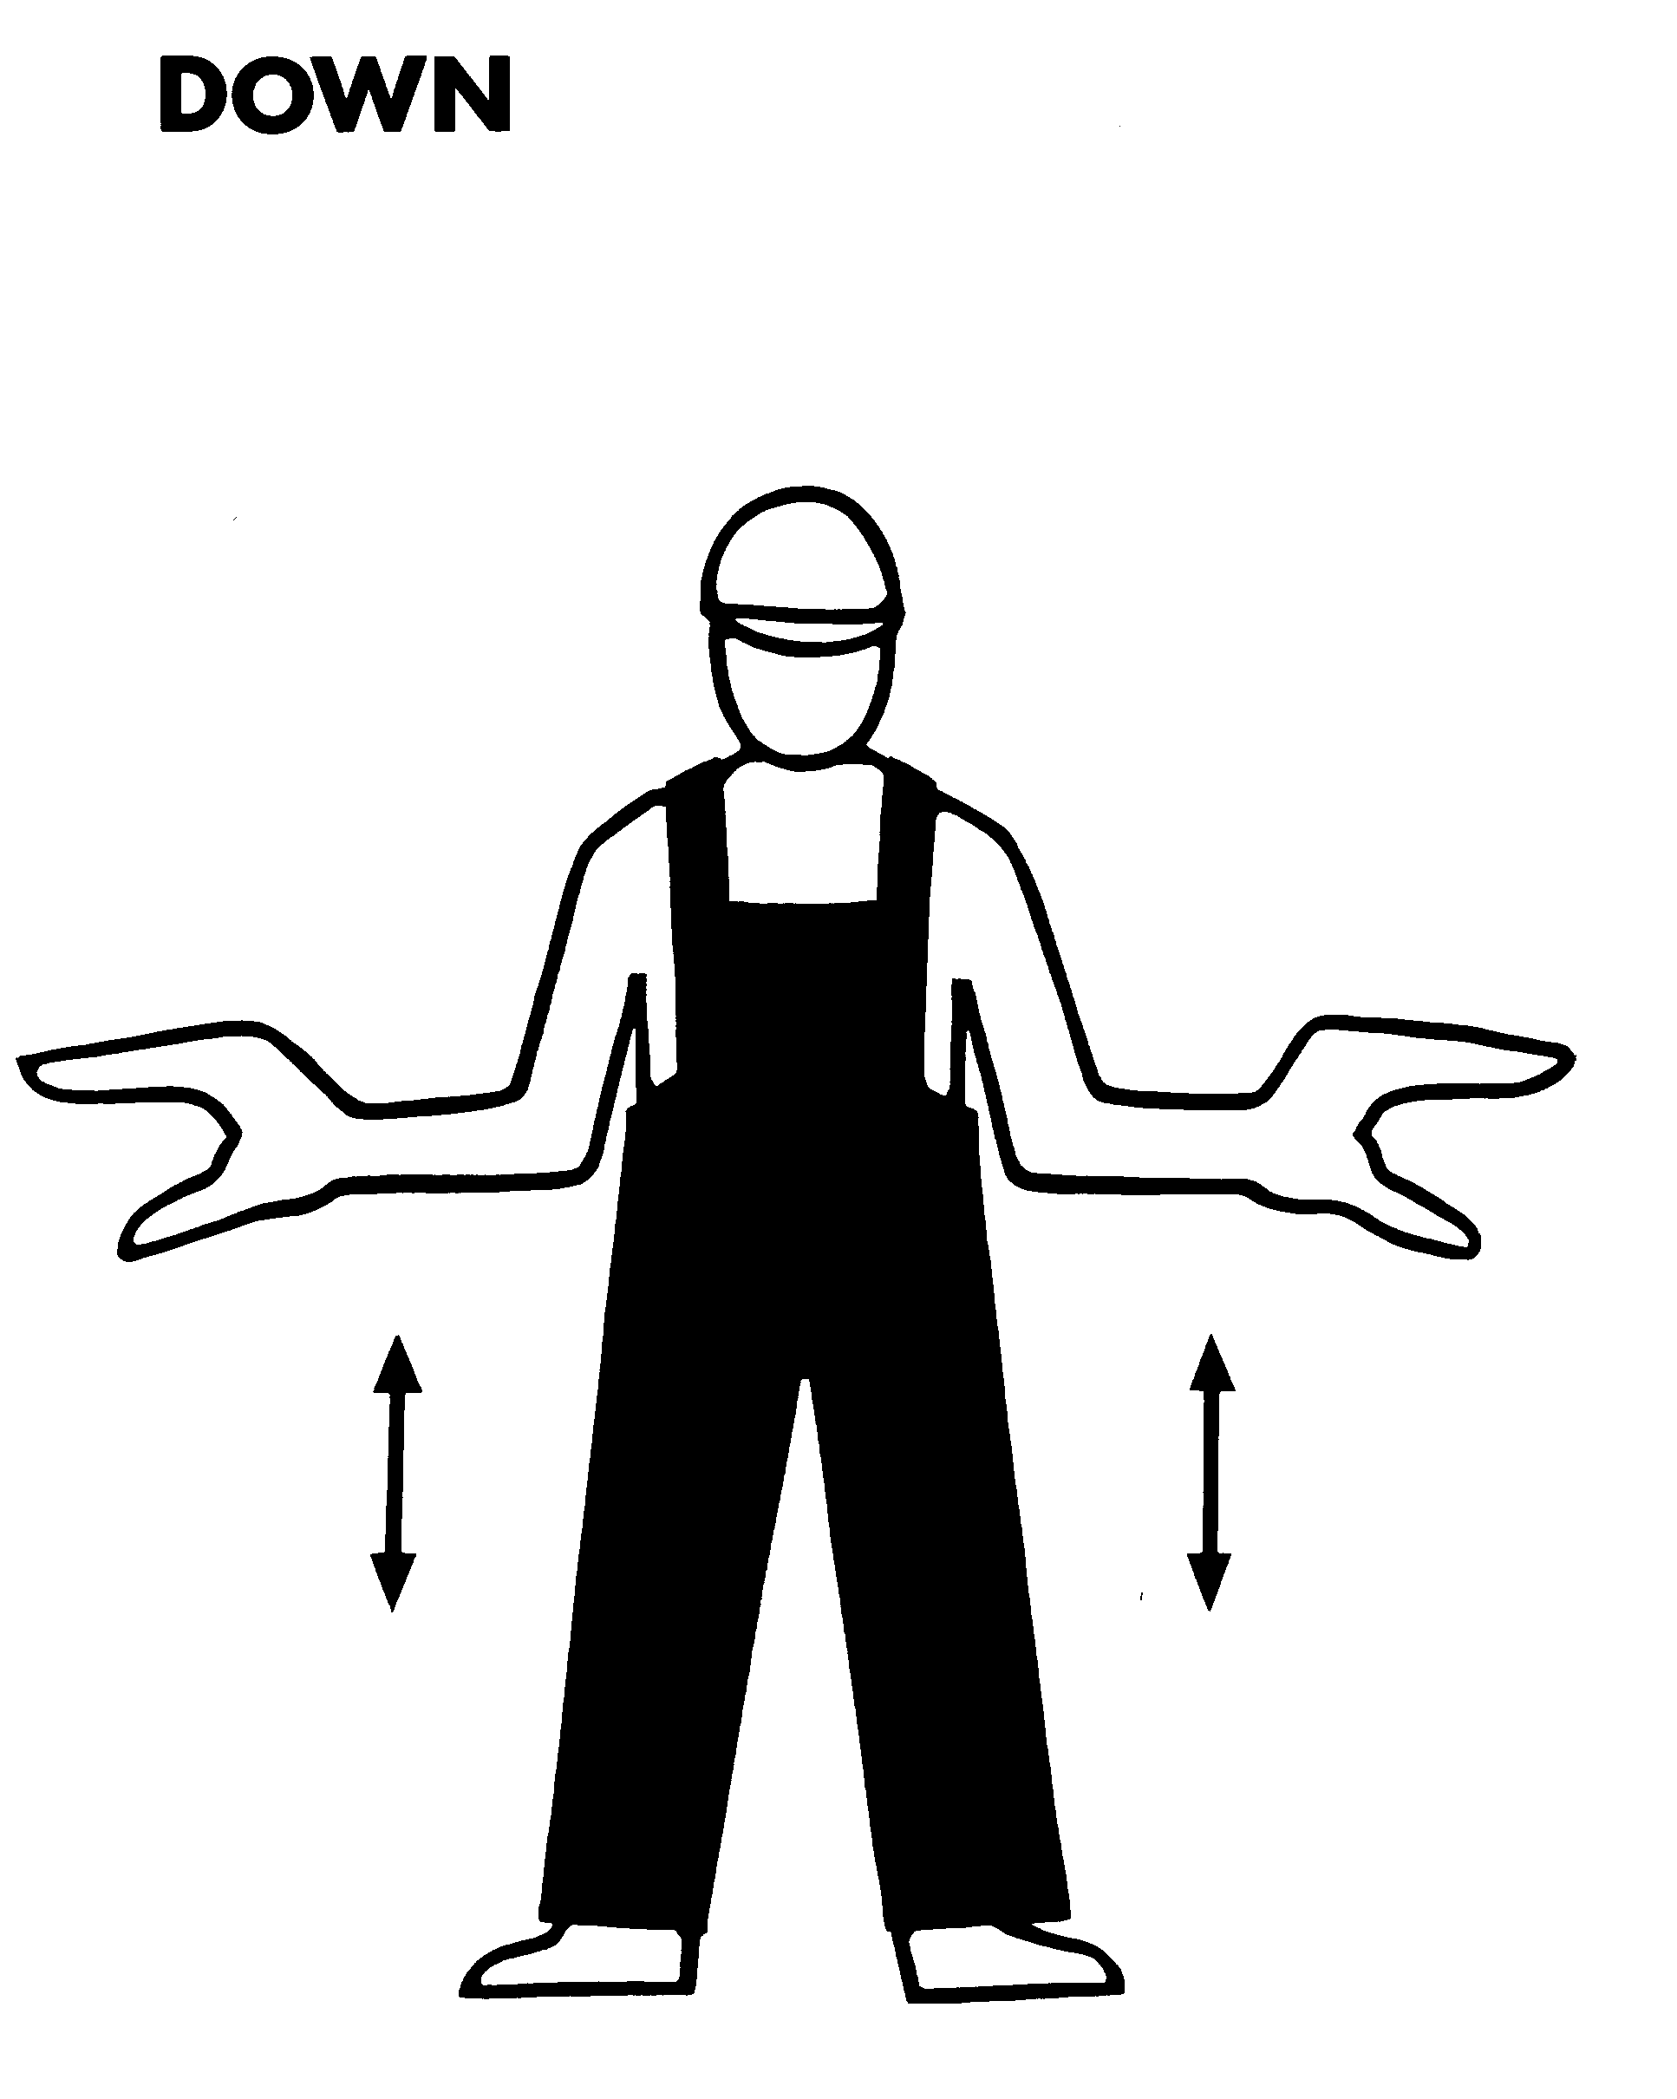
STOP  Hands held high. Palms towards driver. | 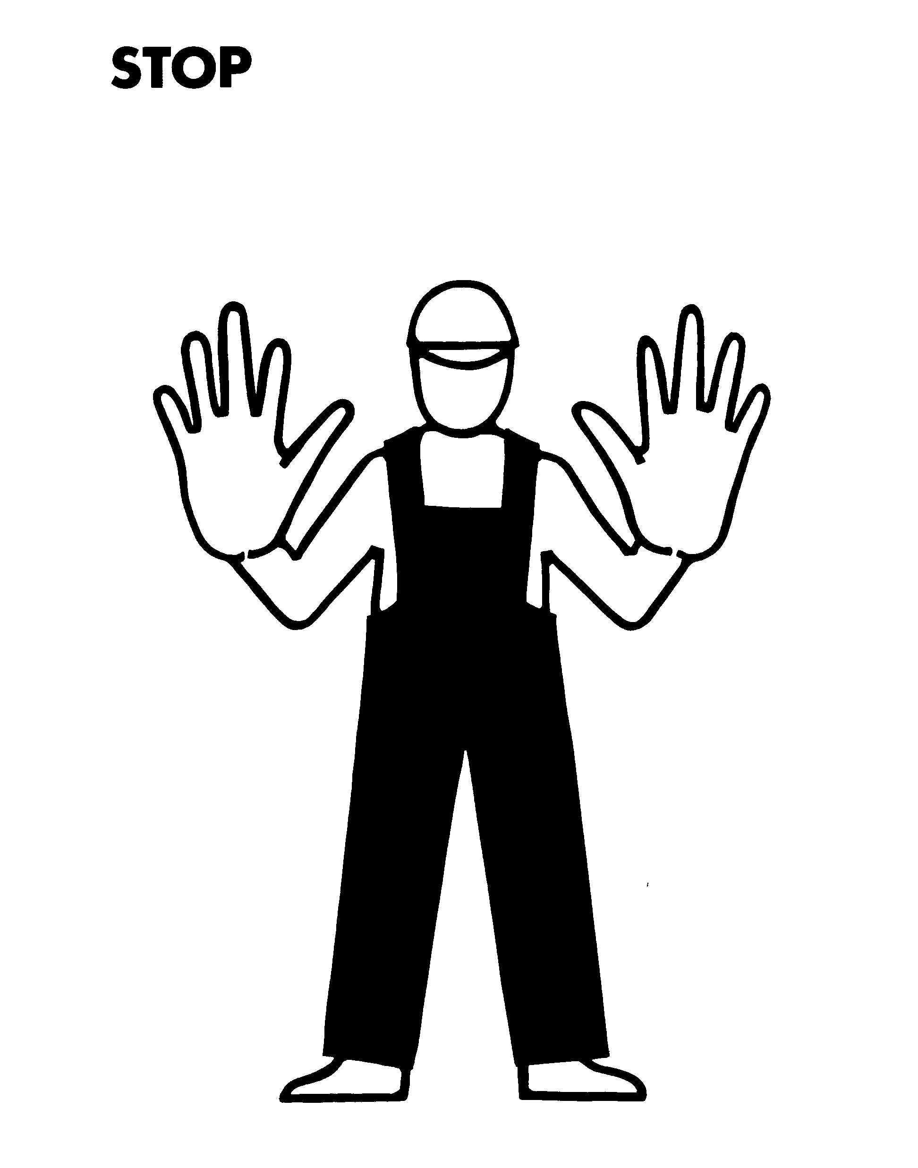
DIRECTION  First finger pointing in direction required. Rest of hand closed. Move hand in direction required. | 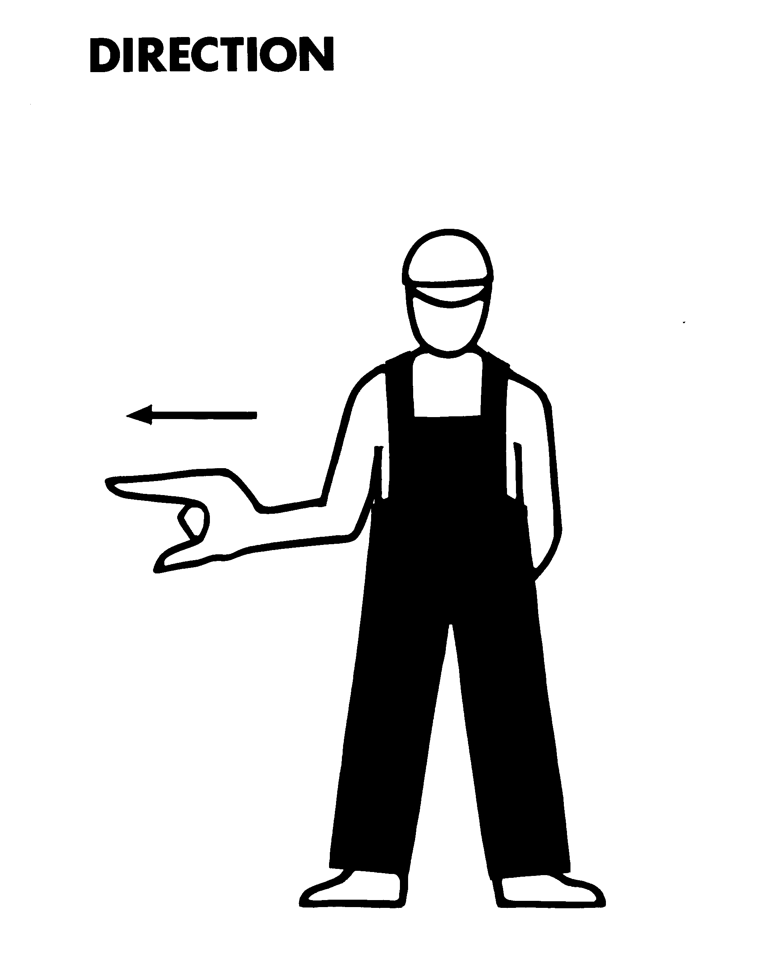
Crane signals
UP  First finger pointing. Rest of hand closed. The whole hand, thumb up, to be moved to indicate upward movement of the jib. | 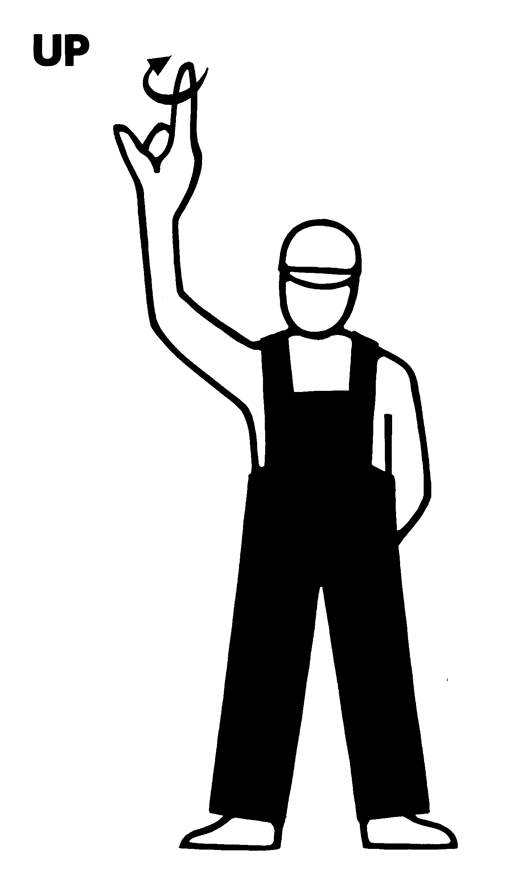 | 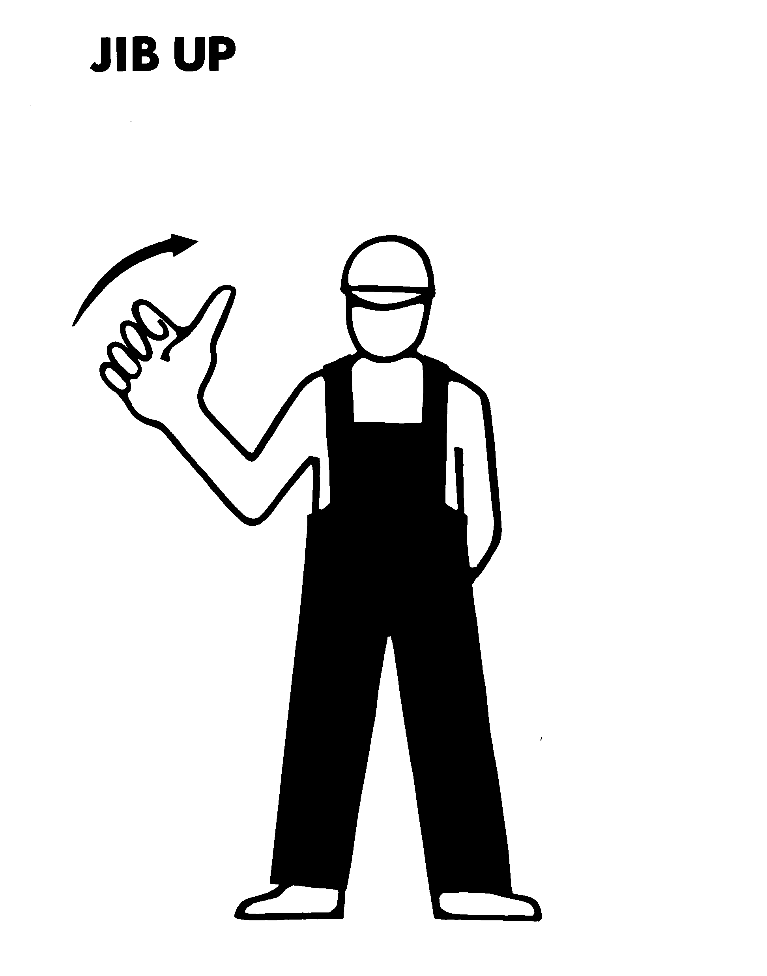
DOWN  Hand fully extended, palm down, move downward.  The whole hand, thumb down, to be moved to indicate downward movement of the jib. | 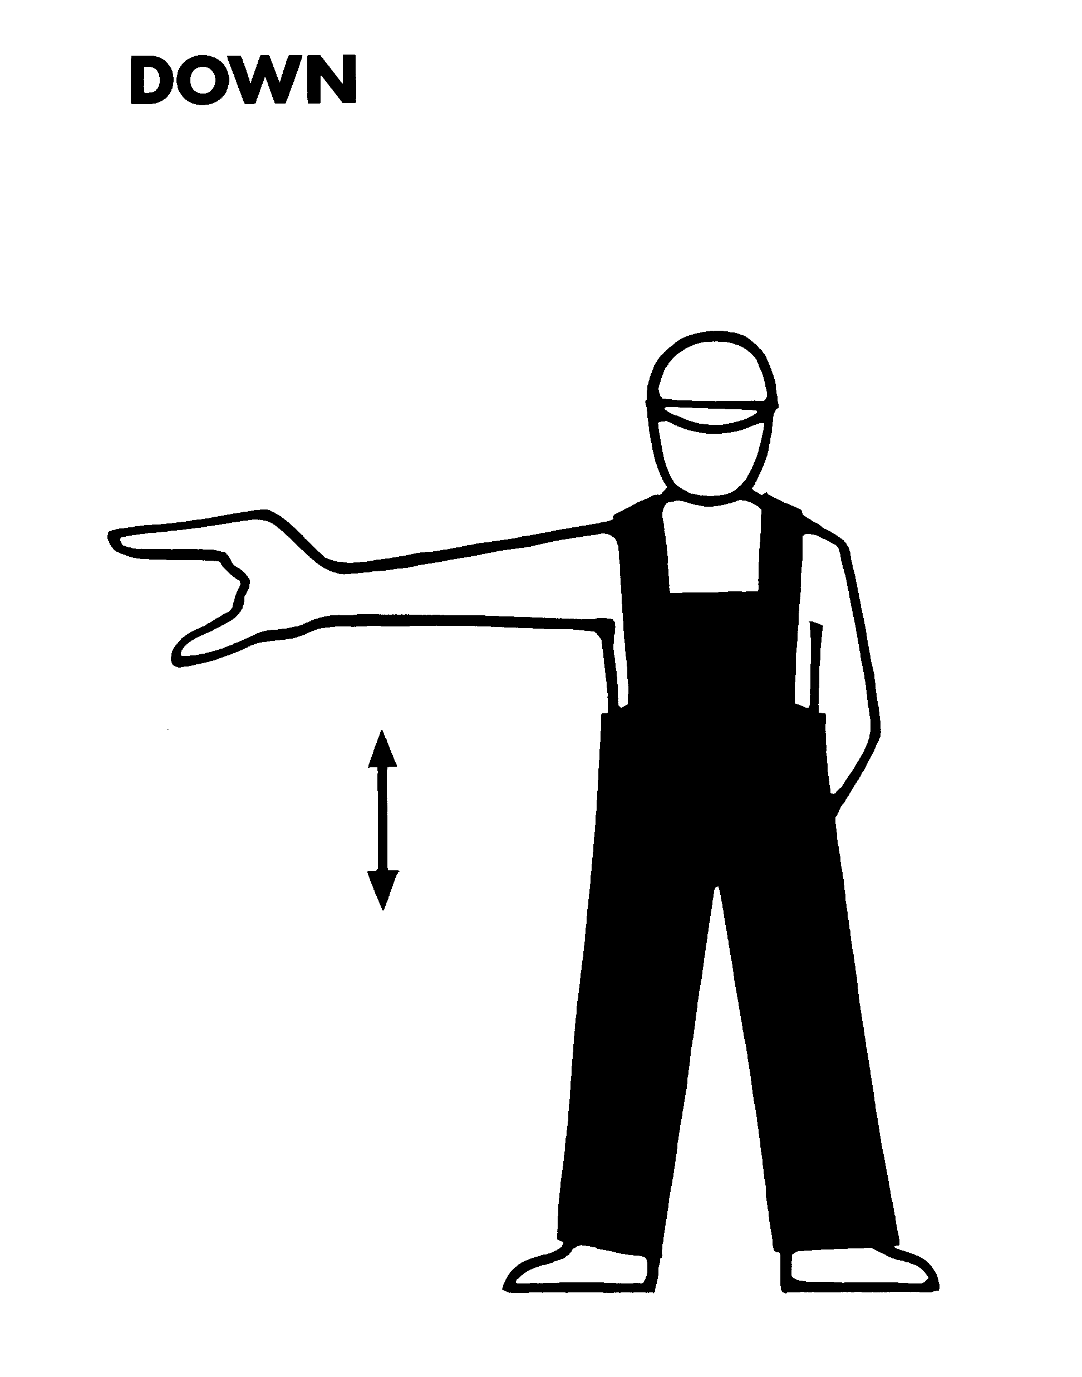 | 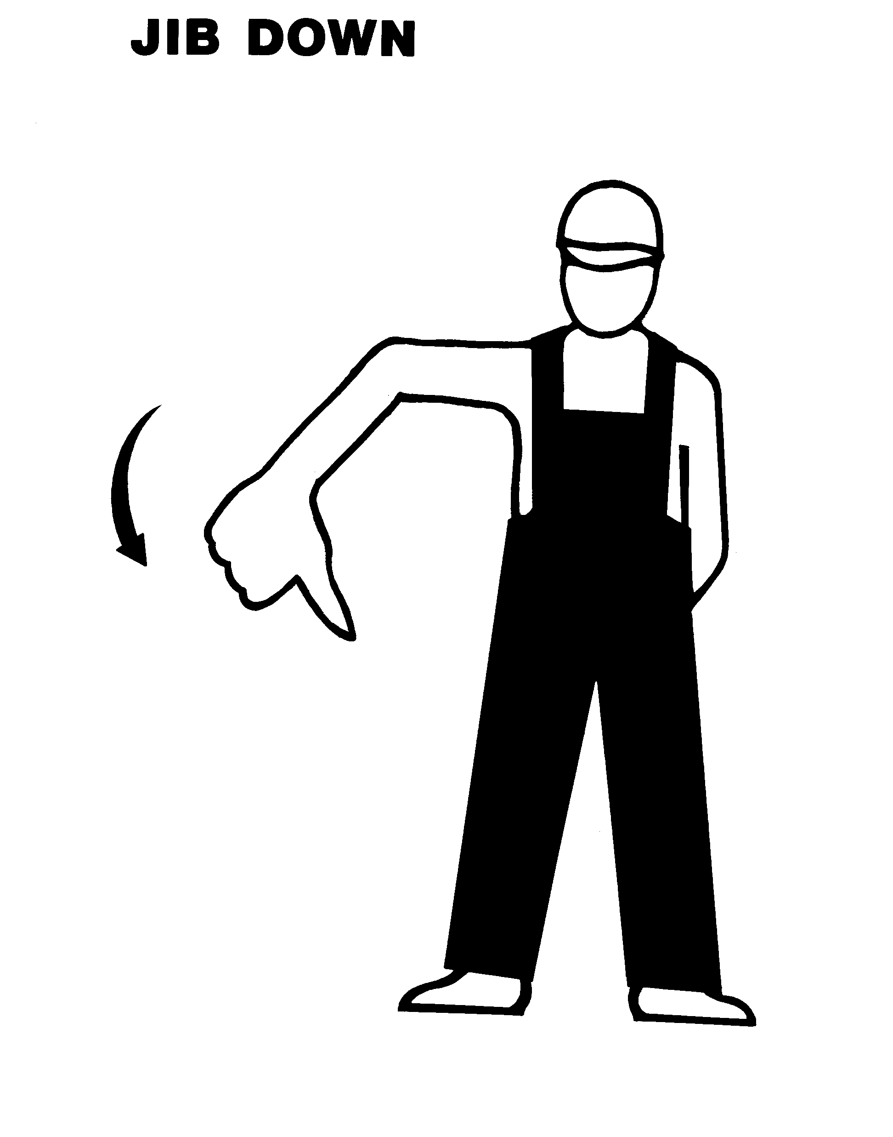
STOP  Hands held high. Palms towards driver. | 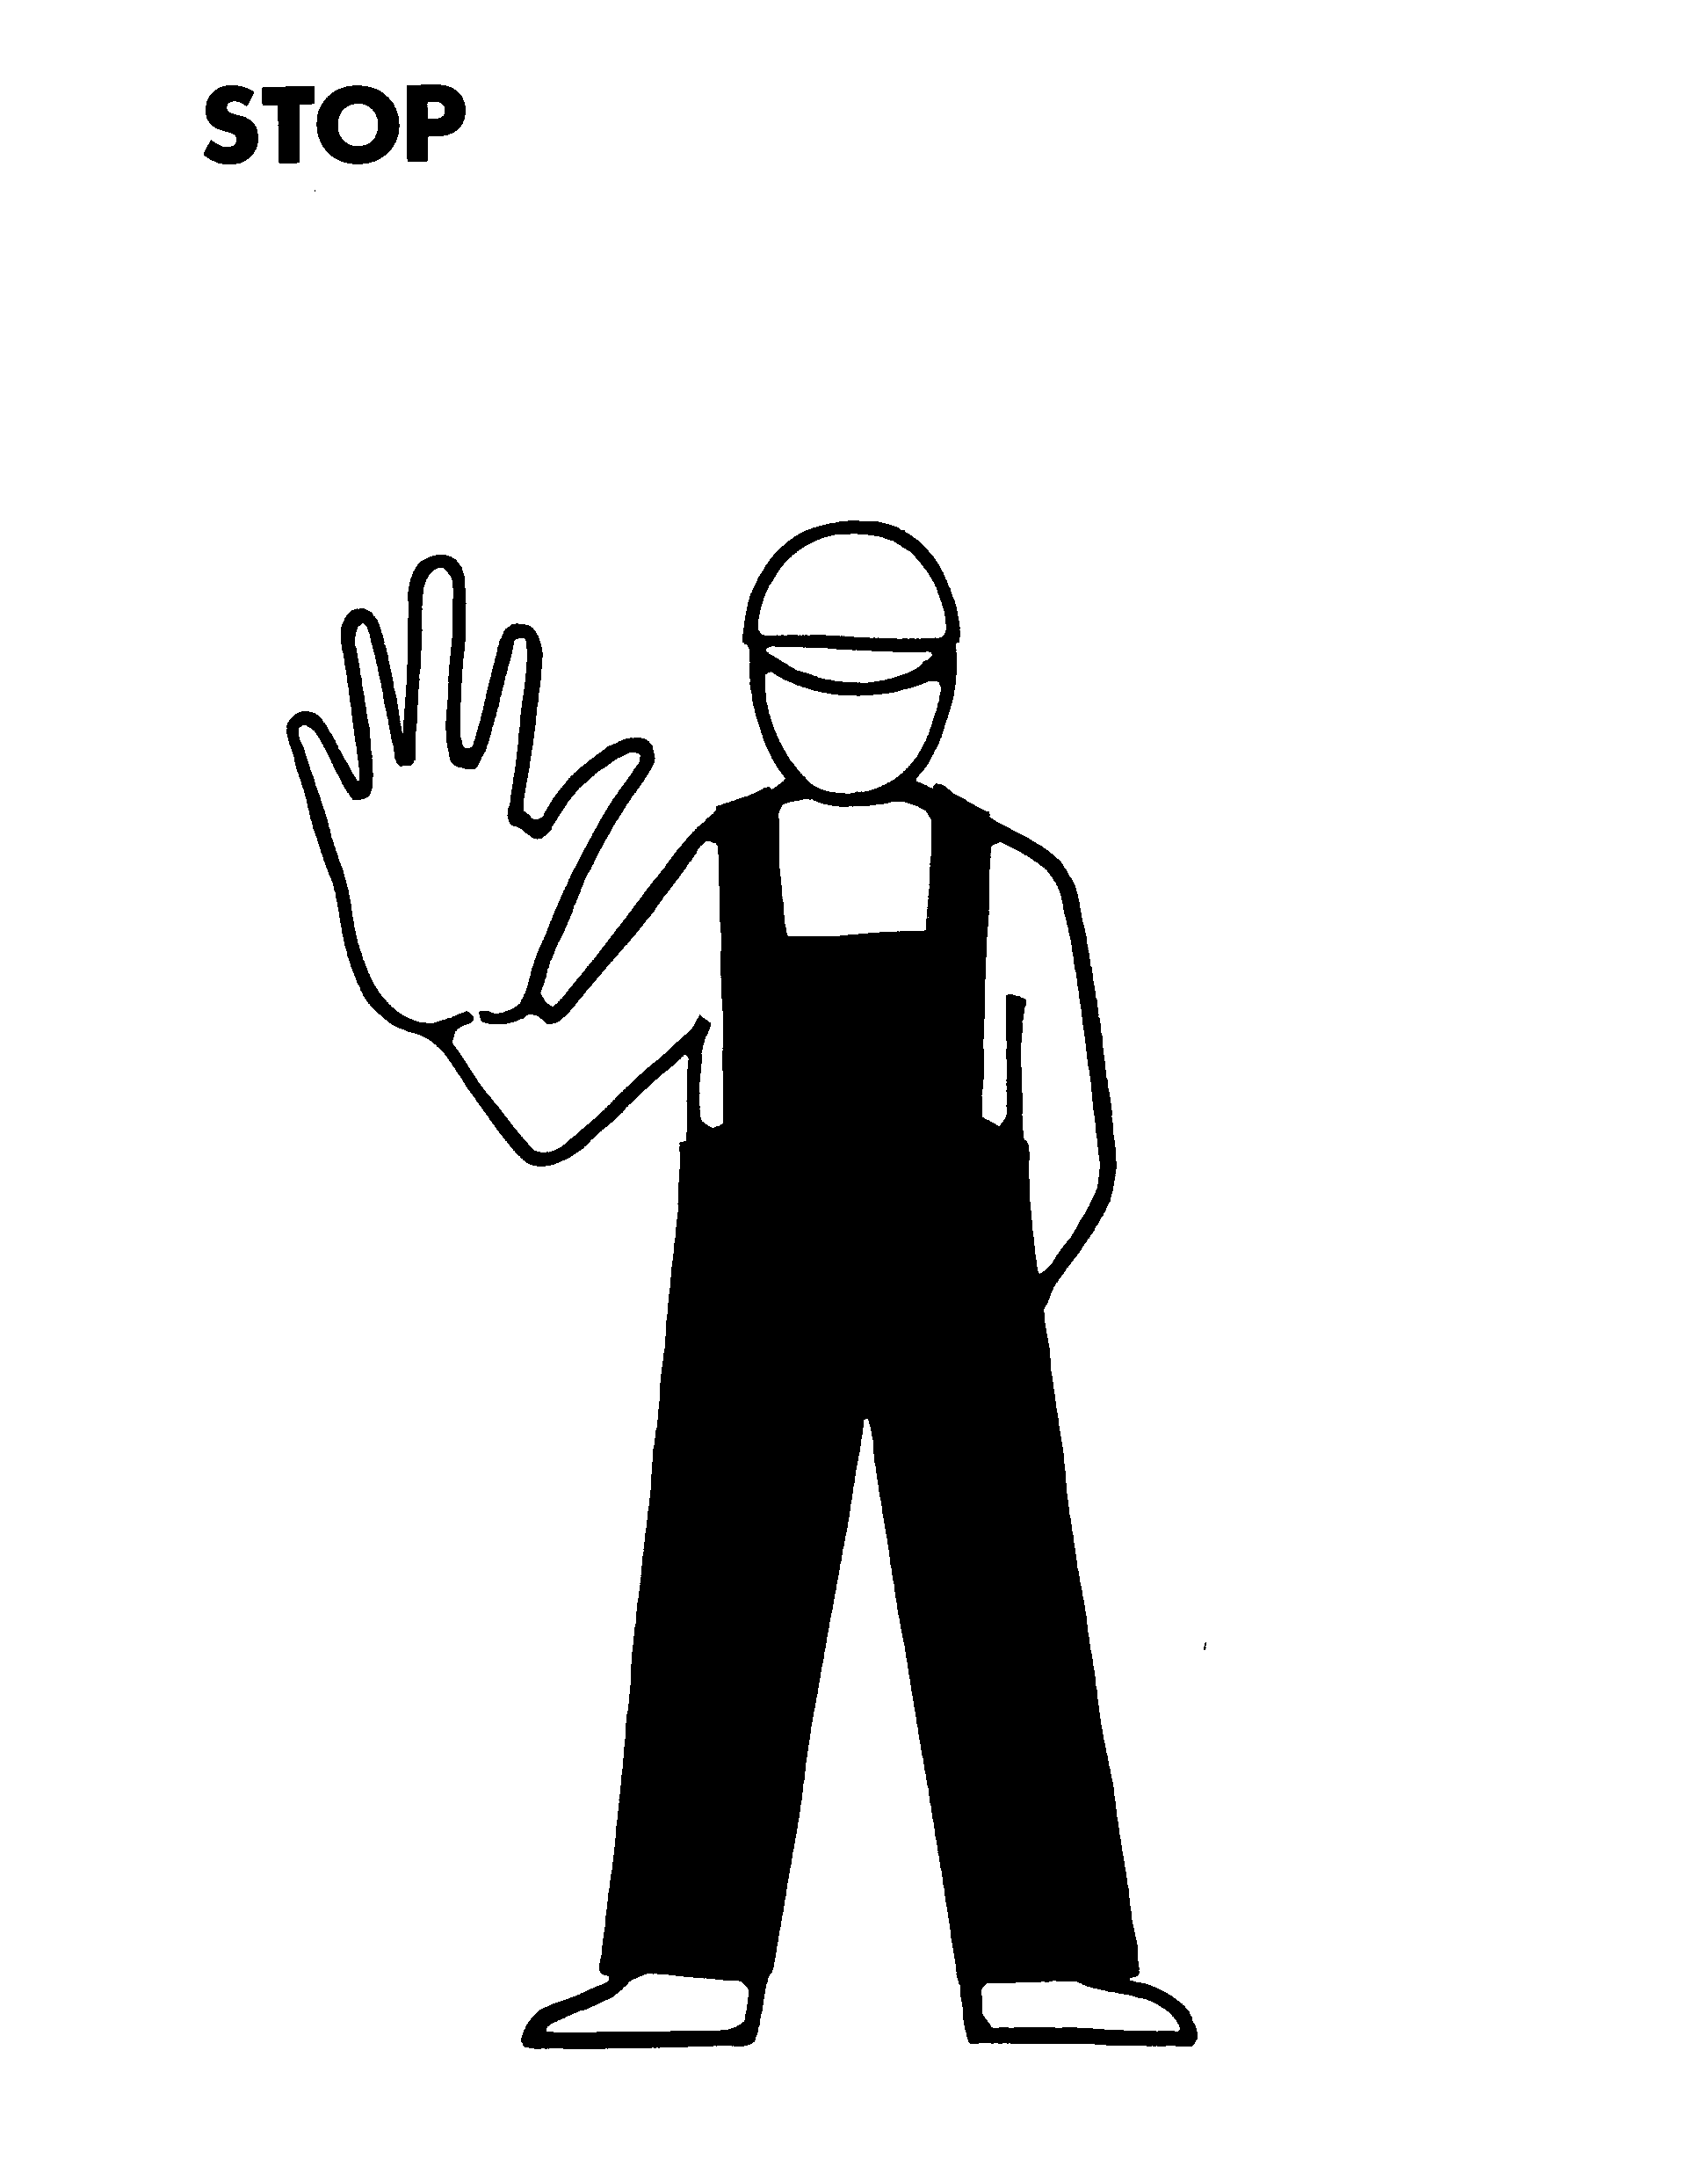
DIRECTION  First finger pointing in direction required. Rest of hand closed. Move hand in direction required. | 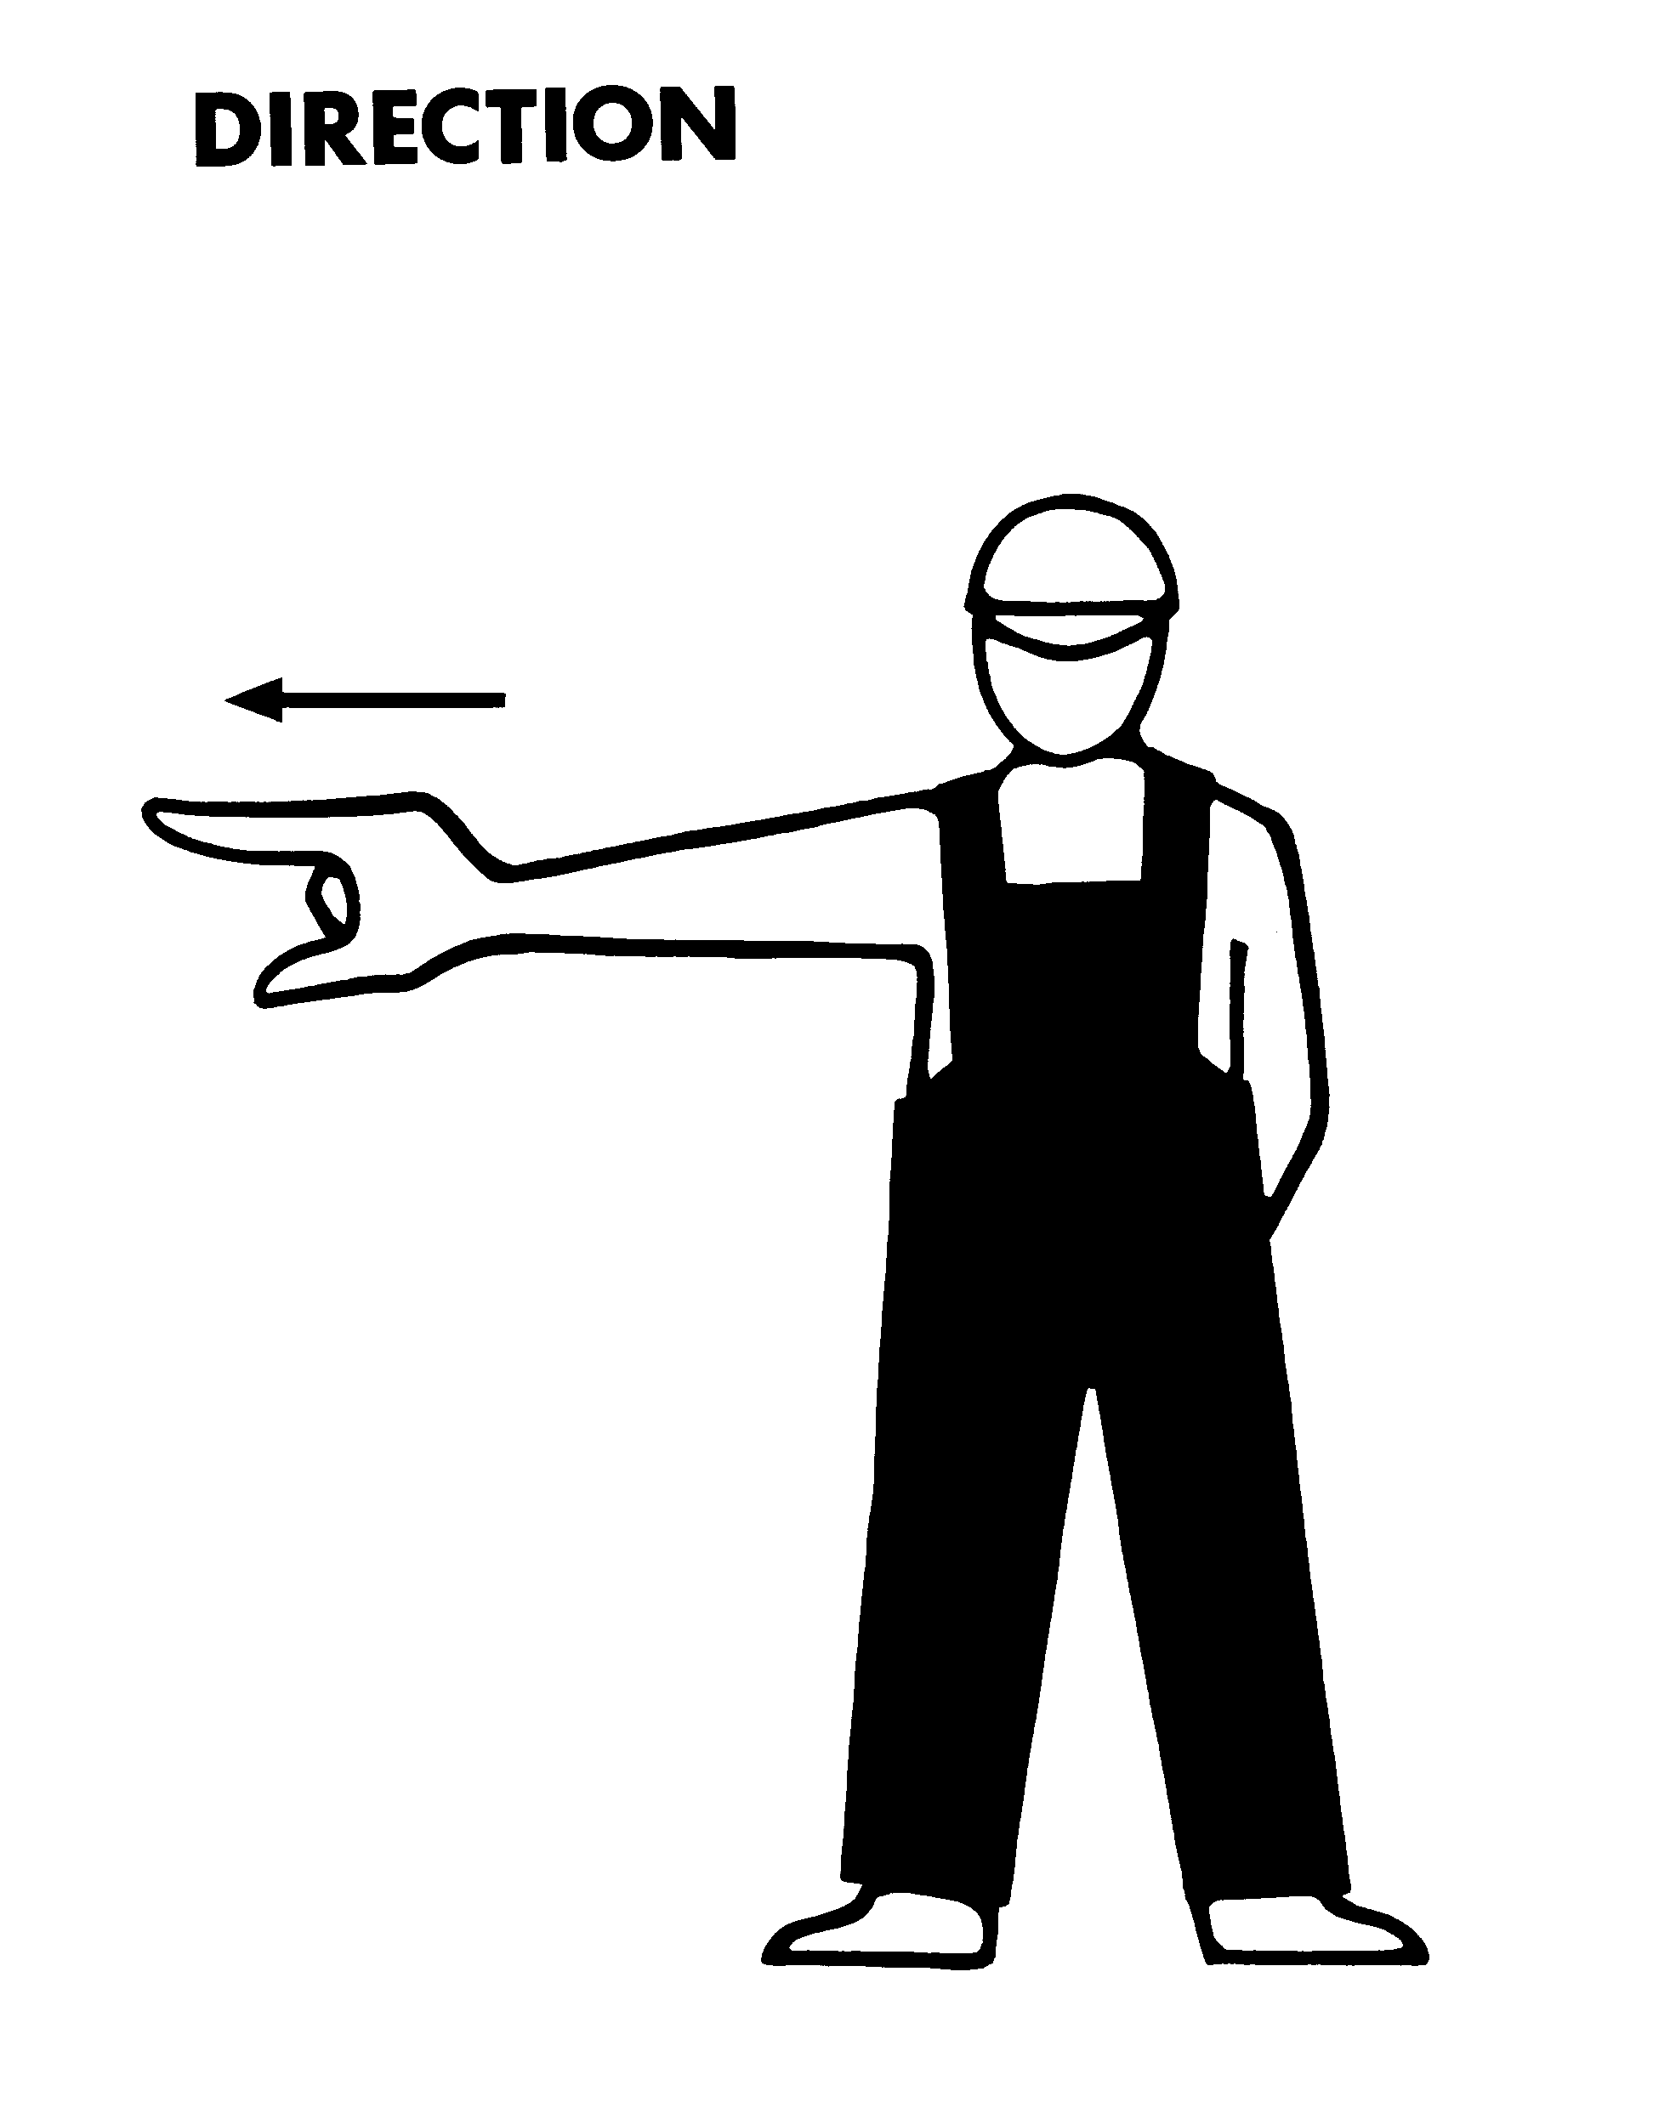
* * * * * *

Appendix 19
Marking of mass

1 Gross mass of cargo
A package or article of cargo or a unit referred to in 2, the gross mass of which is one tonne or more must not be loaded or unloaded unless:
(a) there is marked on it, or on a securely attached label, the gross mass of the package, article or unit, in legible characters not less than 25 mm in height; or
(b) where it is to be unloaded, the person in charge has been advised by the ship's master of the gross mass of the package, article or unit.
Note: Where a package, article or unit on board a ship is not marked as prescribed, the master should endeavour to obtain a statement of the gross mass from the shipper or, in the absence of such a statement, he should use the best information obtainable.

2 Mass of unitised and pre-slung cargo
For the purpose of 1, where packages or articles of cargo are grouped or preslung so as to be handled as a single unit and the aggregate gross mass of the unit does not exceed the designated maximum gross mass of the unit marked on the unit or a label, the gross mass of the unit is deemed to be the designated maximum gross mass.

3 Mass of transport equipment
3.1 Subject to 3.2, where an article of transport equipment is to be loaded or unloaded, the gross mass of that article is deemed to be the maximum operating gross mass or rating of the article, or SWL in the case of a flexible intermediate bulk container, unless the actual gross mass has been marked upon it or the person in charge has been advised of the actual gross mass.
3.2 The gross mass of an article of transport equipment referred to in 3.1 that does not contain cargo and is declared to be empty:
(a) where the article is to be loaded⎯by the shipper; or
(b) where the article is to be unloaded⎯by the master or agent,
is deemed to be the tare mass of the article.

4 Gross mass of mechanical stowing appliance
4.1 A mechanical stowing appliance, or part of such an appliance, must not be hoisted or lowered where the gross mass of the appliance or the part is one tonne or more, unless there is prominently marked on the appliance or part, or on a securely attached label, the gross mass in legible characters not less than 25 mm in height.
4.2 For the purpose of 4.1, the gross mass of a mechanical stowing appliance or part of such an appliance, includes the mass of the appliance or part, fully equipped and, where appropriate, fuelled.
* * * * * *

Appendix 20
Australian standards:
Guide in determining safe working load
Note: The Standards are listed by subject matter and full titles are not included. In some cases the Standard cited may have subsidiary parts which should be consulted.

1 For guidance in determining safe working load
Blocks, cargo | AS 2089-1993
Blocks, chain | AS 1418.2-1997
Chain | AS 2321-1979
Cranes - General | AS 1418.1-1994
- Serial hoists and winches | AS 1418.2-1997
- Bridge, gantry, portal | AS 1418.3-1990
- Mobile | AS 1418.5-1995
Eyebolts | AS 2317-1984
Fibre rope - Care & safe usage | AS 4142.1-1993
- 3 strand hawser laid and 8 strand plaited ropes | AS 4142.2-1993
Hooks | AS 3777-1990
Industrial trucks - General requirements | AS 2359.1-1995
- Operation | AS 2359.2-1985
Lifting components for chain slings | AS 3776-1990
Lifting rings and links | B 291-1971
Lift Code | AS 1735-1986
Pallets | AS 4068-1993
Rigging screws and turnbuckles | AS 2319-1984
Shackles | AS 2741-1992
Slings - fibre rope | AS 1380-1972
- synthetic-webbing | AS 1353-1990
- wire rope | AS 1666-1995
- flat wire coil | AS 1438-1974
- chain - grade T | AS 3775-1990
- roundslings⎯synthetic fibre | AS 4497-1997
Swivels | AS 2318-1990
Wire rope | AS 3569-1989
Wire-rope grips for non-lifting applications | AS 2076-1996

2 Other standards called up in this part
Acoustics⎯hearing protectors | AS 1270-1988
Automotive LP Gas Code | AS 1425-1989
Battery operated vehicles | AS 1915-1992
Carbon monoxide analyser equipment | AS 2094-1977
Classification of hazardous areas  - Explosive gas atmospheres  - Combustible dusts | AS 2430.1-1987  AS 2430.2-1986
Electrical equipment enclosures | AS 1939-1990
Industrial trucks - General requirements  - Operation | AS 2359.1-1995  AS 2359.2-1985
Lighting | AS 1680-1990
Portable Fire Extinguishers  - General requirements  - Foam type  - Powder type  - Carbon dioxide type  - Vaporising liquid type | AS 1841.1-1992  AS 1841.4-1992  AS 1841.5-1992  AS 1841.6-1992  AS 1841.7-1992
Portable Ladders - Metal  - Timber | AS 1892.1-1996  AS 1892.2-1992
Safe working in a confined space | AS 2865-1995
Vehicles - pollutant test methods | AS 2095.1-1977
Wire rope – Care and maintenance | AS 2759-1985
* * * * * *

Appendix 21
Actuating force: control equipment
The maximum actuating force required to operate controls of materials handling equipment is to be no greater than the following:
Finger-operated lever | 10 N (either direction)
Push button | 25 N
Hand-operated lever—  console mounted  floor mounted | 50 N (either direction)  400 N
Pedal | 600 N
Steering wheel—  manually powered  power assisted operating  power assistance not operating | 250 N  250 N  600 N

* * * * * *

Appendix 22
Approved splices in wire rope

1 General
1.1 For the purpose of 2.1(c) of Appendix 15, a splice is required to be well made
and tightly drawn, and must comply with 2.1, 2.2, or 3 of this Appendix, as
appropriate.
1.2 The 'first set' of tucks mentioned in 2 may be made in any sequence that will
enable the splice to be properly made and tightly drawn.
1.3 The number of tucks specified in 2 is the minimum to be used, more tucks being permissible if desired.

2 Types of splice
2.1 Hand spliced eyes should comply with the relevant requirements of Australian Standard AS 2759. Care should be taken to ensure that all splices are well made and tightly drawn.
2.2 Splices must be commenced with a first tuck of each strand end, so that the strand ends leave the rope at the same position along the rope and equally distributed around the rope. Each whole strand end must then include, at least, a second, a third and a fourth tuck (the three being the same type). The splice must then include a fifth set of tucks for tapering the splice in accordance with (a) to (e) hereto or for turning in the ends in accordance with (f). The tucks after the first are to be:
(a) three sets of tucks, with each tuck using a whole strand end of the rope and made over one and under one against the lay. After the fourth tuck, alternate strand ends are cut out and the remaining strand ends tucked similarly to the previous three tucks;
(b) three sets of tucks, with each tuck using a whole strand end of the rope and made over one and under two against the lay. After the fourth tuck, either alternate strand ends are cut out or half the wires are cut out of each strand
ends and the remaining strand ends or remaining wires tucked similarly to the previous three tucks;
(c) three sets of tucks, with each tuck using a whole strand end of the rope and made over one against the lay and under two with the lay. After the fourth
tuck, half of the wires are cut out of each of the strand ends and the remaining wires in each strand end tucked similarly to the previous three tucks;
(d) three sets of tucks, with each tuck using a whole strand end of the rope and made over one against the lay and under two with the lay. After the fourth
tuck, half of the wires are cut out of each of the strand ends and the remaining wires in each strand end tucked over one and under two against the lay;
(e) three sets of tucks, with each tuck using a whole strand end of the rope and made over two against the lay and under two with the lay. After the fourth
tuck, half of the wires are cut out of each of the strand ends and the remaining wires in each strand end tucked similarly to the previous three tucks;
(f) second, third and fourth tucks shall be made as detailed in (a) to (e). After the fourth tuck, alternative ends are tucked backwards into the rope so as to
conceal the ends and the remaining alternative ends are tucked in the same direction and then tucked backwards into the rope to conceal the ends.

3 Swaged splices
3.1 A looped eye or thimble secured by means of a compressed metal ferrule is acceptable as a splice, provided that:
(a) the material used for the manufacture of the ferrule withstands plastic deformation without cracking;
(b) the size of the ferrule is suitable for the diameter of the rope forming the splice and of adequate length in relation to the intended load;
(c) the end of the rope forming the loop passes completely through the ferrule;
(d) the die used to compress the ferrule is of appropriate size; and
(e) the compression pressure to clamp the ferrule is suitable for the die used and adequate to ensure the necessary clamping.
3.2 An alternative method for securing the end of the rope forming the loop may be accepted by the Chief Marine Surveyor, on the report of a surveyor, if a test in accordance with 4.4 of Appendix 5 demonstrates the adequacy of the arrangement.
3.3 For the purpose of 3.1, the following patented methods of swaged splices are acceptable:
(a) Australoc;
(b) Marsplice;
(c) Superloop;
(d) Talurit;
(e) U.S. Wire Rope.

Appendix 23
Forms
Form MO 32/1
CERTIFICATE OF TEST AND EXAMINATION OF DERRICKS, CRANES AND CARGO LIFTS

Ship |  | Certificate No

 | Articles |  | Angle to the
Situation | Distinguishing numbers or marks | Description | horizontal of derrick or crane for purpose of test* | Proof load applied | Date of test | Safe working load | Method used in applying the proof load

Name and address of testing establishment
..............................................................................................................................................................................................................................................................................................................................................................
CERTIFICATION
I, ....................................................................,a responsible person for the purposes of Marine Orders, Part 32 (Cargo Handling Equipment), hereby certify that on the date shown in the column headed 'Date of test' in the table above:
• I tested the articles of materials handling equipment identified in that table, in the manner specified in Appendix 5 to Marine Orders, Part 32 for the above mentioned testing establishment and am in all respects satisfied that each article identified is of sufficient strength to carry the safe working load specified in the column headed 'Safe working load' in the table, relating to that article; and
• I made a thorough examination of each article identified and am in all respects satisfied from the examination that each such article withstood the proof test without injury or deformation.
Position | Technical qualifications
Address .......................................................................  ..................................................................................... | Signature  ....../....../......  Date
* In the case of a crane or derrick crane, the load radius at which the crane or derrick crane was tested may be inserted in this column.
Form MO 32/2
CERTIFICATE OF TEST AND EXAMINATION OF CARGO GEAR, BEING
BLOCKS, CHAINS, RINGS, HOOKS, SHACKLES, SWIVELS, ETC
Ship or store |  | Certificate No

Distinguishing numbers or marks of articles | Description of articles | Material of articles | Number of articles tested | Proof load applied | Date of test | Safe working load | Name and address of makers or suppliers of articles

Name and address of testing establishment
..............................................................................................................................................................................................................................................................................................................................................................
CERTIFICATION
I, ....................................................................,a responsible person for the purposes of Marine Orders, Part 32 (Cargo Handling Equipment), hereby certify that on the date shown in the column headed 'Date of test' in the table above:
• I tested the articles identified in that table, in the manner specified in Appendix 5 to Marine Orders, Part 32, for the above mentioned testing establishment;
• I am in all respects satisfied that each article identified is of sufficient strength to carry the safe working load specified in the column headed 'Safe working load' in the table, relating to that article; and
• I made a thorough examination of each article identified; following application of the proof load, each such article was found to have withstood the load without injury or deformation and to be free from cracks, flaws and other defects.
Position | Technical qualifications
Address .......................................................................  ..................................................................................... | Signature  ....../....../......  Date

Form MO 32/3
CERTIFICATE OF TEST AND EXAMINATION OF PERSONNEL CRADLES, CARGO TRAYS, CRATES, TUBS AND OTHER LOADING AND UNLOADING RECEPTACLES
Certificate No

Distinguishing numbers or marks of articles | Description of articles | Material of articles | Number of articles tested | Proof load applied | Date of test | Safe working load | Name and address of makers or suppliers of articles

Name and address of testing establishment
..............................................................................................................................................................................................................................................................................................................................................................
CERTIFICATION
I, ....................................................................,a responsible person for the purposes of Marine Orders, Part 32 (Cargo Handling Equipment), hereby certify that on the date shown in the column headed 'Date of test' in the table above:
• I tested the articles identified in that table, in the manner specified in Appendix 5 to Marine Orders, Part 32, for the above mentioned testing establishment;
• I made a thorough examination of each article identified; following application of the proof load, each such article was found to have withstood the load without injury or deformation and to be free from cracks, flaws and other defects.
Position | Technical qualifications
Address ......................................................................  ..................................................................................... | Signature  ....../....../......  Date
Form MO-32/4
CERTIFICATE OF TEST AND EXAMINATION OF WIRE ROPE
Certificate No
Name and address of manufacturer
Name
Address
Details of rope
Diameter of rope (mm) | Number of strands |  | Number of wires per strand
Lay |  | Core
Specification to which wires conform
Breaking tensile load of sample of the rope |  |  |  | Date of tensile test
Safe working load⎯subject to any stated qualifying conditions
(such as minimum pulley diameter and direct tensile load)
Name and address of person, firm or company making test and examination
Name
Address

I, ....................................................................,a responsible person for the purposes of Marine Orders, Part 32 (Cargo Handling Equipment), hereby certify that the above particulars are correct.
Signature ......................................................................................... | Date / /

Wire rope supplied to
To be used for
Form MO 32/5
REPORT OF BREAKAGE OR FAILURE OF CARGO GEAR, OR INJURY TO ANY PERSON ON OR ABOUT A SHIP
Name of ship |  |  |  |  | IMO No.
Port of registry
Projected date of departure | Destination
Name of owner or agent at port where breakage or failure of cargo gear or injury occurred
Date of occurrence |  | Time of occurrence |  | Place of occurrence (port and Berth)
Name of person in charge of
operations at time of occurrence
Name of employer of person in
charge
Report

Signature of person in charge of loading or unloading operations |  | The occurrence must be reported as soon as possible, and in any case within 4 hours, to a surveyor at the nearest AMSA Marine Survey office.  This form is to be forwarded, when completed and signed, to the Surveyor in Charge at the nearest AMSA Marine Survey office, to arrive within 72 hours of the occurrence.
 | Date / /

