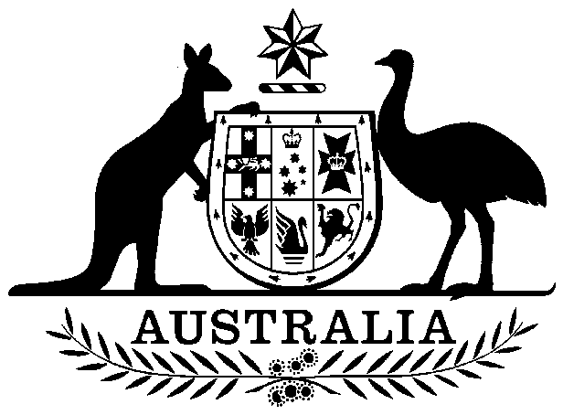
COMMONWEALTH OF AUSTRALIA

Environment Protection and Biodiversity Conservation Act 1999

Amendment of List of Exempt Native Specimens

I, ANDREW MCNEE, Assistant Secretary, Marine Environment Branch, as Delegate of the Minister for the Environment and Water Resources pursuant to subsection 303DC(1) of the Environment Protection and Biodiversity Conservation Act 1999 (EPBC Act), hereby amend the list of exempt native specimens established under section 303DB of the EPBC Act by including in the list the following specimens:

- Specimens that are or are derived from fish or invertebrates, other than specimens that belong to species listed under Part 13 of the EPBC Act, taken in the New South Wales Lobster Fishery, as defined in the management regime made under the Fisheries Management (Lobster Share Management Plan) Regulation 2000 and the Fisheries Management (General) Regulation 2002 in force under the Fisheries Management Act 1994.

with a notation that inclusion of the specimens in the list is subject to the following restrictions or conditions:

- The specimen, or the fish or invertebrate from which it is derived, was taken lawfully; and

- The specimen is included on the list until 30 March 2012.

Dated this 28th day of March 2007

Andrew McNee
…………………………………………
Delegate of the Minister for the Environment and Water Resources

