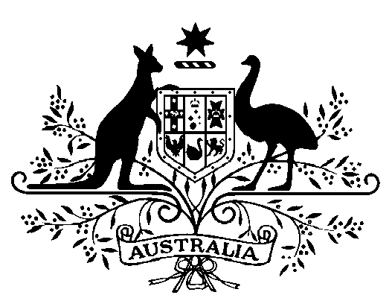

Proclamation

Environment Protection and Biodiversity Conservation Act 1999

I, PHILIP MICHAEL JEFFERY, Governor-General of the Commonwealth of Australia, acting with the advice of the Federal Executive Council and under subsection 350(1) of the Environment Protection and Biodiversity Conservation Act 1999, amend the Proclamation made under subsection 7(2) of the National Parks and Wildlife Conservation Act 1975 and published in the Gazette No. S 61 of 5 April 1979 (as amended by the Proclamations made under subsection 7(8) of that Act and published in the Gazette No. S 552 of 20 December 1985, No. S 126 of 12 June 1987, No. GN 45 of 22 November 1989, and No. S 165 of 24 June 1991) establishing Kakadu National Park by omitting Parts VII, VIII, IX, X and XI of the schedule to that Proclamation and substituting the schedule to this Proclamation.

Signed and Sealed with the
Great Seal of Australia on
23 May 2007

P. M. JEFFERY
Governor-General

By His Excellency’s Command

Malcolm Turnbull
Minister for the Environment and Water Resources
SCHEDULE
PART VII
All that piece of land in the Northern Territory of Australia containing an area of 3699 square kilometres more or less and bounded by lines described as follows: commencing at the most eastern north-eastern corner of Northern Territory Portion 2854; thence easterly by part of the most southern boundary of Northern Territory Portion 4061 to the most western north-western corner of Northern Territory Portion 1662; thence southerly, easterly, again southerly and south-easterly by a western, a southern, a western and the south-western boundary of the said Portion to the most northern north-western corner of Northern Territory Portion 4774; thence generally southerly, easterly and southerly by western, a southern and a western boundary of the said Portion to a northern boundary of Northern Territory Portion 4424; thence westerly by part of the said boundary to the right bank of the Mary River; thence generally north-westerly by the said bank to a southern boundary of Northern Territory Portion 4425; thence easterly and northerly by part of the said boundary and the southern and eastern boundaries of Northern Territory Portion 2854 to the point of commencement.
PART VIII

All that piece of land in the Northern Territory of Australia containing an area of 3025 square kilometres more or less, being the whole of Northern Territory Portion 4774 more particularly delineated on survey plan S95/212 lodged with the Surveyor General, Darwin, including there-in the roads 50 metres wide shown on the aforesaid plan but excluding there-from that part of Northern Territory Portion 4774 that is included in Part I of this Schedule and being the area bounded by lines described as follows: commencing at the north-eastern corner of Northern Territory Portion 4774; thence southerly by part of the eastern boundary of the said Portion to the parallel of south latitude 13 degrees 26 minutes; thence south-westerly to the intersection of the parallel of south latitude 13 degrees 29 minutes 57.8 seconds with the meridian of east longitude 132 degrees 58 minutes; thence west to the meridian of east longitude 132 degrees 55 minutes; thence north to the parallel of south latitude 13 degrees 29 minutes; thence west to the meridian of east longitude 132 degrees 49 minutes; thence south to the parallel of south latitude 13 degrees 29 minutes 57.8 seconds; thence west to the meridian of east longitude 132 degrees 43 minutes 10 seconds; thence north by the said meridian to the northern boundary of Northern Territory Portion 4774; thence easterly by part of the northern boundary of the said Portion to the point of commencement.

