EXPLANATORY STATEMENT

(Issued by Authority of the Minister for the Environment and Water Resources)

Environment Protection and Biodiversity Conservation Act 1999

Proclamation

Subsection 344(1) of the Environment Protection and Biodiversity Conservation Act 1999 (the Act) provides that the Governor-General may, by Proclamation, declare as a Commonwealth reserve an area of land or sea, including an area of sea in a Commonwealth marine area (as defined in section 24 of the Act).

Subsection 346(1) of the Act provides that a Proclamation declaring an area to be a Commonwealth reserve must give the reserve a name, state the purposes for which the reserve is declared, state the depth of any land or seabed included in the reserve and assign the reserve to a World Conservation Union (IUCN) category. In addition, subsection 346(2) of the Act allows a Proclamation to divide a reserve into zones and assign each zone to an IUCN category.

Subsection 350(1) of the Act provides that the Governor-General may revoke or amend such a Proclamation by another Proclamation.

The purposes of the Proclamations are to:
- declare thirteen (13) areas of sea as Commonwealth reserves which, with the addition of the Macquarie Island Commonwealth Marine Reserve, are to be known as the South-east Commonwealth Marine Reserve Network (a map showing the location of the proposed Commonwealth reserves is at Attachment A);
- specify the purposes of the proposed new Commonwealth reserves;
- specify that the seabed to a depth of 100 metres is to be included in the proposed new Commonwealth reserves;
- assign the proposed new Commonwealth reserves to an IUCN category;
- where applicable, divide the proposed new Commonwealth reserves into zones and assign IUCN categories to those zones;
- amend the Proclamation declaring the Macquarie Island Marine Park in order to change the name of the Park to Macquarie Island Commonwealth Marine Reserve to ensure consistent nomenclature for all Commonwealth reserves (details of which are set out in Attachment B); and
- revoke the Proclamation declaring the Tasmanian Seamounts Marine Reserve (declared on 12 May 1999) (details of which are set out in Attachment C) to enable the area to be incorporated into one of the new reserves.

The network of Commonwealth marine reserves make a major contribution to the establishment of a National Representative System of Marine Protected Areas (NRSMPA) in Australia’s marine jurisdiction. The aim of the NRSMPA is to contribute to the long term ecological viability of marine and estuarine systems, to maintain ecological processes and systems, and to protect Australia’s biodiversity at all levels. Each of the reserves in the network aims to contain and protect a comprehensive, adequate and representative sample of the marine ecosystems of the South-east region.

The network of Commonwealth marine reserves in the South-east has been developed through extensive planning and consultation. Through consultation with industry and other stakeholders, the originally proposed network has been altered to considerably reduce the impact on marine industries and user groups. A Regulatory Impact Statement has been prepared and is included at Attachment D.

The network has resulted in a modest cost to industry and to government, with less than $1.0 million in annual catch displaced. Structural adjustment for the Commonwealth fishing industry in the South-east is part of the Australian Government's $220 million Securing our Fishing Future package, announced in 2005. In this package, fishing concessions were bought back to reduce over-fishing in the South-east and the criteria extended to fishers impacted by the proposed South-east reserve network. The Department of Agriculture, Fisheries and Forestry administered this program, and have now completed the buyback of fishing concessions approved through a competitive tender process.

Subsection 351(1) of the Act requires the Minister for the Environment and Water Resources to consider a report from the Director of National Parks (the Director) on the proposal before the Governor-General makes a Proclamation to declare a reserve, or a Proclamation to revoke or amend a Proclamation. Pursuant to subsection 351(2) of the Act, when preparing the report, the Director must publish a public notice stating the subject matter to be dealt with by the Proclamation and invite the public to comment on the same. Under paragraph 351(2)(b), the Director must consider any comments made in response to the invitation for public comment. Subsection 351(5) provides for a period of at least 60 days after the notice is published for public comments to be made.

The Director issued a notice on 24 October 2006 inviting comments on the proposal and specifying 22 December 2006 as the last date for sending comments. No matters were raised in the comments received by the Director that might have led to the Director recommending that the proposal to proclaim the thirteen (13) areas that make up the South-east Commonwealth Marine Reserve Network as marine reserves be withdrawn.

The Proclamations are legislative instruments for the purposes of the Legislative Instruments Act 2003.

The Proclamations commence sixty (60) days after the date they are registered on the Federal Register of Legislative Instruments.

Attachment A

Map showing the location of the proposed new thirteen (13) Commonwealth Reserves

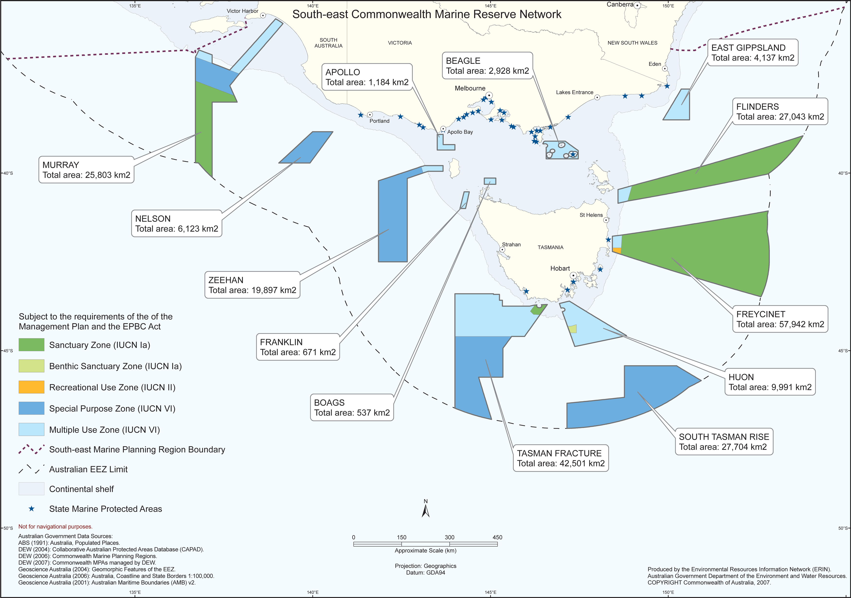
Attachment B

Details of the Macquarie Island Marine Park Amendment Proclamation

Macquarie Island Marine Park was first declared by a Proclamation made under subsection 7(2) of the National Parks and Wildlife Conservation Act 1975 (the Parks Act) on
27 October 1999.

Pursuant to section 3 of Part 2 of Schedule 4 of the Environmental Reform (Consequential Provisions) Act 1999, a Proclamation under Part II of the Parks Act of an area as a park or reserve that was in force immediately before the commencement of the Environment Protection and Biodiversity Conservation Act 1999 (the Act) continues in force as if it had been made under section 344 of the Act immediately after that commencement, so that the area is declared as a Commonwealth reserve under the new Act.

The purpose of the Proclamation is to amend the Proclamation declaring the Macquarie Island Marine Park pursuant to subsection 350(1) of the Act to change the name of the reserve to Macquarie Island Commonwealth Marine Reserve.

Attachment C

Details of the Tasmanian Seamounts Marine Reserve Revocation Proclamation

The Tasmanian Seamounts Marine Reserve was first declared by a Proclamation made under subsection 7(2) of the National Parks and Wildlife Conservation Act 1975 (the Parks Act) on 12 May 1999.

Pursuant to section 3 of Part 2 of Schedule 4 of the Environmental Reform (Consequential Provisions) Act 1999, a Proclamation under Part II of the Parks Act of an area as a park or reserve that was in force immediately before the commencement of the Environment Protection and Biodiversity Conservation Act 1999 (the Act) continues in force as if it had been made under section 344 of the Act immediately after that commencement, so that the area is declared as a Commonwealth reserve under the new Act.

The purpose of the Proclamation is to revoke the Proclamation declaring the Tasmanian Seamounts Marine Reserve pursuant to subsection 350(1) of the Act.

Pursuant to subsection 350(2) of the Act, before the Governor-General makes a Proclamation that results in land, sea or seabed ceasing to be included in a Commonwealth reserve, the Minister must be satisfied:
(a) that the Proclamation, if made, would be in accordance with a resolution passed by each House of Parliament on a motion; and
(b) that the notice of the motion was given at least 15 sitting days of that House before the motion was moved.

The requirements of subsection 350(2) do not apply to a Proclamation that results in land, sea or seabed ceasing to be included in one Commonwealth reserve or zone and being included in another Commonwealth reserve or zone (subsection 350(3) of the Act). The area covered by the Tasmanian Seamounts Marine Reserve is incorporated into, and will be managed part of, the Huon Commonwealth Marine Reserve.

Attachment D

The South-east Commonwealth Marine Reserve Network

Regulatory Impact Statement

Prepared by: Marine and Biodiversity Division,
Department of the Environment and Water Resources
Table of Contents

1. PROBLEM DEFINITION 3
1.1 Background to problem 3
1.2 The Problem 5
2. OBJECTIVES 8
2.1 Legislative Context 8
3. OPTIONS 9
3.1 Option 1: Status Quo 10
3.2 Option 2: December 2005 Draft Proposal 11
3.3 Option 3: the Final South-east CMR Network released for comment in October 2006. 13
4. IMPACT ANALYSIS (COSTS AND BENEFITS) OF EACH OPTION 15
4.1 Impacts of Option 1: Status Quo 15
4.2 Impacts of Option 2: December 2005 Draft Proposal 17
4.3 Impacts of Option 3: October 2006 Final Proposal 20
4.4 Impacts Summary and Comparative Analysis 23
5. CONSULTATION 24
5.1 Stakeholder views on the draft MPA network as proposed in December 2005 (Option 2) 26
5.2 Stakeholder views on the proposed final MPA network (Option 3) 27
6. CONCLUSION 29
7. IMPLEMENTATION AND REVIEW 30
Attachment A - Summary of IUCN Management Categories 33
Attachment B - Spatial Analysis of the Economic Impacts of South-east MPA Network Proposals on Commercial Fishing 34
Attachment C - The statutory processes involved in declaring CMRs and developing management plans 37

- PROBLEM DEFINITION
  - Background to problem
There is growing recognition of the need to protect marine biodiversity for both conservation and economic reasons. Australia’s international obligations and responsibilities for marine biodiversity protection are formally acknowledged as a signatory to the Convention on Biological Diversity (UNEP 1994), the Convention on Migratory Species (Bonn Convention) and bilateral agreements such as those for migratory birds (JAMBA and CAMBA). Under these agreements, Australia has committed to a range of measures including the establishment of a system of protected areas to conserve and protect biological diversity and ecological processes. The Convention of Biological Diversity recognises that there has been a sharp decline in the world’s biodiversity and that action is needed to counter this downward trend in order to allow for ongoing sustainable economic development to meet present and future resource needs.

The international commitments mentioned above are addressed at the national level through a range of agreements between the Australian, Sate and Territory Governments. These include the National Strategy for Ecologically Sustainable Development (Commonwealth of Australia 1992), the National Strategy for the Conservation of Australia’s Biological Diversity (Commonwealth of Australia 1996) and the development of a National Representative System of Marine Protected Areas (NRSMPA).

Australia also supports the World Conservation Union (IUCN) World Commission on Protected Areas program of promoting the establishment and management of a global representative system of MPAs. In 2002, at the World Summit on Sustainable Development Australia reaffirmed its commitment to establishing a representative system of marine protected areas (MPAs) within its jurisdiction by 2012.

The main goal of the NRSMPA is to build a national system of MPAs that will be:
• Comprehensive – include MPAs that sample the full range of Australia’s ecosystems;
• Adequate – include MPAs of appropriate size and configuration to ensure the conservation of marine biodiversity and integrity of ecological processes; and
• Representative – include MPAs that reflect the marine life and habitats of the areas they are chosen to represent.

The aim of the NRSMPA is to contribute to the long term ecological viability of marine and estuarine systems, to maintain ecological processes and systems, and to protect Australia’s biodiversity at all levels. The commitment to the primary goal of biodiversity conservation means that MPAs within the NRSMPA provide a higher level of protection than generally achieved in surrounding waters.

Australia’s Oceans Policy (1998) established regional marine planning as the framework for the establishment and effective management of a representative system of marine protected areas and the complementary sustainable management of adjoining waters (ANZECC 1999). The South-east Regional Marine Plan was the first plan to be developed under this policy. This plan was released in May 2004 and outlined a range of actions to improve oceans management. A key outcome arising from this plan was the development of a network of representative marine protected areas in the South-east Marine Region, which is the subject of this regulatory impact statement.

In September 2005 the Australian Government brought regional marine planning directly under section 176 of the Environment Protection and Biodiversity Conservation Act 1999. Marine bioregional plans, including proposed MPAs, will be developed in Commonwealth managed waters in each of Australia’s five marine regions: the South-east (completed); South-west; North-west; Northern and Eastern Marine Regions (see Figure 1).

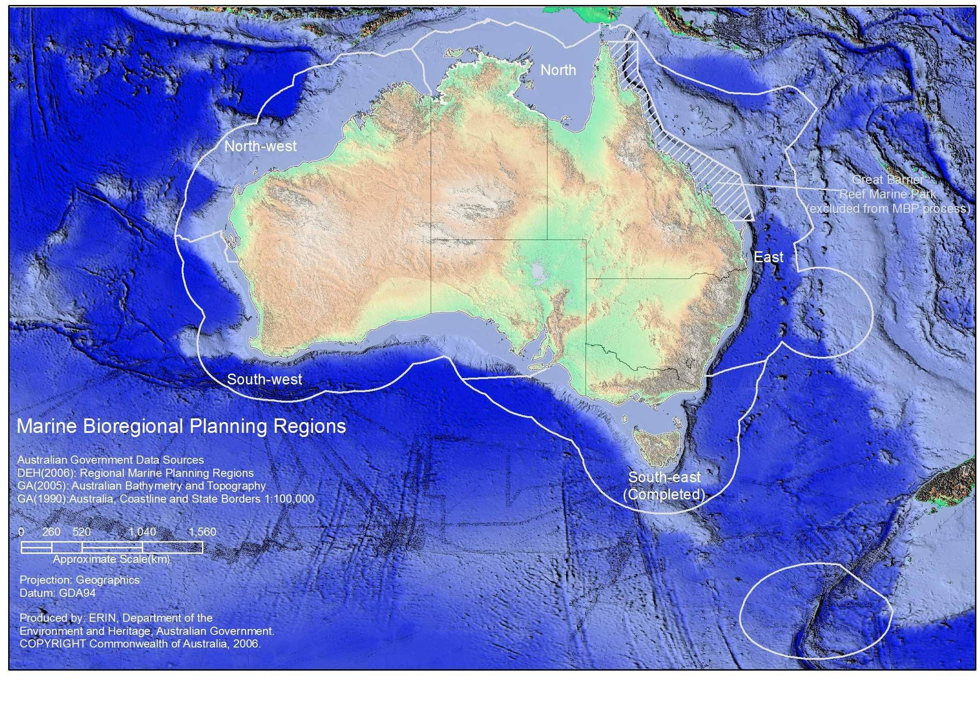
Figure 1: Marine Bioregional Planning Regions

  - The Problem
The South-east marine region of Australia covers more than two million square kilometres of marine waters. The mapping of the sea-floor of the region has revealed spectacular features such as large underwater canyons and towering seamounts. Ecologically, the region has a high level of species endemism and outstanding biodiversity. In addition to these conservation values, the oceans of the South-east provide vital social and economic benefits including natural resources, food, employment, transport, tourism and recreation.

The marine environment throughout Australia, including the South-east, is considered to be in comparatively good condition. However the marine environment in the region is under pressure from a number of sources including marine pollution, overfishing, destructive fishing techniques, bycatch from fishing operations, introduced marine pests and marine debris. The challenge is to ensure that the biological diversity and integrity of Australia’s marine ecosystems is preserved while providing a resource base for internationally competitive and ecologically sustainable ocean uses.

The underlying problem is that the historical regulatory regime in our marine environment is based on managing individual user groups and sectors rather than the holistic management of all biodiversity values in an area. The cumulative impact of these sectorial management arrangements does not provide for the holistic protection of spatially defined areas from all different user groups and can result in the degradation of the entire system without designed refuges in the form of marine reserves. The aim in developing the South-east Regional Marine Plan was to achieve efficiencies in planning and spatial management to prevent problems that could arise through increased future access and use and/or continued or increased unmanaged impacts on the marine resources of the South-east marine region.

Maintenance of the status quo in the South-east region is likely to reduce the overall effectiveness of existing sustainability measures for the marine environment in the long term. There is an unacceptably high risk that potentially harmful impacts on marine species and ecosystems will not be reduced. Failure to alleviate growing pressure on marine resources in the South-east marine region is likely to result in a continual trend of environmental degradation. Excessive resource consumption will likely lead to a decrease in the conservation value of the region and in the long term may have economic consequences for industry and may result in a reduction of community amenity due to reductions in ecosystem health and resilience.

  - Overview of Process to Develop a Representative Network for the South-east Marine Region

The creation of the South-east Commonwealth Marine Reserve (CMR) Network is one of the most important actions under the South-east Regional Marine Plan. The Region includes 1.195 million square kilometres of ocean from the waters off Bermagui on the far south coast of New South Wales, around Tasmania (including Macquarie Island) and Victoria and west to Kangaroo Island, off the south-east coast of South Australia. Commonwealth waters include the area between three nautical miles from the coastline and the limit of the Exclusive Economic Zone (EEZ) at 200 nautical miles from the coastline.

Since the inception of the South-east CMR program in 2002, the Australian Government, marine scientists, industry and conservation groups have worked together to develop the reserves in the South-east Region.

The Australian Government established a set of operational criteria for identifying and selecting a comprehensive, adequate and representative (CAR) system of reserves within the Region and a map of eleven Broad Areas of Interest to provide focus in identifying candidate options for CMRs. These two tools were incorporated in a User’s Guide for identifying candidate areas for a regional representative system of CMRs. The User’s Guide includes ecologically based design specifications to help identify the range of biodiversity values to be included in the South-east CMR Network. These specifications included guidance on how, and how many, significant features like canyons or seamounts should be included and how boundaries should be designed to make compliance and management effective. Stakeholders were invited to develop options for MPAs that incorporated their social, economic and cultural information to help maximise the conservation and socio-economic benefits and minimise any potential adverse impacts.

A fishing risk assessment was also undertaken to inform decisions on the type of fishing activities compatible with those multiple use management zones where fishing is proposed to be allowed.

As well as these products, the Government established a range of consultative forums and networks to ensure a comprehensive and transparent process for stakeholder engagement in developing MPA outcomes for the South-east Region. This included the funding of two liaison positions – one within the commercial fishing industry and one with the conservation sector.

While the South-east CMRs will have minimal impact on the fishing industry, fishermen impacted by the creation of CMRs were able to apply for assistance under the Australian Government’s $220 Million Securing Our Fishing Future structural adjustment programme. This programme supported major fisheries management reform including adjustment arising from the establishment of CMRs.

Support for CMR design has been provided by a Scientific Reference Panel, which advised on the information to be used in the process. A Scientific Peer Review Panel advised the Australian Government on the extent to which the CMR network achieved biodiversity conservation objectives.

The Australian Government used these processes and the best available scientific knowledge, as well as input form stakeholders, to design a draft network of CMRs while at the same time seeking to minimise impacts to industry. The draft proposal for the candidate South-east CMR Network was released on 14 December 2005. This proposal is described in Option 2 below. All interested stakeholder groups were invited to give feedback on the proposed CMR network and alternative suggestions that would meet the CMR design specifications. Several significant changes to reserve boundaries and zoning were made based on stakeholder inputs. The final proposal released for public comment on 24 October 2006 is the outcome of those consultations. The final proposal is described in Option 3 below.

- OBJECTIVES
The primary objective of the South-east CMR network is the protection and maintenance of marine biological diversity in the South-east marine region.

The South-east Commonwealth Marine Reserve Network will make a significant contribution to the NRSMPA. The overarching objective of the NRSMPA is to contribute to the long term ecological viability of all estuarine and marine systems, to maintain ecological processes and systems and to protect Australia’s biological diversity at all levels.

The secondary objectives of the SE CMR network are to:
- Meet Australia’s international and domestic obligations relating to the protection of marine biodiversity; and
- Minimise impacts on various user groups operating in the South-east marine region

  - Legislative Context

Commonwealth MPAs are declared and managed as Commonwealth Reserves under Part 15 Division 4 of the EPBC Act and under the provisions of the Environment Protection and Biodiversity Conservation Regulations 2000 (EPBC Regulations).

- OPTIONS

Three options are presented for consideration in this Regulatory Impact Statement:

Option 1: Status Quo – no new marine protected areas are established in the South-east Marine Region.

Option 2: December 2005 draft proposal – the marine protected area network released by the former Minister for the Environment and Heritage on 14 December 2005 for stakeholder comment.

Option 3: Final proposal as released for comment as part of the formal statutory consultation process from in October 2006 – the final marine protected area network proposed by the then Minister for the Environment and Heritage.

  - Option 1: Status Quo

Under this option no additional CMRs would be declared. The only CMRs in the South-east Marine Region would be the Macquarie Island Marine Park and the Tasmanian Seamounts Marine Reserve.

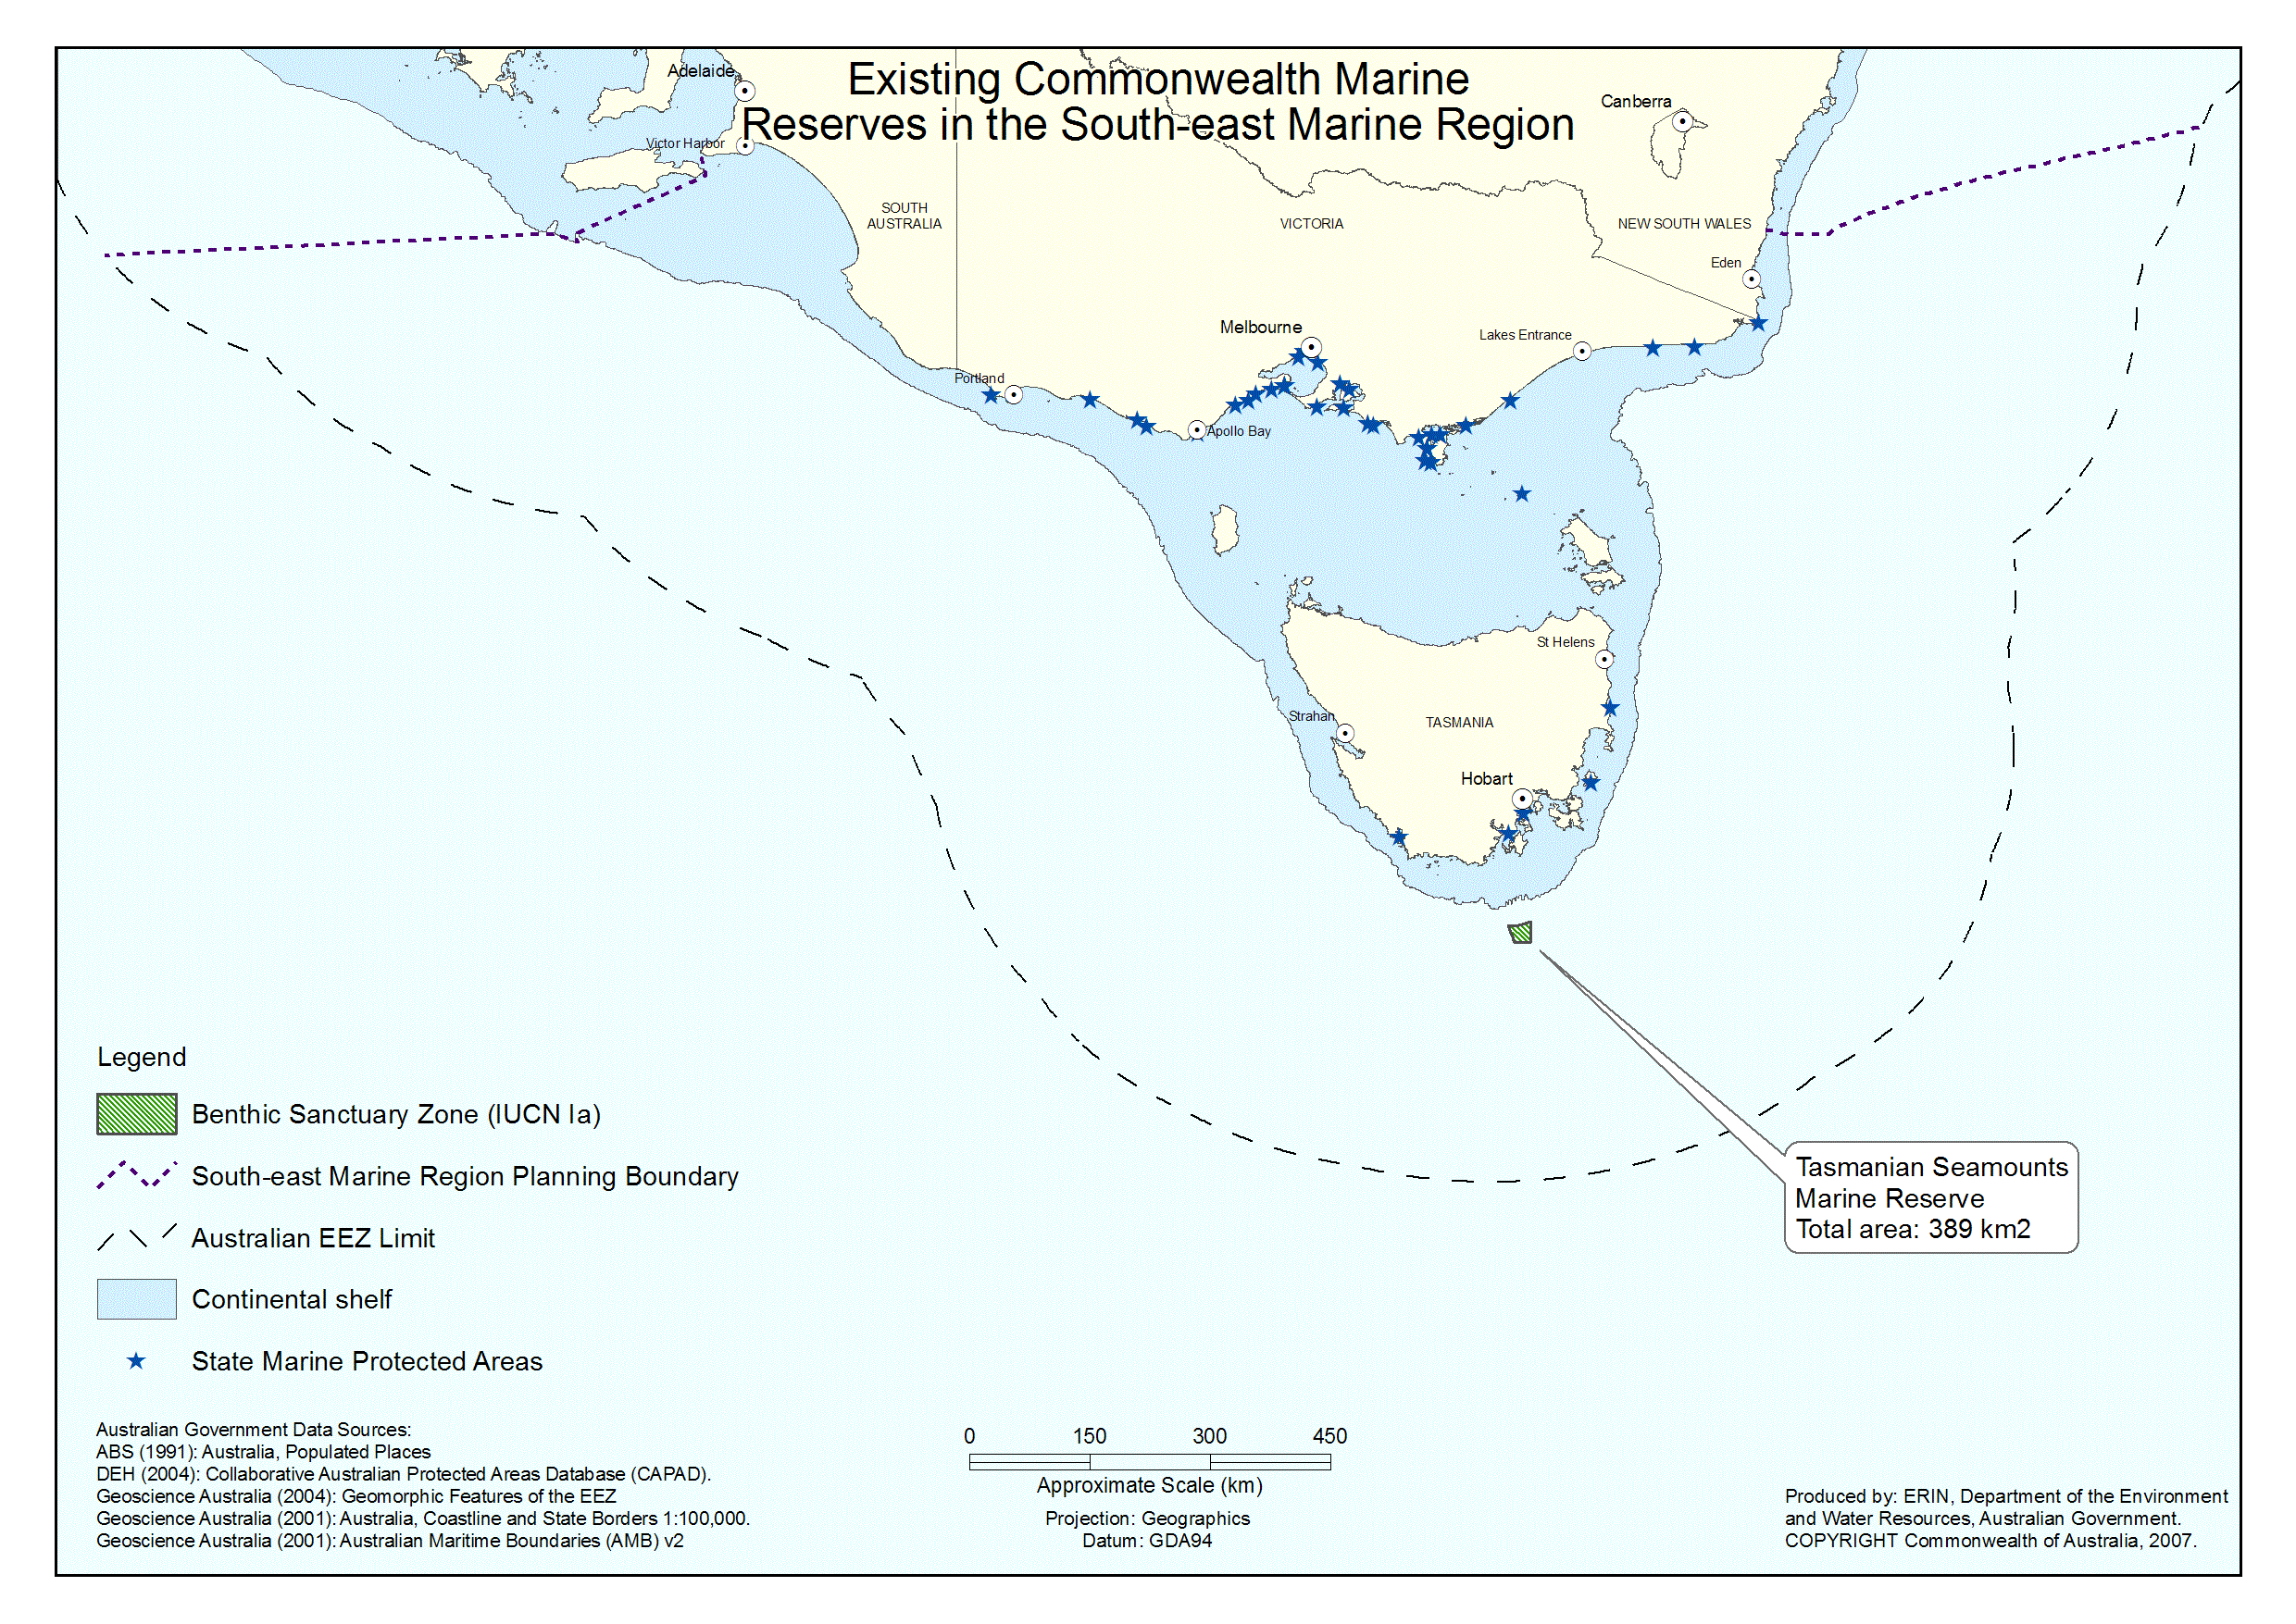
Figure 2: Option 1 – Existing reserves in the South-east Marine bioregion (excludes the existing Macquarie Island Marine Reserve)

  - Option 2: December 2005 Draft Proposal

This option (see Figure 3) is the draft proposal put forward by the Australian Government on 14 December 2005.
Figure 3: Option 2 – December 2005 Draft Proposal (excludes the existing Macquarie Island Marine Reserve)

This proposed network would include an area of 171,000 km² and is comprised of 14 individual CMRs.

This CMR network was developed using seafloor features as surrogates to represent the diversity of habitats in the region. Table 2 shows that many of the key seafloor features recognised as being reservoirs of biodiversity are significantly represented in the CMR network proposed under Option 2. For example 64% of seamounts, 20% of canyons, 6% of shelf and 19% of slope of the South-east Marine region are represented in the CMR network under this option. The network, under option 2 would intersect with a number of human uses in the region including the shipping, tourism, oil and gas and fishing sectors.

Under this proposal individual reserves or zones within the new reserves would be managed according to one of the three management regimes as outlined below. Each of these zones would also be assigned to a category as outlined by the international zoning system described by the World Conservation Union (IUCN).

1. Strict nature zone (IUCN category Ia)
Scientific reference site for research and monitoring as well as appropriate passive use by the public.

2. Managed Resource Protected Zone (IUCN category VI)
Recreational and charter fishing, oil and gas exploration and associated activities, geo-sequestration of carbon, and some forms of commercial fishing excluding demersal trawl, Danish Seine, mesh netting, demersal longline and scallop dredge permissible.

3. Habitat Protection Zone (IUCN category VI)
Recreational and charter fishing, oil and gas exploration and associated activities, geo-sequestration of carbon all permissible. No commercial fishing allowed.

  - Option 3: the Final South-east CMR Network released for comment in October 2006.

This option (see Figure 4) is the latest proposal put forward by the Australian Government. The network would include an area of 226 458 km² and is comprised of 13 individual marine protected areas.

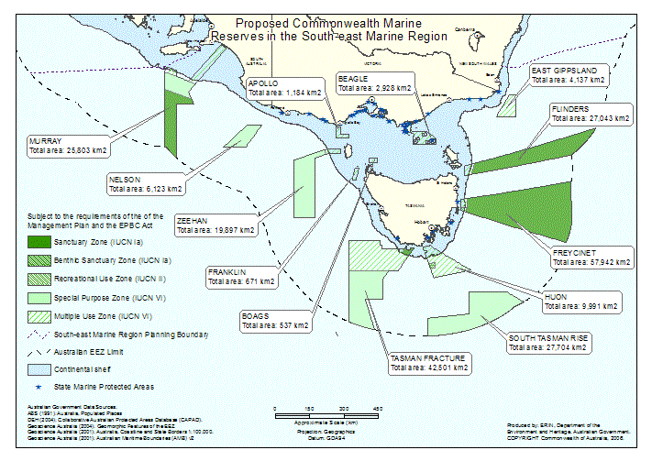
Figure 4: Option 3 – Oct 2006 Final Proposal (excludes the existing Macquarie Island Marine Reserve

In developing the final proposal key stakeholder groups were invited to provide comment and offer viable and constructive alternatives to the proposed network (Option 2). The details of the consultation process and the resulting outcomes are discussed in more depth in Section 5.0, but the most significant changes include a 24% increase in the area protected by the network and a more than 90% reduction to the impact of the network on the commercial fishing sector.

As with option 2, this CMR network was developed using seafloor features as surrogates to represent the diversity of habitats in the region. Table 3 shows that many of the key seafloor features recognised as being reservoirs of biodiversity are significantly represented in the CMR network proposed under Option 3. For example 81% of seamounts, 21% of canyons, 8% of shelf and 27% of slope of the South-east Marine region are represented in the CMR network under this option. The network, under option 3 would intersect with a number of human uses in the region including the shipping, tourism, oil and gas and fishing sectors.

This option has five different zone classes. The key difference to the December 2005 proposal is the inclusion of two new management zones to account for specific management issues and a change to the types of commercial fishing gears allowed in the multiple use areas. The names of the management zones have also been changed to better reflect the activities allowed within them.

The major differences in the boundaries of the reserves between Option 2 and Option 3 are:
- The reserves of Freycinet and Flinders replace the Banks Strait and offshore seamount north;
- The inshore area of Murray CMR has been moved to include a larger transect of the continental shelf;
- The Cascade Seamount reserve has been removed;
- The South Tasman Rise reserve has been extended; and
- The boundary of the Huon reserve has been significantly altered.

There has also been significant change to the zoning plan for the reserves.

1. Sanctuary zone (IUCN category Ia)

Scientific reference site for research and monitoring as well as appropriate passive use by the public.

2. Benthic sanctuary zone (IUCN category 1a)

Prohibits any extractive use in the area from 500 metres below sea level to 100 metres below the seabed. Commercial and recreational fishing activities are allowed in the area between the sea surface and 500 metres depth.

Retains the same zoning as the old Tasmanian Seamount reserve.

3. Recreational use zone (IUCN category II)

The recreational use zone will allow recreational activities including recreational and charter fishing. No commercial fishing or oil and gas exploration permitted.

4. Multiple use zone (IUCN category VI)

Recreational and charter fishing, oil and gas exploration and associated activities, geo-sequestration of carbon, and some forms of commercial fishing excluding demersal trawl, Danish Seine, mesh netting and scallop dredge permissible.

5. Special Purpose Zone (IUCN category VI)

Recreational and charter fishing, oil and gas exploration and associated activities, geo-sequestration of carbon all permissible. No commercial fishing allowed.

- IMPACT ANALYSIS (COSTS AND BENEFITS) OF EACH OPTION
  - Impacts of Option 1: Status Quo
The implementation of this option will have no new impact on marine resource uses, resources or regulatory authorities. However, failure to establish a system of CMRs in the South-east Marine Region will have a number of consequences that should be taken into consideration.
Australia has global and domestic responsibilities to protect and conserve our marine environment. MPAs are needed to adequately protect the different types of marine environments in the South-east Marine Region. Under this option Australia will fail to meet our international and domestic obligations including:
  - The National Representative System of Marine Protected Areas
  - The Convention on Biological Diversity

Potential Costs
- A wide range of scientific studies have illustrated and discussed the potential benefits of MPAs in Australia and throughout the globe. These studies show that properly designed and managed MPAs play important roles in:
  - conserving representative samples of biological diversity and associated ecosystems;
  - protecting critical sites for reproduction and growth of species;
  - protecting sites by minimising direct human impact to help them recover from other stresses such as increased ocean temperature;
  - protecting settlement and growth areas for marine species so as to allow for the migration of marine species from the MPAs into areas adjacent to the MPAs where they are available to be accessed by different users groups in increased numbers;
  - providing focal points for education about marine ecosystems and human interactions with them;
  - providing sites for nature-based recreation and tourism; and
  - providing undisturbed control or reference sites serving as a baseline for scientific research and for design and evaluation of management of other areas.
- Failure to implement MPAs is likely to reduce the overall effectiveness of existing sustainability measures for the marine environment in the long term. In the absence of MPAs there is an unacceptably high risk that potentially harmful impacts on marine species and ecosystems will not be reduced.
- Failure to alleviate growing pressure on marine resources is likely to result in a continual trend of environmental degradation. Excessive resource consumption will lead to a decrease in the conservation value of the region and in the long-term may have economic consequences for industry and may result in a reduction of community amenity due to reductions in ecosystem health and resilience.

Potential Benefits
- No increase in regulatory or administrative burden to marine resource users and management agencies.
  - Impacts of Option 2: December 2005 Draft Proposal
The implementation of this option would see the declaration of 14 new CMRs under section 344 of the EPBC Act (see Figure 2). Within a reserve commercial activities may be allowed under permit or determination from the Director of National Parks or as provided for under a management plan if it can be demonstrated that the activity is not incompatible with the natural and cultural values of the reserve. The zoning arrangements identify human uses that are generally assessed as being compatible with the primary objective of biodiversity conservation.

Table 1: Costs and Benefits of Option 2 by Sector
Sector | Potential Costs | Potential Benefits
Conservation | None identified | Significant protection of key conservation values of the South-east marine region under the EPBC Act.  The creation of the network will be a major contribution to national conservation goals through the NRSMPA.  The creation of the network will promote the long-term sustainable use of the region’s natural resources.
Tourism | Minimal impact – permits or approvals* may be required for tourism related activities in the SE CMRs. | Increased promotional opportunities associated with activities in CMRs.
Oil and Gas | Minimal impact - the EPBC Act recognises existing exploration and production rights. However, the EPBC Act provides that mining operations in Commonwealth reserves must be in accordance with a plan of management in operation for the reserve or in the absence of a management plan under an approval by the Director of National Parks. Permits or approvals* may be required for oil and gas activities within the CMR network. There is a risk that permits/approvals may not be issued where the proposed activity is not compatible with protection of the conservation values of the reserve. | There are no current or prospective oil and gas leases within the no-take zones identified in this draft proposal for a CMR network.
Shipping | Minimal impact – permits or approvals* may be required for shipping related activities. | None identified
Science | Minimal impact – permits or approvals* will be required for science related activities in the SE CMRs | Subject to the restrictions of the management plan and the availability of resources, MPAs may provide opportunities and funding for research.
Recreational and Charter Fishing | Minimal impact – permits or approvals* may be required under the plan of management for charter fishing activities in the SE CMRs. Recreational and charter fishing activities will not be permitted in strict nature zones. The impact is likely to be low as most of the CMRs are located in waters not used for these activities. | The removal of commercial fishing effort from areas may increase fish numbers available to recreational and charter operators.  Some research indicates that reserves may cause an increase in fish size and numbers in adjacent waters although there is not scientific consensus on this and the results vary depending on the characteristics of individual species.
Commercial Fishing | $11.6 Million displaced GVP annually. Attachment B illustrates a breakdown of these impacts by reserve and fishery. Permits or approvals* will be required for commercial fishing activities in the SE CMRs.  A fishing industry structural adjustment package** has been implemented to allow Commonwealth commercial fishers impacted by the implementation of the SE CMR network to leave the industry. | The creation of a CMR network is likely to reduce pressure on commercially targeted fish stocks.  The protection of biodiversity in CMRs may increase the health and abundance of fish stocks.
Australian Government | Costs of managing CMR network.  Potential cost should structural adjustment assistance be provided to industry under the Australian Government’s Policy Statement on Marine Protected Areas and Displaced Fishing | The Australian Government’s domestic and international policies and commitments are met.
*The DEW is still consulting with various user groups on the need for approvals or permits. It is the responsibility of the Director of National Parks (DNP), under the EPBC Act to administer, manage and control Commonwealth reserves. The DNP is conscious of the increased regulatory burden imposed on users by the introduction of Commonwealth reserves and therefore is committed to implementing systems to minimise the costs and administrative burden on operators. The application of these instruments has not yet been finalised although it is the intention to implement permits and approvals at no financial cost to users and to issue them for an extended period of time (potentially the 10 year life of the management plan). DEW is also working to reducing the administrative burden of systems by, where possible, using systems already in place by other government organisations to provide for data collection, compliance and enforcement services etc.

** Commonwealth commercial fishermen impacted by the creation of the SE CMRs were able to apply for assistance under the Australian Government’s $220 Million Securing Our Fishing Future structural adjustment programme. This programme supported major fisheries management reform including adjustment arising from the establishment of the SE CMRs. The release of the draft SE CMR network (Option 2) in December 2005 coincided with the announcement of this adjustment package and the final SE CMR candidate boundaries (Option 3) where released prior to applicant having to submit their final tender documents. All holders of Commonwealth fishing entitlements were invited to apply to be part of this adjustment programme and those impacted by the SE CMR were given a competitive advantage of up to 10%. The adjustment program was an open tender process. More information on the programme can be found at http://www.affa.gov.au/content/output.cfm?ObjectID=62D813A5-CA2D-4485-A9EDC36F7D701A2B&contType=outputs

An analysis of the proportion of geomorphic features included in the South-east CMR Network described in this option is provided in Table 2. Geomorphic features have been used as a surrogate for identifying large scale patterns of biodiversity. The table also includes a breakdown of MPA areas for each zone category.

Table 2: December 2005 Proposal: CMR Area by Broad Feature Category, Specific Feature Type and Zone Category
Broad Feature Category* | Total Area (km²) | MPA area (km²) | % in Region
Shelf | 181,476 | 11,128 | 6.13%
Slope | 430,414 | 84,949 | 19.74%
abyssal-plain/deep ocean floor | 545,226 | 77,079 | 14.14%
Total | 1,157,116 | 173,156† | 14.96%
Specific Feature Type* | Total Area (km²) | CMR Area (km²) | % in Region
shelf | 91,106 | 4,288 | 4.71%
slope | 249,985 | 48,880 | 19.55%
abyssal-plain/deep ocean floor | 539,335 | 73,224 | 13.58%
bank/shoals | 1,341 | 0 | 0.00%
basin | 23,693 | 1,820 | 7.68%
canyon | 40,193 | 7,949 | 19.78%
deep/hole/valley | 21,010 | 1,451 | 6.91%
escarpment | 5,809 | 804 | 13.83%
knoll/abyssal-hills/hills/mountains/peak | 7,173 | 2,574 | 35.89%
pinnacle | 733 | 510 | 69.60%
plateau | 98,570 | 11,610 | 11.78%
ridge | 5,845 | 4,197 | 71.80%
saddle | 30,443 | 4,351 | 14.29%
seamount/guyot | 9,088 | 5,855 | 64.42%
sill | 2,629 | 1,315 | 50.04%
terrace | 22,335 | 2,214 | 9.91%
tidal-sandwave/sand-bank | 5,740 | 979 | 17.06%
trench/trough | 2,088 | 1,135 | 54.37%
Total | 1,157,116 | 173,156† | 14.96%
* Each ‘Broad Feature Category’ listed here includes a number of ‘Specific Feature Types’ from the following section of the table – i.e. the area figures for the shelf ‘Broad Feature Category’ include the entire shelf ‘Specific Feature Type’ in addition to a number of other ‘Specific Feature Types’ found within shelf ‘Broad Feature Category’ boundaries.
† This figure includes an area of a proposed MPA that falls outside of the South-east Marine Region’s borders. The total area of MPAs within the South-east Marine Region is 171,000km²
  - Impacts of Option 3: October 2006 Final Proposal
The implementation of this option will see the declaration of 13 CMRs under section 344 of the EPBC Act. Within a reserve all commercial activities may be allowed under permit or determination from the Director of National Parks or as provided for under a management plan if it can be demonstrated that the activity is not incompatible with the natural and cultural values of the reserve. The zoning arrangements identify human uses that are generally assessed as being compatible with the primary objective of biodiversity conservation.

Table 3: Costs and Benefits of Option Three by Sector
Sector | Potential Costs | Potential Benefits
Conservation | Reduced level of sanctuary zones on shelf and upper slope environments compared to Option 2. | 20% of the Region would be protected in CMRs under the EPBC Act.  The CMRs will be a major contribution to national conservation goals through the NRSMPA.  The CMRs will help promote the long-term sustainability of the region.
Tourism | Minimal impact – permits or approvals* may be required for tourism related activities in the SE CMRs. | Increased promotional opportunities associated with tourism activities within the CMRs.
Oil and Gas | Minimal impact - the EPBC Act recognises existing exploration and production rights. However, the EPBC Act provides that mining operations in Commonwealth reserves must be in accordance with a plan of management in operation for the reserve or in the absence of a management plan under an approval by the Director of National Parks. Permits or approvals* may be required for oil and gas activities within the CMR network. There is a risk that permits/approvals may not be issued where the proposed activity is not compatible with protection of the conservation values of the reserve. | No Impact – there are no current or prospective oil and gas leases identified within the no-take zones identified in this final proposal for a CMR network.
Shipping | Minimal impact – permits or approvals* may be required for shipping related activities. | None identified
Science | Minimal impact – permits or approvals* will be required for science related activities in the SE CMRs | Subject to the restrictions of the management plan, MPAs may provide opportunities and funding for research.
Recreational and Charter Fishing | Minimal impact – permits or approvals* may be required under the plan of management for charter fishing activities in the SE CMRs. Recreational and charter fishing activities will not be permitted in strict nature zones. The impact is likely to be low as most of the CMRs are located in waters not used for these activities.. | The removal of commercial fishing effort from areas may increase fish numbers available to recreational and charter operators.  Some research indicates that reserves may cause an increase in fish size and numbers in adjacent waters although there is not scientific consensus on this and the results vary depending on the characteristics of individual species.
Commercial Fishing | $0.9 Million displaced GVP annually. Attachment B illustrates a breakdown of these impacts by reserve and fishery. This amount of displacement equates to less than 1% the total value of the fisheries in the region so much that there was no need to adjust annual catch levels to account for this displacement and operators can continue to catch their historical catch levels in other parts of the region.  Permits or approvals* will be required for commercial fishing activities in the SE CMRs.  A fishing industry structural adjustment package** has been implemented to allow Commonwealth commercial fishers impacted by the implementation of the SE CMR network to leave the industry. | MPAs may help reduce pressure on commercially targeted fish stocks by increasing the health and abundance of fish stocks.
Australian Government | Costs of managing MPA network. | The Australian Government’s domestic and international policies and commitments are met.
*The DEW is still consulting with various user groups on the need for approvals or permits. It is the responsibility of the Director of National Parks (DNP), under the EPBC Act to administer, manage and control Commonwealth reserves. The DNP is conscious of the increased regulatory burden imposed on users by the introduction of Commonwealth reserves and therefore is committed to implementing systems to minimise the costs and administrative burden on operators. The application of these instruments has not yet been finalised although it is the intention to implement permits and approvals at no financial cost to users and to issue them for an extended period of time (potentially the 10 year life of the management plan). DEW is also working to reducing the administrative burden of systems by, where possible, using systems already in place by other government organisations to provide for data collection, compliance and enforcement services etc.
** Commonwealth commercial fishermen impacted by the creation of the SE CMRs were able to apply for assistance under the Australian Government’s $220 Million Securing Our Fishing Future structural adjustment programme. This programme supported major fisheries management reform including adjustment arising from the establishment of the SE CMRs. The release of the draft SE CMR network (Option 2) in December 2005 coincided with the announcement of this adjustment package and the final SE CMR candidate boundaries (Option 3) where released prior to applicant having to submit their final tender documents. All holders of Commonwealth fishing entitlements were invited to apply to be part of this adjustment programme and those impacted by the SE CMR were given a competitive advantage of up to 10%. The adjustment program was an open tender process. More information on the programme can be found at http://www.affa.gov.au/content/output.cfm?ObjectID=62D813A5-CA2D-4485-A9EDC36F7D701A2B&contType=outputs

An analysis of the proportion of geomorphic features included in the South-east Network of CMRs described in this option is provided in Table 4. Geomorphic features have been used as a surrogate for large scale patterns of biodiversity. The table also includes the proportion of shelf and off-shelf areas in each zone category.

Table 4: Option Three Final proposal: CMR Area by Broad Feature Category, Specific Feature Type and Zone Category
Broad Feature Category* | Total Area (km²) | MPA Area (km²) | % of Region
shelf | 181,477 | 14,933 | 8.23%
slope | 430,416 | 112,956 | 26.24%
abyssal-plain/deep ocean floor | 545,226 | 98,362 | 18.04%
Total Area km² | 1,157,119 | 226,251 | 19.55%
Specific Feature Type* | Total Area (km²) | MPA Area (km²) | % of Region
shelf | 91,107 | 6,599 | 7.24%
slope | 249,986 | 68,001 | 27.20%
abyssal-plain/deep ocean floor | 539,335 | 92,768 | 17.20%
bank/shoals | 1,341 | 0 | 0.00%
basin | 23,693 | 1,761 | 7.43%
canyon | 40,195 | 8,399 | 20.89%
deep/hole/valley | 21,010 | 1,732 | 8.24%
escarpment | 5,809 | 330 | 5.68%
knoll/abyssal-hills/hills/mountains/peak | 7,173 | 2,673 | 37.27%
pinnacle | 733 | 381 | 51.98%
plateau | 98,570 | 17,706 | 17.96%
ridge | 5,845 | 4,959 | 84.84%
saddle | 30,443 | 5,712 | 18.76%
seamount/guyot | 9,088 | 7,396 | 81.39%
sill | 2,629 | 1,315 | 50.04%
terrace | 22,335 | 3,978 | 17.81%
tidal-sandwave/sand-bank | 5,740 | 454 | 7.91%
trench/trough | 2,088 | 2,088 | 100.00%
Total Area km^{2 *} | 1,157,119 | 226,251 | 19.55%
* Each ‘Broad Feature Category’ listed here includes a number of ‘Specific Feature Types’ from the following section of the table – i.e. the area figures for the shelf ‘Broad Feature Category’ include the entire shelf ‘Specific Feature Type’ in addition to a number of other ‘Specific Feature Types’ found within shelf ‘Broad Feature Category’ boundaries.
  - Impacts Summary and Comparative Analysis
The only sector identified as being subject to significant negative impacts as a result of the declaration of a South-east CMR Network is the commercial fishing sector. Attachment B provides a spatial analysis of the economic impacts of the marine reserve networks presented in both Option 2 and Option 3 on the commercial fishing industry. A similar summary table was not produced for the other stakeholder groups as there were no likely economic impacts on other industries.

This analysis shows that under Option 2 , based on mean-annual data adjusted for projected 2007 catch quotas (set by the Australian Fisheries Management Authority for Commonwealth managed fisheries), the total gross value of production (GVP) for Commonwealth and State Fisheries that would be displaced by the implementation of this option is $11.6 Million annually. However the total GVP that would be displaced in Commonwealth fisheries under Option 3 is $785,857annually. In state fisheries the annual displacement would be <$85,000 GVP.

The reduction in impact between the two methods was a result of several modifications including:
- The removal of the Cascade reserve which allows ongoing fishing for orange roughy;
- The replacement of the Banks Strait reserve with the Flinders and Freycinet reserves, which reduced the impact on scallop fisheries;
- The altered zoning of the Tasman Fracture reserve to minimise the impact of Blue eye trevalla catches; and
- The redesign and altered zoning of the Murray reserve to allow harvest of rock lobsters.

Option 3 also includes a superior level of protection for the marine environment in some significant areas. This option is 30% larger than Option 2, contains more areas of biodiversity significance and has a significantly reduced impact on the fishing industry. All but one of the 18 identifiable geomorphic features of the South-east is included in the MPA network. Only banks, shoals – a feature predominantly in State waters – is not represented. The network includes five of the 18 geomorphic features represented by more than 50% of their area. For example, almost 21% of canyons and 81% of seamounts in the region are included in the reserves. As shown in Tables 3 and 4, the area of continental shelf and seamounts protected by Option 3 (14,933 km² and 7,396 km² respectively) is greater than that of Option 2 (11,128 km² and 5,855 km²).

The main criticism of Option 3 relates to the number and size of sanctuary zones on the continental shelf and upper slope. Option 2 outperforms Option 3 in providing for no take zones in these inshore areas. This change accounts for a significant portion of the difference between fisheries displacement values between Options 2 and 3.

Option 3 is regarded as the preferred configuration for a South-east CMR Network as it best meets the objectives of the South-east CMR Network as outlined in Section 2 of this Regulatory Impact Statement.

- CONSULTATION
Since the outset of the South-east CMR development process, the Department has been involved in a highly consultative approach involving detailed discussions with a range of stakeholder groups on MPA development policy, reserve design, and social and economic impacts. The key stakeholders include the oil and gas industry, the commercial fishing industry, the conservation sector, recreational fishing groups and scientific organisations. Relevant Commonwealth and State government agencies were also consulted extensively.

The former Minister for the Environment and Heritage released a candidate CMR network on 14 December 2005 for public comment. This draft network was developed by the Australian Government based on the South-east User Guide and design specifications, previously identified Broad Areas of Interest and input from stakeholders over the preceding three years. All interested stakeholder groups were invited to give feedback and provide alternative suggestions that would meet the specifications by the end of March 2006. Sixteen submissions were received from industry, conservation groups, scientists and members of the community. An overview of the submissions received is provided in Section 5.1.

In addition to these submissions, the Scientific Peer Review Panel has provided advice on the conservation value of the network, and the Bureau of Resource Sciences (BRS) and the Tasmanian Aquaculture and Fisheries Institute (TAFI) have analysed the socio-economic impacts of the proposed network.

Based on the comments received during public consultation, further discussions with stakeholder representatives and scientific advice, the Government finalised the MPA network. It was announced by the then Minister for the Environment and Heritage in May 2006, bringing an end to the pre-statutory consultation process for the South-east CMR Network. One further change was made to the zoning within the proposed Freycinet CMR in response to representations from the recreational fishing sector.

Section 351 of the EPBC Act requires a statutory consultation period prior to the declaration of any CMRs. On 24 October 2006 a notice inviting comment on the proposed CMRs was gazetted and advertised in national and regional newspapers. Interested persons were also contacted directly and invited to comment on the proposal. This consultation provided the opportunity for stakeholders and members of the public to further comment on the proposed CMRs. An overview of submissions received during this consultation phase is provided in Section 5.2. The Director of National Parks will prepare a report which includes the submissions received and his views on the issues raised in them. This report will be considered by the Minister for the Environment and Water Resources and if he is satisfied with the recommendations of the Director on National Parks he will recommend the proclamation be made by the Governor-General in Council.

The statutory process for declaration of the CMR network as marine reserves under the EPBC Act is expected to be completed by May 2007.

Consultative forums and networks

The key stakeholder forums consulted in relation to CMRs include:
- Commonwealth Marine Protected Areas Committee – an interdepartmental forum for Commonwealth agencies to provide input to the CMR development process and integrate complementary marine environment management objectives, such as spatial management of fisheries and CMRs;
- Commonwealth Marine Protected Areas Stakeholder Reference Group: a forum for bringing together the expertise and views of non-government stakeholders into Commonwealth policy for CMR development;
- Natural Resource Management Ministerial Council’s Taskforce on MPAs: a forum for relevant Commonwealth, Territory and State agencies to progress the development of the NRSMPA;
- South-east Marine Plan Working Group: a forum made up of representatives from key stakeholder groups in the South-east Marine Region to assist in the development of the South-east Regional Marine Plan;
- South-east Marine Region CMR Focus Group: a small sub-group of the Stakeholder Reference Group and SERMP Working Group to provide expert advice on the detailed outputs and process for broader consideration by the broader stakeholder forums; and
- The Fishing Industry South-east MPA Working Group.

As well as these forums, the Department has funded two liaison positions/projects – one for the commercial fishing sector and one for the conservation sector. These positions helped to strengthen the capacity of these sectors to engage in the MPA development process. Support was also provided to the recreational fishing sector to assist it in its engagement in the MPA development process.

  - Stakeholder views on the draft MPA network as proposed in December 2005 (Option 2)

(i) Fishing industry

The fishing industry reacted strongly against the network presented in Option 2. Of most concern were the zoning in the Murray CMR which would impact on the South Australia rock lobster industry, and the proposed Banks Strait CMR, which would significantly impact on the Tasmanian scallop industry and the Commonwealth small pelagics fishery. The proposed CMR over the Cascade seamount was also rejected by the industry on the grounds that the area is extensively trawled and that the primary target species on this seamount (orange roughy) is already under a management regime administered by the Australian Fisheries Management Authority. The Banks Strait CMR along with the proposed Tasman Fracture CMR would significantly impact catches of the blue eye trevalla due to the proposed strict nature zones and the exclusion of auto-longlining and demersal longlining from multiple use areas.

The industry also criticised what it viewed as a resource allocation from commercial to recreational fishing through the proposed Habitat Protection Zones. This issue was more one of principal than actual impact, as all areas zoned this way were beyond the reach of most recreational fishermen.

(ii) Recreational fishers
Representatives of recreational fishing associations did not express any objection to the proposed network.

(iii) Conservation groups

The World Wildlife Fund (WWF) generally supported the CMR network presented in Option 2, but highlighted a number of areas where it believed improvement was needed, including the following recommendations:
- The network should include additional areas on the continental shelf and upper slope, including extended protection of the Commonwealth waters into which the Murray River flows;
- The proposed Habitat Protection Zones should exclude both recreational and commercial fishing; and
- The network should provide some protection to key upwelling features, in particular the Nelson CMR should be extended to include part of the Bonney Upwelling on the continental shelf.

Other conservation groups such as the Australian Marine Conservation Society (AMCS), the Nature Conservation Council of New South Wales, the Australian Conservation Foundation and the Wilderness Society were of the view that the proposal would fail to conserve the marine environment. They argued that an adequate outcome would only be achieved with substantial areas (at least 20-50% of all habitat types) set aside as ‘no-take’ (IUCN category Ia). They also argued that the protection of the continental shelf and key fish breeding areas was inadequate. The AMCS recommended that the Broad Areas of Interest originally identified to guide the location of the MPAs should become the CMR network.

(iv) Oil and gas industry

The Australian Petroleum Production and Exploration Association (APPEA) indicated broad support for the CMR network presented in Option 2, noting that oil and gas interests in the Region would not be significantly impacted by the proposed CMRs. The draft zoning policy released with the candidate CMR network allows for oil and gas exploration and development in areas of potential prospectivity. Despite this, industry would not support CMRs covering leases and prospective areas.

(v) Independent Scientists

There was a wide range of views from independent scientists on Option 2. There was general support for the process of developing a NRSMPA network based on the principles of being comprehensive, adequate and representative of the region as a whole but there was some criticism about a lack of representation of shallow water ecosystems (shelf and slope) as no-take zones, lack of representation of productive fishing areas and some concerns over the use of geomorphological features as a surrogate for habitat types. The CSIRO Marine and Atmospheric Research submitted specific proposals to expand the candidate CMR network.

  - Stakeholder views on the proposed final MPA network (Option 3)
(i) Commercial fishing industry

The commercial fishing industry was largely supportive of the proposed network. Opposition was expressed to the zoning of the south-western corner of the Freycinet CMR which allows recreational fishing but not commercial fishing using the same techniques. This was seen a resource allocation to the recreational fishing sector. Concern was also raised over the process of adjustment assistance.

(ii) Recreational and charter fishers

Prior to the release of the notice inviting comment in October 2006 concerns were raised by the recreational fishing sector over access to Freycinet CMR. These concerns were based on the displacement of recreational effort in a regionally important area of Coles Bay and Swansea. This zoning was subsequently amended to allow recreational fishing in the south-west corner of this reserve.

Following this amendment comments received by the recreational and charter fishing sectors were supportive of the proposed network.

(iii) Conservation groups

Comments received from conservation groups were generally not supportive of the proposed network. The submissions suggested that the network was inadequate in providing protection of the continental shelf and upper slope regions. They also claimed that the network was inadequate at providing protection for sites of high conservation significance. A lack of protection for protected species was also suggested.

All comments received from conservation groups concluded that the intent to provide a network that was comprehensive, adequate and representative had not been met.

(iv) Oil, gas and shipping industry

All comments received were fully supportive of the proposed network and thought that the network struck an appropriate balance between conservation and resource use.

(v) Independent Scientists

Comments received by the scientific community were generally not supportive of the proposed network. Submissions received criticised the lack of sanctuary zones for shelf and slope habitats, a lack of representation of productive fishing areas, and a perceived failure of the reserves to meet the stated objective of being comprehensive, adequate and representative of the South-east area as a whole.

There was also concern expressed that the consultation on the development of the reserves appeared to consist largely of discussions with industry and lacked the ongoing engagement of the scientific community. A perceived lack of recognition of MPAs as a fisheries management tool was also raised.

- CONCLUSION

Option 3 is the Australian Government’s preferred option. It is considered a well balanced network that meets the conservation goals set out in the Guidelines for Establishing the National Representative System of Marine Protected Areas while at the same time minimising the impacts on the marine industries of the South-east Marine Region. It is a stronger option than Option 2 from the perspectives of both biodiversity conservation and industry development.

Option 3 provides a representative selection of CMRs that will fulfil the Australian Government’s domestic and international obligations in the South-east Marine Region. Additionally, the consultation process that was conducted following the release of Option 2 in December 2005 has secured significant industry support for Option 3 – a factor that will be important in securing on-going support for compliance and enforcement, research and monitoring of the network.

The status quo option to not deliver a CMR network in the South-east would represent a major policy failure for the Australian Government and as a result Australia would not meet its domestic and international commitments. Whilst under the status quo there is no additional regulatory burden on users of the South-east Marine Region, failure to implement a South-east CMR network would reduce the ability of the Australian Government to protect the integrity and long term ecological integrity of Australia’s marine ecosystems, which may result in serious economic and social consequences as resources are depleted and the environment degraded.

- IMPLEMENTATION AND REVIEW

Implementation
The statutory implementation of the preferred option is a two phase process involving the declaration of the CMRs followed by development of a management plan for the reserves. The statutory processes involved in declaring CMRs and developing management plans is provided in Attachment C.

The declaration process for the South-east Network of CMRs is expected to be completed by around May 2007. Following the declaration, but prior to the implementation of a management plan, interim management arrangements will be put in place by the Director of National Parks to ensure that industry uses that are allowed under the proposed zoning arrangements can continue where this is consistent with the protection of the conservation values for which the reserves have been established.

Awareness and Education Programs
Community and industry awareness and education of management arrangements and reserve values for the South-east CMR Network will be addressed using a variety of media including those listed below:
- National and regional newspapers will be used to inform stakeholders and the general public of critical/key stages in the process including advising of the intention to prepare a management plan and the release of a draft management plan for public comment;
- The Department’s web site contains a large variety of information about the South-east network of Commonwealth Marine Reserves including park specific information;
- An appropriate consultation mechanism will be established with stakeholders;
- A database of contacts will be maintained for users approved or permitted to use or access the marine reserve;
- Memorandums of understanding/agreements will be developed with state government agencies to provide on the ground extension and education services; and
- Digital locational data will be made available for down loading into GPS systems and marine plotters.

Compliance and Enforcement Arrangements
Compliance with management arrangements in the South-east CMR Network is a high priority. The Department intends to ensure high levels of compliance using a number of mechanisms.

Regulation will be provided for in the South-east CMR network through a number of means including:
- the EPBC Act;
- the EPBC Regulations;
- Determinations under the EPBC regulations;
- South-east CMR Network Management Plan;
- Approval regime and conditions associated with various approvals; and
- Permits and conditions associated with various permits.

The basic premise of these arrangements is to work co-operatively with stakeholder groups, peak industry bodies, other government agencies and individuals to ensure that reserve values are well known and that compliance with management arrangements is achieved at a reasonable cost, with the minimum necessary burden on stakeholders.

Compliance monitoring and enforcement are proposed to be carried out by surveillance flights, patrol vessels, and specific chartered operations in identified high risk areas. Port inspections of vessels may also be used to ensure compliance with management arrangements. The Department also expects to enter into contractual arrangements with State based agencies to deliver day to day compliance and enforcement services.

Vessel monitoring systems (VMS), where available, are proposed to be used to provide spatial data on the movement of commercial fishing vessels. The Department will negotiate with Australian and state government agencies to secure access to this key compliance monitoring service.

The development of management arrangements for different industries, sectors and stakeholder groups will differ according to the identified risks, potential impacts, and compliance information and data available. Consultation with stakeholder groups will also influence these arrangements.

Compliance and enforcement measures will be introduced in the form of interim management arrangements at proclamation of the new CMRs and then through the provisions of a management plan. The period between proclamation and the implementation of the management plan will be used to continue discussions with stakeholders and refine management arrangements to ensure adequate ongoing compliance with, and enforcement of, these arrangements.

Administrative Impacts on Business

The ongoing administrative impact of these arrangements on business is difficult to assess accurately until the management plan has been developed. The management plan will:
- assign the protected area to an IUCN protected area category;
- state how the protected area is to be managed;
- state how natural and cultural features are to be protected and conserved;
- specify limitations or prohibitions on what the Director or anyone else may do in relation to the area;
- specify any operations or activities that may/may not be carried out;
- indicate generally the activities to be regulated or prohibited and how this will be done; and
- indicate how the plan takes into account relevant international agreements.

The Department has made a commitment to industry to minimise the administrative burden on businesses operating in the area that result from the management arrangements, and is working with industry to ensure that this commitment is achieved. In relation to the fishing industry, the Department has allocated financial assistance to help industry engage effectively in the development of these agreements.

The Department is examining options to introduce streamlined administrative arrangements for the commercial fishing industry, such as by the use of sectoral approvals issued by the Director of National Parks.

Some sectors will still be required to obtain an individual permit to operate in the reserve. Permit applications require some administrative paperwork but are normally provided to operators at no charge. Permits can be issued from between 1 day to the life of the management plan which is up to ten years.

Performance Indicators

The Management Plan produced for the South-east Network of CMRs will establish a number of management objectives for the reserve network and will set out a number of measurable performance indicators that can be used to measure how effective we have been in meeting our management objectives.

These management objectives and indicators will be developed in consultation with stakeholders, who will then be given the opportunity to provide further comment on these along with other elements of the plan through the statutory consultation phases that occur during management plan development as outlined in Attachment C.

Reviewing the Arrangements

Once proclaimed CMRs stay in effect until they are revoked or amended.

Under the provisions of the EPBC Act, Management Plans for Commonwealth Reserves can be in force for up to ten years unless revoked or amended sooner by another management plan. Performance assessment will be carried out during the life of the Plan. Results from the performance assessment program will be used to undertake a review of the management plan approximately two years before its expiry. The review of the plan will take account of all aspects of management, including internal zoning; management actions, rules, policies and indicators; and research priorities. As part of this review consideration will be given to how well the Department has meet the objectives and performance indicators outlined in the management plan, and what new objectives may be appropriate for inclusion in the next management plan.

Attachment A - Summary of IUCN Management Categories
Category Ia Strict Nature Reserve: Protected Area managed mainly for science
Area of land and/or sea possessing some outstanding or representative ecosystems, geological or physiological features and/or species, available primarily for scientific research and/or environmental monitoring.
Category Ib Wilderness Area: Protected Area managed mainly for wilderness protection
Large area of unmodified or slightly modified land and/or sea, retaining its natural character and influence, without permanent or significant habitation, which is protected and managed so as to preserve its natural condition.
Category II National Park: Protected Area managed mainly for ecosystem conservation and recreation
Natural area of land and/or sea, designated to (a) protect the ecological integrity of one or more ecosystems for this and future generations, (b) exclude exploitation or occupation inimical to the purposes of designation of the area and (c) provide a foundation for spiritual, scientific, educational, recreational and visitor opportunities, all of which must be environmentally and culturally compatible.
Category III Natural Monument: Protected Area managed for conservation of specific natural features
Area containing one or more specific natural or natural/cultural feature which is of outstanding value because of its inherent rarity, representative or aesthetic qualities or cultural significance.
Category IV Habitat/Species Management Area: Protected Area managed mainly for conservation through management intervention
Area of land and/or sea subject to active intervention for management purposes so as to ensure the maintenance of habitats and/or to meet the requirements of specific species.
Category V Protected Landscape/Seascape: Protected Areas managed mainly for landscape/seascape conservation and recreation
Area of land, with coast and seas as appropriate, where the interaction of people and nature over time has produced an area of distinct character with significant aesthetic, cultural and/or ecological value, and often with high biological diversity. Safeguarding the integrity of this traditional interaction is vital to the protection, maintenance and evolution of such an area.
Category VI Managed Resource Protected Areas: Protected Area managed mainly for the sustainable use of natural ecosystems
Area containing predominantly unmodified natural systems, managed to ensure long term protection and maintenance of biological diversity, while providing at the same time a sustainable flow of natural products and services to meet community needs.

Attachment B - Spatial Analysis of the Economic Impacts of South-east MPA Network Proposals on Commercial Fishing

The following tables display the expected impact on the annual Gross Value of Production (GVP) for fisheries in each of the individual MPAs that form part of the proposed South-east MPA Networks. Table 1 shows the GVP displaced in Commonwealth waters by the December 2005 draft proposal (Option 2) and Table 2 shows the GVP displaced in Commonwealth waters by the May 2006 final proposal (Option 3).
The actual costs of displacement are difficult to forecast with accuracy, GVP is not equivalent to likely cost of structural adjustment. Structural adjustment costs may be some multiple of GVP. Likewise, GVP is not equivalent to the likely socio-economic impact of the proposals. However, a comparison of displaced GVP can be used to identify the relative impacts of different proposals.

Note that many of the values used in these tables are classified as commercial-in-confidence and have been replaced with an ‘*’. Consequently, many of the figures reported in Section 4 are not reflected in these tables.
Table 1. December 2005 Draft Proposal (Option 2) - Commonwealth Managed Fisheries - $GVP/ann displaced by gear type (2000-2005 average catches adjusted for 2007 TACs)
MPA/zone | Fishing Method² |  |  |  |  |  | TOT GVP Displaced ¹
MPA/zone | bottom longline | dropline | gillnet | otter trawl | Pelagic longline | other | TOT GVP Displaced ¹
Apollo – Via | * |  | * | 115 |  | * | $2,061
- Banks Strait VIa | 175183 | * | * | 150222 | * | * | $325,436
- Banks Strait VIb | 77816 | 231599 | 2134 | 231816 | * | * | $913,384
Banks Strait Total |  |  |  |  |  |  | $1,238,820
Bass Basin - VIb | 15333 |  | 482115 | 4290 |  | * | $501,758
East Gippsland - VIb |  |  | * | 8102 | 50680 | * | $107,856
- Huon Ia |  |  |  | * | 910 |  | $957
- Huon VIa | 65487 | * | * | 64087 | * | * | $129,578
Huon Total |  |  |  |  |  |  | $130,401
• Murray - Ia | * |  | 774 | 890 |  |  | $2,543
• Murray - VIb | 3331 | 4590 | 84614 | 10696 | 14605 | * | $122,444
Murray Total |  |  |  |  |  |  | $124,987
Nelson - VIb | * | * | 248 | 338 |  |  | $624
Offshore Seamnt (Nth) Ia | * | * | * | 10537 |  | * | $30,009
Offshore Seamnt (Sth) TBA | * | * |  | * |  |  | *
South Tasman Rise - VIb |  |  |  | 146 |  | * | $151
• Tasman Fracture - Ia | 31170 | 83586 | 21942 | 23199 | 4287 | * | $164,210
• Tasman Fracture - VIa | 39456 | * | * | 53786 | * |  | $93,243
• Tasman Fracture - VIb | * |  |  | 3754 | * |  | $5,366
Tasman Fracture Total |  |  |  |  |  |  | $262,819
Zeehan - VIb | * | * | * | 26372 |  |  | $33,227
Zeehan (Mid) - VIa | * | * | * | 3004 |  |  | 3004
Zeehan (North-east) - VIa |  |  | * | * |  |  | *
TOTAL of Displaced GVP¹ | 109372 | 61334 | 94543 | 258806 | 7131 | 197 | $2,436,370
REGIONAL total GVP for sector | $2,181,698 | $1,307,611 | $10,763,568 | $54,605,779 | $5,553,382 | $16,343,401 | $90,818,441
% Regional or State GVP Displaced | 5.01% | 4.47% | 0.88% | 0.47% | 0.13% | * | 2.68%
Notes:
1. Totals may include confidential data (*) not disclosed in the table. The total of displaced GVP does not equal the total of each column as not all effort is displaced according to the proposed zoning arrangements. In the example the categories relate to the zoning as described on page 12 as follows:
VIa – Managed Resource Protected Area (commercial fishing allowed except trawl, scallop dredge, mesh net and Danish Seine)
VIb – Habitat Protection zone (no commercial fishing)
1a – Strict nature zone – No take area.
2. Includes catches in several MPAs that would not be open to bottom set longlines/gillnet/trawl under proposed AFMA spatial management regimes for these gear types.

Table 2. Final Proposal (Option 3)- Commonwealth Managed Fisheries - $GVP/ann displaced by gear type (2000-2005 average catches adjusted for 2007 TACs)
MPA/zone | Fishing Method² |  |  |  |  |  | TOT GVP Displaced ¹
MPA/zone | bottom longline | dropline | gillnet | midwater trawl | otter trawl | other | TOT GVP Displaced ¹
Apollo - VIa |  |  |  |  | 2369 | * | $2,369
Bass Basin - VIa |  |  |  |  | 7729 | * | $7,729
East Gippsland - VI a |  |  |  |  | 8350 |  | $8,350
• Flinders - IA | 2721 | 604 | 10392 |  | 399 | * | $14,116
• Flinders – VIa |  |  |  |  | 63751 | * | $63,751
Flinders Total |  |  |  |  |  |  | $77,867
• Freycinet - IA | 14994 | 1824 | 6794 | * | 70360 | * | $121,408
• Freycinet – VIa |  |  |  |  | 49459 |  | $49,459
Freycinet Total |  |  |  |  |  |  | $170,867
Huon - VIa |  |  |  |  | 74921 | * | $74,921
• Murray - IA | * | * | * |  | 611 |  | $1,656
• Murray - VIa |  |  |  |  | 2966 |  | $2,966
• Murray - VIb | * | 3174 | 10975 |  | 1743 | * | $18,050
Murray Total |  |  |  |  |  |  | $22,672
Nelson - VIb | * | 1566 |  |  | 782 |  | $2,348
South Tasman Rise - VIb |  | * | * |  | 1744 | * | $1,826
• Tasman Fracture - IA | 17928 | 17804 | 6669 | * | 2806 |  | $45,207
• Tasman Fracture - VIa |  |  |  |  | 67624 |  | $67,624
• Tasman Fracture - VIb |  |  |  |  | 1792 | * | $1,792
Tasman Fracture Total |  |  |  |  |  |  | $114,623
• Zeehan - VIa |  |  |  |  | 25117 |  | $25,117
• Zeehan - VIb | * |  | 731 |  | 3338 |  | $4,069
Zeehan Total |  |  |  |  |  |  | $29,186
Zeehan (Mid) - VIa |  |  |  |  | 2042 |  | $2,042
Zeehan (North-east) - VIa |  |  |  |  | * |  | $0
TOTAL of Displaced GVP¹ | $37,834 | $25,141 | $36,018 | $0 | $387,903 | $6,429 | $493,325
REGIONAL total GVP for sector | $2,995,047 | $1,114,094 | $10,018,647 | $3,289,809 | $52,822,354 | $14,385,156 | $84,625,107
% Regional or State GVP Displaced | 1.26% | 2.26% | 0.36% | 0.00% | 0.73% | 0.04% | 0.58%
Notes:
1. Totals may include confidential data (*) not disclosed in the table. The total of displaced GVP does not equal the total of each column as not all effort is displaced according to the proposed zoning arrangements. In the example the categories relate to the zoning as described on page 14 as follows:
VIa – Multiple use zone (commercial fishing allowed except trawl, scallop dredge, mesh net and Danish Seine)
VIb – Special purpose zone (no commercial fishing)
1a – Sanctuary zone – No take area.
.
2. Includes catches in several MPAs that would not be open to bottom set longlines/gillnet/trawl under proposed AFMA spatial management regimes for these gear types.

Attachment C - The statutory processes involved in declaring CMRs and developing management plans

Declaration process
The statutory process leading to the declaration of a Commonwealth reserve under the EPBC Act is:

1. The Director of National parks publishes a notice inviting the public to comment on the proposal to declare a Commonwealth reserve over the area, allowing a minimum period of 60 days for comments. This notice includes a statement of the proposed name of the reserve, the proposed boundaries of the reserve and any zones within the reserve, the purpose for which the reserve is to be declared, the IUCN category that the reserve (and any zones) will be assigned to, and the purposes for which it is intended to manage and use the reserve.

2. Any native title holders, registered native title claimants and native title representative bodies for the area are notified of the proposed declaration, and given an opportunity to comment, in accordance with the requirements of the Native Title Act 1993.

3. The Director of National Parks provides the Minister for The Environment and Water Resources with a report on the Commonwealth reserve proposal. The report must include any comments received and the Director’s views on the comments.

4. If necessary a Regulation Impact Statement examining any impacts that declaration of the proposed Commonwealth reserve would have on business is prepared and provided to the Office of Regulation Review.

5. The Minister for The Environment and Water Resources considers the report from the Director of National Parks.

6. The Minister decides not to proceed
OR
The Minister is satisfied a reserve should be established and the Governor-General is advised accordingly.

7. The Governor-General makes a Proclamation declaring the area to be a Commonwealth reserve. The Proclamation: names the reserve; states the purposes for which it is declared; states the depth of any seabed included in the reserve; and, assigns the reserve to an IUCN category.

8. The Proclamation comes into effect when registered on the Federal Register of Legislative Instruments.

Process for making a management plan

1. The Director of National Parks publishes a notice inviting the public to comment on the proposal to prepare a draft management plan within a minimum period of 30 days.

2. The Director of National Parks prepares the draft management plan.

3. The Director of National Parks publishes a notice inviting the public to comment on the draft management plan within a minimum period of 30 days. Any native title holders, registered native title claimants and native title representative bodies for the area are also notified and given an opportunity to comment, in accordance with the requirements of the Native Title Act 1993. The Director of National Parks considers any comments and may alter the plan accordingly.

4. The Director of National Parks gives the draft management plan to the Minister for The Environment and Water Resources, with the comments on the draft plan and the views of the Director on those comments.

5. If necessary a Regulation Impact Statement examining any impacts the management plan would have on business is prepared and provided to the Minister for his consideration.

6. The Minister considers the draft management plan, the public comments raised and the Director’s views on the comments and when satisfied approves the management plan.

7. The management plan comes into effect when registered on the FRLI

8. Management plans must be tabled in the Commonwealth Parliament and may be disallowed by either the House of Representatives or the Senate. A notice of motion to disallow a management plan must be introduced within 15 sitting days. The plan then comes into operation for a period of 10 years.

Content of a Management Plan for a Commonwealth Reserve

The management plan for a Commonwealth reserve must provide for the protection and conservation of the reserve. In particular the plan must:

(a) assign the reserve to an IUCN category (whether or not a Proclamation has assigned the reserve or a zone of the reserve to that IUCN category); and
(b) state how the reserve, or each zone of the reserve, is to be managed; and
(c) state how the natural features of the reserve, or of each zone of the reserve, are to be protected and conserved; and
(d) if the Director holds land or seabed included in the reserve under lease—be consistent with the Director’s obligations under the lease; and
(e) specify any limitation or prohibition on the exercise of a power, or performance of a function, under an Act in or in relation to the reserve; and
(f) specify any mining operation, major excavation or other work that may be carried on in the reserve, and the conditions under which it may be carried on; and
(g) specify any other operation or activity that may be carried on in the reserve; and
(h) indicate generally the activities that are to be prohibited or regulated in the reserve, and the means of prohibiting or regulating them; and
(i) indicate how the plan takes account of Australia’s obligations under each agreement with one or more other countries that is relevant to the reserve (including the World Heritage Convention and the Ramsar Convention, if appropriate); and
(j) if the reserve includes a National Heritage place:
(i) not be inconsistent with the National Heritage management principles; and
(ii) address the matters prescribed by regulations made for the purposes of paragraph 324S(4)(a); and
(k) if the reserve includes a Commonwealth Heritage place:
(i) not be inconsistent with the Commonwealth Heritage management principles; and
(m) address the matters prescribed by regulations made for the purposes of paragraph 341S(4)(a).

More information on marine bioregional planning is available at http://www.deh.gov.au/coasts/mbp/index.html.
The Region as described in the South-east Regional Marine Plan is approximately 2 million square kilometres but includes waters around Macquarie Island that are already covered by an MPA and were therefore not included in the development of the South-east MPA Network.
More information on the programme can be found at http://www.affa.gov.au/content/output.cfm?ObjectID=62D813A5-CA2D-4485-A9EDC36F7D701A2B&contType=outputs
The development of the National Representative System of Marine Protected Areas is supported by the Australian Government as well as the State and Territory Governments. The primary goal of the NRSMPA is to establish and manage a comprehensive, adequate and representative system of MPAs to contribute to the long-term viability of marine and estuarine systems, to maintain ecological processes and systems, and to protect Australia’s biological diversity at all levels.
Further information on the IUCN category system is at Attachment A
Comparable with Sanctuary Zone under Option 3
Comparable with Multiple-use Zone under Option 3
Comparable with Special Purpose Zone under Option 3
See document: The benefits of MPAs - http://www.deh.gov.au/coasts/mpa/wpc/benefits/pubs/benefits-mpas.pdf)
Throughout this document the term Department is used to refer to both the current Department of The Environment and Water Resources and the former Department of the Environment and Heritage.
These reports are available on the Departments web site www.deh.gov.au/coasts/mpa/southeast/index.html
Australian and New Zealand Environment and Conservation Council, December 1998
IUCN (1994). Guidelines for Protected Area Management Categories. CNPPA with the assistance of WCMC. IUCN, Gland, Switzerland and Cambridge, UK, 261 pp.

