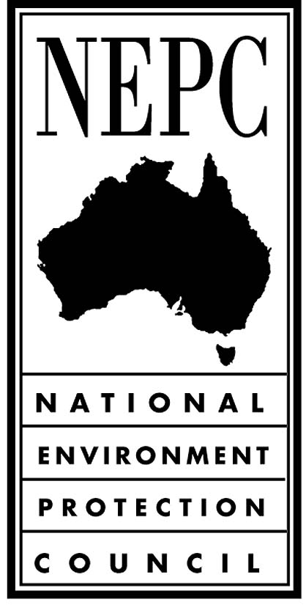

National Environment Protection Council Act 1994

CERTIFICATE

I, Bruce Philip KENNEDY, NEPC Executive Officer, pursuant to Section 62(1) of the National Environment Protection Council Act 1994 and the equivalent provision of the corresponding Act of each participating jurisdiction, certify that:

On 2 June 2007, the National Environment Protection Council made the Variation to the National Environment Protection (National Pollutant Inventory) Measure 2007 pursuant to Section 20 of the National Environment Protection Council Act 1994 and the equivalent provision of the corresponding Act of each participating jurisdiction.

Dr Bruce Philip Kennedy
NEPC Executive Officer
4 June 2007

