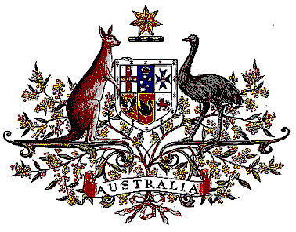

Veterans’ Entitlements Act 1986

Determination of Warlike Service
OPERATION JURAL

I, Bruce Billson, Minister for Veterans’ Affairs:
  - determine that:
    - the area of operations comprises Iraq; and
    - service rendered as a member of the Australian Defence Force assigned for service with the United Kingdom elements of the coalition force operation to patrol the Iraq No-Fly-Zones on Operation JURAL during the period 30 June 1991 to 12 January 2003 in the area of operations is warlike service for the purposes of the definition of “warlike service” in subsection 5C(1) of the Act.
  - this Determination is taken to have commenced on 16 April 2007.

Dated 15 October 2007

Signed Bruce Billson

BRUCE BILLSON
Minister for Veterans’ Affairs

