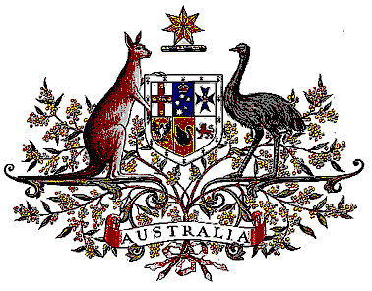

Veterans’ Entitlements Act 1986

Determination of Warlike Service
OPERATION NORTHERN WATCH

I, Bruce Billson, Minister for Veterans’ Affairs:
  - determine that:
    - the area of operations comprises Iraq; and
    - service rendered as a member of the Australian Defence Force assigned for service with the United States elements of the coalition force operation to patrol the Iraq No-Fly-Zones on Operation NORTHERN WATCH during the period 1 January 1997 to 12 January 2003 in the area of operations is warlike service for the purposes of the definition of “warlike service” in subsection 5C(1) of the Act.
  - this Determination is taken to have commenced on 16 April 2007.

Dated 15 October 2007

Signed Bruce Billson

BRUCE BILLSON
Minister for Veterans’ Affairs

