
NATIONAL CAPITAL AUTHORITY
Australian Capital Territory
(Planning and Land Management) Act 1988
NATIONAL CAPITAL PLAN
AMENDMENT 26
ACTON HOUSE
May 1999

AMENDMENT OF THE NATIONAL CAPITAL PLAN
AMENDMENT 26 (ACTON HOUSE)
Amend the National Capital Plan as follows:
1. Amend Figure 10 in Part One of the National Capital Plan by -
1.1 altering the Predominant Land Use Category that applies to Section 24 City from "Social/Community/Educational" to "Residential";
1.2 deleting the words "Social/Community/Educational" from the legend of Predominant Land Uses; and
1.3 deleting notation "F" from the face of the figure and replacing it with notation "D" which will then apply to Sections 7, 8 & 24 City.
Figure 10, amended in accordance with 1.1, 1.2 and 1.3 herein, is as set out at Attachment A.
2. Amend the conditions on the double page following Figure 10 in Part One of the National Capital Plan by -
2.1 deleting section "D" with all the provisions contained in that section;
2.2 altering the heading of section "F" from "F - City Sections 7 & 8" to "D - City Sections 7, 8 & 24";
2.3 under "Other land uses permitted" in Land Use Policy for section D, as altered, amend the references to "Bank" and "Co-operative society" to read as follows:
• Bank and Co-operative society for Sections 7 & 8
• Bank and Co-operative society (ancillary to primary use) for Section 24
2.4 adding a new condition under "Development Guidelines" within the newly altered section "D" which states:
Development on Section 24 City shall be in accordance with the recommendations of a Conservation Management Plan agreed to by the Australian Heritage Commission.
The double page following Figure 10, amended in accordance with 2.1, 2.2, 2.3 and 2.4 herein, is as set out at Attachment B.
Attachment A
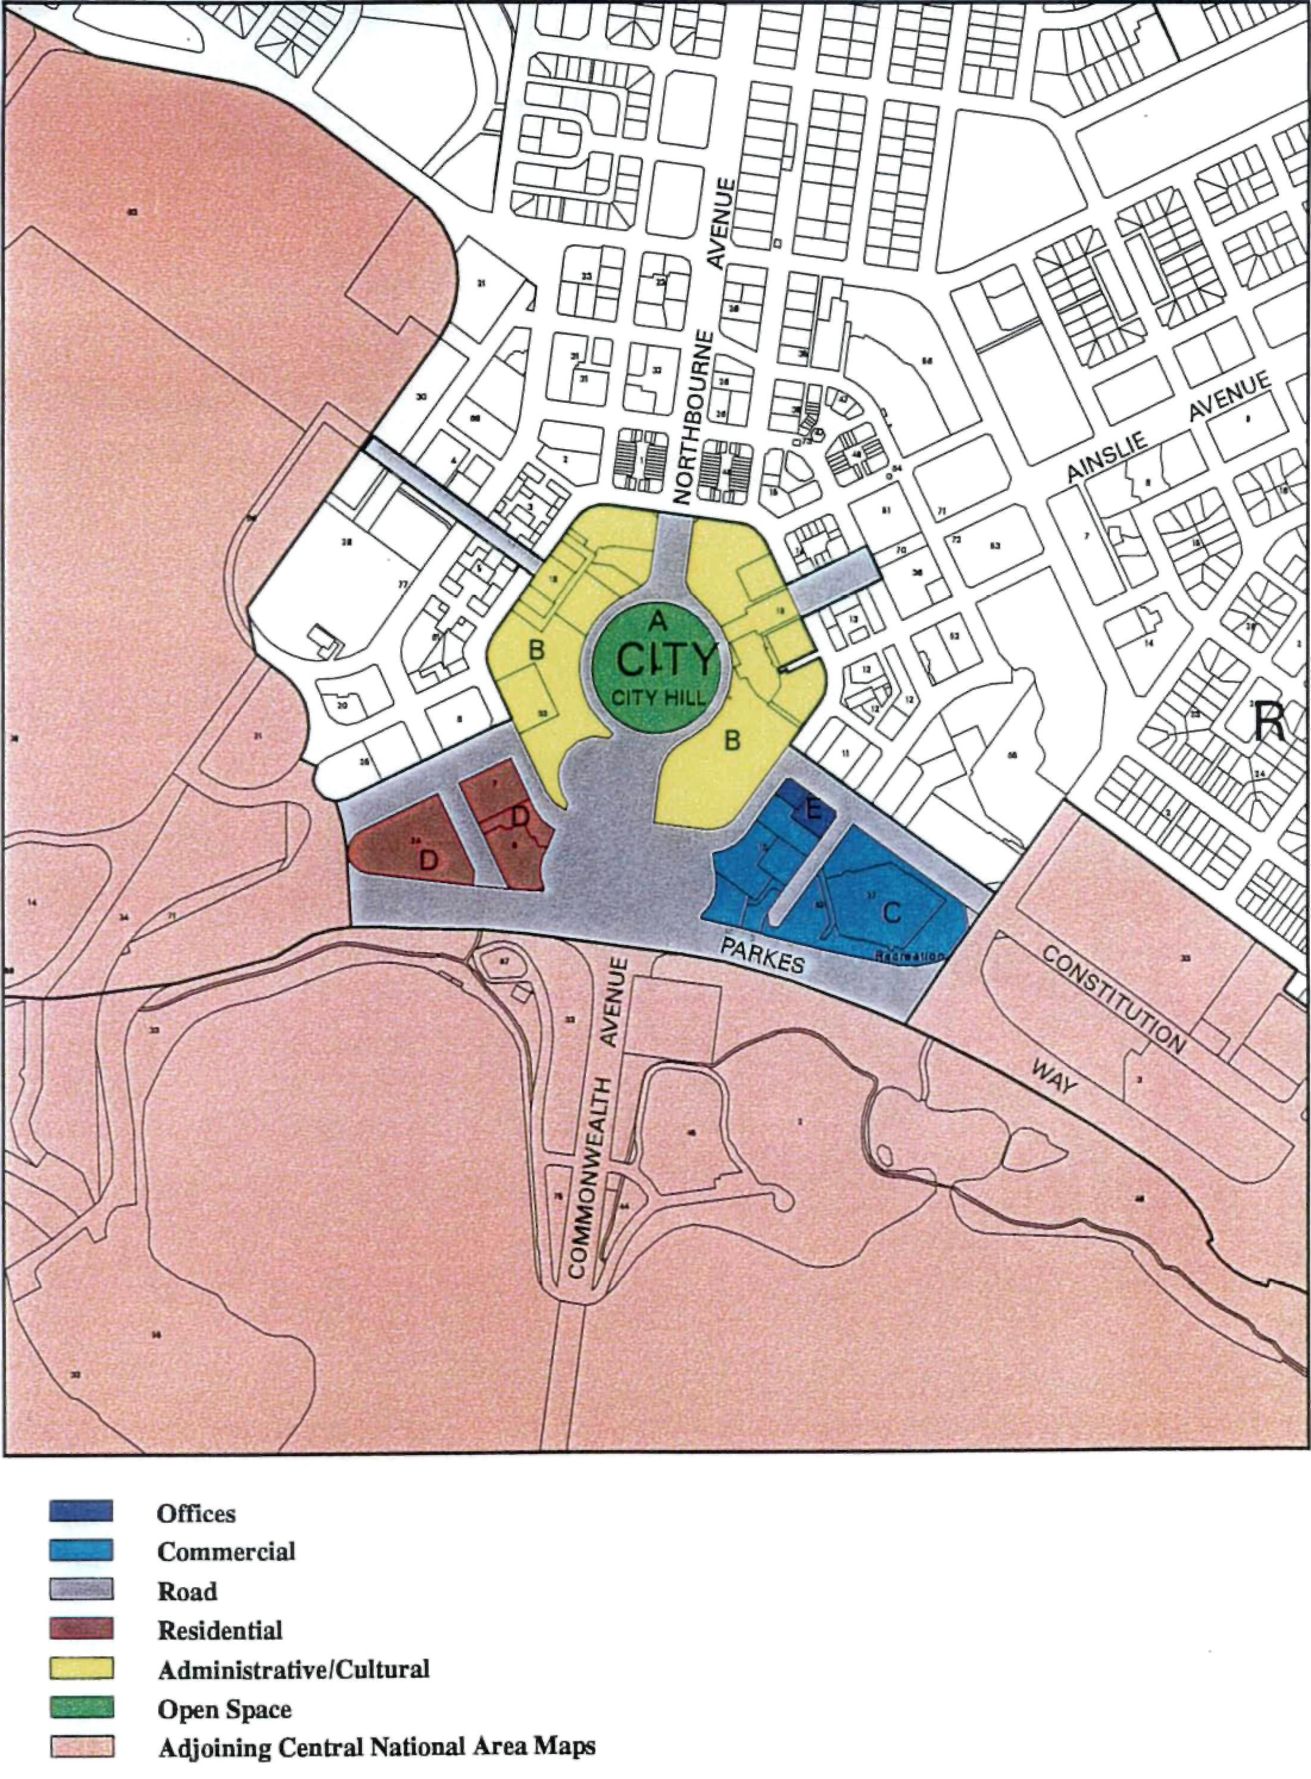
Figure 10
The Central National Area (City)

A City  Section 34  Objectives:  The objectives of the land use policy for the public open space areas are to:  • develop attractive parks in Civic for the use of workers, shoppers visitors and residents  • Provide parks as a venue for recreation to increase the enjoyment of the facilities of Civic  • Provide areas for rest and relaxation  • Provide 'Green Spaces' as a relief in, and element of, the centre structure  • Facilitate the construction of convenient and attractive pedestrian routes.  Land Use Policy  The primary land use for Precinct A is:  • Park  Limited uses complementary and ancillary to the primary use will be considered.  B City  Sections 63, 18 & 19  Objectives  The main objectives of the land use policy for this precinct are to:  • Provide land for administrative uses  • Provides for a wider range of uses to add diversity to Civic, including hotels, tourist and entertainment facilities, private sector offices, offices and carparks. | Land Use Policy  The primary land use for precinct B is:  • Administrative Use.  Other land uses permitted are:  • Retail  • Cafe, bar restaurant  • Personal service  • Office  • Casino  • Tourist facility  • Indoor recreation facility  • Cultural facility  • Social/Community facility  • Health centre  • Place of assembly  • Education establishment  • Scientific Research Establishment  • Community protection facility  • Residential  • Hotel  • Motel  • Park  • Carpark  Development Guidelines  • High quality development with a low building form in a landscape setting  • Development opposite the Sydney and Melbourne Buildings must reflect the historical character of those buildings  • Maximum building height:  - Vernon Circle (3 storeys)  - London Circuit (6 storeys)  C City  Sections 10 (Part), 37 & 62  Objective  The main objective of the land use policy for the tourist and recreation area is to ensure that the area in Civic is reserved for the provision of commercial recreation facilities to serve the health, fitness and leisure needs of the workforce, Canberra residents, tourists and visitors to the Centre. Complementary to this main objective it is also intended that the area accommodate tourist facilities and accommodation which can benefit from a location close to the Convention Centre and that a limited amount of office development may be allowed. | Land Use Policy  The primary land uses for Precinct C are:  • Tourist facility  • Indoor recreation facility  • Outdoor recreation facility but a publicly accessible Olympic Pool complex must be included.  Other land uses permitted are:  • Office (Part Section 10 only), up to a maximum gross floor area of 35,000m² inclusive of offices associated with any Administrative uses  • Retail (ancillary to primary use)  • Cafe, bar, restaurant.  • Personal service establishment  • Club  • Cultural facility  • Social/Community facility  • Place of assembly  • Administrative uses (Section 10 only)  • Community protection facility  • Residential  • Hotel  • Motel  • Park  • Public utility  • Carpark  Redevelopment proposals must always ensure that floodwater is catered for as the south-east corner of the precinct is subject to flooding by overland stormwater flow, and in rare circumstances possibly by Lake Burley Griffin.  Development and redevelopment shall accord with the development conditions set out at Appendix S.

D City  Sections 7, 8 & 24  Objectives  The objective of the land use policy for the area is to promote a range of intensive residential uses so that Civic can benefit from increased use of services at evening and weekends.  The precinct is close to leisure, recreation, retailing and business facilities and services offered by Civic and is close to the recreational opportunities provided by the lake.  Land Use Policy  The primary land uses permitted in Precinct D are:  • Residential  • Hotel  • Motel  Other land uses permitted are:  • Retail (ancillary to primary use)  • Cafe, bar, restaurant  • Bank and Co-operative society for Sections 7 & 8  • Bank and Co-operative society (ancillary to primary use) for Section 24  • Personal service establishment  • Office (ancillary to primary use)  • Club  • Tourist facility  • Indoor recreation facility  • Cultural facility  • Social/Community facility  • Place of assembly  • Park  • Carpark  Development Guidelines  • Development to reflect importance of Edinburgh Avenue and London Circuit frontages.  • Development on Section 24 City shall be in accordance with the recommendations of the Conservation Management Plan for the site agreed to by the Australian Heritage Commission. | • Developments in Section 6 City to abut the front property boundary on London Circuit. | E City  Section 10  Blocks 14 & 15  Objectives  The objectives of the land use policy for the office areas are to:  • Maintain Civic as the main metropolitan office employment location  • Group employment opportunities in close support of retail areas.  Land Use Policy  The primary land use for Precinct E is:  • Office  Other land uses permitted are:  • Retail  • Cafe, bar, restaurant  • Bank  • Co-operative society  • Personal services establishment  • Consulting rooms  • Club  • Indoor recreation facility  • Cultural facility  • Social/Community facility  • Church use  • Health care  • Place of assembly  • Administrative use  • Community protection facility  • Residential  • Hotel  • Motel  • Passenger transport facility  • Carpark  Design and Siting Conditions apply to all blocks (Refer to Appendix H)  *Townscape Conditions apply to all blocks (Refer to Appendix

