SUPERANNUATION (CSS) APPROVED PART-TIME
EMPLOYEE DECLARATION NO 7.
I, JOHN J. FAHEY, Minister for Finance, hereby make the following declaration under the definition of the term "approved part-time employee" in subsection 3(1) of the Superannuation Act 1976.
Dated 1 AUG 1996.
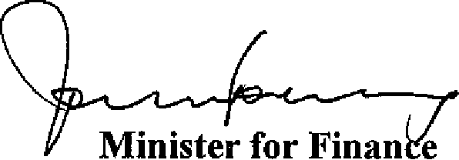
____________________________
Citation
1. This declaration may be cited as "Superannuation (CSS) Approved Part-time Employee Declaration No. 7".
Approved Part-time Employees
2. A person who:
(i) was appointed to the statutory office known as the Development Allowance Authority on a part-time basis commencing 27 June 1995, and on the date of signing of this declaration occupies that office; and
(ii) has elected prior to the making of this declaration, to be treated as an eligible employee for the purposes of the Superannuation Act 1976 for that period; and
(iii) is not remunerated on a per diem basis for the performance of those duties;
is included in a class of persons which is an approved class of part-time employees for the purposes of the Superannuation Act 1976 for the period commencing on 27 June 1995 and continuing while he holds that office.
3. A person who after 30 June 1990 and before the date of the signing of this declaration:
(a) was appointed under the Australian Federal Police Act 1979 and performs the duties of a position on a part-time basis; and
(b) was not remunerated on a per diem basis in respect of that employment; and
(c) has made contributions in respect of the period, or those periods, of part-time employment; and
(d) immediately before becoming so appointed;

(i) the person was an eligible employee; or
(ii) invalidity pension was, or would, but for the suspension of payment, have been, payable to him or her under the Superannuation Act 1976; or
(iii) deferred benefits were applicable to him or her under the Superannuation Act 1976 or the Superannuation Act 1922 or;
(iv) a pension of a kind mentioned in section 64A or 65 of the Superannuation Act 1922 as in force immediately before the repeal of that section was, or but for a suspension of payment would have been, payable to him or her; or
(e) becomes, by virtue of his or her appointment, a re-employed former contributor with preserved rights;
is, while performing the duties of the position on a part-time basis, included in a class of part-time employees, which is an approved class of part-time employees for the purposes of the Superannuation Act 1976.
4. A person who after the date of the signing of this declaration:
(a) is appointed under the Australian Federal Police Act 1979 and performs the duties of a position on a part-time basis; and
(b) is not remunerated on a per diem basis in respect of that employment; and
(c) immediately before becoming so appointed;
(i) the person was an eligible employee; or
(ii) invalidity pension was, or would, but for the suspension of payment, have been, payable to him or her under the Superannuation Act 1976; or
(iii) deferred benefits were applicable to him or her under the Superannuation Act 1976 or the Superannuation Act 1922 or;
(iv) a pension of a kind mentioned in section 64A or 65 of the Superannuation Act 1922 as in force immediately before the repeal of that section was, or but for a suspension of payment would have been, payable to him or her; or
(d) becomes, by virtue of his or her appointment, a re-employed former contributor with preserved rights;
is, while performing the duties of the position on a part-time basis, included in a class of part-time employees, which is an approved class of part-time employees for the purposes of the Superannuation Act 1976.

