Proclamation under the Flags Act 1953
Flags Act 1953
I, PHILIP MICHAEL JEFFERY, Governor-General of the Commonwealth of Australia, acting with the advice of the Federal Executive Council and under section 5 of the Flags Act 1953, appoint the flag reproduced in Schedule 1 and described in Schedule 2 to be the ensign of the Australian Defence Force and to be known as the Australian Defence Force Ensign with effect from 1 October 2006.
Signed and sealed with the
Great Seal of Australia
on 25 January 2008
P. M. JEFFERY
Governor-General
By His Excellency’s Command
JOHN FAULKNER
Cabinet Secretary

Schedule 1 Australian Defence Force Ensign

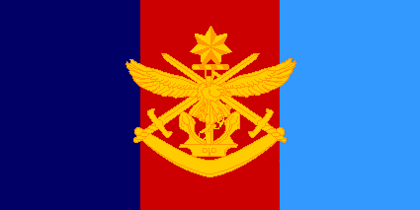
Schedule 2 Description of Australian Defence Force Ensign
The Australian Defence Force Ensign is divided vertically into thirds, the left third being dark blue (symbolising the Australian Navy), the centre third being red (symbolising the Australian Army), and the right third being light blue (symbolising the Australian Air Force). Superimposed centrally and intersecting the outer thirds, in gold, is the Joint Service emblem. The Joint Service emblem incorporates the emblems traditionally representing the 3 Services: an anchor (representing the Australian Navy); superimposed on the anchor are crossed swords (representing the Australian Army); and superimposed on the crossed swords is an eagle (representing the Australian Air Force). The seven-pointed Commonwealth star rests on a wreath directly above, and supported by, the group of Service emblems, and a boomerang (symbolising Australia) is placed horizontally directly below the group of Service emblems supporting and unifying all the emblems.

