Proclamation under the Flags Act 1953
Flags Act 1953
I, PHILIP MICHAEL JEFFERY, Governor-General of the Commonwealth of Australia, acting with the advice of the Federal Executive Council and noting the fact that the flag reproduced in Schedule 1 and described in Schedule 2 is recognised as the flag of the Aboriginal peoples of Australia and a flag of significance to the Australian nation generally, appoint that flag, under section 5 of the Flags Act 1953, to be the flag of the Aboriginal peoples of Australia and to be known as the Australian Aboriginal Flag with effect from 1 January 2008.
Signed and sealed with the
Great Seal of Australia
on 25 January 2008
P. M. JEFFERY
Governor-General
By His Excellency’s Command
JOHN FAULKNER
Cabinet Secretary

Schedule 1 Australian Aboriginal Flag

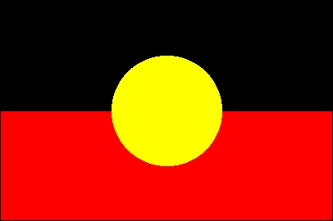

Schedule 2 Description of Australian Aboriginal Flag

The Australian Aboriginal Flag is divided horizontally into halves, the upper half being black (symbolising the Aboriginal peoples) and the lower half being red (symbolising both the Australian soil and ochre, a substance used by Aboriginal peoples at their ceremonies). A yellow disk (symbolising the sun) is superimposed centrally on the black and red halves of the flag.

