Vehicle Standard (Australian Design Rule 81/02 — Fuel Consumption Labelling for
Light Vehicles) 2008

APPENDIX A

FUEL CONSUMPTION LABEL SPECIFICATIONS

  - The fuel consumption label shall be of the form, dimensions and fonts illustrated in Figure 1 of this Appendix A.
  - Figure 2 shall be used for vehicles fuelled by petrol, diesel or liquefied petroleum gas (LPG).
  - Vehicles fuelled by compressed natural gas (CNG) shall use the same label format as Figure 2, except that fuel consumption should be measured and displayed in cubic metres per 100km, not L/100km.
  - The fuel consumption label shall be self adhesive, durable and removable, and of a type suitable for application to the windscreen of the vehicle.
  - The information on the fuel consumption label shall be in the English Language, legible and visible from outside the vehicle when the label is applied to the windscreen.
  - All text and numerals on the fuel consumption label shall be black, except:

1.6.1 the “FUEL CONSUMPTION” heading, which shall be white lettering reversed out of the solid black background surrounding the heading; and

1.6.2 the “More information at www.greenvehicleguide.gov.au” statement, which shall be white lettering reversed out of the solid green background surrounding the statement.
  - The colours used on the fuel consumption label are black, red, yellow and green, with the red to be Pantone Warm Red, the yellow to be Pantone 116 and the green to be Pantone 360CVC.
  - The following background areas of the fuel consumption label shall be white:

1.8.1 The background area between the solid red background surrounding the fuel consumption values and the inner border containing fuel consumption information; and

1.8.2 The background areas between the solid green background surrounding the CO₂ emissions value and the inner border containing CO₂ emissions information.

1.9 The background area between the inner borders specified in clause 1.8, and between the inner borders and the edge of the label shall be yellow.

1.10 A description of the vehicle shall be placed on the yellow background between the fuel consumption heading and the white data boxes.

1.11 The wording of the vehicle description on the label shall have normal spacing of letter, line and word, and be centred horizontally and vertically in the area specified in clause 1.10.

1.12 The vehicle description specified in clause 1.10 shall include the:

1.12.1 vehicle make, model and variant description by which the vehicle is advertised and sold;

1.12.2 transmission type of the vehicle; and

1.12.3 fuel type of the vehicle, using the terms “Petrol”, “Diesel”, “LPG”, “CNG”, “Hybrid” or “Electric” as appropriate.

1.13 The three fuel consumption values in L/100km specified in clause 4.4.1 of this vehicle standard shall be centred in the red areas on the fuel consumption label indicated by the letters “XX.X” in Figure 1.

1.14 The CO₂ emissions value in g/km specified in clause 4.4.2 of this vehicle standard shall be centred in the green area on the fuel consumption label indicated by the letters “XXX” in Figure 1.

1.15 Figure 3 provides a sample label to illustrate placement of the vehicle description and fuel consumption and CO₂ emission values.

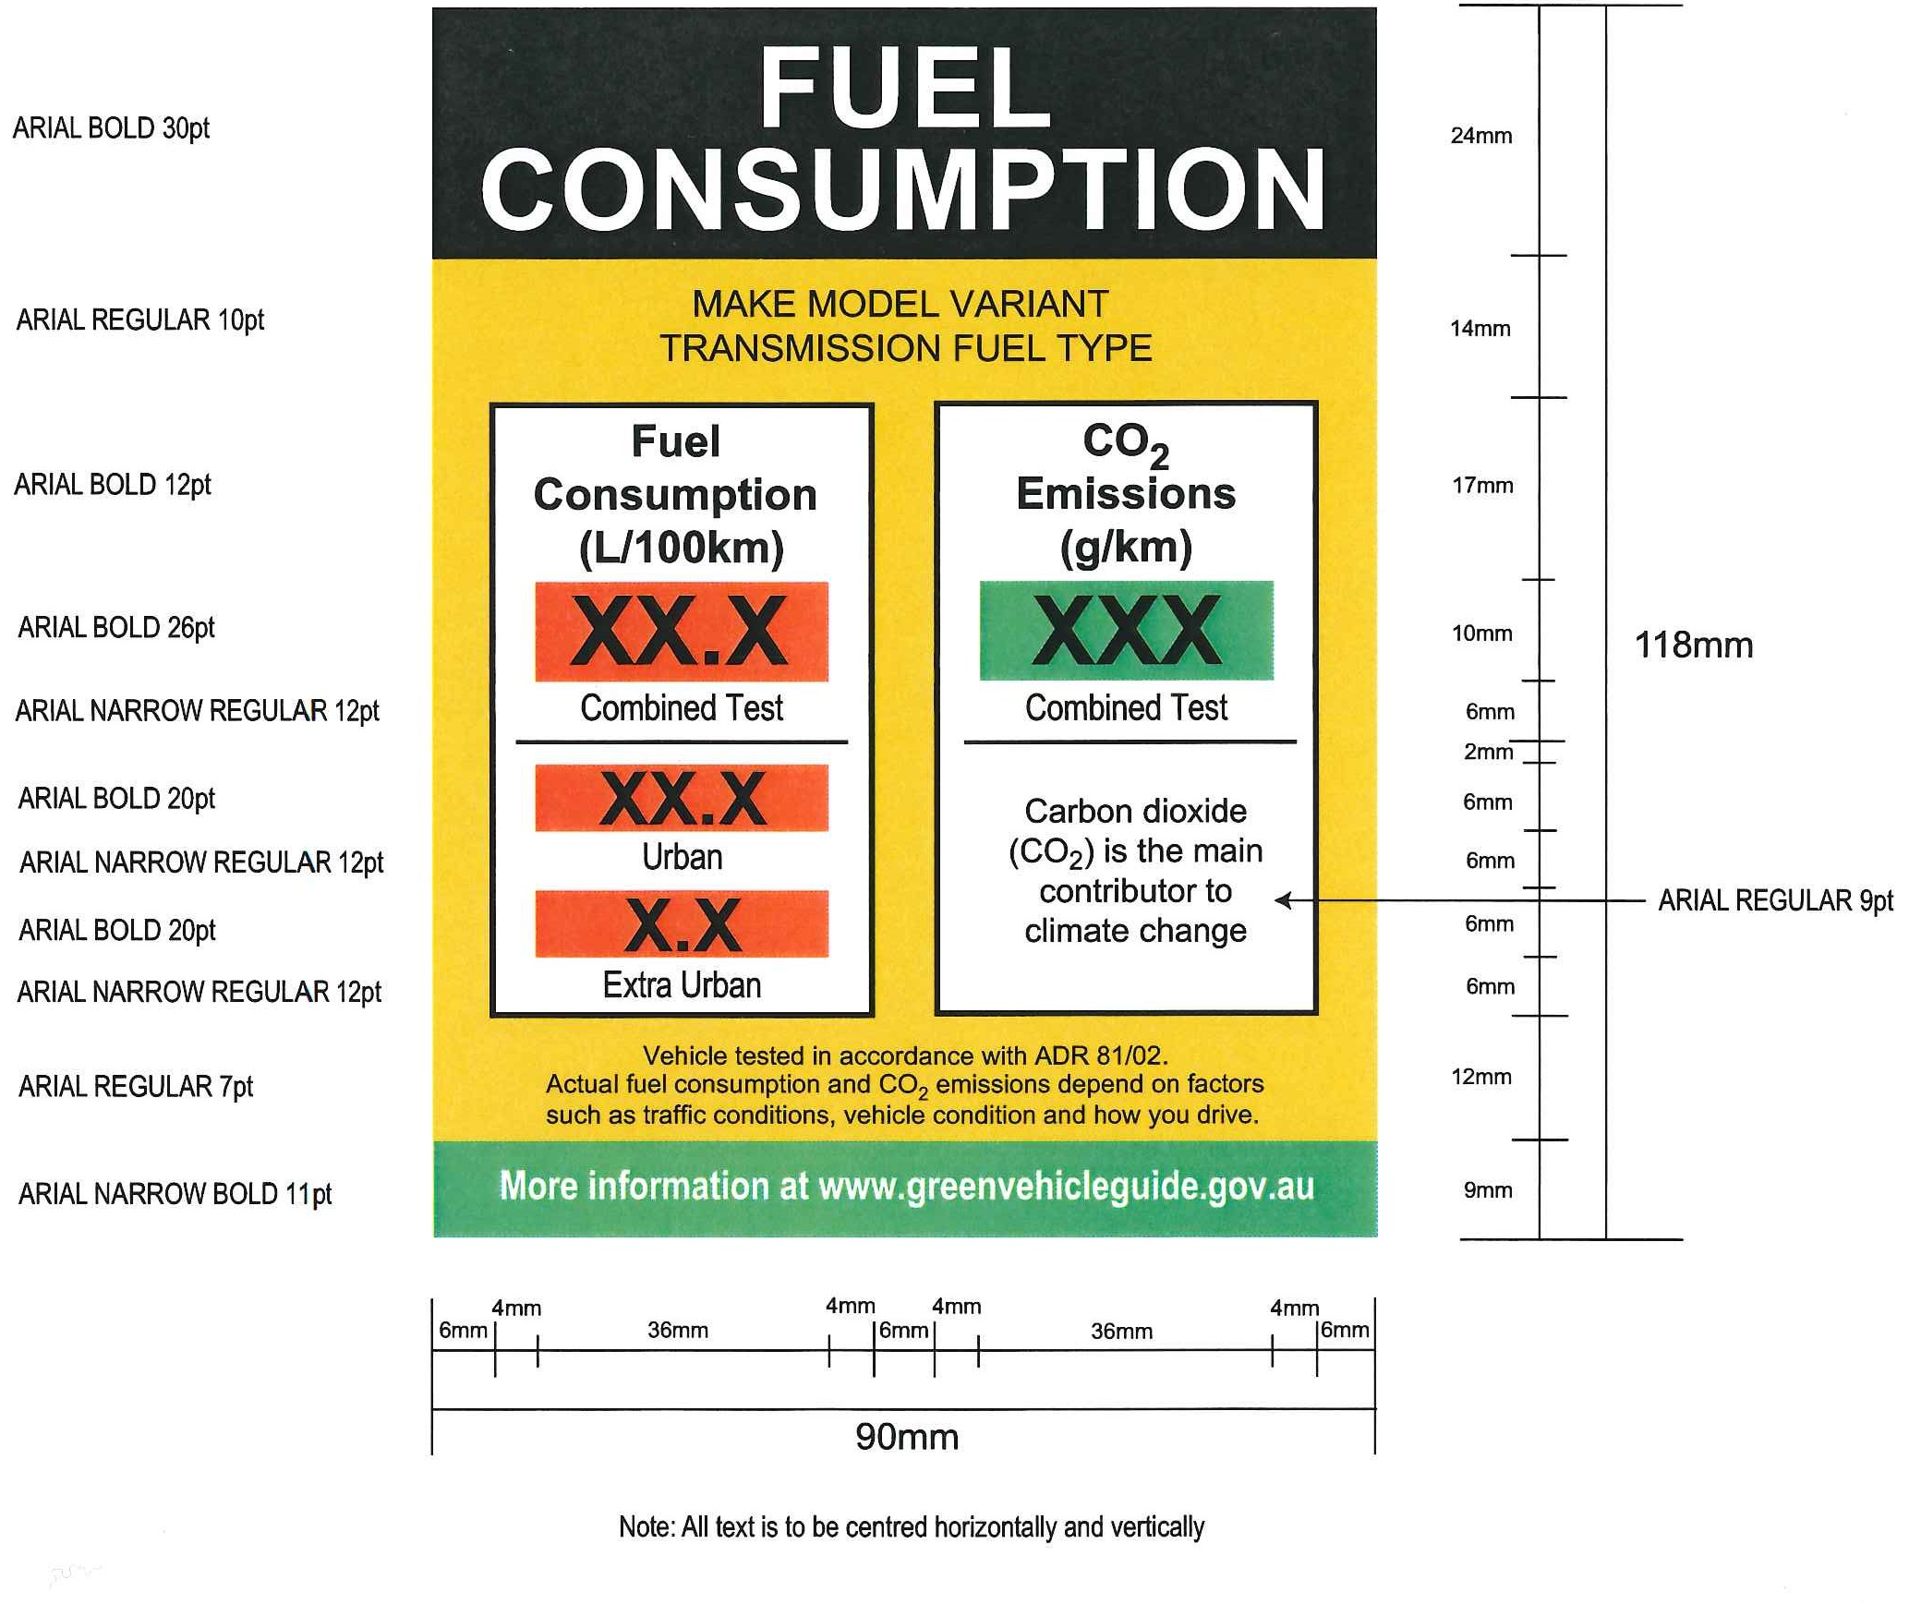
Figure 1: Illustration of Fuel Consumption Label with fonts and dimensions

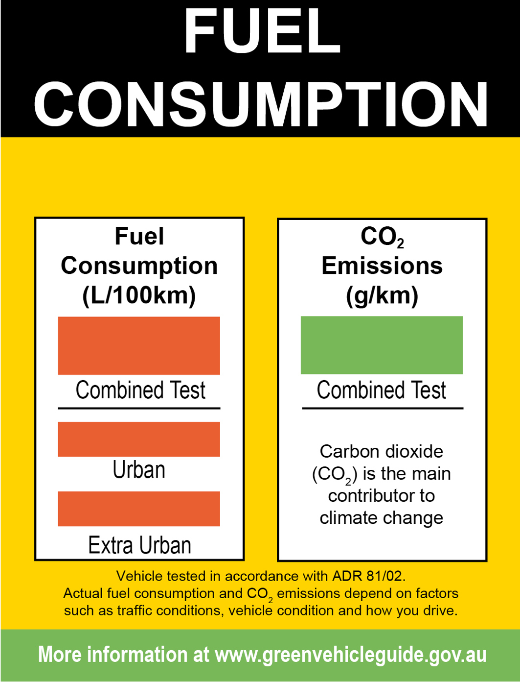
Figure 2: Illustration of Fuel Consumption Label

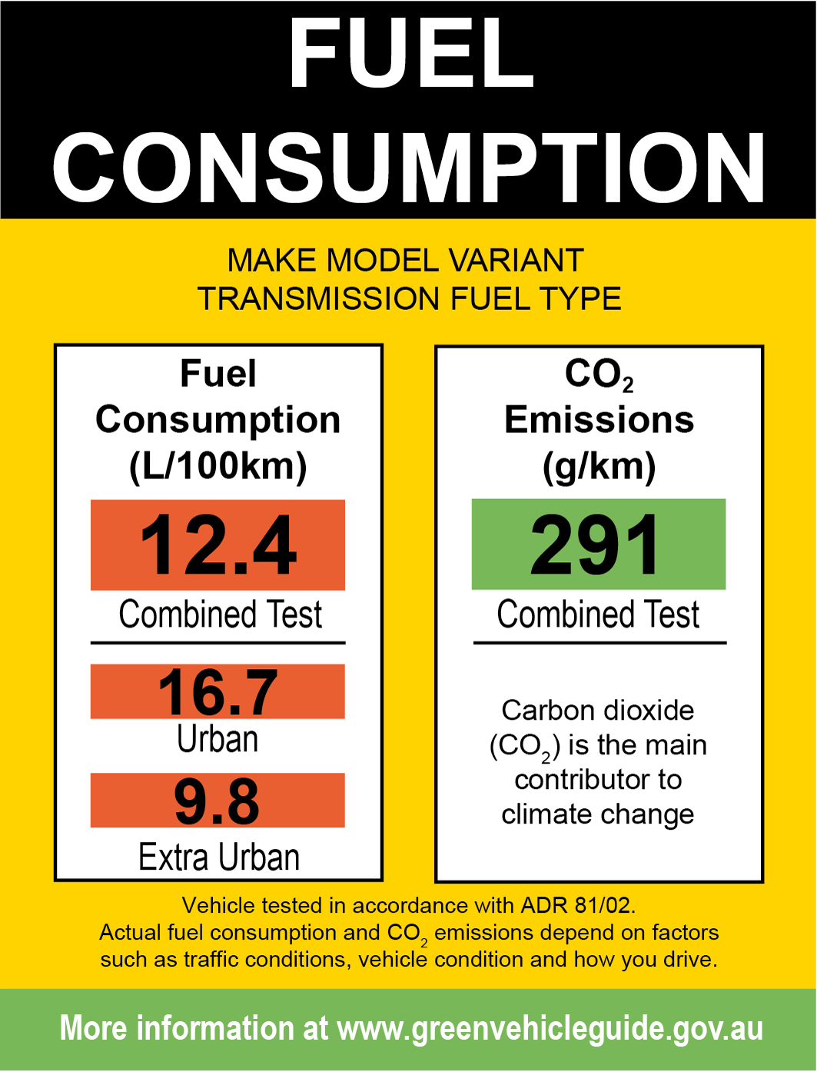
Figure 3: Sample Fuel Consumption Label (for illustrative purposes only)

