POISONS STANDARD AMENDMENT NO. 1 OF 2008

The National Drugs and Poisons Schedule Committee, acting in accordance with its power under paragraph 52D(2)(a) of the Therapeutic Goods Act 1989 (the Act), amends the Poisons Standard 2007 in the manner set out in Schedule 1.

The amendments to the Poisons Standard 2007 as set out in Schedule 1 commence on 1 May 2008.

Signed
DR ROHAN HAMMETT
CHAIR
NATIONAL DRUGS AND POISONS SCHEDULE COMMITTEE

Dated this 29th day of April 2008

Schedule 1-Amendments to the Poisons Standard 2007

STANDARD
FOR THE
UNIFORM SCHEDULING
OF
DRUGS AND POISONS

No. 22

AMENDMENT No. 3

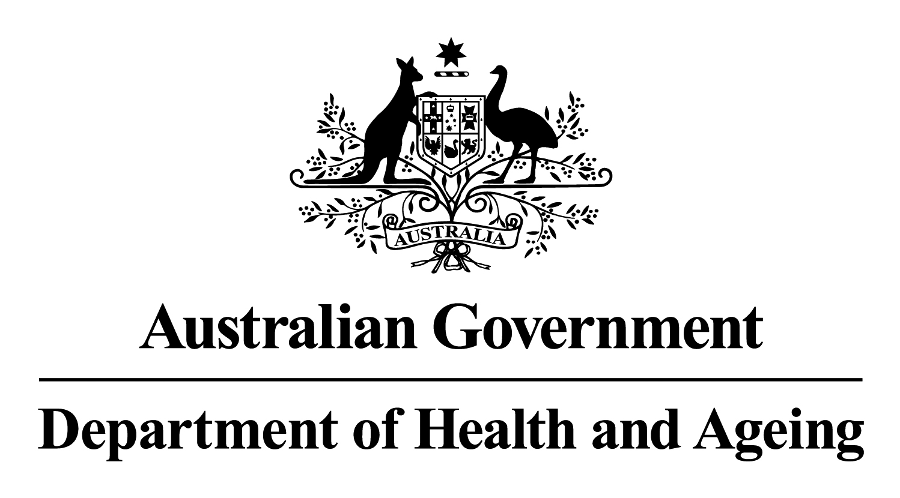

Effective Date – 1 May 2008

© Commonwealth of Australia 2008

ISBN 1-74186-554-9

This work is copyright. Apart from any use as permitted under the Copyright Act 1968, no part may be reproduced by any process without prior written permission from the Commonwealth. Requests and inquiries concerning reproduction and rights should be addressed to the:
Commonwealth Copyright Administration
Attorney-General’s Department
Robert Garran Offices
National Circuit
CANBERRA ACT 2600
or at http://www.ag.gov.au/cca

Published by the Australian Government under the Therapeutic Goods Act 1989.

Publication approval number: P3-3643

The amendments listed in this document were finalised at the October 2007 and February 2008 meetings of the National Drugs and Poisons Schedule Committee (NDPSC) except where separately specified. The basis of these amendments can be found in the ‘Record of the Reasons’, which can be accessed from the NDPSC website:

www.tga.gov.au/ndpsc

Further inquiries should be directed to:

The Secretary
National Drugs and Poisons Schedule Committee
GPO Box 9848
CANBERRA ACT 2601

Or by email: NDPSC@health.gov.au

Media Liaison Unit
Australian Government Department of Health and Ageing
TABLE OF CONTENTS

Part A 4
Part 1 – Interpretation 4
Part 4 – The Schedules 4
Schedule 2 – Amendments 4
Schedule 3 – New Entry 5
Schedule 4 – New Entries 5
Schedule 4 – Amendment 5
Schedule 5 – New Entries 5
Schedule 5 – Amendments 6
Schedule 6 – New Entries 6
Schedule 6 – Amendments 6
Schedule 8 – Amendment 7
Schedule 9 – Amendment 7
PART 5 – appendices 8
Appendix A – New Entry 8
Appendix A – Amendment 8
Appendix C – New Entries 8
Appendix F – Part 1 – New Entry 9
Appendix F – Part 2 – New Entry 9
Appendix F – Part 3 – New Entry 9
Appendix F – Part 3 – Amendment 9
Appendix K – New Entry 10
Editorial Amendments and Errata 11
Part 1 – Interpretation – Amendments 11
Schedule 2 – Amendment 12
Schedule 3 – Amendment 12
Schedule 4 – Amendment 12

Part A
Amendments to the Standard for the Uniform Scheduling of Drugs and Poisons

The National Drugs and Poisons Schedule Committee directs that the amendments below be applied to the Standard for the Uniform Scheduling of Drugs and Poisons No.22 and recommends that these amendments be adopted by the States and Territories with effect from 1 May 2008 unless otherwise stated. The amendments arise from decisions made by the Committee at its October 2007 meeting and confirmed at the February 2008 meeting except where separately specified.

Part 1 – Interpretation
Paragraph 1.(2)(e) – amend to read:
1. (2) Unless the contrary intention appears a reference to a substance in a schedule or an appendix to this Standard includes:
(e) every stereoisomer of the substance and every salt of such a stereoisomer; and

Part 4 – The Schedules

Schedule 2 – Amendments
FORMALDEHYDE – amend entry to read:
† FORMALDEHYDE (excluding its derivatives) for human therapeutic use except:
(a) in oral hygiene preparations containing 0.1 per cent or less of free formaldehyde; or
(b) in other preparations containing 0.2 per cent or less of free formaldehyde.
METHOXAMINE – amend entry to read:
METHOXAMINE for external use except in preparations containing 1 per cent or less of methoxamine.
PARAFORMALDEHYDE – amend entry to read:
† PARAFORMALDEHYDE (excluding its derivatives) for human therapeutic use except:
(a) in oral hygiene preparations containing 0.1 per cent or less of free formaldehyde; or
(b) in other preparations containing 0.2 per cent or less of free formaldehyde.

Schedule 3 – New Entry
The following amended entry for pantoprazole arose from a decision made by the June 2005 meeting, originally with an effective date of 1 March 2006. The October 2005 meeting agreed to vary the implementation date to 1 May 2006. The February 2006 meeting subsequently agreed to amend the implementation date to 1 May 2008.

PANTOPRAZOLE in oral preparations containing 20 mg or less of pantoprazole for the relief of heartburn and other symptoms of gastro-oesophageal reflux disease, in packs containing not more than 14 days of supply.

Schedule 4 – New Entries
AGOMELATINE.
CADMIUM COMPOUNDS for human therapeutic use.
DABIGATRAN.
MIGLUSTAT.
MITRATAPIDE.
ZONISAMIDE.

Schedule 4 – Amendment
METHOXAMINE – amend entry to read:
METHOXAMINE except:
(a) when included in Schedule 2; or
(b) in preparations for external use containing 1 per cent or less of methoxamine.
The following amended entry for pantoprazole arose from a decision made by the June 2005 meeting, originally with an effective date of 1 March 2006. The October 2005 meeting agreed to vary the implementation date to 1 May 2006. The February 2006 meeting subsequently agreed to amend the implementation date to 1 May 2008.

PANTOPRAZOLE – amend entry to read:
PANTOPRAZOLE except when included in Schedule 3.

Schedule 5 – New Entries
FLUBENDIAMIDE.
METAFLUMIZONE.

Schedule 5 – Amendments
CADMIUM SULPHIDE – Delete entry.

Schedule 6 – New Entries
CASTOR OIL, MONOMALEATE (excluding its salts and derivatives) in preparations for cosmetic use except in wash-off preparations containing 1 per cent or less of castor oil, monomaleate.
METHYLNORBORNYLPYRIDINE except in preparations containing 0.5 per cent or less methylnorbornylpyridine.

Schedule 6 – Amendments
The following cadmium compounds entry incorporates an editorial change identified at the February 2008 NDPSC Meeting under item 21.2.

CADMIUM COMPOUNDS – amend entry to read:
CADMIUM COMPOUNDS except:
(a) when included in Schedule 4; or
(b) in paints or tinters containing 0.1 per cent or less of cadmium calculated on the non-volatile content of the paint or tinter.
FORMALDEHYDE – amend entry to read:
† FORMALDEHYDE (excluding its derivatives) in preparations containing 0.05 per cent or more of free formaldehyde except:
(a) for human therapeutic use;
(b) in oral hygiene preparations containing 0.1 per cent or less of free formaldehyde;
(c) in nail hardener cosmetic preparations containing 0.2 per cent or less of free formaldehyde when labelled with the warning statement:
PROTECT CUTICLES WITH GREASE OR OIL; or
(d) in all other preparations containing 0.2 per cent or less of free formaldehyde when labelled with the warning statement:
CONTAINS FORMALDEHYDE.
MONENSIN – amend entry to read:
MONENSIN:
(a) in animal feed premixes containing 12.5 per cent or less of antibiotic substances; or
(b) in stockfeed supplements, blocks or licks containing 0.75 per cent or less of antibiotic substances.
PARAFORMALDEHYDE – amend entry to read:
† PARAFORMALDEHYDE (excluding its derivatives) in preparations containing 0.05 per cent or more of free formaldehyde except:
(a) for human therapeutic use;
(b) in oral hygiene preparations containing 0.1 per cent or less of free formaldehyde;
(c) in nail hardener cosmetic preparations containing 0.2 per cent or less of free formaldehyde when labelled with the warning statement:
PROTECT CUTICLES WITH GREASE OR OIL; or
(d) in all other preparations containing 0.2 per cent or less of free formaldehyde when labelled with the warning statement:
CONTAINS FORMALDEHYDE.

Schedule 8 – Amendment
LEVORPHANOL – amend entry to read:
LEVORPHANOL (excluding its stereoisomers).

Schedule 9 – Amendment
LEVOMETHORPHAN – amend entry to read:
LEVOMETHORPHAN (excluding its stereoisomers).

PART 5 – appendices

Appendix A – New Entry
The following human blood products entry corresponds to that included in the October 2007 NDPSC Record of Reasons. The October 2007 post-meeting Gazette Notice, however, inadvertently used incorrect draft wording and format. The correct wording was also included in the February 2008 post-meeting Gazette Notice for clarity.

HUMAN BLOOD PRODUCTS including:
(a) whole blood;
(b) blood components including red cells, white cells, platelets and plasma (including cryoprecipitate); and
(c) the following plasma-derived therapeutic proteins and their equivalent recombinant alternatives:
(i) albumin;
(ii) anticoagulation complex;
(iii) clotting factors;
(iv) fibrinogen;
(v) protein C;
(vi) prothrombin complex concentrate (PCC); and
(vii) thrombin.

Appendix A – Amendment
WHOLE BLOOD AND BLOOD COMPONENTS – delete entry.

Appendix C – New Entries
FORMALDEHYDE (excluding its derivatives):
(a) in oral hygiene preparations containing more than 0.1 per cent of free formaldehyde;
(b) in aerosol sprays for cosmetic use containing 0.005 per cent or more of free formaldehyde;
(c) in nail hardener cosmetic preparations containing 5 per cent or more of free formaldehyde; or
(d) in all other cosmetic preparations containing 0.05 per cent or more of free formaldehyde except in preparations containing 0.2 per cent or less of free formaldehyde when labelled with the warning statement:
CONTAINS FORMALDEHYDE.
PARAFORMALDEHYDE (excluding its derivatives):
(a) in oral hygiene preparations containing more than 0.1 per cent of free formaldehyde;
(b) in aerosol sprays for cosmetic use containing 0.005 per cent or more of free formaldehyde;
(c) in nail hardener cosmetic preparations containing 5 per cent or more of free formaldehyde; or
(d) in all other cosmetic preparations containing 0.05 per cent or more of free formaldehyde except in preparations containing 0.2 per cent or less of free formaldehyde when labelled with the warning statement:
CONTAINS FORMALDEHYDE.

Appendix F – Part 1 – New Entry
106. Contains formaldehyde.

Appendix F – Part 2 – New Entry
36. Protect cuticles with grease or oil.

Appendix F – Part 3 – New Entry
POISON WARNING SAFETY
STATEMENTS DIRECTIONS

Methylnorbornylpyridine 59

Appendix F – Part 3 – Amendment
POISON WARNING SAFETY
STATEMENTS DIRECTIONS
Formaldehyde

(a) in nail hardener cosmetics. 106 1,4,8,36

(b) in other preparations. 106 1,4,8

Appendix K – New Entry
Zonisamide

Editorial Amendments and Errata

Part 1 – Interpretation – Amendments
“Child-resistant closure” – Amend entry to read:
“Child-resistant closure” means:
(a) a closure that complies with the requirements for a child-resistant closure in the Australian Standard AS1928-2007 entitled Child-resistant packaging as specified or amended from time to time;
(b) a closure approved by any order made under section 10(3) of the Commonwealth Therapeutic Goods Act 1989; or
(c) in the case of a can fitted with a press-on lid, a lid of the design known as “double tight” or “triple tight”.
“Child-resistant packaging” – Amend entry to read:
“Child-resistant packaging” means packaging that:
(a) complies with the requirements of the Australian Standard AS1928-2007 entitled Child-resistant packaging as specified or amended from time to time;
(b) is reclosable and complies with the requirements of at least one of the following standards as specified or amended from time to time:
(i) the International Organization for Standardization Standard ISO 8317:1989 entitled Child-resistant packaging - Requirements and testing procedures for reclosable packages;
(ii) the British Standards Institution Standard BS EN 28317:1993 entitled Child-resistant packaging - Requirements and testing procedures for reclosable packages;
(iii) the Canadian Standards Association Standard CSA Z76.1-99 entitled Reclosable Child-Resistant Packages;
(iv) the United States Code of Federal Regulations, Title 16, Section 1700.15, entitled Poison prevention packaging standards and Section 1700.20, entitled Testing procedure for special packaging;
(c) is approved as child-resistant by any order made under section 10(3) of the Commonwealth Therapeutic Goods Act 1989; or
(d) is in the form of blister or strip packaging in which a unit of use is individually protected until the time of release and that complies with Section 3 (Requirements for non-reclosable packages) of Australian Standard AS1928-2001 entitled Child-resistant packages.

Schedule 2 – Amendment
CICLOPIROX – Amend entry to read:
CICLOPIROX in preparations for dermal use and for application to the nails containing 2 per cent or less of ciclopirox except in preparations for the treatment of tinea pedis.

Schedule 3 – Amendment
CICLOPIROX – amend entry to read:
CICLOPIROX in preparations for dermal use and for application to the nails except:
(a) when included in Schedule 2; or
(b) in preparations for the treatment of tinea pedis.

Schedule 4 – Amendment
PARACETAMOL – Amend entry to read:
PARACETAMOL:
(a) when combined with aspirin or salicylamide or any derivative of these substances except when separately specified in these Schedules;
(b) in slow release tablets or capsules containing more than 665 mg of paracetamol;
(c) in non-slow release tablets or capsules containing more than 500 mg of paracetamol; or
(d) in individually wrapped powders or sachets of granules each containing more than 1000 mg of paracetamol.

