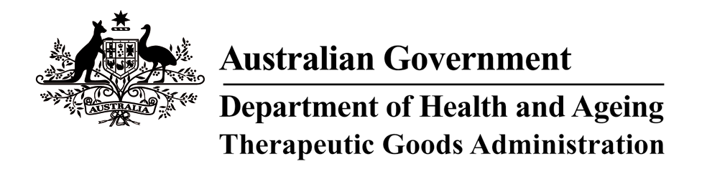

Therapeutic Goods Act 1989

THERAPEUTIC GOODS ORDER NO. 69B

Amendment to Therapeutic Goods Order No. 69 General requirements for labels for medicines

I, ROHAN HAMMETT, delegate of the Minister for Health and Ageing for the purposes of the exercise of the Minister’s powers under section 10 of the Therapeutic Goods Act 1989 and acting under that section, having consulted with the Therapeutic Goods Committee in accordance with subsection 10(4) of that Act, hereby AMEND Therapeutic Goods Order No. 69 General requirements for labels for medicines, made on 27 August 2001, in the manner set out below.

1. Under clause 2 ‘Interpretation’,

DELETE the current definition of ‘Required Advisory Statements for Medicine Labels’; and

REPLACE with the following new definition:

‘Required Advisory Statements for Medicine Labels’ means the document Required Advisory Statements for Medicine Labels (April 2006) published by the Therapeutic Goods Administration on its website (http://www.tga.gov.au).

This Order commences three months after the day it is registered on the Federal Register of Legislative Instruments.
Dated this 3rd day of June 2008.
(Signed by)
Rohan Hammett
DELEGATE OF THE MINISTER FOR HEALTH AND AGEING

