Variation to the National Environment Protection
(National Pollutant Inventory) Measure 2008 (No. 1)
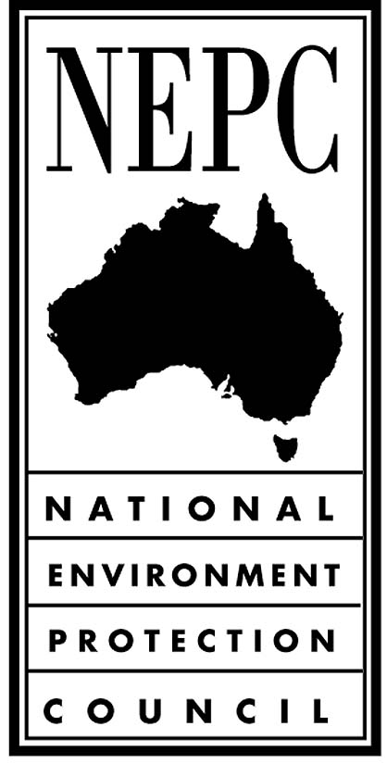

Explanatory Statement

Issued by the National Environment Protection Council

National Environment Protection Council Act 1994
November 2008

Subsection 22A of the National Environment Protection Council Act 1994 (NEPC Act) prescribes that the National Environment Protection Council (NEPC) may make minor variations to National Environment Protection Measures (NEPMs).

About NEPMs
NEPMs are broad framework-setting statutory instruments which, through an extensive process of inter-government and community/industry consultation, reflect agreed national objectives for protecting particular aspects of the environment. NEPMs may consist of any combination of goals, standards, protocols, and guidelines.

Once a draft NEPM has been finalised, it is then formally “made” by NEPC. A decision to make (or to vary) a NEPM requires the support of a two-thirds majority of members of NEPC. NEPMs are implemented by jurisdictions which participate in NEPC within their own jurisdictional legal frameworks.

National Pollutant Inventory NEPM
The National Pollutant Inventory (NPI) is an internet database designed to provide the community, industry and government with information on the types and amounts of certain substances being emitted to air, land and water. The NPI belongs to the general class of pollutant release and transfer registers that have been implemented in some developed countries.

The main objectives of the NPI are to:
- provide information to industry and government to assist in environmental planning and management
- satisfy community demand for accessible information on emissions to the environment, and
- promote waste minimisation, cleaner production, and energy and resource savings.

Industrial facilities, such as power plants and steel works, are required to estimate and report annually on their emissions. Emissions from smaller industrial facilities, such as petrol stations and dry cleaners, and emissions from household and other everyday activities, are estimated by the governments of each state and territory. This approach provides a ‘total’ emissions picture.

The NPI has published facility data since 1998–99 and is currently in its tenth reporting year. The NPI reports on 90 priority substances that were selected following consideration of exposure to health and environmental risks in Australia.
The NPI NEPM has been in place for ten years and the Australian community is increasingly aware of its ability to provide information on emissions of substances to air, land and water.

The NEPC varied the NPI NEPM in 2007 to make a number of changes to enhance the NEPM as a major tool for environmental management and cleaner production. One such change was the inclusion of greenhouse gas emissions reporting as an interim measure, pending the establishment of a new national purpose-built greenhouse gas reporting mechanism.

Following the introduction of the Commonwealth National Greenhouse and Energy Reporting Act 2007 (NGER Act), NEPC has initiated a minor variation process for the NPI NEPM to remove the greenhouse gas and energy reporting provisions in the NEPM, in order to minimise any confusion faced by industries in reporting to the NPI.

Reasons for the proposed variation
At the time of making the NPI NEPM variation in June 2007, NEPC recognised the likely implementation of a new national requirement specifically for greenhouse gas and energy reporting by including provisions for withdrawal of greenhouse gas reporting from the NPI NEPM (Clause 34).

The NGER Act, which was enacted in September 2007, provides for the development of a comprehensive national scheme to collect, report and disseminate information related to greenhouse gas emissions and energy consumption and production. Consequently, the provisions of the NPI NEPM relating to greenhouse gas reporting are no longer required.

The proposed variation will remove redundant clauses from the NPI NEPM and reduce the potential for confusion faced by stakeholders in understanding the reporting requirements of the NPI.

Nature and effect of proposed variation
When NEPC made the decision to vary the NPI NEPM in June 2007, the greenhouse gas and energy reporting clauses were integrated in the NEPM in a manner which allows for their easy identification. Consequently their removal is straightforward.

The greenhouse gas reporting requirements were included in the NPI NEPM with a commencement date of 1 July 2008. Since the NGER Act commenced prior to this date, no changes to the NPI program were made. Therefore, removal of greenhouse gas reporting provisions will have no practical impact on the NPI program.

The types of clauses removed from the NPI NEPM are those relating specifically to greenhouse gas emission and energy reporting. Clauses relating to fuel burning are not being considered for removal because they were not identified by NEPC as greenhouse gas specific clauses and are integral to NPI substance emissions reporting and verification. Facility fuel burning and power consumption figures are used in the NPI program as thresholds to determine whether reporting of certain substances is required. The amount of fuel burned is required for estimating and verifying the reporting of combustion emissions of carbon monoxide, oxides of nitrogen, particulate matter, sulfur dioxide, volatile organic compounds, polycyclic aromatic compounds, metals and other substances.

In summary, the minor variation is an administrative action, the effect of which will be to provide NPI stakeholders with an unambiguous version of the NEPM.

Reasons why the variation is a minor variation
A NEPM variation is a ‘minor variation’ under the National Environment Protection Council Act 1994, provided it is supported by an unanimous resolution of NEPC and the resolution states that the variation does not involve a significant change in the effect of the NEPM.

As outlined above, the following factors were considered by NEPC in determining that the variation is a minor variation:
- greenhouse gas reporting provisions in the NPI were included as an interim measure only
- the NGER Act made the greenhouse gas reporting provisions in the NPI unnecessary
- no changes have as yet been made to support greenhouse gas reporting requirements
- the variation is an administrative action that is only removing clauses that will not be implemented.

REASONS FOR GOVERNMENT INTERVENTION
The NPI is the only Australian database of emissions to air, land or water where information is collected in a nationally-consistent way. Government action is needed to ensure that the NPI continues to fulfil this function.

By making emission information available to the community, governments are able to formulate and assess cost-effective environmental management and pollution reduction policies on the basis of consistent information. Individuals are also able to make informed decisions about issues affecting them and their surroundings.

IMPACT Statement
As this is a minor variation process, no impact statement is required by the NEPC Act.

CONSULTATION
In July 2008, NEPC released a draft NEPM variation and explanatory statement for public consultation for a period of one month (as required for minor variations in the NEPC Act). The public was notified of the release of these documents through statutory notices in newspapers circulating in all jurisdictions and the Commonwealth of Australia Gazette and placement of the relevant documents on the EPHC website.

No submissions were received. The NPI Implementation Working Group (which consists of representatives from the Australian Government and state and territory environmental agencies charged with implementing the NPI NEPM) did provide useful comments.

IMPLEMENTATION
Once a NEPM (or variation) is made by the NEPC, jurisdictions are required to implement the NEPM. Jurisdictions will implement the National Pollutant Inventory NEPM as varied through their environment protection policies or regulations.

As required by the Act, jurisdictions will continue to report annually on the implementation and effectiveness of the NEPM.

LEGISLATIVE REQUIREMENTS
All legislative requirements specified in the Act have been met during the development of this variation.

DESCRIPTION OF THE VARIATION
The variation removes all clauses from the NPI NEPM that made reference to the reporting of greenhouse gases. The NPI Implementation Working Group, however, suggested that the clauses referring to “business entity” and “operational control” (definitions within Clause 3 and Clause 3A of the NEPM) be retained since these clauses have implications for other areas of the NPI program not affected by greenhouse gas reporting such as owner/occupier definitions at ports, airports and other NPI reporting facilities. These clauses have been retained.

This instrument is a legislative instrument for the purposes of the Legislative Instruments Act 2003 and commenced on the day after registration on the Federal Register of Legislative Instruments.

