SUPERANNUATION ACT 1976 DECLARATION
I, Ralph Willis, Minister of State for Finance:
(a) in pursuance of sub-section 134(1) of the Superannuation Act 1976, revoke the declarations that the superannuation schemes specified in the Schedule to this Declaration are eligible superannuation schemes for the purposes of Division 3 of Part IX of that Act;
(b) in pursuance of sub-section 145(11) of the Superannuation Act 1976, revoke the declarations that the superannuation schemes specified in the Schedule to this Declaration are approved superannuation schemes for the purposes of section 145 of that Act; and
(c) specify the day on which this declaration is notified in the Commonwealth of Australia Gazette as the day on which this declaration is deemed to have come into force.
THE SCHEDULE
(i) The La Trobe University No. 1 Superannuation Scheme;
(ii) The University of Tasmania Staff Superannuation and Additional Benefits Scheme;
(iii) The University of Adelaide Superannuation Scheme;
(iv) The Superannuation System of the Flinders University of South Australia;
(v) The Flinders University of South Australia Ancillary Staff Superannuation Scheme;
(vi) The Commonwealth Hostels Provident Fund;
(vii) The Melbourne University Staff Superannuation Scheme;
(viii) The University of Sydney Professorial Superannuation Scheme;
(ix) The University of New England Professorial Superannuation System;
(x) The Monash University Statute 3.6 Superannuation Scheme;
(xi) The University of Queensland Staff Superannuation Scheme;
(xii) The Griffith University Staff Superannuation Scheme;
(xiii) The University of New South Wales Professorial Superannuation Scheme;
(xiv) The James Cook University of North Queensland Staff Superannuation Scheme;
(xv) The Australian National University Staff Superannuation Scheme;
(xvi) The University of Western Australia Superannuation Scheme - 1963; and
(xvii) The University of Western Australia Superannuation Scheme - 1979.
Dated this 5th day of September 1990.
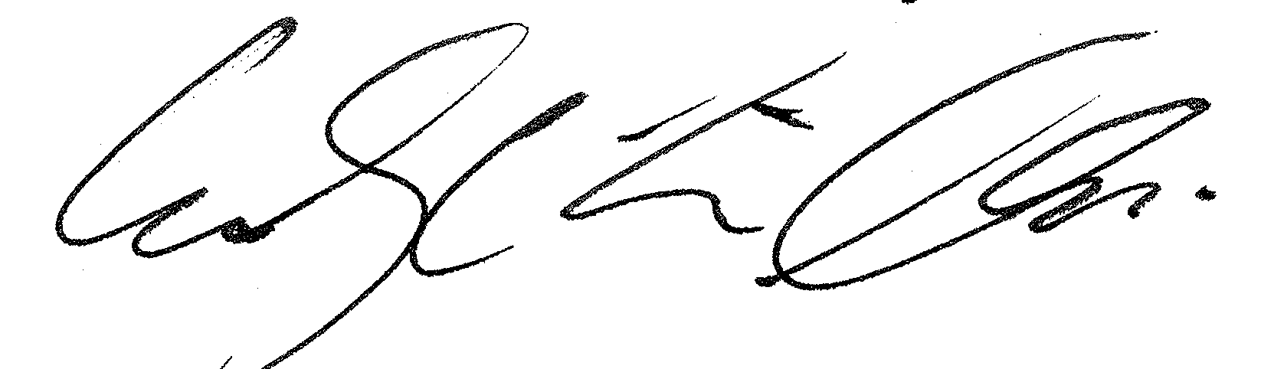
Ralph Willis

