PART-TIME EMPLOYMENT
DECLARATION
I, Peter Alexander Walsh, Minister of State for Finance hereby declare that for the purposes of sub-section 3(1) of the Superannuation Act 1976 the following employees are a class of part-time employees which is an approved class of part-time employees for the purposes of that Act:-
- a person who is an officer for the purposes of the Public Service Act 1922; and
- a person employed by the Commonwealth or by an approved authority as defined in section 3(1) of the Superannuation Act 1976, in a permanent capacity.
Provided that person is permitted by his or her terms and conditions of employment to undertake employment on a part-time basis in a permanent capacity.
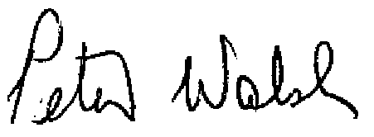
PETER WALSH
Minister of State for Finance
1st April 1986

