DEFENCE FORCE RETIREMENT AND DEATH BENEFITS ACT 1973
DECLARATION
In pursuance of sub-section 72(1) of the Defence Force Retirement and Death Benefits Act 1973, I, Eric Laidlaw Robinson, Minister of State for Post and Telecommunications, acting for and on behalf of the Treasurer:-
(a) declare employment, whether within or outside Australia, by a person, or by persons included in a class of persons, specified in the schedule to this Declaration to be public employment for the purposes of Division 3 of Part IX of that Act; and
(b). specify the first day of July, one thousand nine hundred and seventy six as the day on which this Declaration is deemed to have come into force.
THE SCHEDULE
The Commonwealth
The States
The Administration of a Territory
An authority or other body, being:-
(i) a body corporate incorporated for a public purpose by an Act, regulations made under an Act or a law of a Territory;
(ii) an authority or body, not being a body corporate, established for a public purpose by, or in accordance with, the provisions of an Act, regulations made under an Act or a law of a Territory;
(iii) a company or other body corporate incorporated under a law of a State or Territory, being a body corporate in which the Commonwealth has a controlling interest; or
(iv) an authority or body established, whether by or in accordance with the provisions of an Act, regulations made under an Act or a law of a Territory or otherwise, and whether a body corporate or not, being an authority or body which is financed in whole or in substantial part, either directly or indirectly, by moneys provided by the Commonwealth.
The Government of the United Kingdom of Great Britain and Northern Ireland.

Bodies corporate established for a public purpose by laws in force in the United Kingdom of Great Britain and northern Ireland.
Dated this fourteenth day of October 1976.
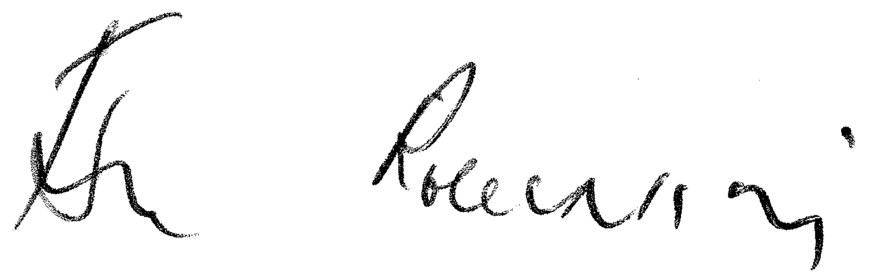
Eric L. Robinson

