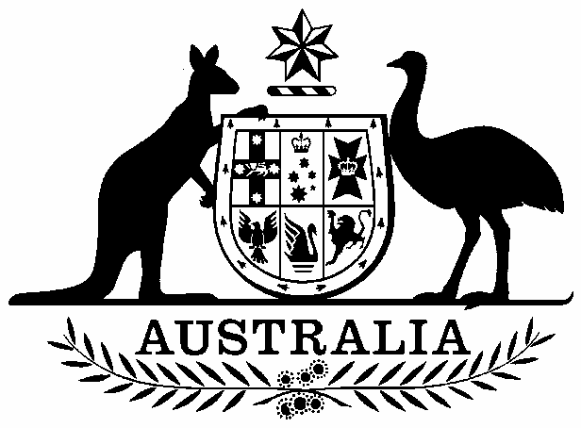

Commonwealth of Australia

Inclusion of ecological communities in the list of threatened ecological communities under section 181 of the Environment Protection and Biodiversity Conservation Act 1999

I, PETER ROBERT GARRETT, Minister for the Environment, Heritage and the Arts, pursuant to section 184(1)(a) of the Environment Protection and Biodiversity Conservation Act 1999, hereby amend the list referred to in section 181 of that Act by:

including in the list in the critically endangered category
Gippsland Red Gum (Eucalyptus tereticornis subsp. mediana) Grassy Woodland and Associated Native Grassland
as described in the Schedule to this instrument.

Dated this….......Seventeenth.............................day of…........December....................2008.

Peter Garrett

Minister for the Environment, Heritage and the Arts

SCHEDULE
Gippsland Red Gum (Eucalyptus tereticornis subsp. mediana) Grassy Woodland
and Associated Native Grassland

The Gippsland Red Gum (Eucalyptus tereticornis subsp. mediana) Grassy Woodland and Associated Native Grassland ecological community is endemic to Victoria, specifically to the central Gippsland Plain between Morwell and Swan Reach. Most occurrences fall within the Gippsland Plain (IBRA subregion SCP1; Victorian bioregion GipP) with some patches extending into the immediately adjacent parts of the East Gippsland Lowlands (IBRA subregion SEC1; Victorian bioregion EGL).
The national ecological community typically occurs on undulating to flat plains with some occurrences extending onto low hills. The soils of the plain are usually fertile and duplex, comprising loamy topsoils over a clay or clay-loam subsoil.
The ecological community occurs in two structural forms: grassland and grassy woodland. Both structural forms originate from the same open savannah woodland that formerly occupied much of the Gippsland Plain.
The woodland form has a tree canopy that is dominated by Gippsland Red Gum (Eucalyptus tereticornis subsp. mediana). Other tree species may occur in the canopy with Gippsland Red Gum including: Allocasuarina verticillata (Drooping Sheoak), A. littoralis (Black Sheoak), Eucalyptus angophoroides (Apple-topped Box), E. bosistoana (Coast Grey Box), E. bridgesiana (But But), E. globoidea (White Stringybark), E. melliodora (Yellow Box), E. pauciflora subsp. pauciflora (Snow Gum), E. polyanthemos (Red Box), E. rubida (Candlebark) and E. viminalis (Manna Gum). Small pockets of the ecological community may be locally dominated by other canopy species, for instance Drooping Sheoak or Black Sheoak.
The ecological community exhibits variable degrees of tree canopy cover. In the grassland form, the tree canopy is typically absent or only scattered trees may be present with a projective foliage cover of no more than 5%. The usual expression of the woodland form is a regrowth characterised by closely spaced thin trees with occasional, scattered large trees. These regrowth stands are stable and can persist for decades if there is no serious disturbance to the tree canopy (e.g. as occurs from strong windstorms felling trees). Such patches are included in the national ecological community. The open, mature woodland structure is relatively uncommon and characterised by large, widely spaced mature trees.
The ground layer of the ecological community is dominated by a suite of native graminoids, including perennial tussock grasses, non-tussock grasses, sedges and other graminoids. A variety of other herbs and wildflowers, such as daisies, may occur amongst the graminoids, especially during spring. The ground layer is the dominant vegetation layer of the grassland form. There are similarities in ground layer species composition between the woodland and grassland forms. However, differences in the long-term management of these two forms of the ecological communities has resulted in a divergence of their species composition.
Shrubs are not considered to be a defining feature of the listed ecological community in its natural state but may be present, especially in the woodland form. The shrub layer typically accounts for projective foliage cover values of less than 10%. There is an issue involving the invasion of native shrubs into the ecological community through disturbance or as part of natural plant dynamic processes. The presence of a shrub layer with a higher cover value than 10% does not necessarily preclude the inclusion of a patch within the listed ecological community if it otherwise conforms to the description of the ecological community. In these situations, patches are included in the national ecological community if the projective foliage cover of the native shrub layer is 50% or less of the total area of the patch.
The key defining attributes for the Gippsland Red Gum (Eucalyptus tereticornis subsp. mediana) Grassy Woodland and Associated Native Grassland are:
- The ecological community occurs in two forms.
  - A grassland form in which the ground layer is the dominant vegetation layer. The tree canopy is absent or of scattered trees only (projective foliage cover of trees is 0 to 5%).
  - A woodland form in which the tree canopy layer is the dominant vegetation layer (projective foliage cover of trees is greater than 5%). The woodland form varies in appearance from a stable regrowth with mostly thin and closely spaced trees to an open, mature woodland with large and widely spaced trees.
- The ground layer is dominated by native graminoids. That is, 50% or more of the vegetation cover of the ground layer is made up of native grasses and grass-like plants (such as sedges, rushes, lilies, Lomandra and similar plants).
- The tree canopy layer is typically dominated by Gippsland Red Gum (Eucalyptus tereticornis subsp. mediana). Small, localised occurrences of Black Sheoak or Drooping Sheoak may occur within patches of the ecological community.
- The geographic distribution is limited to the central Gippsland Plain, generally between the Strzelecki Ranges and the Tambo River valley.

