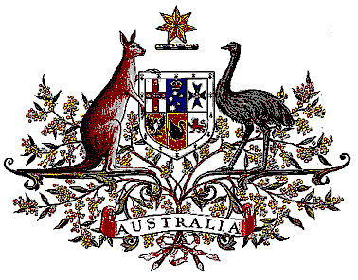

Veterans’ Entitlements Act 1986

Determination of Warlike Service
OPERATION RIVERBANK

I, Warren Snowdon, Minister for Defence Science and Personnel for the Minister for Defence:
  - determine that:
    - service rendered as a member of the Defence Force assigned for service with the Australian Defence Force contribution to the United Nations Assistance Mission in Iraq on Operation RIVERBANK on and from 21 July 2008 in the specified area is warlike service for the purposes of the definition of “warlike service” in subsection 5C(1) of the Veterans’ Entitlements Act 1986.
    - the specified area comprises Iraq, and
  - this Determination is taken to have commenced on 21 July 2008.

Dated Second of June 2009

Signed by Warren Snowdon

WARREN SNOWDON
Minister for Defence Science and Personnel
for the Minister for Defence

