POISONS STANDARD AMENDMENT NO.2 OF 2009

The National Drugs and Poisons Schedule Committee, acting in accordance with its power under paragraph 52D(2)(a) of the Therapeutic Goods Act 1989 (the Act), amends the Poisons Standard 2009 in the manner set out in Schedule 1.

The amendments to the Poisons Standard 2009 as set out in Schedule 1 commence on 1 September 2009.

Signed
DR RUTH LOPERT
CHAIR
NATIONAL DRUGS AND POISONS SCHEDULE COMMITTEE

Dated this 3rd day of August 2009

Schedule 1-Amendments to the Poisons Standard 2009

STANDARD
FOR THE
UNIFORM SCHEDULING
OF
DRUGS AND POISONS

No. 24

AMENDMENT No. 1

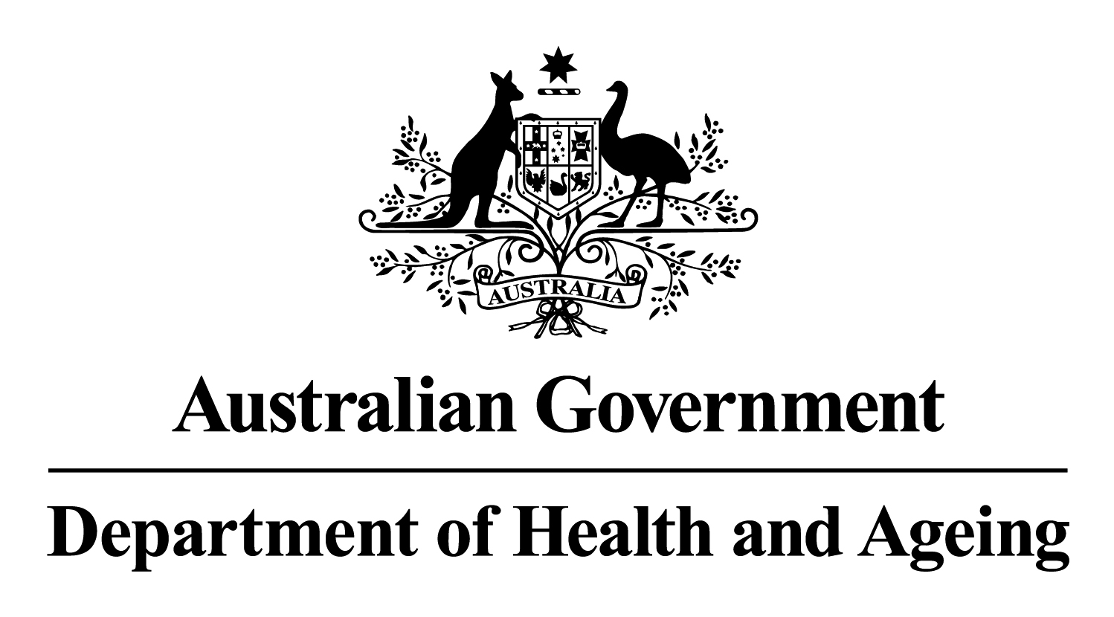

Effective Date – 1 September 2009
© Commonwealth of Australia 2009

ISBN 1-74186-909-9

This work is copyright. Apart from any use as permitted under the Copyright Act 1968, no part may be reproduced by any process without prior written permission from the Commonwealth. Requests and inquiries concerning reproduction and rights should be addressed to the:
Commonwealth Copyright Administration
Attorney-General’s Department
Robert Garran Offices
National Circuit
BARTON ACT 2600
or posted at http://www.ag.gov.au/cca

Published by the Australian Government under the Therapeutic Goods Act 1989.

Publication approval number: P3-5402

The amendments listed in this document were finalised at the February and June 2009 meetings of the National Drugs and Poisons Schedule Committee (NDPSC) except where separately specified. The basis of these amendments can be found in the ‘Record of the Reasons’, which can be accessed from the NDPSC website:

www.tga.gov.au/ndpsc

Further inquiries should be directed to:

The Secretary
National Drugs and Poisons Schedule Committee
GPO Box 9848
CANBERRA ACT 2601

Or by email: NDPSC@health.gov.au

Media Liaison Unit
Australian Government Department of Health and Ageing
TABLE OF CONTENTS

Part 4 – The Schedules 1
Schedule 2 – New Entry 1
Schedule 2 – Amendment 1
Schedule 4 – New Entries 1
Schedule 4 – Amendments 2
Schedule 5 – New Entries 2
Schedule 5 – Amendment 3
Schedule 6 – New Entry 3
Schedule 6 – Amendment 3
Schedule 9 – New Entries 4
PART 5 – appendices 4
Appendix C – New Entry 4
Appendix D – Sub-paragraph 6 – New Entry 4

Amendments to the Standard for the Uniform Scheduling of Drugs and Poisons

The National Drugs and Poisons Schedule Committee directs that the amendments below be applied to the Standard for the Uniform Scheduling of Drugs and Poisons No.24 and recommends that these amendments be adopted by the States and Territories with effect from 1 September 2009 unless otherwise stated. The amendments arise from decisions made by the Committee at its February 2009 meeting and confirmed at the June 2009 meeting except where separately specified.

Part 4 – The Schedules

Schedule 2 – New Entry
(The following entry for guaiphenesin also incorporates an editorial change identified at the June 2009 meeting under item 21.2)

GUAIPHENESIN in a modified release dosage form of 1200 mg or less of guaiphenesin with a recommended daily dose of 2400 mg or less when not labelled for the treatment of children under 12 years of age.

Schedule 2 – Amendment
(The following entry for hydroquinone also incorporates an editorial change identified at the June 2009 meeting under item 21.2)

HYDROQUINONE – Amend entry to read:
HYDROQUINONE (excluding monobenzone and other alkyl ethers of hydroquinone included in Schedule 4) in preparations for human external therapeutic or cosmetic use containing 2 per cent or less of hydroquinone except in hair preparations containing 0.3 per cent or less of hydroquinone.

Schedule 4 – New Entries
ALPHA1-PROTEINASE INHIBITOR (HUMAN).
AMBRISENTAN.
BAZEDOXIFENE.
CILOSTAZOL.
DAPOXETINE.
ETRAVIRINE.
GEMTUZUMAB OZOGAMICIN.
METHYLNALTREXONE.
PHOSPHODIESTERASE TYPE 5 INHIBITORS except when separately specified in these Schedules.
RIVAROXABAN.
SUGAMADDEX.
TOCILIZUMAB.

Schedule 4 – Amendments
(The following entry for guaiphenesin also incorporates an editorial change identified at the June 2009 meeting under item 21.2)

GUAIPHENESIN – Amend entry to read:
GUAIPHENESIN for human therapeutic use except:
(a) when included in Schedule 2;
(b) in oral liquid preparations containing 2 per cent or less of guaiphenesin; or
(c) in divided preparations containing 200 mg or less of guaiphenesin per dosage unit.
HYDROQUINONE – Amend entry to read:
HYDROQUINONE (other than its alkyl ethers separately specified in this Schedule) in preparations for human therapeutic or cosmetic use except:
(a) when included in Schedule 2; or
(b) in hair preparations containing 0.3 per cent or less of hydroquinone.

Schedule 5 – New Entries
(The following entry for diethylene glycol also incorporates an editorial change identified at the June 2009 meeting under item 21.2)

† DIETHYLENE GLYCOL (excluding its salts and derivatives) in preparations containing not less than 10 mg/kg of denatonium benzoate as a bittering agent except:
(a) in paints or paint tinters;
(b) in toothpastes or mouthwashes containing more than 0.25 per cent of diethylene glycol; or
(c) in other preparations containing 2.5 per cent or less of diethylene glycol.
PROTHIOCONAZOLE-DESCHLORO except in preparations containing 0.5 per cent or less of prothioconazole-deschloro.
PROTHIOCONAZOLE-TRIAZOLIDINETHIONE except in preparations containing 0.5 per cent or less of prothioconazole-triazolidinethione.

Schedule 5 – Amendment
(The following entry for ethylene glycol also incorporates an editorial change identified at the June 2009 meeting under item 21.2)

ETHYLENE GLYCOL – Amend entry to read:
† ETHYLENE GLYCOL (excluding its salts and derivatives) in preparations containing not less than 10 mg/kg of denatonium benzoate as a bittering agent except:
(a) in paints or paint tinters;
(b) in toothpastes or mouthwashes containing more than 0.25 per cent of ethylene glycol; or
(c) in other preparations containing 2.5 per cent or less of ethylene glycol.

Schedule 6 – New Entry
(The following entry for diethylene glycol also incorporates an editorial change identified at the June 2009 meeting under item 21.2)

† DIETHYLENE GLYCOL (excluding its salts and derivatives) except:
(a) when included in Schedule 5;
(b) in paints or paint tinters;
(c) in toothpastes or mouthwashes containing more than 0.25 per cent of diethylene glycol; or
(d) in other preparations containing 2.5 per cent or less of diethylene glycol.

Schedule 6 – Amendment
(The following entry for ethylene glycol also incorporates an editorial change identified at the June 2009 meeting under item 21.2)

ETHYLENE GLYCOL – Amend entry to read:
† ETHYLENE GLYCOL (excluding its salts and derivatives) except:
(a) when included in Schedule 5;
(b) in paints or paint tinters;
(c) in toothpastes or mouthwashes containing more than 0.25 per cent of ethylene glycol; or
(d) in other preparations containing 2.5 per cent or less of ethylene glycol.

Schedule 9 – New Entries
1-(8-BROMOBENZO[1,2-B;4,5-B]DIFURAN-4-YL)-2-AMINOPROPANE *(Bromo-Dragonfly).
4-FLUORO-N-METHYLAMPHETAMINE.
N-PHENETHYL-4-PIPERIDONE.

PART 5 – appendices

Appendix C – New Entry
ETHYLENE GLYCOL for use in toothpastes or mouthwashes except in preparations containing 0.25 per cent or less of ethylene glycol.

Appendix D – Sub-paragraph 6 – New Entry
AMBRISENTAN for human use.

