Explanatory Statement

Small Pelagic Fishery Management Plan 2009

Subsection 17(1) of the Fisheries Management Act 1991 (the Act) provides that the Australian Fisheries Management Authority (AFMA) must determine plans of management for each fishery that it manages. AFMA intends to determine the Small Pelagic Fishery Management Plan 2009 (the Plan).

Table of Contents

The Small Pelagic Fishery 2

Determination and acceptance - consultation 3

Regulation Impact Statement 5

PART 1: Preliminary 5

PART 2: Specific ecosystem requirements 6

PART 3: Total allowable catch 6

PART 4: Right to fish in the fishery 7

PART 5: Availability of SFRs 8

PART 6: Transfer and lease of SFRs 9

PART 7: Obligations applying to holders of SFRs 9

PART 8: Directions not to engage in fishing 10

PART 9: Miscellaneous 10

PART 10: Transitional 10

SCHEDULES 11

The Small Pelagic Fishery

The Small Pelagic Fishery (SPF) comprises fishing activities in the Australian Fishing Zone, using the methods of purse seine and mid water trawl, to target a number of pelagic species. These include Jack Mackerels (Trachurus declivis, T. murphyi), Redbait (Emmelichthys nitidus), Blue Mackerel (Scomber australasicus) and Australian Sardines (Sardinops sagax). The Real Gross Value Production in 2007-08 was $1.07 million (Bureau of Rural Sciences, Fishery Status Report 2009). Catches can be used for several end purposes, including bait for fishing operations, fish meal for agricultural feed, and human consumption.

Since December 2001, the fishery has been managed by a system of permits under the Management Policy for the Commonwealth Small Pelagic Fishery. Historically, the fishery has been divided into four zones (A to D) (Fig. 1).

Figure 1. Areas of waters and zones for the Small Pelagic Fishery.

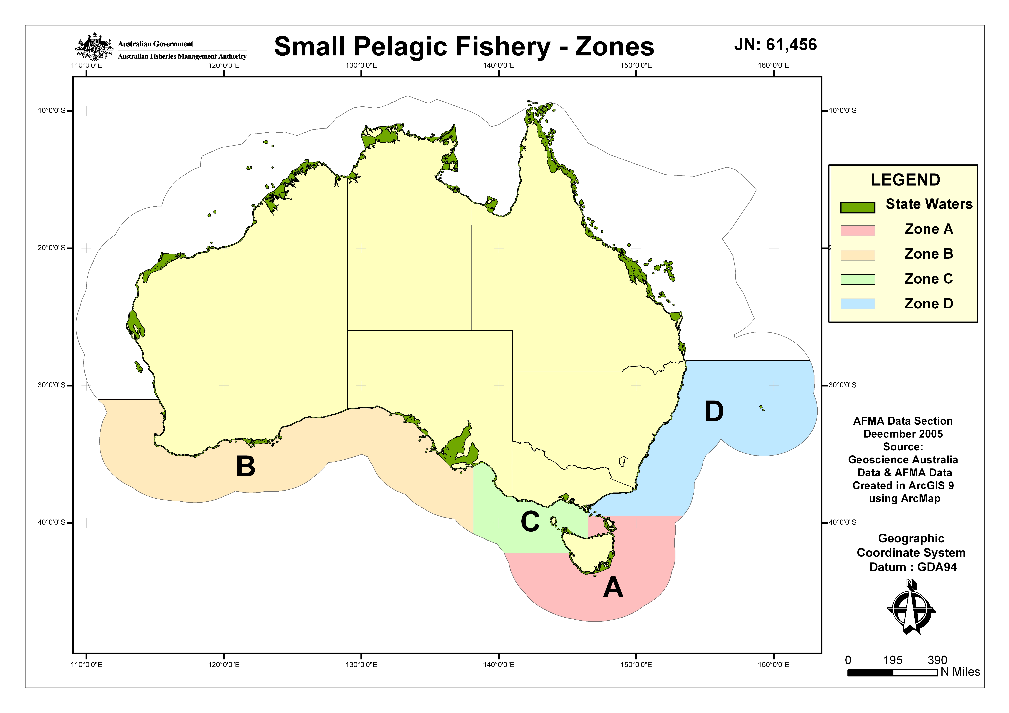

For the purposes of pursuing stock based management under the Plan, the previous zonation will be superseded and the fishery for Jack Mackerels, Blue Mackerel and Redbait will be divided into two sub-areas east and west of longitude 146°30’ E (Fig. 2). The fishery will also be extended north along the east coast to latitude 24° 29′ 54″ S and an Australian Sardine sub-area designated to accommodate activities currently authorised by Informally Managed Fishery Permits (IMFP). The fishery does not include State waters and extends to the outer limit of the Australian Fishing Zone.

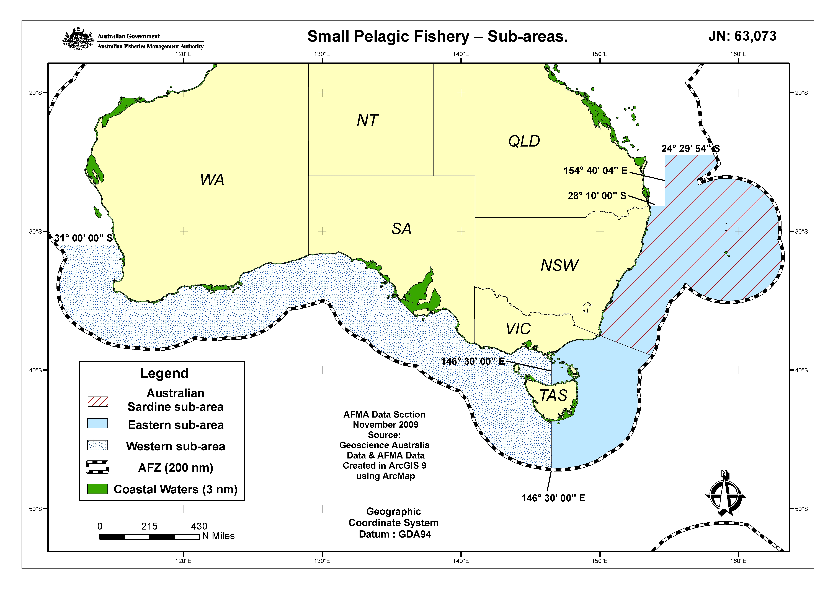
Figure 2. Areas of waters and the three sub areas for the SPF under the Plan

Determination and acceptance - consultation

AFMA has developed the Small Pelagic Fishery Management Plan 2009 (the Plan) in accordance with Section 17 of the Fisheries Management Act 1991 (the Act). An Independent Allocation Advisory Panel (IAAP) was established to advise the AFMA Board on the most appropriate allocation system for SFRs in the Fishery. This process sought to maintain the relative economic position of participants in the Fishery by reflecting the relative historic value of their permits.

It is Commonwealth Government policy (Looking to the Future – A Review of Commonwealth Fisheries Policy, June 2003) to implement management plans for all Commonwealth fisheries. Management plans provide secure access rights to fishers and market-based incentives for operators to improve and conserve fisheries resources, and best achieve AFMA’s legislative objectives. A more detailed analysis of the likely impacts on industry of the type of fishing rights introduced under the Plan is provided in the Regulation Impact Statement.

Fees raised from industry for management of the Fishery (as required under AFMA’s cost recovery policy) are raised under separate legislation. The quantum of fees raised is unlikely to be affected by the Plan but some individual fees may change.

Section 17 of the Act requires that the Plan can only be determined after consultation with such persons engaged in fishing as appear to AFMA to be appropriate and, after giving due consideration to any representations made to AFMA on the Plan. Subsection 17(2) of the Act requires that interested persons must be invited, by public notice, to make representations on a draft of the plan. Subsection 17(2A) provides that persons and organisations listed in the register, established under Section 17A, must also be notified that a draft Plan is available and that representations may be made in connection with the draft Plan. AFMA has met all of the consultation and notification processes required under legislation.

AFMA has informed the Minister of the consultations that were conducted and of representations that were received before determining the Plan. The Minister was then in a position to judge if AFMA gave due consideration to any representations received and conducted adequate consultations when accepting the Plan in accordance with the Act.

The AFMA Commission determined the Plan on 2 November 2009.

The Minister has accepted the Plan. Notification of the determination and acceptance of the Plan was published in the Gazette in accordance with subsection 19(1) of the Act.

Content of Plan

Subsection 17(5) of the Act provides that a plan of management for a fishery is to set out the objectives of the Plan, the measures by which the objectives are to be attained and performance criteria against which the measures taken may be assessed. These are designed to accord with the Environment Protection and Biodiversity Conservation Act 1999 (the EPBC Act).

The objectives of the Plan reflect the objectives set out in Section 3 of the Act.

The measures by which the objectives are to be achieved are set out in Section 12 of the Plan. These include providing the services needed to manage the fishery including data collection, research and consultation, granting of transferable statutory fishing rights (SFRs), the setting of total allowable catch (TAC), the development of management strategies, research, data collection, monitoring, compliance and the recovery of costs for the management of the Fishery.

Subsection 17(5A) of the Act provides that the measures to be set out in a plan of management include, among other things, providing for AFMA to direct that fishing is not to be engaged in (in) the Fishery or part of the Fishery. Section 53 of the Plan makes provision for such a power.

In addition, subsection 17(6D) of the Act provides that a plan of management must contain measures directed at reducing the incidental catch of fish and other species to a minimum. The Plan provides that AFMA must implement a by-catch action plan (BAP), which is to be reviewed at least every second year. The development, implementation and review of the BAP are included as a measure by which the objectives of the Plan will be achieved. Assessment of the impact of catch on non-target species are included in the performance criteria for assessing those measures.

The Plan provides for a system of transferable Blue Mackerel (Scomber australasicus), Jack Mackerels (Trachurus declivis and T. murphyi), Redbait (Emmelichthys nitidus), and Australian Sardine (Sardinops sagax) statutory fishing rights (SFRs). The Blue Mackerel, Jack Mackerel and Redbait SFRs will be granted for the eastern and western sub-areas and the Australian Sardine SFR’s will be granted for the Australian Sardine sub-area. For a season, each SFR entitles the holder of that SFR to an equal share of the total allowable catch (TAC) for the Fishery. TACs for each species and sub-area will be determined annually by AFMA in accordance with the Plan. The SFRs remain in force until the day specified in the certificate, or if no such day is specified, until cancelled or surrendered or otherwise they cease to have effect under the Act.

Under the Plan, TACs for a season are to be determined by AFMA in time for the commencement of the season. When setting the TACs, AFMA will take into account information from the relevant Management Advisory Committee (MAC) and Resource Assessment Group (RAG). The MAC and RAG include members who are engaged in industry, environmental groups, research and government.

Specific obligations on holders of SFRs are set out in the Plan. These obligations are primarily designed to ensure that the fishing that takes place in the Fishery:
- does not result in fishing effort exceeding the TACs;
- can be independently observed; and
- is done in accordance with all relevant legislation, including the Act, Regulations, Legislative Instruments, conditions on SFRs and other laws as they apply from time to time.

The Plan also provides for AFMA to make Directions that will prohibit holders of SFRs from carrying on activities specified in those Directions. Except in an emergency, AFMA must consult with the relevant MAC and RAG before making a Direction.

The Plan allows for the leasing of SFRs. Under a lease, the owner of the SFR would grant to the lessee of the SFR the right to use the SFR for the period of the lease.

The Plan provides a number of other mechanisms designed to focus, and provide for, the management of the Fishery.

The Plan will be supported by the Fisheries Management (Small Pelagic Fishery) Regulations 2009. The Regulations set out matters that must be included in the Register of Statutory Fishing Rights and also prescribe matters, such as the timing of the fishing season, that are more conveniently prescribed by regulations.

Regulation Impact Statement

A Regulation Impact Statement (RIS) was prepared for the Small Pelagic Fishery Management Plan 2009 and assessed by the Office of Best Practice Regulation (OBPR). OBPR advised AFMA on 25 June 2009 that the RIS satisfied the Australian Government’s RIS requirements (the OBPR identification number for the RIS is 7370). The RIS is attached at Attachment A.

The Plan commences on the day after it is registered. A detailed description of the Plan is set out below.

PART 1: Preliminary

Section 1 provides for the Plan to be cited as the Small Pelagic Fishery Management Plan 2009.

Section 2 provides that the Plan commences on the day after it is registered.

Section 3 sets out the definitions of certain terms used in the Plan.

Section 4 specifies the origin of geographical coordinates used within the Plan.

Sections 5 defines ‘holds a sequence of permits or licences’

Section 6, 7 and 8 explain what is meant by ‘sequence of Zone A purse seine permits’, ‘sequence of Zone D permits’ and ‘sequence of Mackerel B permits’ respectively.

Section 9 sets out the meaning of uncaught quota.

Section 10 provides for AFMA to determine 1 or more periods during which fishing is permitted in the fishery.

Section 11, 12 and 13 set out the objectives of the Plan, the measures by which AFMA will attain the objectives and the performance criteria for assessing achievement against the objectives. The objectives are consistent with the Act.

The measures for achieving the objectives address the key issues of sustainability, economic efficiency, impacts on non-target species and the marine environment, the collection and use of fishery data, efficient and cost-effective management and consistency with international obligations.

The performance criteria against which the measures taken under the Plan may be assessed are set out in Section 13.

PART 2: Specific ecosystem requirements

Section 14 requires AFMA to develop and implement a bycatch action plan (BAP) to ensure that the bycatch of the Fishery is reduced to or kept at a minimum. AFMA must review this Plan at least every two years to ensure that it is achieving it objectives. Subsection 14 (6) provides that if information gathered under a BAP shows that it is necessary, AFMA must consider making changes to the Plan, consider issuing a direction to stop fishing, or consider making changes to conditions on gear SFRs.

Section 15 specifies that AFMA must establish a Harvest Strategy for each quota species, as soon as practicable after the Plan comes into force, and may review the Harvest Strategy to ensure that it remains appropriate for maintaining ecologically viable stocks of the quota species and an ecologically sustainable fishery. Subsection 15 (3) provides that AFMA may establish a Harvest Strategy for a non-quota species if appropriate for maintaining ecologically viable stocks of the quota species and an ecologically sustainable fishery.

PART 3: Total allowable catch

Division 3.1 Total allowable catch – quota species

Section 16 provides that Division 3.1 sets out the requirements for the determination of total allowable catch (TAC) for a quota species.

Section 17 provides that AFMA must determine a TAC for each quota species for a sub-area of the fishery and for a season before the start of the season. In that determination AFMA must specify the amount of the species that may be taken in weight, and the sub-area or part of a sub-area to which the determination applies.

Section 18 requires that in determining a TAC for a quota species for a sub-area or part of a sub-area of the fishery for a season, AFMA must consult with and have regard to any view from the advisory committee in addition to taking into account advice from the relevant resource assessment group about the stock status of a quota species. AFMA must also take into account the Harvest Strategy, all fishing mortality of the quota species, the ecological implications of taking the amount of the species, the distribution, population and structure of the species, the precautionary principle and may consider the views (if any) of any other interested person.

Section 19 specifies that after determining a TAC for a quota species for a sub-area or part of a sub-area of the fishery for a season, AFMA must as soon as practicable give written notice to the SFR holder stating the TAC and quota allocated for the species for the sub-area or part of the sub-area for a season.

Division 3.2 Total allowable catch – non quota species

Section 20 provides that Division 3.2 sets out the requirements for the determination of total allowable catch (TAC) for a non-quota species.

Section 21 provides that AFMA may determine a TAC for a non-quota species. In that determination AFMA must specify the amount of the species that may be taken in weight, and the sub-area or part of a sub-area to which the determination applies.

Section 22 requires that in determining a TAC for a non-quota species for a sub-area or part of a sub-area of the fishery for a season, AFMA must consult with and have regard to any view from the advisory committee in addition to taking into account advice from the relevant resource assessment group about the stock status of the species. AFMA must also take into account the Harvest strategy, all fishing mortality of the species, the ecological implications of taking the amount of the species, the distribution, population and structure of the species, the precautionary principle and may consider the views (if any) of any other interested person.

Section 23 specifies that after determining a TAC for a non-quota species for a sub-area or part of a sub-area of the fishery for a season, AFMA must as soon as practicable give written notice to the SFR holder stating the species, that amount of the species that may be taken under the TAC, the period for which the TAC applies and the sub-area or part of the sub-area to which the TAC applies.

Section 24 specifies that when the amount allocated as TAC for a non-quota species has been taken then AFMA must give each SFR holder for the TAC written notice stating that the species may no longer be taken from the sub-area or part of the sub-area during the period that the TAC is in force.

PART 4: Right to fish in the fishery

Division 4.1 General

Section 25 specifies that in order to fish for a quota species in the Fishery, an operator must hold SFRs for the quota species in a sub-area or part of a sub-area, use purse seine, mid-water trawl or other fishing method determined by AFMA under Section 27, and have them nominated against a boat to fish in the Fishery. In addition the SFR holder must not fish for a quota species unless they have uncaught quota for the species in the sub-area or part of a sub-area.

Section 26 specifies the requirements the operator must meet in order to fish for a non-quota species in the Fishery including holding SFRs for the Fishery, the use of purse seine, mid-water trawl or other fishing method as determined by AFMA under Section 27, having a boat nominated for the purposes of the SFR, that a TAC has been determined and remains available for the species, and it is an incidental catch.

The person is allowed to take and keep the catch if the non-quota species is a species for which quota has been granted under another plan of management and the SFR holder has the quota to take that amount of species under that plan or obtains a quota entitlement to take that amount of species under that plan.

Section 27 provides that AFMA may determine a fishing method other than purse seine or mid-water trawl fishing methods for use by persons fishing in the fishery. The determination must specify the fishing method that may be used, the SFRs, period and area to which the determination applies.

Section 28 prescribes the conditions under which a person may use a boat to carry, tranship or process fish taken in accordance with the Plan.

Division 4.2 Overcatch and Undercatch

Section 29 specifies the holder’s obligations relating to overcatch where a SFR holder exceeds the holder’s share of the total allowable catch in the relevant season. The over catch is deducted from the SFR holder’s entitlements in the next season. AFMA specifies the degree to which this can occur for each species each season and the method that AFMA will use to determine the overcatch.

Section 30 specifies the holder’s obligations relating to undercatch. Where a SFR holder has not used their entire quota allowed by their SFRs in a season, the holder is permitted to carry over a certain percentage of SFRs into the following season.

PART 5: Availability of SFRs

Section 31 specifies the conditions for registration as an eligible person for the grant of statutory fishing rights in the fishery.

Sections 32 to 40 stipulate the formulae for the allocation of quota SFRs to those persons eligible for the grant of one or more such SFRs under the Plan.

Section 41 provides that if a person is an eligible person, the person is taken to have made a request under Section 31 of the Act for a grant of an SFR or SFRs that are available to that person.

Section 42 prescribes the information required to be noted on the certificate evidencing the grant of SFRs for the fishery.

Section 43 sets out the process for SFR holders applying to have a boat nominated as an eligible boat on the Register and sets out the information to be included on the Register, such as the name of the nominated boat. This section permits a boat to be nominated to only one SFR holder. The application nominating a boat must include a statement as to the suitability of the boat to carry an observer. If AFMA approves an application to nominate a boat, it must enter that nomination onto the Register and provide the applicant with a signed extract of the registered nomination. AFMA can refuse an application if the boat cannot carry an observer safely.

A decision made by AFMA to not enter a boat in the Register as the nominated boat for the SFR is a reviewable decision under Section 165 of the Act.

Section 44 allows for AFMA to cancel the approval of a boat as a nominated boat for an SFR where the boat nominated is determined safe for carrying an observer and the master of the boat or the holder of the SFR for which the boat is nominated refuses to carry an observer. A decision made by AFMA to remove a boat from the Register is a reviewable decision under Section 165 of the Act.

Section 45 provides that AFMA must cancel a boat nomination when requested in writing from the holder of an SFR for which the boat is the nominated boat.

PART 6: Transfer and lease of SFRs

Section 46 prescribes the circumstances where AFMA may refuse to approve the transfer of an SFR, namely:
- where proceedings for an offence under the Act or Regulations are underway, or
- if an application for registration of another interest in the SFR has been received by AFMA (before the application for transfer is received and has not been dealt with), or
- where the SFR has been suspended or pending a decision or application for review relating to suspension or cancellation, or
- during a period from 14 days before issuing a levy notice to when the levies are paid.

Section 47 provides for the issue of certificates by AFMA for transferred SFRs.

Section 48 specifies that the holder of an SFR for a season may lease the SFR to another person only if the holder has not taken fish under that SFR in the same season.

PART 7: Obligations applying to holders of SFRs

Section 49 provides that the purpose of this Part is to impose conditions on all holders of SFR’s for the purposes of paragraph 22(3)(a) of the Act.

Section 50 sets out the general obligations on the holders of SFRs. These include, among other things, a requirement to:
- comply with the Plan and any Regulation made under the Plan;
- comply with any direction made under subsection 17(5A) (a) of the Act for the fishery;
- retain by-catch if required, and take steps to minimise by-catch and the impact of fishing on the environment;
- minimise the loss of fishing gear;
- ensure that all fish are unloaded within Australia or an external Territory;
- carry a vessel monitoring system;
- carry an observer(s);
- when required, provide AFMA access to biological, economic or technical information or samples;
- carry on board an extract of the SFR Register relevant to that boat; and
- sell (or otherwise dispose of) fish only to persons holding a fish receiver permit, however the SFR holder may, after unloading the catch, dispose of maximum of 10kg of quota species of fish to one or more persons who are not holders of a fish receiver permit.

Section 51 sets out obligations relating to fishing in more than one area, in particular a SFR holder must not fish under a State or Territory permit if there are fish on board that were taken under the SFR. In addition, if there are fish on board that have been taken in another sub-area, in the high seas or under another State or Territory permit, then the SFR holder must not fish in a sub-area of the fishery. AFMA may provide written approval to the holder to allow a multi-jurisdictional trip.

Section 52 sets out the obligations on the holder of an SFR relating to interactions with certain species and marine communities. These obligations include taking all reasonable steps to avoid interactions with certain species and communities, such as threatened species and threatened ecological communities and, where an interaction results in the death of one of these species or communities, not disposing of the carcass in a way that attracts other birds or mammals. This section also sets out what should be done if any such interactions occur, including recording (in logbooks) and reporting any interactions with listed species or communities, and taking all practical steps to aid an injured member of the listed species.

PART 8: Directions not to engage in fishing

Section 53 specifies that AFMA may give a written Direction that fishing is not to be engaged in in the fishery, or a sub-area or part of a sub-area of the fishery in a particular period or periods. Before giving such a direction AFMA must consult with the relevant advisory committee about the content of the direction. Except in an emergency AFMA must, at least 7 days before the direction takes effect, notify all holders of SFRs, scientific permits and foreign fishing licences about the direction.

PART 9: Miscellaneous

Section 54 provides that AFMA may delegate, as prescribed, any of its powers or functions under this Plan, other than its powers of functions under Sections 17, 21, 24, 29 and this section.

Section 55 provides that AFMA may approve a form for the purposes of a section of this Plan and requires that an approval must be in writing.

Section 56 provides that if the holder of an SFR appoints a person as an agent for any matter to which the Plan applies, the holder must, as soon as practicable, give AFMA notice of the appointment in the approved form, specifying the name of the agent and the powers that may ne exercised by the agent. The appointment of an agent is of no effect for the purposes of the Plan unless AFMA has been notified of the appointment.

Section 57 sets out the details for the dispatch and receipt of notices required under the Plan and the circumstances in which a notice is deemed to have been given to AFMA or to an eligible person, or to the holder of an SFR or of a fishing permit.

PART 10: Transitional

Section 58 sets out the transitional arrangements, which will take effect on commencement of the Plan and continue until ceased through a public notice in the Gazette. These arrangements will allow for fishing to continue during this transition period under a system of fishing permits.

SCHEDULES

Schedule 1 Sub-areas of the Fishery
Parts 1, 2 and 3 of this Schedule together define the area of the fishery as the part of the Australian Fishing Zone (AFZ) beginning at the parallel of latitude 28º 10’ 00”S running progressively east to the point of intersection with the meridian of longitude 154º 40’ 04” E to the intersection 24º 29’ 54”S along the outer limit of the AFZ extending south, then westerly to the western coastline of Australia to the latitude of 31º 00’ S. Part 1 defines the Eastern sub-area, which is separated from the Western sub-area (Part 2) by the longitude 146º 30’E.

Part 3 defines the Australian sardine sub-area which effectively forms a subsector of the Eastern sub-area that extends from the northern most part of the fishery southward to the line that is a continuation of landward boundary between New South Wales and Victoria out to the edge of the AFZ.

Schedule 2 Zones A, B, C and D.
Historically, the Commonwealth Small Pelagic Fishery has been divided into zones (A to D). This zonation description is provided for the purposes of SFR allocation.
- Part 1 defines the sub-area of fishery called Zone A.
- Part 2 defines the sub-area of fishery called Zone B.
- Part 3 defines the sub-area of fishery called Zone C.
- Part 4 defines the sub-area of fishery called Zone D.

Schedule 3 IMF and IMF 2 sub-areas
Part 1 and 2 of the Schedule provide area definitions for the purposes of SFR allocation that facilitates the differentiation between permits in the area of the fishery formerly known as the Informally Managed Zones (IMF) 1 and IMF 2 sub-areas respectively.

Schedule 4 Quota species
This Schedule lists the four quota species that may be caught in the fishery for which there will be SFRs granted under the Plan.

