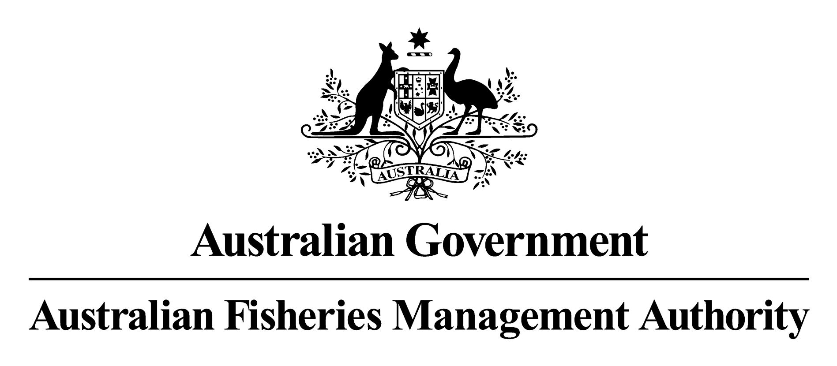

Regulation Impact Statement

SMALL PELAGIC FISHERY MANAGEMENT PLAN 2009

INTRODUCTION 4
PROBLEM IDENTIFICATION 5
Management of Commonwealth Fisheries 5
OBJECTIVES 7
OPTIONS 8
Option 1 Continue granting annual fishing permits (Maintain status quo) 8
Option 2 Implementation of a Management Plan under the FMA that would allow for the grant of SFRs in the form of either Individual Transferable Effort units (ITEs) or Individual Transferable Quota (ITQs). 9
IMPACT ANALYSIS 9
Affected sectors 10
Community 10
Business (industry) 10
Government 10
Analysis against benefits and costs of options 11
Option 1 - Maintain the Status Quo (grant annual fishing permits) 11
Option 2 – Development of a Management Plan and grant of statutory fishing rights as either ITQs or ITEs (see 2a and 2b below for ITQ and ITE specific costs and benefits). 13
Option 2a – Granting SFRs in the form of ITQs. 15
Option 2b – Granting SFRs in the form of ITEs. 17
CONSULTATION 18
CONCLUSION AND RECOMMENDED OPTION 19
Implementation and review of the preferred option 20
(a) Granting SFRs 20
(b) Appeals 21
(c) Table 2: Avenues of appeal for each type of decision under the FMA 22
Review of SPF Management Plan 22
Cost Recovery 22
Appendix 1 24
THE SMALL PELAGIC FISHERY 24
AREA OF WATERS 24
Target Species And Methods 24
Figure 1. Area of Waters and zoning for the Small Pelagic Fishery. 24
Zones B, C and D management arrangements 25
Zone A management arrangements 25
Consultative mechanism 25

Introduction
This Regulation Impact Statement (RIS) examines the proposed introduction of the Small Pelagic Fishery Management Plan 2009 (the Plan). The need for new regulation and an analysis of why the Plan is the preferred regulatory option is provided. The proposed option and two alternatives were considered and assessed in terms of costs and benefits to the community, business and government. Consultation, implementation and review procedures for the Plan are also outlined.

The Small Pelagic Fishery

The Small Pelagic Fishery (SPF) is currently divided into four zones (A to D) within an area of waters that extends from the Queensland/New South Wales border around southern Australia to a line at latitude 31º south (near Lancelin north of Perth). The fishery only includes waters between 3nm and the outer limit of the Australian Fishing Zone. The Plan amalgamates the current zones into two sub areas (Fig. 1). This new division is based on scientific evidence which indicates that for most target species there are discrete stocks east and west of longtitude 146º 30 through Tasmania. A third sub area will be created to accommodate the inclusion of Informally Managed Fishery Permits (IMFP) which allow the take of Australian Sardines. The Australian Sardines sub area will cover the Commonwealth waters off NSW and those waters off Queensland covered under SPF permits.

The Plan proposes targeted purse seine and midwater trawl fishing for six small pelagic species:
- Jack mackerels - Trachurus declivis, T. murphyi
- Blue mackerel - Scomber australasicus
- Red bait - Emmelichthys nitidus
- Australian Sardine - Sardinops sagax

Figure 1 Area of waters for the Small Pelagic Fishery proposed under the Plan

There are currently 73 permits held within the SPF by 33 concession holders, however only 5 of these permits are currently fished against. As a consequence, there is a high level of latent effort in the fishery, if a significant number of these permits were activated it is unlikely that the fishery could remain profitable.

The SPF stocks are also targeted by recreational fishers. Table 1 outlines the number of recreational fishermen in each state and the percentage of these fishers catching SPF species.

Table 1. * SPF species included are yellowtail scad, blue mackerel, jack mackerel. Source: National Recreational Fishing Survey 2001; Bureau of Rural Science.
State of Residence | Number fishers catching SPF species* | Number diarists who fished | Percent fishers catching SPF species
01.NSW | 126 | 2058 | 6.1
02.VIC | 24 | 1453 | 1.7
03.QLD | 19 | 2222 | 0.9
04.SA | 64 | 1740 | 3.7
05.WA | 176 | 2182 | 8.1
06.TAS | 86 | 1282 | 6.7
08.ACT | 6 | 216 | 2.8
All States except NT | 501 | 11153 | 4.5

Problem identification

Management of Commonwealth Fisheries
The Australian Fisheries Management Authority (AFMA) is responsible for the management of fisheries within Commonwealth waters, Australian fishers on the high seas and by agreement with the States, to the low water mark in some cases. Commonwealth waters are those generally between 3nm and 200nm from the coastline. AFMA manages these fisheries on behalf of the community and its participants in accordance with the Fisheries Management Act 1991 (FMA) and Fisheries Administration Act 1992 (FAA).

Almost all Commonwealth managed fisheries are affected by overcapitalization and overfished stocks (McLouglin, K, 2006). At the same time there is increasing community demand and statutory requirements for Commonwealth Fisheries to be managed under a system of ecosystem based fisheries management. Developing a framework to alleviate problems of overfishing and overcapitalization and to preserve the marine environment in accordance with reasonable community expectations is a key challenge facing fisheries management.

Excess fishing capacity has been recognised as a major impediment to achieving sound fisheries management outcomes (DAFF, 2003; DPIE, 1989) and has generally arisen through the lack of effective property rights. In the absence of secure and transferable access rights there are few safeguards against overcapitalisation and few market-based incentives for operators to conserve resources for the long-term.

In recognition of these challenges, on 14 December 2005, the then Federal Minister for Fisheries, Forestry and Conservation, Senator Ian Macdonald directed AFMA to cease overfishing, recover overfished stocks and manage broader environmental impacts of fishing.
In order to meet these objectives, in 2003 AFMA made a policy commitment to the Department of Agriculture Fisheries and Forestry (DAFF; 2003) which required them to:
- Complete fisheries management plans for all major fisheries, as soon as practicable, as required under the FMA;
- Ensure that Statutory Fishing Rights (SFRs) of access are implemented in all major Commonwealth fisheries; and
- Retain an emphasis on using output controls in the form of Individual Transferable Quotas (ITQs) as the preferred management approach.

This 2003 policy commitment was a reiteration of the long standing policy of the Australian Government for Commonwealth fisheries (since 1989) and is preferred as:
- Statutory management plans provide a clear administrative framework, allow for a wide range of measures needed to pursue ecosystem based fisheries management; and give rise to the grant of SFRs.
- SFRs are an ongoing secure access right that provides greater investment certainty for industry and therefore incentive to utilise fisheries resources in a sustainable manner. and
- ITQ SFRs reward productivity improvements and enable adjustment to market pressures by operators (therefore maximizing the profitability of the fishery).

Management of the Small Pelagic Fishery and informally managed fishing activities

Current management arrangements for the SPF and IMFP fishing activities are not consistent with Government policy and put AFMA’s ability to achieve its legislative objectives at risk. Both the SPF and IMFP fishing activities are regulated through annual Fishing Permits. Management arrangements are imposed through permit conditions. In accordance with section 32 (7) of the FMA, permit conditions may specify: i) the species of fish that may be taken; ii) the quantity of fish that may be taken; iii) the rate at which fish may be taken; iv) the methods or equipment that may be used to take fish; or v) the methods or equipment that may be used to process or carry fish.

The broad limitation of this approach is that it does not provide long term secure access rights or promote certainty in the ongoing management environment for the fishery. From an industry perspective there is no guarantee of ongoing access as AFMA may exercise its discretion in approving the grant of permits, and although rarely used it is possible for AFMA to vary its management arrangements without consultation. Permits also promote uncertainty and destabilisation of the industry through the potential for frequent litigation. Under section 165 of the FMA, decisions relating to the grant of a fishing permit (including permit conditions) are reviewable by AFMA and the Administrative Appeals Tribunal within 21 days of their issue. If there are grounds on points of law, further appeals can be made to the Federal Court. This potential for increased litigation inhibits AFMA from achieving its cost effective management objective.

Although AFMA believes that the existing management arrangements for the SPF and Informally Managed Fishing Permits (IMFPs) remain precautionary under low levels of effort, it is recognised that significant development potential and the risk of unsustainable capital investment exists. In 2004, interest in small pelagic species increased with investors expressing plans to use vessels with significantly greater capacities than the current Australian fleet. Potential also exists for markets to expand or emerge for human consumption, fish meal and aquaculture feed both domestically and internationally. Despite such development potential industry argue that the current management arrangements do not offer a secure investment environment and do not encourage autonomous restructuring. There is currently a high level of latent effort in the fishery and it is unlikely that the fishery could remain profitable if a significant number of these permits became active, as all vessels would not be able to make profit in unison. There is a moderate risk of the fishery expanding to fish at this unprofitable level in the future. Although it is possible to enforce lower catch limits under a permit system, giving greater investment security by issuing permits for up to five years, as outlined in the Ministerial Direction, this is not the preferred option for management of Commonwealth fisheries as it does not provide an ongoing access right and is less efficient and secure than Quota SFRs. Further, permit conditions (such as catch limits) can be appealed upon annual grant of permits, resulting in increased costs and inefficient running of the fishery.

In line with cost effective management and noting the overlap of species and methods, The AFMA Board has decided to manage IMFP activities as part of the SPF under a single plan of Management. A description of current management arrangements for both the SPF and IMFPs is provided in Appendix 1.

Objectives
In accordance with AFMA’s legislative obligations the following objectives must be pursued when performing its functions:
- Implementing efficient and cost-effective fisheries management on the behalf the Commonwealth;
- ensuring that the exploitation of fisheries resources and the carrying out of any related activities are conducted in a manner consistent with the principles of ecologically sustainable development (which include the exercise of the precautionary principle), in particular the need to have regard to the impact of fishing activities on non-target species and the long term sustainability of the marine environment;
- maximising the net economic returns to the Australian community from the management of the Australian fisheries;
- ensuring accountability to the fishing industry and to the Australian community in AFMA’s management of fisheries resources; and
- achieving government targets in relation to the recovery of the costs of AFMA.

AFMA must also have regard to the objectives of:
- ensuring, through proper conservation and management measures, that the living resources of the AFZ are not endangered by over-exploitation;
- achieving the optimum utilisation of the living resources of the AFZ; and
- ensuring that conservation and management measures taken in relation to the fishery implement Australia’s obligations under relevant international agreements.

Options
Options considered for the future management of the SPF are:

Option 1 continue granting annual fishing permits (Maintain status quo)
This approach would continue limited entry management of the SPF and current IMFPs through the grant of annual Fishing Permits and IMFPs under section 32 (7) of the FMA. All management arrangements would continue to be implemented through conditions on transferable fishing permits. As outlined above, within the SPF these permits place restrictions on the amount of fish which may be caught within each zone by setting a competitive Total Allowable Catch limit.

Short term access to the fishery would be granted by AFMA every year (annual fishing permits), with AFMA having the power to exercise discretion over granting fishing permits. AFMA will also have the discretion to change permit conditions upon the annual grant of fishing permits (Section 41A (2)), including changes to the area of the fishery or introducing area and seasonal closures. When a fishing permit is in force, AFMA may only change a permit condition after consultation with relevant permit holders.

Although granting annual permits facilitates easy changing of permit conditions when required, it can also lead to uncertainty and destabilisation of the industry, as under section 165 of the FMA, conditions on fishing permits (i.e. catch limits or closures) are reviewable (internal review) by AFMA within 21 days of a concession holder receiving an annual permit. If people are dissatisfied with the internal review process, appeals can be made to the Administrative Appeals Tribunal (AAT), within 28 days of the internal review decision. Further, if there are grounds on points of law, then further appeals can be made to the Federal Court. This potential for frequent review processes discourages autonomous adjustments, and hence does not allow for the Government’s cost effective fisheries management objective to be achieved. Further, although annual fishing permits regulate fishing effort in a similar method as SFRs, they do not provide a secure long term access right to concession holders. As a result, they are less likely to promote sustainable fishing practices as concession holders are not guaranteed long term access to the fishery.

Consultation with Management Advisory Committees (MACs) and Resource Advisory Groups (RAGs) would be retained as the method for developing management arrangements and AFMA would continue cost recovery for the fishery through the levy base.

Option 2 Implementation of a Management Plan under the FMA that would allow for the grant of SFRs in the form of either Individual Transferable Effort units (ITEs) or Individual Transferable Quota (ITQs).
Statutory Management Plans determined under the FMA allow for the application of a wide range of management measures needed to pursue ecosystem based fisheries management and for the allocation of Statutory Fishing Rights (SFRs – section 31 of the FMA). SFRs can be in the form of input (i.e ITEs) or output (i.e. ITQs) controls and provides long-term, secure, tradable access rights which are more secure than providing access rights as a permit condition. Further Management Plans provide operators with a clear framework for management decisions; appeals and consultation processes are set out in the plan and objectives and performance criteria are outlined. Once determined, Management Plans remain in force indefinitely or until revoked in accordance with section 20(3) of the FMA. SFRs in turn remain valid for the life of a Plan.

Under option 2 management arrangements would continue to be developed through consultation with MACs and RAGs. AFMA would continue cost recovery for the fishery through the levy base.

Option 2 a) Individual Transferable Quota (ITQs)
Under an ITQ system, seasonal catch limits (Total Allowable Catch - TACs or global quota) are placed on particular species. The use of ITQs is more likely to facilitate sustainable fishing and help to achieve AFMAs environmentally sustainable development objective as TACs may be placed on species at high risk of becoming overfished and not for “low risk” species. Further, this system provides operators with a strong, secure access right as rights to a specified quantity of fish are not threatened by other operators. This will further promote sustainable fishing practices as operators will hold a relatively permanent stake in the fishery.

Option 2 b) Individual Transferable Effort units (ITEs)
Individual Transferable effort units can be administered in a fishery in a number of forms including annual gear limitations (i.e. metres of trawl net), vessel storage capacity or fishing days. ITE units provide incentive to maximise efficiency of each shot, as each effort unit expended during a fishing event will come off the seasonal effort allowance. This system will also provide incentive to maximise catch and minimise interactions with unwanted/low value species. Alternatively, as an ITE management system is a blanket arrangement for all species within a fishery, it provides no catch flexibility for species that are at low risk of becoming overfished and no additional security for high risk species. Further, there is potential for effort creep as industry improves efficiency under current gear restrictions. This makes it more difficult for AFMA to achieve its environmentally sustainable development objective.

Impact analysis
The impact of each regulatory option has been assessed in terms of costs and benefits to the community, business and government (‘affected’ sectors, described below). Option 2, which is the implementation of a statutory management plan has been analysed in three parts. The first (option 2) outlines the impacts of implementing a statutory management plan. The second and third parts (option 2a and 2b) discuss the costs and benefits of implementing ITQs (2a) compared to ITEs (2b).

Affected sectors

Community
In general, members of the Australian public are consumers and protectors of fishery resources. The key interest of the community in fisheries resources comes from:
- long and short term impacts on supply and price of commercially caught fish;
- the stock of future wealth that can be gained from the resource if it is managed cost-effectively, including the recovery of the attributable costs of management from those that directly benefit financially form the use of fishery resources;
- access to recreational and sport fishing, diving and visiting experiences if the marine ecosystem is conserved under good management; and
- the intangible benefits associated with knowing the marine ecosystem is conserved under good management.

Business (industry)
The main business stakeholders are the fishers/fishery operators. The fishery is based on high volume low value species. The gross value of production of the SPF in 2003/04 was estimated to be around $1.7 million.
The key interests of fishers are:
- secure access rights to fisheries resources;
- management that will maximise the economic efficiency of the fishery resources;
- cost-effective management;
- accountability of the management process; and
- long term sustainability of the fishery.

Government
AFMA is accountable to the Minister for Fisheries, Forestry and Conservation, the Australian parliament and public for the management of fisheries that ultimately exploit a community owned resource. AFMA is bound by legislative objectives in the FMA. AFMA must also manage fisheries in accordance with provisions of the Environment, Protection and Biodiversity Conservation Act 1999 that are designed to ensure activities such as fishing do not have significant impact on protected matters of national environmental importance.
AFMA must pursue the management of fisheries under its jurisdiction in a manner that:
- is efficient and cost-effective;
- is consistent with the principles of ecologically sustainable development and the precautionary principle;
- maximises economic efficiency;
- is accountable; and
- achieves government targets for cost recovery.

Table 1. Analysis against benefits and costs of options

Option 1 - Maintain the Status Quo (grant annual fishing permits)
Benefits | Community | Business (industry) | Government
Benefits |  | Operators will not have to participate in trading SFRs which is known to be difficult if SFRS are spread too thinly across the fishery, or at certain periods during the fishing season. | Flexibility in changing management arrangements as permits conditions may be changed every year without having to undergo a statutory consultation process.
Benefits | No additional financial costs which would be associated with developing and implementing a Management Plan as under option 2:
Benefits | Community  There is less chance of an increase in fish prices or decrease in supply which can be associated with increased costs to industry. | Business (industry)  This means a higher economic return for industry. | Government  This will help AFMA to achieve its cost effective fisheries management objective.
Costs | Community | Business (industry) | Government
Costs | If latent effort is activated, this may put the long-term profitability of the resource at risk (not promoting the economic efficiency objective). Further, lack of long-term secure access rights may deter fishers from taking greater responsibility for the long-term sustainability of the resource (ESD objective).  Market flooding may reduce the medium term supply of the resource if TACs are used up early in the season due to a high level of effort. Likely consequences are reductions in quality and availability of fish and increases in market prices due to decreased supply. | High probability of overcapitalisation due to the high level of latent effort in the fishery. This may result in reduced economic return.  Uncertainty of long-term access rights due to the short life of fishing permits (1 year) reduces security for industry.  Operators pay a fixed levy rate for all permits regardless of the rate they fish and zones they have access to. Smaller operators are most disadvantaged. | AFMA does not satisfy its policy requirements to develop and implement Management Plans and long-term on-going access rights in all Commonwealth Fisheries.  Under current management arrangements, industry competes for catching trigger catch limits. If latent effort in the fishery is activated this may lead to overcapitalisation which will prevent AFMA from meeting its economic efficiency objective.  Fishing permits are an inefficient and unstable method for regulating fishing effort or catch levels as appeals can be made every time a permit is issued. If this occurs excessive Government funds are likely to be spent on repetitive litigation.
 | Appeals can be made every time a permit condition is changed or a permit is issued. This may lead to uncertainty and destabilisation of the fishery, and may increase levy costs due to increased AFMA resources (i.e. management staff will be dealing with litigation instead of dealing with other management issues).
 | Community  May lead to increased market costs of fish | Business (industry)  Increased levy costs will decrease profits for industry | Government  Increased litigation will require more government time and reduce the potential for AFMA to achieve its Economic Efficiency Objective
 | Management of the SPF under the current arrangements (through the grant of fishing permits has) an ongoing cost of approximately $25 000 annually. There are currently 70 operators within the fishery and this cost is divided between them.

Option 2 – Development of a Management Plan and grant of statutory fishing rights as either ITQs or ITEs (see 2a and 2b below for ITQ and ITE specific costs and benefits).
Benefits | Community |  | Business (industry) |  | Government
Benefits | Secure access rights promote sustainable fishing practices as fishers have a long term stake in the fishery. This reduces the risk of overcapitalisation/ (as it is in industries best interest) and helps maintain the fishery for the medium to long-term. |  | SFRs provide a long-term stake in the fishery which promotes the use of sustainable practices and long-term economic returns for industry.  Long term access rights make investment in the fishery less risky, which promotes efficient development of the fishery. |  | SFRs provide a long term stake in the fishery which promotes the use of sustainable practices due to industy’s long term investment in the fishing resource. This reduces the risk of overcapitalisation and will help AFMA to achieve its Environmentally Sustainable Development and Economic Efficiency objectives.  Granting SFRs in the SPF helps AFMA to achieve its policy objectives to develop a management plan for all AFMA managed fisheries (DPIE 1989).  A management plan and SFRs will increase the stability of management arrangements as SFRs are granted for the life of the Plan (compared to annual year permits).  SFRs provide market driven incentives for autonomous restructuring. This will maximise economic efficiency over time (economic efficiency objective).
Benefits | Appeal of SFR allocation is limited to one litigation process when SFRs are initially allocated, which reduces the costs associated with litigation (in contrast to permits which may be appealed annually upon grant). Further Restrictions to SFRs can be issued through directions and determinations, which can not be changed/appealed by industry:
Benefits | Community  This may reduce costs for industry which may result in a better supply of the resource, and better market prices. |  | Business (industry)  This reduces costs to industry as increased litigation may lead to an increased levy base.  It also provides more security in access rights which promotes autonomous restructuring within the fishery |  | Government  This reduces Government costs and management demands associated with litigation. This will help AFMA to achieve its cost effective management objective.
Costs | Community |  |  | Business (industry) |  |  | Government
Costs | The community resource is assigned to industry for the life of the Management Plan, i.e. indefinitely (however the plan can be revoked through a complex process). |  |  | Less opportunity to appeal conditions which industry are not happy with (only on initial grant of SFR). |  |  | Less flexibility to adjust conditions as more information becomes available (only on initial grant of SFR). However TACs are set annually as a determination under the Plan to allow them to be changed with changes in stock status.
Costs | Implementing a management plan of the SPF will have an approximate one off development cost of $25 000. There are currently 70 operators within the fishery which this cost will be divided between. This includes the costs to AFMA management and licensing sections, as well as the costs of drafting the management plan through the Office of Legislative Drafting and Publishing (OLDP). , however these costs are only one off for the implementation of the Management Plan, and you need to considered the reduced ongoing costs due to fewer opportunities for litigation and more effective fisheries management.
Costs | Community  This may lead to increased market prices or decreased supply. |  | Community  This may lead to increased market prices or decreased supply. |  | Government  This may not assist AFMA in achieving its cost effective fisheries management objective.
Costs | If no restructuring occurs and there are too many operators, SFRs may be spread too thin making it difficult to reconcile quota. Industry may be unwilling to sell/trade SFRs, or may sell/trade them for an increased price:
Costs | Community  This may lead to increased market prices or decreased supply. | Business  This may increase costs to industry in terms of quota leasing. It could make it difficult for industry to obtain enough SFRs for efficient fishing, which may drive industry to discard quantities of catch for which they do not hold quota. |  |  |  | Government  If industry discard as they do not have sufficient quota to cover catch and cannot lease in quota, this inhibits AFMA from achieving its Environmentally Sustainable Development objective. Alternatively, increased prices for sale of SFRs reduces the economic efficiency of the fishery.
 | Ongoing licensing costs are estimated at $25 000 for the first year and ~$16 000 p.a. after the first year. This is cheaper than the ongoing permit costs. There will also be less chance for litigation which will further reduce ongoing costs. There are currently 70 operators within the fishery and the costs will be divided between them.
 | Community  Decreased costs to industry may filter through to | Business  Decreased ongoing costs to industry leads to increased profits to industry members. |  |  |  | Government  This will assist AFMA in achieving its cost effective fisheries management objective.

Option 2a – Granting SFRs in the form of ITQs.
Benefits | Community |  | Business (industry) |  | Government
Benefits |  |  | ITQs give individual concession holders access to a given quantity of resources each season, providing some economic security (i.e. not competing for access as in existing arrangements). This should lead to more rational fishing and minimise the costs of fishing over time. |  | Granting ITQ SFRs is AFMAs preferred option for fisheries management for all Commonwealth fisheries.  ITQs allow for direct control of catch as they place an absolute limit on the quantity of fish that may be caught each season (ESD objective).  Assuming ITQs provide operators with greater ownership of decisions over the resources, it may encourage them to take responsibility for the health of the Fishery and lead to improved compliance outcomes (i.e. less compliance costs – cost effective fisheries management objective).  ITQs are readily traded and provide a market-driven mechanism for a fishery to adjust itself towards maximum economic efficiency over time.  ITQs are usually valued by the market in a relationship closer to the costs of production than other forms of fishing rights. This is an important aspect of a potential fishery restructure.
Benefits | More likely to achieve sustainable exploitation of resources than ITE’s (option 2b) through the setting of TACs through the Harvest Strategy Policy (HSP).
Benefits | Community  more secure supply of species for the community in medium and long term. |  | Business (industry)  Long term economic return from the fishery |  | Government  Helps achieve ESD objective
Costs | No additional cost compared to ITEs |  | Environmental (not overharvesting related) fluctuations in the stock levels may effect TAC setting processes (HSP) and have an impact on investor certainty in TAC levels (and SFR value). |  | A small minority of SPF industry are opposed to output controls (ITQs). This could increase the cost of monitoring and compliance with new management regulations in the short to medium term.  AFMA’s adoption of output controls against the advice of industry (small minority) could lead to a decrease in industry confidence in the  management arrangements and subsequent trust and cooperation.

Option 2b – Granting SFRs in the form of ITEs.
 | Community | Business (industry) |  | Government
Benefits | No obvious benefits when compared to ITQs. | No obvious benefits when compared to ITQs. |  | Ability to reduce the value of individual gear units, thereby rationalising the latent effort in the fishery.
Benefits | ITEs encourage industy to maximise the efficiency of each shot, reducing bycatch species and small and other unmarketable species
Costs | It is difficult to determine what level of effort will result in a given (sustainable) level of catch when using ITEs (ITQs do not have this problem). There is also potential for fishers to become more efficient over time, increasing the catch associated with the initial effort constraints. Although provisions can be made which allow ITEs to be changed with increased efficiency, there is increased chance of overcapitalisation and overfishing if increased efficiency is not detected. Also, ITEs do not eliminate competition between fishers as ITQs do, as there is competition to increase gear efficiency.
Costs | Community  This may put long term sustainability at risk. |  | Business  Overcapitalisation has the potential to cause the fishery to crash, thus long term economic return is uncertain. |  |  | Government  Possibility of overexploitation of fish stocks and overcapitalisation which will prevent AFMA from meeting its legislative objectives.
Costs | As the SPF has different gear methods, monitoring of an input system such as ITEs may be difficult and costly. This may lead to increased compliance costs.
Costs | Community  Increased costs to AFMA and industry are likely to feed through to increased market prices for the resource. |  | Business  Management of Commonwealth  fisheries are fully borne by industry, thus increased compliance costs result in a lower economic return for industry. |  | Government  Increased compliance increases costs and inhibits AFMA from achieving its economic efficiency and cost effective management objectives.

Consultation
AFMA promotes a partnership approach to the management of marine resources under its jurisdiction. Cooperation with relevant stakeholders, such as the fishing industry, government agencies, the community and others with an interest in the sustainable management of the Commonwealth's fisheries resources, is a vital part of this approach. The SPF provides opportunities for stakeholders to have input into the management process through the SPF MAC. The SPF MAC meets two to three times annually and is the link between fishery’s managers and industry. This is the forum where management recommendations are discussed for presentation to the AFMA Commission.

Significant consultation has occurred with all effected stakeholders in relation to the future management of the SPF, and the proposition to implement a management plan. In September 2004, AFMA released a paper which discussed the future management options for the SPF Fishery described above. This paper was sent to all SPF concession holders and other effected stakeholder groups including fish receivers, quota brokers, non government organisations, scientists, fisheries managers and any other interested community members. Comments on this paper were invited from these stakeholders and were discussed at the SPF working group on 15 October 2004. The draft Plan will be released for public comment in 2009, which will provide another opportunity for stakeholders to comment on the draft Plan before implementation.

Summary of stakeholder views
11 submissions were received regarding the future management options, seven from industry, three from state fisheries (WA, SA and Tasmania) and one from the Small Pelagic Fisheries working groups conservation member. No submissions were received from consumers, however there will be another public consultation period for the draft SPF Plan.

In general, there was broad support for moving to a statutory management plan as it was recognised that the current arrangements did not provide protection against overfishing with significant increases in fishing effort. There was strong in principle support for ITQs as the primary management measure for the SPF, however it was discussed that supplementary measures are required to address ecosystem issues effectively. A range of issues were also raised to be taken into account when drafting the plan. These include;
- Make agreements between State and Commonwealth Governments regarding resource sharing when State has retained jurisdiction for SPF species. Similarly, it was suggested that by-catch limits should be set for operators in other fisheries which catch SPF species (i.e. SEF and GAB);
- Support was given for ITQs, however one submission suggested that ITQs should be introduced into the fishery once current trigger catch limits set under permits have been reached and consequentially, the Small Pelagic Fishery Working Group and the Small Pelagic Research Assessment Team recommend a change in management arrangements;
- Some recreational fishers supported the implementation of a management plan if recreational fishers are still given rights to fish in the SPF; and
- Some stakeholders recommended that the TAC for the SPF include all catches of SPF species, including those taken in all other Commonwealth Fisheries around Australia. Further a precautionary approach should be taken for the TAC setting process; and
- Concern was raised the ITQs may form a barrier for potential investors, and ITQs may result in profiteering from concession holders who do not have an interest in developing the fishery. It was suggested that ITQs just be granted to people who are making a contribution to the development of the fishery.

All comments received regarding the future management arrangements were taken into consideration when drafting the plan. In order to ensure stakeholders are satisfied with the inclusion of the above comments, and to give an opportunity to make any further comments on the future management arrangements for the SPF and the SPF Management Plan, the draft Plan aims to be released for public comment in 2009.

Conclusion and recommended option
Continuing the grant of annual fishing permits (option 1 - maintaining status quo) is not considered a viable option for the management of the SPF. It has the potential to put the fishery at risk of overcapitalisation due to the high level of latent effort in the fishery. It promotes a competitive environment in which fishers have the incentive to race to catch the available quota. The potential for annual litigation upon the grant of permits has potential to increase costs, reducing AFMAs ability to meet its economic efficiency and cost effective fisheries management objectives. Also, permits do not optimize the long-term benefits for the fishery or provide certainty in the ongoing access for stakeholders in the fishery. Finally, as outlined in the 1989 (revised in 2003) policy statement, the preferred management option for AFMA managed fisheries is through the implementation of a management plan and grant of SFRs. This option should be implemented unless there is adequate evidence that this approach is inappropriate for a specific fishery. This is not the case in the SPF.

In line with the 1989 policy statement, the preferred option for future management of the SPF fishery is the implementation of a management plan and issuing SFRs based on ITQs (Option 2a). The recommendation of this option is the result of an extensive consultation process with external stakeholders and the MAC, and has the capacity to achieve AFMA’s legislative objectives under the FMA. ITQ management allows for a direct control over catch with direct catch limits set according to the sustainability of individual species and these levels are calculated using the rigorous harvest strategy process. Further, these amounts can be changed between years as further stock information is obtained. This provides protection for species that may be at risk of being overfished (helps achieve AFMAs ESD objective), and allows operators to target their efforts on one particular species as other their quota holdings for other species become exhausted. The option also provides stronger access rights for industry giving them added security in the future of the fishery. Finally, due to the reduced opportunities for litigation under a management plan, there is potential for decreased costs allowing AFMA to achieve its economic efficiency and cost effective fisheries management objectives.

Option 2a, implementation of a management plan and grant of ITEs is not considered to be a suitable option for management of the SPF for the following reasons:
- Government Policy is for the implementation of a Statutory Management Plan and Individual Transferable Quota units. A decision to move away from this form of management must be adequately justified, which can not be done in this case;
- Effort limitations are an inefficient and high risk control method as there is potential for effort creep as industry improve their fishing techniques. As there is not direct limit on the catch of specific species there is potential for overfishing of high risk species, inhibiting AFMA from achieving its ESD objective.

Implementation and review of the preferred option

The Draft SPF Plan will be distributed for public comment in 2009, once finalised by the MAC and AFMA Board and accepted by the Minister for Agriculture, Fisheries and Forestry and the Minister for Environment and Heritage. All people eligible (as outlined in the SPF Plan) for the grant of SFRs will be notified in writing of the commencement of the plan and the steps they must undertake to be granted SFRs.

In order for the SPF Management Plan to come into effect the following steps must be taken:
- the Minister for Environment and Heritage must signal his intention to accredit the SPF Management Plan;
- AFMA’s Chief Executive Officer must sign (determine) the SPF Management Plan;
- the Minister for the Environment and Heritage must accredit the SPF Management Plan;
- the Minister for Environment and Water Resources (formally Department of Agriculture Fisheries and Forestry) must accept the SPF Management Plan;
- the plan must be registered with the Federal Register of Legislative Instruments (FRLI);
- the SPF Management Plan, the RIS and explanatory statement and the strategic assessment report must be tabled in Parliament for 15 sitting days.

The allocation process

Granting SFRs
An independent Allocation Advisory Panel (IAAP) was established to advise AFMA on determining a method for the allocation of SFRs under the Management Plan, and determine when the plan should come into effect. In undertaking this task, the AAP consulting widely, undertook formal public comment periods, and held two meetings with stakeholders to thoroughly considered all issues. The final proposed formula for allocation of SFRs had regard to AFMA policy and legislative objectives. The IAAP recommendation aims to maintain the relative economic standing of members of the fishery with regard to:
- the flow of wealth to operators (measured by history of catch); and
- the stock of wealth (measured by the value of the permit held).

The IAAP made the following recommendations regarding the implementation of SFRs in the SPF:
- ITQ SFRs should be granted in the SPF fishery as soon as possible;
- eligible persons are those that held a Commonwealth SPF permit prior to AFMAs investment warning in July 2004;
- SFRs for each zone will include a “basket” of all SPF species, however ITQs will be allocated individually for each species within the basket. Further species SFRs should be seperately tradeable;
- In order to recognise the different gear values, ITQ SFRs should be allocated accoring to the following formula:a purse seine permit should receive one share, a mid-water trawl permit 1.5 shares, and a dual permit should receive 2 shares;
- Allocation of ITQ SFRs in zone B and C be should be allocated consistent with the above gear ratios;
- For zone D, 50% of the acclocation should be in line with the above gear ratios, and the other 50% should be based on catch history using all available logbook data prior to July 2005 (AFMAs investment warning);
- The allocation method for blue mackerel and pichards was conducted through direct industry consultation rather than through the IAAP;
- Zone A was not included in this process due to the joint management between State and Commonwealth.

A further IAAP was formed to consider the implications of incorproating IMF permits into the SPF. The outcomes of this panel were released in 2008 and provided to the AFMA Board to inform decsions on the draft management plan.

Appeals
Should a concession holder be dissatisfied with decisions made under the new Management Plan they have several avenues of appeal open to them. The avenue of appeal depends on the type of decision to be appealed, as set out in the table below.

Table 2: Avenues of appeal for each type of decision under the FMA

Decisions made by AFMA | Avenues of appeal
In the Plan, Regulations, Directions and Determinations. | Parliament may disallow any of these management tools within 15 sitting days of their being tabled in parliament. Once these management tools have been accepted by parliament the only avenue of appeal is through the Federal Court.
Registered as being eligible for the grant of an SFR | If a concession holder has not been registered as eligible for the grant of an SFR under the conditions of registration set out in the Plan and they believe they should be, then they may seek an internal review by AFMA within 21 days. If they are dissatisfied with the outcome of the review then they may apply to the Administrative Appeals Tribunal (AAT) within 14 days for a further review.
Grant of an SFR under the Plan | If a concession holder has been registered as eligible for the grant of SFRs but is dissatisfied with the number of SFRs they have been granted under the plan then they can apply for the decision to be reviewed by the Statutory Fishing Rights Allocation Review Panel (SFRARP) within 14 days.
Conditions on SFRs | The conditions on an SFR are appellable to AFMA within 21 days of being granted the SFR. If the conditions of the SFR are modified then the condition is appellable within 21 days of being notified of the change. If a concession holder is dissatisfied with the outcome of the appeal (review) then they may apply to the AAT for a further review within 28 days. SFRs will only be granted once in the life of the Plan.

Review of SPF Management Plan
The FMA does not require fishery management plans to have a “sunset clause”, that is an end date. However, Section 7 of the SPF Management Plan outlines performance criteria that require AFMA and the MACs to undertake periodic reviews.

Cost Recovery
In February 2004, AFMA completed a cost recovery impact statement consistent with the Commonwealth Government guidelines. The process for determining levies for the fishery will be triggered as part of implementing the Management Plan. The process involves consideration and recommendation by the SPFMAC (involving consultation with key stakeholders), and a decision by the AFMA Board consistent with AFMA’s legislative objectives.

The cost recovery impact statement was revised for 2009.

References

(DAFF) Department of Agriculture Fisheries and Forestry (2003). Looking to the future, a review of Commonwealth Fisheries Policy. Commonwealth Department of Agriculture Fisheries and Forestry Australia: Canberra.

DPIE (Departments of Primary Industries and Energy) (1989). New Directions for Commonwealth Fisheries Management in the 1990s – a government Policy Statement December 1989. Australian Government Publishing Service: Canberra

McLoughlin, K. (ed.) (2006). Fishery Status Reports 2005: Status of Fish Stocks Managed by the Australian Government. Bureau of Rural Sciences: Canberra.

Appendix 1

The Small Pelagic Fishery

Area of waters
The SPF is currently divided into four zones (A to D) (Fig. 2) within an area of waters that extends from the Queensland/New South Wales border around southern Australia to a line at latitude 31º south (near Lancelin north of Perth). The fishery only includes waters between 3nm and the outer limit of the Australian Fishing Zone.

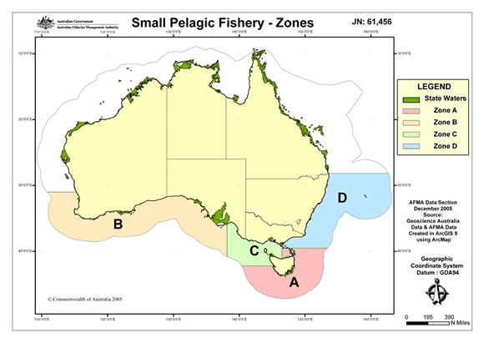
Figure 2. Area of Waters and zoning for the Small Pelagic Fishery.

Target species and methods
The SPF authorises purse seine and midwater trawl fishing for the following species;
- Jack mackerel - Trachurus declivis, T. murphyi
- Blue mackerel - Scomber australasicus
- Red bait - Emmelichthys nitidus
- Yellow tail scad - Trachurus novaezelandiae

Current Management Arrangements

Zones B, C and D management arrangements
Zones B, C and D are managed by Permits (granted annually) in accordance with the Management Policy for the Commonwealth Small Pelagic Fishery, 1 March 2002. Under the existing policy AFMA has applied a range of input controls including, limited entry, gear restrictions and spatial controls. Catch levels are regulated through precautionary catch trigger limits (TCL) and protocols to be followed upon reaching a TCL are prescribed within the Management Policy. To support the management integrity of the Southern and Eastern Scalefish and Shark Fishery (SESSF), SPF midwater trawl permit holders must also hold entitlements for the relevant SESSF trawl sectors operating in the same area of waters.

Zone A management arrangements
Zone A is managed through a joint arrangement between the Commonwealth and Tasmanian Governments. Under this arrangement an annual Total Allowable Catch is determined by the Tasmanian Department of Primary Industries, Water and Environment, entry is limited and gear restrictions apply. Zone A operators hold either or both a Commonwealth Fishing Permit or a Tasmanian Fishing License.

In line with cost-effective management, both the Australian and Tasmanian Governments have agreed to set aside the existing agreement and to manage Zone A under a single management plan for the entire fishery. Subject to the final Ministerial approval, Zone A will be managed under the proposed SPF Plan.

Consultative mechanism
AFMA maintains a co-management approach with stakeholders involving them in the development of policies and encouraging them to share responsibility for management of Commonwealth fisheries resources. Key consultative groups established by AFMA are Management Advisory Committees (MACs) and Resource Assessment Groups (RAGs). MACs and RAGs provide direct advice to the AFMA Board on the management and assessment of AFMA managed fisheries. In 2005, the AFMA Board appointed members to the first MAC and RAG for the SPF.
A Cetacean Mitigation Working Group (CMWG) has also been formed to provide specialist advice on dolphin mitigation strategies.

Effort
In 2005/06 AFMA granted 76 SPF fishing permits. Of these permits fishing activity was only recorded against 10 permits. Catches across the fishery remain well below the catch limits imposed.

Informally Managed Fishing Permits (IMFPs)

Area of waters
The waters covered by IMFPs extend from Queensland to South Australia and only between 3nm and the outer limit of the Australia Fishing Zone. Most IMFPs (type 1 IMFPs) provide access to the entire area shown in Figure 2 while one IMFP (type 2 IMFP) is restricted to waters adjacent to NSW.

Target species and methods
IMFPs authorise purse seine fishing for various species in particular waters. The two types of authorisations provided are purse seining fishing for unlimited levels of:
- scalefish (excluding SESSF quota and tuna and tuna like species) in water adjacent to NSW, VIC, TAS and SA and SPF species (see above) in waters adjacent to Queensland below the parallel of latitude 24°30’s - Type 1 IMFP; and
- pilchards (Australian sardines) and sandy sprat by purse seine method in waters adjacent to NSW – Type 2 IMFP.

Management Measures
There is no formal management policy for IMFPs and no restrictions on the take of most species. Some limits exist for byproduct species that are managed principally in other fisheries.

Consultative mechanism
Historically there have been no formal consultative arrangements for IMFPs (i.e. MAC or RAG). Since the AFMA Boards decision to manage the IMFP activities under a management plan for the SPF however SPFMAC has operated as a consultative forum for IMFP issues.

Effort
In 2005/06 AFMA granted four IMFPs. Of these permits fishing activity was only recorded against 1 permit. Catches for years 1994-2005 remain less than 215 000 Tonnes annually.

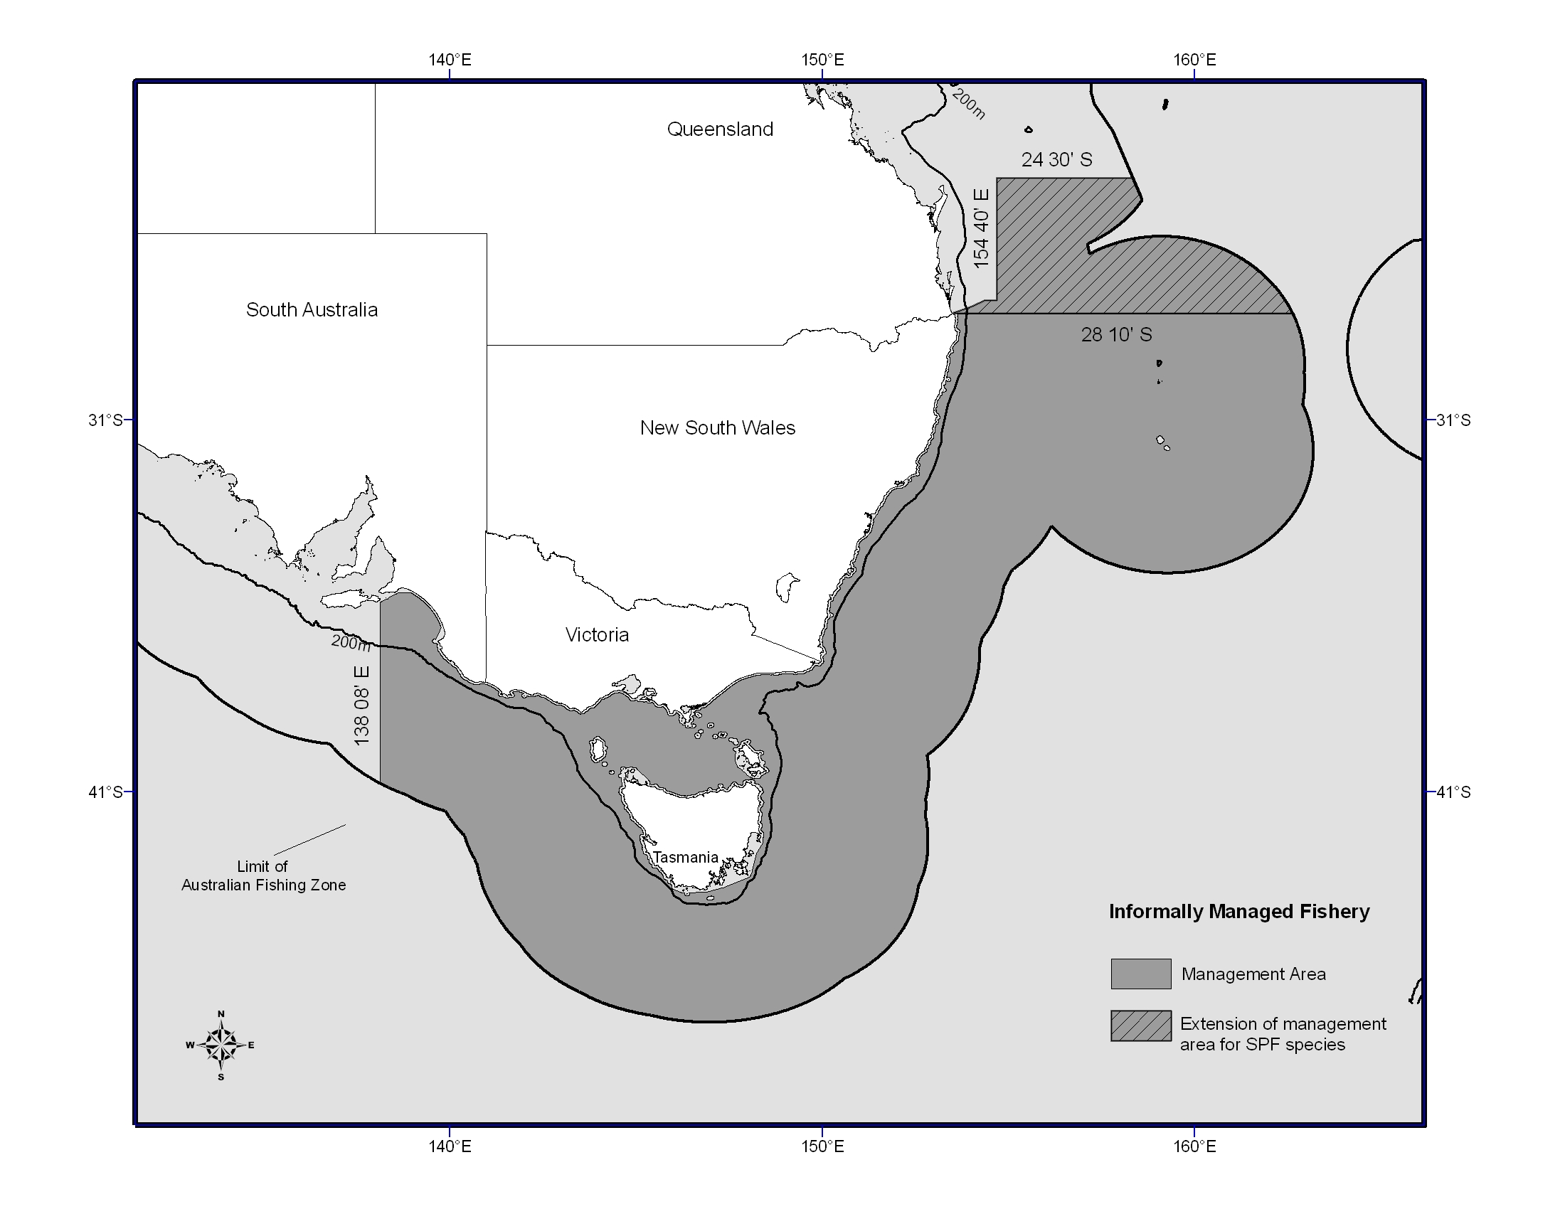
Figure 3. Area of waters for IMFP Type 1.

Latent effort arises from permits/fishing authorities being held by operators which are not being used. Only 6 of the 75 permits currently issued in the SPF are being fished against.
Under section 91 of the FAA the Minister may give directions to AFMA concerning the performance of its functions and exercise of its powers. AFMA must comply with those directions.
Fishing permits are granted under section 32 of FMA
SPRAT and SPFWG were informal management bodies (similar to a MAC), which anyone were allowed to attend. Members were not appointed by the board as in the official MAC and RAG process that now occurs.
Although targeted to a small extent, yellowtail scad is considered a byproduct species in the SPF

