Vehicle Standard (Australian Design Rule 81/02 — Fuel Consumption Labelling for Light Vehicles) 2008 Amendment 3
I, ANTHONY NORMAN ALBANESE, Minister for Infrastructure and Transport, determine this vehicle standard under section 7 of the Motor Vehicle Standards Act 1989.
Dated 22 September 2010

Anthony Norman Albanese
Minister for Infrastructure and Transport

CONTENTS

1 LEGISLATIVE PROVISIONS 2
2 AMENDMENT OF VEHICLE STANDARD 2
3 SCHEDULE 1 2

1 LEGISLATIVE PROVISIONS

  - NAME OF LEGISLATIVE INSTRUMENT

    - This instrument is the Vehicle Standard (Australian Design Rule 81/02 – Fuel Consumption Labelling for Light Vehicles) 2008 Amendment 3.
    - This instrument may also be cited as ADR 81/02 Amendment 3.

  - COMMENCEMENT

    - This instrument commences the day after it is registered.

2 AMENDMENT OF VEHICLE STANDARD

    - The changes specified in Schedule 1 amend Vehicle Standard (Australian Design Rule 81/02 – Fuel Consumption Labelling for Light Vehicles) 2008.

SCHEDULE 1

[1] Amend clause 1.1 to read:
“1.1 This vehicle standard prescribes the requirements for the measurement of vehicle fuel consumption, carbon dioxide emissions, energy consumption and range, and the design and application of fuel consumption labels and energy consumption labels to vehicles.”

[2] Insert following text at the beginning of clause 2.2:
“Except as specified in clause 2.3,”

[3] Insert new clause 2.3 which reads:
“This vehicle standard applies from 1 March 2011 in relation to pure electric vehicles and externally chargeable hybrid electric vehicles produced on or after 1 March 2011.”

[4] Renumber existing clauses 2.3 and 2.4 as 2.4 and 2.5, respectively.

[5] Renumber existing clause referenced in clause 3.1 from 2.3 to 2.4.

[6] Amend clauses 4.1, 4.2, 4.3 and 4.4 to read:
“4.1 Every vehicle shall have applied to its windscreen a fuel consumption label or energy consumption label meeting the specifications of the appropriate label illustrated in Appendix A.
4.2 The fuel consumption label or energy consumption label shall be placed in a bottom corner of the front windscreen on the inside of the windscreen.
4.3 The fuel consumption label shall be applied to vehicles powered by an internal combustion engine only and to hybrid electric vehicles which are not externally chargeable.
4.4 The energy consumption label shall be applied to pure electric vehicles and to hybrid electric vehicles which are externally chargeable.”

[7] Insert new clauses 4.5, 4.6 and 4.7 which read:
“4.5 Subject to the requirements of paragraph 5.5 of Appendix B, the manufacturer shall report:
4.5.1 for vehicles specified in clause 4.3, the three fuel consumption results and three carbon dioxide emissions results for the vehicle from Part One (urban) and Part Two (extra-urban) of the Type I test and from the full (combined) Type I test, as determined in accordance with Annex 6 or Annex 8 of Appendix B; and
4.5.2 for vehicles specified in clause 4.4:
4.5.2.1 the combined fuel consumption and combined carbon dioxide emissions results (if applicable) as determined in accordance with Annex 8 of Appendix B;
4.5.2.2 the energy consumption results as determined in accordance with Annex 7 or Annex 8 of Appendix B; and
4.5.2.3 the range as determined in accordance with Annex 9 of Appendix B.
4.6 The values displayed on the fuel consumption label shall be:
4.6.1 for fuel consumption, the urban, extra-urban and combined values reported for the vehicle under clause 4.5.1; and
4.6.2 for carbon dioxide emissions, the combined value reported for the vehicle under clause 4.5.1.
4.7 The values displayed on the energy consumption label shall be:
4.7.1 for energy consumption and range, the values reported for the vehicle under clause 4.5.2; and
4.7.2 if applicable, for fuel consumption and carbon dioxide emissions, the combined value reported for the vehicle under clause 4.5.2.”

[8] Amend clause 6.1 to read:
“6.1 Subject to clause 6.1.1, the values for fuel consumption, carbon dioxide emissions, energy consumption and range declared for the vehicle by the manufacturer in accordance with the requirements of United Nations Economic Commission for Europe Regulation No. 101 UNIFORM PROVISIONS CONCERNING THE APPROVAL OF PASSENGER CARS POWERED BY AN INTERNAL COMBUSTION ENGINE ONLY, OR POWERED BY A HYBRID ELECTRIC POWER TRAIN WITH REGARD TO THE MEASUREMENT OF THE EMISSION OF CARBON DIOXIDE AND FUEL CONSUMPTION AND/OR THE MEASUREMENT OF ELECTRIC ENERGY CONSUMPTION AND ELECTRIC RANGE, AND OF CATEGORIES M1 AND N1 VEHICLES POWERED BY AN ELECTRIC POWER TRAIN ONLY WITH REGARD TO THE MEASUREMENT OF ELECTRIC ENERGY CONSUMPTION AND ELECTRIC RANGE, are deemed to be equivalent to the values for fuel consumption and carbon dioxide emissions, energy consumption and range required under clause 4.5 of this vehicle standard.”

[9] Insert new clause 6.1.1 which reads:
“6.1.1 The versions of UN ECE Regulation 101 deemed acceptable under clause 6.1 are UN ECE Regulation 101 Revision 2 – Amendment 1, including all amendments up to and including Supplement 7, and UN ECE Regulation 101 Revision 2 – Amendment 2.”

[10] Amend Appendix A heading “FUEL CONSUMPTION LABEL SPECIFICATIONS” to read:
“1 FUEL CONSUMPTION LABEL SPECIFICATIONS”

[11] Amend clauses 1.1 and 1.2 of Appendix A to read:
“1.1 The label shall be of the form, dimensions and fonts illustrated in Figure 1 of this Appendix A, with Figure 2 providing an illustration of the label for printing purposes.
1.2 Figure 1 shall be applied to vehicles powered by an internal combustion engine fuelled by petrol, diesel or liquefied petroleum gas (LPG) and to hybrid electric vehicles which are not externally chargeable.”

[12] Amend clause 12.3 of Appendix A to read:

“1.12.3 fuel type of the vehicle, using the terms “Petrol”, “Diesel”, “LPG”, “CNG”, “Petrol/Electric Hybrid”, “Diesel/Electric Hybrid” or “LPG/Electric Hybrid” as appropriate.”

[13] Amend clauses 12.3 of Appendix A to read:

“1.13 The three fuel consumption values in L/100km specified in clause 4.6.1 of this vehicle standard shall be centred in the red areas on the label indicated by the letters “XX.X” in Figure 1.
1.14 The CO₂ emissions value in g/km specified in clause 4.6.2 of this vehicle standard shall be centred in the green area on the label indicated by the letters “XXX” in Figure 1.”

[14] Insert new Section 2 in Appendix A which reads:
“2 ENERGY CONSUMPTION LABEL SPECIFICATIONS
2.1 The label shall be of the form, dimensions and fonts illustrated in Figure 4 of this Appendix A, with Figure 5 providing an illustration of the label for printing purposes.
2.2 Figure 4 shall be applied to pure electric vehicles and hybrid electric vehicles which are externally chargeable.
2.3 The label shall be self adhesive, durable and removable, and of a type suitable for application to the windscreen of the vehicle.
2.4 The information on the label shall be in the English language, legible and visible from outside the vehicle when the label is applied to the windscreen.
2.5 All text and numerals on the label shall be black, except:
2.5.1 the “ENERGY CONSUMPTION” heading, which shall be white lettering reversed out of the solid black background surrounding the heading and statement; and
2.5.2 the “CO₂ Emissions and Vehicle Recharging” heading and associated statement, which shall be white lettering reversed out of the solid green background surrounding the statement.
2.6 The colours used on the label are black, red, yellow and green, with the red to be Pantone Warm Red, the yellow to be Pantone 116 and the green to be Pantone 360CVC.
2.7 The following background areas of the label shall be white:
2.7.1 The background area between the solid red background surrounding the energy consumption, range and fuel consumption values and the inner border containing these values; and
2.7.2 The background area between the solid green background surrounding the CO₂ emissions value and the inner border containing this value.
2.8 The background area between the inner borders specified in clause 2.7 and between the inner borders and the edge of the label shall be yellow.
2.9 A description of the vehicle shall be placed on the yellow background between the energy consumption heading and the white data boxes.
2.10 The wording of the vehicle description on the label shall have normal spacing of letter, line and word, and be centred horizontally and vertically in the area specified in clause 2.9.
2.11 The vehicle description specified in clause 2.9 shall include the:
2.11.1 vehicle make, model and variant description by which the vehicle is advertised and sold;
2.11.2 transmission type of the vehicle; and
2.11.3 the fuel type of the vehicle, where:
2.11.3.1 for pure electric vehicles, the term ‘Electric’ shall be used for the fuel type; and
2.11.3.2 for externally chargeable hybrid electric vehicles, the term “plug-in petrol/electric hybrid”, “plug-in diesel/electric hybrid” or “plug-in LPG/electric hybrid” shall be used, as appropriate, for the fuel type.
2.12 The energy consumption value in Wh/km specified in clause 4.7.1 of this vehicle standard shall be centred in the red area on the label indicated by the letters “XXX” in Figure 4.
2.13 The range in km specified in clause 4.7.1 of this vehicle standard shall be centred in the red area on the label indicated by the letters “XXX” in Figure 4.
2.14 The fuel consumption value in L/100km shall be centred in the red area on the label indicated by the letters “XX.X” in Figure 4, and:
2.14.1 for externally chargeable hybrid electric vehicles, the value shall be as specified in clause 4.7.2 of this vehicle standard; and
2.14.2 for pure electric vehicles, the value is to be displayed as “0”.
2.15 The carbon dioxide emissions value in g/km shall be centred in the green area on the fuel consumption label indicated by the letters “XXX” in Figure 4, and:
2.15.1 for externally chargeable hybrid electric vehicles, the value shall be as specified in clause 4.7.2 of this vehicle standard; and
2.15.2 for pure electric vehicles, the value is to be displayed as “0”.
2.16 The dimensions of the red and green areas featuring the energy consumption, range, fuel consumption and CO₂ emission values may be varied by up to 1mm to allow for printing tolerances.
2.17 Figure 6 provides a sample label to illustrate placement of the vehicle description and energy consumption, range, fuel consumption and CO₂ emission values.

[15] Insert new Figure 4, Figure 5 and Figure 6 as follows:

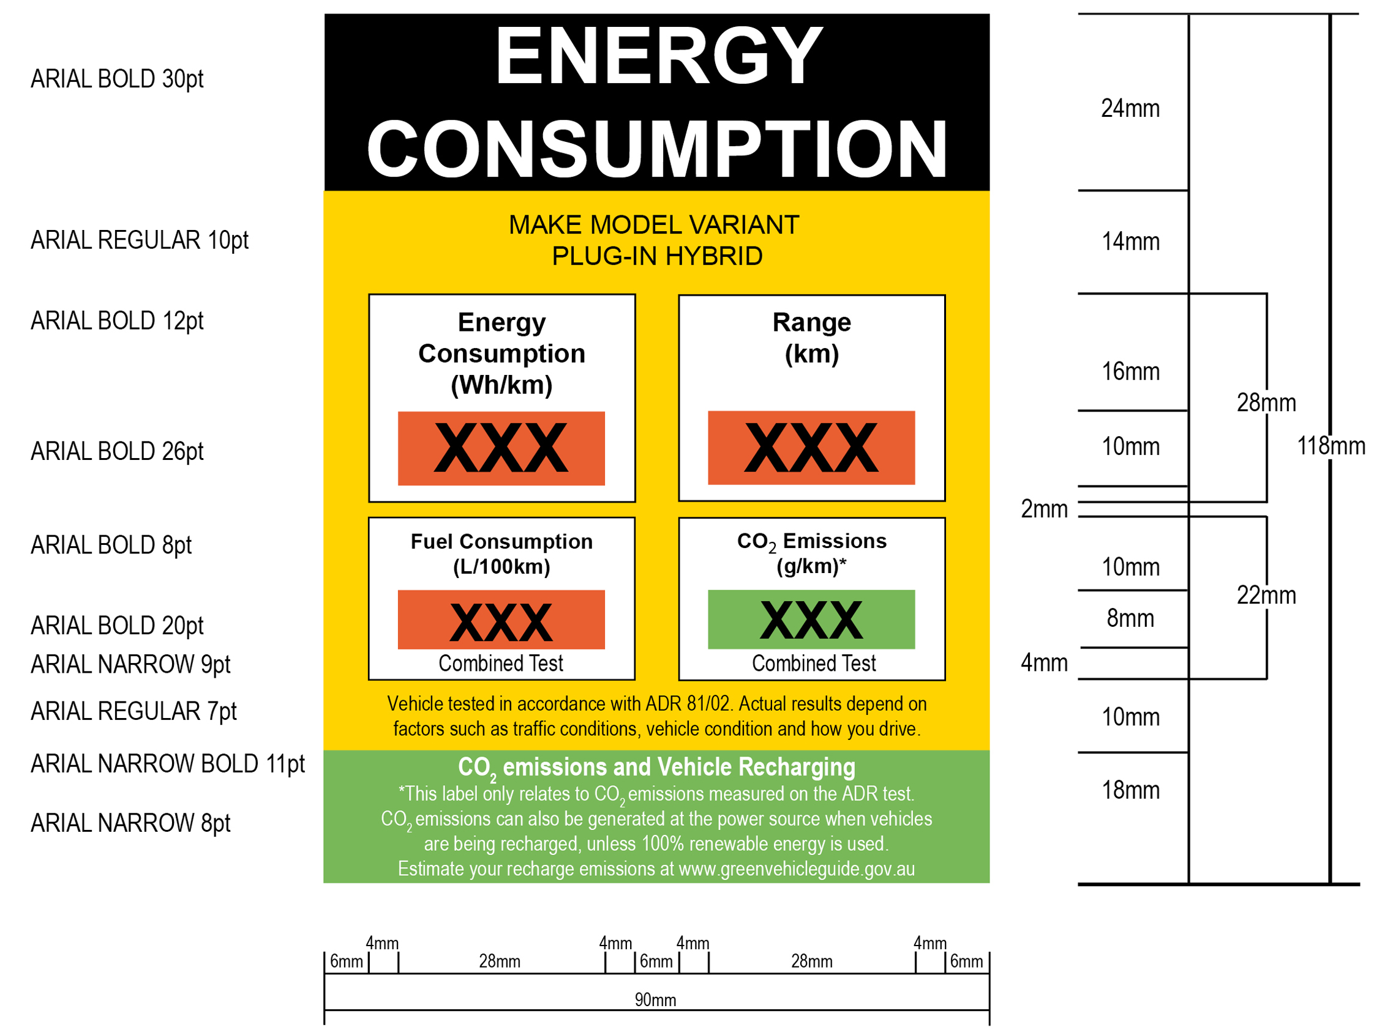

Figure 4: Illustration of Energy Consumption Label with fonts and dimensions
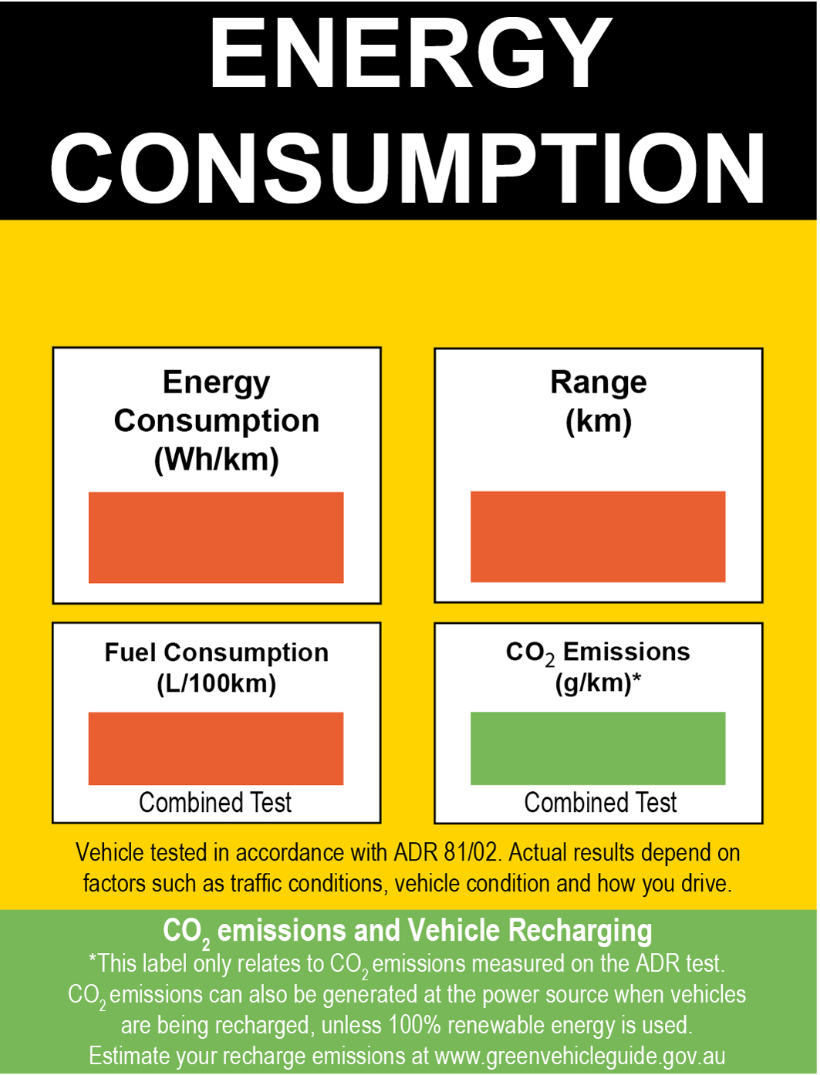

Figure 5: Illustration of Energy Consumption Label
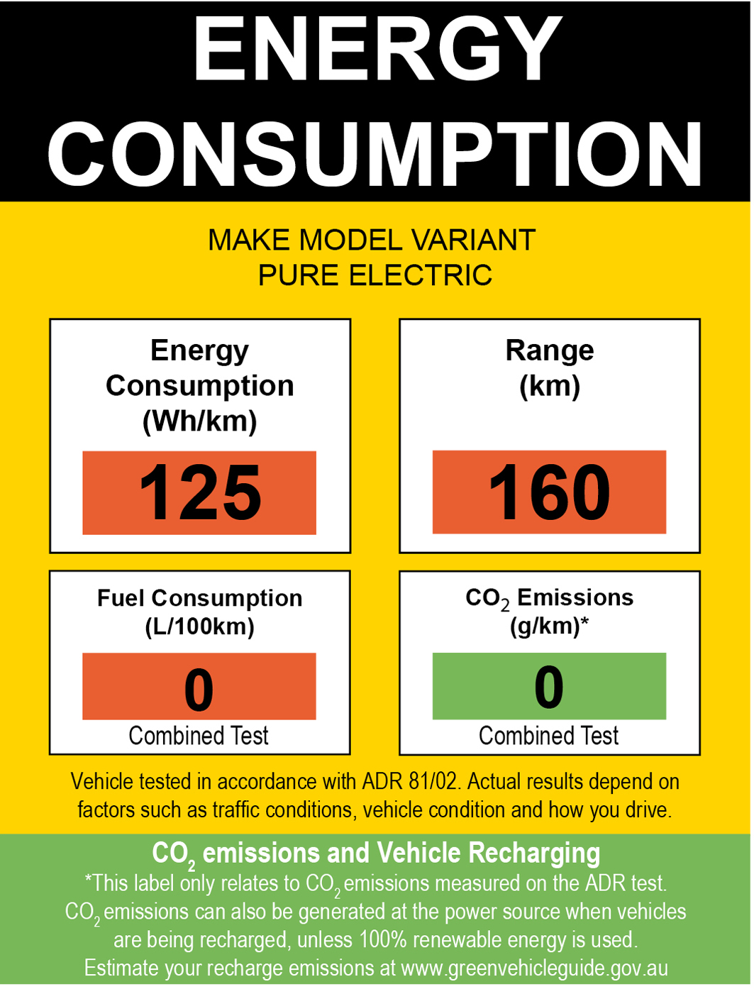

Figure 6: Sample Energy Consumption Label (for illustrative purposes only)

