COMMONWEALTH OF AUSTRALIA
CEO Instrument of Approval No. 3 of 2010
Customs Act 1901
I, MICHAEL JOSEPH CARMODY, Chief Executive Officer of Customs, under section 4A of the Customs Act 1901 (the Act) and regulation 41 of the Customs Regulations 1926, hereby approve the attached “Incoming passenger card” form (No. 15 (Design date 11/10)) as an approved form for the purpose of providing, in the English language, information required under section 71AAAB of the Act in relation to imported goods that are accompanied personal or household effects of a passenger of a ship or aircraft.
This instrument commences on the day after it is registered.
Dated: 24 September 2010
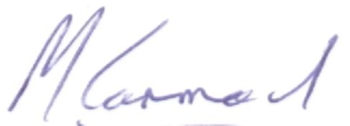
MICHAEL JOSEPH CARMODY
Chief Executive Officer of Customs

