Explanatory Statement
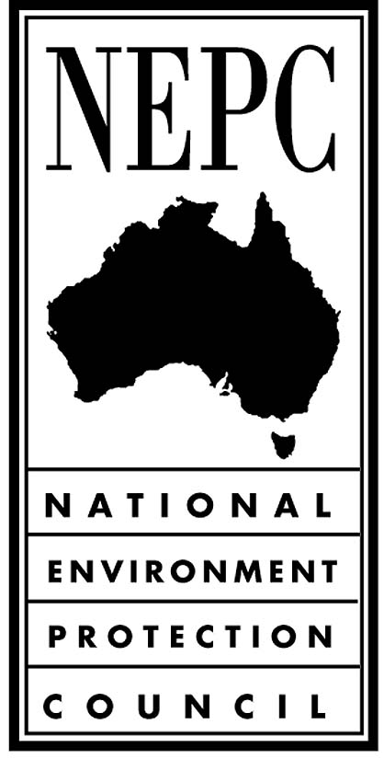

for the Proposed Minor Variation to the
National Environment Protection (Movement Of
Controlled Waste between States And Territories)
Measure

The Movement of Controlled Waste between States and Territories NEPM
The Movement of Controlled Waste between States and Territories NEPM (the NEPM) was developed to minimise the potential for adverse impacts associated with the movement of controlled waste on the environment and human health. The NEPM provides a basis for ensuring that controlled wastes that are to be moved between States and Territories are properly identified, transported, and otherwise handled in ways that are consistent with environmentally sound practices for the management of these wastes. The NEPM provides a national framework for the management of the movement of controlled wastes between States and Territories originating from commercial, trade, industrial or business activities.

Reasons for the proposed minor variation to the NEPM
Submissions received from stakeholders consulted during the Review of the NEPM indicated that some minor variations were needed to remove clauses that are no longer required, to provide greater clarity to the Schedules and certainty to industry when completing documentation and to reduce the regulatory burden where requirements do not achieve any significant environmental benefit. In addition some stakeholders also made submissions indicating that the NEPM needed some clarification as to the types of policies and legislation that should be considered by jurisdictions when making decisions about the move

Nature and effect of the proposed variation to the NEPM
The nature and effects of the proposed minor variation are outlined below:

Clause 3, Definitions in which a variation has been made to the definition of producer as the current definition does not encompass those who may consign waste, such as a licensed waste consolidation or storage facility, but are not producers of waste. Consignors are not authorised by jurisdictional agencies and therefore may be considered unauthorised to arrange the interstate transport of waste. The variation includes consignors in the definition of producer.

Clause 10, Review of the Measure in which a variation has been made to specify a ten year period. Clause 10(a) currently specifies a five year review period. Comprehensive review of the NEPM in 2003 and 2010 resulted in only minor variations to the NEPM. Implementation issues are dealt with by the jurisdictions through the Implementation Working Group and the Agreement between Agencies. The ten year review period recommended does not preclude NEPC from initiating a review earlier than the 10 year period if necessary.

Clause 10(b) is deleted as its purpose is no longer relevant. This Clause was included prior to the 2004 amendment to the NEPC Act which provided for the making of a minor variation. Clause 10(b) of the NEPM is no longer required.

Clause 13, Licensing and mutual recognition 13(c), (d) and (e) are deleted as states and territories have implemented the NEPM and these clauses are no longer required.

Clause 13, Prior Notification and Consignment Authorisation is varied to include an explanatory note to provide further clarification to jurisdictions on the types of policies and legislation that should be included in consideration of consignment authorisations. The NEPM stipulates that each jurisdiction should require a producer intending to move controlled wastes to another state or territory to obtain a consignment authorisation prior to the movement taking place. Authorisations are only refused where a licence or policy requirement of the jurisdiction is not met.

Schedule A List 1: Waste Categories, is varied to include more concise descriptions for wastes that are currently tracked under the NEPM. The descriptions included are “oxidising agents”, “reactive chemicals” and “reducing agents” and will clarify the list for industry. Similarly minor variations are made list entries for cyanides (organic), encapsulated waste and filter cake and the entry for “fly ash” is varied to clarify that it does not apply to fly ash generated at Australian coal fired power stations, reflecting practice of jurisdictions under the NEPM.

The entry for “sewage sludge and residues including nightsoil and septic tank sludge” is deleted from the list as this waste has been identified in submissions as being managed under national programs or that the current risks to the environment from the interstate movement of the waste are limited and adequately dealt with through other controls

Schedule B: is varied to delete entries for “waste origin code” and “contaminant(s)” as submissions have identified that the documentation requirement for each movement was adding costs and confusing to industry, and did not achieve any substantive environmental benefit.

Schedule B is also varied to allow for the recognition of systems that provide equivalent accessibility to a paper certificate during transport, particularly during a response to an accident or for roadside inspections.

Reasons why NEPC is satisfied that the variation is a minor variation
The proposed variation does not affect the goal and desired environmental outcome contained in the NEPM and will have no financial impacts. As a consequence, the economic, environmental and social impacts of the NEPM are unchanged.

Consultation
The draft variation and a copy of this Explanatory Statement were placed on the EPHC website on 16 July with a closing date for submissions on 18 August. A notice was placed in the Commonwealth Gazette on 16 July and in newspapers in each state and territory on 17 July advising of the intention to vary the NEPM and how to access the proposed variation and make submissions.

The consultation draft variation and Explanatory Statement included a proposal to remove “tyres” from the list of waste categories. Following the consultation process it was agreed to retain tyres in the list and the variation and this copy of the Explanatory Statement were appropriately amended.

