Explanatory Statement

Eastern Tuna and Billfish Fishery Management Plan 2010

Subsection 17(1) of the Fisheries Management Act 1991 (the Act) provides that the Australian Fisheries Management Authority (AFMA) must determine written plans of management for each fishery that it manages.

The Eastern Tuna and Billfish Fishery

The Eastern Tuna and Billfish Fishery (the Fishery) is located throughout the Australian Fishing Zone (AFZ) east of Cape York in Queensland to the South Australia / Victoria border, including the waters of the AFZ adjacent to Norfolk Island. The Fishery also includes the high seas areas covered by the Convention on the Conservation and Management of Highly Migratory Fish Stocks in the Western and Central Pacific Ocean. The AFZ is defined consistently with the Exclusive Economic Zone and extends out to 200 nautical miles from the coastlines.
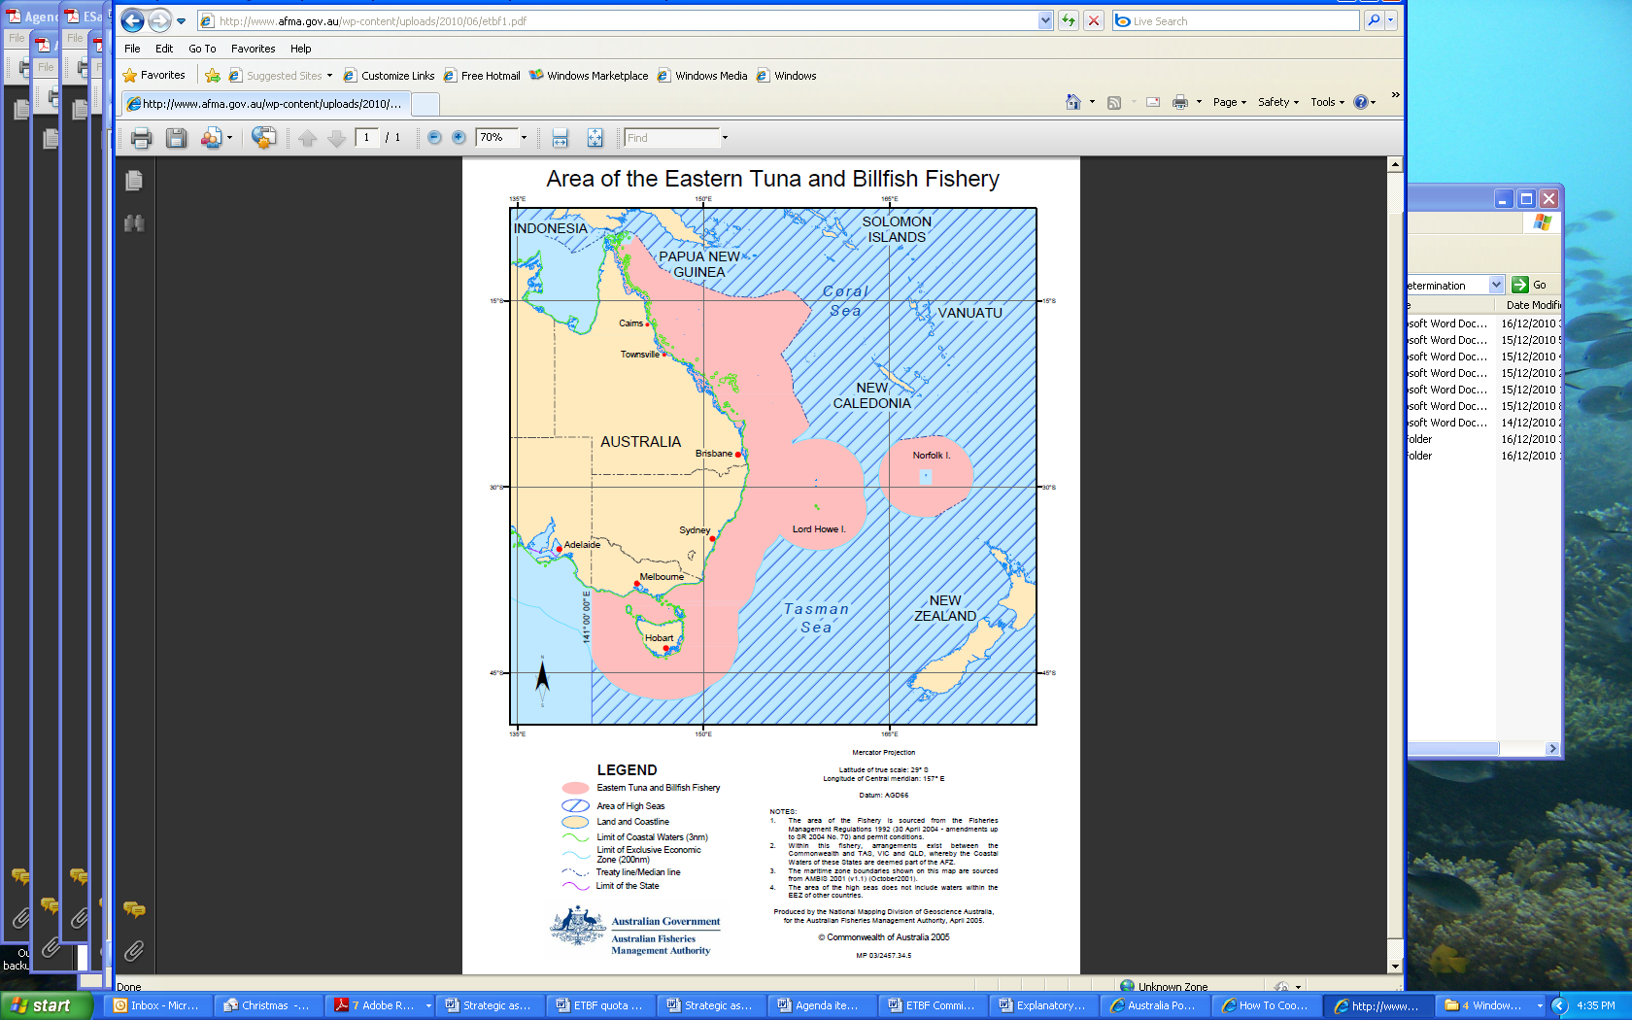

The primary species in the fishery are Albacore Tuna (Thunnus alalunga), Bigeye Tuna (Thunnus obesus), Billfish (Families Istiophoridae and Xiphiidae), Longtail Tuna (Thunnus tonggol), Northern Bluefin Tuna (Thunnus orientalis), Rays Bream (Family Bramidae), Skipjack Tuna (Katsuwonus pelamis) and Yellowfin Tuna (Thunnus albacares). Fishing for all primary (Schedule 2) species is permitted by means of pelagic longline and minor line (troll, rod and reel, hand line). Other methods may be declared by AFMA in accordance with the Plan of management for the fishery.

The Fishery was previously managed under the Eastern Tuna and Billfish Fishery Management Plan 2005 (the previous Plan). In order to change the management arrangements from an input controlled system, under which the number of hooks set is controlled, to an output controlled system (quota), where the catch of target species is limited, AFMA has revoked the previous Plan and determined the Eastern Tuna and Billfish Fishery Management Plan 2010 (the new Plan) in its place.

The new Plan implements the recommendations of the Independent Allocation Advisory Panel (IAAP) commissioned by AFMA in 2009 to determine how to translate the hook based statutory fishing rights (SFRs) issued under the previous Plan to quota based SFRs issued under the new Plan.

The change in management arrangements, from input controls to output controls, is in accordance with the Ministerial Direction of December 2005, issued under section 91 of the Fisheries Administration Act 1991, that required AFMA to implement the government policy of managing Commonwealth fisheries using output controls in the form of individual transferable quotas by 2010.

Determination and Acceptance

Section 17 of the Act requires that the new Plan can only be determined after consultation with such persons engaged in fishing as appear to AFMA to be appropriate and, after giving due consideration to any representations made to AFMA on the new Plan in accordance with section 17. AFMA has consulted on the new Plan as required by section 17, including by inviting interested persons by public notice to make representations in connection with the new Plan.

The Office of Best Practice Regulation (OBPR) advised that no further analysis, in the form of a Regulation Impact Statement, is required (OBPR reference: ID 12105).

The AFMA Commission determined the new Plan on 20 December 2010.

As required by section 18 of the Act, AFMA submitted the Plan to the Minister and informed the Minister of the nature of the representations received, and the consultations it conducted, before determining the new Plan. The Minister was satisfied of the matters specified in section 18(2) of the Act and accepted the Plan on 10 January 2011.

Notification of the determination and acceptance of the Plan was published in the Gazette in accordance with subsection 19(1) of the Act.

Statutory Fishing Rights options

Each person who held SFRs of a particular class (the relevant class) under the previous Plan immediately before it was revoked holds an SFR option in respect of fishing rights of the particular class. The two classes of SFRs are longline SFRs and minor line SFRs. After the revocation of the previous Plan and the determination of the new Plan come into force, following registration of both instruments on the Federal Register of Legislative Instruments, AFMA will determine under section 31C of the Act the SFRs each option holder is entitled to be granted under the new Plan.

Content of Plan

Details of the Plan are set out below:

Part 1 Preliminary

Section 1.1 – provides that the name of the Plan is the Eastern Tuna and Billfish Fishery Management Plan 2010.

Section 1.2 – provides that the Plan commences on the day after it is registered (on the Federal Register of Legislative Instruments).

Section 1.3 – defines various terms used in the Plan.

Section 1.4 – specifies how geographical coordinates used in the Plan are to be determined.

Section 1.5 – specifies the objectives of the Plan, and the objectives for AFMA to pursue when it is administering the Plan, in accordance with subsection 17(5) of the Act.

Section 1.6 – specifies, for the purposes of paragraph 17(5)(b) of the Act, the measures by which the objectives of the Plan are to be attained.

Section 1.7 – specifies, for the purposes of paragraph 17(5)(c) of the Act, the performance criteria for assessing the measures to be taken to achieve the objectives of the Plan.

Section 1.8 – specifies persons to whom the Plan does not apply.

Part 2 – Specific ecosystems requirements

Section 2.1 – provides that as soon as practicable after the Plan commences, AFMA will establish an ecological risk management plan for the fishery, and specifies requirements for the content, and review, of that plan.

Section 2.2 – specifies, for subsection 17(5C) of the Act, that the stock-specific reference points for straddling fish stocks are as set out in the ETBF Harvest Strategy, and that AFMA may review the Strategy, and change the Strategy as a result of the review. It also provides that AFMA may establish a Harvest Strategy for non-quota species that is appropriate to maintaining ecologically viable stocks of those species and an ecologically sustainable fishery.

Part 3 – Total Allowable Commercial Catch (TACC)

Section 3.1 – Directions by AFMA

In accordance with section 17(5A) of the Act, this section provides for AFMA to direct that fishing is not to be engaged in in the fishery, or a particular part of the fishery, in a particular period or periods; and requirements for giving such directions.

The Fisheries Legislation Amendment Act 2010 (the Amendment Act) repeals section 17(5A), amongst other measures. At the time the new Plan was determined, the Amendment Act had received Royal Assent but was not yet in force. When the Amendment Act does commence, this section of the Plan will no longer apply and such directions will instead be given under section 41A of the Act (as amended).

Section 3.2 – requires AFMA to determine, before the start of each fishing season, a TACC for each quota species for one or more seasons; and other requirements concerning the determination of the TACC.

Section 3.3 – specifies the formula for determining the quota for an SFR for a quota species for a fishing season.

Section 3.4 – specifies that AFMA must send a notice to each owner of an SFR for a quota species before the start of each fishing season, and the information the notice must contain.

Part 4 – Statutory fishing rights and fishing permits

Division 4.1 – Who may fish in the fishery

Section 4.1 – Who may engage in commercial fishing in the fishery

Subsections 4.1(1) and (2) - define “commercial fishing” and provide that a person may use an Australian boat to engage in commercial fishing in the fishery only in accordance with the section.

Subsection 4.1(3) – specifies the conditions for fishing in the fishery (excluding the Coral Sea Zone) for a species using pelagic longline equipment.

Subsection 4.1(4) – specifies the conditions for fishing in the Coral Sea Zone of the fishery for a species using pelagic longline equipment.

Subsection 4.1(5) – species the conditions for fishing in the fishing for a species using minor line equipment.

Subsection 4.1(6) – specifies that subject to subsections (7) and (8), a person may fish in the fishery for a quota species using equipment mentioned under paragraph 4.1(1)(c) only if the person holds a quota SFR for that species; and the SFR has unused quota for that species for the season. Paragraph 4.1(1)(c) refers to equipment, other than pelagic longline equipment or minor line equipment, that is allowed by AFMA in a condition specified on one of the four types of fishing concession listed in the paragraph.

Subsection 4.1(7) – specifies that a condition specified on an SFR granted under the Plan, or a fishing permit granted under section 4.15 of the Plan, must not authorise a person to take skipjack tuna using purse seine equipment, or southern bluefin tuna.

Subsection 4.1(8) - provides that subsection (6) does not apply to the holder of an eastern skipjack purse seine permit until AFMA publishes a notice under this section; and that such a notice must be published as soon as practicable after AFMA grants SFRs under section 4.10.

The purpose of this subsection is to enable the holders of eastern skipjack purse seine permits to continue to fish under their permits, after the Plan commences, until SFRs are granted to the holders of eastern skipjack purse seine permits under section 4.10.

Subsection 4.1(9) – defines ‘unused quota’ for the purposes of subsections (3)-(6).

Subsection 4.1(10) – specifies the requirements for using the nominated boat to take fish for bait.

Section 4.2 – Foreign commercial fishing

This section specifies the requirements for using a foreign boat in a fishing season in the part of the fishery that lies within the AFZ.

Section 4.3 – Carrying or processing fish

This section specifies the requirements for using a boat to take or process fish under section 4.1 or 4.2. Note: ‘fishing’, as defined in section 3 of the Act, includes ‘(g) the taking, carrying or transporting of fish that have been taken’.

Subsection 4.4 – Scientific research

This clause provides that a person may only use a boat in the area of the fishery for scientific research about the fishery only if the person holds a scientific permit that authorises the use of the boat in the area of the fishery for that purpose. Scientific permits are granted under section 33 of the Act.

Division 4.2 – Overcatch and Undercatch

Section 4.5 – Obligations relating to overcatch

This section specifies the consequences, for a holder’s catch, in the subsequent season, where the holder takes a weight of fish in a fishing season that exceeds the quota allocated to the quota SFRs for that species held by the holder in the season. Catch is deducted from the holder’s entitlements in the next season, as specified in the section.

Section 4.6 – Obligations relating to undercatch

This section specifies the consequences, for a holder’s catch, in the subsequent season, where the holder takes a weight of fish in a fishing season that is less than the quota allocated to the quota SFRs for that species held by the holder in the season. The holder is permitted to take a weight of fish in the subsequent season, as specified in the section, in addition to the quota allocated to the SFRs held by the person in that season.

Division 4.3 Grant of SFRs and fishing permits

Section 4.7 – Conditions of registration as an eligible person

This section specifies, for the purposes of paragraph 26(2)(a) of the Act, the conditions for registration as a person eligible for a grant of SFRs under the Plan. These conditions include that the person has not exercised an option within the meaning of section 31A of the Act arising out of the previous Plan. This restriction reflects the fact that option holders may choose to obtain a grant of the SFRs to which they are entitled either by exercising their option, or by applying under this section 4.7 to be registered as an eligible person; and means that those persons cannot obtain a grant of SFRs by both routes.

Subsection 4.7(3) - provides for a grant of SFRs to the persons who held an eastern skipjack purse seine permit immediately before the revocation of the previous Plan. A person in this category is entitled to register for a grant of SFRs under the Plan, whether or not the person held, or has exercised, an option arising out of the revocation of the previous Plan, because holding an option will not entitle a person to be granted SFRs on this basis. Therefore, the SFRs can only be granted to the person if the person is registered as eligible under this section 4.7.

Section 4.8 – specifies the SFRs available to be granted to an eligible person for each longline SFR held by the person immediately before revocation of the previous Plan.

Section 4.9 - specifies the SFRs available to be granted to an eligible person for each minor line SFR held by the person immediately before revocation of the previous Plan.

Section 4.10 - specifies the SFRs available to be granted to an eligible person for each eastern skipjack purse seine permit held by the person immediately before revocation of the previous Plan.

Section 4.11 – specifies the boat SFRs (longline boat SFRs, minor line boat SFRs and Coral Sea Zone boat SFRs) available to be granted.

Sections 4.8, 4.9 and 4.11 – each provide that any SFRs granted to the person on the same basis, through the exercise of an option arising out of the revocation of the previous Plan, are to be subtracted from the SFRs that would otherwise be available to be granted to the person. This means that a person cannot obtain a grant of SFRs on the same basis both by exercising an option, and through registering under the Plan as eligible for a grant.
Section 4.12 – Limits on availability

This section ensures that a person who registers as eligible for a grant on the basis that the person held an eastern skipjack purse seine permit is only eligible for a grant on that basis (under section 4.10), and must exercise an option to secure a grant of any other SFRs available to be granted to the person. (As noted, a person who held a longline SFR or a minor line SFR immediately before revocation of the previous Plan will hold an option, or options, under s31A of the Act upon revocation of the previous Plan).

Section 4.13 – Request for grant

This section provides that if a person is an eligible person the person is taken to have made a request under section 31 of the Act for a grant of the SFRs that are available to be granted to the person.

Section 4.14 – Certificate showing grant

This section specifies the details to be included on the certificate issued under subsection 22(2) of the Act, and requires AFMA to give to a person to whom an SFR is granted an extract from the Register that states the conditions to which the SFR is subject and is signed for AFMA by a person having authority to sign it.

Section 4.15 – Permit to fish using another method

This section enables AFMA to grant a permit to the holder of a quota SFR authorising the person to fish using a method other than pelagic longline fishing, in accordance with the section. Such a permit is not transferable.

Division 4.4 – Boat nomination

Section 4.16 – Nomination of boat

This section requires the holder of a boat SFR to nominate a boat to be used under the SFR before using the boat in accordance with the SFR. (Under each of subsections 4.1(3), (4), and (5) a person can only fish using use the nominated and registered boat). It also specifies that AFMA must register the boat as the nominated boat unless one or more of the specified circumstances applies.

Section 4.17 – Request to cancel boat nomination

This section specifies the requirements for cancelling a boat nomination.

Section 4.18 – Removal of boat from Register

This section specifies the circumstances in which AFMA may remove a boat from the Register; and provides that a person may seek a review of such a decision as if the decision were reviewable under s165 of the Act.

Part 5 – Obligations of SFR holders

Section 5.1 Observers and other requirements

This section specifies the obligations of the holders of SFRs regarding the carrying of observers, retention of by-catch, access to specified information, use of VMS and the disposal of fish landed from the fishery.

Section 5.2 – Interactions with other species

This section specifies the obligations on holders of SFRs regarding interactions with certain species and marine communities.

Part 6 – Miscellaneous

Section 6.1 – specifies the circumstances in which AFMA may replace a certificate for an SFR or fishing permit.

Section 6.2 - specifies the obligations on the hold of an SFR where the holder appoints a person to be the holder’s agent for a matter to which the Plan applies.

Section 6.3 – specifies certain presumptions regarding the giving of notices required, or allowed, by the Plan to be given in writing.
SCHEDULES

Schedule 1 Area of the Fishery

Parts 1 and 2 of the Schedule together define the Australian Fishing Zone (AFZ) area of the Fishery as that part of Australia’s EEZ east of Cape York in Queensland and east of 141°E, being the border between South Australia and Victoria. Part 2 of the Schedule describes the Coral Sea zone of the Fishery, an area of the AFZ adjacent to the central Queensland coast. Part 3 of the Schedule describes the high seas zone of the Fishery, the area within the competency of the Convention on the Conservation and Management of Highly Migratory Fish Stocks in the Western and Central Pacific Ocean.

Schedule 2 Primary species of fish

This Schedule lists the primary species that may be caught in the Fishery.

